

Module: Human Capital Management
Module code:LCMB7023
Assignment
Title: Individual report

- Student name: Dipenkumar Kamleshbhai Patel
- Student ID number: 2503885
- Program: Master of Business Administration
- Module: Human Capital Management
- Module code: LCMB7023
- Assignment Title: Assessment component 1: Individual report
- Lecturer’s Name: Gladius Kulothungan
- Word count: 2500 words

Executive Summary
The use of technologies such as Artificial intelligence has reduced the job opportunities for skilled workers. In addition, the existence of demographic factors such as an ageing population and migration has increased the employment of workers across the globe. The organisations have also improved the incentive structure for meeting the financial requirements of the workers and improving the engagement level of its staff. In addition, the inclusion of tools such as personal SWOT has helped the workers in identifying strengths and weaknesses that has helped the individuals in achieving professional growth. The existence of digital and financial initiatives has helped in improving job opportunities for skilled workers.

Table of content
Introduction 2
Question 1 3
1.1 Overview of Technological Transformation 3
1.2 Implications for Human Resource Management (HRM)/IHRM 5
Question 2 7
2.1 Key Demographic Factors 7
2.2 Key Geopolitical Factors 9
2.3 Challenges for HR Professionals 11
Question 3 12
3.1 Understanding the Causes of Skills Gaps 12
3.2 Strategic HRM Approaches 12
3.3 Sector-Specific Responses 14
Question 4 16
4.1 Introduction 16
4.2 Self-Assessment (Gibbs' Reflective Cycle) 16
4.3 SWOT Analysis 17
4.4 Development Plan 18
4.4.1 Strengths 18
4.4.2 Weakness 18
Conclusion 19
Reference list 20

Introduction
Context of the Study
The labour market has been influenced by geopolitical, demographic and technical factors that have reduced employment opportunities across the globe. The enhancement in job losses has also reduced the productivity level of workers
Purpose and Structure of the Report
The report has provided a critical evaluation regarding the impact of digitalisation on the work pattern of employees across the globe. In addition, the investigation has also included details regarding the utility of recruitment strategies of the organisation for improving its employee productivity.

Question 1

1.1 Overview of Technological Transformation
- Automation & AI
The role of AI encounters job displacement of humans by performing “data intensive tasks” through automation. For instance, 92 million jobs were dos[laced in 2025 among 170 jobs due to automation, where 39% of skills changed jobs by 2030 (WEF, 2025). AI enhances transformation by providing high skilled jobs for the enthusiast talents by boosting demand towards IT cybersecurity and data analytics.
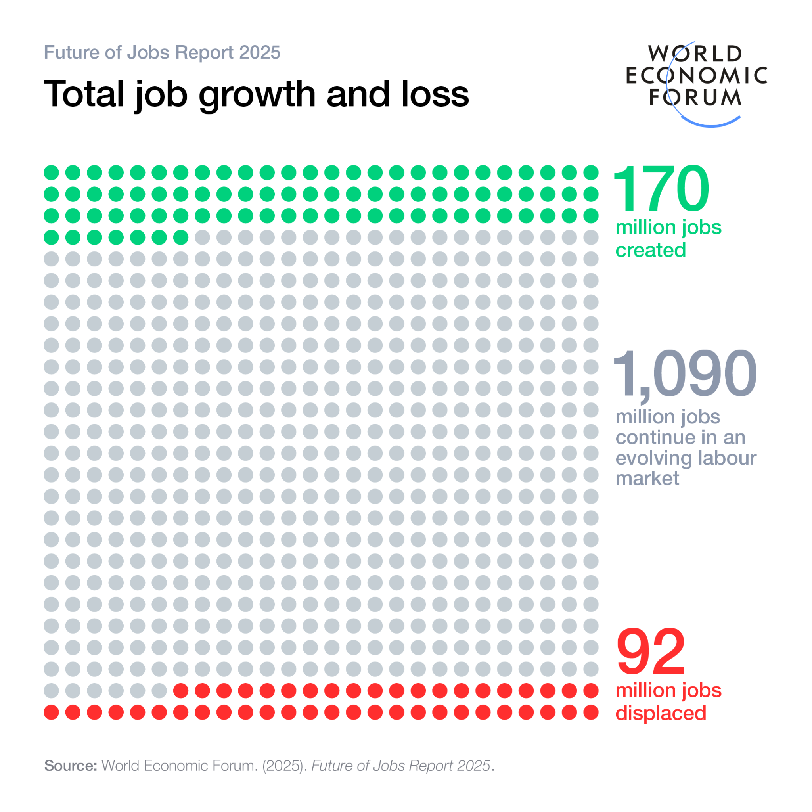
Figure 1: Job displacement through uses of AI
(Source: WEF, 2025)
- The Gig Economy & Digital Platforms
In the rapid changing era, shifts in long term employment that address based on assessing employees knowledge towards digital platforms and relying on flexibility. The Gig workers include both men and females, where 65% for men and 35% for women that varies based on job security and flexibility (Fennell, 2021). The shift in traditional employment to contractual leads to significant job loss due to transition of employment, struggling with leaves and protections regarding unfair dismissal.
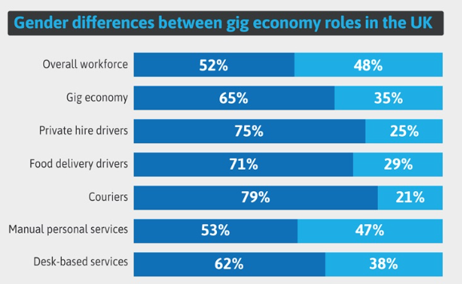
Figure 2: Gig economy at UK
(Source: Fennell, 2021)
- Skills Churn
The rapid transformation in the workforce requires high skilled talent and continuous learning opportunities of individuals to enhance transition in business. For instance, the UK economy boosts about £23 billion for digital skills by hiring AI talent, data analysts and cloud experts which enhance improvement in the workforce (Future, 2025). Unilever served women with Fellowship sponsors to achieve a sustainable future by collaborating with 780 scientists (STEM, 2025). The labor market is enhanced through technological innovation by adoption of AI which reshapes its business by reduction of digital literacy and serves employment opportunities which encounter transformation.

1.2 Implications for Human Resource Management (HRM)/IHRM
- Talent Acquisition and Recruitment Innovation
The companies have focused upon including innovation in its recruitment strategies for acquiring skilled employees in its business operations. For example, Tesco has collaborated with “Tribepad” worth $3m for adopting an “End-to-End Recruitment Platform” that helps the organisation in improving the safety of employee information (Tribepad, 2025). The partnership has helped Tesco in enhancing the efficiency of its workforce.
- Learning and Development
Learning and Development has been considered as an important tool that helps organisations in improving the knowledge of its workers. The companies have emphasised upon enhancing the skills of its workforce to increase its productivity. For instance, Amazon has invested $3bn in developing infrastructures such as “Driver Academy” that has helped the company in providing AI training to its delivery partners in 2024 (Kulisch, 2025). The adoption of the skill development initiatives has improved the engagement level of the workers.
- Strategic Workforce Planning
Strategic Workforce Planning is also an important tool that has been adopted by organisations for meeting the financial and operational requirements of its workforce. For example, Amazon has invested $2.1bn in developing the “Delivery Service Partner Programme” that has helped organisations collaborate with small entrepreneurs in 2024 (Today, 2024). The initiative has helped the e-commerce company improve its worker relationships. Amazon has enhanced its staff from 100000 employees in 2020 to 150000 employees in 2025 (Bosze, 2024). The improvements in the workforce has also increased the productivity of Amazon.
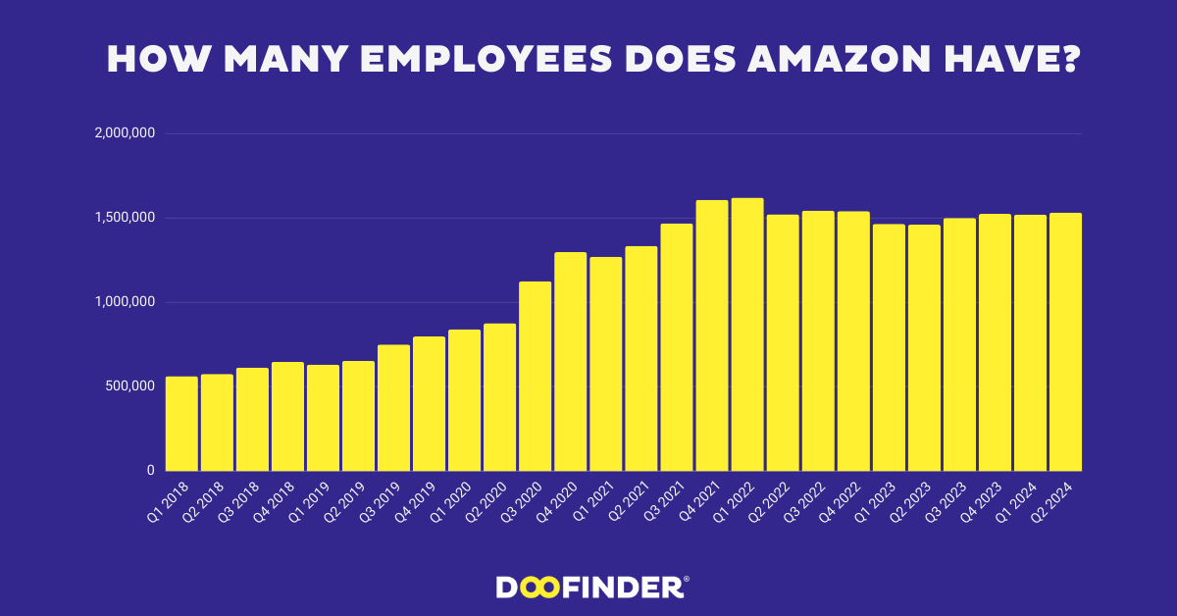
Figure 3: Workforce of Amazon
(Source: Bosze, 2024).

Question 2

2.1 Key Demographic Factors
- Ageing Population and Workforce Participation
The aging population has been a critical demographic issue that has reduced the workforce quality of countries across the globe. In Japan, the volume of “Working Senior Citizens” has increased from 6.5m in 2013 to 9m in 2023 (Government of Japan, 2024). The enhancement in the involvement of ageing employees has reduced the productivity of the Japanese companies.
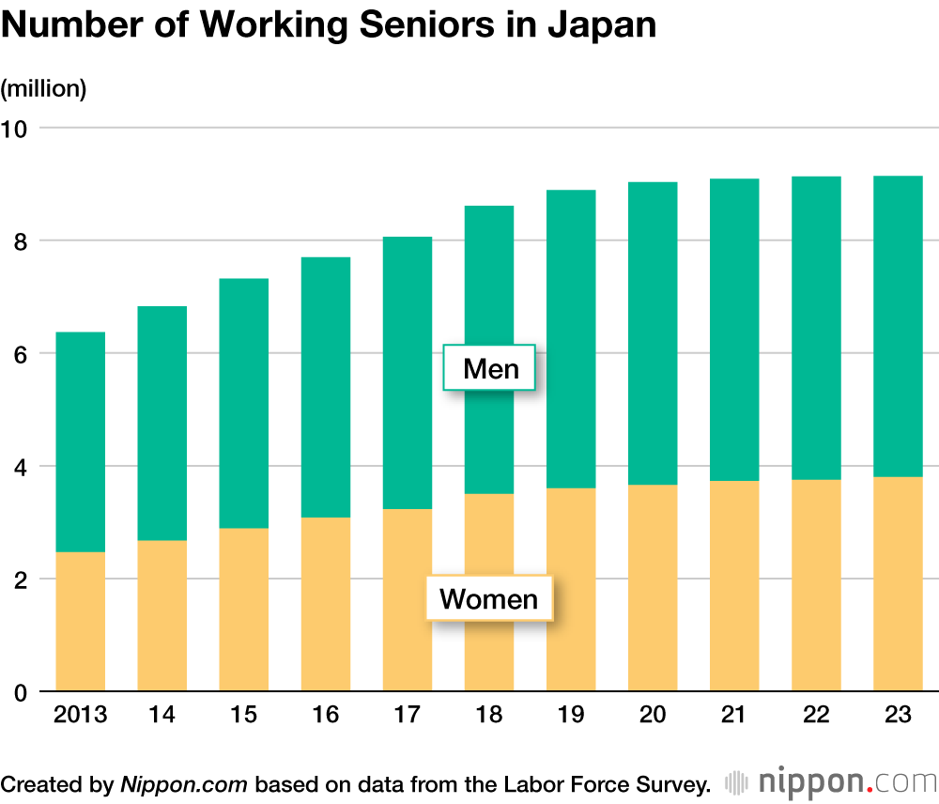
Figure 4: Working Senior Citizens of Japan
(Source: Government of Japan, 2024)
- Migration and Global Talent Mobility
The enhancement in the migration of workers has also been a critical demographic issue that has reduced productivity of companies. In the UK , around 228000 labourers have migrated to other countries for employment opportunities in 2024 (Pettinger, 2024). The improvements in global mobility of employees has reduced labour efficiency in organisations.
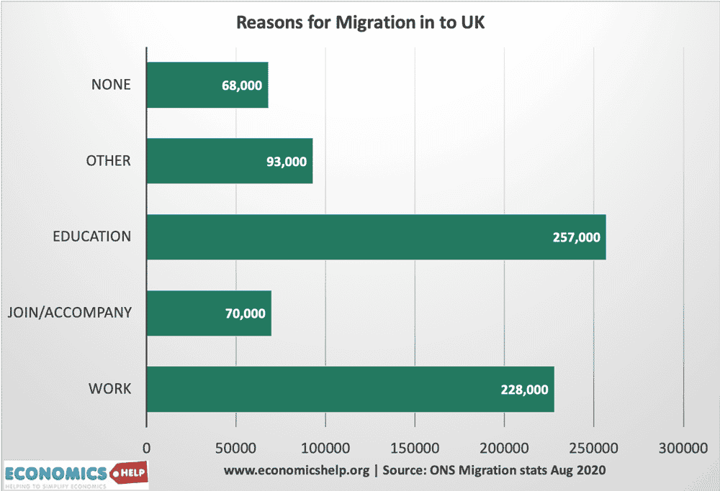
Figure 5: Migration of Workers in the UK
(Source: Pettinger, 2024)
- Workforce Diversity
Workforce Diversity helps organisations in improving its organisational harmony and productivity significantly. For example, around 11% of the companies have adopted the use of employee diversification strategies for enhancing its operational quality in 2024 (PwC, 2025). The promotion of workforce expansion has helped companies in strengthening worker relationships.
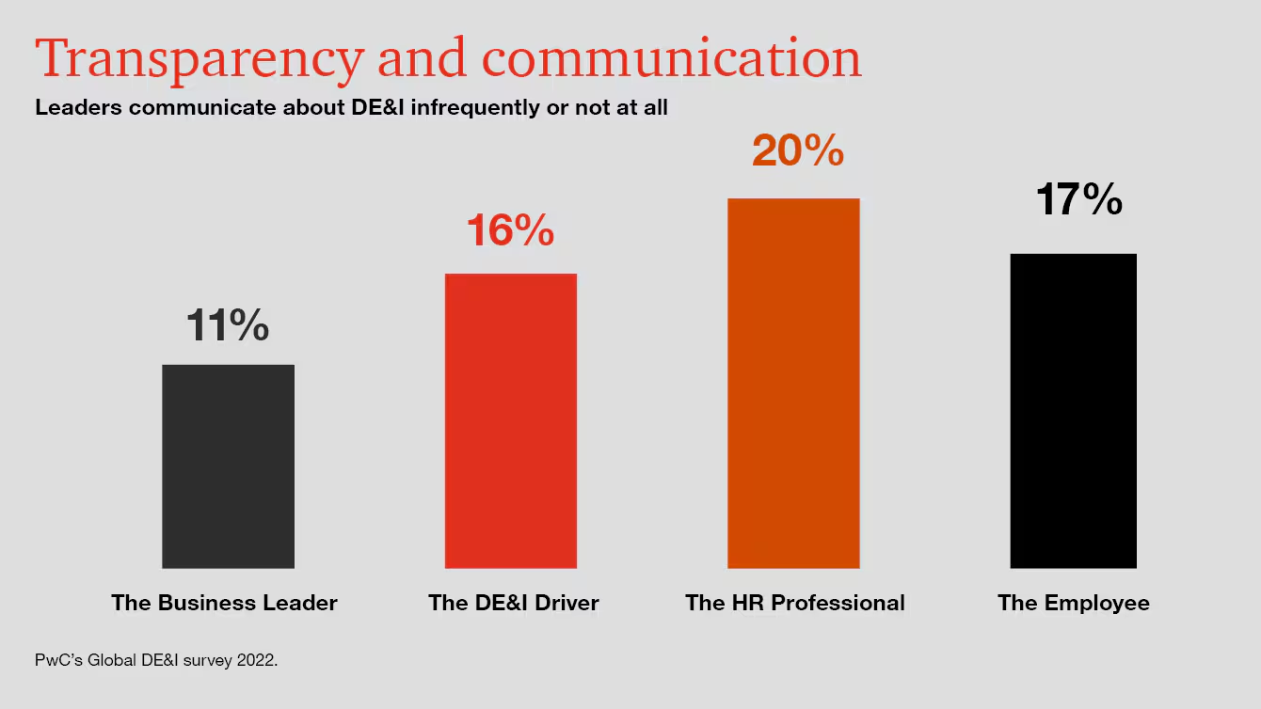
Figure 6: Opinion on Workforce Diversification
(Source: PwC, 2025)

2.2 Key Geopolitical Factors
- Trade Wars & Protectionism
Trade war encounters disruption in the supply chain by addressing shifting its import and export cost, high rises of tariff charges which in term leads to potential job loss. This in term leads to the rise of the “International Monetary Fund” with a credit facility of about US$1.92 billion showcasing focal consolidation in raising tariff rate (Chandak and Shrivastava, 2025).
Political Instability & Sanctions
The political instability in the UK is about 0.51 points which fall due to Brexit issue and rapid changes in leadership and due to market volatility (The Global Economy, 2025). The risk for expatriates occurred due to an unstable political environment and high rises of inflation affect overall spending of customers. Unilever addressed a job cut about 1,500 from its management role due to poor flexibility in working and slow career growth (BBC, 2022).
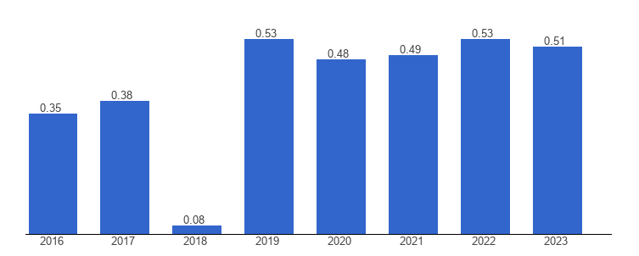
Figure 7: Political instability of UK
(Source: The Global Economy, 2025)
- Pandemics & Global Health Crises
The impact of pandemic reshape the professional services by shift to remote working reflects that 18% of the responses from 30-49 age prefer work from home facilities (Fennell, 2022). The rise of remote jobs leads to high job turnover, enhancing flexibility of business. UK follows “Health and Safety Act 1974” and strict measures by addressing changes in business layout (Government of UK, 1974).
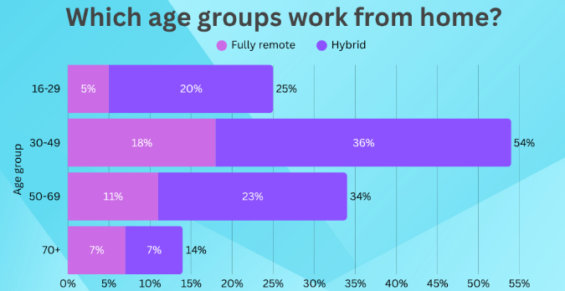
Figure 8: Age prefer to work remotely
(Source: Fennell, 2022)

2.3 Challenges for HR Professionals
- Talent Mobility
HR professionals address issues to manage visa requirements and immigration which leads to hamper operational efficiency of the business (Moodie, 2025). The extended processing time leads to rising high financial risk which in term hampers talent by conducting mobility readiness through pro-active planning.
- Risk Management
The HR professional addresses “Health and Safety” challenges of Worker due to ineffective regulatory compliances, enforcing political instability. The impact of these challenges is due to ineffective contingency planning and priorities on mental health that leads to rises of distress. ILO in order to address robust crises follow a decent work culture and develop peacebuilding in organisations to enhance recovery (ILO, 2024).
- Compliance
HR professionals address issues regarding internal and national employment while following a hybrid compliance framework. This has its massive impact on HR practices by adopting standardized document policies which ensure consistency in business. In Japan, HR follows the “Industrial Safety and Health Act” in order to protect employees from sponsored checks (Government of Japan , 2025).
- Cultural Integration
HR manages its diverse team by addressing communication challenges and conflict in taking decisions in managing work practices. EY talent faced concern due to long working hours and ability to cope with different cultures and their decisions which hamper overall reputation of business (EY, 2022).

Question 3

3.1 Understanding the Causes of Skills Gaps
Skills gaps persist as rapid technological change continuously reshapes job requirements faster than education systems adapt. The expanding global education technology (EdTech) market valued at USD 142.4 billion in 2023 and projected to reach USD 348.4 billion by 2030 with a 13.6% CAGR offers opportunities to bridge these gaps (Grand View, 2024). However, emerging technologies such as AI, automation, and data analytics demand new skills, while academic curricula often lag behind digital workplace market $234 billion by 2032 (Market, 2024).
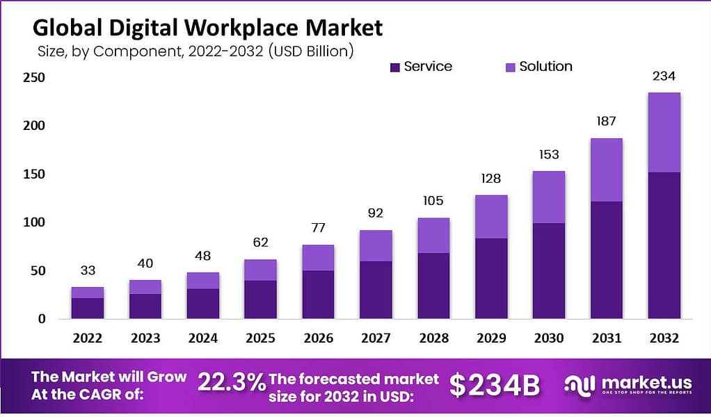
Figure 9: Global digital workplace market
(Source: Market, 2024)

3.2 Strategic HRM Approaches
- Build Strategies
The adoption of team-building strategies has helped organisations in ensuring the timely completion of its business operations. For instance, Tesco has invested $30m in developing initiatives such as “CSR Month” that has promoted tree plantation, blood donation activities among its employees in 2024 (Tesco, 2025). The programme has helped Tesco in improving the coordination level among its workers.
- Buy Strategies
The organisations have emphasised upon enhancing its hiring process for acquiring a skilled workforce in its operational activities. For example, Walmart has collaborated with “Talkpush” worth $3bn to provide job opportunities to around 1800 workers in 2024 (Talkpush, 2024). The partnership has helped Walmart in improving its goodwill among the workforce.
- Borrow Strategies
The adoption of borrowing strategies helps companies in improving the efficiency of its workforce. In the UK, the government has provided a working visa to around 102981 Indian labourers in 2024 (Teri, 2025). The diversification of the labour force has helped in improving the business growth of the country.
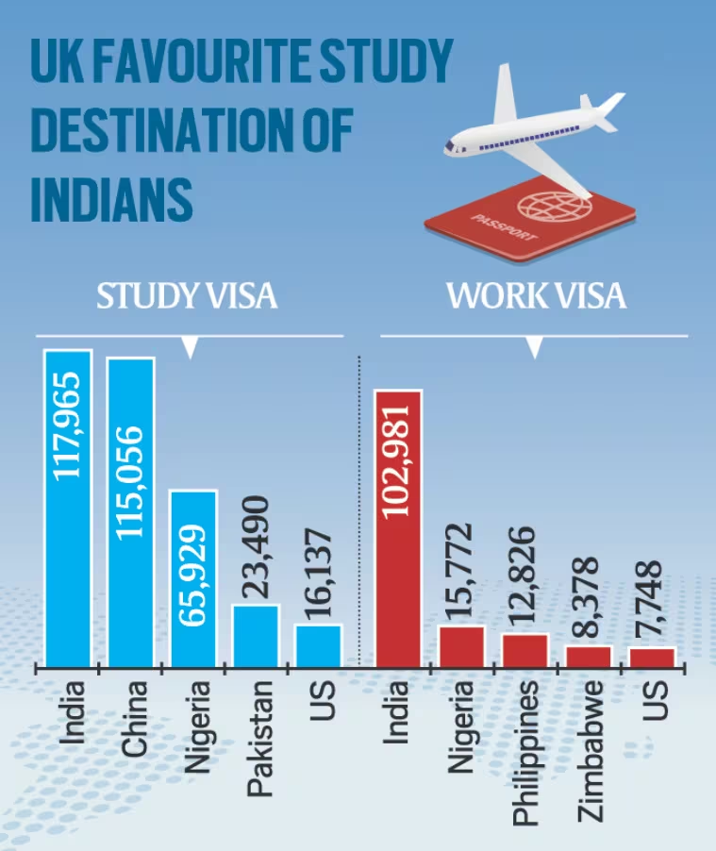
Figure 10: Working Visa in the UK
(Source: Teri, 2025)
- Bind Strategies
The adoption of binding strategies helps companies in enhancing the efficiency of its employee retention activities. For instance, Sainsbury has increased the value of its hourly wages from £12 in 2023 to £12.45 in 2024 (Labiak, 2025). The improvements in the incentive structure have helped Sainsbury in improving the engagement level of its workers.

3.3 Sector-Specific Responses
Technology
According to Grand View Research, (2024), the market for graph technology worldwide was worth USD 3.26 billion in 2022 and is expected to increase at a CAGR of 22.0% to USD 15.80 billion by 2030. Further, the proper incorporation of “build” strategies helpful with enhancement of skill through internal AI and data engineering programs. On another hand, “borrow” strategies also collaborate with external tech experts and partners to accelerate innovation.
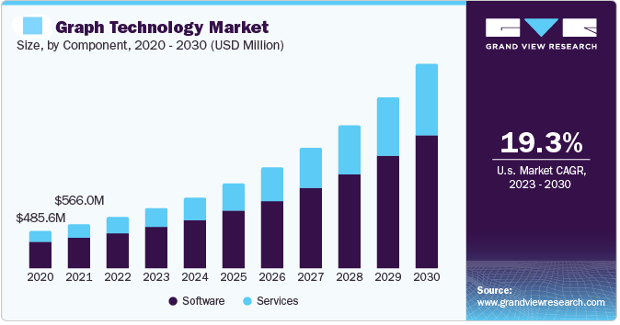
Figure 11: Graph technology market
(Source: Grand View Research, 2024)
Healthcare
The digital transformation of the healthcare market will also be rapid growth from 2017 with an increasing rate of 254% approximate value of $3.4 trillion by 2026 (Pisuwala, 2024). The development of in-house digital platforms and telemedicine systems align with the “build” strategy. However, “bind” strategies also focus on cloud-based HR platforms with long-term collaborations with tech providers.
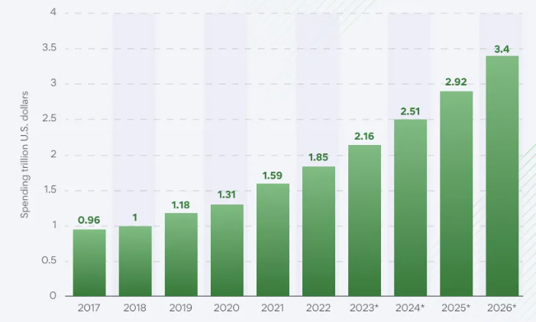
Figure 12: Healthcare transformation
(Source: Pisuwala, 2024)
Hospitality
The technological change will also abruptly impact the working process with the hospitality management software market at $6.29 billion by 2030, growing at a CAGR of 7.6% (Grand View Research, 2025). The implementation of “build” strategies associated with in-house property management systems (PMS), AI-powered chatbots for guest services, and mobile apps for contactless check-in/check-out and room control. However, “buy” strategies, involving adoption of third-party cloud software such as Oracle Hospitality OPERA Cloud and Salesforce for improved efficacy..

Question 4

4.1 Introduction
Global and adaptive competitive skills are necessary for MBA graduates to succeed in today’s dynamic business environment. It is also helpful to counteract diverse cultural context and respond properly about the key market changes. These skills foster innovation, strategic thinking, and resilience, ensuring long-term success in global and competitive industries.

4.2 Self-Assessment (Gibbs' Reflective Cycle)
Description
During my MBA, I engaged in group projects using MS Teams, Excel, and AI tools for enhancing data synthesis skills. I also collaborated in a multicultural team for a contribution presentation to develop my communication skills effectively. Hence, self driven study also improves learning new software that is necessary for a future career.
Feelings
From my MBA courses, I have analysed that positive feedback regarding my presentation helps me to improve my teamwork skills which encounter professional growth. I have the ability to handle the conflict by collaborating with the team member, actively listening to peer decisions which are reliable for project execution.
Evaluation
During the course of my MBA programme, I observed that my teamwork and collaboration skills have helped in strengthening my relationship with my group members. In addition, I was also able to improve my leadership and communication skills by having interactions with my superiors regarding the project. I evaluated that my limited technical knowledge has hampered the efficiency of my MBA project. .
Analysis
I have addressed that my leadership qualities help me to execute projects by taking proper initiatives in analysing the adaptability of new LMS. I also improve my time management skills that help me to priorities tasks and initiate new skills that affect future learning. I evaluate that structured scheduling, prioritising on task and regular reviews is more relevant which encounter my career development opportunities in the long run.
Conclusion
During the completion of my MBA course, I observed that I need to improve my digital skills for acquiring career development opportunities. I have also analysed that the improvements in my leadership and communication skills have improved my confidence of achieving professional success effectively.
Action plan
Area | Action Plan | Timeline | Expected Outcome
Technology | Learn advanced data analytics and visualization tools (Power BI, Tableau). | 3 months | Improved digital proficiency and data-driven decision-making.
Communication | Participate in public speaking and cross-cultural communication workshops. | 4 months | Enhanced clarity and confidence in diverse settings.
Leadership | Take initiative in future group projects and mentor peers. | Ongoing | Stronger leadership and collaboration skills.
Table 1: Action plan

4.3 SWOT Analysis
Strength | Weakness
- Proficient in digital tools like MS Teams and Excel.  - Strong communication and collaboration skills in multicultural teams. | - Tends to take on excessive workload in group projects.  - Needs improvement in advanced data analytics and time management.
Opportunity | Threats
- Exposure to global networks and leadership workshops through the MBA.  - Growing demand for AI and digital transformation expertise. | - Rapid technological evolution requires continuous upskilling.  - Competitive job markets and risk of burnout from multitasking.
Table 2: Personal swot analysis

4.4 Development Plan

4.4.1 Strengths
- In the competitive market, I think that my data-driven knowledge helps me to weekly execute handling new HR platforms which encounter job success.
- I access the job trends and ability to handle software manuals by continuously upgrading skill encounter career development.

4.4.2 Weakness
- I can improve my emotional intelligence by collaborating with multi-cultural teams and seeking feedback to manage emotion.
- I faced difficulty in managing time which led to delays in project address through user collaboration and Proactive verification.

Conclusion
It has been summarised that technological transformation through AI enhances labor market and leads to rises of digital talent by ability to boost productivity of business. The aging population, participation of employees and workforce diversity are key demographic factors for employment. The geopolitical issue such as trade war, political instability and pandemic crises affect HR professionals which encounter strong changes in internal and national laws. The ski gap among HR professionals hampers the overall productivity of business.

Reference list
BBC (2022) ‘Marmite maker Unilever to cut 1,500 jobs worldwide’, BBC News, 25 January. Available at: https://www.bbc.com/news/business-60119599.
Bosze, A. (2024) How many employees does Amazon have? (2024), www.doofinder.com. Available at: https://www.doofinder.com/en/statistics/how-many-employees-does-amazon-have.
Chandak, A. and Shrivastava, S. (2025) ‘Global trade war hits UK business sentiment, growth outlook: Reuters poll’, Reuters, 23 April. Available at: https://www.reuters.com/markets/europe/global-trade-war-hits-uk-business-sentiment-growth-outlook-2025-04-23/.
EY (2022) Four digital M&A culture integration talent challenges, www.ey.com. Available at: https://www.ey.com/en_us/insights/strategy-transactions/digital-m-a-three-talent-and-culture-challenges.
Fennell, A. (2021) Gig Economy Statistics UK | 2024 Industry Report, StandOut CV | Create a winning CV in minutes with our simple CV builder. Available at: https://standout-cv.com/stats/gig-economy-statistics-uk.
Fennell, A. (2022) Remote working statistics UK 2024 | Updated regularly, StandOut CV | Create a winning CV in minutes with our simple CV builder. Available at: https://standout-cv.com/stats/remote-working-statistics-uk.
Future (2025) Lack of digital skills in workforce costing UK over £23 BILLION per year - FutureDotNow, FutureDotNow. Available at: https://futuredotnow.uk/lack-of-digital-skills-in-workforce-costing-uk-over-23-billion-per-year/.
Government of Japan (2024) Number of Seniors in Employment Continues to Rise in Japan, nippon.com. Available at: https://www.nippon.com/en/japan-data/h02137/.
Government of Japan (2025) Industrial Safety and Health Act - English - Japanese Law Translation, www.japaneselawtranslation.go.jp. Available at: https://www.japaneselawtranslation.go.jp/en/laws/view/3440/en.
Government of UK (1974) Health and Safety at Work etc. Act 1974, legislation.gov.uk. Available at: https://www.legislation.gov.uk/ukpga/1974/37/contents.
Grand View (2024) Education Technology Market Size & Outlook, 2030, Grandviewresearch.com. Available at: https://www.grandviewresearch.com/horizon/outlook/education-technology-market-size/global.
Grand View Research (2024) Graph Technology Market Size, Share & Growth Report 2030, www.grandviewresearch.com. Available at: https://www.grandviewresearch.com/industry-analysis/graph-technology-market-report.
Grand View Research (2025) Hotel And Hospitality Management Software Market Report, 2030, Grandviewresearch.com. Available at: https://www.grandviewresearch.com/industry-analysis/hotel-hospitality-management-software-market-report.
ILO (2024) Crisis situations and response, International Labour Organization. Available at: https://www.ilo.org/topics-and-sectors/crisis-situations-and-response.
Kalish, I. (2025) Global economic outlook, January 2025, Deloitte Insights. Deloitte. Available at: https://www.deloitte.com/us/en/insights/topics/economy/global-economic-outlook-2025.html.
Kulisch, E. (2025) Amazon invests in more driver training, tech and pay, Yahoo Finance. Available at: https://finance.yahoo.com/news/amazon-invests-more-driver-training-181039215.html (Accessed: 7 November 2025).
Labiak, M. (2025) ‘Sainsbury’s raises pay but is cautious on hiring’, BBC, 10 January. Available at: https://www.bbc.com/news/articles/crm7wj3m28po.
Market (2024) Digital Workplace Market Size, Trends | CAGR of 22.3%, Market.us. Available at: https://market.us/report/digital-workplace-market/.
Moodie, A. (2025) Managing Work Visa Compliance: Tips for HR Professionals, Boundless.com. Available at: https://www.boundless.com/blog/work-visa-compliance-tips-for-hr-professionals (Accessed: 7 November 2025).
Pettinger, T. (2021) Impact of Immigration on UK Economy - Economics Help, Economics Help. Available at: https://www.economicshelp.org/blog/6399/economics/impact-of-immigration-on-uk-economy/.
Pisuwala, U. (2024) Digital Transformation in Healthcare: Trends, Challenges & Their Solutions, Peerbits. Available at: https://www.peerbits.com/blog/digital-transformation-in-healthcare.html.
PwC (2025) Global diversity, equity and inclusion survey, PwC. Available at: https://www.pwc.com/gx/en/services/workforce/global-diversity-and-inclusion-survey.html.
STEM (2025) | STEM, Stem.org.uk. Available at: https://www.stem.org.uk/resources/resources-by-publisher/422 (Accessed: 7 November 2025).
Talkpush (2024) Optimizing Recruitment for 1 Million Annual Job Applicants: Walmart’s Success Story, Talkpush.com. Available at: https://www.talkpush.com/case-studies/optimizing-recruitment-for-1-million-annual-job-applicants-walmarts-success-story.
Teri, D. (2025) Indians get largest number of study, visitor and skilled worker visas from UK, The Indian Express. Available at: https://indianexpress.com/article/india/indians-get-largest-number-of-study-visitor-and-skilled-worker-visas-from-uk-8112090/ (Accessed: 7 November 2025).
Tesco (2025) Tesco Bengaluru Archives - Company CSR - Sustainable & Responsible News - Beyond Words, Company CSR. Available at: https://companycsr.com/tag/tesco-bengaluru/ (Accessed: 7 November 2025).
The Global Economy (2025) United Kingdom Political stability - data, chart | TheGlobalEconomy.com, TheGlobalEconomy.com. www.theglobaleconomy.com. Available at: https://www.theglobaleconomy.com/United-Kingdom/wb_political_stability/.
Tomay, B. (2024) Amazon’s $2.1 billion DSP investment: rate increases, new services, Aboutamazon.com. US About Amazon. Available at: https://www.aboutamazon.com/news/transportation/amazon-delivery-service-partner-dsp-rate-increases-investment.
Tribepad (2025) Recruitment Management System Used by Two Retail Giants, Tribepad. Available at: https://tribepad.com/article/how-tribepad-transformed-recruitment-for-two-retail-giants/.
WEF (2025) Future of jobs report 2025: The jobs of the future – and the skills you need to get them, World Economic Forum. World Economic Forum. Available at: https://www.weforum.org/stories/2025/01/future-of-jobs-report-2025-jobs-of-the-future-and-the-skills-you-need-to-get-them/.

