Changemakers: Building your Personal Brand for Sustainable Employment (BMHP5015_BIRM)

Name: Kareemot Adekilekun Tijani Tijani
Student ID: 2320438

Title – Assignment Report
Component 2
Lecturer Name: Danni Dunne
SUBMMITED DATE:25th November 2025

Abstract
As a Health and Social Care student preparing to progress into employment, I recognise that employability has become an essential factor shaping career success in today’s complex and changing sector. This report explores my employability skills and career development in relation to a future role within a local authority Housing Directorate, focusing specifically on the position of Housing Options Officer. I analyse the job description and person specification, assess my own skills using employability frameworks and SWOT analysis, and identify areas for improvement. I then outline how I intend to build my personal brand, professional identity, and network to enhance my employability. A detailed five-year action plan and visual timeline illustrate how I plan to progress towards achieving this career goal. Through this reflection, I aim to demonstrate how personal growth, continuous learning, and professional development can support my journey into the housing and social care sector.

Table of Contents
Cover Page --------------------------------------------------------------------------------------------- 1
Abstract -------------------------------------------------------------------------------------------------- 2
Table of contents ---------------------------------------------------------------------------------------3
- Introduction -----------------------------------------------------------------------------------------4
- Job Role Analysis ---------------------------------------------------------------------------------5
2.1 Vacancy Overview ------------------------------------------------------------------------5
2.2 Job Description and Person Specification ------------------------------------------5
2.3 Employability Skills Required --------------------------------------------------------5-6
- My Personal Employability Skills Evaluation------------------------------------------------6
3.1 SWOT Analysis---------------------------------------------------------------------------6-7
3.2 Employability Frameworks --------------------------------------------------------------7
3.3 Current Experience and Skills ---------------------------------------------------------7
3.4 Areas for Development ---------------------------------------------------------------7- 8
- Building My Personal Brand and Professional Identity ----------------------------------8
4.1 Personal Brand ----------------------------------------------------------------------------8
4.2 Professional Identity---------------------------------------------------------------------8-9
4.3 Networking ---------------------------------------------------------------------------------10
- My Action Plan and Timeline -------------------------------------------------------------------11
5.1 SMART Goals ------------------------------------------------------------------------------11
5.2 Timeline Overview -------------------------------------------------------------------- 11-12
5.3 Resources Required ----------------------------------------------------------------------12
5.4 Communicating My Skills to Employers ----------------------------------------------12
- Conclusion -------------------------------------------------------------------------------------------13
- Reference List ---------------------------------------------------------------------------------------14
- Appendix 1: Vacancy Screenshot, SWOT Chart, and Visual Timeline ------------ 15 -19

Employability Skills and Career Development for a Housing Directorate Role in UK Health and Social Care Sector.
1. Introduction
As someone who is deeply enthusiastic about improving people’s lives, employability goes beyond academic qualifications; it reflects the ability to apply knowledge, skills, and values in real - world situations. For me, employability means combining compassion, resilience, and problem-solving with a commitment to fairness and social responsibility. These personal values drive my motivation to work within the Housing Directorate, where I can help vulnerable people secure stable housing and access the support, they need to rebuild their lives.
My core values include empathy, integrity, accountability, and respect for diversity. These align strongly with the principles underpinning the UK’s health and social care system. Having developed these values through both personal experience and academic study, I aim to bring a people-centred approach to professional practice, ensuring that every client feels heard, supported, and valued.
My unique selling points (USPs) lie in my strong interpersonal communication, emotional intelligence, and ability to remain calm and purposeful under pressure. I am also highly digitally literate, comfortable using Microsoft Office and online platforms to manage data and communicate professionally. Combined with my growing academic knowledge of safeguarding and equality legislation, I believe these qualities will enable me to contribute effectively to a multidisciplinary team within a Housing Directorate.
I am particularly interested in pursuing a career within a local authority Housing Directorate, as this field connects directly to the prevention of homelessness, the promotion of wellbeing, and the provision of stable housing for vulnerable people. Safe housing is a key social determinant of health, and the Housing Directorate plays an essential role in integrated care systems (Clarke, 2018).
In this report, I focus on the Housing Options Officer role, which I identified as a current vacancy within a UK local authority. I will analyse the employability skills required for this position, evaluate my own skills, and develop a realistic plan for my career progression. I will also explore how I can build my personal brand, strengthen my professional identity, and expand my network to enhance my chances of securing employment in this area.

2. Job Role Analysis
2.1 Vacancy Overview
While researching potential roles, I found a current vacancy for a Housing Options Officer at Maidenhead Berkshire and in Manchester City Council (2025). This position focuses on homelessness prevention, offering housing advice, and collaborating closely with local partners to ensure suitable accommodation for individuals in need. The role appeals to me because it combines problem-solving, communication, and social responsibility all values I strongly identify with.
(See Appendix 1 for screenshot of the vacancy.)
2.2 Job Description and Person Specification
The main responsibilities listed for this role include:
- Assessing homelessness applications under the Housing Act 1996 and Homelessness Reduction Act 2017.
- Providing advice about housing options, tenancy rights, and welfare benefits.
- Supporting clients with safeguarding and emotional needs.
- Keeping accurate electronic case records and maintaining confidentiality.
- Working collaboratively with health, social care, and voluntary sector partners.
The person specification highlights:
- Effective communication and interpersonal skills.
- Knowledge of housing and welfare systems.
- Sound decision-making and problem-solving abilities.
- Good IT and case management skills.
- Relevant qualifications in housing or social care.
- Empathy, professionalism, and resilience.

2.3 Employability Skills Required
From this job description, I identified several essential employability skills that I will need to develop or strengthen:
- Communication and Interpersonal Skills: Engaging effectively with service users, especially those facing homelessness, requires empathy, clarity, and respect (NHS England, 2023).
- Critical Thinking and Problem-Solving: The role involve assessing complex cases and providing realistic solutions (Knight & Yorke, 2004).
- Knowledge of Legislation: Understanding housing law and safeguarding frameworks ensures legal compliance and effective practice (Gov.uk, 2023).
- Collaboration and Teamwork: The job relies heavily on collaborating with other professionals to deliver integrated support (Glasby & Dickinson, 2014).
- Resilience and Emotional Intelligence: Supporting vulnerable people can be emotionally demanding, so maintaining wellbeing is essential (Clarke, 2018).
- Digital Competence: Efficient use of case management software and online systems is vital for modern service delivery.
This analysis helped me understand that success in the Housing Directorate depends not only on technical knowledge but also on interpersonal skills and personal values.

3. My Personal Employability Skills Evaluation
3.1 SWOT Analysis
I used a SWOT analysis to reflect on my strengths, weaknesses, opportunities, and threats in relation to this career goal.
Strengths | Weaknesses
Effective communication skills developed during my H+SC studies. | Limited direct experience in housing services.
Good understanding of safeguarding and equality legislation. | Need for more knowledge of housing law and welfare systems.
Experience volunteering with vulnerable groups in community settings. | Limited professional network within the housing sector.
Good IT and digital literacy skills. | Lack of experience with case management systems.

Opportunities | Threats
Availability of training courses on housing and welfare law. | High competition for local authority positions.
University careers service and employability workshops. | Changes in housing policy could affect future roles.
Membership in the Chartered Institute of Housing (CIH) and LinkedIn networking. | Potential skill gaps if I do not engage in CPD early.
(See Appendix 1 for SWOT chart.)

3.2 Employability Frameworks
Using Dacre Pool and Sewell’s (2007) Career EDGE model, I reflected on my employability profile. I feel confident in my degree subject knowledge, communication, and teamwork, but I recognise that I need to strengthen my practical experience and career development learning. My emotional intelligence is developing through reflective practice, but exposure to real housing environments would enhance my resilience and understanding.
3.3 Current Experience and Skills
At present, I have:
- Qualifications: I am completing my degree in Health and Social Care, which has given me a strong understanding of safeguarding, equality, and partnership working.
- Experience: I have volunteered in community projects that support vulnerable individuals and promote wellbeing.
- Skills: I am skilled in communication, teamwork, empathy, digital literacy, and reflective practice.

3.4 Areas for Development
I recognise that I need to:
- Build a deeper understanding of housing law and policy, especially the Homelessness Reduction Act 2017.
- Expand my professional network through LinkedIn and CIH membership.
- Gain practical experience with housing databases and case management tools such as Northgate or Jigsaw.
- Develop more confidence in advocacy and conflict resolution to support clients effectively.

4. Building My Personal Brand and Professional Identity
4.1 Personal Brand
When I think about my personal brand, I see it as a reflection of both my personality and my professional purpose. I want to be recognised as a compassionate, proactive, and ethical professional who brings positivity, reliability, and care to every situation. My values of empathy, fairness, and continuous learning shape how I engage with others, particularly those facing housing insecurity or social exclusion.
My unique selling points include:
- The ability to build rapport with people from diverse backgrounds, gained through voluntary work and teamwork at university.
- Strong communication and listening skills, which help me understand people’s needs and respond appropriately.
- Emotional resilience, allowing me to stay professional and supportive even in challenging situations.
- A genuine passion for advocacy and empowerment, ensuring that service users’ voices are heard.
- Confidence in using digital tools and online research to manage cases effectively and stay informed about policy changes.
By consistently demonstrating these strengths, I aim to build a trustworthy personal brand that reflects both my commitment to social justice and my potential as a future Housing Options Officer (Holmes, 2013).

4.2 Professional Identity
My professional identity is shaped by my values, education, and experiences, and continues to evolve as I gain confidence and knowledge within the health and social care field. I have learned that professional identity is not fixed; it develops through reflection, learning, and collaboration (NMC, 2018). For me, being a professional means demonstrating integrity, empathy, and accountability in all circumstances, particularly when supporting people facing vulnerability or housing insecurity.
I align strongly with the principles of equality, inclusion, and safeguarding, which underpin both housing and social care. These values influence how I engage with clients and colleagues, ensuring that I approach every interaction with respect and cultural sensitivity. Upholding professional standards also means maintaining ethical awareness, confidentiality, and sound professional judgement when making decisions that affect people’s lives (Clarke, 2018). I understand that each decision can have far-reaching social consequences, so remaining reflective and values-driven is vital.
To strengthen my professional identity, I plan to engage actively with the Chartered Institute of Housing (CIH) through webinars, online forums, and conferences. These will allow me to learn from experienced professionals, understand current housing policy, and explore leadership expectations within the sector. Exposure to best practice models will also help me develop confidence in applying theory to practice.
I view continuous professional development (CPD) as central to sustaining a strong identity. I intend to undertake relevant training, reflective journaling, and supervision to assess my progress and identify learning needs. Reflection helps me link theory to real experiences and ensures that my values compassion, fairness, and respect are evident in everyday actions. Ultimately, I see my professional identity as a reflection of who I am, what I stand for, and how I consistently use these values to promote positive change in people’s lives.

4.3 Networking
I recognise that networking is an area I must strengthen to enhance my employability and professional growth. Networking involves building purposeful professional relationships that promote learning, collaboration, and opportunity (Dacre Pool & Sewell, 2007). By forming connections across the housing and social care sectors, I can expand my understanding of best practice and career pathways.
To develop my network, I plan to join the CIH as a student member, gaining access to professional briefings, training, and networking events. I will also attend housing conferences, university employability fairs, and local authority recruitment events to explore current workforce trends and employer expectations. Volunteering with charities such as Shelter or Crisis will allow me to apply my skills, observe multi-agency working, and meet practitioners who can offer advice or mentorship.
I will further use LinkedIn and my university’s career service to connect with professionals, alumni, and organisations. Sharing reflections on volunteering and housing issues will enhance my visibility and build my reputation as an emerging professional. According to Holmes (2013), active networking improves employability by helping graduates understand the culture and standards of their chosen field.
Through these strategies, I aim to build confidence, maintain industry awareness, and develop lasting professional relationships. Over time, these connections will help me transition from student to practitioner, contributing to collaborative housing solutions and improved community wellbeing within the Housing Directorate.

5. My Action Plan and Timeline
5.1 SMART Goals
Goal | Action | Timeline
Gain knowledge of housing law. | Complete online courses on the Homelessness Reduction Act 2017 and attend CIH webinars. | Within 12 months.
Build housing-related experience. | Volunteer with Shelter or Crisis to gain direct sector experience. | - 2years.
Strengthen my personal brand. | Build LinkedIn profile and attend two CIH networking events each year. | Ongoing.
Develop digital and case management skills. | Complete training on systems such as Northgate or Jigsaw. | By Year 3.
Secure entry-level housing role. | Apply for Housing Support Worker or Housing Assistant roles. | By Year 3–4.
Progress to Housing Options Officer. | Complete CIH Chartered Membership programme. | By Year 5.

5.2 Timeline Overview
Year 1 - 2:
- Enrol in housing law training and CIH webinars.
- Begin volunteering with a housing charity.
- Build professional online presence and attend networking events.
Year 3:
- Apply for entry-level positions.
- Undertake case management training.
Year 4:
- Secure a housing-related post.
- Begin CIH professional membership route.
Year 5:
- Achieve Housing Options Officer position.
- Continue professional development and reflective practice.
(See Appendix 1 for visual timeline.)

5.3 Resources Required
To achieve my goals, I will need:
- Financial support for CIH membership and training courses.
- Guidance from mentors or supervisors in the housing sector.
- Access to university employability services for CV and interview preparation.
- Digital resources such as LinkedIn and job portals for career search.

5.4 Communicating My Skills to Employers
I plan to communicate my employability skills through:
- A targeted CV and cover letter tailored to each role.
- A professional LinkedIn profile featuring recommendations and voluntary work.
- Effective interview preparation using the STAR method.
- A portfolio including academic work, certificates, and reflections on my development.

6. Conclusion
Writing this report has helped me reflect on the values and strengths that make me unique as an emerging professional in health and social care. My core values of empathy, integrity, and respect underpin everything I do, while my unique selling points strong communication, emotional intelligence, and digital competence, as well as a sound understanding of housing law and safeguarding set me apart as someone who can bring both compassion and professionalism to a Housing Directorate team.
Through my SWOT analysis and use of the Career EDGE model, I identified both my strengths and the areas I need to develop further. My five-year action plan gives me a clear roadmap to follow combining training, volunteering, networking, and continuous professional development to achieve my goal.
I have learned that employability is not only about qualifications but also about how I apply my personal qualities and values in professional contexts. My action plan provides a structured roadmap to achieve my goal of becoming a Housing Options Officer within five years. By staying true to my values, maintaining resilience, and continuing to develop my knowledge and skills, I believe I can make a meaningful contribution to preventing homelessness and improving people’s lives across the community.

7. Reference
Clarke, J. (2018) Critical perspectives on housing and social policy in the UK. Bristol: Policy Press.
Dacre Pool, L., and Sewell, P. (2007) ‘The key to employability: Developing a practical model of graduate employability’, Education + Training, 49(4), pp. 277–289.
Glasby, J. and Dickinson, H. (2014) Partnership working in health and social care: What is integrated care and how can we deliver it? 2nd ed. Bristol: Policy Press.
Gov.uk (2023) Homelessness Reduction Act 2017: Policy summary. Available at: https://www.gov.uk/guidance/homelessness-reduction-act-2017 (Accessed: 8 November 2025).
Holmes, L. (2013) ‘Competing perspectives on graduate employability: Possession, position or process?’, Studies in Higher Education, 38(4), pp. 538–554.
Knight, P. and Yorke, M. (2004) Learning, curriculum, and employability in higher education. London: Routledge Falmer.
Manchester City Council (2025) Housing Options Officer Vacancy. Available at: https://www.manchester.gov.uk/jobs (Accessed: 8 November 2025).
NHS England (2023) Integrated care and collaboration in housing and health. Available at: https://www.england.nhs.uk/ (Accessed: 8 November 2025).
Nursing and Midwifery Council (NMC) (2018) The Code: Professional standards of practice and behaviour for nurses, midwives, and nursing associates. London: NMC.
NHS England (2023) Core skills training framework. Available at: https://www.e-lfh.org.uk (Accessed: 21 September 2025).
Yorke, M. (2006) Employability in higher education: What it is, what it is not. York: Higher Education Academy.

8. Appendix
A. Vacancy Screenshot:
(Insert screenshot of Housing Options Officer vacancy.)
Appendix 1: Screenshot of Housing Options Officer vacancy (Maidenhead Berkshire)
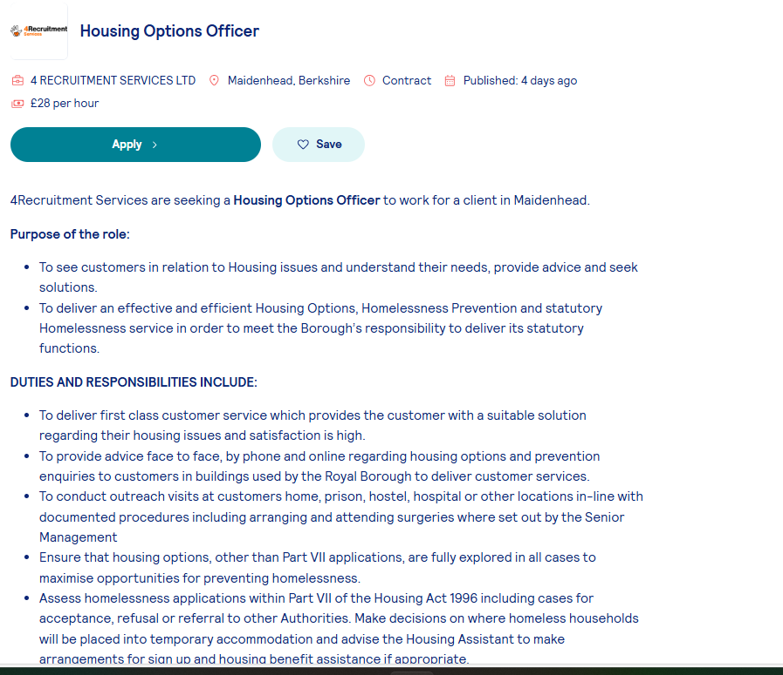

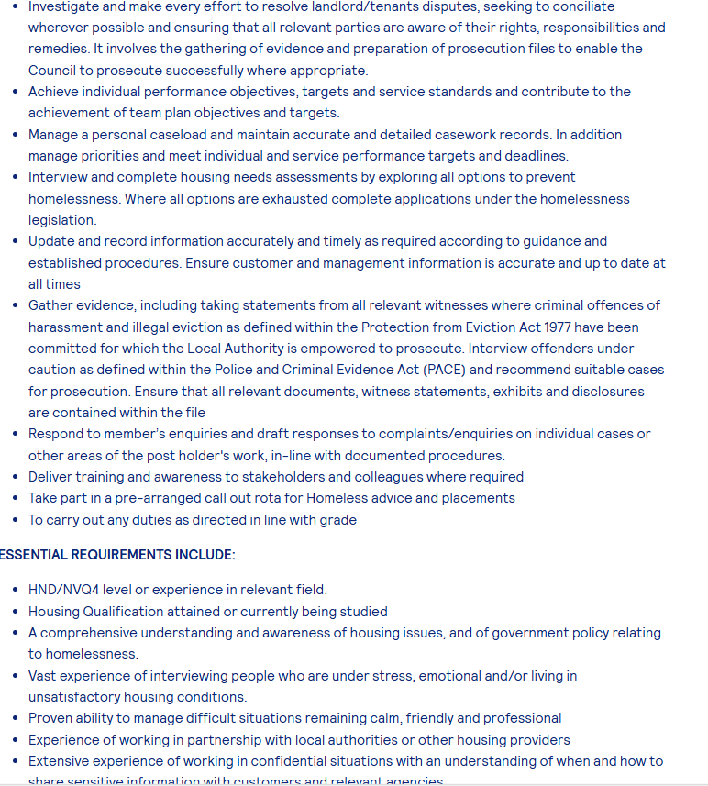
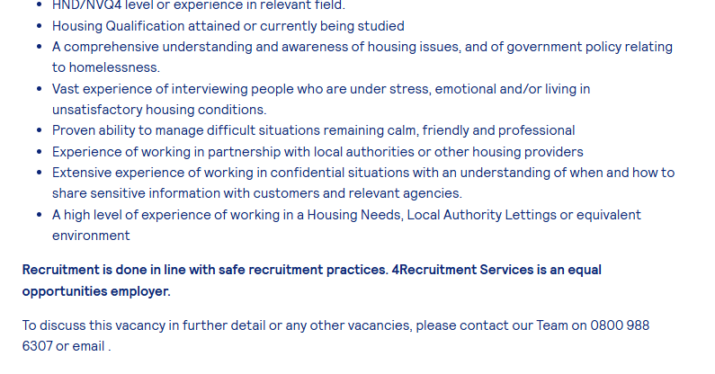

Manchester City Council, 2025).


B. SWOT Chart:
(Insert visual SWOT chart showing strengths, weaknesses, opportunities, and threats.)
See Appendix 1 for screenshot of SWOT chart.
Appendix 2: SWOT Analysis Table.
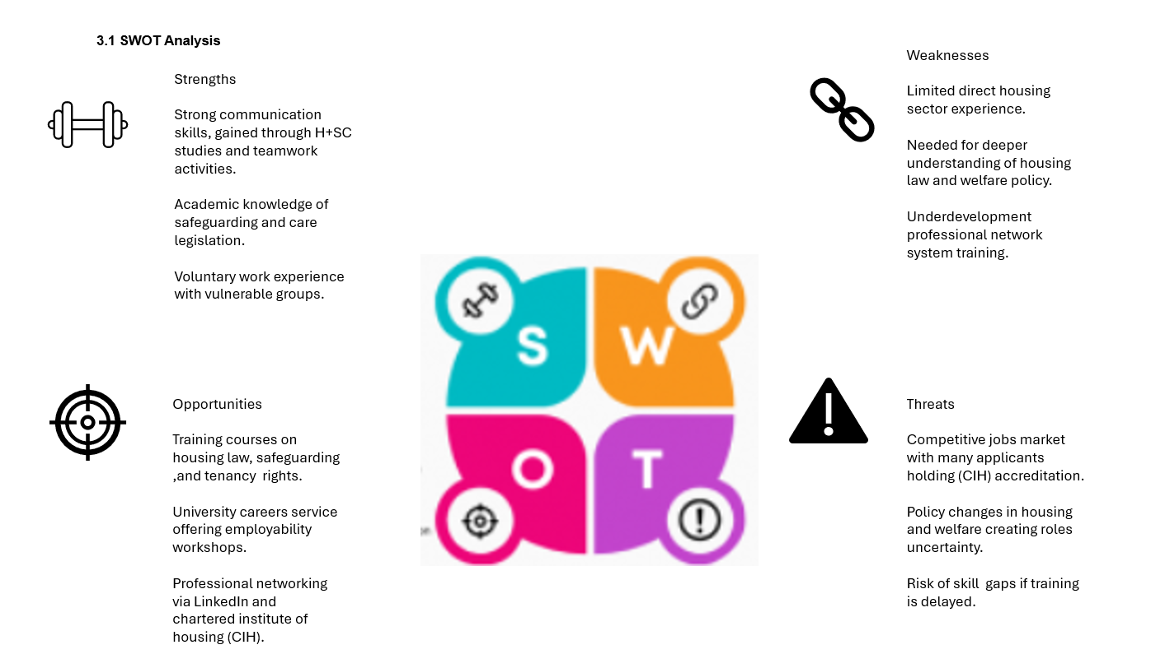

C. Visual Timeline:
(Insert timeline showing career development goals across Years 1- 5.)
Appendix 3: Action Plan Timeline (Gantt chart).


