Tonio George (2312861)
2312861@student.uwtsd.ac.uk
Synthesize a solution to a potential real life scenario
Networks and Cyber Security Essentials
ACCA4024

Contents
1. Introduction 2
2. Threat Identification 2
3. Security Policies 2
4. Mitigation Strategy 3
5. Incident Response Plan Response Steps: 4
6. Employee Training Program 4
7. Implementation Roadmap 5
8. Conclusion 5
References 5

Introduction
The digital environment exposes financial institutions such as FinSecure Ltd (FSL) to major security risks through cyber threats. The recent phishing attacks and unauthorized access incidents demonstrate the necessity for a complete security strategy.
The document presents a proactive cybersecurity framework that aims to:
- The framework identifies and fights against threats which originate from inside and outside the organization.
- The organization will implement security controls which meet industry standards.
- The organization should create detailed procedures for handling incidents.
- The organization will provide employees with training to detect and stop cyber threats.
The plan follows ISO 27001 [1] and NIST and GDPR [2]standards to protect FSL data confidentiality and integrity and availability while developing security awareness throughout the organization.

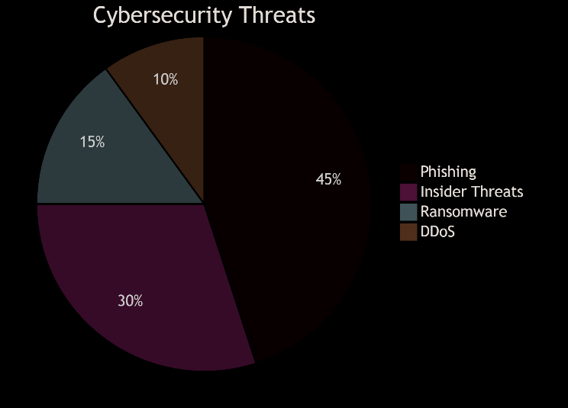
Threat Identification
- Key Threats:
- External: Phishing, ransomware, DDoS, cloud vulnerabilities [3].
- Internal: Accidental breaches, weak passwords, unauthorized access [4]

Security Policies
- Core Frameworks:
- Access Control (RBAC + MFA) [1]
- Data Protection (Encryption + GDPR) [2]
- Incident Response (4-stage protocol)

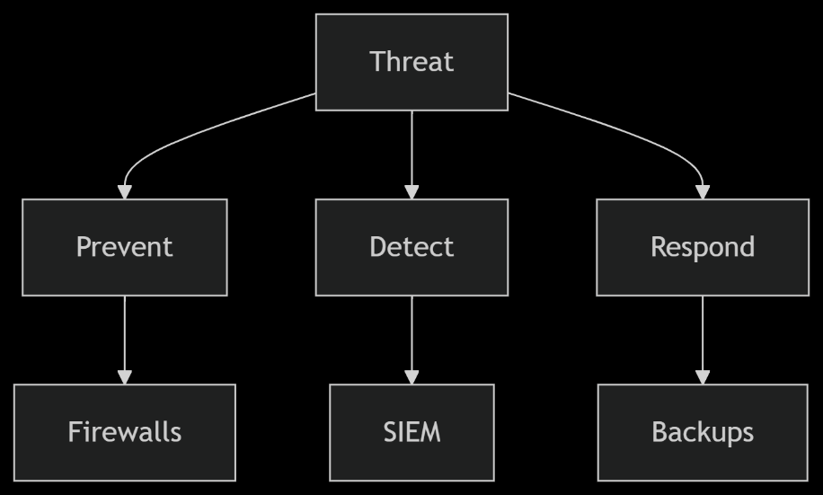
4. Mitigation Strategy
The following mitigation strategies are implemented:
- Key Controls:
- Firewalls, email filtering, patch management
- SIEM monitoring, UEBA analytics
- Automated backups, IR playbooks

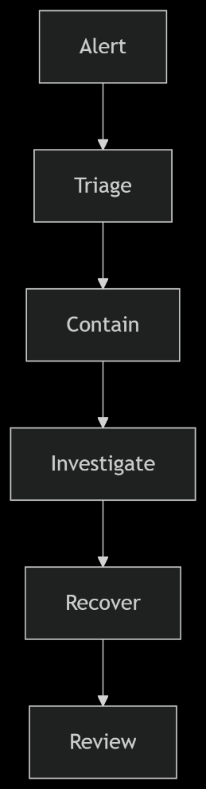
5. Incident Response Plan Response Steps:

- Detect & Triage
- Contain & Investigate
- Recover & Improve

6. Employee Training Program
- Monthly phishing simulations
- Quarterly security workshops
- Role-specific cybersecurity training

7. Implementation Roadmap
Phase | Timeline | Key Actions
Planning | Month 1-2 | Risk assessment, policy drafting [1]
Tech Rollout | Month 3-6 | Firewalls, MFA, SIEM deployment
Training | Month 4-8 | Department-wise sessions
Maintenance | Ongoing | Audits, updates

8. Conclusion
The established policy framework of FSL provides strong cybersecurity protection through preventive measures and detection systems and employee security education to address current and future threats. The organization will perform periodic assessments to maintain best practices in line with industry standards.

References

[1] | "ISO/IEC," 2022. [Online]. Available: https://www.iso.org/standard/27001.
[2] | " European Union," Apr 2016. [Online]. Available: https://gdpr-info.eu.
[3] | "Cloud Security Alliance," Security Guidance for Critical Areas of Focus in Cloud Computing, 2021. [Online]. Available: https://cloudsecurityalliance.org.
[4] | "NIST," Protecting Controlled Unclassified Information in Nonfederal Systems, 2020. [Online]. Available: https://doi.org/10.6028/NIST.SP.800-171r2.

Appendix


