  Academic and employability skills  My own reflection
  Module Number | BMSW4001
  Lecturer | Sylvia Hoffman
  Student Name | Loraine Tabila
  Student Identify Number | 1917097

Table of contents

Table of Contents
Introduction 2
Time management 2
Cover letter in the Curriculum Vitae 3
Development of academic skills 4
Analytical thinking 5
Conclusion 7
Appendix Cover letter 8
Appendix Analytical thinking 9
References 10
Works Cited 10

Introduction

In this term in my university they asked us to write our own reflection report, using four topics that we learn during the first and second term. With this report I will explain which model of reflection I had used, analysed one by one of the topics that I had previously chosen and for the last I will give a conclusion of my own criteria.

But what is really a reflection? A reflection is analytical thoughts by our past, to get new understanding through the experiences. (David Boud, 1985)

Starting with this report I had my problems of indecisiveness choosing the best role model to guide, to express my reflection report.
I was doubting between Kolb’s learning by experience and Gibb’s learning by doing.

David Kolb’s in 1984 he developed the experimental circle, through the experience. This model has four stage that is: concrete the experience, reflect the observation, abstract the concept and active the experience. (Andrew Grant, 2017)
Graham Gibbs published his reflective cycle on 1988. This reflective model helps in each individual to analyse their own situations that they experienced. And is consist in six steps that is: Description of the experience, feeling in that moment, evaluation of the experience, analyse the experience, give a conclusion and make a personal plan. (Andrew Grant, 2017)

However, I did choose these four or five topics based on my own swot analysis.
Concentrating more by analysing my own weaknesses that with that I can improve myself during this term and in my future personal plan development.

Time management

In my whole life I been always running late everywhere, going to work or just for a dinner with my friends.
I always remember that day, when I meet my friends, we planned to meet at 7 because they did book a table for four. And I had arrived when they are already eating their dessert.

My time management is one of my weaknesses, that I always trying to be on time but for some many circumstance I have been always late, and to be honest I’m not feeling proud of it, even I am trying to woke up one hour earlier and prepare all my stuffs one night before, still I cannot be on time.

Of course, this experience is not good at all, because if I meet people that they don’t know me they might think I am not a responsible and I am not taking the aspects seriously. And in that aspect, I cannot grow or progress in my employability.

Time management is designed as an important skill that should be acquired by all type of persons and in all different aspects of life. Some individuals are totally busy in studies, works, families or household. In order to prevent feelings; stress or feel pressured due to work, it is advisable to implement time management effectively.
Time management is important: when in the individual adapt to manage the time effectively, in that definitely learns to manage the life effectively
(Kapur, 2018).
By organizing and manage the time effectively it will resolve more my weaknesses.
Not only with that I will be able to manage and structure better my personal things.

I will create with an organizing time to develop it and write every day my plans.

Cover letter in the Curriculum Vitae

One of the few activities that Sylvia asked us, was to do a cover letter, in the week three.
Giving us a list of job roles that we need it to choose, read the job description and do a cover letter using the role job that we had chosen.
The job roles were: Administrator, Sales Assistant, Office Manager, Project Manager, Restaurant, Manager and Recruitment consultant.

And here I go again doubting and dreaming which one will be easy for me to do a cover letter, and of course I did choose sales assistant because I do have an experience working it. And thought will be easy, but I had never done before and I didn’t know how to start and developed.

I done the activity that Sylvia asked us, but I didn’t participate in the class when she asked if we have done it. I didn’t want to share my work just because I get scared if it wasn’t good. The inconvenience of that circumstance is that I am not sure if the activity is god enough .Beside that I am happy to learn about cover letter.

The cover letter makes you like an introduction of yourself and market together with your curriculum vitae. It shows the story of yourself by standing out your strengths and motivation for the person or and company that you are applying for, rather than mentioning all the skills that you had already show in your curriculum vitae. (Oxford, 2020)

Having the acknowledge and structure properly the cover letter and expressing better my skills related with my curriculum. With that as well it helps us to know about the company that we applied and help us with the interview.
A part of that I should participate and try to not being shy with my own activities and share with other to know what I did wrong and good.

My personal plan I will try to apply more details that I had used in my learning times in the university adding my skills.

Development of academic skills

Our first lecturer of this module, Lloyd asked us to write our own personal development plan in the second day of the university.
That day my brain starts developing and accepting the data.
And I start asking myself if this course it will help me to progress academically, because I did stop my studies nine years ago.

I felt motivated while I was writing about my future because I am positive and motivated to learn.
But of course, I get scared if grammatically writing I am expressing myself properly, because I am indecisive woman and especially not precise in giving my own opinion.
Luckily in this term we had Sylvia, given us a lot of activities to do, that she can check our grammatical writing.

I did choose this topic to reflect in how I develop in my academic skills by checking my report in the first term of this assignment. And I felt sad that I didn’t develop and structure properly, but for other side I am happy that I did understand the meaning of each words and I can expose in the future.

Checking the report that I done before I did find out that I couldn’t explain properly what is summarizing, paraphrasing, plagiarism, citation and refencing.
That is really important part of this module because we demonstrate in the university, that we can express our own words and paraphrase someone else works that is the reason we use citation and reference to provide that we use the proper researches. Without providing any citation we can provide to our lecturer that we done plagiarism, that is to use works and ideas from other people without having any idea (Morgan, 2017). Doing that we can have an academic misconduct. That is the reason why is better to give our own opinion based of the data we research.

This assignment helps us to reflect, analyse and develop our own writing skills using the proper grammatical methods.
Improving grammatically, it helps us to get higher position in the future place or in our actual workplace.
This course, especially this assignment provided me that developing the skills that I have and focusing myself grammatically we can do an essay or report easily if we did understand the contain of the assignment using the general principles of assessment at the university.

My personal action is to not repeat again with this inconvenience that I couldn’t manage to develop it.
Reading books, practising more in writing and keeping learning in each subject we will clarify our doubts by analysing, searching and expressing better our thought and ideas. Of course, without forgetting to citate all the works that we provide.

Analytical thinking

One of the activities that Sylvia asked us, is to write our own reflective analytical thinking that I had never done it before. She did explain to us, step by step how is the process, in what consist the steps and why is important to have it; in academic, employability and our daily personal life.

While I was doing the activity that I need to submit her, I didn’t know how to start, I get panic and confused because for me it’s hard to express my own opinion, that in the end I just give a summarizing of analytical thinking.
Her feedback was; that is not really an own reflection because I am not giving my own opinion and I repeat a lot with my words.

Based on her comment I realize that I should express more my thoughts, feelings and to not feel shy in being wrong. On the positive side of her comment, is that I know how to summarize, and I do understand what is about having an analytical thinking.

In consideration of the activity I should research, analyse the main purpose of the data and do the three aspects of analytical thinking that is: differentiating, organizing and attributing.
Analytical thinking is the process to exanimate and research an information by identifying the problem, making a conclusion and finding a result. (Aziza Karenina, 2019).
Having an analytical thinking we increase to talk about problem solving that is really important to have both in our daily life.

Having the data clear and expressing better the feelings and thoughts, I can lead and organize wisely my position in my workplace, not only in workplace, in personal and daily life, doing the steps properly.
Analysing and taking the conclusion it will be easily for me to resolve any of the problem.

Being clear, analysing and searching myself I can develop my indecisive part of myself. Practising more activities to analyse, participating in the classes it can help me improve myself and gain more confidence.

Conclusion

Not only with writing our own reflection, we (students of University of Wales Trinity Saint David) learn more in how to structure a report that in my case I couldn’t manage to structure properly.
Is because, having a lot of information is harder for me to structure and organize it. Using the proper tools of time management and organization it helps me to guide and structure better my report.

Besides that, I am indecisive woman, being indecisive I had struggles to start with this report by choosing the right model, how I explain before in my introduction, however in the end I did choose Gibb’s model because one of the steps was to explain our feelings, and is another weakness of myself.
With that I did practise how to be precise and express better myself describing my feelings and analysing all steps of each topic.

Doing this report I did analyse more myself through what I have done by my experiences and find a solutions for my future.

Appendix Cover letter

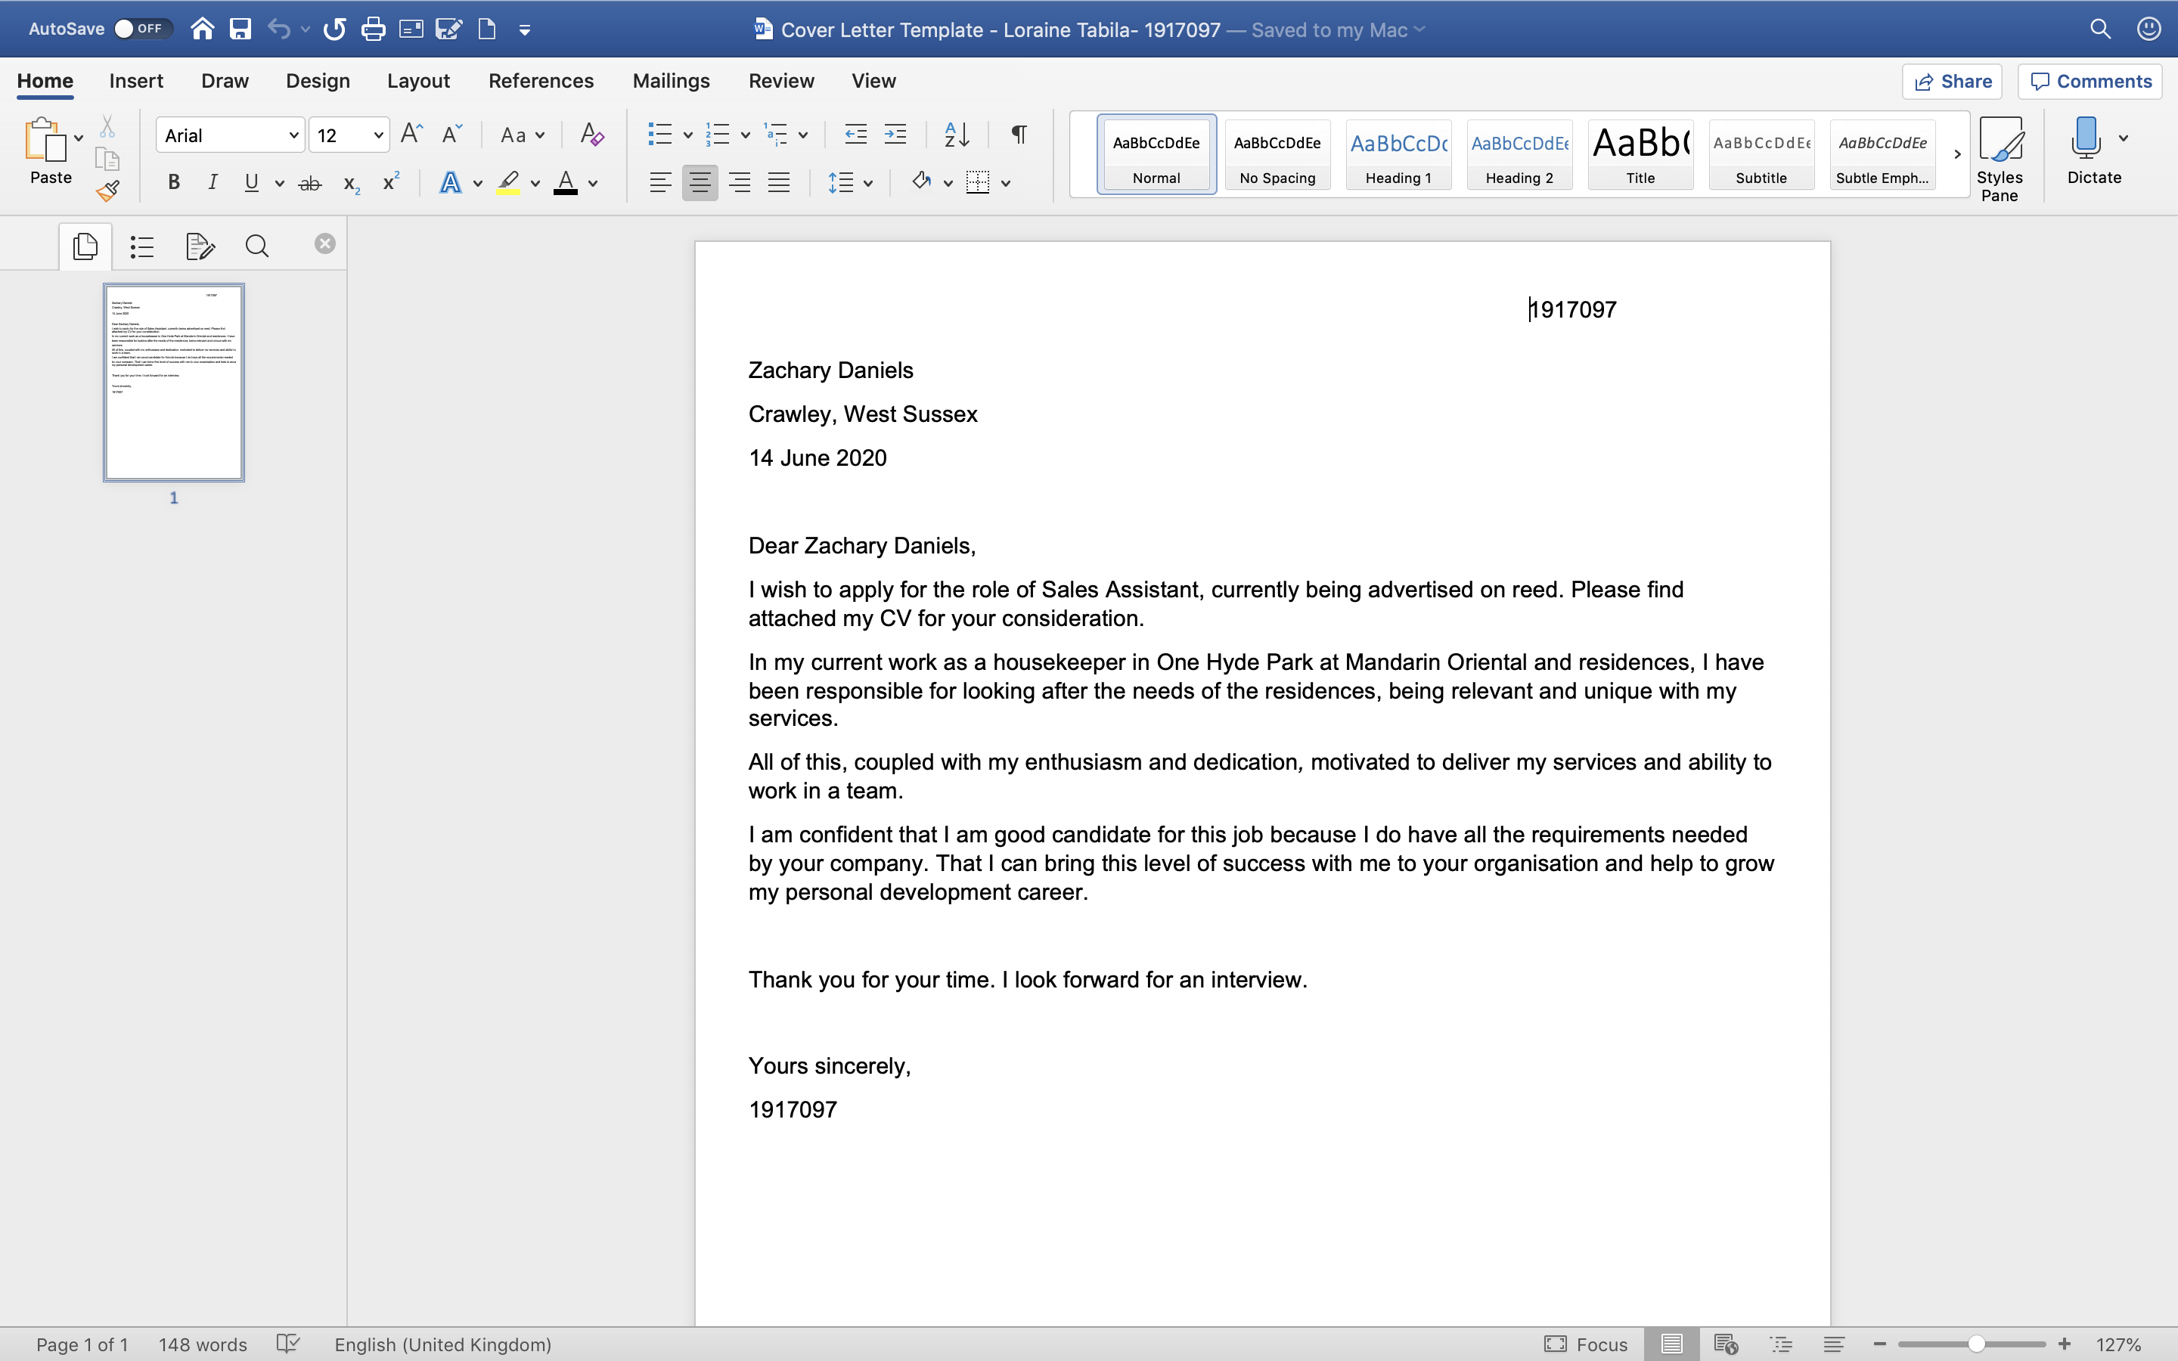

Appendix Analytical thinking

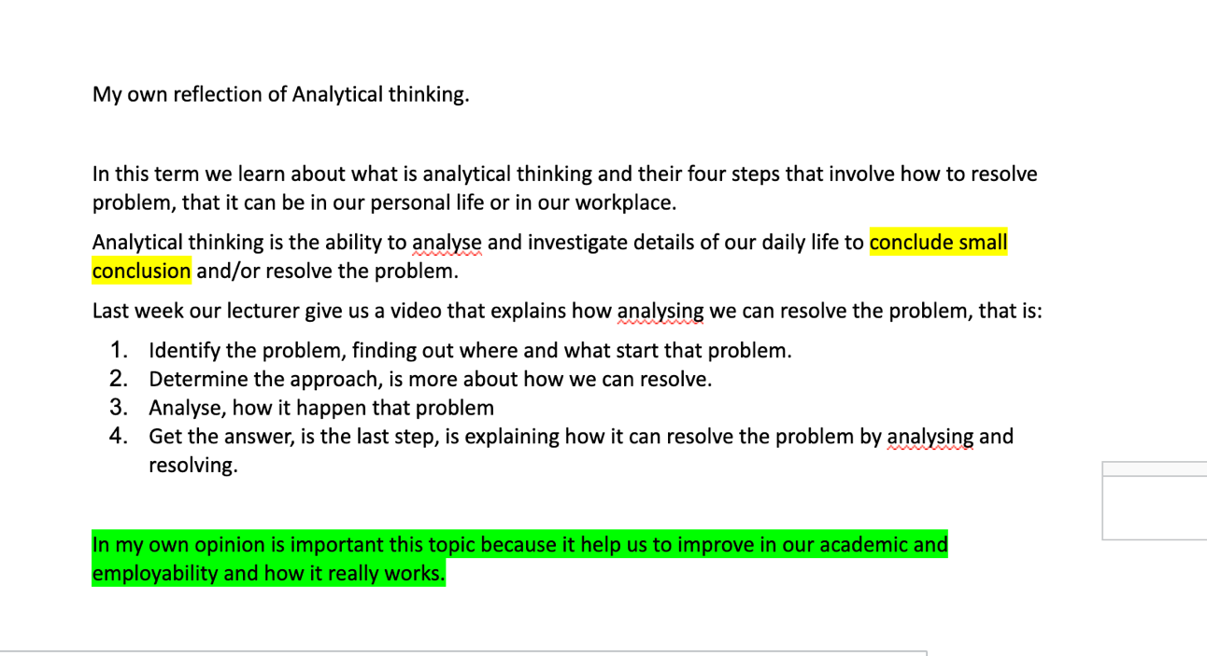

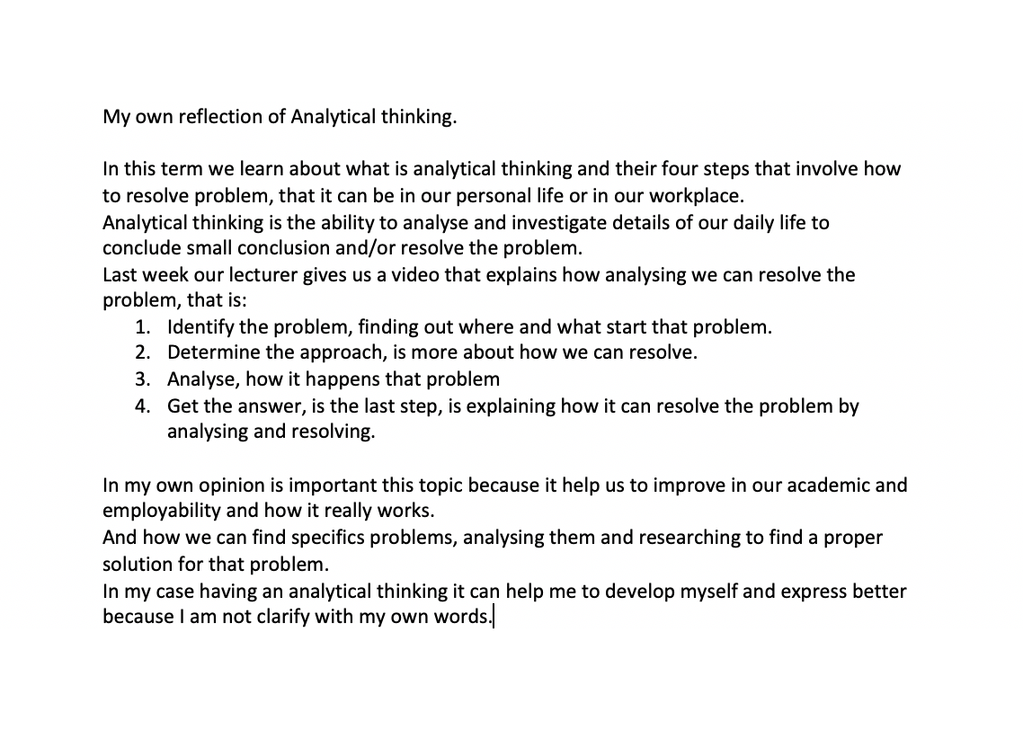

References

Works Cited
Andrew Grant, J. M. F. M., 2017. Frameworks for reflection . In: W. Blackwell, ed. Developing Reflective Practice. London: John Willey & Sons Ltd, pp. 28-31.

Aziza Karenina, S. W. B. A. P., 2019. Effectiveness of problem solving-based module to improve analytical thinking. Surakarta, Indonesia, IOP Publishing Ltd.

David Boud, R. K. D. W., 1985. Reflection: Turning Experience into Learning. In: R. K. D. W. David Boud, ed. What is a Reflection in Learning. London : RoutledgeFalmer, p. 7.

Morgan, P., 2017. General Principles of Assessment at university. In: Sage, ed. The Business Student's Guide to Study and Eployability . London: Sage, pp. 118-133.

Oxford, U., (2020). Careers Service Oxford University. [Online]
Available at: https://www.careers.ox.ac.uk/cover-letters
[Accessed 2020 August 25].

Kapur, R., (2018). Time Management. A case Study. Available at https://www.researchgate.net/publication/323825275_Time_Management_-_A_Case_Study. [Accessed 25 August 2020]

