E-PORTFOLIO

Module name: Changemakers Creativity and values
Module code: BMHP5014
Lecture name: Diola Bijlhout
Student name : Yelmi Sebastiao
Student ID : 2122805

Table of Contents
Introduction 3
ARTEFACT 1: Mind Map 4
Central Idea 5
Campaign Objectives 5
1. Raise Awareness 5
2. Destigmatise Mental Health 5
3. Advocate for Policy Change 5
4. Supportive Resources 5
5. Measuring Success 6
ARTEFACT 2: BLOG 7
References 11

Introduction
The key objective of this assignment is to create an e-Portfolio centered on two artefacts from the provided list of artefacts. To create these artefacts, the 3rd idea, i.e., developing and promoting a campaign inspired by the author’s passion, has been selected. The campaign is based on addressing the social stigma of mental health conditions and ways to address them. To fulfil the key requirements of the e-Portfolio, a mind map (Artifact 1) of the campaign will be created. In addition to this, a blog on the campaign (Artifact 2), explaining the story behind the campaign idea, will be incoporated.

ARTEFACT 1: Mind Map

3
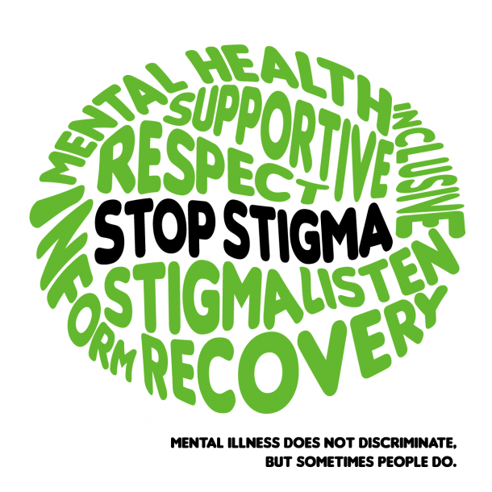

2
MDF, 2023
1
Mental Health Matters
Break the Stigma
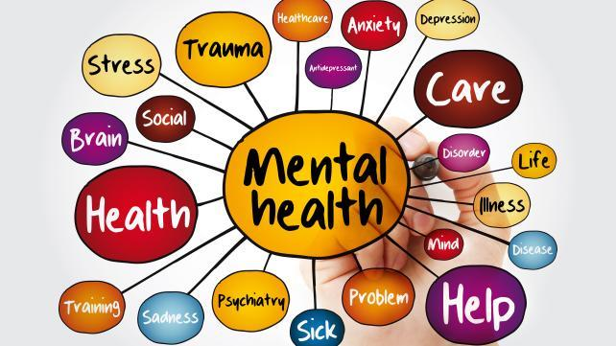
Murray PHN, 2023
Barcus, 2023


5
4
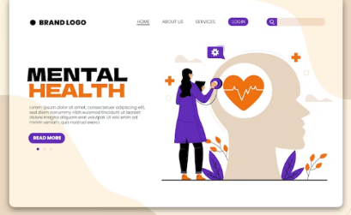
Freepik, 2023

SourcesOfInsight, 2023

This mind map is a visual representation of the extensive effort created to dispel the stigma associated with mental health issues and increase awareness, comprehension, and support for them. This campaign intends to have a beneficial effect on people individually, in families, and in communities by addressing important facets of mental health advocacy.

Central Idea
"Mental Health Matters" is the central concept of this mind map. This statement captures the central message of the campaign, which accentuates the significance of mental health as an essential component of overall well-being.

Campaign Objectives
The mind map divides the campaign's overall goals into five subgoals that each focus on a different but equally important component of the campaign's overall purpose.

1. Raise Awareness
This objective emphasises the significance of public education regarding the prevalence and impact of mental health issues. Maintaining a strong social media presence, sharing personal experiences, and hosting webinars and seminars are all strategies for reaching a large audience and disseminating vital mental health information.

2. Destigmatise Mental Health
The campaign's primary goal is to face up to and eliminate the stigma attached to mental health. In order to achieve this, frank and compassionate dialogue shall be promoted. By doing this, the campaign hopes to encourage a culture that is more caring and tolerant.

3. Advocate for Policy Change
Working with government authorities and campaigning for legislation that protects the rights of persons suffering from mental health issues is required to achieve this goal. The mind map underlines the importance of policy advocacy in effecting systemic change.

4. Supportive Resources
It is essential to provide services and information accessible so that individuals and communities can better understand and manage their mental health. The mind map suggests creating an extensive resource hub, which would include articles, videos, self-help tools, and an index of mental health practitioners. It is also proposed that a peer support network be established with trained volunteers to build relationships and support.

5. Measuring Success
The campaign's success is evaluated in the mind map's final section. It specifies particular indicators for determining the effectiveness of the campaign's efforts and ensuring accountability. These metrics consist of the following components.

- Increased Awareness: This indicator demonstrates the campaign's capacity to reach and inform a larger audience on mental health through social media engagement, website traffic, and event attendance.

- Stigma Reduction: Surveys and focus groups have been offered as measures for assessing changes in public perception and attitudes towards mental health. This statistic assists in determining the efficacy of destigmatisation efforts.

- Policy Impact: The mind map recommends that the campaign's advocacy activities be used to track legislative changes and improved financing for mental health care. This score quantifies the campaign's impact on systemic change.

- Resource Utilisation: Measuring the utilisation of the online resource centre and peer support network ensures that the campaign's resources are being utilised effectively to assist those seeking assistance.

- Stories of Change: As a qualitative metric of the campaign's impact, collecting and sharing narratives from people who received assistance from the campaign's resources highlights real-world success stories.

ARTEFACT 2: BLOG

What Inspired the Idea?
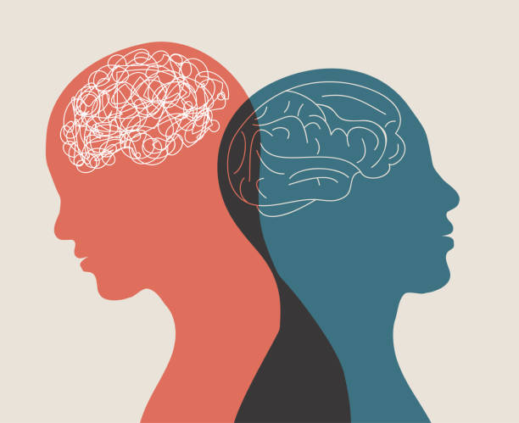
Social services campaigns are usally designed to address pressing social issues in the society. These campaigns aim to raise awareness, change attitudes, or inspire action on a specific issue that affects society (Health, 2020). In that context I will be sharing the story of how the idea for our campaign “Mental Health Matters” came to life. The idea kickstarted through the burning passion for a cause close to my heart – mental health (Fig 1).
Figure 1. Illustration of Mental Health. Source: iStock, 2023

The Thought Process
It was a cool morning in the autumn, and I was sitting indoors with a mug of coffee in my hand, watching the leaves rustle outside. When I was thinking about how to make a difference in the world, the notion of pushing for better mental health care and spreading awareness struck me like a bolt of lightning. Taking care of one's mental health is often overlooked despite its criticality. Millions of people all across the world were suffering from mental health problems in silence (Fig. 2), and they weren't getting the help they needed.

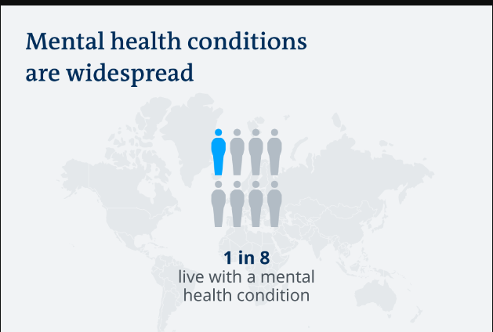
Figure 2. Global Mental Health Statistics
Source: WHO, 2022

Campaign Objectives
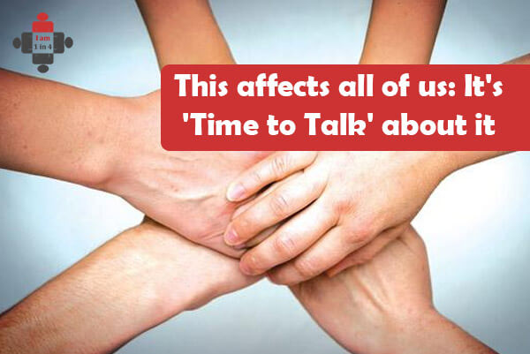
Raising awareness about the prevalence of mental health issues, in my opinion, is the first step towards changing things. It was important that people stop treating mental health like a taboo subject. Our campaign would bring attention to the fact that we are all affected by mental health in some way (Fig 3). Our goal was to make a safe place where people could talk freely and without fear of being judged. Awareness and talking about it are just the beginning. The goal of the effort was to get policy changes, increased funding for mental health care, and easier access to beneficial services. Now was the time to demand concrete action from all levels of government. To empower individuals and communities, we propose developing a Mental Health Resource Hub (Fig 4). Articles, videos, self-help tools, and a directory of mental health specialists would all be available on this digital platform.
Figure 3. Mental Health Affects Everyone. Source: TimetoTalk, 2023

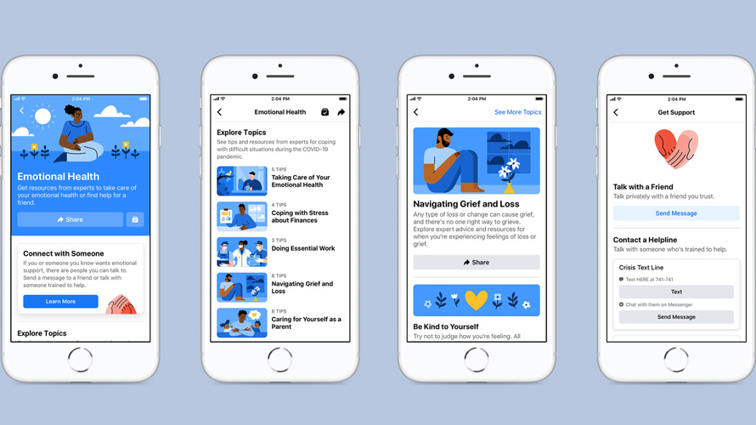
Figure 4. Mental Health Support Hub by Facebook
Source: Nover, 2022
We would work with community groups, schools, and colleges to put on events like mental health seminars and support group meetings. This would help the campaign reach more people and be more successful. Through the provision of peer support volunteer training, our goal is to create a system built on compassion and appreciation for one another. The obvious things to do next seemed clear. We would provide webinars and workshops where professionals in the field of mental health could share their expertise and experiences, and we would use social media to get our message out there. And finally, how will we determine what constitutes success?

Measuring Campaign’s Success
We would track website traffic, event attendance, and social media participation to gauge our reach. Surveys and focus groups would be used to gauge how the public's views and perceptions of mental health have changed. We firmly think that by banding together, we can eradicate the stigma associated with mental health and ignite hope for a more promising and psychologically sound future.

References
Barcus, S. (2023) May Is Mental Health Awareness Month, York Properties Inc.. Available at: https://yorkproperties.com/may-is-mental-health-awareness-month/ (Accessed: 11 September 2023).
Freepik | Mental health web template (2023). Available at: https://www.freepik.com/free-vector/mental-health-web-template_16863541.htm (Accessed: 11 September 2023).
Health, T.L.G., 2020. Mental health matters. The Lancet. Global Health, 8(11), p.e1352. https://doi.org/10.1016%2FS2214-109X(20)30432-0
iStock (2023) Istockphoto.com. Available at: https://www.istockphoto.com/illustrations/mental-health (Accessed: 11 September 2023).
MDF | Advocacy & Policy Influencing: strategy and skills (2023). Available at: https://www.mdf.nl/courses-categories/advocacy-policy-influencing-strategy-skill (Accessed: 11 September 2023).
Murray PHN – Stop Stigma (2023). Available at: https://www.murrayphn.org.au/stopstigma/ (Accessed: 11 September 2023).
Nover, S. 2020. “Facebook Introduces Mental Health Resource Hub.” Adweek, October 5, 2020. https://www.adweek.com/performance-marketing/facebook-will-launch-mental-health-resource-hub/.
SourcesOfInsights | Jd. 2021. “The Best Way to Measure Success Is Against Your Mission and Vision.” Sources of Insight, September. https://sourcesofinsight.com/measure-of-success/.
Time to Talk | This affects all of us: It's 'Time to Talk' about it - I am 1 in 4 (2018). Available at: https://iam1in4.com/2018/02/mental-health-affects-everyone-time-talk/ (Accessed: 11 September 2023).
Turner, E., 2020. Be Less Zombie: How Great Companies Create Dynamic Innovation, Fearless Leadership and Passionate People. John Wiley & Sons. https://books.google.com/books?hl=en&lr=&id=fsbKDwAAQBAJ&oi=fnd&pg=PR15&dq=Be+Less+Zombie:+How+great+companies+create+dynamic+innovation,+fearless+leadership+and+passionate+people&ots=hRbBA-Cnec&sig=lWHE4PqzlZ1QgfRMrcDThEozgAY#v=onepage&q&f=false
WHO | Mental health (2022). Available at: https://www.who.int/news-room/fact-sheets/detail/mental-health-strengthening-our-response/?gclid=Cj0KCQjw9fqnBhDSARIsAHlcQYSC5-mlIAsMEqArcqLboIia4J_MilEp2P6X1OmXt0nrxmA6nD2GNmAaAg4YEALw_wcB (Accessed: 11 September 2023).

