Student Name: Nicolae Mihai
Student Number: 2124103
Lecturer Name: Akash Puranik
BMSW4003_BIRM
Subject: Effective team working and communication
.

Report :
First time the time I start to do I'll try to take things as it should in after I start looking answer Google school library indeed And after I start to collect ideas for all this tree page and I put in my project make for me more easy to collect the information and I make my ideas with all the information to collect for Internet .
Table of Contents

How can you develop an effective team and what theoretical model can be used ………………….1
What are the types of roles that are needed to create an effective team …………………………….…..2
What type of impact can effective teamworking have on team success…………………………………….3
What are the barriers to effective teamworking identified in this scenario…………………………..…..4

Abstract
The purpose of this article is to construct an integrated theoretical model for building effective teams based on a literature review guided by several research questions on all aspects of teams, team building, team member selection, team development, and theoretical constructs that affect the development of effective teams. The principal outcome of this article is a relationship model that is grounded in the teams, teamwork, and team building literature and based on several theoretical frameworks. This rigorous model may be applied consistently among human resource development (HRD) practitioners and scholars to assist them in building effective teams.

The authors examined the role of cross-training in developing shared team-interaction mental models, coordination, and performance in a 2-experiment study using computer simulation methodology (for Experiment 1, N=45 teams; for Experiment 2, N=49 teams). Similar findings emerged across the 2 experiments. First, cross-training enhanced the development of shared team-interaction models. Second, coordination mediated the relationship between shared mental models and team performance. However, there was some inconsistency in the findings concerning the depth of cross-training necessary for improving shared mental models. Results are discussed in terms of the impact of different levels of cross-training on team effectiveness. (PsycINFO Database Record (c) 2016 APA, all rights reserved)

This paper presents a review of recent survey-based research looking at the contribution of teamwork to organizational performance. In particular, it focuses on empirical studies in which both teamwork and performance are directly measured in a quantitative way. The paper begins by identifying four interrelated dimensions of teamwork effectiveness: attitudinal, behavioural, operational and financial. The first two represent transmission mechanisms by which organizational performance can be improved. The latter two provide direct measures of organizational outcomes. The review shows that teamworking has a positive impact on all four dimensions of performance. It also reveals that, when teamwork is combined with structural change, performance can be further enhanced. The paper concludes by highlighting some important research gaps that future studies could address
The development of teamworking and multidisciplinary communication across organizational settings, and particularly in healthcare, reflects a growing awareness of the benefits to be derived from this way of working. These benefits, in the form of improved healthcare delivery and better member well-being, are described by reference to research evidence.

Conclusion
in the 4 weeks we worked and understood how we can become a better person in the field that we will work what it means to work in a team and what are the methods that can help you work in a more orderly and easier way with the people around you and especially how you can select a team in which you can work in different situations and be able to carry out the project
Recommendations

Google Scholar,

Library and Learning Resources | University of Wales Trinity Saint David (uwtsd.ac.uk)

https://www.google.co.uk
Job Search | Indeed

List of References
Gilley, J.W., Morris, M.L., Waite, A.M., Coates, T. and Veliquette, A., 2010. Integrated theoretical model for building effective teams. Advances in Developing Human Resources, 12(1), pp.7-28.
West, M.A., 2012. Effective teamwork: Practical lessons from organizational research. John Wiley & Sons.
Delarue, A., Van Hootegem , G., Procter, S. and Burridge, M., 2008. Teamworking and organizational performance: a review of survey‐based research. International Journal of Management Reviews, 10(2), pp.127-148.
Gluyas, H., 2015. Effective communication and teamwork promotes patient safety. Nursing Standard (2014+), 29(49), p.50.
West, M., 1999. Communication and teamworking in healthcare. NT research, 4(1), pp.8-17.

Research design

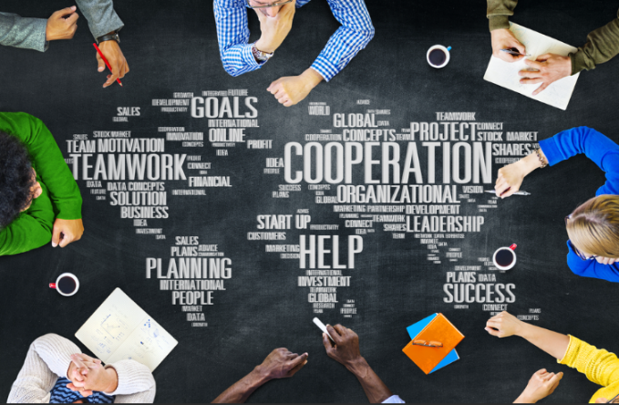


Research Question

How can you develop an effective team and what theoretical model can be used?
First time you need to know each other after you need to have the plan second time, he needs to know about everything, and you need to know also the people you are working with you and after to make the good plan everything more easy To finish the project.
What are the types of roles that are needed to create an effective team?
You need to know how many persons you have in your team after cheque people his qualification for the job to see what position is better for him to working with you to be easy for everybody end to go good result To project end everybody to be happy to work with you.
What type of impact can effective teamworking have on team success?
The time you start working the team do you have more resulted better can you have job easy to finish in time and good resulted and people will be happy to working with you because you think how is better to do the job to be easy and to be more satisfied for that job you started with the team all the team will be great to working with you if you are person to understand Evie part of the job you start with the team and to give it all the members do something to be great and to be easy to put in the middle job to do finally step to make great job.
What are the barriers to effective teamworking identified in this scenario?
To have the great team you need to choose different person with different qualification for going to the next level with the team is mean every person have different qualification he can have different idea how is working and you put together any need to choose good part right here what time you choose the better idea you need to put in practice and everybody need to be professional happy and to do what you need to do to make finally mark peace 100% to make the project finally very good end the result that will be not negative will be positive in all the team will be have success for that project you started together and also you need to have good respect each other person to working with you to respect your project and to be 100% dedicate for he sparked to do for finally peace working together

Result
understand four ways together to start a new team in need to understand first and you need to know you better and after we need to know every skill in your habit to do better for the next job also you need to choose different person with different skill to make difference and to have new idea to choose the better idea for that job you starting to do in to make good choice and finish the project you starting together with all team together

Introduction

How can you develop an effective team and what theoretical model can be used?
To be able to start a project you need a team how you can do this have personal needs in Which to form a group of people between 3si 6 or more people gather a team aspect must know each Person individually how he has sons who we are and what qualities we have and what we do not Have in the way so we con to know us better and it way these we will you know who can do one Or the other and for this we must see each other face to face and discuss for the project in which we Want to be able to create it with a lot of confidence in another and to be a strong team with good results and to be able to achieve the proposed goal
What are the types of roles that are needed to create an effective team?
in order to be able to create an efficient team we have to work with constere each and see where we have the minuses and each person and where we have pluses and in this way we can understand ourselves much better and create an efficient team on the able to work and to be able to gather a team a face and a single person so in view of being a team with all the good and bad things not so anymore we can make a team with a balance and respect to work in the most beautiful way in the team with respect
What type of impact can effective teamworking have on team success ?
im momnetul in which you have what you have a team well put things in place much better and the results will be on the waiting echpei that are at the moment and times what project will be much easier I would lead to good sfrisit and work with much more confidence to work in the team is working in this momnetul no longer so you can balance everything for your team and you can equip in a pleasant and beautiful way should come bonuses or increases of salaries or prizes in which you can be
What type of impact can effective teamworking have on team success?
an equilibrium in the team are the reasons: respect for the confidence to say all the time when he made mistakes and to restore everything again without being subjected sup presume by the leader in which is in the possie team that was assigned to answer for iea to be able to keep a team in the most beautiful way of work and as a lidar has the power to speak to carry bonuses for his team and that the whole team can be happy and contain everything to be a balance of bringing the team to the highest level
What are the barriers to effective teamworking identified in this scenario?
Teamwork requires co-operation, co-ordination and communication between members of a team to achieve desired outcomes. In industries with a high degree of risk, such as health care, effective teamwork has been shown to achieve team goals successfully and efficiently,
a doctor needs to know very well the team that collaborates and to be very effective a team of 2-5 people who know good medicine when he enters the operating room to bring to the end and a positive result no longer than you can consider that teamwork is working and then the results will be very good

Discussion
In this for weeks I understand What is the team how we know each other how to building good team to have good resulted to put everything step by step to make great job and more important in to have the team you need to have respect each other to know each other has a friend only like that you can make good job with everybody any and To finish in the time everything what you start In make great job

