18th December 2022
Carmarthen County Council
County Hall,
Castle Hill,
Carmarthen,
SA31 1JP
Dear Recipient,
I am writing to you regarding the proposed development of Ysgol Glangwili from the invitation to tender and would like to express my interest in my below response.
Under the Government's plan released in the year 2011, which outlined several initiatives the Government would carry out to change business procedures, cut waste, and improve value from its construction procurement. Its overall goal is to cut building project costs by 15-20%, with the money saved being invested in other government schemes across the UK. By 2016, all centrally procured construction contracts would need to be fully collaborative 3D BIM (Building Information Modelling). A Publicly Available Standard (PAS), 1192-3:2014, which specifies the information management for the operational phase of assets using the key standards of BIM. (Office, 2012)

With the levels of BIM graded from 0-3, the grading I am proposing to you that this project to be completed at BIM level 2 maturity. This level of collaboration involves flawless coordination between all the systems and the stakeholders, as well as giving each stakeholder their own 3D CAD model and modernising information interchange connected to the project. (BIM, 2022)
Reading Girls Secondary, Westfield Academy in Watford, and Longden Secondary in Hertfordshire are three examples of BIM achievement on secondary school projects totalling 150 million pounds. BIM was primarily used to reduce clashes and keep the batch under its constrained budget, both of which were successful. The model was also utilised for construction sequencing and design logistics, and the customer wished to use it for design validation and data import into its custom CAFM system. (Ravenscroft, 2023)
Responding to the Employer's Information Requirements (EIR) is how BIM Level 2 achieves this. I would then create a BIM Execution Plan (BEP), a master information delivery plan, and a task information delivery plan to accomplish this. During this tender stage I would carry out the Pre-contract BEP and demonstrate my abilities to meet your requests. If successful, I will offer the BIM Execution Plan (BEP) with contractual value. As stated, the BEP is processed in accordance with the individual order, which complies with the specifications and provides an accurate analysis and description of the BIM fields of application within the BIM project. (Biblus, What makes a BIM Execution Plan good?, 2022)
A BIM Execution Plan can offer several significant advantages that will keep everyone informed and present a clear plan of objectives at each stage. Along the various production stages, it will provide better communication. Collaboration and standard alignment, especially for bigger projects, as discussed in the Ysgol Glangwili briefing. It will outline important deliverables, processes, and other data that will streamline the BIM process and keep everyone moving forward while preventing misunderstandings and pointless delays with working procedures which in the long run will save a lot of time. (Ramage, 2022)
I will be assisted in doing this by the digital plan of works, which when combined with everything else will offer a framework for the project deliverables, the timetable, and everyone's positions and duties at each step of the project. Regarding the kind of customer and project, PAS 1192-5 offers technological security considerations for securely sharing project data prior, during and after the projects finalises. As a result, measures that guarantee the secure sharing of information must be put in place. (BIM A. , 2016)
Responsibility and trust can only be effective if each participant's role in the Ysgol Glangwil project is understood. The degree of definition at BIM level 2 entails the caliber of data that is related to or incorporated within various types of elements in the selected group model. It is important to agree on the level of definition at each stage with the intention of determining the extent to which each project team member is legally required to develop model elements, linking design, construction, and facilities management aspects to the model, and determining the extent to which other team members can rely on model elements and the associated data. (Saxon)
Expectations for information exchange during a facility's lifetime are outlined in BS 1192-4:2014. This makes it possible to prepare and use information without having to be familiar with the sending and receiving programs or databases. It makes sure that the sharing of information can be examined and verified for compliance and consistency. (Knowledge, 2014)
By assisting you to carefully plan the work so the risks involved are managed from start to finish, the appropriate personnel, cooperate and coordinate your work with others, have the right information about the risks and how they are being managed, and consult with workers about the risks and management under the CDM Regulations 2015 which covers the management of health, safety, and welfare when carrying out the Ysgol Glangwili. (Regulations, n.d.) For the collaborative exchange and use of structured health and safety information using BIM, PAS 1192-6 is a specification. (NBS, 2022)
Furthermore, in contrast to the level of detail (LOD) and level of information (LOI), appended in my report would aid in determining the model elements' completeness and what information is needed for the formal issue to each project team member at each data point drop for Ysgol Glangwili. Appended to this letter is a report that describes the scope of the requirement, how it interacts with the RIBA's seven stages, and how information exchanges at the end of each step are coordinated.
As the project's main consultant, I would adhere to the guideline structure shown in Figure 1 of the report's appendices, which supports the UK's adoption of the ISO 19650 series. This advice paper is a part of a larger guidance framework that is depicted in Figure 1. The purpose of guidance part 3 is to aid in the implementation of BS EN ISO 19650-3, which describes the information management procedure for the asset life cycle's operating phase. (Kemp, 2020)
Thank you for taking the time for reading my letter in response to the Ysgol Glangwili Project. I can make myself available intermittently to answer any questions via telephone or email.
Thank you for your consideration.
Sincerely,
Mr Kamran Leigh Davies

Appended Report

Table of Contents
1. Introduction 5
2. Method Findings 6
3. BIM Outline 6
4. Level of Information Need 6
Geometrical information 7
Alphanumeric information 7
Documentation 7
Level of Detail (LOD) 7
LOD 1 (Brief) 8
LOD 2 (Concept) 8
LOD 3 (Developed Design) 8
LOD 4 (Production) 8
LOD 5 (Installation) 8
LOD 6 (As Constructed) 9
LOD 7 (In Use) 9
Level of Information (LOI) 9
5. RIBA Stages 9
6. Conclusion 10
References 10
Appendix 13

Introduction
Throughout this document, I will be acting as lead consultant to construct a new infant school in for my client, Camarthen County Council which is jointly funded with the Welsh Government and adhering to the BIM maturity standards. My client has requested that I demonstrate from studied examples the level of information needed for the project throughout the RIBA stages so they can determine what they should include in the EIR, stating a requirement for entire life monitoring of the asset through a CAFM system. My information will be shared, coordinated, and managed using BEP and the applicable international standards in a letter to the client, demonstrating my awareness of the needs of BIM maturity for this project. (PORR, n.d.)

Method Findings
The subject matter from this report will be sourced from books, online resources and lecture presentations uploaded through Microsoft teams.

BIM Outline
BIM is a digital project management technique used in the building sector. Work is done by all project participants using a common virtual building model. The system generates and organises all project-relevant content from a single location and makes it accessible to the various project teams in addition to giving a visual representation of the finished building or project. This makes it possible to document and increase the transparency of development process so that they can still be tracked after the project is over. For the long-term administration and maintenance of buildings and associated technological installations, the information contained in the BIM model is particularly crucial.

Level of Information Need
A framework known as the Level of Information Need stated in the BS 17412-1:2020 establishes the scope and level of information required. When employing building information modelling, it determines the level of information of the information deliveries being a part of the information exchange activities during the life cycle of built assets (BIM). (BSI, Guideline for the implementation of BIM Execution Plans (BEP) and Exchange Information Requirements (EIR), 2019)
The standards, EN ISO 19650-1, and EN ISO 29481-1 all cover the key ideas related to information exchange. The relationships at the time of the release of this standard are depicted in Figure 2, see attached in appendix Information requirements in terms of level of interchange, process maps, and interaction. Information exchanges defined by the exchange information requirements (EIR) lead to information deliverables being exchanged. (BSI, BSI Standards Publication, 2020)

Geometrical information
Geometrical information is a explanation of the specifics and amount of information communicated through sizes, structure, position, and detail. Varying on the project's goal and delivery milestones, the ongoing amount of information need develops throughout the project.

Alphanumeric information
Information expressed using symbols and numbers is referred to as alphanumeric information.

Documentation
The term "documentation" refers to any project-related documentation, involving any supporting methods, judgments, and approvals.
(Catenda, 2022)
These three ideas each deal with a particular issue at a given agreed-upon time or delivery milestone. According to the clients' requirements for exchanging information, the level of information need provides techniques or methods for describing how information will be supplied or exchanged (EIR).

Level of Detail (LOD)

The idea of LOD has been devised to provide for more explicit control over the how much question. Several organisations have offered a specification for LOD. Based on the BIM protocol is the LOD specification (BIM Forum, 2013). Explicitly stating the level of detail that each component of a building information model should have at various phases serves as the foundation for the set of requirements. It is evident that model authors will greatly benefit from this, and it will help ensure that models created by various project stakeholders have similar information at various phases of development. The LOD definition tackles various fundamental concerns related to information transmission and plays a critical role in allowing seamless collaboration among all project participants. For instance, the requirement to indicate what LOD the pieces in the model are at and, as a result, what the model's limits may be. With a clear articulation of this, the model's receivers can then use it appropriately for their objectives. The owners of the asset in issue will find this to be of great use because they can use it to confirm their understanding of the project's status and take the appropriate actions to make sure their expectations are being met. The LOD information can also be used by design managers to control their operations at several critical points. (Kumar, 2015)
The UK definitions are contained in PAS 1192, the publicly available specification that sets out how information should be managed on BIM projects and shown in figure 3 of each stage in appendix.

LOD 1 (Brief)
- A model that communicates the performance needs as well as the location constraints.

LOD 2 (Concept)
- The essential regions and volumes, as well as the orientation and cost, are all included in the conceptual or volumetric model. In the RIBA Plan of Work, this is equivalent to stage 2.

LOD 3 (Developed Design)
- Systems with approximate amount, size, form, location, and placement. This is equivalent to RIBA stage 3.

LOD 4 (Production)
- Technical design model includes precisely modelled and coordinated features that can be used to evaluate expenses and confirm monitoring. This is equivalent to RIBA stage 4.

LOD 5 (Installation)
- Model suited for construction and assembly, with precise requirements and components which would include geometry and data.

LOD 6 (As Constructed)
- Model includes important information about how the asset was built, which can be used during its management and maintenance phases.

LOD 7 (In Use)
- An asset information model that will be utilised for continuing protection and monitoring operations.

(Biblus, What are LOD and LOIN in BIM and what are they for?, 2022)

Level of Information (LOI)
The Level of Information (LOI) specifies the information content of a BIM object at a certain point in the project. LOI refers to an object's qualities, such as dimensions, material specifications, insulation, or the cost of a building piece. (Baldwin, 2018)

RIBA Stages
Figure 4 in the appendix depicts the Royal Institute of British Architects (RIBA) project stages. The RIBA Plan of Work is a shared design and construction framework that serves as a process map as well as a management tool. When analysing insurance liabilities, work stages have been used to designate stage payments and specify team members' obligations, and they frequently appear in contracts and appointment documents. The Plan of Work has changed to include multiple procurement routes, more diverse roles, multi-disciplinary teams, government gateways, and stages that take place before and after design and construction. (Buildings, 2023)
The RIBA Plan of Work is divided into eight stages (0-7) and work together to guide the briefing, design, construction, handover, and use of a building. The RIBA Plan of Work can be used by a client at the beginning of a project to assist them in setting up their project, or by any project team member during the project. This will then remind them of the key duties that should be complete at a certain stage. It is critical to recognise how the RIBA Plan of Work allows the evolution of many goals, designated here as Project Strategies, through the RIBA stages in addition to comprehending the outcomes of each stage. (RIBA, 2020)

Conclusion
To finish this report, I can highlight the level of information needed by the client can vary at each data drop, but it is critical that all levels of information requirements are explicitly agreed upon and documented. A lack of user control, a failure to address the BEP, a lack of model element detail, or even an overly complex input can all lead to failures in asset delivery of a project. From the findings I can share the importance of the level of information need which is crucial in a project in the decision making of what they client should include in their EIR’s.

References
Advenser. (2022). Level of Detail For BIM. Retrieved from Advenser: https://www.mepbim.com/building-information-modeling/bim-level-of-development/
Baldwin, M. (2018). Five BIM concepts in 2 minutes: BIM, openBIM, IFC, LOD, LOI. Retrieved from BIM Connect: https://bimconnect.org/en/wiki/five-concepts-in-90-seconds/#:~:text=The%20Level%20of%20Information%2C%20or,costs%20of%20the%20building%20element.
Biblus. (2022, July 06). Exchange Information Requirements: What is an EIR in BIM? Retrieved from Biblus: https://biblus.accasoftware.com/en/exchange-information-requirements-what-is-an-eir-in-bim/
Biblus. (2022, March 14). What are LOD and LOIN in BIM and what are they for? Retrieved from Biblus: https://biblus.accasoftware.com/en/what-are-lod-and-loin-in-bim-and-what-are-they-for/
Biblus. (2022, 04 29). What makes a BIM Execution Plan good? Retrieved from What is the BIM Execution Plan (BEP) and what is used for?: https://biblus.accasoftware.com/en/what-is-the-bim-execution-plan-bep-and-what-is-used-for/
BIM. (2022). BIM MaturityLevels Explained - Level 0, Level 1, Level 2, Level 3. Retrieved from BIM Levels Explained : https://www.united-bim.com/bim-maturity-levels-explained-level-0-1-2-3/
BIM, A. (2016). What Is BIM Level 2. Retrieved from BIM Level 2 Explained: https://bim360.autodesk.com/what-is-bim-level-2/
BIM, Y. W. (2015, March 01). BUILT CASE STUDIES OF BIM. Retrieved from https://yeswebim.wordpress.com/2015/03/01/built-case-studies-of-bim/
BSI. (2019). Guideline for the implementation of BIM Execution Plans (BEP) and Exchange Information Requirements (EIR).
BSI. (2020). BSI Standards Publication. London: The British Standard.
Buildings, D. (2023, January 13). RIBA Plan Of Work. Retrieved from The Construction Wkik: https://www.designingbuildings.co.uk/wiki/RIBA_plan_of_work
Catenda. (2022). What is the level of information need? Retrieved from Catenda: https://catenda.com/bim/level-of-information-need/
Ellis, M. (2020, July 12). Level of Detail or Development: LOD in BIM. Retrieved from https://rebim.io/level-of-detail-or-development-lod-in-bim/: https://rebim.io/level-of-detail-or-development-lod-in-bim/
GSA. (n.d.). Defining LOD. Retrieved from GSA: https://www.gsa.gov/real-estate/design-and-construction/3d4d-building-information-modeling/bim-software-guidelines/document-guides/level-of-detail#:~:text=Level%20of%20Design%20%2F%20Development%20%2F%20Detail,data%20associated%20with%20the%20objects.
Kemp, D. A. (2020). Information Management According To BS EN ISO 19650. UK BIM Framework.
Knowledge, B. (2014, 07). Codes Of Practice . Retrieved from Codes Of Practice : https://knowledge.bsigroup.com/products/collaborative-production-of-information-fulfilling-employer-s-information-exchange-requirements-using-cobie-code-of-practice/standard
Kumar, B. (2015). A Pratical Guide To Adopting BIM In Construction Projects. Dunbeath: Whittles Publishing.
NBS. (2022). What is PAS 1192-6? Retrieved from NBS: https://www.thenbs.com/knowledge/what-is-pas-1192-6
Office, C. (2012). Government Construction Strategy. London: Cabinet Office.
PORR. (n.d.). BIM - an outline. Retrieved from PORR: https://worldofporr.com/en/storys/bim-an-outline/
Ramage, M. (2022, April 06). What Is a BIM Execution Plan and What Should It Include? Retrieved from Trimble Construction: https://constructible.trimble.com/construction-industry/what-is-a-bim-execution-plan-and-what-should-it-include
Ravenscroft, T. (2023). Case study: BIM helps secondary schools stick to budget. Retrieved from BIM Plus: Case study: BIM helps secondary schools stick to budget
Regulations, C. (n.d.). The Construction (Design and Management) Regulations 2015. Retrieved from CDM REGULATIONS: https://www.cdm-2015-regulations.co.uk/
RIBA. (2020). Plan of Work 2020. London : RIBA.
Saxon, R. G. (n.d.). BIM For Construction Clients . NBS.

Appendix
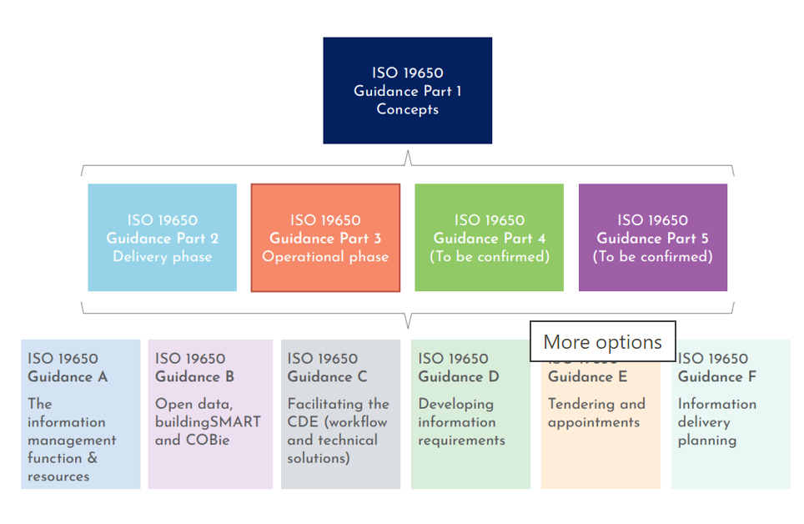
Figure 1 – ISO 19650 Guidance Framework (Kemp, 2020)

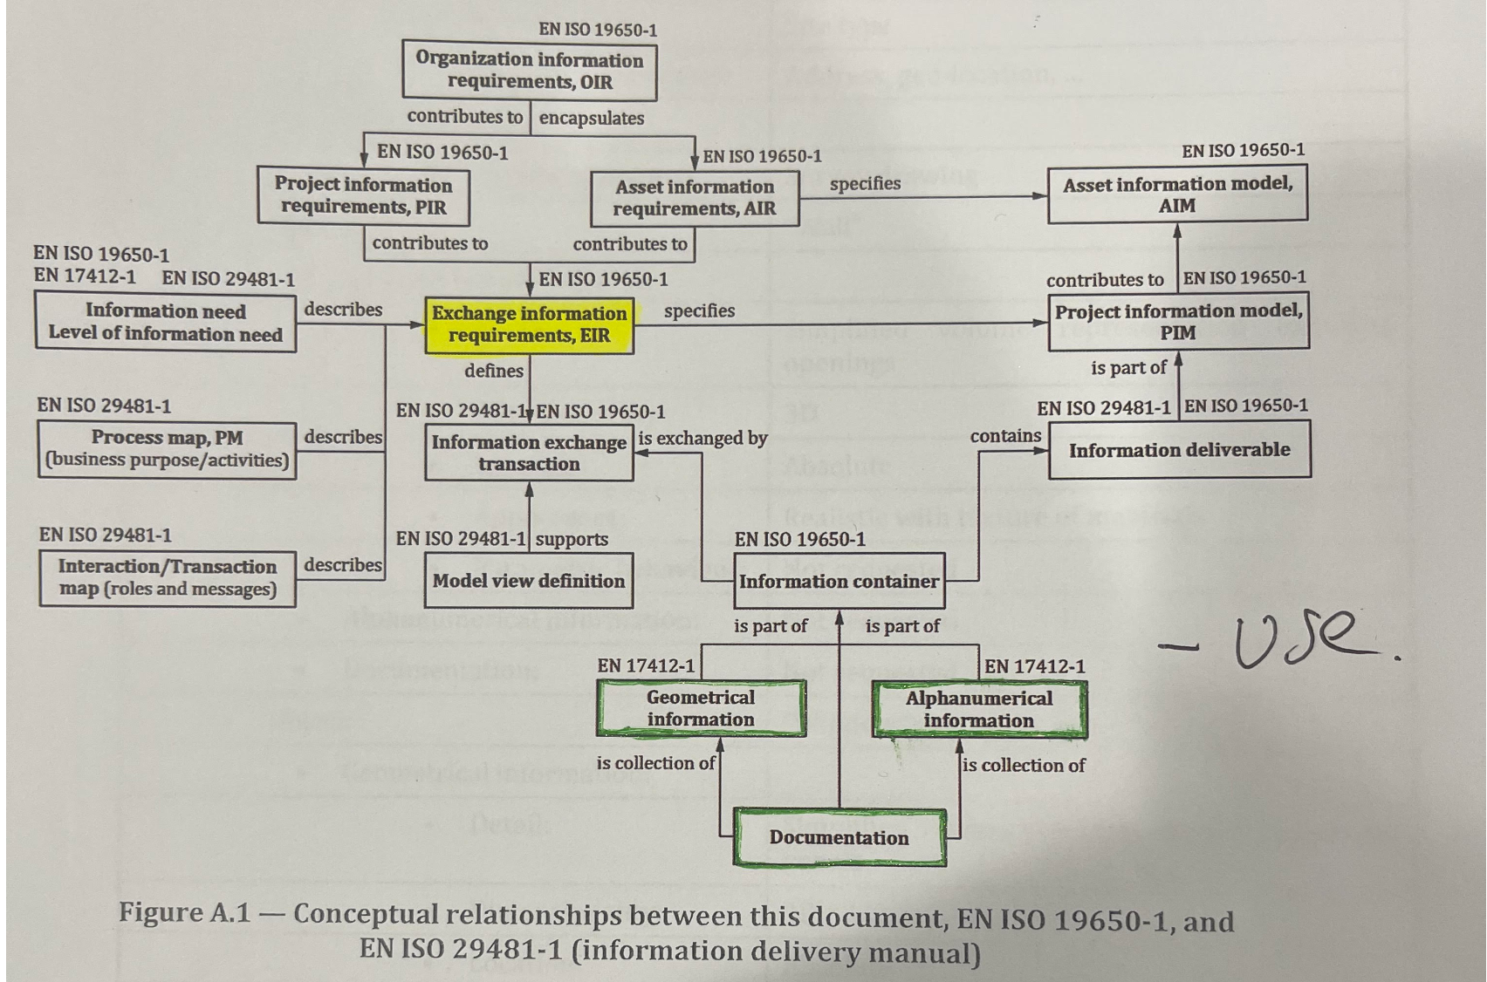
Figure 2 – Conceptual relationships between this document, EN ISO 19650-1, and EN ISO 29481-1. (BSI, BSI Standards Publication, 2020)
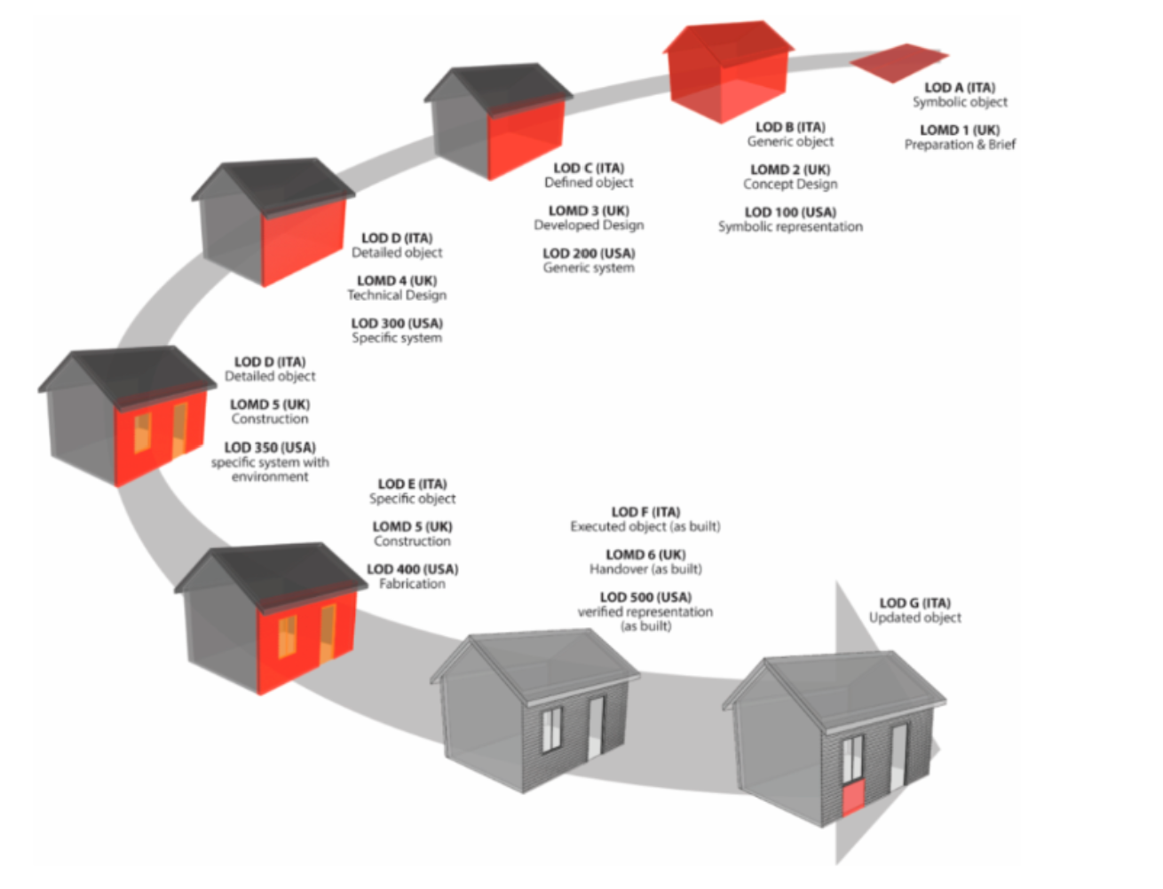
Figure 3 – Level of Detail stages 1-7 (Ellis, 2020)
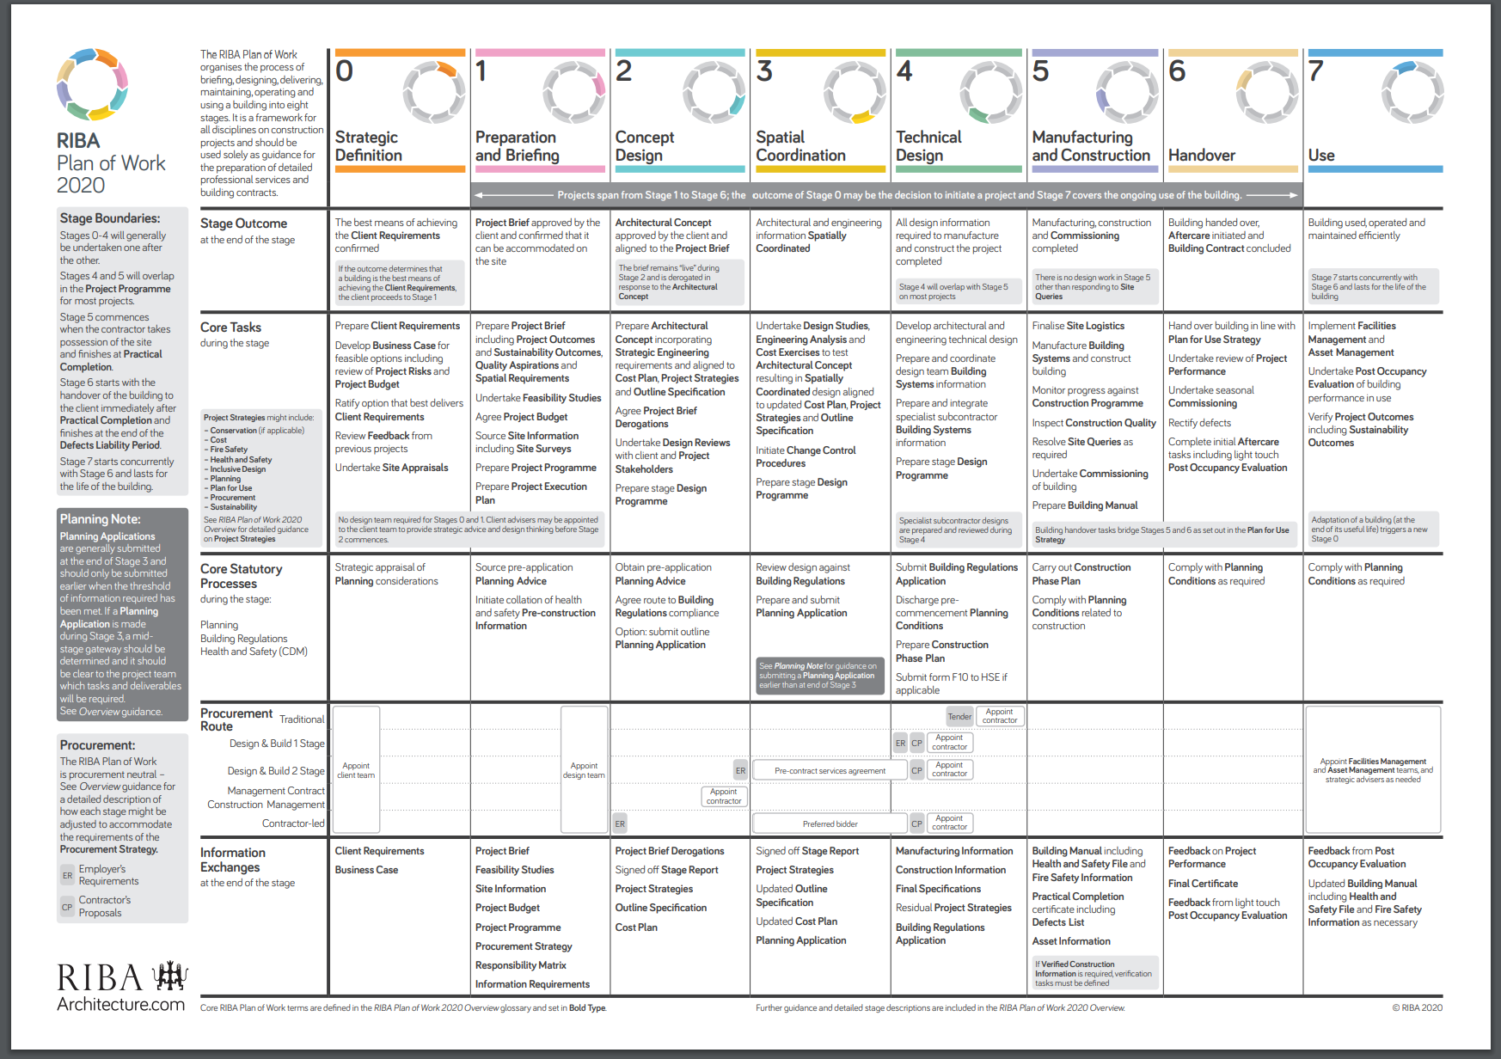
Figure 4 – RIBA Plan of Work 2020 (RIBA, 2020)
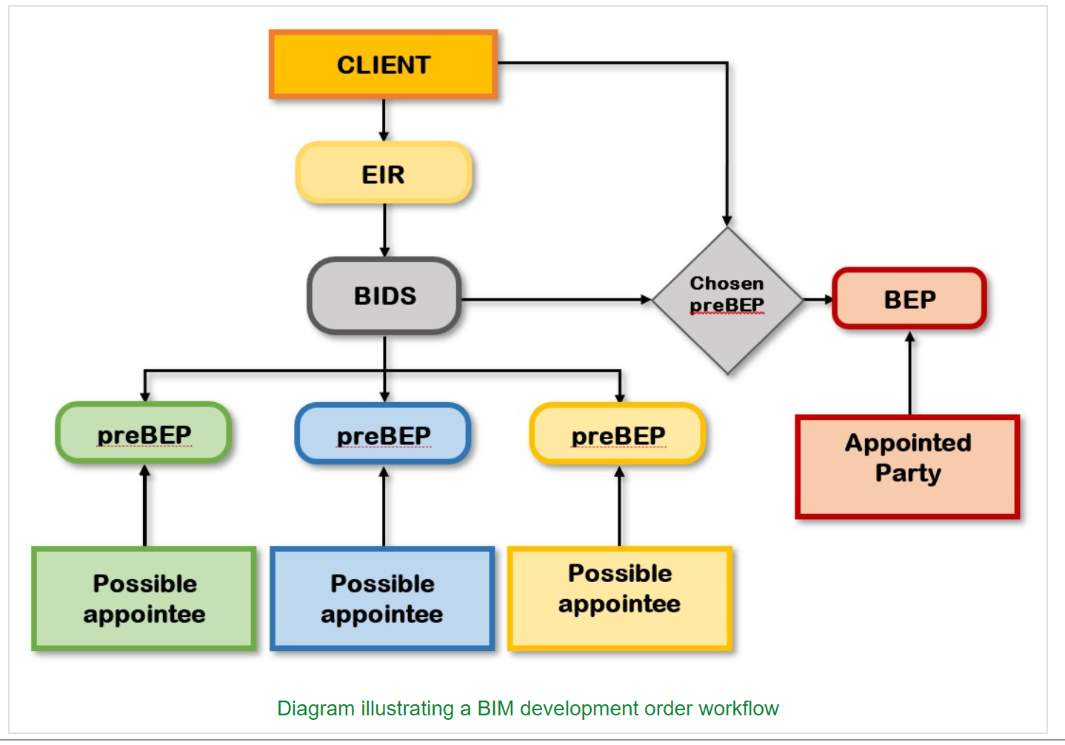
Figure 5 – Diagram illustrating a BIM development order (Biblus, Exchange Information Requirements: What is an EIR in BIM?, 2022)

