Ioan-Alexandru Blaj

Student ID: 2028527

Assessment – 2

Report and demonstration – Network Programmability

Background of Ansible 3
Advantages of Ansible 3
Disadvantages of Ansible 4
Analyse the features of Ansible 4
Installation and configuration of Apache Server 5
Installing Ansible 6
Installation and configuration of My SQL 10
Installation and configuration of PHP 12
Evaluation Of Ansible As A Network Programming And Automation Tool 12
Advantages of Ansible 13
Disadvantages of Ansible 13
Ansible Playbooks 13
YAML 14
Ansible Playbook Example 14

Background of Ansible
Ansible is a free and open-source software provisioning, configuration management, and application-deployment tool. It runs on many Unix-like systems, and can configure both Unix-like systems and Microsoft Windows. Ansible was developed by Michael DeHaan and acquired by Red Hat in 2015. Ansible is agentless, meaning no additional software needs to be installed on managed hosts. It uses an inventory file to track which hosts to manage, and a Play book to define the tasks to be run on each host. Playbooks are written in YAML, and can be run from the command line or via an included Ansible Tower product [1], [2].
Ansible is easy to get started with, and can be used to manage small deployments as well as complex multi-tier systems. Ansible can be used to automate tasks such as application deployments, configuration management, and provisioning [1], [2], [3].

Advantages of Ansible
1. Agentless - Ansible does not require any additional software to be installed on managed hosts, making it very easy to get started.

2. Idempotent – Tasks executed by Ansible are idempotent, meaning they can be run multiple times without changing the desired state of the system. This is a major advantage when deploying applications, as it ensures that the correct versions of dependencies are always installed.

3. Declarative – Ansible playbooks are declarative, meaning they describe the desired state of the system, rather than the steps needed to reach that state. This makes playbooks much easier to read and understand, and also allows Ansible to automatically handle tasks such as dependency resolution.

4. Open Source – Ansible is open source software, released under the GNU Public Licence. This makes it free to use and redistribute, and also allows anyone to contribute to the development of Ansible.

5. Powerful – Ansible is a very powerful tool, capable of managing complex deployments and providing a high degree of flexibility [1], [2], [3].

Disadvantages of Ansible
1. Limited Windows Support – Ansible is primarily a Unix-based tool, and as such has limited support for Windows systems. This can be a major disadvantage when deploying applications to a mixed Windows/Unix environment.

2. YAML Syntax – The YAML syntax used by Ansible can be complex and difficult to read. This can make playbooks difficult to understand, and can also lead to errors when playbooks are not properly formatted.

3. Agentless Architecture – The agentless architecture of Ansible can be a disadvantage in certain situations, as it can lead to increased security risks. Additionally, agentless architectures can be more difficult to troubleshoot and debug [1], [2], [3].

Analyse the features of Ansible
Ansible is a popular choice for tasks such as provisioning new servers, setting up VMs, and managing configuration files. It is different from other network automation tools in that it uses play books to manage tasks. A play book is a set of instructions that tell Ansible what to do. Ansible can be used to manage both physical and virtual machines. It can also be used to perform tasks such as installing software, managing servers, and managing network devices. Ansible's playbooks are written in a declarative language that is easy to read and understand. Ansible's playbooks are also idempotent, meaning that they can be run multiple times without changing the state of the system [1], [3], [4].
As said, Ansible is agentless, meaning that it does not require any software to be installed on the network devices that it manages. Ansible also uses a push model, meaning that the Ansible control machine pushes the configuration changes to the managed devices [1], [3].
Ansible is highly scalable and can be used to manage thousands of devices from a single control machine. Ansible also has a large and active community that contributes modules, plugins, and playbooks [1], [3].
It can be used to manage both physical and virtual network devices. Ansible's playbooks can also be used to provision and configure cloud resources, such as Amazon Web Services (AWS) and Google Cloud Platform (GCP) resources [1], [3].
Ansible provides greater flexibility than other network automation tools like Chef or Salt, which both require manual configuration of their commands before they can be run. Ansible also allows you to define multiple hosts/nodes per play book, whereas Chef only allows one host per play book and Salt does not support multiple nodes at all. Ansible works by executing commands on remote servers, which are defined in a play book. The terms ”play” and ”book” are often used interchangeably in discussions about Ansible, but they can be distinguished: a play is a single command that executes on one or more nodes; while a book is a collection of plays that will execute over time (e.g., one hour) [4], [5].
Chef is a configuration management tool that is similar to Ansible in many ways. Like Ansible, Chef is agentless and also uses a push model. Chef is also idempotent and highly scalable. However, there are some key differences between Ansible and Chef. Chef is written in Ruby, while Ansible is written in Python. Chef also uses a different syntax for writing playbooks. In addition, Chef is not as widely adopted as Ansible [1], [4], [5].
Salt is another popular network automation tool. Salt is similar to Ansible in that it is also agentless and uses a push model. However, Salt uses a different syntax for writing playbooks. Salt is also not as widely adopted as Ansible [5], [6].
In conclusion, Ansible is a popular choice for network automation due to its simplicity, flexibility, and scalability. However, there are other popular network automation tools available, such as Chef and Salt [4].

Installation and configuration of Apache Server
Installing and configuring an Apache server on CentOS 7 can be done in a few simple steps. First, we need to install the Apache server software. This can be done using the yum package manager. Once the server software is installed, we need to edit the Apache configuration file to set the server's hostname and document root. Finally, we need to start the Apache server and enable it to start automatically on boot.
The first step in installing the Apache server is to install the httpd package. This can be done using the yum package manager.

# yum install httpd

Once the httpd package is installed, we need to edit the Apache configuration file. The configuration file is located at /etc/httpd/conf/httpd.conf. The main configuration settings that we need to set are the server's hostname and document root. The server's hostname is the domain name or IP address that clients will use to access the server. The document root is the directory that contains the server's web files. By default, the document root is set to /var/www/html.
Once we have set the server's hostname and document root, we need to start the Apache server. The server can be started manually using the following command:

# systemctl start httpd

To enable the Apache server to start automatically on boot, we need to enable the httpd service. This can be done using the systemctl command.

# systemctl enable httpd

Once the Apache server is up and running, we can test it by accessing the server's web files. To do this, we need to open a web browser and enter the server's hostname or IP address into the address bar. If the server is configured correctly, we should see the default Apache web page.

Installing Ansible
Ansible is a powerful configuration management tool that can greatly simplify the process of provisioning, configuring, and managing servers. We will begin by installing Ansible on our control server. We will then create a basic inventory file and playbooks to help us configure our server.
Ansible is available in the default repositories of most Linux distributions. However, the version included in these repositories is often outdated. For this reason, it is recommended that we install Ansible from the official Ansible repositories.
To do this, we first install the EPEL repository on our control server by using the command:

yum install epel-release -y
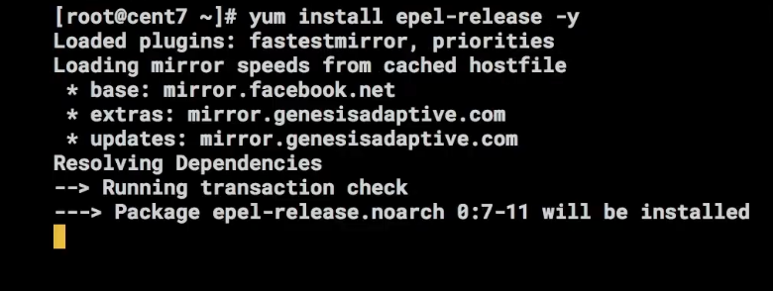
Figure 1. Using the command to install the EPEL repository

Once the repository has been installed, we can install Ansible with the following command:

yum install ansible -y
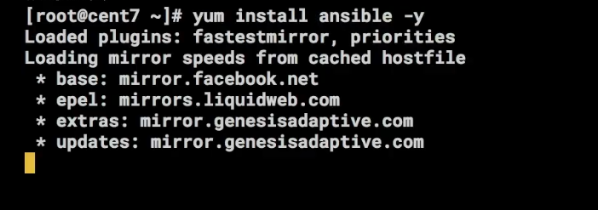
Figure 2. Installing Ansible with the terminal command

Once the installation is complete, we can verify it by checking the version number:

ansible --version

After that, we need to add a user for Ansible to use on both nodes. We do this by typing the following:

useradd admin
passwd admin


Figure 3. Setting up the user admin

Next, we will run the following command to generate an SSH keypad:

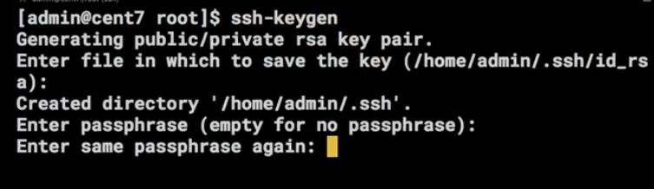
Figure 4. Generating an SSH keypad

We will run the following command, followed by the hostname of our managed node:

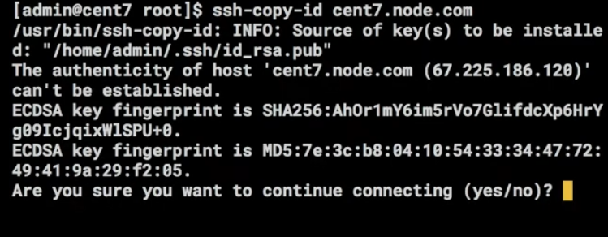
Figure 5. Copying the key

The last step is to create Ansible playbooks that are used to manage server configurations and deploy software applications. In this regard, we create a simple play book to install the Apache web server.

First, create a new directory for the play book:

mkdir /etc/ansible/playbooks

Next, we create a new file called apache.yml in the /etc/ansible/playbooks directory:

sudo nano /etc/ansible/playbooks/apache.yml

Add the following lines:
---

- hosts: all

tasks:

- name: Install Apache

yum: name=httpd state=present

- name: Start Apache

service: name=httpd state=started

We save and close the file.

In the above file, we have defined two tasks. The first task is to install the Apache web server. The second task is to start the Apache service. We have also specified that these tasks should be run on all the servers in the hosts file. Now that the play book is ready, it is time to run it. We can do this by using the ansible-playbook command:

ansible-playbook /etc/ansible/playbooks/apache.yml

If the play book is executed successfully, we should see the following output:

PLAY [all]

TASK [Gathering Facts]

ok: [192.168.1.100]

ok: [192.168.1.101]

TASK [Install Apache]

ok: [192.168.1.100]

ok: [192.168.1.101]

TASK [Start Apache]

ok: [192.168.1.100]

ok: [192.168.1.101]

PLAY RECAP

192.168.1.100 : ok=3

Installation and configuration of My SQL
MySQL is a free and open source relational database management system. It is the world's most popular database system, used by millions of websites and applications. MySQL is developed, distributed, and supported by Oracle Corporation.
MySQL runs on all major operating systems, including Linux, UNIX, and Windows. MySQL is available in two editions: Community Edition and Enterprise Edition. The Community Edition is free and open source, while the Enterprise Edition is a commercial product with a wide range of additional features.
First, we need to add the MySQL Yum repository to our system. We can download the repository package from the MySQL website.

wget http://repo.mysql.com/mysql-community-release-el7-5.noarch.rpm

Next, we need to install the downloaded RPM file.

sudo yum install mysql-community-release-el7-5.noarch.rpm

Once the repository is installed, we can update the package index and install MySQL.

sudo yum update

sudo yum install mysql-server

During the installation process, we will be prompted to set a password for the MySQL root user. Once the installation is complete, we start the MySQL service and enable it to start automatically on boot.

sudo systemctl start mysqld

sudo systemctl enable mysqld

At this point, MySQL should be up and running on our CentOS 7 server. The next step is to secure the MySQL installation. We will run the mysql_secure_installation script to improve the security of our MySQL installation.

sudo mysql_secure_installation

This script will guide us through a series of questions. First, we will be asked to set a password for the MySQL root user. We should choose a strong password that is not easy to guess. Next, the script will ask if we want to change the MySQL root password. It is recommended that we answer ”n” to this question. The password we set during the installation process is automatically generated and is very secure.
The script will also ask if we want to remove anonymous users. Anonymous users are users who can access the MySQL database without having to authenticate themselves. This time, we will answer “y” to this question.
Next, the script will ask if we want to disallow remote root login. Remote root login is when we connect to the MySQL database from a remote server. Like in the above, we will answer "y" to this question.
Finally, the script will ask if we want to remove the test databases. These databases are used for testing purposes and can be safely removed. It is recommended that we answer "y" to this question. Once the script has been run, MySQL will be secure and ready for production use.

Installation and configuration of PHP
Now that we have a web server and database server up and running, we can install PHP. PHP is available in the default CentOS repositories. To install PHP, we run the following command:

sudo yum install php php-mysql

Once PHP is installed, we will restart the Apache web server to make the changes take effect:

sudo systemctl restart httpd.service

Now that PHP is installed, we can test to see if it is working correctly. Create a file called test.php in the /var/www/html directory with the following contents:

<?php

phpinfo();

?>

After that, we will save the file and exit the text editor. Then, we will open http://localhost/test.php in our web browser. If PHP is working correctly, we will see a page similar to the one below.

Evaluation Of Ansible As A Network Programming And Automation Tool
As discussed in the previous sections, Ansible is a powerful configuration management and orchestration tool, used for tasks such as configuration, deployment, and management of server infrastructure. Ansible's playbooks are written in the YAML language and are used to define the desired state of a system, as well as the steps necessary to achieve that state. Ansible is designed to be simple and easy to use, making it an ideal tool for those new to configuration management and orchestration. However, Ansible's simplicity belies its power, as it is capable of managing complex infrastructure deployments [1], [3], [4].

Advantages of Ansible
Ansible's main advantages are its simplicity and flexibility. As Ansible playbooks are written in YAML, they are easy to read and understand, even for those new to configuration management and orchestration. Additionally, Ansible's use of declarative configuration means that playbooks are easy to write and maintain [6], [7].
Another advantage of Ansible is its agentless architecture. Ansible does not require any software to be installed on managed nodes, making it easy to deploy and manage. Additionally, as Ansible uses SSH for communication, there is no need to open any additional ports on managed nodes [6], [7].
Finally, Ansible is highly extensible, with a wide range of modules and plugins available to extend its functionality [6], [7].

Disadvantages of Ansible
While Ansible's simplicity is one of its main advantages, it can also be seen as a disadvantage. As Ansible playbooks are written in YAML, they can be difficult to read and understand for those new to configuration management and orchestration. Additionally, as Ansible does not have a centralized management console, it can be difficult to manage large numbers of hosts [6], [7].
Performance-wise, Ansible can be slower than some of its competitors, such as Puppet and Chef. This is due to the fact that Ansible playbooks are executed sequentially, rather than in parallel. However, for many users, the benefits of Ansible's simplicity and flexibility outweigh any performance concerns [3], [6], [7].

Ansible Playbooks
Ansible's playbooks are written in the YAML language and are used to define the desired state of a system, as well as the steps necessary to achieve that state. Playbooks are made up of a series of tasks, which are executed in order. Each task is a self-contained unit of work, which can be run on its own or as part of a larger play book. Tasks can be run on any number of hosts, in parallel or sequentially [3], [4].
Playbooks can also include variables, which can be used to parameterize tasks. Additionally, playbooks can be organised into roles, which allow for reusing and sharing of tasks [3], [4].

YAML
YAML is a human-readable data serialisation language, which is used for writing Ansible playbooks. YAML is designed to be easy to read and understand, even for those new to configuration management and orchestration. YAML is also highly extensible, with a wide range of modules and plugins available to extend its functionality [8].

Ansible Playbook Example
The following is a simple Ansible play book, which instals the Apache web server on a managed node.

- hosts: all
tasks:
- name: install Apache
yum:
name: httpd
state: present

This play book consists of a single task, which uses the yum module to install the Apache web server. The task is run on all hosts in the play book. Ansible's playbooks can be much more complex, with tasks that conditionally run based on variables, as well as tasks that run in parallel on multiple hosts. However, the basic structure of a play book remains the same [3], [4].

Conclusion
Ansible is a powerful configuration management and orchestration tool, which is easy to use and highly extensible. Ansible's playbooks are written in YAML, making them easy to read and understand. Additionally, Ansible's agentless architecture makes it easy to deploy and manage. While Ansible can be slower than some of its competitors, its simplicity and flexibility make it an ideal tool for many users.
References

[1] | M. Heap, Ansible: From beginner to pro, 1st ed. New York, NY: APRESS, 2016.
[2] | D. Hall, Ansible Configuration Management. Birmingham, England: Packt Publishing, 2013.
[3] | J. Keating, Mastering Ansible. Birmingham, England: Packt Publishing, 2015.
[4] | G. Shah, Ansible Playbook Essentials. Birmingham, England: Packt Publishing, 2015.
[5] | P. Masek, M. Stusek, J. Krejci, K. Zeman, J. Pokorny, and M. Kudlacek, Unleashing full potential of ansible framework: University labs administration. IEEE, 2018.
[6] | Likitha, “Automation of server configuration using Ansible,” Int. J. Res. Appl. Sci. Eng. Technol., vol. 10, no. 6, pp. 4109–4113, 2022.
[7] | L. Hochstein, Ansible: Up and running: Automating configuration management and deployment the easy way, 2nd ed. O’Reilly Media, 2017.
[8] | O. Ben-Kiki, C. Evans, and I. Döt Net, “YAML ain’t markup language (YAMLTM) version 1.2 3 rd edition, patched at 2009-10-01,” Nasa.gov. [Online]. Available: https://www.earthdata.nasa.gov/s3fs-public/imported/YAML%201.2%20Spec.pdf. [Accessed: 10-Oct-2022].

