Hospitality and Guest Services

A Presentation on Hilton Worldwide
The Role and Importance of Hospitality and Guest Services within the Hotel Industry

Student: Maria Mihaela Hirs
Student Number: 2226556
Module: Hospitality and Guest Service Management
Module code: BMIH4003
Module tutor: Luciana Suardi

Contents
Introducing the hotel: 3
Identifying the main consumers: 4
The nature, scope and role of the guest services and facilities: 4
Explaining the need to consider the role and function of guest services in general: 5
The importance of hospitality and how hotels meet/exceed guest expectations: 6
Conclusion: 7
References: 8

Introduction:

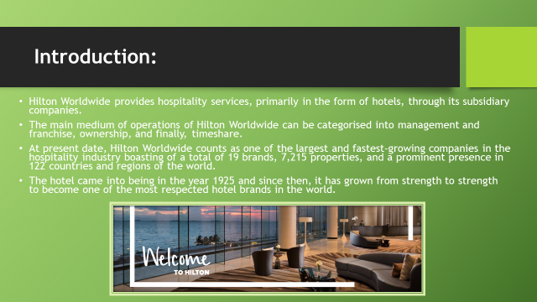

Hilton Worldwide provides hospitality services, primarily in the form of hotels, through its subsidiary companies. The main medium of operations of Hilton Worldwide can be categorised into management and franchise, ownership, and finally, timeshare. At present date, Hilton Worldwide counts as one of the largest and fastest-growing companies in the hospitality industry boasting of a total of 19 brands, 7,215 properties, and a prominent presence in 122 countries and regions of the world. The hotel came into being in the year 1925 and since then, it has grown from strength to strength to become one of the most respected hotel brands in the world. The core values of Hilton Worldwide drive its policies and commitment (Welcome to Hilton, 2023). As a leading hospitality company operating on the global stage, Hilton Worldwide strives to deliver exceptional guest experience, and do the right thing, always and every time. The business leaders of Hilton Worldwide are leaders in the organisation and the communities and thus, led by example. As a management, the leaders encourage teamwork in all its forms and magnificence and take full ownership of their decisions and actions. The core value of Now entails that the company operates with a sense of discipline and urgency.

Identifying the main consumers:
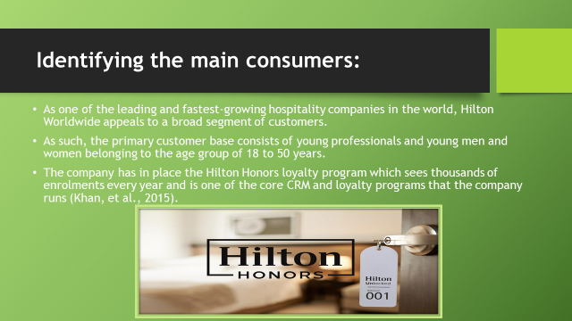

As one of the leading and fastest-growing hospitality companies in the world, Hilton Worldwide appeals to a broad segment of customers. Though the customer targeting strategies vary to some extent on the basis of the territory or region the hotel operates in, it strives to have something for everyone on the table. As such, the primary customer base consists of young professionals and young men and women belonging to the age group of 18 to 50 years. The company has in place the Hilton Honors loyalty program which sees thousands of enrolments every year and is one of the core CRM and loyalty programs that the company runs (Khan, et al., 2015). The tourists and business professionals are the primary customers of Hilton Worldwide properties across the globe, and Hilton Worldwide is dedicated to understanding their unique needs and preferences and fulfilling them in the most convenient and meaningful way possible. The different properties in the form of business hotels, resorts, niche category hotels, homestays and the like are meant to appeal to the tastes of these different segments of customers. Therefore, as the customer base of Hilton Worldwide is broad and immensely diverse, the company operates hotels and properties of all these different kinds.

The nature, scope and role of the guest services and facilities:
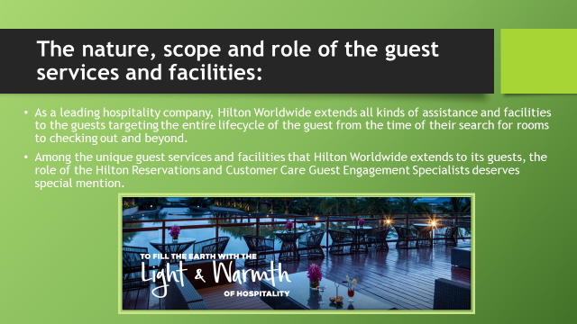

Hilton Worldwide takes pride in being a business which serves people and ensures that the team members engaged with the company extend their passion for hospitality and commitment to the utmost satisfaction of the guests beyond the four walls of the hotel. As a leading hospitality company, Hilton Worldwide extends all kinds of assistance and facilities to the guests targeting the entire lifecycle of the guest from the time of their search for rooms to checking out and beyond. Among the unique guest services and facilities that Hilton Worldwide extends to its guests, the role of the Hilton Reservations and Customer Care Guest Engagement Specialists deserves special mention. These personnel are entrusted with the responsibility of preserving the human touch while using state-of-the-art technologies and tools to ensure utmost convenience for guests in the comfort of their homes (Rahimi and Gunlu, 2016). These personnel act as the first point of contact for the guests and ensure that the warmth and commitment to superior services are extended to the prospective guests right at the outset of their engagement. Moreover, Hilton Worldwide also has a prompt and proactive customer relationship management program which not only seeks continuous feedback from the guests but also answers their queries and addresses their grievances. As far as the loyalty programs and Hilton Honors are concerned, the CRM department of Hilton Worldwide ensures that the guests are informed and deals, offers, special packages and discounts are communicated to these loyalty program members well in time.

Explaining the need to consider the role and function of guest services in general:
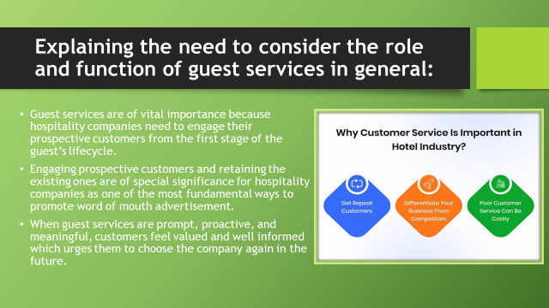

The hospitality industry is extremely sensitive to the behaviour and spending trends of customers. The needs and choices of these customers are different and may change with time. Hence, customer insights and customer research are some of the integral components of the marketing strategy of any steadfast hospitality company (Welcome to Hilton, 2023). The same applies in the case of Hilton Worldwide. However, in a more generic sense of the term, guest services are of vital importance because hospitality companies need to engage their prospective customers from the first stage of the guest’s lifecycle or purchase making journey (Rahimi and Kozak, 2017). Engaging prospective customers and retaining the existing ones are of special significance for hospitality companies as one of the most fundamental ways in which these companies generate profits is through repeat costumes and word of mouth. Hence, when guest services are prompt, proactive, and meaningful, customers feel valued and well informed which urges them to choose the company again in the future. It also increases the likelihood of them recommending the hotel to their friends and family.

The importance of hospitality and how hotels meet/exceed guest expectations:
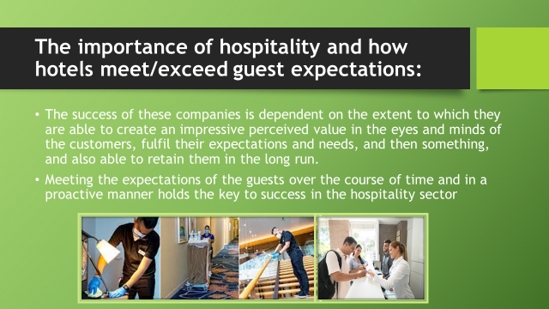

The hospitality industry, as a whole, offers a wide range of services ranging from food and beverage to leisure and adventure activities, from transportation to accommodation, to niche category services. Tourism is one of the most prosperous sectors across the globe and it employs millions of employees driving the multi-billion-pound industry across the world. However, the success of these companies is dependent on the extent to which they are able to create an impressive perceived value in the eyes and minds of the customers, fulfil their expectations and needs, and then something, and also able to retain them in the long run, while incessantly generating new leads (Rahimi and Kozak, 2017). Hence, meeting the expectations of the guests over the course of time and in a proactive manner holds the key to success in the hospitality sector.

Conclusion:
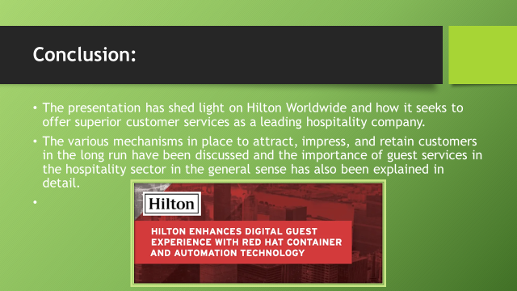

The presentation has shed light on Hilton Worldwide and how it seeks to offer superior customer services as a leading hospitality company. The various mechanisms in place to attract, impress, and retain customers in the long run have been discussed and the importance of guest services in the hospitality sector in the general sense has also been explained in detail.
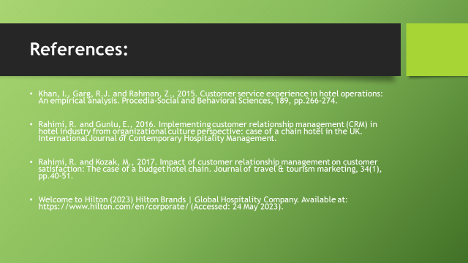

References:
Khan, I., Garg, R.J. and Rahman, Z., 2015. Customer service experience in hotel operations: An empirical analysis. Procedia-Social and Behavioral Sciences, 189, pp.266-274.

Rahimi, R. and Gunlu, E., 2016. Implementing customer relationship management (CRM) in hotel industry from organizational culture perspective: case of a chain hotel in the UK. International Journal of Contemporary Hospitality Management.

Rahimi, R. and Kozak, M., 2017. Impact of customer relationship management on customer satisfaction: The case of a budget hotel chain. Journal of travel & tourism marketing, 34(1), pp.40-51.

Welcome to Hilton (2023) Hilton Brands | Global Hospitality Company. Available at: https://www.hilton.com/en/corporate/ (Accessed: 24 May 2023).

