EXAMINATION SOLUTIONS
(to accompany the examination paper sent to the external examiner
but NOT to be seen by students)

Programme: | BEng Motorsport & Automotive Engineering | Level: | 6
Module: | Advanced Vehicle Dynamics
Author: | M Sandford | Page:

Q 1 | Question | Marks
1.a | Calculate the distance from the front axle to the Centre of Gravity : distance ‘a’.  The weight spit is 58% front and 42% rear.  So the centre of gravity will be closer to the front  Distance = wheelbase x rear weight bias  = 2718 mm x 0.42 = 1142 mm | 2
1.b | Calculate the distance from the Centre of Gravity to the Inertia Conjugate.  Which is distance ‘c’ on the diagram.  Distance of the Centre of Percussion behind the Center of Gravity (c).  C= Izz / m x a (where a is the distance from front axle to C of G)  C = 1300 kg.m² / (1170kg x 1.142m)  C = 0.973 m | 2
1.c | Calculate the Radius of Gyration (k) for the vehicle.  I = mk²  k² = I / m = 1300 kg.m² / 1170 kg = 1.1m  k = $\sqrt{1.1m}$ k = 1.0488m | 2
1.d | Calculate the Dynamic Index (DI) for the vehicle and comment on your findings  DI = Inertia / Mass x a x b  DI = m.k² / mass x a x b = k² / a x b  DI = 1.1 m / 1.142 m x (2718m – 1.142 m ) = 0.62  DI = 0.62 is very low  A DI of one is when the centre of percussion is on the rear axle  A DI > 1 = a very stable vehicle that is reluctant to ‘turn in’.  A DI < 1 = a stable vehicle that turns in ok  If the DI < 0.8 the vehicle is very unstable, turns in too well and is difficult to balance/control. | 2
1e | - Draw a diagram to show the effect of the calculated DI on rear tyre slip angle.  Analyse the effect of the rear tyre slip angle on vehicle dynamic behaviour.  The student should explain that when the DI is less than 1; when the vehicle turns in the rear wheels will move outward building a slip angle and generating lateral grip.  Whilst the vehicle is in the corner any additional steering angle application will result in rear wheels moving outward building a slip angle. If the rear tyres are on the limit and the grip is saturated this additional slip angle will reduce lateral grip. With a DI of 0.62 the vehicle would respond very quickly, probably too quickly and become ‘undrivable’ on the limit of grip.  a  b  c | 4
1f | Discuss the physiological limitations affecting vehicle driver’s perception and response times.  - Inner ear inputs are decoded along with muscle tensions to unscramble the motion of the support platform – the so-called “seat of the pants”  - Although less complex than visual processing, there is still a delay around 300 msec associated with this processing route  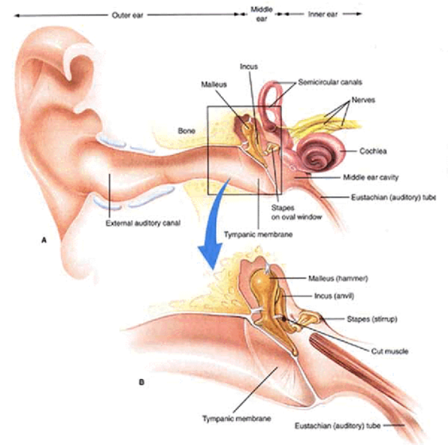  Consequently there are limits to the speed that humans can:  Perceive changing external environment  Process the meaning of the changes  Plan a strategy to respond to the information  Effect changes to the body (steering hand wheel angle and right foot  activity) | 2
1g | The vehicle engineers wish to increase the Dynamic Index to 0.87 by placing additional mass in the front and rear bumpers (3m apart). The vehicle inertia will increase from 1300kg.m² to 1850kg.m²  - What will be the new radius of gyration (k) ?  DI = m.k² / mass x a x b = k² / a x b  k² = DI x a x b  k = $\sqrt{DI . a . b}$  k² = 0.87 x 1.142m x 1.576m = 1.57m  k = $\sqrt{1.57m}$  k = 1.253m  - Assume the mass is distributed evenly between the front and rear bumpers. What mass should be placed in each bumper?  Inertia needs to increase from 1300 kg.m² to 1850 kg.m²  Extra inertia required = 1850 kg.m² - 1300 kg.m² = 550 kg.m²  Masses to be placed in bumpers 3m apart.  So k = 1.5m  k² = 2.25 m  I = m.k² m = I / k²  Mass = 550 kg.m² / 2.25m = 244 kg  Mass in each bumper = 122 kg | 3  3

Q2 | Question | Marks
 | A rear wheel drive vehicle has the following specification  Mass distribution: front 750kg, rear 750kg  Centre of gravity height 600mm  Track width 1.5m  Wheel base 2.1m  Frontal area = 3m^2  Coefficient of drag = 0.5  Coefficient of rolling resistance = 0.013 N/N  Tyre rolling radius 290mm  Assume the tyre road interface has a constant coefficient of friction (mu) of 1.0 which is the same at all vertical loads.  The vehicle enters a corner with a 25m constant radius at 50 kph rotating clockwise. | 2
2.a | What is the centripetal acceleration?  50kph = 50000/60 x 60 m/s = 14m/s  Centripetal accel = vel²/rad = 14 x 14 / 25 =7.8 m/s/s | 2
2.b | What is the vehicle yaw rate in a steady state condition?  Circumference = pi x dia = 3.14 x 50 = 157m  157m/14m/s = 11.2 sec/lap  Yaw rate = 360/11.2 = 32 degs/sec or 2 x pi / 11.2 = 0.56 rads/sec | 2
2.c | Assuming the spring rate is constant front and rear. What is the weight on each wheel?  Static weight on each wheel is 1500kg x 9.81 / 4 = 3679N  Weight transfer = CofG height x mass/2 x centripetal accel / track  = 0.6m x 1500kg/2 x 7.8m/s/s / 1.5  = 2340N on each axle  Therefore:  Left side outer wheels 3676N +2340 = 6016N each  Right side inner wheels = 3676 – 2340 = 1336 N | 2
2.d | - What drive force is required to maintain the constant 50kph vehicle speed?  Rolling resistance = 1500kg x 9.81 x 0.013 = 191 N  Aero drag = 0.5 x cd x area x density of air x velocity²  = 0.5 x 0.5 x 3 x 1.3 x 14 x 14 = 176N  Therefore total drive force required = 176 + 191 = 367N | 2
2.e | What is the lateral force on each axle ?  1500kg/2 x 7.8 = 5850N | 1
2.f | What is the lateral force resistance on the inside and the outside wheels?  Each wheel has the same amount of slip therefore the lat grip will be shared out in proportion to the vertical loading.  Total vert force on one axle = 750kg x 9.81 = 7358N  Left side outer wheel loading percentage = 6016/ 7358 = 80%  Right side inner wheel = 1336 / 7358 = 20%  Therefore  Lat force resistance on outside wheel = 80% x 5850 = 4680N  Lat force resistance on inside wheel = 20% x 5850 = 1170N | 3
2.g | Draw and label two frictions circles with the longitudinal and lateral forces. One for the rear outer wheel and one for the rear inner wheel. Calculate the additional drive force that could be applied before the inside wheel forces exceed the available grip. (assume the vehicle has an open differential.)  Using Pythagoras (1336N²) –(1170N²) = longitudinal drive force grip²  Therefore available longitudinal drive force -= 645N  The vehicle already needs 184N from each wheel  There the additional drive force is 645 – 184 = 461N on each wheel. | 4
2.h | The addition of a torque vectoring differential would allow additional drive force to be directed to the outside wheel.  Explain how a torque vectoring differential can obtain a greater drive force to the outside wheel. Use graphs and/or diagrams to support your discussion. How would the torque capacity of the unit be selected?  The mu slip curve should be drawn and an explanation of the requirement to increase speed of the wheel. The max slip of 15% or similar should be mentioned.  The torque capacity would have to ensure that it was as great as the grip levels  Eg static vert load is 375 kg x 9.81 = 3677N  3677N x 0.29m = 1067Nm | 4

Q3 | Question | Marks
A front wheel drive vehicle has the following specification
Mass distribution : front 750kg, rear 750kg
Rotational inertia – 2200 kgm^2
Centre of gravity height 600mm
Track width 1.5m
Wheel base 2.650m
Tyre rolling radius 290mm
Steering ratio 15:1

The vehicle is braking on a surface with split levels of grip. As shown.
The left of the vehicle is on ice with:
a rolling coefficient of friction 0.1
and a sliding (locked wheel) coefficient of friction of 0.05
The right of the vehicle is on asphalt with
a rolling coefficient of friction 0.9
and a sliding (locked wheel) coefficient of friction of 0.7

Initially the vehicle is not equipped with ABS and is travelling at 50kph.
The driver applies the brakes on an emergency stop and locks all four wheels.

3a | What is the rate of deceleration?  Vertical force on each side of the vehicle is 750kg x 9.81 = 7358N  Left side grip = 7358 x 0.05 = 368N  Right side grip = 7358 x 0.7 = 5151N  Total grip = 5151 + 568 = 5519 N  Deceleration = force / mass = 5519/1500 = 3.68 m/s/s | 3
3b | What is the yaw moment generated ?  Difference in braking forces = 5151 – 368 = 4783N  Moment = 4783 x 0.75 m = 3587 Nm | 2
3c | Calculate the resulting rotational acceleration  Moment = Vehicle inertia x rotational accel  Accel = moment / inertia  = 3587Nm / 2200 kgm^2 = 1.63 rads/sec/sec | 2
3d | What lateral force from the front steered wheels is required to counter the asymmetric braking force rotational moment?  Yaw moment from asymetric braking was 3587Nm  Wheel base / 2 = 2.650/2 = 1.325m  Torque = force x radius.  Force = torque / radius = 3587 / 1.375 = 2609N | 2
3e | The tyre on the right hand side provides a tyre cornering stiffness of 1000N/degree.  What steering handwheel angle would be required to counter the rotational moment ?  (2 marks)  The student wouls be expected to ignore the grip on the low mu side as it is so little.  2609N / 1000N/deg = 2.609 degs at the road wheel  2.609 x 15 (steering ratio) = 39 degrees steering correction required. | 2
3f | The vehicle is now equipped with ABS  . In ideal conditions what would be the maximum rate of deceleration  Vertical force on each side of the vehicle is 750kg x 9.81 = 7358N  Left side grip = 7358 x 0.1 = 735.8N  Right side grip = 7358 x 0.9 = 6622N  Total grip = 6622 + 736 = 7358 N  Deceleration = force / mass = 7358/1500 = 4.9 m/s/s | 3
3g | Describe using graphs and diagrams how the ABS system would operate in order to achieve controllable vehicle deceleration.  (6 marks)  The student should explain the humans have a limited response rate due to.  Sensors monitoring the yaw acceleration (eyes and ear-balance)  The rate of assimilating the information and selecting a course of action  The delay in the response of the hand and arm action to the request.  This response will vary between people and an individual can have different response rates due to a variety of factors eg mood, concentration, alertness to dangers etc.  Consequently the ABS system will.  - Control the rate of increase of braking force on the high grip side so that the driver has time to react and apply a suitable steering handwheel compensatory angle.  - Utilise a rear axle ‘select low’ control system so that the rear wheel have some lateral grip and hence will resist the asymmetric braking moment.  Both of the above will reduce the deceleration rate and hence increase stopping distances. However vehicle stability will be improved. | 6

Q4 | Question | Marks
4a | What tractive effort is required to maintain the constant 54 kph during the turn?  Rolling resistance = 1500kg x 9.81 x 0.02 = 294 N  Aero drag = 0.5 x cd x area x density of air x velocity²  = 0.5 x 0.6 x 3 x 1.2 x 15x 15 = 243N  Gradient resistance = mass x 9.81 x sine 2.5  = 1500kg x 9.81 x 0.0436 = 642N  Therefore total drive force required = 294 + 243 + 642 = 1179N  Tractive power = 1179N x 15 m/s = 17.69 kw | 2
4b | What is the vehicle yaw rate in a steady state condition?  Circumference = pi x dia = 3.14 x 124m = 390m  390m/15m/s = 26 sec/lap  Yaw rate = 360/26 = 13.9 degs/sec or 2 x pi / 26 = 0.242 rads/sec | 1
4c | Due to changing road conditions the vehicle yaw rate increases. The yaw acceleration that occurs is 4 degs/sec². After 2 seconds what is the vehicle’s yaw velocity?  Initial yaw velocity = 13.9 degs / sec = 0.243 rads/sec  New yaw velocity = 13.9degs/sec + ( 4 degs/sec x 2 secs)  = 21.9 degs/sec = 0.3822 rads/sec | 2
4d | The vehicle is equipped with Electronic Stability Controller. The driver has made no adjustment to the handwheel (steering wheel) angle or to the tractive drive torque. What braking force must be applied to the front left wheel in order to stop the rotational acceleration of the vehicle? Discuss limiting factors.  The rotational acceleration must be stopped.  4 degs/sec² = 4/360 x 2π = 0.698 rads/sec  Torque = Inertia x rotational acceleration  = 2500 kg.m² x 4 degs/sec x π / 180  = 175 Nm  Torque = force x radius (radius is half the track)  Force = Torque / radius = 175Nm / (1.85m / 2) = 189N  The applied brake torque will only arrest the spin. The body will still have a slip angle. More force could be applied to return the vehicle to it’s original attitude.  A limiting factor would be the available longitudinal grip. | 3
3e | In order to generate variable brake line pressure the vehicle braking system requires a pump and a Proportional Pressure Regulating Valve (PPRV).  The PPRV has an electrical range of 0 - 12v for a pressure control range of 0-110 bar.  The bake calliper applies a force between the pads of 1500N per bar of applied pressure at a radius of 100mm.  What Voltage applied to the PPRV will result in 190N brake force at the contact patch?  Force at contact patch x rolling radius = wheel torque  190N x 0.36 = 68.4 Nm  Tangential force exerted by brake pads = 68.4Nm / 0.1m = 684N  If mu = 0.5 the force applied to the pads =684 x 2 = 1368N  1368N/1500N per bar =0.912 bar required.  0.912 bar x (12v/100bar) = 0.109 volts required. | 3
3f | Initially the engineers specified a Proportional controller.  Draw a diagram of the controller. Explain the proportional gain theory.  Analyse the Plant or Process element.  Evaluate possible variables that could affect the repeatability of the plant model  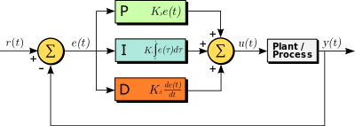  The controller responds to the current error (e) buy multiplying it buy a gain factor ($k_{p}$) to produce a signal to effect change in the plant. In this case it is applying a voltage to a proportional pressure control valve.  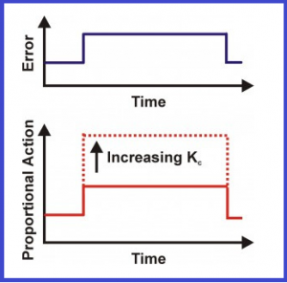  - changing over time like this blue line in the proportional path the output is the error scaled by the KP so you can see here that when the error is large the proportional path will produce a large output when the error is zero the output in the path is zero and when it’s negative the output is negative  Proportional control cannot eliminate the offset error, which is the difference between the desired value and the actual value, SP − PV error, as it requires an error to generate an output. When a disturbance (deviation from existing state) occurs in the process value being controlled, any corrective control action, based purely on Proportional Control, will always leave out the error between the next steady state and the desired setpoint, and result in a residual error called the offset error.  t  s  s_{goal}  Variability in the system could be caused by any of the plant components  - Response and accuracy of the proportional pressure control valve.  - Compliance within the piping system (including aeration).  - Brake pad / rotor disc friction characteristics (material, temp, moisture etc). | 3
3g | Analyse how employing an integrator element into the controller can help to eliminate steady state error from the gain function of the proportional element of the controller. Use diagrams to support your discussion.  To overcome the problem of offset error an integrator element can be added which accumulates the past error signals.. Thus will integrate the error signal causing it’s output to increase due to the integral gain ( $k_{i}$ ).  - In the integral path as the error moves over time the integral will continually sum it up and multiply it by the constant ki in this plot it’s easy to see that the integral path is the area under the curve where this blue section is the positive area in this green section here is negative area now the integral path is used to remove constant errors in a control system since no matter how small the constant error eventually the summation of that error will be significant enough to adjust the controller output  This can result in integral wind up and overshoot. As the overshoot continues the proportional gain output will attempt to return it to the set point.  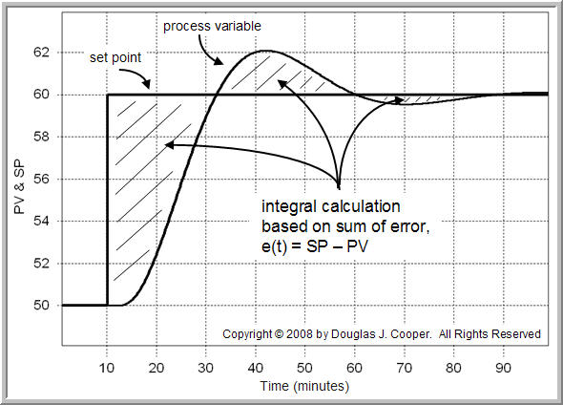 | 3
3h | - If the integrator is over enthusiastic, what are the consequences?  How can a differentiator be employed to limit any adverse effects?  Use diagrams/graphs to support your discussion.  A differentiator element can be added. This will look at the rate of reduction of the error. It is in effect looking into the future as the controlled value closes in on the set point value. The gain ( $k_{d}$ ) can reduce the effect of the PI controller as the target is approached to minimise the potential for overshoot.  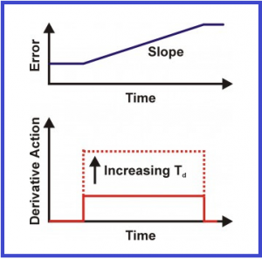  - Now in the derivative path, it’s the rate of change of the error that contributes to the output signal when the change in error is moving relatively slowly like it is at the beginning, then the derivative path is small and the faster the error changes the larger the derivative path becomes.  - Now at this point you can just sum up each of these three paths and you’ve got the output of a PID controller. | 3

