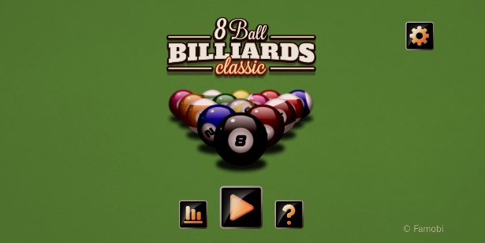
Introduction: This project focuses on the adaptation and evaluation of a realistic, browser-based 8-ball pool game [1]. The initial plan was to develop a simple 2D pool game using HTML5 and JavaScript, supported by cloud-based score storage and optional user login. During development, a high-quality MIT-licensed open-source pool engine was identified, featuring accurate physics, full gameplay logic and a polished interface. To maximise project reliability and ensure a fully functional artefact for assessment, that codebase was adopted as the foundation. The work presented here highlights the customisation, optimisation, evaluation and documentation applied to the game, along with a review of its overall performance and player experience.
Web-Based Realistic 8-Ball Pool Game
Design, Customisation and Perfomance Evaluation
Made by Cristian Darius Samartinean.

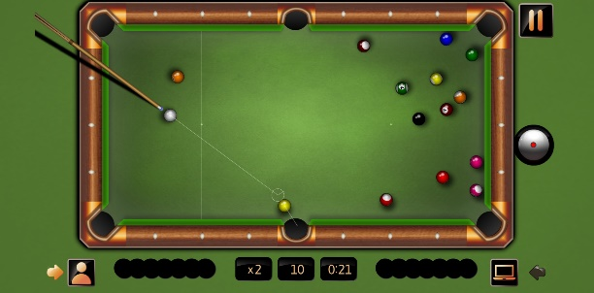

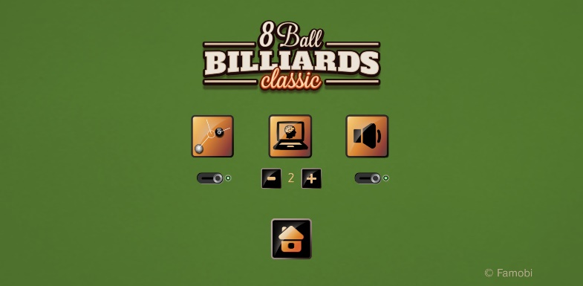
Aim and Objectives: The project aims to deliver a reliable and realistic web-based 8-ball pool game by customising and evaluating an open-source physics engine. Work focused on integrating the engine into a browser environment, refining gameplay behaviour such as ball speed, spin and table friction, redesigning key interface elements, improving responsiveness across devices, assessing realism through structured testing, and fully documenting the development process and outcomes.

Design and Implementation: The game was customised by refining its physics engine, adjusting ball speed, friction and rebound behaviour to achieve smoother and more realistic shot responses. Several interface elements—including menus, buttons, icons and the help/tutorial panel—were redesigned to create a more coherent visual style and improve usability. Additional work included stabilising cue-ball control, improving shot detection, and fixing issues related to scaling and responsiveness on different display sizes. Sound control was reworked through a cleaner toggle system, and redundant processing in the rendering cycle was removed to improve performance. Together, these refinements resulted in a polished, fully playable and visually consistent browser-based 8-ball pool experience.
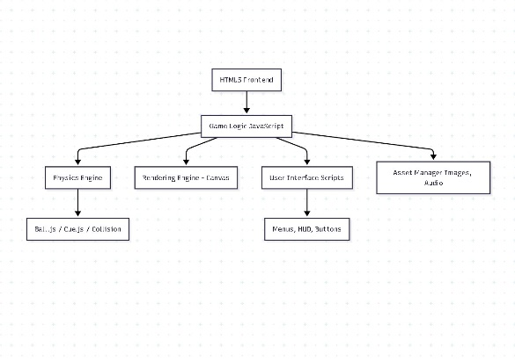





Technical Tools:
Future Work: Future development could expand the game by incorporating online multiplayer using WebSockets, enhancing game modes such as 9-ball and practice challenges, and introducing a player profile system with achievements or rankings. Additional improvements may include gesture-based controls for mobile devices, upgraded graphical effects such as dynamic shadows and cue animations, and a more advanced physics model to support trick shots and spin visualisation. These extensions would elevate both the technical depth and player engagement of the game.

