Student Name: | KATRINA WILLIAMS
Student Number: | 1811539
Module No: | BMSK 4006
Module Title: | REFECTION

Table of Contents
Introduction 3
The Team 4
Conclusion 5
Appendix 6 7 8 9
Bibliography 10

Introduction
Throughout this reflection the author will try and explain what she got out of the assignment. How she felt working with her team members. What she has new skills she has got out of studying this past last year helping her to complete this assignment. The author has broken up her learning and working with her team in to steps. The author has tried to reflect on her new learned working skills that has helped her to better her job already in the conclusion. The author has also added an old and new swot and personal development plan in the appendix to show where she was and where is now going.

The team
When we were told that we were doing a business plan and that we would be up into groups again I was hoping that I would have the same people that I had on my last assignment. When we assigned are groups I was put in with Margaret and mayesha, two of the people had the less to do with in the class itself. Finding out that I was a part of the team was through social media WhatsApp when mayesha the team leader made the group so we could liaison thought it, while reading through the message I was very grateful that I was not picked for that job team leader.
While we were having sessions in class on this module michaela was say don’t underestimate the unit it gets harder and boy she was right. Going through the slides and having them explained on the white board I was thinking how am I going to get through this one it blows my head.
We were offered a week end way learning at campus, I did not attend because of work commitments. I was gutted and worried that I would miss out on a lot of learning that I could really do with the help. My team was not very happy that I could not attend the week end away, they must have got over it quick as mags would face time me, post slides, and explanations on the group chat.
Most of the decisions were made that week end jobs were allocated, what the business was going to be, that we were going to be llp and not ltd etc, I was like aww ok. I got over it quick as they say, “you snooze you lose”.
We managed to meet up about a week after while on a shift in work. I was bomb barded with loads of stuff, we manged to agree on a name, packages names, prices. Then I was told that I was finance I was thinking I am going to fail how can I do that and was not over keen on that role. It didn’t stop there mags wanted me to phone up companies as a potential client and get quotes. When we when through all the rolls and jobs that needed to be done it did not look as bad as I first thought but would have to use all my new learned skills to do this.
Meeting up was hard as we all have jobs, children, mayesha getting married, we relied on WhatsApp and zoom call. Using this was great because we were all busy even had a zoom call at polocrosse in the middle of a field.
Setting off to do my part of the plan I did leave it for a long time before I started them, I started to panic. When I had the name and prices of the packages that we are going to offer I set out sorting them out playing with numbers. I enjoyed sourcing the net putting a start-up cost and graphs together, emailing back and through to each other drafts spotting mistakes adding and taking out as we were putting the plan together checking on each other’s work. This I found hard don’t know if it was because I was stressed, tied or thought they were just picking. A few times I felt like quitting but got on with it because it was not just me, I was letting down it was my team.
Wednesday WhatsApp was going crazy with us checking and over checking I was thinking do I really need to be doing this?. We had zoom chat in the even about 9 when we were all free which help us know what we were doing feeling more confident in our business plan.
On the day of presentation, I was feeling sick and worried that I would let the team down. It didn’t go as bad as I thought it would we pulled it together as a team. I could have done better at the finance part. I would say that I worked well in team settings as team worker.

Conclusion
Taking part in the business plan made me more aware of what is actually needed to open and run your own company whatever it might be. I was glad that is assignment was the last one as I need all my new learned skills from the other assignments to get through this one. One of the best learned tools was a mind map which when on to brain storming helped me to list and branch off to make sure that all was covered. skills that I have learned form this year has helped me to get through the modules but has also helped me in my working job roll at present, working toward a manger roll in the future.
When I first enrolled on the leadership and management level 4 course I was working as a care assistant within the community. I already had the skills such as time management, delegating and prioritizing jobs (Stephen Covey). I was out of my depth and comfort zone I didn’t have much knowledge on using computers and writing assignments. As the classes when on we learned what type of learner, we all were using the Honey and Mumford, while taking part in this I learned that I was a visual learner which now helps me a lot when taking on new jobs and rolls.
When we were learning about barriers to learning, we were asked to make a list of our own barriers mine where time, writing skills, family, and computer knowledge. On knowing this it helped me to make the time to do research and complete my assignments. With the computer skills I got my children to show me and I can now use word and excel.
On learning about learning cycles such as Kolb, Gibbs learning, My favoured learning cycle is by Noel Burch (Gordan) which I think is me as I am capable of much more than I think I can do.(“ I know what I know and I know what I don’t know” that my favourite saying).
From October 2018 to September 2019 my work life has changed I was working as a key worker then lost my job but manged to take the hole company over to a new company ,in doing this manged to jump the ladder and is now working as a care co-ordinator with my own team. The skills that I have learned in my course this last year has help me a lot. I now currently working towards branch manager. Who would have thought when I walked into Trinity university a year later, I would have achieved all this?
I use my new learned skills to the max even the computer, I do personal development plans with my staff to help them achieve their goals. I have put in swot and pdp see appendix to show the difference with in the year.
I don’t think I would have finished the year if it wasn’t for the flexibility of the learning, the help and support of the class, chats online with the tutor included. The class lessons were also relaxed and enjoyable with a tutor that was in tune with all her pupils even though we had different ways of learning, this way of learning has also helped me to realise that we all learn differently and work differently and it is up to me as a leader to understand and recognise this.

Appendix
By using swot analysis this would help me to know what my strengths, weakness, opportunities and treats are. The first swot analysis would have been when I first started the course in October 2018, the second swot is a more up to date swot at the end of my leadership and management course in September 2019

S W
Outgoing, gets on well with other people.  Very determined.  Can cope well under pressure. | English spelling.  Not being able to use a computer.
Better job at the end of course.  More money.  Meeting different people. | Time family /children.  More hours working not enough time in the day.
0 T

S W
Can cope well under pressure.  Can delegate jobs well.  Have the ability to prioritize jobs.  I now know the best way to learn new things for me.  Flexibility.  Communication.  Very determined.  More confident. | Using a computer.  Not as confident as I thought I was.  Spelling.  Public speaking.
More money.  Better job.  Being my own boss.  Being able to pick my own team. | Family/children.  More hours working.  More stress.  Other people after my job.  Physical work.

Using a personal development plan, I have learned it will let me visually see what I am going to do how I am going to get there helping me to keep track. The first Personal development plan was when I started the course in October 18, the second is on finishing in sept 19.

What I am going to do | How will I achieve it? | How long will it take? | Funding. | How and how often will I check my progress, and who. | What will I Achieve when finished? | Will it be worth it?
Enrol on level 4 leadership and management course | Attend trinity university. | 12 months | Student finance. | On every assessment.  My tutor. | Pass level 4 leadership and management | yes
Computer course | Enrol at the hub. | 6 months. | Free. | My tutor | Be able to use the computer at a good level. | yes
Level 5 QCF | Enrol at aspirations. | 12 months. | Through work. | My QCF tutor after all assessments. | Be able to make branch manager. | yes

From this pdp the only thing that I have managed to do was the management and leadership course, due to time work and family.

What I am going to do | How will I achieve it? | How long will it take? | Funding. | How and how often will I check my progress and who | What will I Achieve when finished? | Will it be worth it?  What will I get? Was it necessary?
Become a branch manager. | By enrolling in level 5 QCF. | 69months. | Through work. | Every month with my boss. | Have my own work team. | Yes.  Be my own boss.  Yes.
English course. | By enrolling in collage/hub | 12 months | Free. | Every month. With tutor | Have better understanding | Yes  Send better emails, folder work etc. yes
Level 5 QCF | By enrolling in aspirations | 6 months | Through work. | Every month with tutor and boss. | Have my own work team. | Yes.  Run a great team. yes

From October 2018 to September 2019 my work life has changed I was working as a key worker then lost my job but manged to take the hole company over to a new company ,in doing this manged to jump the ladder and is now working as a care co-ordinator with my own team. The skills that I have learned in my course this last year has help me a lot. I now currently working towards branch manager. Who would have thought when I walked into Trinity university a year later, I would have achieved all this?
I use my new learned skills to the max even the computer.
I don’t think I would have finished the year if it wasn’t for the flexibility of the learning, the help and support of the class chats online with the tutor included. The class lessons were also relaxed and enjoyable with a tutor that was in tune with all her pupils even though we had different ways of learning, this way of learning has also helped me to realise that we all learn differently and work differently and it is up to me as a leader to understand and recognise this.

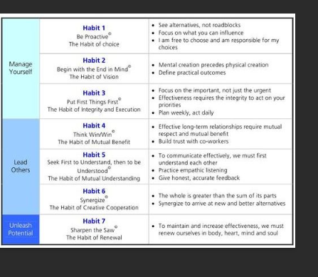

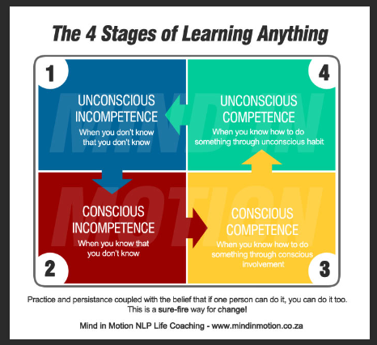

Your bibliography

8 habits of highly effective people by Stephen R. Covey
In-text: (Slideshare.net, 2019)
Your Bibliography: Slideshare.net. (2019). 8 habits of highly effective people by Stephen R. Covey. [online] Available at: https://www.slideshare.net/HaseebEjaz/8-habits-of-highly-effective-people-48699106 [Accessed 20 Sep. 2019].

Experiential Learning (Kolb) - Learning Theories
In-text: (Learning Theories, 2019)
Your Bibliography: Learning Theories. (2019). Experiential Learning (Kolb) - Learning Theories. [online] Available at: https://www.learning-theories.com/experiential-learning-kolb.html [Accessed 20 Sep. 2019].

Honey and Mumford's Learning Styles Questionnaire
In-text: (Nwlink.com, 2019)
Your Bibliography: Nwlink.com. (2019). Honey and Mumford's Learning Styles Questionnaire. [online] Available at: http://www.nwlink.com/~donclark/hrd/styles/honey_mumford.html [Accessed 20 Sep. 2019].

