January 27, 2020
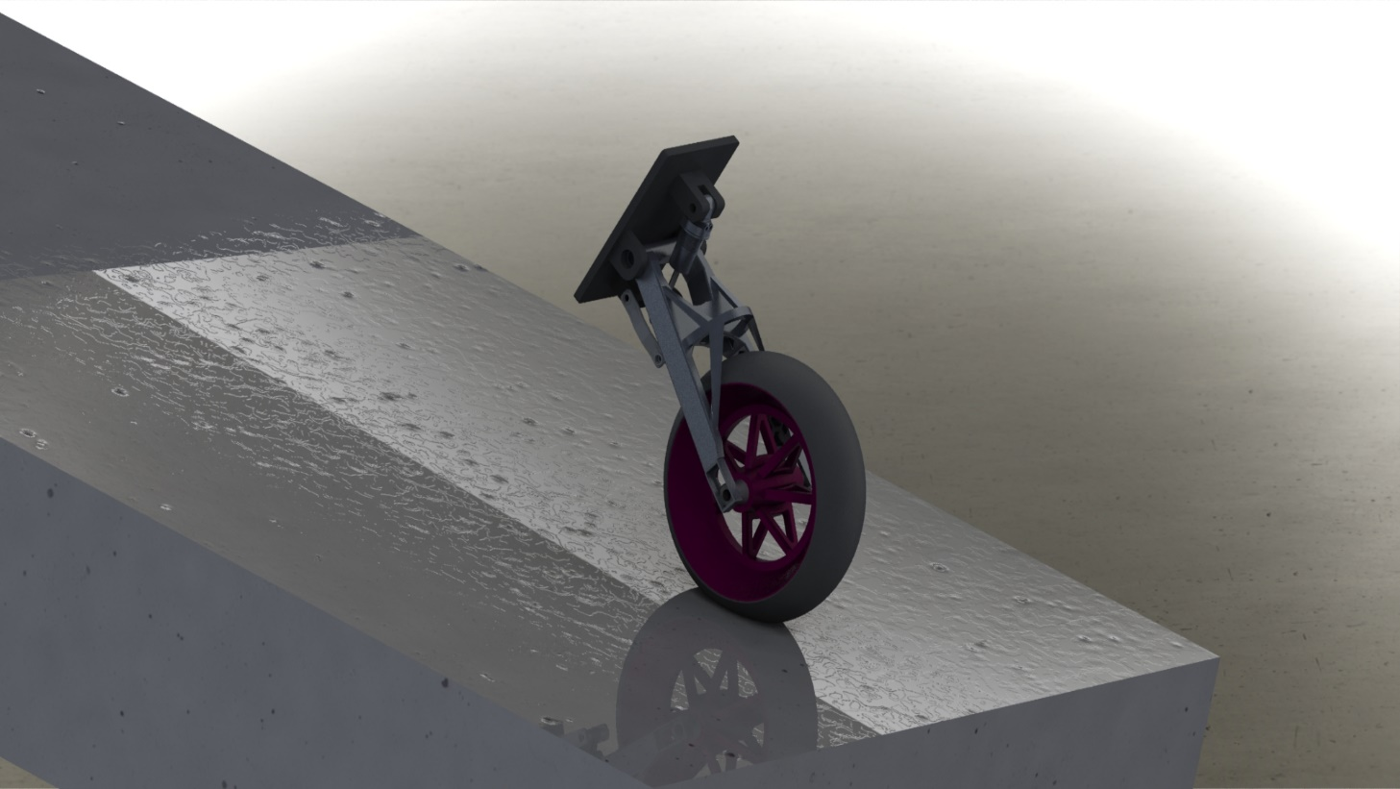

Paul Gormlie (P149642)
Lecturer: A. harrison
M6X00408
ACM: Motion simulation module
solidworks motion sim and f.e.a

Contents
Contents 1
Introduction: 2
Methodology: 3
Components: 3
Modelling: 9
Motion Study: 12
Linear motor: 12
Linear spring: 12
Linear damper: 13
Normal force: 13
Rotary motor: 13
Motion settings: 13
Solid body contacts: 13
Motion Loads: 14
Rear wheel: 14
Suspension lower wishbone: 14
Shock absorber piston: 15
Analysis: 17
Results, Design Study 1, Rear wheel: 17
Results, Design study 2: Lower suspension wishbones: 20
Results, Design Study 3: Shock piston: 22
Discussion: 25
Conclusion: 26
Appendix: 27
References: 28

Figure 1: Swingarm model 1st iteration 4
Figure 2: Rear wheel – 1st iteration 5
Figure 3: Rear Spindle 5
Figure 4: Rear shock absorber assembly render 6
Figure 5: Rear tyre 7
Figure 6: Shock linkage 8
Figure 7: Lower shock absorber wishbone – in original configuration 8
Figure 8: Road for motion sim. 9
Figure 9: Example of revolved boss Figure 10: Example of extruded boss for swingarm 10
Figure 11: Example of swept boss for rear shock spring 11
Figure 12: Complete rear suspension assembly 12
Figure 13: Example of motion loads imported for rear wheel FEA 15
Figure 14: Motion loads imported for lower suspension wishbone 16
Figure 15:Shock absorber piston load distribution 16
Figure 16: Example iteration table from design study 17
Figure 17: Unmodified wheel von Mises stress Figure 18: Unmodified wheel deformation 18
Figure 19: FOS final wheel design Figure 20: von Mises final wheel design 19
Figure 21: Shock wishbone original design 21
Figure 22: Wishbone with ribbing on rear face Figure 23: Mesh control applied to load bearing face of wishbone 21
Figure 24: Wishbone design 2 showing excessive stress beyond yield strength of material. 22
Figure 25: Final design wishbone, below yield 22
Figure 26: Max shock piston loading under bump conditions. 25
Figure 27: Swingarm with ribbing, low stress concentration 27
Figure 28: Braced final swingarm design, showing resistance to bending. 28

Introduction:

For level 6 ACM 1: Motion simulation module, students have been tasked with completing an assembly of their choice within the Solidworks software. This model should be relative to the area of study in which the student is enrolled. This assembly must be modelled accurately and possess the material and mass properties of the real-life components. When the assembly is completed, a motion study can be carried out in order to simulate loads encountered by the assembly in an operating situation, the loads encountered can the be studied and used to generate a design study and subsequent finite element analysis of a part or parts within the assembly.
Following completion of the relevant design study, the part(s) may be modified or optimised to provide an improvement on the part design. Following modifications, the part is re-inserted to the assembly, the same loads are exerted and the design study can again be performed in order to validate the modification of the parts in question.
To conclude, an analysis of the stresses and strains encountered will be carried out and will result in discussion regarding the effectiveness of modifications to relevant parts.

Methodology:

Components:

In order to complete the motion study component, various parts had to be modelled in order to be assembled to complete the motion study. These parts have been modelled with the correct geometry to be affixed to a Suzuki GSX-R motorcycle frame and have the relevant materials and masses applied in order to generate as accurately as possible the stresses and strains encountered by their physical counterparts in a dynamic simulation.
Below is a list of parts modelled in order to recreate the rear suspension of the Suzuki GSX-R in question. Although these parts can be fitted to the GSX-R frame, they are bespoke to this study and do not represent the original Suzuki parts. Below is a list of the parts modelled in order to produce a working suspension model in order for simulation to be carried out.
- Rear swingarm
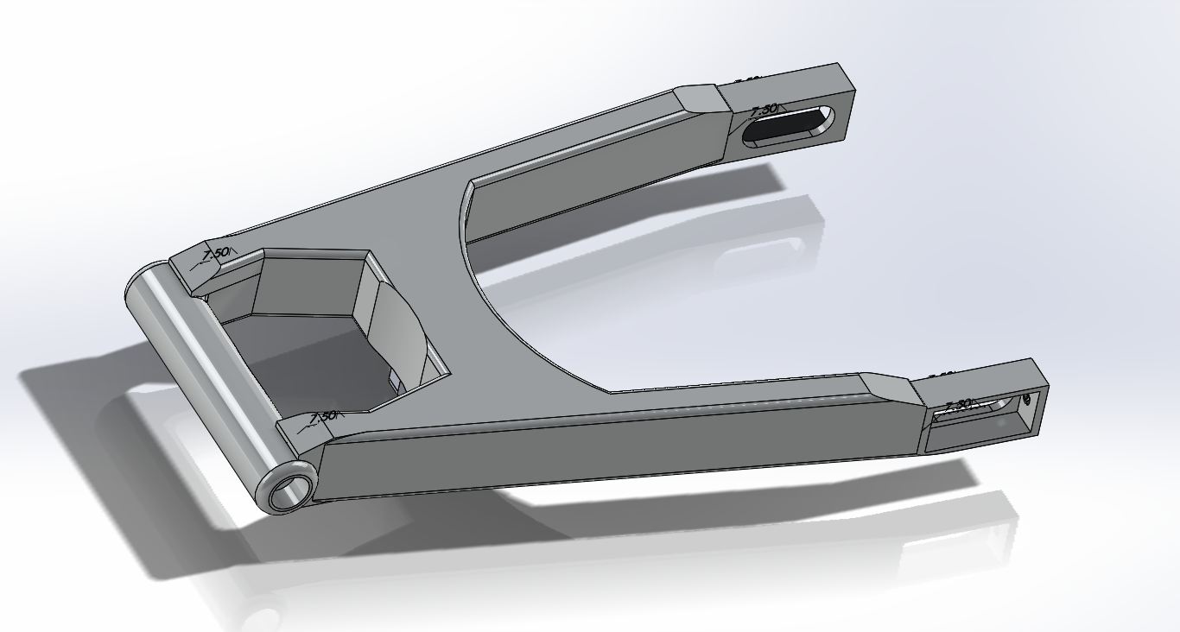
Figure 1: Swingarm model 1st iteration

- Rear Wheel
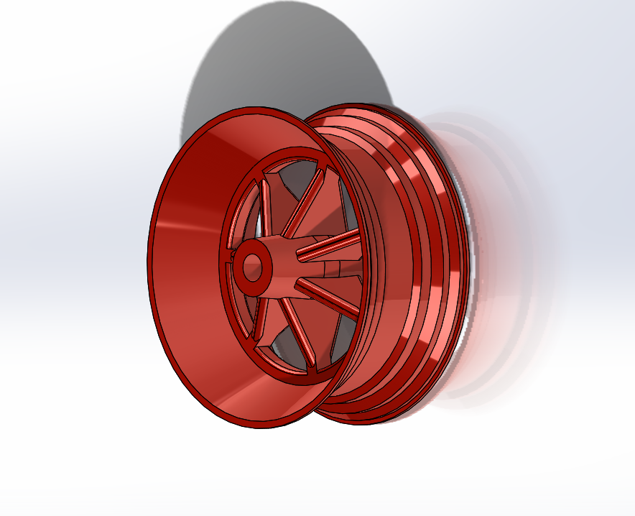
Figure 2: Rear wheel – 1st iteration

- Spindle
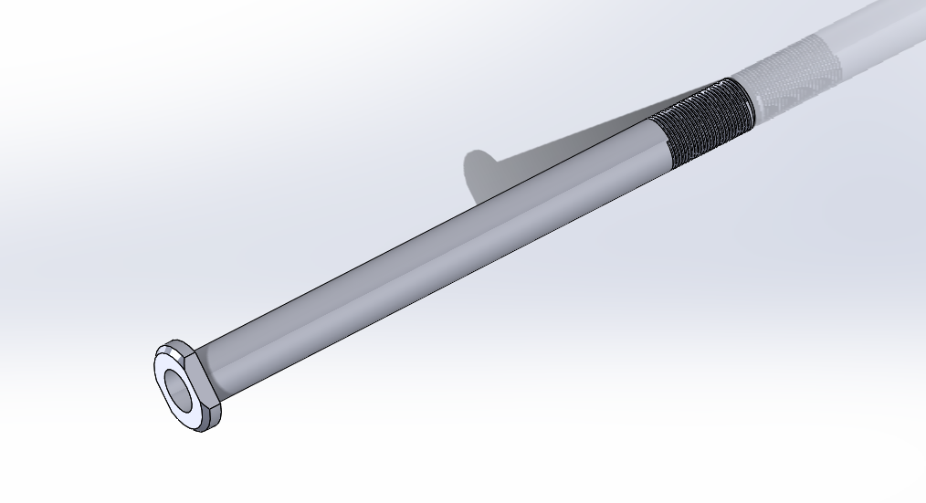
Figure 3: Rear Spindle
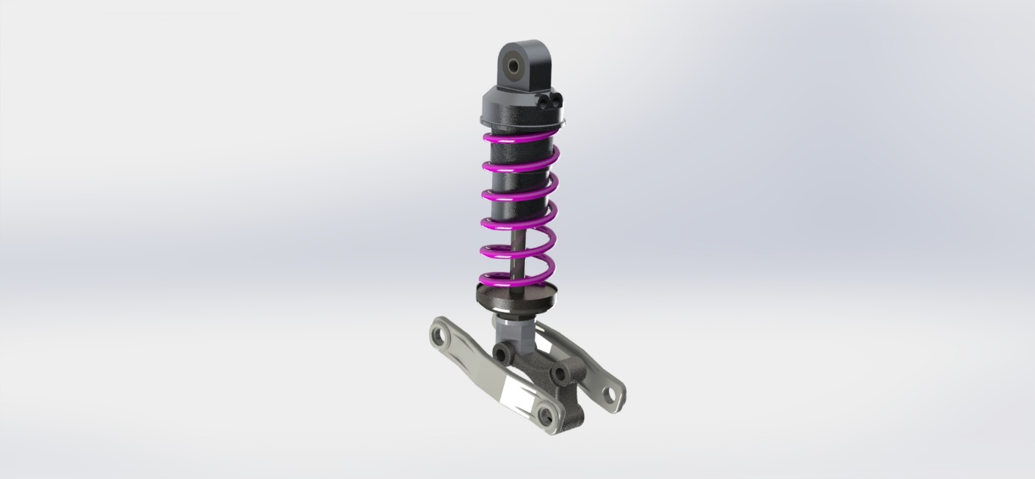
- Rear shock

Figure 4: Rear shock absorber assembly render

- Rear tyre

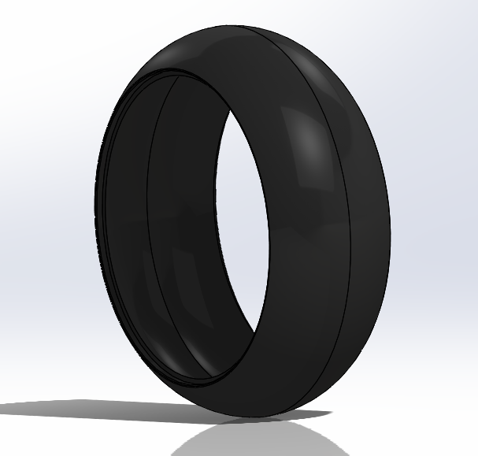
Figure 5: Rear tyre

- Shock linkage
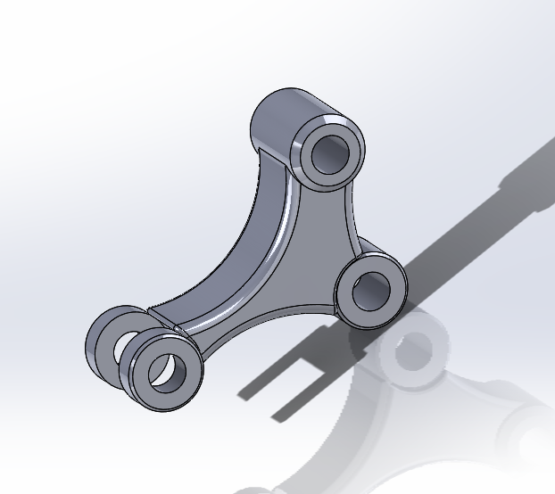
Figure 6: Shock linkage
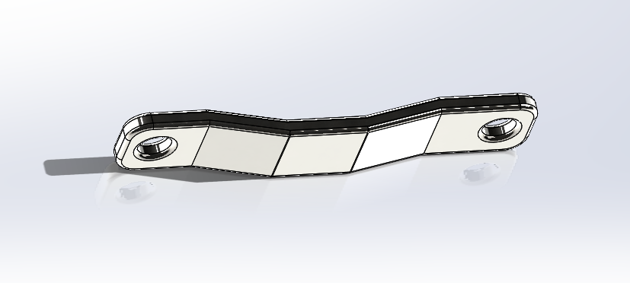
- Shock wishbones

Figure 7: Lower shock absorber wishbone – in original configuration
- Road for motion simulation
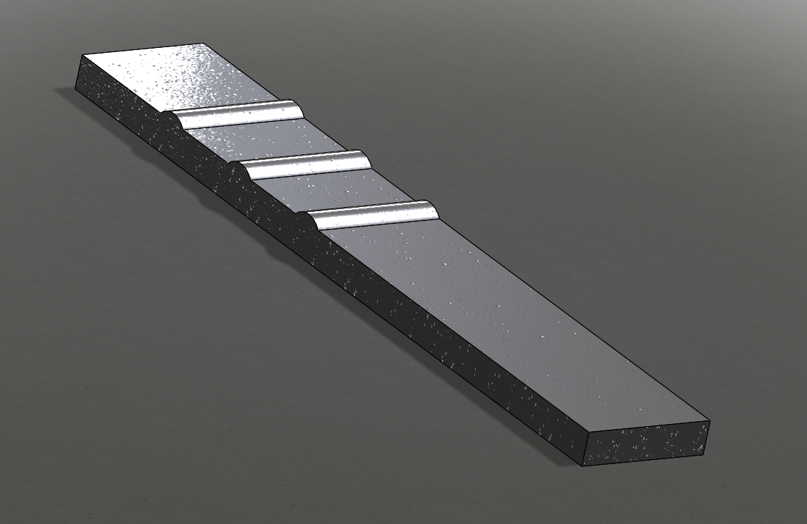
Figure 8: Road for motion sim.

Modelling:

To model the above parts an array of methods within the Solidworks software have been utilised, some of the procedures are listed below along with examples of the processes to model certain parts within the assembly.
- Extruded boss/base
- Extruded cuts
- Swept bosses/base
- Swept cuts
- Lofts
- Mirrors
- Application of reference geometry
- Fillets
- Chamfers
- Offsets
- Threads
- Equations
- Revolved bosses/bases

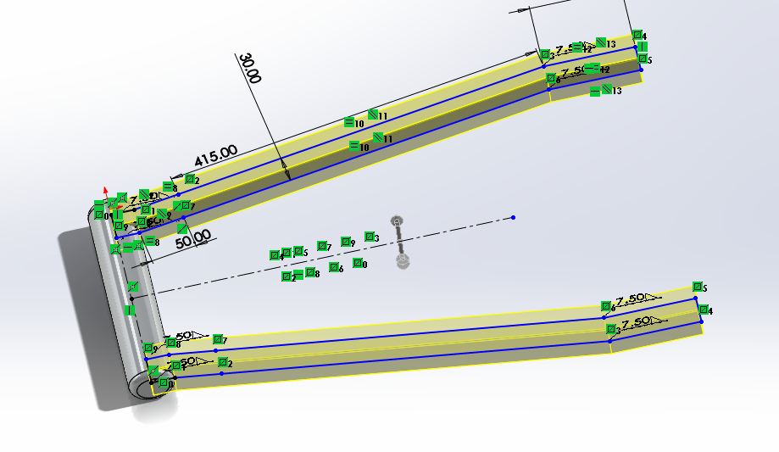
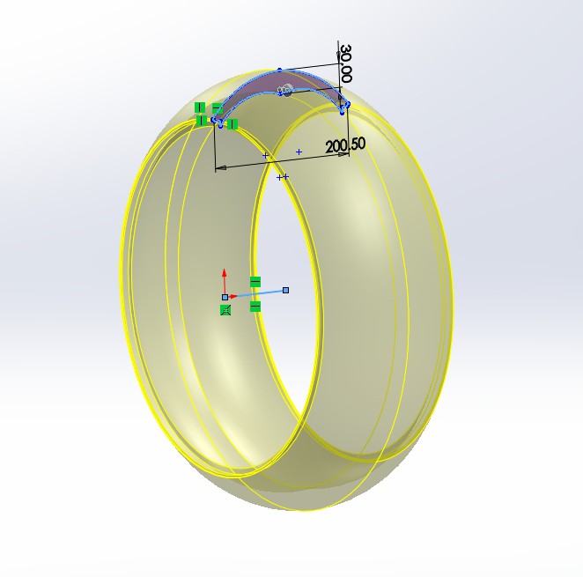

Figure 9: Example of revolved boss Figure 10: Example of extruded boss for swingarm
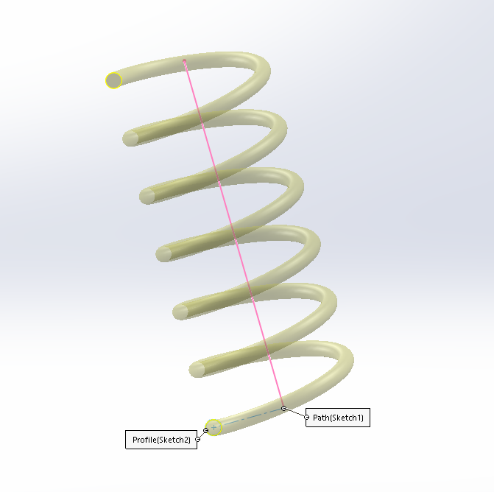
Figure 11: Example of swept boss for rear shock spring
Following the modelling of all components and application of material properties, all necessary parts have been assembled in Solidworks assembly mode, which is necessary in order to carry out the required motion simulation. Below is an image of the complete assembly arranged in preparation for the motion sim.
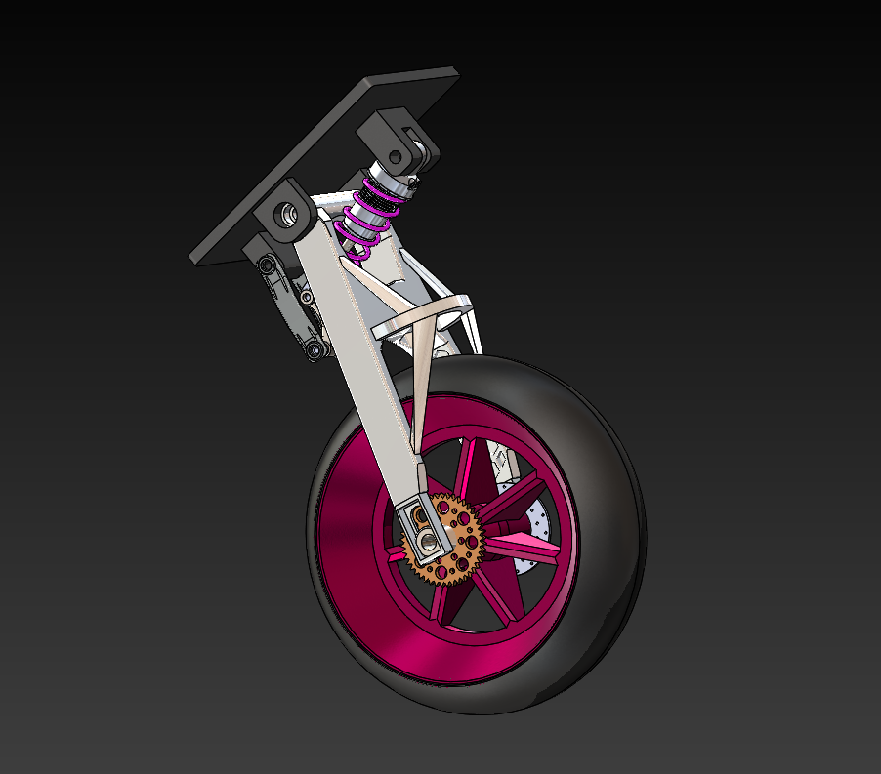
Figure 12: Complete rear suspension assembly

Motion Study:

Following the modelling of all components, an assembly is created using the appropriate assembly mates for each part, using a combination of the mates listed below, a fully defined operational model of the assembly can be created.
- Hinge mates
- Concentric mates
- Width mates
- Angle mates
- Parallel mates
- Coincident mates
When the assembly is complete, it is necessary to set out the initial conditions of the model and also to apply loads and forces in the correct areas and at the correct time, in order to produce a reasonable representation of the loads that may be encountered by these components in real life.
From the mate folders, the pertinent mate can be selected within the assembly and the analysis tab within the mate selected, at this point the necessary load bearing faces can be identified for the purpose of the motion analysis.
Using the motion study feature in Solidworks a number of constraints can be set to define the model and constrain as required in order to perform the simulation. In this instance, the simulation consists of the rear suspension model as described previously, being motored across the section of road created for the motion study. The model has been constrained using the factors listed below which can now be discussed in further detail.

Linear motor:

Using the linear motor function on the road model, it is possible to move the road beneath the suspension model in order to perform a dynamic analysis on the suspension components when the wheel contacts the bumps extruded from the road. The motor is directed in the positive ‘Z’ direction and set at a velocity of 3 M/s. This gives a 5 second snapshot of movement as the road is 25M in length.

Linear spring:

Using the linear spring function, the spring rate for the shock absorber assembly can be set, this will allow a dynamic spring response to be calculated when the simulation is run. Using widely accepted data for spring rates of a typical sports motorcycle a value of 95 N/mm has been input for the linear spring rate. The spring has been set with approximately 10mm of preload to account for the mass of the assembly and normal force added to simulate the mass of the rearward component of motorcycle mass.

Linear damper:

To in order to damp the spring, a damping co-efficient of 5 N-s/mm has been applied to simulate a realistic damping response for the selected spring rate and mass of the rear suspension assembly. It can be noted that the damping has been added in the bump and rebound strokes of the suspension travel.

Normal force:

As previously mentioned, a normal force of 500N has been applied to the centre of the swingarm in an attempt to recreate the sprung mass of the rear of the motorcycle acting through the suspension.

Rotary motor:

A rotary motor has also been applied to the rear wheel and tyre with the intention of simulating the effects of squat on the rear suspension, the effects may be negligible in this case due to the nature of the motion simulation, whereby the road has been motored to allow for movement of the suspension.

Motion settings:

The motion study has been run at 1000 frames per second in order to give a clear animation of the simulation, this also allows for easier retrieval of data for the motion loads section of the study.

Solid body contacts:

In order to enhance the realism of the motion simulation, a set of solid body contacts between the road and the tyre have been added also, these contacts have been given the material properties of dry rubber for the tyre and dry steel for the road giving a factor of $μ$ between these contacts.

Motion Loads:

Upon completion of a successful motion study, the motion loads can now be imported to the relevant part file upon which the design analysis will be carried out on. In this instance design analyses have been carried out on a number of parts within the assembly, with the intention of proving the suitability each component. The following components have been studied and re-iterated to ensure compliance to safety factors and resistance to dynamic stress loads.

Rear wheel:
A number of iterations of rear wheel model were implemented in this design study, initially the wheel was modelled in cast alloy steel and had a mass of approx. 39Kg, removal of some spoke material was performed in order to reduce inertial loads and torque loads but this was found to only reduce the wheel mass by approx. 3Kg. A material change was applied to the wheel to Aluminium alloy (6061-T6) and this was found to reduce mass significantly (to approx. 14Kg) without affecting the integrity of the component by a discernible amount. Diagrams and discussion will proceed in the following section.
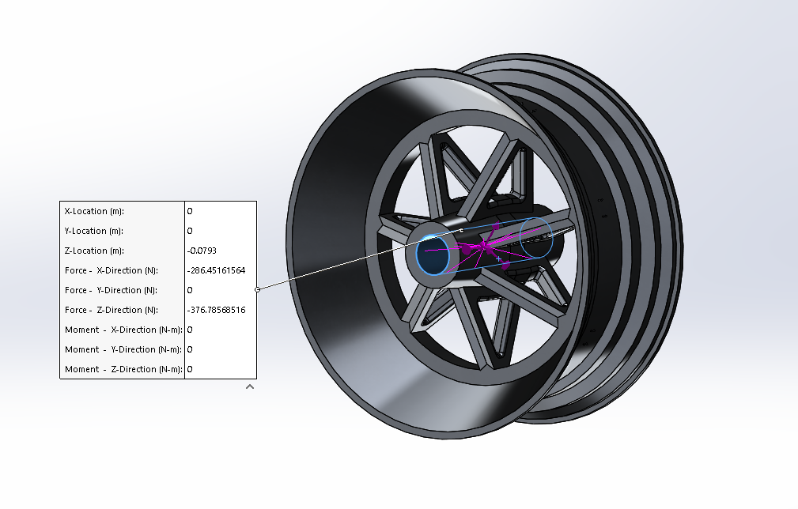
Figure 13: Example of motion loads imported for rear wheel FEA

Suspension lower wishbone:

Again, a number of iterations of suspension wishbone designs were experimented with, a kinked design was used initially which was then iterated to include ribbing on the inside face and finally to include ribbing on the outer faces also. These iterations were found to improve the overall strength and safety factor of the component and will also be discussed further in the next section.
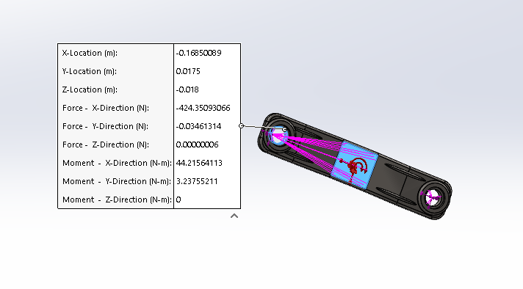
Figure 14: Motion loads imported for lower suspension wishbone

Shock absorber piston:

Two design iterations were carried out on the shock piston design, one with a solid piston shaft and an uprated, lighter hollow piston shaft, with the latter iteration showing improvements in strength along with a mass reduction.
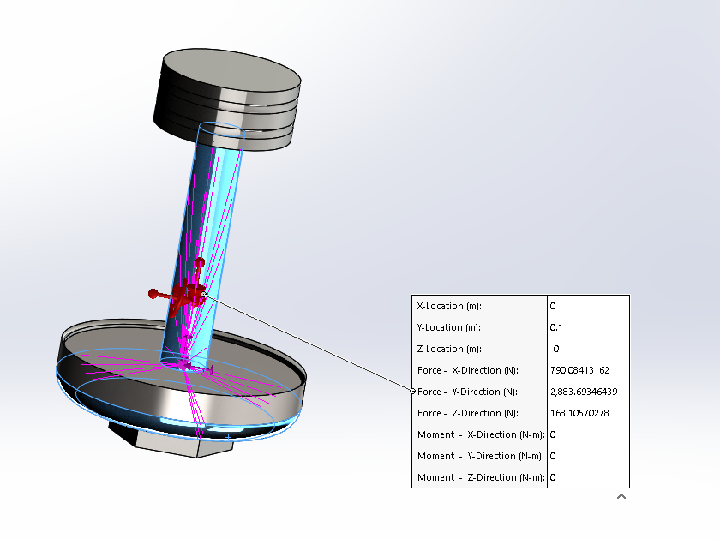
Figure 15:Shock absorber piston load distribution

To set up the design study, the motion loads are imported from the motion sim and the frame numbers selected in order to represent the section of time in the simulation where loads are expected to be at their greatest, following this procedure a series of iterations are run within the FEA solver.
Following the solver, results for stress (von mises, principle 1st, 2nd and 3rd), strain and deformation of each component can be obtained. This will give a detailed analysis of where the part may be weak or the areas of highest stress and strain occur and also highlight the areas of greatest stress concentrations.
Following analysis of results in the design study, if necessary, the component may be strengthened or lightened as required in order to achieve a reasonable failure safety factor and to mitigate any potentially weak areas within the design. If the part is found to satisfy all factors concerned it may be deemed fit for use, with no further iterations of design required.
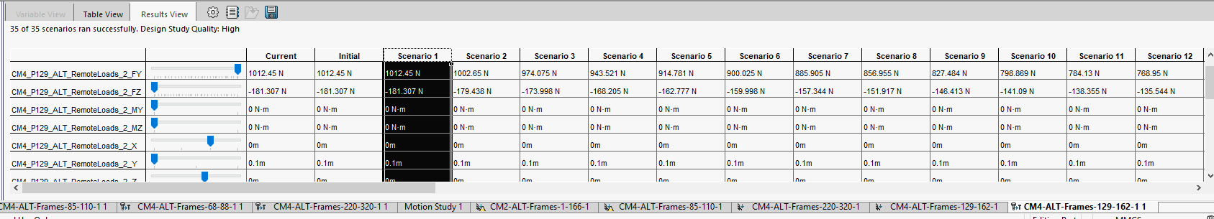
Figure 16: Example iteration table from design study

Analysis:

Before analysis of parts, it is necessary to speak about the method by which the Solidworks software performs calculations on bodies and also how results are displayed and interpreted.
In order to process the loads encountered by a part and predict stress and strain accurately, the software must break the part into smaller pieces which are simple to compute. The software splits the part into shapes or elements called tetrahedrals, which are 3 dimensional triangles that are arranged in a mesh spread across the surfaces of the part being analysed. (Rao, 1999) These are joined together at the tips by parts called nodes, the size of each element will dictate how fine or coarse the mesh to be applied will be. During analysis, the software performs calculations on each element and predicts the stress, strain and deformation in the part. These parameters will represent the part’s reaction to loads encountered and will be explained below:
- Von Mise’s stress – A general value for stress based on the distortion energy within a material and its resistance to change in volume. Useful for predicting yield within a material. (Engineer's edge, 2000-2020)
- 1st Principal stress – Normally describes the tensile stress in the material or stress acting normal to the plane in which shear stress is zero.
- 3rd Principal stress – Can be described as the maximum compressive stress in a material.
- Strain – Can be described as deformation of a material due to stress.
- Deformation – The amount of deflection in a material when subjected to stress.
- Safety factor – Can be described as the maximum stress of a material/normal working stress incurred.

Results, Design Study 1, Rear wheel:

Resulting from the motion study where all components are in their initial, unmodified state, the loads applied through the bearing surfaces on the inside of the wheel are used to produce a graphical representation of the stresses, strains and deformation encountered by the wheel. The stresses encountered are measured in von Mises, 1st, 2nd and 3rd principal stresses.
On the first iteration, the wheel was found to have good strength properties and did not encounter any high stress concentration points with negligible deformation.
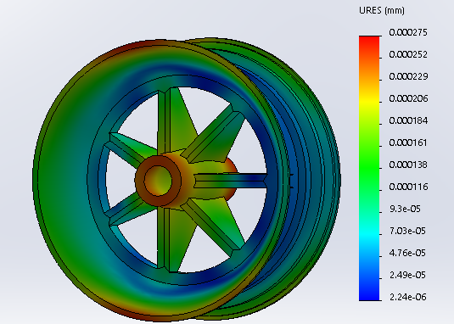
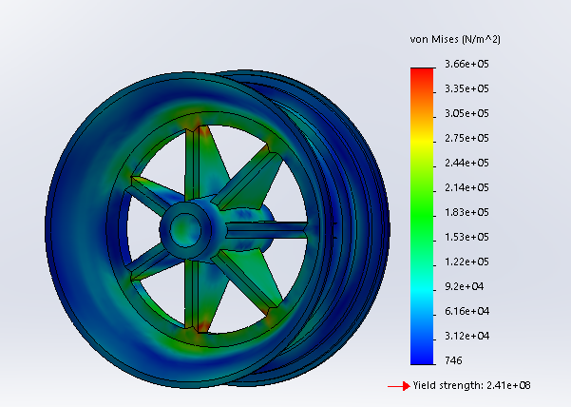
Figure 17: Unmodified wheel von Mises stress Figure 18: Unmodified wheel deformation

Although this study did yield very favourable results, with a static safety factor of ~659, the mass of the wheel was found to be excessive at approx. 39 KG and it was deemed necessary to remove mass from the component, at this time the material was changed also to aluminium alloy (6061-T6) and the motion sim re-run.
The results of this simulation were also favourable with the component material coming nowhere close to yield and negligible deformation also, the new study gave a S.S.F of 286 therefore deeming the component more than suitable for use in its application with a very low chance of failure even under dynamic loading.
There was also a mass reduction of approx. 24 KG or 60% between the removal of mass and material choice in the wheel, Examples can be seen in the images below:

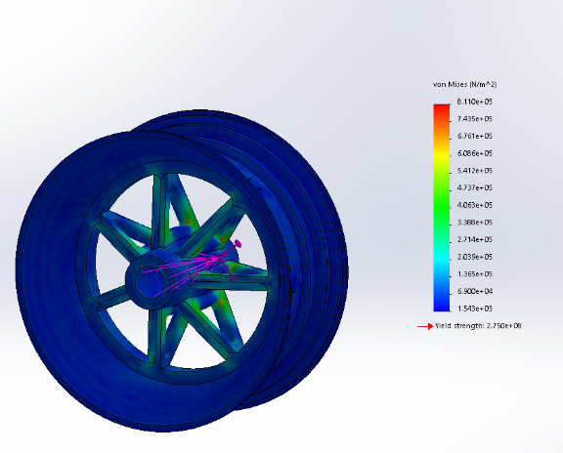
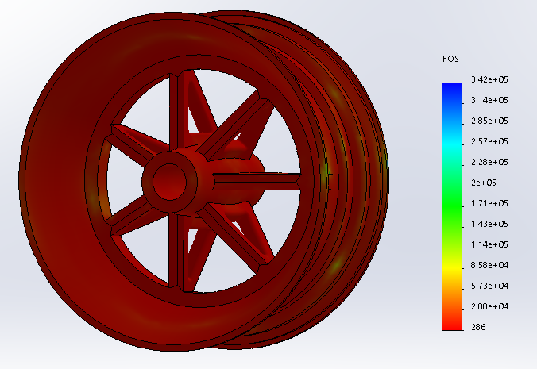

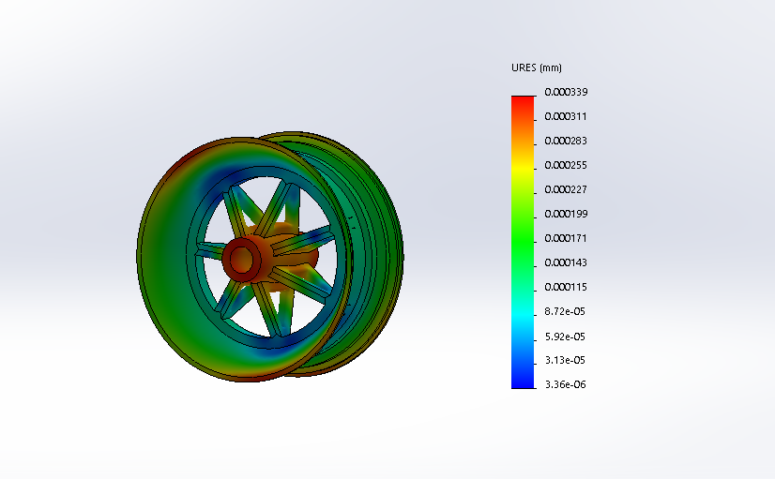
Figure 19: FOS final wheel design Figure 20: von Mises final wheel design

Figure 21: Image displaying displacement of nodes in modified rear wheel (6061-T6)
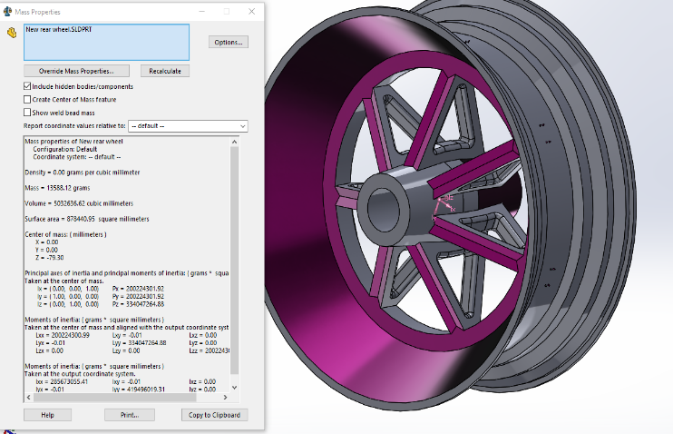
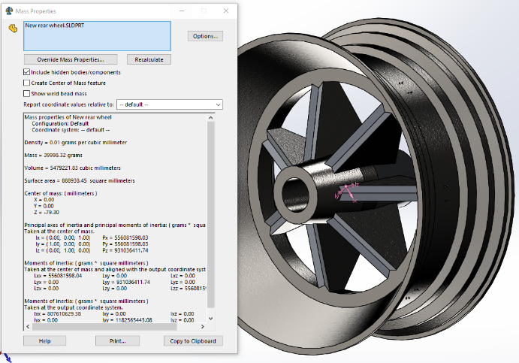

Figure 24: Comparison of mass properties between original and modified wheel.

Results, Design study 2: Lower suspension wishbones:

In the second study, there are 3 iterations of shock wishbone design. This iterative design process was conceived as a result of variation of motion loads created due to the reduction in the mass of the wheel and the knock-on effect this had on the design of the wishbone.
In the first iteration, the load was found to be very high due to the high mass of the wheel and the length of the swingarm, which caused a high lateral load to be created at the mounting hole areas of the wishbones, the design was then changed with the heavy wheel mass configuration and again re-designed as the loads generated were causing high stress concentrations and displacements in the aforementioned areas.
The final design appears to have remedied the high concentrations, with the addition of ribs on both inner and outer faces of the part, also material has been added around the mounting holes without infringing on the fitment of the part within the assembly. Results are shown and discussed below:
Figure 21: Shock wishbone original design
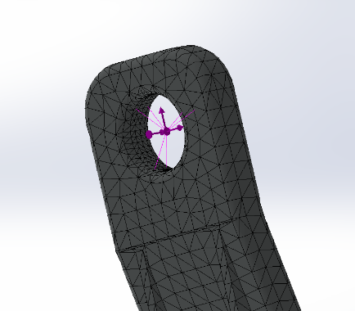
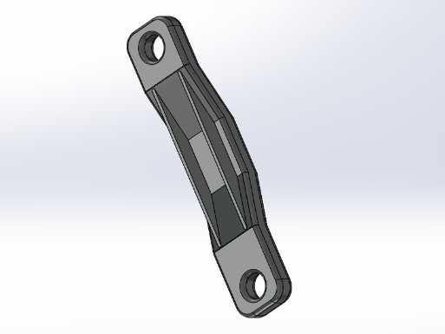
Figure 22: Wishbone with ribbing on rear face Figure 23: Mesh control applied to load bearing face of wishbone

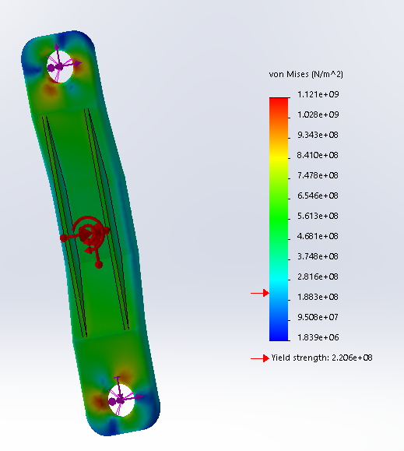
Figure 24: Wishbone design 2 showing excessive stress beyond yield strength of material.
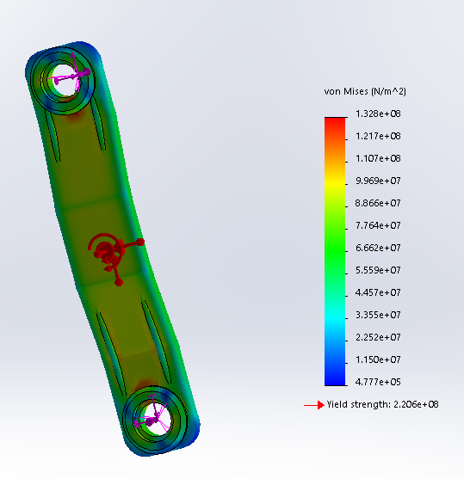
Figure 25: Final design wishbone, below yield
As can be seen in the final design, the addition of extra material and ribbing on the front faces of the material provides extra rigidity and load bearing surface to the component, thus increasing the factor of safety of the component to an acceptable number of 1.66, suggesting suitability for use with, again, a very high loading force required to put the material into yield.

Results, Design Study 3: Shock piston:

For the final analysis, the shock absorber piston was inspected in an attempt to analyse the forces encountered by the damping forces generated by the sharp bump reaction upon meeting an obstacle.
Initially the part was modelled incorporating a solid piston shaft, following initial testing, the piston shaft was found to exhibit favourable properties and deemed fit for purpose with a S.S.F of 27.6. Due to having safety factor in reserve, the shock piston was then made hollow and the load simulation re-run to analyse the effects of lightening the piston rod on the integrity of the part.
Post simulation the piston rod was found to be marginally weakened, with a higher stress concentration (1.071*10^7 N/m² as opposed to 8.151*10^6 N/m²) utilising a 2.5mm wall thickness on the piston rod only reduces the S.S.F by 7 to 20.6. This modification also results in a weight saving of approx. 50g or 5% overall
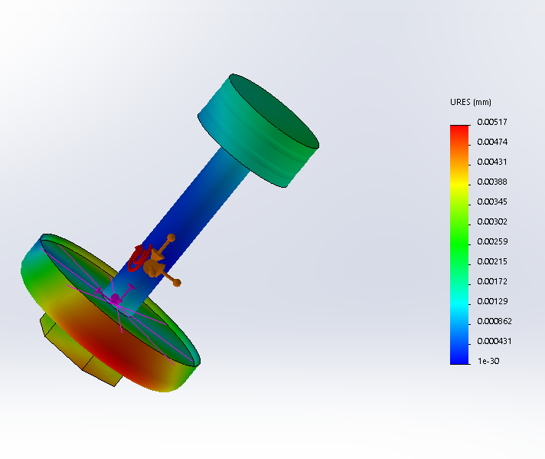
Figure 25: Image showing displacement in shock piston at full bump loading.

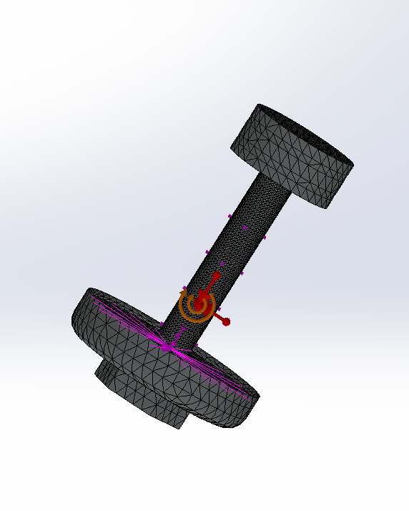
Figure 26: Application of mesh control region on shock piston rod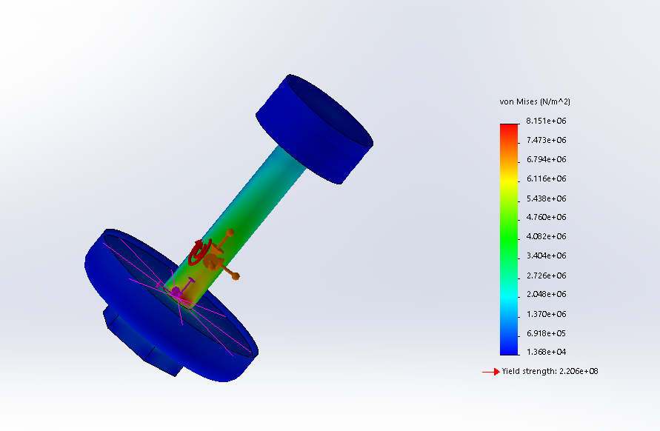Figure 27: Image showing von Mises stress distribution through shock piston under full bump loading.

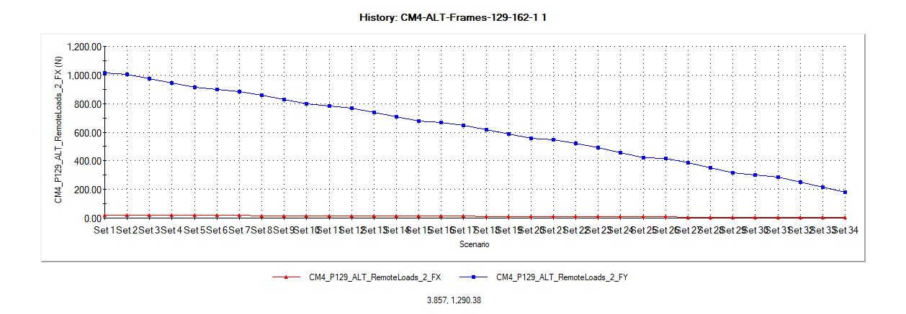
Figure 26: Max shock piston loading under bump conditions.

Conclusion:

Post simulation it has been found that several modifications can be made to the rear suspension assembly of a motorcycle that will enhance performance by the lightening of components whilst maintaining structural integrity.
By manually optimising the parts in question, the overall weight saving of the assembly was over 25Kg, which in real-world application would result in better handling characteristics of the motorcycle along with reductions in manufacturing costs.
This demonstrates the effectiveness of the CAD program and its ability to successfully simulate the forces encountered in a real-world scenario, without the need for part prototyping and physical testing. This increases the productivity of the engineer and reduces the cost involved in the design stage of a product whilst retaining quality and safety considerations.

Appendix:

Whilst modelling components, a topology study was carried out on the swingarm component of the rear suspension assembly. The study did not yield the desired results in the sense that material required to be structural to the assembly appeared to be removed in the study.
Possible causes for the failure of the tool may be attributed to the relatively complex shape of the part in question or a mis-interpretation by the operator of input loads.
Further analysis of this area is required in order to produce favourable results.
A static stress analysis was carried out on the swingarm throughout several of its design iterations and evolutions. Expected results were achieved through this study and the final design iteration reflects the findings of said study.
The following diagrams should give some insight to the study and represent the design path taken to achieve the final design.
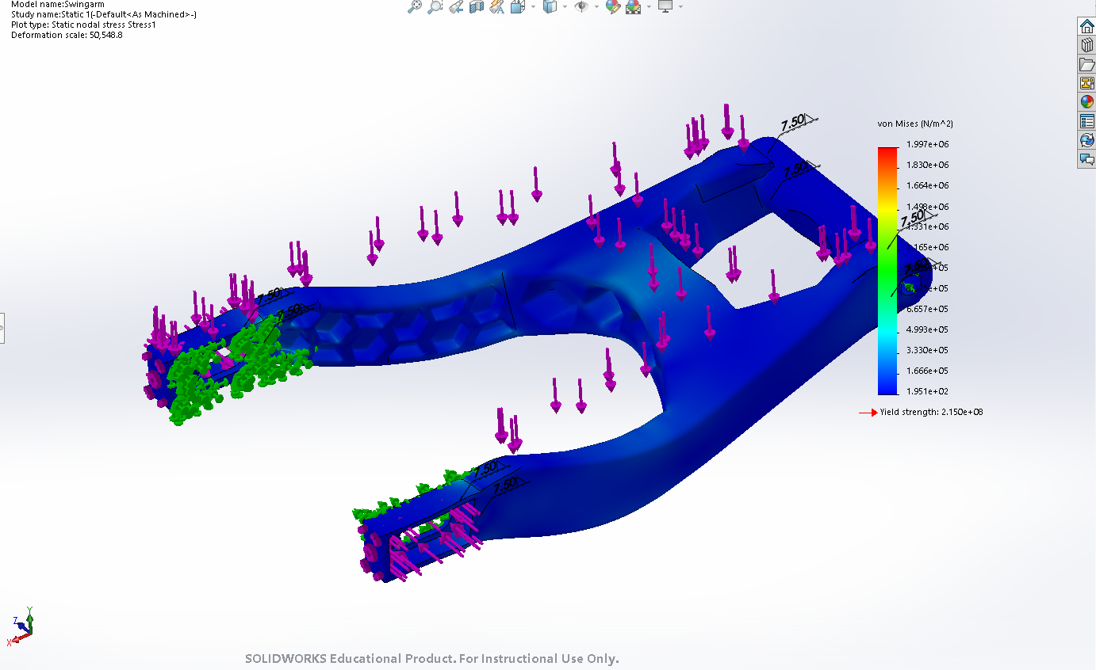
Figure 27: Swingarm with ribbing, low stress concentration
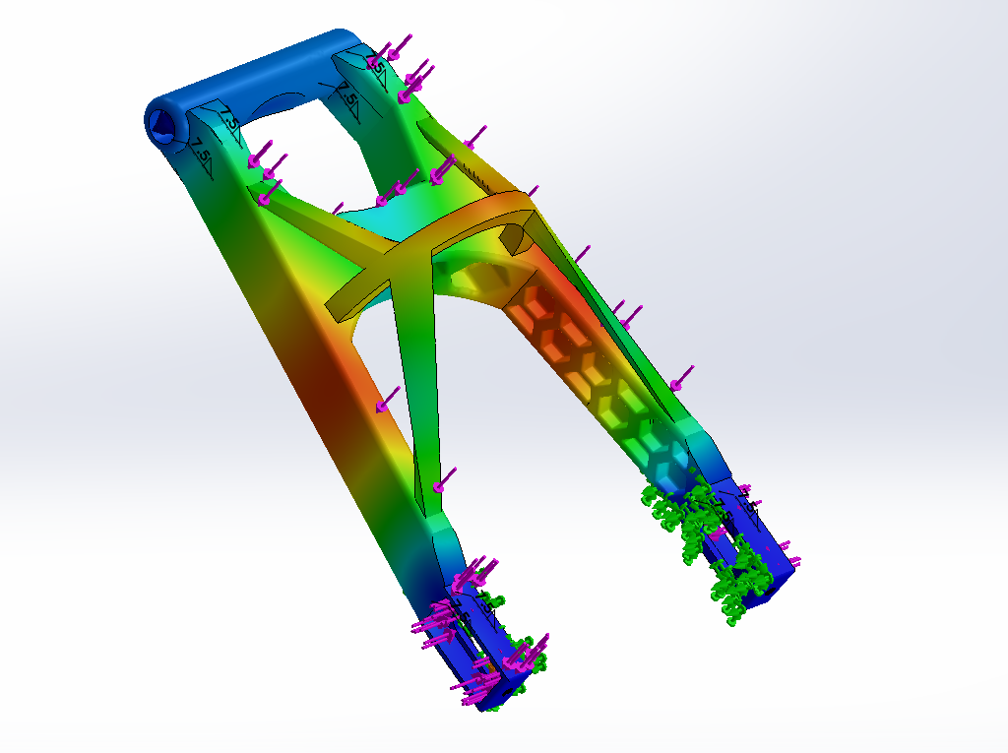
Figure 28: Braced final swingarm design, showing resistance to bending.

Bibliography
Engineer's edge. (2000-2020). Von Mises criterion. Retrieved from https://www.engineersedge.com/material_science/von_mises.htm
Lee, K. (1999). Principles of CAD/CAM/CAE systems. Reading, Ma: Addison, Wesley, Longman Inc.
Liou, F. W. (2008). Rapid prototyping and engineering applications. Boca Raton, Fl.: CRC press.
Medland, A. (1992). The computer-based design process. London: Chapman & Hall.
Rao, S. S. (1999). The finite element method in engineering. Woburn, Ma.: Butterworth-Heinemann.
Schaeffler. (2014). Technical pocket guide. Herzogenaurach: Schaeffler technologies GmbH & co. KG.
Tilley, R. (2004). Understanding solids. Chichester: John Wiley and sons LTD.

