Context.

- Introduction Page 2
- Findings. Page 3
2.1 Introduction to Tesco and Customer Relationship Management. Page 3
2.21 What was the significant change to Tesco’s CRM technology. Page 4
2.3 Tesco’s Ethical Exploration of CRM. Page 5
2.31 Comparing Tesco’s Ethical policies with Sainsbury’s. Page 5
2.4 Tesco’s sustainability of their future. Page 6
2.41 Archie Carrols CSR model in relation to Tesco. Page 6
2.42 Elkington Johns Triple Bottom Line and Tesco. Page 7
2.5 Tesco’s Segmentation and the Loyalty ladder. Page 8
2.51 Frederick Reichheld’s Loyalty effect & Clive Humby’s scoring system analysis with Tesco Page 9
2.52 Recommendation’s to Tesco. Page 10
2.53 Conclusion. Page 11
2.54 References. Page 11,12, & 13

1.0 Introduction to Tesco and the benefits of CRM.

This report compiled by Damien Roberts and requested on the 25/02/2022 for Ken Murphy the CEO of Tesco on the 27/01/2022 for the customer relationship management of its organisation. The topics that are discussed in this report are firstly the future sustainability of the company and the impact of the organisations ethical approach, and how these are positively or negatively effecting the company based on its findings. Satisfaction, trust, and commitment are key factors in Tesco’s customer retention and value, reflecting an important image of the organisation and discussing how CRM technology can influence these drivers.
There are many discussion topics from reputable sourced information that will allow the findings to map out how Tesco can approach these topics to align the companies, staff, and consumer’s needs. Many areas of media research will be involved such as textbook, journals, news articles, and internet source’s etc. There is information that will be criticality involved in understanding of all aspects of these findings so that there is a clear image on how the company is to best resolve and adapt in an ever changing economic and social climate. There is exploration in discussions of appliance of customer relationship management as a number one focal point and a key factor in their future OF sustainability and ethical approach in comparison to prospective competitor.

2.0 Findings

2.1 Introduction to TESCO and CRM
According to Tesco in (2012), Tesco rated one of the world’s top 10 retail chains with Wall mart following at number 2 and then Carrefour in France considered as the third largest retailer in the world (CRM, 2016). However current statistics by (Tugba Sabanoglu, 2021) show that Tesco is the highest rated as number 1 with a 52.9 Billion turnover with market retailer Sainsburys following behind at 29 Billion and then competitors Asda and Morrisons slowly following (Statista,2021).
Tesco was originated by Sir Jack Cohen back in 1919, with the Clubcard scheme then being produced in 1995 as an exclusive CRM tool to design service benefits to the customer in a unique way boosting customer loyalty and satisfaction whilst improving the company’s retention of its customers. Tesco.com was delivered in 2020 in encouragement of e-commerce trade.
Information gathering tools such as the club cards information on areas like merchandizing, pricing, customer services, promotions, customer acquisitions, media effectiveness, customer communications and market research were great and enormously effective generators for creative and innovative CRM techniques in focusing what the customer wanted most as a consumer reaping benefits by becoming the customers champion in 2001 and 2002.
One of the most powerful marketing tools the retail sector has experience in years is CRM and the maximised profit with supportive roles that CRM can play. Customer relationship management in recent years has become an essential phenomenon in the business entity where competitions are far more aggressive than ever before where customer concentration is essential to exist. As Tesco’s is one of the major pioneers in modernised CRM framework the business has both been able to expand within and beyond the UK by adapting to changing patterns within market dynamics. Formulation by Tesco for success and planning also depends on the analysis of the organisation’s performance for both customers and the retailer. This report has objectives designed from a cross contamination viewpoint with key influential aspects of CRM, identification, critical analysis, and trending CRM adoption (CRM,2016).
CRM is an application to an activity where businesses strive to achieve retention of customers whilst also trying to amplify the loyalty and value of its customers. The biggest part of a business aspect are its customers in the organisation. No business can develop with an expectation of any prospects unless there is a loyalty by customers without a mutually satisfied relationship. Therefore, organisations must employ a plan with clear strategies for treating customers and in sighting loyalty through a customer centric approach. (Han, Kamber and Pei, 2012).
According to the Club card loyalty program manager of Tesco, Mr. Crawford Davidson, the entire philosophy of Tesco is to balance the business for the customers. This then can impact from a result of the combination of the company’s importance of culture, insight, and the customer (IJMVSC. 2013).

2.21
What was the significant change?

Historically traditional business only used to focus on profitable transactions, product unit, financial scorecard, brand advertising and customer acquisition, not only had no customer satisfaction measurement but also under promised deliveries to success. However, where global research and development makes the diversity and surplus of goods more than the number of consumers then this seams to prevail, where you have a business to consumer focus where standards of service and efficiency are to impress customers by a higher standard.
According to Paul R Gamble, Merlin Stone and Neil Woodcock (1999), "The conflict between specialized marketing disciplines and customer relationship marketing can often be better understood if they are seen in a historical perspective."
Volumes of innovative products are increasing indicating more complexities in consumer behaviour therefore new requirements of information technology and strategic marketing are needed. Tesco’s use of database marketing and new technology created the Clubcard tool as a marriage of success along with online shopping, unique easy to use sitemap layout and nationwide coverage. However, with the competition of large retailers such as Aldi and Liddle offering verry competitive prices there are logistical hurdles for competition where Tesco’s seek to outweigh these by offering larger car parks and better facilities in CRM battles for success (Ms. Promrawee V erasophon, 2002).
The 13th of February is not just any day for Tesco and if they celebrated it, you wouldn’t be able to blame them. The 13th of February 1995 fundamentally changed the way the company did business forever and it was the day that the club card was launched. A customer loyalty programme that not only displayed Tesco’s loyalty to its customers but a fantastic CRM tool that would help shape psychological and behaviour studies of shoppers understanding what the customers wants and needs are. Attributes of the business and its management from the club card displayed strong team ethics and commitment to serving customers and most of all top to bottom retailers’ pragmatism. Whilst other retailers CRM models of loyalty schemes were failing Tesco’s responded to its critics by building sales measurably through the club cards tool of knowledge created to improve the way it runs its business forever (Humby, Hunt and Phillips, 2004).

Martin Glen president of PepsiCo, quoted,
“Tesco’s marketing works because they combine insight with creativity, value and scale. Its interesting to note that Clubcard and the computers for schools’ scheme have clearly stood the test of time and defined the way that loyalty schemes are done in the UK” (Humby, Hunt and Phillips, 2004).

2.3
Tesco’s Ethical exploration of CRM.

Tesco have an approach to their Human Rights policy where they believe that the trade is a force for good by creating opportunities for jobs and communities of people from around the world. This is supported by a commitment to ensure jobs have great support systems and clear standards on working hours, practices, health and safety, no child or forced labour and ensuring discrimination does not take place. This also supported by a responsibility to respect human rights, make a difference to colleagues, customers and the people who work throughout their supply chain (Tesco plc, 2022).
Tesco’s plc in 2019 scored the consumers best rating for supply management. On their website its policies documents were supplied as; “our approach to human rights”, “Modern slavery statement” and “supplier code of conduct”.
However, an unfortunate discovery at the same time which was advertised and broadcasted by journalists discovered that one of their suppliers had been caught using slave labour following a three-year police investigation. This was one of the UKs largest modern slavery rings to be uncovered involving 400 victims working for less than 50 p per day in areas such as farms, recycling, and meat factories. Tesco’s response was that they had no idea they were being exploited”. Following this Tesco received the worst Ethical consumer rating in September 2019, (Ethical Consumer, 2022)
Tesco also advocates through their online policy as a responsible taxpayer stating that they recognise the responsibilities and the importance of the tax Payments on the communities that they serve. Tesco also state that these are the principles aligned with the values of the company which guide every action and every decision in their business (Tesco Plc,2020)
However, a political concern was raised by several stakeholder groups in 2019 where Tesco had been using tax avoidance strategies through tax havens where no explanation was provided for what they were for, so Ethical consumer gave Tesco the worst rating for the likely use of tax avoidance strategies, also in 2019, (Ethical Consumer, 2022).

2.31 Comparing Tesco’s Ethical policies with Sainsbury’s.

When comparing the supermarket Sainsbury’s on their ethical policies an article written by (M, Chapman, 2013) explains how Sainsbury’s slammed Tesco’s ad campaign and the ethics of its rival’s products, where watchdog ad ruled Tesco’s price promise made valid comparisons between own label products and fresh food.
A national press campaign launched by Sainsbury’s featured a statement quoting “Same price, Different values” which was with images of its British sourced ham and fair-trade bananas stating that things such as provenance i.e., brand or origin, and ethics were a major factor in consumers purchasing decision, where Tesco Price Promise featured branded products such as Colman’s and own label and fresh food alongside other retailers on a like for like basis which Sainsbury’s argued they were not the same when it came to customer preference.
Sainsbury’s fair trade bananas advertisement stated “its bananas a fair trade for producers irrespective of market forces” unlike those provided by Tesco. Tesco’s response to this was that fair trade certifications were not a major factor in a consumer purchasing decision. However, Sainsbury’s pointed to another Tesco ad published on 3 March, that claimed all its fresh chickens were from UK farms, as proof that contractively Tesco then admitted the importance of an ingredient’s provenance when customers were making a purchase decision which would go against Tesco’s normative ethics of their policies’ (UK Campaign, 2022).
Sainsbury’s snubbed the Advertising Standards Authority and Tesco after the horsemeat scandal of 2013, where 29% of Tesco products contained horsemeat which were advertised as beef within the packaging. This was misleading information of products as it is traditionally banned in the UK and were found by the Food Safety Authority of Ireland (Lagos business School, 2017).
Mike Coup director at Sainsbury’s made it clear that after the horse meat scandal stated, "it is absolutely clear that provenance and ethics form a fundamental part of customers’ decision-making as they choose what to feed their families" (Chapman, M, 2013).
Mike Coup then arguing that the descriptive ethics of Tesco not being true as there is a contradiction between their advertising and how Tesco operate their Price Promise. Tesco argued that this was not an advertisement focusing prominence but a highlight a commitment to a better supply chain.

2.4
Sustainability of Tesco’s future.

The synthesis of sustainability and CRM as both trends are gaining significant importance when it involves the management of sustainability for growth of the company. Customer centric approaches are redefining CRM through mega trends such as demographic changes, digitalisation and mindset or behaviour patterns of consumers (Lubin and Etsy 2010). With concerns growing over scarcity of natural resources, environmental degradation, and social inequalities have led to consumers being aware that impacting patterns of consumption and production are having on future sustainability (Silvius and schipper 2010). With customers now transitioning into roles of more sustainable lifestyles the marketplace must balance profitability with environmental and social responsibility (Graham and Havlick, 1999). This then advocating an emerging culture geared toward personal health, lifestyles, and environmental sustainability and a consumer base willing to pay more toward these types of products (Anna Muller, 2014).
2.41 Archie Carrols CSR theory and relation to Tesco.
When looking at Archie Carrols theory of the CSR Pyramid it closely aligns the corporate and social responsibility of Tesco by fulfilling all its economic policies with rules and regulations and with practices of being ethical by serving healthy food from local products being more cautious about their impact on the neighbourhood and the future of environmental changes. Responsible approaches through philanthropic practices serving communities throughout the country as a business, employer, and good neighbour.
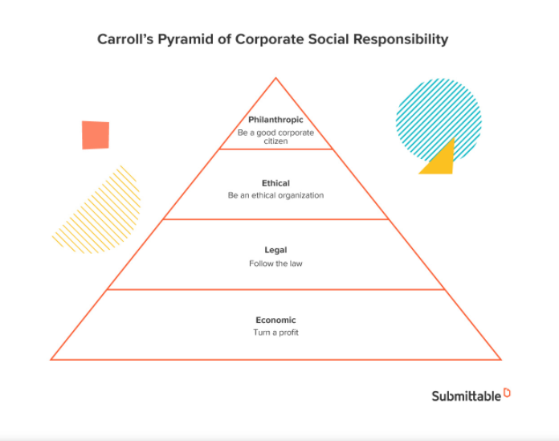
Even though Archie Carroll’s model is closely aligned with Tesco’s ethical and legal policies they must be aware of the supply and work chain that has reported legal and ethical laws that have been broken as discussed in section 2.2 of the findings. At its core level a company needs to create profit through growth and sustainability. Any interest that a company has in supporting society over the long term havefiduciary responsibility to meet core economic alignments with shareholders and stakeholders (Paul Perry 2020).

2.42 Elkington Johns Triple Bottom Line and Tesco.
Tesco’s Little Helps Plan explains that the decisions and actions that they take is the Tesco value that is underpinned in their approach to sustainability. This framework is there to shape their long-term approach to sustainability by enabling them to demonstrate, monitor and improve performance both within the wider supply change and their operations under the frameworks four pillars’ People, product, planet, and places. This is then a proposal of tackling issues on diversity, health, sustainable diets, climate, and poverty.
Rather than just focusing on profitability solely, Tesco follows an obligation to maximise its positive impacts environmentally but but minimising negative effects in being a contributing member to society. This is exemplary of Elkington, J (1994) model of the triple bottom line where Tesco also concern themselves with societies long term needs of economic and human resources. Many things have been done by Tesco to appear to be within the public service for internal and external stakeholders where in 2013 Tesco decided to increase wages for their workers returning profit back to their employees through lucrative expansion, which falls in line with Elkington J Economic and Social part of the model. According to an article by (Cardwell, 2013) Tesco has said that there are over 40% of Apple products dumped into trash each year equivalent to 28,000 tonnes where advertising solutions were financed to create awareness in society to this problem. This is an environmental sustainability issue which Tesco have invested as an Economic and Social aspect of Elkington J model (Bartlebay Research, 2021).
The general goal of a sustainable business strategy is to positively impact the environment, society, or both, while also benefiting shareholders. This triple Bottom Line model positions the organisation to commit environmentally and socially on the impacts that are affected in addition to financial performance. This incentivises strategic methods to benefit not just the organisation but creates business to effect positive change (Kelsey, M, 2020).

Elkington Johns triple bottom Line Model.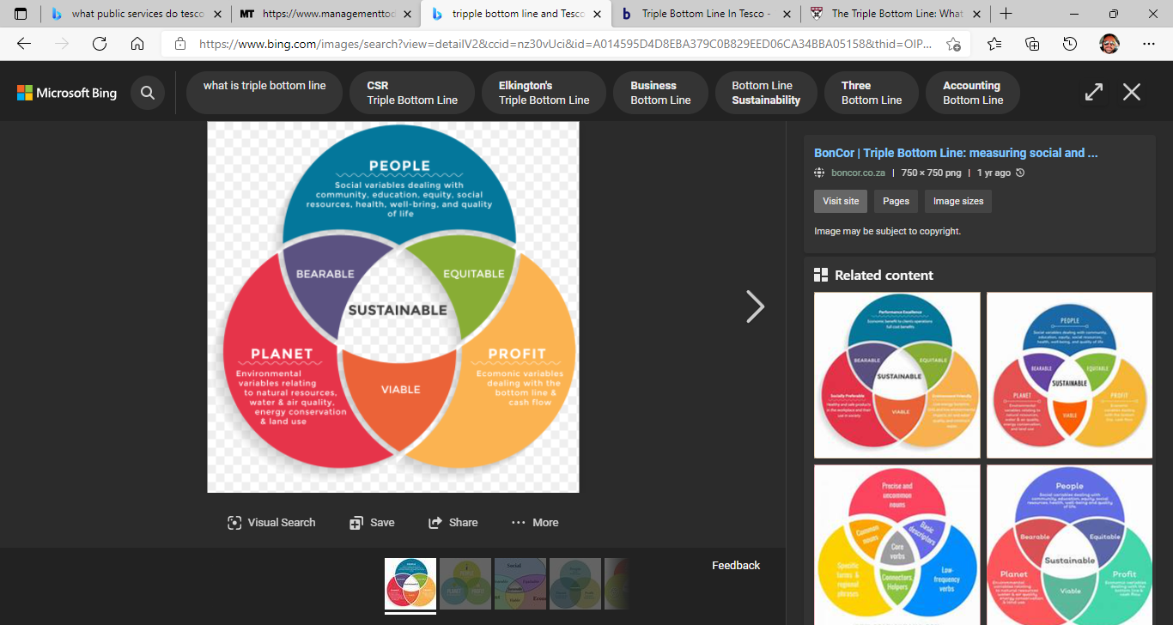
2.5 Segmentation of Tesco and The Loyalty Ladder.

With businesses today becoming more customer centric Tesco’s success has been predominantly based on its marketing relationship strategies where the launch of the Clubcard has been their most successful information gathering CRM tool. The lifetime loyalty that has been gained through this strategy has been invaluable and a lifetime key for heir continuous success. Tesco uses the Kotler 1997 Loyalty ladder for categorising customers based on its marketing relationship strategies. This is a customer retention strategy focused on relationships formed with them through information gathering via Clubcard by mutual exchange of services by incentivisation in what Clubcard can give back in terms of value to their customers (UK Essays, 2017).
The retention of its customers used through the loyalty ladder through six different stages as follows:
Logged on
Cautionary
Developed
Established
Dedicated
Logged off (Needs to win back the confidence).
Tesco uses this sequence upside down as they believe that newest customers can make an impression or lose it. Systems where event messaging via contact information encourages them to make regular purchases by offering discounts or vouchers through emails or surveying techniques where asking them about their online or physical shopping experiences transfers into gathering tools focused on how the customer spends their money based on different demographics such as age, family orientation, budget and lifestyle offering value or personalised offers in each segmented area. Online shopping has reduced the usual shopping expedition from one hour to just 35minutes to enhance efficiency thus reducing time and transportation costs. All customers are unique with varied tastes and preferences where segregation of customers is to recognise potential clients from the existing ones i.e., income, taste, preferences, and other factors (Hubert, 2000).
2.51 Frederick Reichheld’s Loyalty effect and Clive Humby’s scoring system analysis with Tesco
When evaluating Frederick Reichheld’s theory on Loyalty Effect and mutually beneficial relationships, Tesco and the loyalty ladder fall correctly in place with loyalty for their internal and external stakeholders as the theory strongly forms a practical guide to building and fostering these aspects. These being mutually supportive by implementing successful tools such as the Clubcard as concepts to ensure long term success. Reichheld’s theory strongly suggests a clear sense of company mission-based value and rather than profit and the use of partnership to align motivate and manage the organisation (Frederick Reichheld, 2016).
At an interview with Bob Thompson in 2004 on the topic of customer loyalty and CRM, Bob asks Clive Humby “Define loyalty marketing”.
To which Humby replies, “Loyalty marketing, to me, is about doing things for individual groups of customers that grows their lifetime loyalty. So, recognizing that individual customers have specific needs, and that doing something for them and their peers is good for them, and it’s not the same thing as doing something for someone else.” A perfect example of understanding the loyalty ladder (Clive Humby 2004).
Tesco Chairman Lord MacLaurin stated himself quoting: "What scares me about this is that you know more about my customers after three months than I know after 30 years."
When analysing Clive Humby’s scoring points system, himself along with Terry Hunt marketing experts explain how Tesco innovatively analysed customer data to become the retail giants they are now. The Tesco Clubcard was then jazzed up with IT information in a visually engaging way to set a new standard in knowing their customers. The way that Humby and Hunt used technological advancements in micro segmenting their customers was challenging but through interesting techniques such as personality traits from evaluating what certain individuals put in their shopping carts, they were able to analyse lifestyle habits and rich customer data in culture (Clive Humby, 2022).

2.52 Recommendation’s
Tesco’s could focus more on attitudes and satisfaction of customers especially in developing economic conditions for retention purposes where there has shown very little study in this.
Gaining more customers through expansion where other competitors are less known.
As Tesco’s have developed unique express shops around the country then opening up stores in closer proximities where other large retailers are based will incentivise consumers to shop closer to home especially if offering better prices than further travelling for consumers to the larger stores.
Better offers provided for repeat customers where they act as incentives rewarding the customers for loyalty.
Developing satisfaction strategies outside of the consumer behaviour approach where intervening variables in society will not be such a casual link.
If Tesco’s can increase the number of regular shoppers through different marketing tools, then the revenue can be expected to rise.
Increasing the opening hours of smaller located stores by Tesco could help reduce the any lack in customer retention if other major retailors outside of their proximity are open longer but take longer to travel. This could be a major retention tool for the organisation.
Maintaining a more regular inspection of how Tesco’s sources of goods are adhered to within their ethical and legal policies can eliminate or limit the impact of damaging exposure from this.
Consumers may visit any store based on its most visibility so building stores that are clearly visible through any constructable methods can increase the amount of shopper’s direction from their original plan.

2.53 Conclusion.

There is a lifetime loyalty of commitment by Tesco to their customers forever striving to gain value for them whilst delicately balancing the ability to be competitive as a business also seeking out to make profit. Historically there is sufficient evidence to show how much investment has been made by the company to expand its organisation whilst also tackling the consumers behaviour science, and their competitive rivalry with other large supermarket retailers.
Unlocking key technological advances in customer relationship management has been a considerable breakthrough in understanding these consumer behaviours. It has been very apparent throughout the report that paying attention to ongoing norms and trends of business and consumer ethics throughout their journey has been a difficult task. Sometimes these tasks have been pointed out and exploited by supply organisations for ethical or political policies that have not been adhered to behind the public eye. This can have miss judgements of trust and loyalty from consumers if not respected in the alignment of what the company has promised, however considering these events Tesco has continued to invest heavily in sustainability as not just part the company’s growth and consumer loyalty and retention, but sustainability in a green environmentally growing economy.
Tesco’s customer relationship management aspires to be the leading future of how company’s grow and succeed through awareness, loyalty, innovation, and marketing mix strategies. All of these strategies paying respect to customers irrespective of their economic or financial status as the people’s champions.

2.54 References.

Han, J., Kamber, M. and Pei, J., 2012. Data mining. Amsterdam: Elsevier, p.THE CRM STATEGY. Available at 4113ijmvsc01-with-cover-page-v2.pdf (d1wqtxts1xzle7.cloudfront.net). Assessed: 27/01/2022.
International Journal of Managing Value and Supply Chains (IJMVSC) Vol. 4, No. 1, March. Available at 4113ijmvsc01-with-cover-page-v2.pdf (d1wqtxts1xzle7.cloudfront.net). Assessed: 27/01/2022.
Tesco. 2012. Home. [Online] available at: http://bit.ly/6Sg5e. Assessed: 27/01/2012.
Statista, 2021. Available at: • Leading 10 retailers in the UK 2021 | Statista. Assessed: 27/01/2022.
IJMVSC, 2013. Available at: 4113ijmvsc01-with-cover-page-v2.pdf (d1wqtxts1xzle7.cloudfront.net). Assessed: 27/01/2022.
How Tesco is winning customer loyalty. Clive Humby and Terry Hunt with Tim Phillips. Available at: Scoring Points - Google Books. Assessed: 27/01/2022.
Mrs Promrawee Verasophon. CRM AND THE CRITICAL ANALYSIS OF DATABASE MARKETING: A CASE STUDY OF TESCO CLUBCARD. Available at: content (au.edu). Assessed: 7/02/2022.
Tesco plc. Our Approach to Human Rights Policy. Available at: Our approach to human rights - Tesco PLC. Assessed: 07/02/2022.
Paul, R. Gamble, Merlin Stone, and Neil Woodcock. "Up Close and Personal Customer Relationship Marketing@Work," Clays Ltd., St Ives plc., 1999. Available at: content (au.edu). Assessed: 7/02/2022.
Tesco Ethics and compliance policies 2020. Available at: Tesco's approach to tax - Tesco PLC. Assessed on 07/02/2020.
Ethical Consumer 1989. Tesco plc. Available at: Tesco ethical issues | Ethical Consumer. Assessed: 07/02/2022.
Lubin DA, Esty DC (2010) The sustainability imperative. Harv Bus Rev 88(5):42–50. Available at: Sustainability-Oriented Customer Relationship Management – Current State of Research and Future Research Opportunities (fim-rc.de). Assessed: 07/02/2022.
Silvius GAJ, Schipper Ron (2010) A Maturity Model for Integrating Sustainability in Projects and Project Management, 24th World Congress of the International Project Management Association, Istanbul. Available at : Sustainability-Oriented Customer Relationship Management – Current State of Research and Future Research Opportunities (fim-rc.de). Assessed 07/02/2022.
Graham JW, Havlick WC (1999) Corporate Environmental Policies. Scarecrow Press, London. Available at: Sustainability-Oriented Customer Relationship Management – Current State of Research and Future Research Opportunities (fim-rc.de). Assessed : 07/02/2022.
Anna Muller 2014. Sustainability-Oriented Customer Relationship Management – Current State of Research and Future Research Opportunities. Available at: Sustainability-Oriented Customer Relationship Management – Current State of Research and Future Research Opportunities (fim-rc.de). Assessed 07/02/2022.
Paul Perry 2020. Understanding and applying Carroll’s CSR Pyramid. Available at: Understanding & Applying Carroll's CSR Pyramid - Submittable Blog. Assessed: 07/02/2020.

Mathew Chapman 2013. Available at: Tesco wins right to market Price Promise after Sainsbury's challenge fails (campaignlive.co.uk) . Assessed: 23/02/2022.
UK Campaign, 2022. Available at: Sainsbury's slams Tesco's ethics with 'Same price, different values' push | Campaign US (campaignlive.com). Assessed 23/02/2022.
Lagos Business School, 2017. Available at: Tesco: 2013 Horsemeat Scandal - The Case Centre. Assessed: 23/02/2022.
Bartlebay Research 2021. Triple Bottom Line in Tesco. Available at: Triple Bottom Line In Tesco - 1794 Words | Bartleby. Assessed: 23/02/2022.
Kelsey Miller 2020. THE TRIPLE BOTTOM LINE: WHAT IT IS & WHY IT’S IMPORTANT. available at: The Triple Bottom Line: What It Is & Why It’s Important (hbs.edu). Assessed: 23/02/2022.
Elkington J 1994. The Triple Bottom Line and Tesco. Available at: tripple bottom line and Tesco - Bing images. Assessed: 23/02/2022.
Majestic grades 2022. Advantages of customer loyalty to Tesco. Available at: Advantages of Customer Loyalty to Tesco - Majestic Grades. Assessed: 23/20/2022.
UK Essays, 2017. The Tesco Loyalty Card Scheme. Available at: The Tesco Loyalty Card Scheme (ukessays.com). Assessed: 23/02/2022.
Frederick Reichheld, The loyalty Effect. Available at: The Loyalty Effect by Frederick Reichheld – The Rabbit Hole (blas.com). Assessed: 22/02/2022.
Clive Humby 2004, Tesco shines at loyalty: An interview with Clive Humby. Available at: Tesco Shines at Loyalty: An Interview With Clive Humby | Customer Think. Assessed: 15/02/2022.
Clive Humby 2022. Scoring Points. Available at: Scoring Points (Summary) by Clive Humby · OverDrive: ebooks, audiobooks, and more for libraries and schools. Assessed: 23/02/2022.

