Phoebe McGowan: 1600144
Medieval Manuscript Studies (AHMS5005)
Analyse different ways in which Insular Gospel Books portray the evangelists.

This explorative essay aims to analyse and explore the different ways in which Insular Gospel Books portray the evangelists. To establish the exact scope and extent of my enquiry, the definition of both insular and gospel books is critical. Insular manuscripts are dated and derived from ‘7th- through mid-9th-century Irish, Anglo-Saxon, Welsh, Pictish, British, and Scottish contexts’. The exact description of ‘insular’ gives a greater insight into the exact categorisation of manuscripts which are needed to look into and analyse the different representations of the four evangelists. ‘Taken literally [Insular], it is the native decorative art of the western fringe of early medieval Europe, and therefore the product of the islands which now comprise the nations of Ireland and greater Britain’. From these two sources, one can assume that the focus of this essay and the manuscripts which can be seen as a basis throughout the analysis, are manuscripts dated between the seventh and ninth century, related to the countries that come together now as Britain and Southern Ireland. A gospel can be identified as ‘one of the four writings in the New Testament that describes the life and teaching of Jesus of Nazareth’. These four gospels are found under the names of the four evangelists. An evangelist is a person who announces ‘good news’ to other people. The evangelists stated within the gospels are as followed: Saint Matthew, Saint Mark, Saint Luke and Saint John. These can be identified through the use of symbols, with each evangelist associated with a particular beast. Within the gospels, the evangelists can be identified as follows: ‘the Angel of Saint Matthew, The Lion of Saint Mark, The Ox/Calf of Saint Luke and the Eagle of Saint John’. The use of symbolism is a way in which gospels can be identified within medieval manuscripts, and the portrayal of both portrait and symbol differ throughout Insular Gospel Books. Throughout this essay, a selection of medieval Insular Gospel Books, whoms characteristics were identified earlier, are to be analysed and explored in terms of their portrayals of the four evangelists, as well as taking into account their provenance and identifying the differences in which the four evangelists were portrayed. The Insular manuscripts referred to amongst this essay include: The Lindisfarne Gospels, The Book of Durrow, Additional 40618, Codex Aureus, as well as others which may hold relevance to the investigation. These manuscripts, though varied in popularity and research, as well as in access to their pages, aim to be used in an aspect that suits them, rather than to be utilised to the advantage of a particular statement. Throughout this essay, the different approaches to the portrayal of the evangelists will be explored and analysed to establish the stylistic features of the insular art era, as well as any possible aesthetics between the seventh and ninth century, and how the representations are perceived through a scholarly perspective.
The symbols which represent the four evangelists originated from the Vision of Ezekiel found within the Old Testament and is the first place where the four evangelists are referenced in beast-like form. Within Chapter One, specifically Verse 10, the provenance of the four symbols is established. Ezekiel says, in reference to his dream, that: ‘each had the face of a man; each of the four had the face of a lion on the right side, each of the four had the face of an ox on the left side, and each of the four had the face of an eagle’. We see this scene portrayed famously in The Winchester Bible, illuminated on the page which portrays the dream itself, and where the four beasts are depicted. (See Figure One). Though not insular by nature, the manuscript is a portrayal of the origins of the four symbols; and though not dated to the rest of the manuscripts which are to be explored, it shows the progression between artistic styles of the Romanesque era and the Hiberno-Saxon insular era and is therefore important in terms of this enquiry. There is an obvious link between the four beasts being winged- to give them an angelic impression- and this portrayal is shown between lots of insular manuscripts, for example: The Lindisfarne Gospels, which will be explored in greater detail later. Whilst on this exploration of the origins of the symbols used to represent the four evangelists, it is important to note a key anomaly within the representation of the four evangelists in The Book of Durrow. The symbolism used within the gospel is different to the rest of the insular medieval manuscripts which will be referred to throughout the rest of this essay. It is particularly different due to its odd representation of the four evangelists. The symbol of Saint Mark within The Book of Durrow is represented by the symbol of the eagle, whereas traditionally it would be found as the symbol of Saint John, and the symbol traditionally representative of Saint Mark, is used to represent Saint John as the lion. This is strange to see, as it is evident throughout the Irish tradition, that the use of symbolism to represent the four evangelists is relative to the rest of the gospel books explored during this essay. According to a Seventh Century Irish Commentary, it is stated that ‘there are four symbols which designate the four Evangelists: a man’s face for Matthew; a calf’s face for Luke; a lion’s face for Mark; and an Eagle’s face for John’. To see an Irish gospel book go against this, leads the audience to believe that the mix up was due to either the mistakes of the scribe, or another tradition pre-dating this written commentary. It is suggested that this reversal of symbols is related to the writings of St. Irenaeus, a Bishop of Lyon from the 2nd century. However, upon further enquiry, it is apparent that the symbols traditionally found within the Irish tradition were consolidated by St. Irenaeus and therefore this scholarly statement must have been misinformed. He was the first bishop in France to ‘acknowledge the main figures of the New Testament gospels’, utilising the dreams of Ezekiel to ensure that the symbols of the four evangelists are as they are seen in the seventh century commentary.
The Book of Durrow versus the Lindisfarne Gospels, is a case study which identifies the difference between the portrayal of the four evangelists in gospel books, purely as symbols, opposed to the combination of portrait and symbolism. The representation of the evangelists within The Book of Durrow are purely symbolic, whereas in the Lindisfarne Gospels, which displays portraits as well as symbols. The Book of Durrow contains framed symbols of the Evangelists… [and though it is certain that it is an insular manuscript], its date is uncertain and controversial’. This gospel book is one of the earliest examples of an insular manuscript which shows the layout of a traditional insular gospel book, including illustration and composition. Written between the years 650-675 AD, symbolism is used to identify the evangelists at the beginning of each of the four gospels. For example, when looking at the introductory page of the gospel of Saint Matthew (See Figure Two), it can be assumed that the symbols used to represent the evangelists were recognisable to the medieval audience, making it easily identifiable without having to show the portrait of the saint themselves. We can infer from this that the symbolism used to portray the four figures were used a lot throughout the gospel books, with their popularity becoming a part of medieval identity and culture. We can also take from this folio the aesthetics and artistic styles of the insular era, allowing an element of contrast when looking at other manuscripts further on in this essay. It is established when looking at both the Saint Matthew page and those following, such as Saint Mark (The lion), that the aesthetic of this era was based around the concept of warfare. The armour found on the bodice of both illustrations infer the presence of armour and metal work. The border that frames the illustration is also metal like- lifeless- and so it can be inferred that warfare is the inspiration behind both illustrations. The artistic styles that have been used within this illustration include a simplistic design, representations though not naturalistic artwork and abstract proportions. Though it could be inferred that symbolism are used on their own as the symbols known would be popular and integrated into the medieval societal framework, so well recognisable to the whole audience and acted as a sort of short-hand, it could be said that the use of both portraits and symbols in the Lindisfarne Gospels acted as a sort of learning and visual aid. The gospel was ‘made and used at Lindisfarne Priory on Holy Island…in the 7th or early 8th century’. Looking at another illustration of Saint Matthew, which is synonymous in the message to be portrayed though represented differently, it is noticeable that the portrait of Matthew is found alongside his symbol. (See Figure Three). The illustration is also found along his name ‘Matthew’. It is clear within this folio that the use of portrait and symbol is used to reinforce the statement that this is the representation of Matthew, acting as a visual aid, either for educational uses for someone who is getting used to the layout of the gospels, or for a young audience. As this piece is in the latter years of the insular period, it is noticeable that the adoption of a more linear approach has been taken on by the illustrator. For example, the folds in the draperies appear a lot more bold and dense, almost Romanesque looking (1000-1200 AD). This transitional art is representative of how the evangelists are portrayed in a variety of different ways dependent upon the illustrations function, trying to utilise this concept, as well as using symbolism versus portrait figures dependent on the society it is produced in.
The position of both symbolism and portrait is also significant in its portrayal of the four evangelists within gospel books. As noted previously, the symbolic beasts were derived and originated from the Old Testament, and this could be the reasoning behind the placement of both the symbol and the portrait. The allocation of the symbols above the heads of the Saints is common within insular art, (See Figure Four and Five) though it is evident that this positioning must have some influence on the reader and the images themselves. This repetitive design creates an iconography which is associated with the Saints, with their assigned symbols found looking down on the four portraits, almost as though they are positioned within heaven, resting on the banners which are a common setting for the symbols to rest on. These angelic connotations also reinforce the origins of the four evangelists, as they were derived and originated from the Old Testament. It could even be suggested that nit makes the portraits seem even closer to God, as they are positioned above the mortal men. When looking at the definition of an evangelist, it is evident that one of the roles that they play is announcing good news to the laity, words of God and the trials of Jesus. This is inferred from the use of the banners found over the architecture used to set the illustrations. It could also be concluded that the use of inanimate objects, such as buildings and chairs, which consequently raises the positions of the evangelists so they are found perhaps lifted onto a pedestal, reinforces the judgement that the portraits and symbols of the evangelists are above those that they preach too, as a saint is ‘one officially recognized especially through canonization as preeminent for holiness’. The role as the giver of good news raises their station above others. Both symbols portrayed in the Additional 40618 and Codex Aureus are found holding a book, as if reading from it and announcing it to those below them. However, there is an instance of reversal found within the Royal 1 E VI, where the symbol id the main illustration and the portrait of the saint is smaller and above. (See Figure Six). This reversal in the position of both symbol and portrait could portray the influence that evangelical symbols had on an insular medieval society. It could be said that the symbols were concrete in society; well-known and therefore part of the medieval culture. The illustrations therefore, would have more of an impact as the symbol may be more identifiable than the portrait. The constant portrayal of the symbolic evangelists seen heavily within insular gospels gave way to a society which, already strongly driven by religion, knew well of the symbols representative of the four evangelists.
In conclusion, the representation of the four evangelists within insular gospel books varies in portrayal, either through the positions of the illustrations on the page or the evangelists’ occupation within portrait or symbol. In a society heavily driven by religion, and ecclesiastical institutions as the main production of insular manuscripts, it is evident that the portrayal of the evangelists was popular within the insular period of medieval manuscripts, not limited to gospel books but also found within psalters and other manuscripts. The portrayal of the evangelists, taking into account their origins within the dream of Ezekiel as divine beasts, is a common state by which they are represented, though as explored throughout this essay, it is also mentionable that they are found in combination with their portrait selves at the beginning of gospel pages, in conjunction with their relevant gospel number.
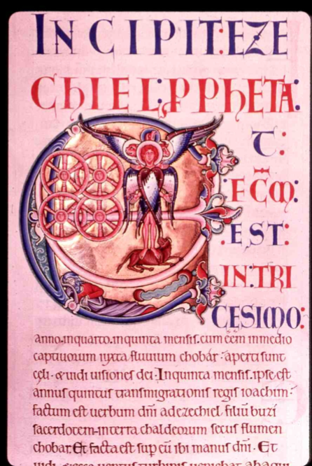
FIGURE ONE: The Winchester Bible

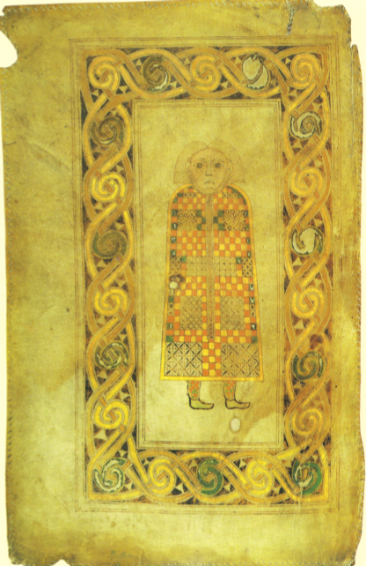
FIGURE TWO: The Book of Durrow f.21v FIGURE THREE: The Lindisfarne Gospel f.25v
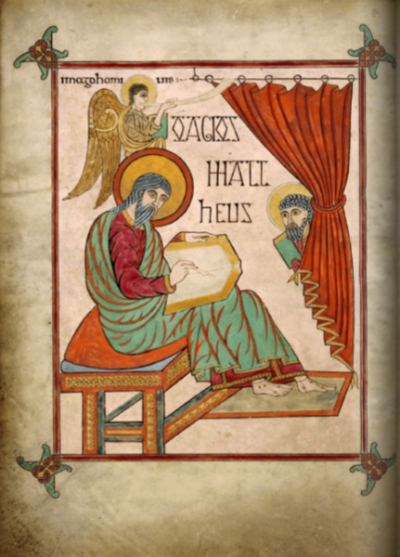

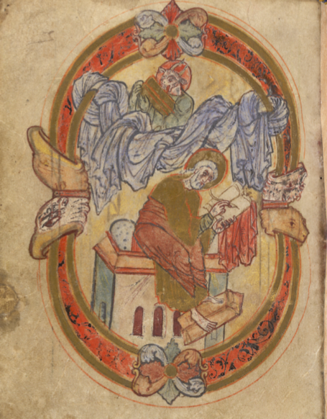
FIGURE FOUR: Additional 40618 f.22v FIGURE FIVE: Codex Aureus f.308
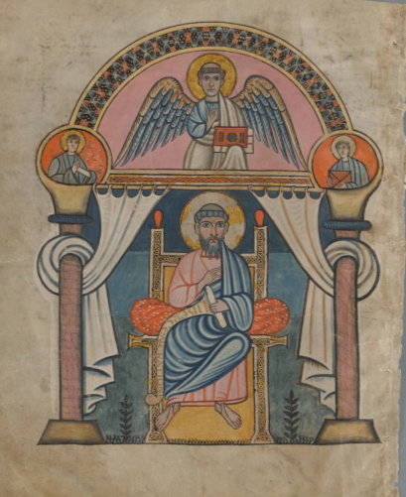
FIGURE SIX:
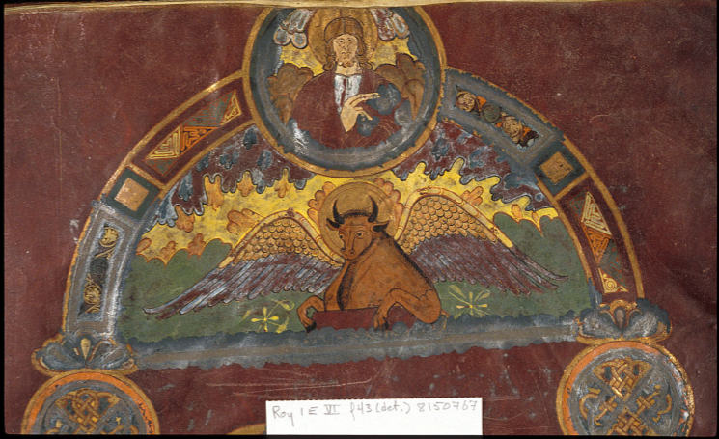

BIBLIOGRAPHY
PRIMARY SOURCE MATERIALS:
Book of Kells, Dublin, Trinity College Dublin, MS A.I.[58], fols 27v.
Codex Aureus, Stockholm, National Library of Sweden, MS A.135, fols. 20 and 308.
Book of Durrow, Dublin, Trinity College Dublin, MS A.4.5.(57), fols 21v and 191v.
London, British Library, Additional 40618 MS, fols. 22v and 49v.
London, British Library, Royal 1 E VI, fol. 43.
The Lindisfarne Gospels, London, British Library, MS Cotton Nero D.IV fols 25v and 93v.
Winchester Bible, Winchester, Winchester Cathedral Library, MS M.619.

SECONDARY SOURCE MATERIALS
Anglandicus, The Symbols of the Evangelists in the Irish Tradition, Anglandicus, Available from http://anglandicus.blogspot.co.uk/2013/02/the-symbols-of-evangelists-in-irish.html, Accessed on [03/04/2018].
Bernard Meehan, The Book of Kells: Symbols of the Four Evangelists, Trinity College Dublin, Available from http://www.tcd.ie/library/manuscripts/blog/2013/03/the-book-of-kells-symbols-of-the-four-evangelists/, Accessed on [10/04/2018].
Bible Gateway, Ezekiel 1: New King James Version, Bible Gateway, Available from https://www.biblegateway.com/passage/?search=Ezekiel+1&version=NKJV, Accessed on [10/04/2018].
British Library, Lindisfarne Gospels, British Library collection, Available from https://www.bl.uk/collection-items/lindisfarne-gospels, Accessed on [10/04/2018].
British Library, Lindisfarne Gospels, British Library Online Gallery, Available from http://www.bl.uk/onlinegallery/sacredtexts/lindisfarne.html, Accessed on [10/04/2018].
Farr, C., A., Insular Manuscript Illumination, Oxford Bibliographies, Available from http://www.oxfordbibliographies.com/view/document/obo-9780195396584/obo-9780195396584-0046.xml, Accessed on [10/04/2018].
Lang, J., Survival and Revival in Insular Manuscripts, in The Insular Tradition, ed. C.E. Karkow, R.T. Farrel and M. Ryan (Albany: University of New York Press, 1997).
Merriam Webster, Definition of Saint, Merriam Webster.com, Available from https://www.merriam-webster.com/dictionary/saint, Accessed on [30/04/2018].
Reddish, M., G., An Introduction to the Gospels (Nashville: Abingdon Press, 1997).
Richert, S., P., Who are the Four Evangelists?, Thoughtco.com, Available from https://www.thoughtco.com/who-are-the-four-evangelists-4082531, Accessed on [03/04/2018].
The National Gallery, The Four Evangelists, The National Gallery.com, Available from https://www.nationalgallery.org.uk/paintings/glossary/the-four-evangelists, Accessed on [03/04/2018].
Typographia Historia, The Book of Durrow: The Insular Manuscript, Codex 99, Available from http://www.codex99.com/typography/33.html, Accessed on [10/04/2018].
Winchester Cathedral, The Winchester Bible, Winchester Cathedral, Available from http://www.winchester-cathedral.org.uk/gallery/the-winchester-bible/, Accessed on [10/04/2018].

C.A. Farr, Insular Manuscript Illumination, Oxford Bibliographies, Available from http://www.oxfordbibliographies.com/view/document/obo-9780195396584/obo-9780195396584-0046.xml, Accessed on [10/04/2018].
J. Lang, Survival and Revival in Insular Manuscripts, in The Insular Tradition, ed. C.E. Karkow, R.T. Farrel and M. Ryan (Albany: University of New York Press, 1997), p.63.
M.G. Reddish, An Introduction to the Gospels (Nashville: Abingdon Press, 1997), p.18.
S.P. Richert, Who are the Four Evangelists?, Thoughtco.com, Available from https://www.thoughtco.com/who-are-the-four-evangelists-4082531, Accessed on [03/04/2018].
The National Gallery, The Four Evangelists, The National Gallery.com, Available from https://www.nationalgallery.org.uk/paintings/glossary/the-four-evangelists, Accessed on [03/04/2018].
Bible Gateway, Ezekiel 1: New King James Version, Bible Gateway, Available from https://www.biblegateway.com/passage/?search=Ezekiel+1&version=NKJV, Accessed on [10/04/2018].
Winchester Bible, Winchester, Winchester Cathedral Library, MS M.619.
Anglandicus, The Symbols of the Evangelists in the Irish Tradition, Anglandicus, Available from http://anglandicus.blogspot.co.uk/2013/02/the-symbols-of-evangelists-in-irish.html, Accessed on [03/04/2018].
E. Howie, Early Insular Illuminated Manuscripts: Merging of Oral and Literate Cultures, unc.edu, Available from http://www.unc.edu/celtic/catalogue/manuscripts/essay.html, Accessed on [15/04/2018].
B. Hutchinson, St. Irenaeus, The Holy Gospels, Available from https://the-holy-gospels.weebly.com/symbols.html, Accessed on [15/04/2018].
J. Norman, The Book of Durrow (Circa 650-750), Jeremy Norman’s History of Information, Available from http://www.historyofinformation.com/expanded.php?id=1779, Accessed on [15/04/2018].
Typographia Historia, The Book of Durrow: The Insular Manuscript, Codex 99, Available from http://www.codex99.com/typography/33.html, Accessed on [10/04/2018].
Book of Durrow, Dublin, Trinity College Dublin, MS A.4.5.(57).
British Library, Lindisfarne Gospels, British Library Online Gallery, Available from http://www.bl.uk/onlinegallery/sacredtexts/lindisfarne.html, Accessed on [10/04/2018].
The Lindisfarne Gospels, London, British Library, MS Cotton Nero D.IV.
London, British Library, Additional 40618 MS
Codex Aureus, Stockholm, National Library of Sweden, MS A.135.
Merriam Webster, Definition of Saint, Merriam Webster.com, Available from https://www.merriam-webster.com/dictionary/saint, Accessed on [30/04/2018].
London, British Library, Royal 1 E VI.

