Neil Hammett HR Skills Development Module: Human Resource Management Module Code: BMMB7007

An Evaluation of Recruitment, selection and onboarding at Nexperia Newport

Executive Summary
The following report analyses the recruitment needs and processes at Nexperia Newport and critically evaluates their ability to meet the strategic plans of the business. Comparisons are drawn with similar organisations located in South Wales.
Human Resource Management is rooted in what the organisation wants to achieve but evaluation demonstrates that there is a great void in the recruitment levels required and the ability to do it.
The main body discusses the challenges, and the conclusion analyses these further. Recommendations are introduced and these will be discussed in more detail in Assignment 2.

Table of Contents
Executive Summary 1
Introduction 3
Organisation Overview 4
Main Body 6
Conclusion 12
Recommendations 14
Appendix 0

Introduction
The purpose of the following report is to conduct an analysis of the human resource function at Nexperia Newport (NN)with a view to gaining an understanding of the critical internal and external environmental factors affecting the organisation. Focusing on those factors deemed to be a priority, the main objective will be to develop a strategic plan that will improve the situation in important areas that meet the demands of the market in which Nexperia operates. This concurs with the explanation of Strategic HRM (SHRM), that priorities should be dealt with strategically by integrating them into the overall business strategy. (Armstrong, 2020)
To provide context to the reader of this report, the author is an employee of NPTC but has visited Nexperia for many years in fulfilling his role as an assessor.

Organisation Overview
Amidst fears in government of a risk to security, Newport Wafer Fab (NWF) was controversially acquired by an organisation called Nexperia in 2021. Based in Amsterdam Nexperia are owned by Wingtech Technology who are a Chinese listed company.
The site in Newport, which is the largest semi-conductor plant in the UK, begun trading as INMOS before becoming a manufacturing and world class R&D centre for the Californian based company called International Rectifier (IR). The Welsh based R&D team were key to Newport’s success and were not interested in relocating to head office in the USA. However, when German semi-conductor giant Infineon acquired IR, it meant that much of the talent in the R&D team were willing to relocate to Germany. Infineon sold the plant to a Welsh government backed company called Neptune 6, who had ideas of developing a cluster of semiconductor companies and universities in South Wales called C.S. Cluster. The plant then became known as NWF. (This is Business This is Wales, 2021).
Nexperia Newport (NN) currently employs over four hundred staff and still remains a member of the C.S. Cluster maintaining the idea of developing a Welsh Silicon Valley. The organisation structure of NN and the parent company Nexperia are detailed below. Whilst the SVP for HR oversees HR globally. Newport’s HR function is decentralised allowing it to be flexible in reacting to local conditions in the market.Nexperia Newport Organisation Structure – Sourced via interviews conducted by the author with HR staff at Nexperia. Figure. 1

Nexperia Executive Management Team - (Nexperia, 2022) Figure. 2

Main Body
A study of the macro-environmental factors faced by NN since Brexit and the emergence of Covid 19, demonstrate challenges that the company have not experienced before (Appendix). The acquisition of NWF by Nexperia is indeed a consequence of the supply shortage of electronic chips in all markets including vehicle and smart phone manufacture. The acquisition has allowed Nexperia to vertically integrate its production of chips where it couldn’t when it was just a customer of the plant.
In reaction to the world chip shortage, Nexperia now want to expand operations at the plant so that it can meet their own demand for chips, by doubling the workforce and expanding the production facility.
Manufacture at NN is undertaken in a world renowned revolutionary high-tech building designed by Richard Rogers for rapid expansion of the production facility without affecting the day-to-day manufacture. The plant produces small chips on 6- and 8-inch diameter silicon wafers. Plans involve adding 12-inch wafers to the production capability which would greatly increase the throughput. New equipment is extremely expensive and will need to be shipped and installed. This is not an easy task but as the TOWS Analysis conducted by the author helps to demonstrate (Appendix), is a lesser hurdle than that faced by the HR Department.
It is evident that Nexperia will need to ramp up its recruitment levels to meet the strategic direction of the company. In line with (CIPD, 2021) Nexperia must focus on not just the immediate but the future and will need to establish an innovative HR strategy if they are to attract the right people to the organisation. The structure of both NN (Fig.1) and the Executive structure (Fig.2) support this with the Senior Vice President for HR sitting on the executive team at head office, and the Director of HR at NN making decisions that are not only integrated with the business strategy but also driven by the HR department. There is clear commitment for the consideration that people must be central to any business strategy if value creation is to be sustained.
To remain at the forefront of technology, talent will be needed at every level of the organisation. Even at operational level the work is skilled, and many operators currently in post are trained process engineers. That talent pool can be a lot easier to locate if you’re based in the heart of Silicon Valley in California. Here in South Wales a long-term HR Strategy is vital if you are to develop and attract the necessary human resource.
Brexit has impacted the ability to attract engineers from the EU. The Newport Site has always attracted well educated labour particularly from Eastern Europe. There is a shortage of Manufacturing and Engineering skills available in Wales and the UK, further exacerbated by the specialisation of the semiconductor industry. A list that was updated on the government website in February this year regarding UK visas and immigration, supports this. It highlights shortages in all areas of engineering and manufacturing’ outlining that foreign nationals could apply for a skilled worker visa. (Gov.UK, 2022)
In a 2019 a survey conducted with Welsh employers they were asked about the recruitment methods they had used in the past 12 months Figure. 3 highlights the response and demonstrates the most common recruitment methods that were undertaken. Word of mouth or personal recommendations remains a favourite although if overdone this would not suit an organisation such as Nexperia who are in a rapidly moving technological market and value the diversity of its workforce to aid in its strategy of continuous improvement and innovation.
(Welsh Government, 2019) Figure. 3
At operational level NN has a good relationship with a recruitment agency called Smart Solutions even winning The Skills Collaboration of the Year Award in 2021 from Enginuity, the awarding organisation for Engineering and Advanced Manufacturing. (Enginuity News, Industry News, 2021) This collaboration has been useful in filling operating positions quickly with agency workers. Many of the staff employed now, started at Newport with Smart Solutions, and gained full time employment even completing apprenticeships in Engineering which are rarely offered to agency staff in other organisations. However, there was also quick turnover of staff with many agency workers offered full time employment and therefore security elsewhere even within the same consortium that NWF was part of.
The company website lists all vacancies and clearly explains the selection process which is in 6 stages. A vacancy list with a simple Apply button. If there isn’t anything suitable it invites prospective employees to submit a CV in a general application area. This is useful as a resource for future opportunities or even calling in an applicant if a CV is submitted that is particularly good. The downside of course is that the applicant’s situation can rapidly change, and they may not be available by the time a suitable role is vacant. It could also attract applicants that because they’ve only had to submit a CV have not demonstrated full commitment to joining the organisation. Initial screening is then conducted by the recruitment team and a line manager which is standardised. Interviews are then conducted by recruiters, line managers and other stakeholders and maybe in person or via video conferencing, again these are standardised. Candidates are informed whether they’ve been selected or not and a proposal is given which includes the start date and salary. Information regarding the induction process is then communicated on acceptance. (Nexperia, 2022)
The induction process at Newport includes a supervised tour of the manufacturing areas and is useful in integrating new employees into clean room culture. Onboarding is the same whatever department or job you have been recruited for. It focuses on health & safety and working in a clean room environment. This in isolation is good practice because employees will come across some very hazardous chemicals, high voltages and explosive gases. Production at Nexperia requires a Class 1 cleanroom so failure to abide by the clean room procedures needed to manufacture silicon chips would lead to contamination and misprocess of very expensive product.
Wages at the plant have been an obstacle in both attracting and retaining skilled employees. IQE Newport are part of the same consortium as NN and are a manufacturer of silicon wafers of the type NN need to fabricate their chips. Table 1 and Table 2, indicate the wages at both IQE and Nexperia. The information from payscale.com which they state is validated clearly indicates that Nexperia employees are higher paid than IQE employees. However, this does not represent the wages on the Newport site. A reliable source could not be found for either NN or NWF. However, extensive research of recruitment sites and websites, including Glassdoor revealed that at operational level the wages are around minimum wage.
IQE Average base salary per year is 31 K, 88.9% of the workforce is male.
Table 1
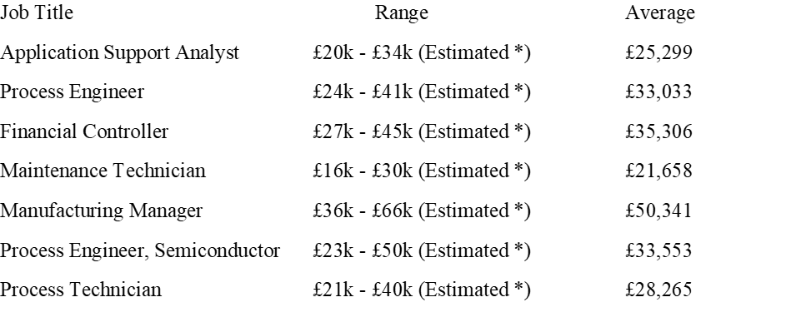
(payscale.com, 2021)

Table 2
(payscale.com, 2022)
By providing a living wage and drawing on funded training as a means of motivation. HR have targeted work-based learning and apprenticeships to help alleviate the recruitment and retention problem. In many cases the strategy has fostered poor morale and even stress, with staff expected to work their shifts, then attend college and complete assignments on their days off.
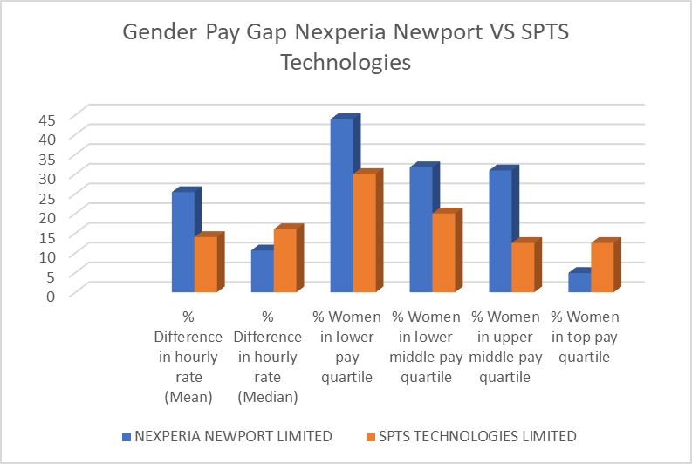
Source of data to create chart (GOV.UK, 2021)
At SPTS women are employed in 30% of the lowest paid jobs and 12.5% of the highest paid jobs but only 20% of the workforce are female.
At Nexperia women are employed in 41.3% of the low paid jobs and 6.3% of the high paid jobs. By manipulating the data provided there were approximately 106 females employed of a workforce of 384 which calculates to 27.6% of the workforce. However, the Newport HR Director stated in his report that they were confident that men and women are paid equally for doing the same jobs. (Argent, 2020)

Conclusion
To meet the manufacturing capacity planned for Nexperia Newport, the organisation plans to double its workforce. Recruitment, selection, on boarding and training is therefore critical to meet strategic objectives.
Recruitment and selection methods are good in some areas but not innovative. Vacant posts are advertised with a wide range of recruitment agencies that specialise in specific areas. The company uses its website well to advertise and select candidates for interview. (Reddy, 2018) considered that artificial intelligence should be used more widely by HR to screen, engage, re-engage, check that applicants remain interest, provide offer of acceptance, continue cultural integration, orientation and onboarding, inform of career development opportunities and answer any queries with regard employee relations and scheduling meetings.
The partnership with Smart Solutions is good but the organisation needs to first concentrate on retaining its current employees especially when the cost of training is considered. The movement from agency worker to full time employee needs to be quicker to prevent experienced agency staff leaving for full time employment.
Consideration should also be given to aligning the Newport site’s wages with other sites forming Nexperia UK. This is a bone of contention between long term agency workers in the same role as full time employees and if alignment doesn’t begin will be another demotivator.
The attraction of candidates for recruitment, via promises of vocational and non-vocational training is a good idea but needs to have less impact on work life balance. Innovative ideas for attracting attention to vacant posts must be sought.
There appears to be no gender pay gap regarding like for like roles but improving the ratio of men: female employees, particularly in higher paid roles could provide an opportunity to address the skill shortage. This does not require positive discrimination because Nexperia’s strategy is to double the workforce very quickly and Nexperia need to attract both genders to meet increasing demand. This is a real challenge that if met will benefit not just Nexperia but schools, colleges, universities, and the Welsh economy.
It is a fact that there is minimal representation of females in Science, Technology, Engineering and Mathematics (STEM). (Hobbs, 2019) considered that the problem is self-perpetuating with very few visible female role models to improve upon a STEM workforce in the ratio of 14:86. Nexperia need to plan to improve the situation in South Wales and HRM would benefit from liaising with WISE to help achieve gender balance through following the 10 Steps.
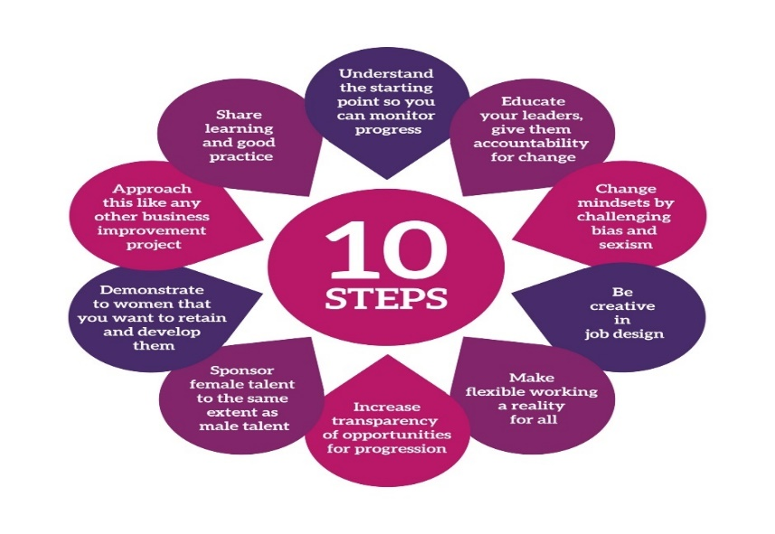
Sourced (WISE, 2022)

Recommendations
Relationships should be fostered with schools across South Wales. Encouraging interest in a technical career from the age of 12 and instilling the perception that it is cool to be an engineer irrespective of gender. A level and GCSE Level students must be made aware of the advantages of apprenticeships, higher apprenticeships and degree apprenticeships over regular academic routes. The best students in Swansea and Cardiff Universities should be offered MPhil and PhD opportunities with remuneration. A team will need to be recruited to conduct this and there will also be costs involved in PhD’s.
Recommendations to meet the recruitment demands faced by Nexperia Newport will be dealt with in greater detail in Assignment 2. The following is a brief of these recommendations
Create a team to research AI in HRM and find a solution that will improve communication in all areas of the HR function. Time and cost of solution will need to be accounted for.
It will come with a cost for increased manning but f the organisation wants to demonstrate that their commitment to wellbeing and CSR is real, a rethink is required to enable the development of staff during working hours.
A study of local wage thresholds must be conducted and reported upon with a view to overhauling the current wage structure that is causing so many problems. An increase in the labour budget will be required
The induction process needs overhaul and needs to be more bespoke. Integration should begin during the advertising stage and continue to build. The buddy method used to assist in the early part of employment is good practice. (Nexperia, 2022)
The availability of foreign national, work visas must be taken advantage of and discussions with Welsh Government must take place.

References
Argent, S., 2020. Nexperia Newport Gender Pay Gap Report 2020. [Online]
Available at: https://www.nexperia.com/about/corporate-social-responsibility/reports.html
[Accessed 23 March 2022].
Armstrong, M., 2020. Armstrong's Handbook of Human Resource Management Practice p.15. 15th ed. London, New Delhi, New York: Kogan Page.
CIPD, 2021. Strategic human resource management. [Online]
Available at: file:///C:/Users/hammnei/Downloads/strategic-hrm-factsheet_20220324T133245.pdf
[Accessed 16 March 2022].
Enginuity News, Industry News, 2021. Skills Award Winners Announced. [Online]
Available at: https://enginuity.org/news/skills-awards-winners-announced/
[Accessed 17 March 2022].
GOV.UK, 2021. Employer Pay Gap Service Employer Comparison. [Online]
Available at: https://gender-pay-gap.service.gov.uk/compare-employers
[Accessed 23 March 2022].
Gov.UK, 2022. Guidance Skilled Worker visa: shortage occupations. [Online]
Available at: https://www.gov.uk/government/publications/skilled-worker-visa-shortage-occupations/skilled-worker-visa-shortage-occupations
[Accessed 16 March 2022].
Hobbs, L. F.-R. a. L., 2019. Catch 22 — improving visibility of women in science and engineering for both recruitment and retention. JCOM Journal of Science and Communication, 18(4).
Nexperia, 2021. Nexperia at a glance. [Online]
Available at: https://assets.nexperia.com/documents/leaflet/Nexperia_Document_Company_Factsheet_2021.pdf
[Accessed 12 March 2022].
Nexperia, 2022. Executive Management Team. [Online]
Available at: https://www.nexperia.com/about/management-team.html
[Accessed 15 March 2022].
Nexperia, 2022. Nexperia Job Search. [Online]
Available at: https://www.nexperia.com/careers/job-search.html
[Accessed 23 March 2022].
payscale.com, 2021. Average Salary for IQE Employees in UK. [Online]
Available at: https://www.payscale.com/research/UK/Employer=IQE/Salary
[Accessed 23 March 2022].
payscale.com, 2022. Average Salary for Nexperia Employees in UK. [Online]
Available at: https://www.payscale.com/research/UK/Employer=Nexperia/Salary
[Accessed 23 March 2022].
Reddy, D. G. R. a. B. S., 2018. Recruitment Through Artificial Intelligence: A Concetual Study. International Journal of Mechanical Engineering and Technology (IJMET), 9(7), pp. 63-70.
This is Business This is Wales, 2021. Newport Wafer Fab Forging Ahead. [Online]
Available at: https://tradeandinvest.wales/inside-story/newport-wafer-fab#:~:text=The%20site%20was%20set%20up,of%20a%20Hong%20Kong%20company.
[Accessed 14 March 2022].
Welsh Government, 2019. Employer Skills Survey 2019: Wales Report, Cardiff: Crown Copyright.
WISE, 2022. Ten Steps Framework. [Online]
Available at: https://www.wisecampaign.org.uk/what-we-do/ten-steps-programme/
[Accessed 24 March 2022].

Appendix

 |  | Internal Factors Ranked 1-5 ( 1 = Low Importance, 5 = High importance) in accordance with time to react and greatest impact in current environment
Nexperia Newport TOWS Analysis |  | Strengths |  | Weaknesses
 |  | S1  (5) | Core staff are experienced and highly trained | W1  (4) | Age demographic is high with core staff
 |  | S2  (4) | Good relationship with colleges and universities in South Wales and still working with CS Connected. | W2  (3) | Minimum age to work in production at Nexperia is 18
 |  | S3  (5) | At Nexperia Newport HR has representation at Director level.  At head office there is representation from HR at Executive Level | W3  (4) | Vocational and non-vocational qualifications up to Level 4 do not fit the requirements of the semi-conductor industry.
 |  | S4  (3) | Meetings with Pearson the awarding body for HNC and HND have brought about changes in National Occupational Standards (NOS) that reflect the semi-conductor industry. | W4  (5) | There is a shortage of Engineers throughout Wales
 |  | S5 | Building allows for rapid growth in production
 |  | (5)
 |  | S6  (5) | New owner is willing to spend money to fulfil need to expand.
Opportunities |  | S-O Strategies |  | W-O Strategies
O1 | Lack of females undertaking STEM subjects and pursuing a career in Engineering | S-O1 | S1 S2 and S3 - O1 | W-O1 | W4 - O1
O2 | Extend relationship with schools and colleges beyond just the Engineering faculty at colleges | S-O2 | S1 and S2 - O2 | W-O2 | W2 and W4 - O2
O3 | The world focus on clean energy is driving the sales of electric vehicles (EV) that use Nexperia’s product | S-O3 | S2, S3, S4 and S5 - O3 | W-O3 | W2 and W4 - O3
O4 | The project CSConnected is based around integrating research excellence with markets. | S-O4 | S3, S4 and S5 - O4 | W-O4 | W3 and W4 - O4
O5 | Foreign National Visas |  | S3 to O5
Threats (Pandemic considered) |  | S-T Strategies |  | W-T Strategies
T1 | A career in Engineering is rarely considered by many females. | S-T1 | S1, S2, and S3 – T1 | W-T1 | W1 and W3 - T1
T2 | Skills shortage in Wales particularly in Engineering, further exacerbated by Brexit. Semi-conductor Skills in the area are greater than other parts of the UK but are nowhere near enough to satisfy the needs of Nexperia and CS Cluster | S-T2 | S1, S2, S3 – T2 | W-T2 | W1, W3, W4 – T2
T3 | Induction / Onboarding is relatively weak | S-T3 | S3 - T3 | W-T3 | W1 - T3
T4 | Low pay compared to local semi-conductor plants | S-T4 | S3 -T4 | W-T4

