

University of Wales Trinity Saint David
Master of Business Administration (MBA)

Human Capital Management
LCMB7023

Assessment component 1: Individual report (50%)

A STRATEGIC HUMAN CAPITAL ADVISORY REPORT FOR HELIOS URBAN MOBILITY (HUM)

Student Name: Motivaras keval Kishorbhai
Student ID Number: 2532691
Programme: Master of Business Administration
Module: Human Capital Management (LCMB7023)
Lecturer: Shahrukh Irfan
Word Count: 2616
Submission Date: 17th July 2026

Executive Summary
Helios Urban Mobility (HUM) is a start-up which is facing challenges in organisational socialisation of new employees and declining retention of staff. The target of this work is to provide human capital suggestions to address the challenges of this company. Transforming traditional onboarding system to efficient socialisation through application of relevant theories is a useful suggestion to improve employee engagement in this company. This study also proposes a strategic job design intervention for Helios Urban Mobility in order to address their declining engagement and high-potential graduate attrition.
Table of Contents

Introduction 4
Task A: Socialisation, Identity & Business Activism 4
TASK B: Job Design 10
TASK C: Reflective report 14
Conclusion 18
References 19

Introduction
Helios Urban Mobility (HUM) is a start-up that has been facing different organisational challenges involving weak organisational socialisation. Various suggestions are proposed to improve employee engagement in this new business.

Task A: Socialisation, Identity & Business Activism
Critical evaluation of traditional onboarding versus strategic organisational socialisation
Liao et al., (2022) have mentioned that employee socialisation is a significant strategic process. It assists newly hired employees in an organisation in acquiring knowledge. New employees learn to value necessary organisational behaviours and skills to become an effective member of an organisation. As per Ibrahim et al. (2022), traditional onboarding procedure can be frustrating as spending days attending lectures on instructions can be tedious for new workers. On the other side, a strategic organisational socialisation approach extends the process beyond administrative orientation. This process is more engaging for the new employees. A prolonged ramp-up time and high attrition among high-potential graduates are being experienced by HUM. It indicates the necessity of this company to renew its socialisation approach to get sustainable performance from employees by engaging maximum staff. The process of strategic organisational socialisation (OS) focuses on continuous improvement in staff interaction. Galema et al., (2022) have highlighted that Van Maanen and Schein's OS theory provides tactics for socialising new employees.
Tactic of OS | Description of the tactic
Collective and individual | It provides a degree of socialising new employees in a group by having common experiences. It also guides socialising employees separately for having different experiences.
Formal and informal | Participation of new employees in a tailored program. This program differentiates the job roles of new employees from other employees. The new staff can learn from trial-and-error process.
Fixed and variable | This degree implies that organisations expect occurrence of socialisation within an effective and fixed timeframe. Variables give new employees some cues within a given boundary.
Sequential and random | This degree reflects the plan of an organisation regarding offering gradual socialisation or random socialisation to new employees.
Investiture and divestiture socialisation | The previously acquired values of employees are considered in this degree of socialisation.
Table 1: OS Tactics recommended in Van Maanen and Schein’s OS theory
(Source: self-created)
Application of Van Maanen and Schein’s OS theory at HUM: Consistency in learning pathways of new employees at HUM can be provided by the company by combining approaches of this OS theory.
According to Woodrow et al. (2024), “psychological contract theory” helps understand that beliefs of an individual are shaped by exchange agreement in an organisation. For this reason, the relationships between employer and their employees in an organisation that influence employee commitment can be analysed through this theory.
Aspects | Theory | Application to HUM
Employee expectations | Fairness, recognition, career progression, and continuous development are demands of employees. | This theory can encourage HUM to provide clear expectations related to employees’ career growth.
Employer responsibilities | Organisations need to support expectations of their employees to foster commitment. | Graduate employees can need structured development. Employers can arrange a regular feedback system to improve employees' skills consistently. Similarly, employers can engage employees in innovative projects to improve their growth opportunities.
Table 2: Utilisation of “psychological contract theory”
(Source: self-created)
Identity construction theory: Awan and Abbas (2025) have implied that strategies related to organisational identity and team identity of newcomers in an organisation can be derived through “identity construction theory”. This theory helps explain that newcomers who understand organisational goals can collaborate more in an organisation. These employees can also demonstrate commitment towards the organisation during sudden changes. This company can engage employees through innovation, environmental and social missions by offering meaningful work.
Designing a structured socialisation framework for Helios
Stages | Activities | Anticipated outcomes
Pre-boarding | - Offering digital welcome pack  - Introduce to organisational culture  - Virtual meeting with team  - Mentor assignment  - Finishing administrative formalities | - Establishes a psychological contract  - Generates positive first-day impression  - Minimises uncertainties
First 90 days | - Technical training  - Formal introduction  - Sessions for giving weekly feedback to employees  - Engaging employees in cross-functional organisational projects  - Mentoring | - Improves clarity regarding job roles  - Accelerate learnings  - Organisational integration is strengthened
Year one | - Leadership coaching  - Plan for individual development  - Innovation projects  - Career reviews | - Improves organisational commitment  - Improves retention  - Generates organisational citizenship  - Supports career development
Table 3: Proposed socialisation framework for HUMs
(Source: self-created)
Justification: As per Rožman et al. (2023), employees demand continuous development scope. For this reason, this framework can be appropriate to improve organisational socialisation techniques at HUM as it can offer scope for continuous development to employees. Combination of structured learning, career development scope, regular feedback and mentoring opportunities can strengthen expectations related to psychological contract among employees. The organisational identification can be strengthened at HUM by following this framework. Besides, it can reduce adjustment time of new employees in a company and improve retention of graduate employees.
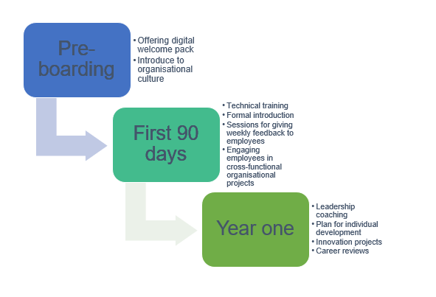
Figure 1: Flowchart for structured socialisation framework for Helios
(Source: self-created)
Proposing effective mechanisms to cultivate
Organisational identification | - Provide opportunity to employees to work with different departments on a project.  - Ensure employees are valued within the company.  - Sharing mission of the company with employees.
Ethical professionalism | - Arrangement of training related to professional ethics for employees can promote ethical professionalism (Osman et al., 2025).  - Training on responsible governance of AI in business can improve ethical professionalism of employees.  - Effective leadership needs to be incorporated so that employees can look up leaders as role models.  - Incorporation of ethical behaviour as a trait for performance appraisal can inspire employees.
“Business activist” mindset | “Ulrich’s HR business partner evolution”  "Ulrich's HR business partner evolution" implies the employees are important partners in an organisation (Mmaditla and Ndlovu-Hlatshwayo, 2022). HUM can encourage the employees to share strategic ideas to generate value for community and environment.  “Stakeholder capitalism perspective”  "Stakeholder capitalism perspective" inspires creating value to engage diverse stakeholders (Biancone et al., 2024). By considering this approach, HUM can encourage employees in responsible innovation, community engagement and sustainability initiatives.
Table 4: Proposed mechanisms for HUM
(Source: self-created)
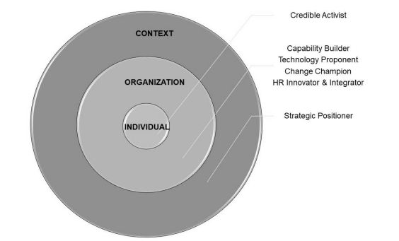
Figure 2: Ulrich’s HR business partner Competencies
(Source: Mmaditla and Ndlovu-Hlatshwayo, 2022)

TASK B: Job Design
Diagnosis of Helios - Why Traditional Job Design is Failing Helios
Helios Urban Mobility has only a 54% engagement score and high turnover of its top graduates, which signals an underlying problem caused by obsolete work design. Helios's 8-month ramp-up time is not just about acculturation, but it also reflects poorly designed roles, and it is a direct outcome of clearly separated tasks and the difficulty for new hires to figure out how to apply their disrupted contributions in order to achieve a strategically meaningful purpose. It is likely Helios has reverted to a traditional Tayloristic division of labour that restricts knowledge and confines people to the functions for which they are being paid, limits autonomy and eliminates task identity (Diehl and Preisendörfer, 2025). This form of organisation runs counter to all the needs of knowledge-intensive businesses, where meaningfulness, responsibility and knowledge of results are essential requirements for intrinsic motivation.
This old legacy infrastructure needs to be changed with the ambition of a high-potential system which further helps the skills and provides a visible and tangible output, far more than process rigour. The enduring engagement deficit and turnover cause an implicit problem for the architecture of work that has transformed from a springboard for growth into a challenge to professional development and corporate innovation. Most strategic needs for Helios are to undertake a radical transformation from a rigid job architecture to a flexible skill marketplace in which talent can be released. There should be an ongoing learning process that can be stimulated to restore innovative potential, which is required to be in a constant state of strategic renewal.
Theoretical Framework: The Core Concepts
Job Categories Model of Hackman and Oldham
The Job Characteristics Model of JCM continues to be a seminal framework that helps to understand work motivation and it suggests that there are 5 core job dimensions, as depicted in the figure below, which impact three important psychological states. These are experienced meaningfulness, experienced responsibility and knowledge of results and all these psychological states are predictive of positive outcomes (Geeks for Geeks, 2025). They are intrinsic motivation, job satisfaction and quality of performance, but for Helios, the JCM offers a diagnostic view. It helps the company to redesign disrupted and over-bureaucratised roles, and a strategic strategy might be to intentionally make jobs more enriching along these dimensions.
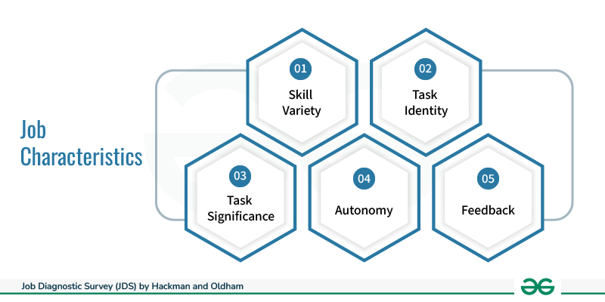
Figure 3: Job Categories Model of Hackman and Oldham
(Source: Geeks for Geeks, 2025)
Engineer cross-functional projects to increase skill variety and task identity and explicitly connect roles to urban sustainability outcomes to increase task significance and give decision-making authority to increase autonomy. As per Astakhova et al. (2024), the motivational circuit would be completed by incorporating continuous performance feedback systems and by deliberately pursuing these design parameters. The company can create psychological conditions for employees in order to view their work as inherently meaningful and worthy of their full discretionary effort.
Job Crafting Theory of Wrzesniewski and Dutton
Job design has long held a core and critical position in many business administration disciplines, but one aspect it cannot explain is a macro and hierarchical perspective. According to Bodnar et al. (2024) Wrzesniewski and Dutton define job crafting as the physical and cognitive changes individuals make to their task portfolios, relational connections and perceptual framing of their work. It is to increase personal meaning and identity and these theoretical perspectives are particularly relevant to Helios' high-potential graduates who often have a strong growth orientation and a desire to make an impact.
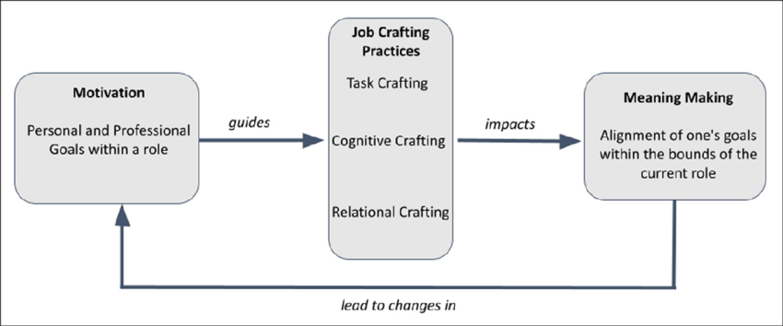
Figure 4: Job Crafting Model
(Source: Bodnar et al., 2024)
It allows employees to create their own roles and addresses the isolation caused by standardised and generic roles that do not take into consideration their unique abilities. Formalisation of these job crafting interventions would come perhaps with more formally structured job-crafting schemes like dedicated time for innovation or offering job project autonomy in order to improve engagement, boost psychological ownership, and open personalised routes to impact (Yun, Lee and Choi, 2024). These interventions can directly challenge the very homogenisation that high-potentials are discouraged from. They enable work to be seen not just as a compulsory duty but also as a self-expressed form of professional identity.
The Proposed Innovative Strategy for Helios
The recommended plan is divided into 4 integrated phases that gradually transition the current job architecture at Helios. Phase One is to break the walls, where the first step involves deconstructing all existing job descriptions into individual tasks, skills and competencies. It is an important first step that helps to deconstruct the complex boundaries that inhibit innovation, and the audit report will point to the skill gaps and redundancies within London, Berlin and Singapore (Manyo'e, 2025).
Phase Two is empowering talent as it sets up the foundation of the internal talent marketplace by placing all employees into cross-functional teams working on time-bound projects (Sultana, 2026). It promotes task variety, task identity, autonomy and employee engagement because it gives them the option to choose projects based on their skills and passions.

Figure 5: Proposed Design
(Source: Self-created)
Phase Three is structured craftsmanship and it is a phase that involves formalised Job Crafting through an innovative 70/20/10 allocation and the necessity for each employee to complete their own personal crafting Plan with 90-day review periods (Manyo'e, 2025). These plans help employees in order to identify their current skill portfolios and work on redefining them and still address company goals.
Phase Four is inspiring impact narratives and these are short and impactful narratives that tie all the project outcomes to the sustainability mission of Helios. This is very helpful for validating the significance of the tasks performed and encouraging professional development of ethical standards (Iman and Wahyuningtyas, 2025). This all-inclusive plan is highly focused, as the proposal aims to transform Helios from an employer to a thriving ecosystem of employees who contribute to sustainable urban change.
Justification and Expected Outcomes
The strategic reason for the strategy is that it handles the motivational deficits that are addressed through JCM which gives employees power through job crafting. Helios can utilise a skills-based architecture to foster psychological states conducive to intrinsic motivation (Yun, Lee and Choi, 2024). The concept seeks to increase the engagement score over 54% and with more engagement from the company, it would reduce attrition by creating engaging career pathways. The company would make it possible to improve innovation through cross-functional team working and the strategy is heavily focused on human capital and strategic agility in order to thrive in the dynamically fluctuating markets.

TASK C: Reflective report
Decision on using of AI as a decision-support tool without eroding critical human judgement
According to Venugopal et al. (2024), Artificial Intelligence (AI) is being used in "human resource management" (HRM) systems to improve workforce planning and retirement strategy. Besides, as an effective HR professional, I will ensure that AI is not used as a decision-maker. Nevertheless, I have decided that I will ensure that AI is only utilised as a decision-support tool in the future. AI is beneficial in analysing large volumes of organisational workforce data (Krishna and Sidharth, 2023). Similarly, current trends in recruitment policies in the market can be identified by AI. These benefits of AI-based HR-related tools demonstrate the effectiveness of this technology in HRM. Nevertheless, over-reliance on AI can involve bias in HR strategies as it uses historical data regarding an organisation (Okon et al., 2024). I will maintain critical judgement in HRM by ensuring that final decisions remain under control of humans. AI can help shortlist effective candidates after analysing predefined criteria of the job. I will verify AI-driven information before making a strategic HRM-related decision. I will ensure if the candidates fit with organisational culture prior to recruiting them.
Outlining a personal capability development plan to enhance my future employability capabilities
Capability | Development processes | Career-related advantages
AI augmentation utilisation in HRM | - Study prompt engineering.  - Learn predictive analytics.  - Study platforms associated with AI-driven HRM systems.  - Study responsible HRM | - Align use of AI and ethical decision-making.  - Ensure human-driven decision-making.
Change management | - Participating in organisational change-related projects.  - Learning frameworks on change management involving ADKAR and Kotter’s model. | - Give effective support during organisational transformations.  - Ensure effective employee adaptation.
Awareness regarding global mobility | - Improve knowledge regarding cross-cultural management.  - Study international strategies for HRM.  - Study labour laws.  - Gaining an idea on talent management in a global context. | - Support mobility of international workforce.  - Manage teams involving multicultural members.
Data literacy | - Complete training related to Power BI, HR analytics and Excel.  - Interpretation of workforce dashboard.  - Interpretation of KPIs. | - Improving HRM-related decision-making by including evidence-based planning.  - Include evidence-based knowledge in workforce planning.
Awareness regarding (Environmental, social, governance) ESG and sustainability | - Improving knowledge on ESG reporting.  - Enhancing understanding of sustainable HRM.  - Attending professional courses to gain knowledge regarding stakeholder capitalism. | - Ensure sustainable initiatives are incorporated in the HRM-based decisions.  - Focus on ESG-related aspects in organisational decisions.  - Include sustainability principles in employee management.
Skills associated with strategic influence | - Participating in workshops that offers knowledge on leadership skills.  - Practising negotiation. | - Utilise learnings gained from senior leaders.  - Support organisational decisions.  - Support changes in the company.
“Continuous professional development” (CPD) | - Gain professional certificates.  - Attend webinars and conferences. | - Maintaining HR knowledge.  - Focus on career progression.  - Gain long-term success.
Emotional intelligence (EQ) | - Improving skills of conflict resolution is a part of EQ skills (Sharma et al., 2024).  - Improving self-awareness.  - Leadership practice. | - Effective leadership.  - Teamwork.
Skills related to digital transformation | - Improve knowledge associated with “human resource information system” (HRIS).  - Gain knowledge in handling digital collaboration technologies. | - It can assist me in leading HR transformational practices.  - I can work in digital-based company in the future.
Table 5: Personal capability development plan
(Source: self-created)

Conclusion
Helios Urban Mobility’s renewal strategy is fundamentally built around reinventing its human capital structure by moving to a skills-based job design. It incorporates Job Characteristics Model components that are supported by the formalism of job crafting for Helios to be able to turn unengaged workers into intrinsic business activist resources.

References
Astakhova, M.N., McKay, A.S., Doty, D.H. and Wooldridge, B.R., (2024). Does one size fit all? The role of job characteristics in cultivating work passion across knowledge, blue‐collar, nonprofit, and managerial work. Human Resource Management, 63(3), pp.443-462.
Awan, N.A. and Abbas, M., (2025). Organizational socialization strategies and newcomers' identity development: A social identity perspective. Human Resource Development Quarterly, 36(1), pp.69-87.
Biancone, P.P., Secinaro, S., Brescia, V. and Calandra, D., (2024). Which direction for stakeholder capitalism? Approaches and reporting towards POP accounting. Sustainable Development, 32(6), pp.6579-6594.
Bodnar, C.A., McCave, E., Smith-Orr, C., Strong, A.C., Faber, C.J. and Lee, W.C., (2024). Surviving the Wilds of Academia: Personas Depicting Early-Career Engineering Education Scholars Role Crafting to Achieve Their Goals. Studies in Engineering Education, 5(2), pp. 47-66.
Diehl, C. and Preisendörfer, P., (2025). Inefficiencies in the division of labour in human societies. Philosophical Transactions of the Royal Society B: Biological Sciences, 380(1922), p.20230278.
Galema, G., Duvivier, R., Pols, J., Jaarsma, D. and Wietasch, G., (2022). Learning the ropes: strategies program directors use to facilitate organizational socialization of newcomer residents, a qualitative study. BMC Medical Education, 22(1), p.247.
Geeks for Geeks, (2025). Job Diagnostic Survey (JDS) by Hackman and Oldham. https://www.geeksforgeeks.org/hr/job-diagnostic-survey-jds-by-hackman-and-oldham/ (Accessed: July 15, 2026).
Ibrahim, U.S.G., Yusof, R.B. and Ibrahim, H.I.B., (2022). The role of employee onboarding training program in mitigating deviant workplace behavior: Job satisfaction as a mediator. Global business and management research, 14(3s), pp.983-1007.
Iman, N.R. and Wahyuningtyas, R., (2025). The Influence of Professionalism and Career Development on Employee Performance (Case Research: BKD Provincial Government of West Java). American Journal of Economic and Management Business (AJEMB), 4(8), pp.1350-1360.
Krishna, S. and Sidharth, S., (2023). AI-powered workforce analytics: maximizing business and employee success through predictive attrition modelling. International Journal of Performability Engineering, 19(3), p.203.
Liao, G., Zhou, J. and Yin, J., (2022). Effect of organizational socialization of new employees on team innovation performance: A cross-level model. Psychology Research and Behavior Management, pp.1017-1031.
Manyo'e, E.T., (2025). MODEL 70-20-10 VS ADDIE: A COMPARATIVE ANALYSIS OF LEARNING MODELS FOR ENHANCING APPARATUS COMPETENCE. Jurnal Administrasi Negara, 31(2), pp.107-126.
Mmaditla, T. and Ndlovu-Hlatshwayo, E.N., (2022). The perceived applicability of coaching skills among human resource business partners of South African state-owned entities. Journal of Management and Entrepreneurship Research, 3(2), pp.106-120.
Okon, R.I.C.H.A.R.D., Odionu, C.S. and Bristol-Alagbariya, B.E.R.N.A.D.E.T.T.E., (2024). Integrating data-driven analytics into human resource management to improve decision-making and organizational effectiveness. Ire Journals, 8(6), p.574.
Osman, E.H.E., Hafeez, G.T.A. and Mohammed, A.T.A., (2025). The impact of implementing professional ethics standards on job performance and professional behavior of employees in information institutions in Khartoum State: An analytical study. Edelweiss Applied Science and Technology, 9(10), pp.908-930.
Rožman, M., Tominc, P. and Milfelner, B., (2023). Maximizing employee engagement through artificial intelligent organizational culture in the context of leadership and training of employees: Testing linear and non-linear relationships. Cogent Business & Management, 10(2), p.2248732.
Sharma, P., Dhanta, R. and Sharma, A., (2024). Emotional intelligence and conflict resolution in the workplace. In Leveraging AI and emotional intelligence in contemporary business organizations (pp. 102-121). IGI Global Scientific Publishing.
Sultana, R., (2026). A Framework for Cross-Functional Collaboration: Aligning Project Coordination, QA Engineering, and Client Communication to Maximize Project Performance. American Journal of Scholarly Research and Innovation, 5(01), pp.327-381.
Venugopal, M., Madhavan, V., Prasad, R. and Raman, R., (2024). Transformative AI in human resource management: enhancing workforce planning with topic modeling. Cogent Business & Management, 11(1), p.2432550.
Woodrow, C., Erdem, C. and Guest, D.E., (2024). The role of previous experience in the analysis of the psychological contract and its outcomes during the socialization process: a signalling theory perspective. The InTernaTIonal Journal of human resource managemenT, 35(18), pp.3145-3171.
Yun, M.S., Lee, M. and Choi, E.H., (2024). Job crafting, positive psychological capital, and social support as predictors of job embeddedness on among clinical nurses-a structural model design. BMC nursing, 23(1), p.192.

