Assessment 2 The Global Business Environment
Module Code:LCCB4005 Lecturer: Dr Rexon Nting
(Individual Report)
Analytical Report
Impact of the Covid - 19 Pandemic
on Tesla Plc

Stefan Vasilev Zamfirov
University of Wales Trinity Saint David, London Campus,
BA Business and Management, London, United Kingdom
2024063@student.uwtsd.ac.uk

Executive Summary
In this work, with respect to Tesla INC, an analysis of the global environment has been conducted. Also, the impact of the coronavirus pandemic upon the automobile industry and the functioning of Tesla INC has been completely analysed. The forces that shape the global business environment, the changes in this environment and its impact upon the automobile industry and Tesla INC have been analysed. Also, the reasons for engagement of the company in international trade has been considered.

Table of Contents
Introduction 4
Forces shaping the Global Business Environment 5
Changes in the Global Business Environment 6
Impact of the pandemic on the Automobile Industry 7
Success and Survival of the industry in consideration with Megatrends 10
Reasons for engagement of the organisation in International Trade 12
Analysis of the Market 13
Conclusion 15
References 16

Introduction
The Tesla Inc. is a clean energy and electric vehicle company which manufacturers and designs electric cars, solar panels, battery energy storage and many other products. It is a very valuable automaker in the entire world and occupies the market capitalisation of nearly $1 trillion (Alghalith, 2018).
In this report, the analysis of the impact that the COVID-19 pandemic has created upon the automobile industry has been considered. In this context, the factors that contribute towards the survival and success of the Tesla INC in the automobile industry have also been discussed. Also, the several megatrends impacting the automobile industry and the functioning of Tesla INC have also been discussed.


Figure 1:Tesla
Source: (Bruijl, 2017)

Forces shaping the Global Business Environment
There are several factors and forces present that play an important role in shaping the international business environment. The analysis of these forces is being conducted for the purpose of evaluating the context of Tesla INC and analysing how it conducts its activities in such a dynamic global environment. The various forces comprise of monetary, technological, climatic, social, economic and regulatory forces (Almenhali, et al., 2021). Due to the advent of modern technologies constantly, huge technological shift starts taking place in the business environment and thus, it is very essential for the Tesla INC to undergo through technological changes and to adopt modern and innovative technologies. As a result, it will facilitate expansion of the organisation and it will be able to compete with the changing global environment. Another very essential force that has an impact of shaping the global business environment is the monetary force and it comprises of fluctuations in currency value that impacts the operations of Tesla INC in several countries where it operates. These monetary factors must be effectively taken into consideration. Moreover, the climatic changes have a huge impact upon influencing the direction and functioning of the Tesla INC (Chirra and Kumar, 2018).

Changes in the Global Business Environment
When the business operations are to be conducted with respect to a global scenario, it is seen that, there are several changes that needs to be implemented by Tesla INC. These changes are in the form of external and internal factor changes and some of them comprise of emerging markets, privatization and globalization, technological evolution, more emphasis on sustainable and clean energy generation etc. (Çitilci and Akbalık, 2020). Some of these changes have a positive impact, whereas, some have negative impact upon the functioning of Tesla INC. When Tesla uses modern technologies, its development and expansion takes place in the global environment. However, several government laws and regulations need to be abided by the company in order to conduct its operations with efficiency.

Impact of the pandemic on the Automobile Industry
Due to the outbreak of the COVID-19 pandemic during the second half of the year 2019, the functioning of automobile industry has been immensely impacted. Several restrictions have been imposed that needs to be complied by the automobile industry (Friesendorf and Uedelhoven, 2021). Thus, it has created a lot of imbalances, imposition of restrictions on import and export of raw materials, disruption in operations due to lack of human resource availability etc. As a result, several obstacles to smooth functioning have been faced by Tesla INC. The impact that the pandemic has created upon the automobile industry can be discussed as follows-
1. Government regulations regarding restricting Travels: Several travel related restrictions have been imposed by the government of different countries. This has led to reduction in the demand for vehicles and automobiles. As a result, the demand for Tesla’s vehicles have also decreased considerably. Moreover, it has been observed that, people are considering to purchase more of second-hand vehicles instead of investing in first and vehicles due to reduction in their disposable income and reduced requirements of vehicles during the time of the pandemic. Thus, there has been negative impacts upon the demand for Tesla’s vehicles due to these restrictions.
2. Decrease in auto shows: Auto shows are interactive events and platforms that help in the promotion of new vehicles. However, due to the advent of the coronavirus pandemic, there was complete stoppage in the conduct of auto shows in which Tesla INC had also invested much finance. These uncertain cancellation of auto shows have led to several losses hand had a negative impact upon the profitability of Tesla INC. Thus, it has been observed that, the pandemic has created negative impact upon the company due to the cancellation of several auto shows that has led to reduction in its profit margin (Itoh and Shibata, 2018).
3. Retrenchment of the employees: By way of retrenchment, the Tesla INC had asked many of its employees to stop their services and to leave the organisation during the time of the pandemic. Thus, the layoff of its various competent workers has impacted the functioning of the company in a negative manner. However, after the pandemic, the company is again recruiting candidates as its business operations have started to be conducted in the normal manner as was done before the pandemic. However, this process is increasing the costs of the company as a thorough recruitment process needs to be conducted which is expensive (Janssens, et al., 2020).
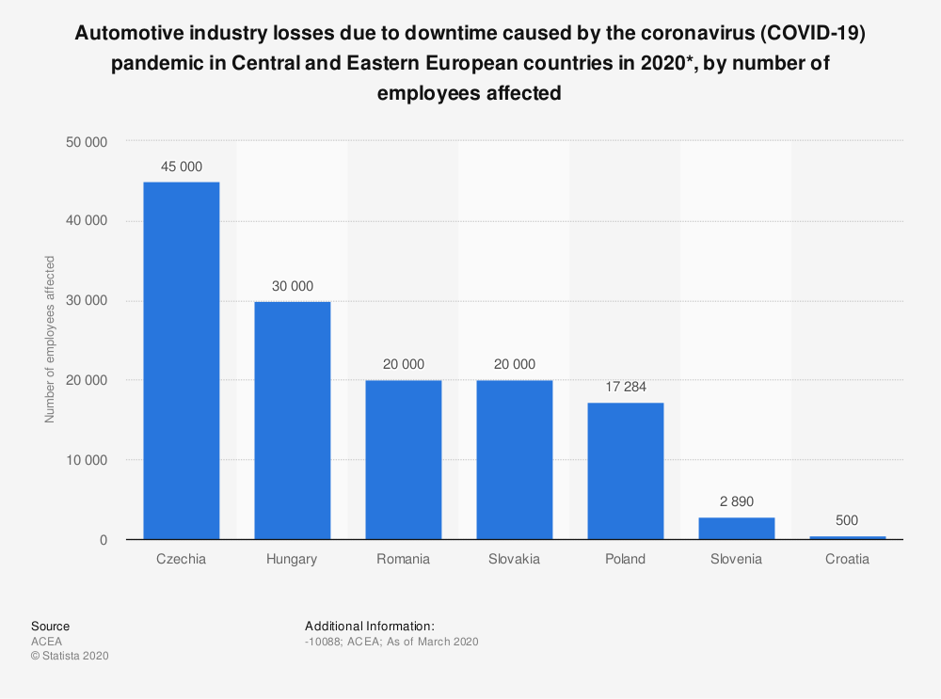
Figure 2: Impact of pandemic on the Automobile Industry
Source: (Kretschmar, 2020)
4. Low demand of Tesla cars: Due to the difficulties that the pandemic has caused to the people, their abiding by the several social distancing related norms and regulations imposed by the government. Moreover, the visits of people in several social gatherings have also reduced significantly due to which the demand for vehicle is not as high as it was before. This has led to reduction in the demand for Tesla’s vehicles. Moreover, in the present scenario, the consumers are now preferring to purchase second-hand products as they do not want to spend more on purchasing first hand automobiles. They have become more conscious towards their spending and this is reducing the demand for Tesla’s vehicles (Khan, et al., 2020).
5. Adopting latest technologies: The use of modern technology is being done by Tesla INC for the purpose of providing best driving experience to their customers keeping into consideration the protocols related to the coronavirus pandemic. Thus, it has adopted a virtual reality test drive program by which it is able to provide test drive to its customers virtually. Moreover, several precautionary measures are being taken by the company to ensure that their customers remain safe. For the purpose of implementing this technology, huge amount of investment has been made by the Tesla INC as a result of which its operational costs have increased significantly and its profitability has reduced (Khan, et al., 2020).

Success and Survival of the industry in consideration with Megatrends
It is seen that; huge technological developments are taking place and several megatrends are also being witnessed in the automobile sector. These megatrends comprise of human machine interface, shared mobility, artificial intelligence, blockchain mechanism, electrification etc. These megatrends contribute immensely towards the survival and success of the Tesla INC. These factors facilitate the company to enhance its customer engagement and to provide best facilities to the customers so that they are attracted and retained (Lang, et al., 2021). As a result of these technologies, the Tesla INC is being able to promote its vehicles effectively by using several digital and online platforms. These megatrends have contributed immensely towards the success and survival of Tesla Inc in the automobile industry. As a result, it is able to function effectively in the global business environment and can overcome the latest dynamic changes effectively. This can be discussed as follows–
Use of latest technology: In order to increase consumer attraction and engagement, Tesla INC is using innovative automotive technologies. The company is trying to create a multi-channel vehicle buying experience for its customers. It is also adapting to several online promotional strategies and is working on establishing and strengthening its digital presence especially, during the time of the COVID-19 pandemic.
Digital enabled business model: The business model of the Tesla INC has been highly converted into a technology oriented one as a result of which, it is able to enhance its revenue streams and it is one of the success factors of the Tesla Inc in the automobile industry (Matovic, 2020).
Development of strategic relationships: Another essential factor that leads to contribution of success and development of Tesla INC is its maintenance of strong strategic relationships. It maintains good relationships with its customers, suppliers, lenders etc. Moreover, it has good relationships with its stakeholders and constantly tries to maximise their value. Moreover, the company makes best use of technology and conducts regular research and development for the progress of business and its stakeholders.
Automotive supply chains: The supply chain management system of the Tesla Inc is very effective and it includes all processes that are involved in dispatch of the vehicles from warehouse to the time when it reaches the customers. All these stages are performed very systematically and it is ensured that regular supply of vehicles is done so let the customers get their booked vehicles on time (Radic, et al., 2020).

Reasons for engagement of the organisation in International Trade
The Tesla INC is very active in conducting international trade and it enjoys several advantages as a result of it. It is involved in international trade in order to enhance its revenues. Also, due to international trade related activities, the companies getting good exposure in the global environment. Its profitability is also increasing consistently as a result of international transactions. Also, it facilities risk management for Tesla Inc and it is being able to export huge number of vehicles which helps in earning significant foreign currency. The various reasons behind engagement of the Tesla Inc in international trade comprise of benefit of foreign exchange, better risk management, growth prospects, disposal of surplus goods, earning higher revenues and maintaining significant growth, capturing large share in the automobile industry of the world etc. (Smys and Ranganathan, 2019).

Analysis of the Market
With respect to Tesla INC, the global business environment can be analysed as follows-
1. Micro-economic Foundation: The microeconomic factors are very significant and are to be effectively analysed while conducting global business environment related activities. These factors comprise of technological changes, market size, availability of raw materials, infrastructure and transportation and facilities, growth rate of the market, amount of investment, competitor analysis etc. The Tesla INC analyses these factors considerably while conducting global operations (Zulkifli, et al., 2020).
2. Macroeconomic Foundations: The relevant macroeconomic factors need to be analysed completely before conducting any type of global business. These factors comprise of economic activities, political stability, cultural differences, social differences, legal regulations, environmental regulations etc. The Tesla Inc analyses these factors completely before entering any country for conducting operations.
3. Market structures and their influence on firm strategy: The operations of Tesla INC are mainly conducted in the automobile industry and it occupies more than 60% sharing this industry. The market shares and customer base of the company has enhanced due to an effective global expansion strategy adopted by the Tesla Inc. The company makes use of the best technology in order to enhance its customer base and to function effectively keeping into consideration the market changes and structure (Alghalith, 2018).
4. Long-run Changes: The Tesla INC implements various long-term changes for the purpose of expanding in the industry and these changes comprise of mergers and acquisition, activities related to research and development, entering into joint ventures, franchising etc.
5. Short-run Changes: Various short-term changes are done by the Tesla INC for operating effectively in the global market. The various changes comprise of changing business model, changing the strategy of human resource recruitment and selection, changing its organisational vision and culture etc. (Almenhali, et al., 2021).

Conclusion
Thus, it is seen that, several business environmental factors need to be analysed in order to conduct operations in the global business environment. The Tesla Inc analyses the several factors effectively and formulates its strategies accordingly. Moreover, the company is engaged in international business for the purpose of enhancing its growth, customer base and profitability.

References
Alghalith, N., (2018). Tesla: innovation with information technology. International Journal of Business Research and Information Technology, 5(1), pp.37-51.
Almenhali, A., Alhajeri, H., Almansoori, H., Aljneibi, N., Almansoori, N., Alsulaity, N., Mohammed, Y. and Nobanee, H., (2021). Financial Analysis of Tesla. Available at SSRN 3896901.
Bruijl, G.H.T., (2017). Tesla Motors, Inc.: Driving digital transformation and the digital ecosystem. Inc.: Driving Digital Transformation and the Digital Ecosystem (October 14, 2017).
Chirra, S. and Kumar, D., (2018). Evaluation of supply chain flexibility in automobile industry with fuzzy DEMATEL approach. Global Journal of Flexible Systems Management, 19(4), pp.305-319.
Çitilci, T. and Akbalık, M., (2020). The Importance of PESTEL Analysis for Environmental Scanning Process. In Handbook of Research on Decision-Making Techniques in Financial Marketing (pp. 336-357). IGI Global.
Friesendorf, C. and Uedelhoven, L., (2021). Digital Transformation of Global Mobility Markets. In Mobility in Germany (pp. 1-9). Springer, Cham.
Itoh, M. and Shibata, J., (2018). A study of the operations of Japanese firms in Asia: the electrical machinery industry. In Corporate Links and Foreign Direct Investment in Asia and the Pacific (pp. 187-202). Routledge.
Janssens, C., Havlík, P., Krisztin, T., Baker, J., Frank, S., Hasegawa, T., Leclère, D., Ohrel, S., Ragnauth, S., Schmid, E. and Valin, H., (2020). Global hunger and climate change adaptation through international trade. Nature climate change, 10(9), pp.829-835.
Khan, S.A.R., Yu, Z., Belhadi, A. and Mardani, A., (2020). Investigating the effects of renewable energy on international trade and environmental quality. Journal of Environmental management, 272, p.111089.
KM, K.R. and KG, N.K., (2021). Impact of Covid-19 Pandemic in the Automobile Industry: A Case Study. International Journal of Case Studies in Business, IT and Education (IJCSBE), 5(1), pp.36-49.
Lang, J.W., Reber, B. and Aldori, H., (2021). How Tesla created advantages in the ev automotive paradigm, through an integrated business model of value capture and value creation. Business & Management Studies: An International Journal, 9(1), pp.385-404.
Matovic, I.M., (2020). PESTEL Analysis of External Environment as a Success Factor of Startup Business. ConScienS, p.96.
Radic, N., Radic, V. and Stevanovic, M., (2020). Economy Impact of the Coronavirus Pandemic on the Automobile Industry. Oditor, p.55.
Smys, S. and Ranganathan, G., (2019). Robot assisted sensing control and manufacture in automobile industry. Journal of ISMAC, 1(03), pp.180-187.
Zulkifli, N.A., Yazid, M.F.M. and Shamsudin, M.F., (2020). How will the market players in the automotive industry strengthen their market positioning during the pandemic Covid-19 outbreak and recession. Journal of Postgraduate Current Business Research, 1(1).

