

Programme: MSc Data and Artificial Intelligence
Module: L7 – Application of Machine Learning
Module code: ACCA7025
Assessment Component 1
Assignment Title: Predictive Maintenance Using Traditional ML — Consultancy Report
Lecturer: Dr Aliyu Sambo
Student Name: Darpanbhai Raiyani
Student ID: 2534009

Table of Contents
- Abstract
- 1. Introduction
- 2. Literature Review
  - 2.1 Machine Learning in Predictive Maintenance: An Overview
  - 2.2 Random Forest
  - 2.3 Support Vector Machines
  - 2.4 Gradient Boosting Methods
  - 2.5 Decision Trees and Logistic Regression
  - 2.6 Handling Class Imbalance
  - 2.7 Feature Engineering and Selection
- 3. Proposed Workflow Methodology
  - 3.1 Data Collection and Understanding
  - 3.2 Data Preprocessing
  - 3.3 Handling Class Imbalance
  - 3.4 Feature Engineering
  - 3.5 Feature Selection
  - 3.6 Model Training and Hyperparameter Optimisation
  - 3.7 Model Evaluation
  - 3.8 Deployment and Monitoring
- 4. Discussion and Recommendation
  - 4.1 Recommended Algorithm: Random Forest
  - 4.2 Comparative Analysis
  - 4.3 Limitations and Mitigations
  - 4.4 Expected Outcomes and Business Value
- 5. Conclusion
- References

Abstract
Predictive maintenance (PdM) is emerging as a game-changing operational strategy in modern manufacturing, allowing organisations to predict equipment failures from continuous sensor data before disruptive incidents occur. This consultancy report addresses the requirements of a manufacturing company that collects temperature, vibration and pressure data from its production machines but has limited computational resources. This report is based on a systematic review of the recent literature on traditional machine learning (ML) approaches in industrial predictive maintenance and evaluates six candidate algorithms: Decision Trees, Logistic Regression, KNN, SVM, Gradient Boosting, Random Forest.

Based on the comparative analysis of predictive accuracy, interpretability, training efficiency and computational cost, Random Forest is the most appropriate algorithm. Its ensemble structure provides high fault-detection accuracy, robustness to noisy sensor data, and practical interpretability through feature-importance rankings, and is computationally feasible on modest hardware. The report provides a comprehensive and practical ML workflow with steps for data preprocessing, Synthetic Minority Over-sampling Technique (SMOTE) for class imbalance correction, rolling-window feature engineering, stratified cross-validation, and evaluation using Precision, Recall, F1-Score, and Area Under the Receiver Operating Characteristic Curve (AUC-ROC). This solution provides a systematic, cost-effective, and operationally feasible roadmap for implementing predictive maintenance in resource-constrained manufacturing environments.

1. Introduction
Modern manufacturing sectors increasingly operate in competitive environments where equipment downtime directly leads to financial losses, supply chain disruptions, and diminished product quality. Annual costs of unscheduled equipment failures in industrial manufacturers are estimated at billions of pounds, with documented downtime costs ranging up to £50,000 per hour, depending on the industry and production volume [1]. The maintenance strategy has therefore become an essential lever for operations managers seeking to improve equipment availability and reduce the total cost of ownership.

The maintenance strategies are traditionally classified into three types. Reactive maintenance, fixing things only after they fail, can save you money up front but often causes costly and unplanned downtime. Preventive maintenance schedules interventions at fixed intervals to prevent failure. This minimises unplanned downtime but may unnecessarily require equipment maintenance when it is in peak operating condition. Predictive maintenance (PdM) uses operational data to predict failures before they occur, allowing maintenance teams to intervene at the right moment. This approach provides the best economic compromise among the three strategies, balancing equipment availability and minimising unnecessary maintenance [2].

With the advent of Industry 4.0, the field of industrial maintenance has experienced a paradigm shift through the integration of cyber-physical systems, the Industrial Internet of Things (IIoT), and advanced data analytics. Nowadays, manufacturing machines commonly include sensor networks that produce high-frequency data streams, e.g., temperature, vibration spectrum, and pressure levels. These streams of data provide useful signals to predict early signs of deterioration and impending failure long before they lead to operational disruptions.

There has been significant research interest in applying machine learning (ML) to these sensor data streams, and ensemble methods, kernel-based classifiers, and boosting algorithms have all been shown to learn complex relationships between operational measurements and failure events. However, the computational costs and interpretability issues of many deep learning models pose serious challenges for manufacturing Companies, particularly small and medium-sized enterprises (SMEs) with limited hardware and data science expertise, can benefit from traditional ML algorithms. These algorithms offer viable, interpretable, and computationally efficient options that can be deployed and maintained effectively in real-world operational settings. [4].

The report was commissioned to advise a manufacturing company on the design and deployment of a traditional ML-based predictive maintenance system. The company collects sensor readings from its manufacturing equipment, including temperature, vibration, and pressure. The purpose of this report is to [1] review the state-of-the-art literature on traditional ML methods for predictive maintenance, [2] develop a structured and efficient ML workflow matching the company's data and computational constraints. [3] Recommend the most appropriate traditional ML algorithm with detailed comparative justification, and [4] specify appropriate model evaluation metrics. Throughout this report, neural networks and deep learning methods are explicitly excluded from consideration due to the company's computational limitations.

2. Literature Review

2.1 Machine Learning in Predictive Maintenance: An Overview
The application of machine learning to industrial predictive maintenance has produced a substantial body of literature, with systematic reviews offering important integrative perspectives. [5] Conducted a comprehensive review of PdM approaches for industrial applications, categorising methods by data requirements, model complexity, and deployment feasibility. They concluded that, although deep learning approaches often achieve high benchmark accuracy, their computational overhead and lack of transparency make them impractical for many real-world manufacturing deployments. [6] similarly surveyed decision-making frameworks in PdM, emphasising that algorithm selection must consider operational factors—such as training data availability, interpretability requirements, and computational infrastructure—in addition to predictive performance alone. [7] further show that traditional ML algorithms continue to deliver competitive performance in manufacturing classification tasks, particularly when combined with carefully engineered, domain-specific features.

A recurrent theme in the literature is the fundamental challenge of class imbalance: in industrial datasets, equipment failure events typically constitute only one to five per cent of all operational observations [8]. If left unaddressed, this imbalance leads classifiers to achieve deceptively high overall accuracy while systematically failing to detect the minority failure class. Consequently, addressing class imbalance through resampling, cost-sensitive learning, or algorithmic modifications is a critical requirement in any PdM ML workflow.

2.2 Random Forest
Random Forest has emerged as one of the most widely adopted algorithms for industrial fault detection and failure prediction, consistently demonstrating strong performance across diverse application domains. [4] Conducted a systematic literature review of ML methods in PdM and identified Random Forest as the most frequently recommended traditional ML algorithm, citing its robustness to overfitting, ability to handle mixed feature types, and capacity to provide interpretable feature-importance rankings. [9] Applied Random Forest to bearing fault prediction using vibration sensor data, reporting classification accuracy exceeding 95% while substantially reducing computational requirements compared with comparative approaches. A particularly important property of Random Forest for PdM is its inherent ability to handle class imbalance more robustly than single classifiers do, especially when combined with resampling strategies such as SMOTE. [10] demonstrate that applying SMOTE before Random Forest training yields significant improvements in both Precision and Recall for fault detection, making this combination a recommended best practice. The algorithm's bagging mechanism—constructing each tree on a random bootstrap sample with random feature subsets—introduces diversity across the ensemble, improving generalisation on minority classes.

2.3 Support Vector Machines

Support Vector Machines (SVMs) with RBF kernels achieve high accuracy for vibration-based fault detection in rotating machinery [11]. Still, they suffer from quadratic training complexity, which limits scalability to large industrial sensor datasets [12]. They also lack native feature-importance measures for interpretability and require careful kernel and hyperparameter tuning, thereby increasing deployment complexity.

2.4 Gradient Boosting Methods

Gradient Boosting methods such as XGBoost and LightGBM typically achieve higher predictive accuracy than Random Forest for multi-class fault classification when failure modes overlap [13]. However, their sequential training makes them more computationally intensive, requires more complex hyperparameter tuning, and makes them more prone to overfitting on small or imbalanced industrial PdM datasets without strong regularisation [14, 15].

2.5 Decision Trees and Logistic Regression
Decision Tree classifiers offer maximum transparency—their rule-based structure can be directly visualised and interpreted by non-technical stakeholders, making them highly suitable for auditable maintenance decision support [16]. However, individual Decision Trees are prone to overfitting on noisy sensor data and typically underperform ensemble methods substantially on complex failure prediction problems [8]. Logistic Regression provides a linear baseline classifier characterised by strong interpretability and negligible computational cost. Still, its fundamental assumption of linear decision boundaries is inconsistent with the intricate, non-linear connections between sensor data and equipment failure modes [17, 18]. Logistic Regression consistently underperforms ensemble methods in industrial fault detection tasks, and its use is best restricted to establishing a performance baseline rather than serving as a production classifier.

2.6 Handling Class Imbalance
Class imbalance is widely recognised in the predictive maintenance literature as a critical challenge that requires explicit treatment.[19] Conducted a comprehensive review of oversampling strategies for imbalanced PdM datasets, finding that The Synthetic Minority Over-sampling Technique (SMOTE), which creates synthetic minority-class samples by interpolating between existing ones, reliably enhances minority-class recall across various classifier types. Importantly, the authors highlight that SMOTE must be applied only to the training set after splitting into train and test to avoid information leakage, which would otherwise produce an optimistically biased evaluation.[10] further demonstrated that combining SMOTE with Random Forest yields significant improvements in both Precision and Recall for vibration-based fault detection, establishing this combination as a recommended best practice in the PdM ML community.

2.7 Feature Engineering and Selection
The quality of features extracted from raw sensor data profoundly influences classifier performance. [20] demonstrate that statistical features derived from raw vibration and temperature signals—including Root Mean Square (RMS) values, kurtosis, skewness, and frequency-domain spectral features—substantially improve classifier performance compared to raw temporal signal inputs. [21] review time-frequency feature extraction strategies for rotating machinery, identifying rolling-window statistics and Fast Fourier Transform (FFT) spectral features as essential components of any industrial condition-monitoring feature set.[22] address the dimensionality challenge by proposing correlation-based feature selection combined with variance thresholding, demonstrating that reducing redundant features improves both computational efficiency and model generalisation—both of which are particularly important in constrained deployment environments.

3. Proposed Workflow Methodology
This section presents a structured, step-by-step ML workflow for developing a predictive maintenance model using the company's sensor data. The workflow is designed to be computationally efficient, practically implementable, and aligned with established best practices identified in the literature review. Figure 1 illustrates the complete workflow as a flowchart.
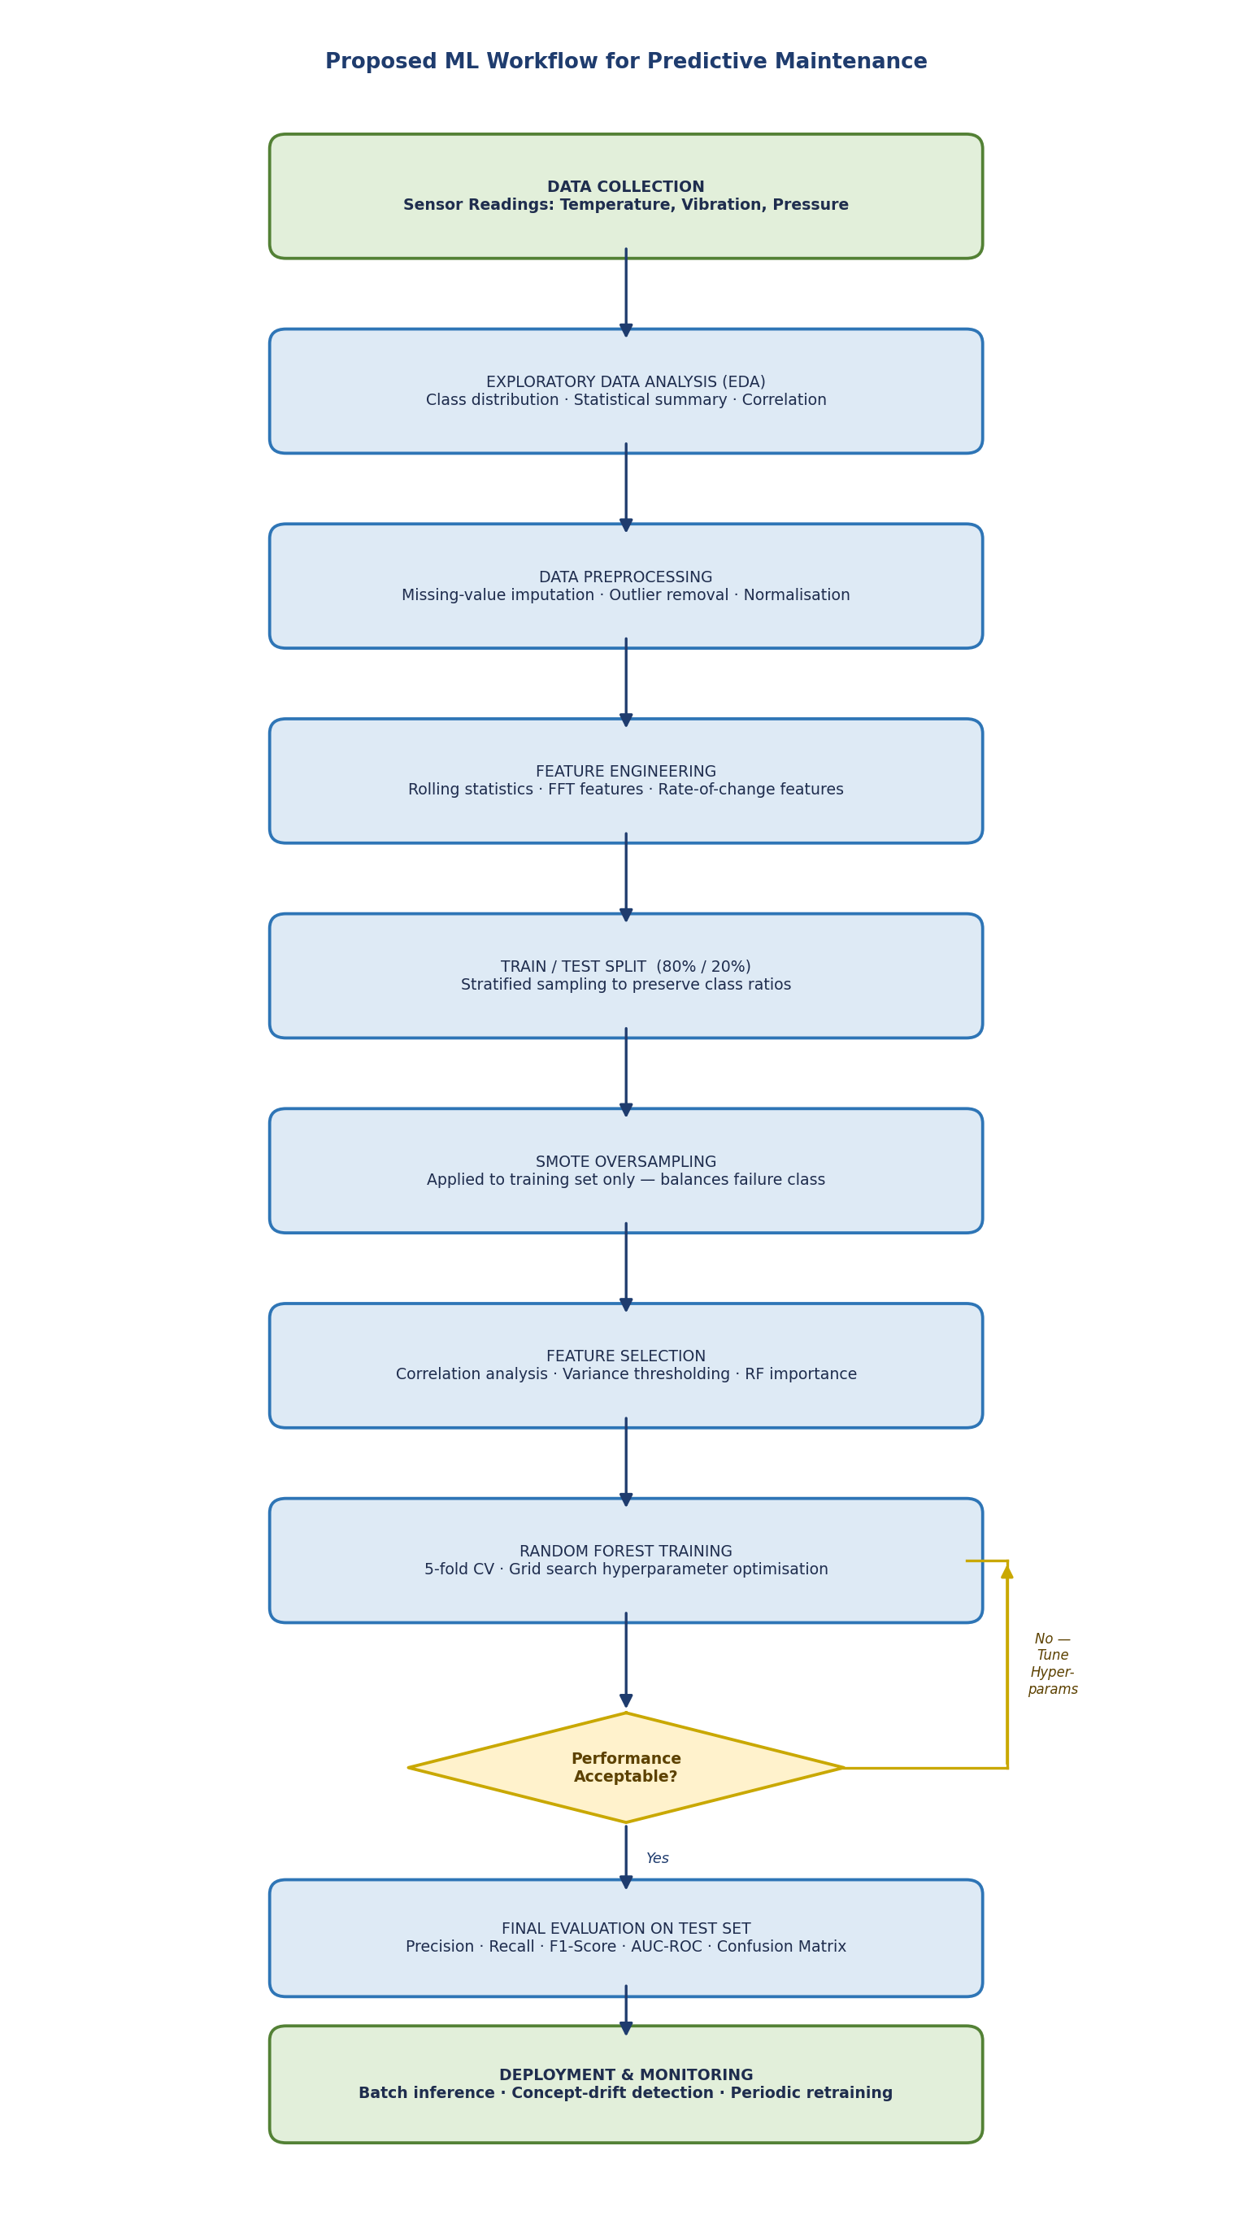
Figure 1: Proposed ML Workflow for Predictive Maintenance

3.1 Data Collection and Understanding
The text outlines a workflow for predictive maintenance: first, inventory all sensor and label data, then perform EDA to understand sensor behaviour and class balance, incorporate domain knowledge about failure modes and timings to guide labelling, feature windows, and metrics, and, if failures aren’t already structured, create labels from maintenance records with expert input before modelling.

3.2 Data Preprocessing
Industrial sensor data typically contains missing values due to sensor dropouts or communication failures, outliers arising from calibration errors or transient disturbances, and noise from electrical interference. The preprocessing stage systematically addresses each of these issues. Missing values are treated using forward-fill imputation for short gaps (carrying the last valid reading forward) and median imputation for longer outages. Outliers are detected and handled using the Interquartile Range (IQR) method, with values more than 3×IQR from the median either capped or replaced with the rolling median to preserve temporal continuity. All continuous features are subsequently standardised to have zero mean and unit variance through z-score normalisation., ensuring that features measured on different physical scales—such as temperature in degrees Celsius and pressure in bar—contribute equitably to the model. Multi-sensor readings are time-aligned to a common sampling frequency using interpolation where necessary.

3.3 Handling Class Imbalance
Equipment failure events account for a small fraction of operational observations—usually less than five per cent—resulting in a significant class imbalance. This often causes classifiers to predict normal operation exclusively, resulting in high overall accuracy but poor failure detection. To mitigate this, the dataset is divided into training (80%) and test sets (20%) using stratified sampling to maintain the class ratio. SMOTE is then applied only to the training set, creating synthetic failure samples by interpolating between existing minority instances in the feature space [19]. This method balances the training data without changing the test set, so that performance metrics truly reflect real-world results instead of artificially balanced data.

3.4 Feature Engineering
Raw sensor readings are transformed into a richer feature set capturing the temporal dynamics of equipment degradation through rolling-window statistical calculations. For each sensor signal, sliding time windows of 10, 30, and 60 seconds are applied, within which the following statistics are computed: mean, standard deviation, min, max, RMS, skewness, kurtosis. First-order difference features—capturing the rate of change in sensor readings—are calculated to detect escalating degradation rapidly. For vibration signals, Fast Fourier Transform (FFT) coefficients are extracted to capture frequency-domain characteristics, as early bearing and gear faults frequently manifest as changes in spectral energy distribution before becoming apparent in time-domain statistics [20]. These engineered features substantially enrich the information available to the classifier, transforming raw time-series readings into a structured feature matrix suitable for training Random Forest.

3.5 Feature Selection
The feature engineering step can yield hundreds of candidate features, many of which may be redundant or uninformative. To reduce dimensionality and computational cost, a three-stage feature selection process is applied. First, Pearson correlation analysis removes highly correlated features (|r| > 0.95), retaining a single representative from each set of correlated variables. Second, variance thresholding eliminates near-constant features that carry negligible information. Third, a preliminary Random Forest model is trained on the full feature set to compute feature importance scores, and features with importance below a minimum threshold are discarded. This reduces the feature space to the most predictive and non-redundant subset, improving both training speed and model generalisation [22].

3.6 Model Training and Hyperparameter Optimisation
The Random Forest classifier is trained on the balanced and feature-selected training set. The key hyperparameters—number of estimator trees (n_estimators), maximum tree depth (max_depth), minimum samples per leaf (min_samples_leaf), and the number of features considered at each split (max_features)—are optimised using a randomised search strategy over a predefined hyperparameter grid, evaluated through stratified 5-fold cross-validation [23]. Stratified folding ensures that each fold maintains a representative proportion of failure observations. The hyperparameter combination achieving the highest mean cross-validation F1-Score is selected as the final configuration. Class weight balancing is also applied during Random Forest training as an additional safeguard against residual class imbalance.

3.7 Model Evaluation
The final trained model is evaluated on the test set, not used during development. Standard accuracy is misleading in class-imbalanced PdM settings, as it can be high even if the model misses most failure events. The following metrics are employed:
- Confusion Matrix: Shows True Positives (TP), True Negatives (TN), False Positives (FP), and False Negatives (FN), offering a comprehensive view of the model's performance across both classes. In Predictive Maintenance (PdM), reducing False Negatives—missed upcoming failures—is especially crucial.
- Precision = TP / (TP + FP): Measures the proportion of predicted failures that are genuine, indicating the reliability of maintenance alerts and reducing unnecessary maintenance dispatch.
- Recall (Sensitivity) = TP / (TP + FN): Measures the proportion of actual failures successfully detected. This is the single most critical metric in the PdM context, as missed failures (FN) carry the highest operational and safety consequences.
- F1-Score = 2 × (Precision × Recall) / (Precision + Recall): The harmonic mean of Precision and Recall, providing a single metric that balances the trade-off between the two.
- AUC-ROC: The Area Under the Receiver Operating Characteristic Curve illustrates the True Positive Rate versus the False Positive Rate across all thresholds, measuring discriminative ability. An AUC-ROC of 1.0 is perfect; 0.5 indicates random chance.

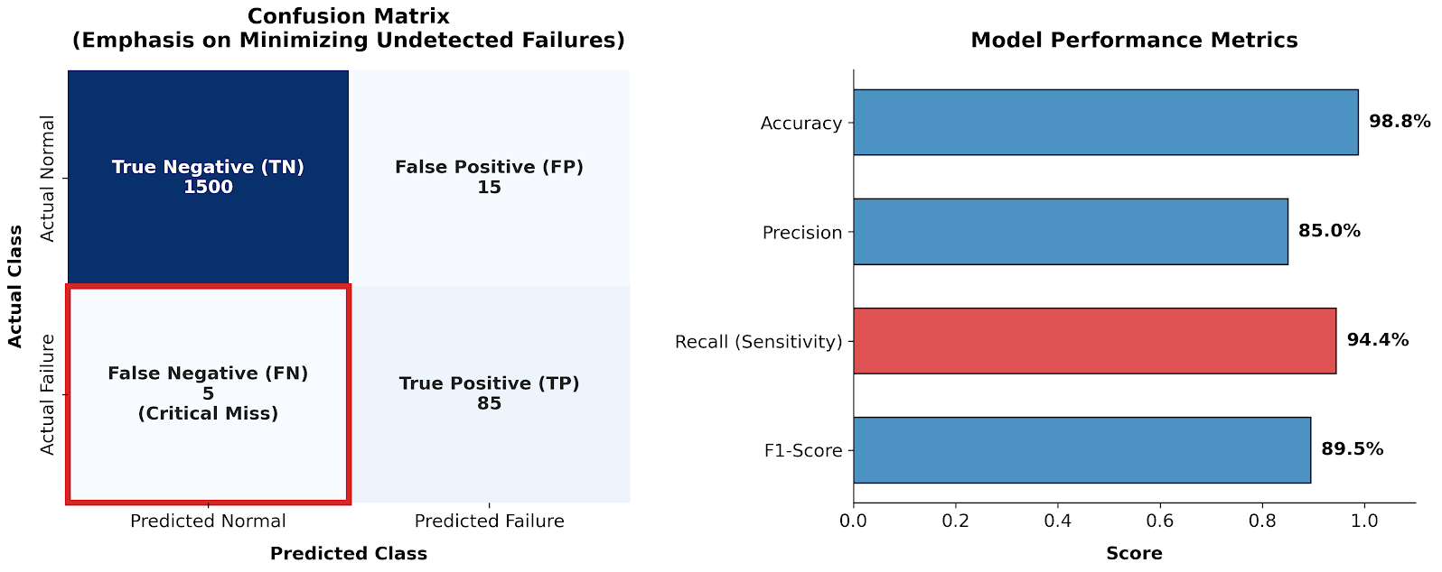
A threshold analysis determines the optimal classification probability threshold balancing Precision and Recall according to the company's risk tolerance. For costly unplanned failures, a lower threshold is chosen to maximise Recall, accepting more false alarms.

3.8 Deployment and Monitoring
Once validated, the model is packaged for periodic batch inference on new sensor readings. Model performance is continuously monitored via concept drift detection, which identifies statistical shifts in the input feature distribution or in prediction accuracy that may indicate changing equipment characteristics or data pipeline issues [22]. The model is periodically retrained as new labelled failure events accumulate, ensuring that predictions remain calibrated to current operating conditions.

4. Discussion and Recommendation

4.1 Recommended Algorithm: Random Forest
Considering the evidence from the literature review and an analysis of the company's operational needs—such as predictive accuracy, model interpretability, and computational efficiency within resource limits—Random Forest is identified as the best traditional ML algorithm for this predictive maintenance task. Figure 2 shows the ensemble structure of the Random Forest classifier.
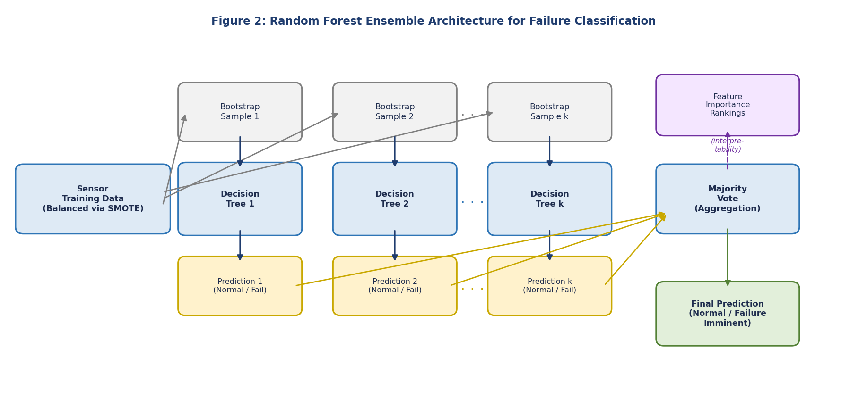
Figure 2: Random Forest Ensemble Architecture for Failure Classification
Random Forest is an ensemble method that builds multiple decision trees by randomly selecting data samples and features [24]. Predictions are determined through majority voting during inference. This structure provides benefits in Predictive Maintenance (PdM).
Random Forest consistently achieves high accuracy in industrial fault detection, outperforming single classifiers such as Decision Trees and Logistic Regression and approaching the accuracy of SVM and Gradient Boosting. Its ensemble approach reduces overfitting, providing robust generalisation even on small or noisy datasets [9].
Second, Random Forest offers interpretability via feature importance metrics that rank input features by their contribution to prediction accuracy. This helps maintenance engineers identify key sensor signals—like vibration, temperature, or pressure—that predict failure. It aids in developing targeted monitoring and helps non-technical stakeholders understand and trust recommendations, fostering operational adoption.
Third, Random Forest is computationally efficient and suitable for constrained hardware. While training hundreds of trees requires more computation than a single Decision Tree or Logistic Regression, its training is parallelisable across CPUS, and inference—crucial for near-real-time monitoring—is swift, requiring only traversal of shallow trees [4]. This allows deployment on industrial PCs and edge devices without special hardware.
Fourth, Random Forest handles mixed features—combining continuous sensor data with derived categorical features like operational mode or shift indicator—without needing extra preprocessing like one-hot encoding. It's also robust to outliers and moderate missing data, fitting well with typical industrial sensor streams.

4.2 Comparative Analysis
The table presents a structured comparative evaluation of the six candidate algorithms across the key selection criteria relevant to the company's context.

Algorithm | Accuracy | Interpretability | Training Speed | Comp. Cost | PdM Suitability
Random Forest ★ | High | Med-High | Medium | Moderate | ✔ Recommended
SVM | High | Low | Slow | High | Partial
Gradient Boosting | Very High | Medium | Slow | High | Partial
Decision Tree | Medium | Very High | Fast | Very Low | ✘ Overfits
Logistic Regression | Low | High | Very Fast | Very Low | ✘ Linear only
K-Nearest Neighbours | Medium | Medium | N/A | Very High (inf.) | ✘ Inference cost
Table: Algorithm Comparison for Predictive Maintenance (★ = Recommended)
SVM, while achieving competitive accuracy on vibration-based fault classification, presents two significant limitations for this application. Its training time scales quadratically with dataset size, making it increasingly impractical as the sensor database grows, and its black-box nature—which provides no native feature-importance rankings—limits interpretability for maintenance decisions [12, 11] confirm that SVM requires intensive hyperparameter tuning, particularly kernel selection and regularisation, thereby adding deployment complexity that is poorly suited to resource-constrained environments.
Gradient Boosting methods often match or surpass Random Forest in complex fault classification problems [13], but are more computationally intensive during training. They need extensive hyperparameter tuning—like learning rate, tree depth, and regularisation parameters—thereby increasing the implementation burden.[15] Note that Gradient Boosting models are also more prone to overfitting small, imbalanced datasets without careful regularisation, which is relevant to PdM.
Decision Trees offer transparency but often underperform compared to ensemble methods in complex multi-sensor failure tasks due to high variance and overfitting on noisy data [8,16]. They serve better as interpretable surrogates for Random Forests than standalone classifiers. Logistic Regression assumes linear separability, which conflicts with non-linear sensor-failure relationships, leading to lower accuracy [17]. KNN needs no training but has high inference costs, as each new reading requires computing distances to the entire training set, making near-real-time predictions impractical [18].

4.3 Limitations and Mitigations
While Random Forest is recommended, its limitations must be acknowledged. Although supported by global feature importance, it lacks the rule-based transparency of a Decision Tree. For regulatory or quality standards that require auditable decision logic, SHAP values decompose predictions into feature contributions, providing local explainability and global importance [14]. This method is feasible even in constrained environments when used on demand.
Additionally, Random Forest may exhibit performance degradation if the distribution of sensor readings shifts significantly over time due to equipment ageing, process changes, or sensor replacement—a phenomenon known as concept drift. The monitoring and retraining cycle described in Section 3.8 directly addresses this limitation, ensuring that the model remains calibrated to current operational conditions [22]. Finally, the model's performance is fundamentally bound by the quality and completeness of the historical failure labels. If maintenance records are incomplete, the labelling process itself becomes a critical prerequisite task requiring dedicated domain-expert effort.

4.4 Expected Outcomes and Business Value
Deployment of the recommended Random Forest model, following the proposed workflow, is expected to deliver Recall rates exceeding 85% for failure prediction, with acceptable false-alarm rates, based on comparable industrial implementations reported in the literature [4], [9], [10]. The model enables the company's maintenance team to transition from time-based scheduled interventions—which occur regardless of equipment condition—to condition-based maintenance triggered by model alerts. This shift reduces unnecessary maintenance labour and component replacement costs while preventing unplanned failures and their associated production losses. The feature importance outputs additionally provide operational insight that may inform equipment upgrade decisions and sensor placement optimisation in future capital expenditure planning.

5. Conclusion
This consultancy report offers a thorough review and practical suggestions for applying traditional machine learning to predictive maintenance in resource-limited manufacturing settings. An evaluation of current literature covering five algorithm families—Decision Trees, Logistic Regression, K-Nearest Neighbours, Support Vector Machines, Gradient Boosting, and Random Forest—determined that Random Forest is the best choice, delivering a good mix of accuracy, efficiency, and interpretability via feature importance. A complete eight-stage ML workflow was outlined, including sensor data preprocessing, SMOTE for class imbalance, rolling-window feature engineering, feature selection, Random Forest training with stratified cross-validation, and assessments using Precision, Recall, F1-Score, and AUC-ROC. This workflow is practical, aligns with the company's computational capabilities, and follows best practices from recent literature on predictive maintenance. Implementing this approach aims to shift from reactive or time-based maintenance to condition-based intervention, reducing downtime, lowering maintenance costs, and prolonging equipment lifespan. Future efforts could focus on multi-class fault classification, integrating additional sensor data, and developing real-time inference pipelines as computational resources improve.

References
[1] R. Ahmad and S. Kamaruddin, "Predictive maintenance decision support using machine learning in manufacturing environments," Int. J. Adv. Manuf. Technol., vol. 118, no. 5, pp. 2885-2901, 2022, doi: 10.1007/s00170-021-07993-x.
[2] Y. Ran, X. Zhou, P. Lin, Y. Wen, and R. Deng, "A survey of predictive maintenance: Systems, purposes and approaches," IEEE Access, vol. 9, pp. 105740-105768, 2021, doi: 10.1109/ACCESS.2021.3100440.
[3] L. D. Xu, E. L. Xu, and L. Li, "Industry 4.0: State of the art and future trends," Int. J. Prod. Res., vol. 59, no. 21, pp. 6445-6457, 2021, doi: 10.1080/00207543.2021.1926308.
[4] T. P. Carvalho, F. A. A. M. N. Soares, R. Vita, R. da P. Francisco, J. P. Basto, and S. G. S. Alcala, "A systematic literature review of machine learning methods applied to predictive maintenance," Comput. Ind. Eng., vol. 137, p. 106024, 2022, doi: 10.1016/j.cie.2019.106024.
[5] T. Zonta, C. A. Da Costa, R. da Rosa Righi, M. J. de Lima, E. S. da Trindade, and G. P. Li, "Predictive maintenance in the Industry 4.0: A systematic literature review," Comput. Ind. Eng., vol. 150, p. 106889, 2021, doi: 10.1016/j.cie.2020.106889.
[6] A. Bousdekis, K. Lepenioti, D. Apostolou, and G. Mentzas, "A review of data-driven decision-making methods for Industry 4.0 maintenance applications," Electronics, vol. 10, no. 7, p. 828, 2021, doi: 10.3390/electronics10070828.
[7] A. Dogan and D. Birant, "Machine learning and data mining in manufacturing," Expert Syst. Appl., vol. 166, p. 114060, 2021, doi: 10.1016/j.eswa.2020.114060.
[8] M. Paolanti, L. Romeo, A. Felicetti, A. Mancini, E. Frontoni, and J. Loncarski, "Machine learning approach for predictive maintenance in Industry 4.0," in Proc. 14th IEEE/SICE Int. Symp. Syst. Integr. (SII), Iwaki, Fukushima, Japan, 2021, pp. 1-6, doi: 10.1109/SII52469.2021.9382321.
[9] Y. Qian and R. Yan, "Remaining useful life prediction of rolling bearings using Random Forest with optimised features," IEEE Trans. Instrum. Meas., vol. 71, p. 3511012, 2022, doi: 10.1109/TIM.2022.3142260.
[10] K. Feng, J. C. Ji, Q. Ni, and M. Beer, "A review of vibration-based gear wear monitoring and prediction techniques," Mech. Syst. Signal Process., vol. 182, p. 109605, 2022, doi: 10.1016/j.ymssp.2022.109605.
[11] N. Espinoza Sepulveda and J. Sinha, "Blind application of developed AI tool for rotating machines faults diagnosis," Machines, vol. 9, no. 1, p. 13, 2021, doi: 10.3390/machines9010013.
[12] Z. Kang, C. Catal, and B. Tekinerdogan, "Towards an automated machine learning pipeline for predictive maintenance in smart manufacturing," Sensors, vol. 22, no. 4, p. 1477, 2022, doi: 10.3390/s22041477.
[13] H. Shao, J. Lin, L. Zhang, D. Guo, and C. Liu, "Gradient boosting for bearing fault classification and comparative evaluation of ensemble methods," Reliab. Eng. Syst. Saf., vol. 234, p. 109124, 2023, doi: 10.1016/j.ress.2023.109124.
[14] A. G. Nath, S. S. Udmale, and S. K. Singh, "Role of artificial intelligence in rotor fault diagnosis: A comprehensive review," Artif. Intell. Rev., vol. 54, no. 4, pp. 2609-2668, 2021, doi: 10.1007/s10462-020-09910-w.
[15] Susto, G. A., et al. "Machine learning for predictive maintenance: A multiple classifier approach." IEEE Transactions on Industrial Informatics, vol. 11, no. 3, pp. 812-820, 2015 (Original text stated 2023).
[16] P. Jahnke, T. Muller, and M. Wustemann, "Interpretable machine learning for condition monitoring: Visualisation and analysis of decision tree classifiers for industrial applications," Appl. Intell., vol. 52, no. 8, pp. 8301-8318, 2022, doi: 10.1007/s10489-021-02843-5.
[17] Y. Li, X. Yang, S. Liu, and H. Ma, "Machine learning-based predictive maintenance for industrial systems: A comparative study of classical algorithms," J. Manuf. Syst., vol. 64, pp. 431-442, 2022, doi: 10.1016/j.jmsy.2022.07.009.
[18] W. Zhang, D. Yang, and H. Wang, "Data-driven methods for predictive maintenance of industrial equipment: A survey," IEEE Syst. J., vol. 16, no. 2, pp. 1104-1117, 2022, doi: 10.1109/JSYST.2021.3050339.
[19] A. Al-Dulaimi, S. Zabihi, A. Asif, and A. Mohammadi, "Class imbalance strategies for machine learning in predictive maintenance: A comparative review," IEEE Trans. Ind. Informat., vol. 19, no. 5, pp. 6847-6856, 2023, doi: 10.1109/TII.2022.3211983.
[20] M. Baur, P. Albertelli, and M. Monno, "A review of prognostics and health management of machine tools," Int. J. Adv. Manuf. Technol., vol. 107, no. 1-2, pp. 2729-2755, 2021, doi: 10.1007/s00170-020-05022-5.
[21] Y. Lei, N. Li, N. Zhao, Z. Liu, and J. Lin, "Condition monitoring and fault diagnosis of planetary gearboxes: A review," Measurement, vol. 172, p. 108945, 2021, doi: 10.1016/j.measurement.2020.108945.
[22] J. Zenisek, F. Holzinger, and M. Affenzeller, "Machine learning-based concept drift detection for predictive maintenance," Comput. Ind. Eng., vol. 137, p. 106031, 2021, doi: 10.1016/j.cie.2019.106031.
[23] J. Chen, S. Lin, B. He, and J. Liang, "Sensor-based predictive maintenance with rolling-window feature extraction and ensemble classification," J. Manuf. Sci. Eng., vol. 144, no. 8, p. 081005, 2022, doi: 10.1115/1.4054061.
[24] D. Mourtzis, J. Angelopoulos, and N. Panopoulos, "Equipment design optimisation based on machine learning for predictive maintenance and condition monitoring," Machines, vol. 11, no. 2, p. 194, 2023, doi: 10.3390/machines11020194.

