An analysis into Concrete and Steel framed Structures

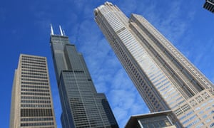

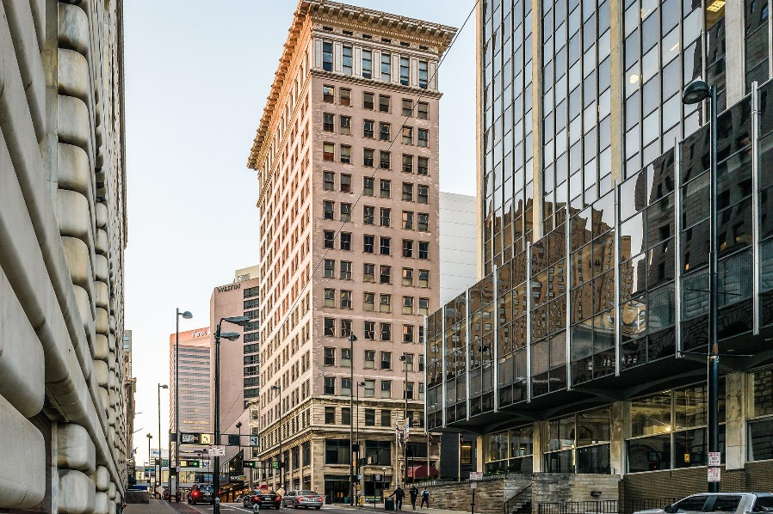

[ 1896 Words ]

Student Name : | James Lloyd
Student Number / ID : | 1900878
Lecturer : | Alan Nantel  alan.nantel@uwtsd.ac.uk
An Analysis into Concrete and Steel Framed Structures
Contents :

 |  | Page Number
Contents | : | 2
Introduction | : | 3
Methodology | : | 4
Data Presentation, analysis and interpretation of findings | : | 5
Conclusion | : | 8
Bibliography | : | 10

An Analysis into Concrete and Steel Framed Structures
Introduction :

Purpose and Tasks
The purpose of my investigation is to undertake research into a habitable steel framed and concrete framed structure from around the world. The main area of study of this research will be to explore and probe the details of their original design planning, with consideration to sustainability, at the site of the build. All my research and evidence will be reported and documented throughout this investigation.
Furthermore, I wish to further investigate the two structures by analysing the comparisons and contrasts between their framing material, these being steel and concrete. This will be done by studying the following areas:
- Their likely durability and resistance to climatic events, such as the environmental conditions they are exposed to at the site from day-to-day.
- The ease of assembly of each of the frames and the potential ease of its adaptation to different building shape and use, considering the life cycle of the building.
- Finally, the sustainably of both framing materials, post production and its impact on the environment.

Justification of Investigation
As discussed above, the main foundation of the investigation is examine, whilst comparing and contrasting the choice of two framing materials, steel and concrete. Therefore I was required to have to research into two live examples of buildings constructed using these framing materials from around the world. For the steel framed case study I have decided to investigate the Willis Tower, formerly referred to as the ‘Sears Tower’ situated in Chicago, Illinois. Whereas, concerning the concrete framed structure, I chose to analyse the Ingalls Building, built in 1903 in Cincinnati, Ohio.
An Analysis into Concrete and Steel Framed Structures
Methodology :

Data Collection
To accomplish and complete my investigation into two inhabitable buildings, constructed with a steel and concrete frame, I will need to analyse a range of sources and relevant information. This will include, reports on the subject, historical articles written during the construction process, photos and data obtained through onsite investigations and surveys. Furthermore, I will reference any material I use in my bibliography/reference page, at the end the investigation write up.
In order to gather information regarding the details of the original design planning, with consideration to sustainability at the site of the build for the two chosen buildings, I will direct my attention to online resources such as website articles, reports and images. As for the sustainability of the site, I believe that planning and design information from pre-construction will be of great importance and value to this assessment. Finally, I will consult my lecture notes regarding the two framing materials to obtain an understanding of the processes involved in the manufacture and adaption. This information will be most relevant when comparing and contrasting steel and concrete frames, in regard to the advantages and disadvantages of using such frames.

An Analysis into Concrete and Steel Framed Structures
Data Presentation, analysis and interpretation of findings

Willis Tower
Willis Tower, formerly known as ‘Sear’s Tower’ is situated in the heart of downtown Chicago, Illinois. At completion in 1973, the 110 floor Chicago office building surpassed the world Trade Centre in New York to become the “Tallest Man-Made Structure” in the world, a title it held for 3 years before being surpassed in 1976 by the CN Tower in Toronto. The Tower was designed in 1969, at the request of a much needed office for the global retailer Sears. Chicago’s busy urban location resulted in Space being considered a premium, so the iconic setback structure was designed to use a considerable amount of floors for offices, rooms for tenants and larger open spaces.
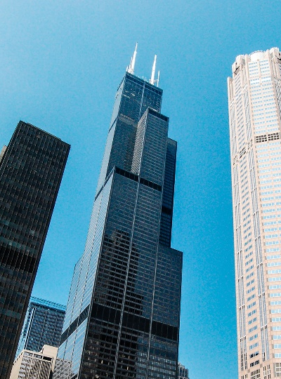
Standing 1,450ft tall, it’s black aluminium and bronze-tinted glass exterior has become emblematic of Chicago, a city crazy about its architecture. Although its record-breaking height has been surpassed several times over, The Willis Tower’s innovative structural design remains noteworthy, with it laying the foundation for the supertall buildings being built today.
“While Willis Tower (Chicago) is “only” the 23rd tallest building in the world now, many structures on the record-breaking list use a composite construction model made up of multiple materials. The Willis Tower however, can proudly state that its structural frame is made entirely of steel.” Jordan Dalladay, (2019): Willis Tower (aka Sears Tower) - Steel Structure and Construction.
Willis Tower is widely considered a seminal achievement for architect Fazlur Rahman Khan. Utilizing the bundled tube system, Khan was able to address and overcome structural problems never encountered or seen before at this scale. The tower’s core structure comprises of nine squared steel tubes supported by a concrete caisson base and traditional bedrock. The tubes, each rigid within itself without the requirement of internal supports acting as a singular unit, created the result of the building’s tubes are supporting one another, strengthening the structure as a whole. The first 50 floors saw a 3x3 square grid constructed within the frame, however this changes during the ascent as the tubes terminate at varying heights – producing a multi-tired form. The reason behind the varying tube heights is that it disrupt the force of the wind.
“Steel was central to the entire project as it provided the affordability, sustainability and durability required to construct the world’s tallest building.” Jordan Dalladay, (2019): Willis Tower (aka Sears Tower) - Steel Structure and Construction.
The project, over the duration of three years, saw 76,000 tonnes of steel pre-assembled in sections on site before being bolted down, and $175m of investment in total before it was finally ready to open its doors to workers and residents.
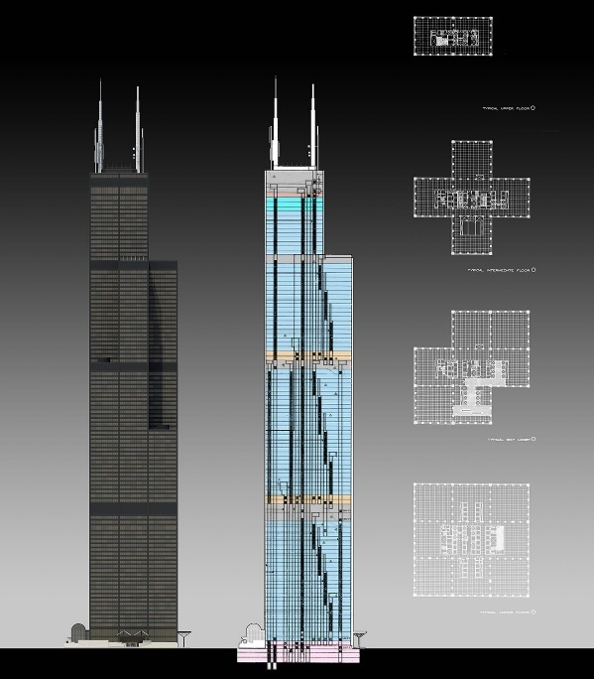
On November 8th, 2018 marked the date that Willis Tower was Awarded the Leadership in Energy and Environmental Design (LEED) Gold from the U.S. Green Building Council. This was achieved through the a half a billion dollar renovation undergoing within the tower seeing a number of upgrades to reduce the environmental footprint. Such changes and innovations included the installation of high-efficiency lighting systems and improvements to the tower’s HVAC exhaust and return fan dampers in which the operating team saw an improvement in control to internal temperatures. Ventilation was further enhanced through new air media (fan gearboxes and blades). In addition to these, Willis Tower managed to reduce its water consumption by 30% (11million gallons) by upgrading water consumption management controls for sinks, toilets and urinals. It was reported that officials of Willis Tower worked with Rivion, a Wisconsin-based energy consulting firm, to plan, implement and manage these energy saving initiatives. It was later announced that this is just the beginning of Willis Tower's growing efforts to reduce its environmental footprint.
"Willis Tower is a major destination in the heart of Chicago, and for more than 15,000 people, it's also their workplace," said David Moore, Senior Vice President and Portfolio Director, EQ Office. "As we redevelop this iconic Tower, we're making a conscious effort to find ways to improve energy efficiency and reduce our environmental footprint. Earning the LEED Gold certification is a credit to our entire team for their hard work." EQ Office, (2018). Willis Tower Receives LEED Certification for Sustainable Achievements.

Ingalls Building
The Ingalls Building saw its construction completed in 1903, where it was recognised as the world’s first reinforced concrete skyscraper. The 16 story building is situated in Cincinnati, Ohio and was named after its primary financial investor, Melville E. Ingalls. The lead architect for the once considered courageous at the time of construction but now admirable engineering feat was Cincinnati architectural firm Elzner and Anderson (A & E). The success of this project granted the acceptance of concrete framed construction in high rise buildings.
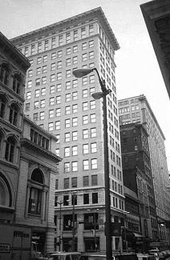
Prior to the Ingalls Building, the tallest documented reinforced concrete building had a total of six stories in height, therefore A&E had the audacious task of constructing a building nearly tripling the height. Amid the designing of the 210ft structure, A&E made the decision to utilize concrete. The decision to procced with concrete was reinforced because of its fireproof properties and the expense compared to steel.
Before the commencement of works on site, a considerable debate was undertaken to get the necessary permits to build the controversial structure. This battle went on for two years with Cincinnati’s Building department fearing a concrete building would not be able to withstand wind and concrete shrinkage. A&E eventually won the debate after managing to convince them of the building’s stability and durability.
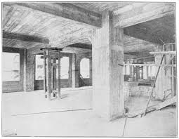
Due to the shear size and dimensions of the Ingalls building, the concrete frame contained multiple solid columns and foundations with square-twisted steel bars. Each floor slab provided a rigid diaphragm to steady the building from wind loads.

An Analysis into Concrete and Steel Framed Structures
Conclusion :

1). Their likely durability and resistance to climatic events, such as the environmental conditions they are exposed to at the site from day-to-day.
Despite mild steel possessing the properties for improved strength to tension, compression and shear forces and it’s ability to withstand shocks and impacts well, mild steel is prone to rusting through exposure to wet and damp climates. This can be a growing problem during the construction phase because until sufficiently covered, such as with concrete for floor slabbing and columns, it can deteriorate in strength. Thus ultimately if not identified and replaced, can prove to be a massive problem for the building through construction, and post construction – through its lifecycle. This can be avoided however by utilising high carbon steel in which it resists corrosion better whilst still improving the tensile strength. The cost of this compared to mild steel is that it will be more brittle and less ductile.
Concrete on the other hand, is far more hardwearing than steel. Frequently, concrete will be combined with steel in the use of reinforced concrete for columns and slabs. This is because concrete is defined as its ability to resist weathering action, chemical attack, abrasion and/or any other process of deterioration. Hence when used with steel, which as mentioned, can be prone to rusting, the concrete must be impermeable, preventing such damage to be inflicted to the steel reinforcements. Steel is therefore protected from corrosion if it has adequate cover of good quality, well compacted and cured concrete. Insufficient cover caused by incorrect fixing of steel reinforcement or formwork can allow steel to corrode.

2). The ease of assembly of each of the frames and the potential ease of its adaptation to different building shape and use, considering the life cycle of the building.
To begin with, steel has many properties related to its ability to be made into a variety of shapes yet retaining its strength and toughness. Steel can be easily forged and due to it being both malleable and ductile, it can forged into unique shapes for a variety of construction uses, e.g. curvature for a smooth angle of a building. Continuing, steel is commonly prefabricated, therefore meaning it is made remotely from site and the erected/assembled quickly upon arrival. Steel production is also precise and predictable due to improvements to quality control. Despite its far lighter weight, in comparison to concrete, it is stronger when considering its strength to weight ratio.
Moving onto discuss concrete, in order for concrete to be successfully used as a framing material, it is commonly combined with the use of steel through reinforced cement concrete (RCC). Concrete is strong in compression but weak in tension with tensile strength of concrete usually being 10-15% of the compressive strength. Steel is therefore incorporated in concrete as reinforcing material as steel is strong in tension, forms a good bond and has a similar coefficient of thermal expansion to concrete.

3). Finally, the sustainably of both framing materials, post production and its impact on the environment.
Steel is nearly 100% recyclable, with approximately 90% of steel used today within structural framing being created from previously recycled steel. Due to its long lifecycle, steel can regularly be adapted multiple times with little to no compromise to its original structural integrity. When it is manufactured, fabricated and treated with considerate care and is done so properly, steel will have a minimal impact on the environment.
Concerning concrete, the elements that comprise concrete are found naturally within the environment, therefore reducing the harm to our world. Similar to steel, concrete can also be recycled and reused as it may be crushed down back into future mixtures. If done successfully,, this type of recycling can reduce the presence of concrete in landfills.

An Analysis into Concrete and Steel Framed Structures
Bibliography :

- Jordan Dalladay. (2019). Willis Tower (aka Sears Tower) - Steel Structure and Construction. Available: https://metalhub.com/articles/willis-tower-aka-sears-tower-steel-structure-and-construction. Last accessed 28th Dec 2019.

- Chicago Architecture Centre. (2015). Willis Tower. Available: http://www.architecture.org/learn/resources/buildings-of-chicago/building/willis-tower/. Last accessed 28th Dec 2019.

- EQ Office. (2018). Willis Tower Receives LEED Certification for Sustainable Achievements. Available: https://www.prnewswire.com/news-releases/willis-tower-receives-leed-certification-for-sustainability-achievements-300744211.html. Last accessed 28th Dec 2019.

- JBDAdmin. (2018). Ingalls Building, First Reinforced Concrete Skyscraper. Available: https://www.idesign.wiki/tag/ingalls-building/. Last accessed 3rd Jan 2020.

- Concrete frame Structures. Available: http://www.understandconstruction.com/concrete-frame-structures.html. Last accessed 6th Jan 2020.

- Steel frame Structures. Available: http://www.understandconstruction.com/steel-frame-structures.html. Last accessed 6th Jan 2020.

