Assignment on Employability
Student Name: Dilowar

Introduction
This assignment is on the basis of employability. Employability is regarded as the term which is used in describing the attributes, assets and the achievements through which individuals become more likely to attain employment and become successful in the career (Dessler and Varkkey, 2008). Through the recruitment and selection process, the eligible candidates for the posts are chosen. An organization needs to provide advertisement their vacancy for the candidates providing job description and person specification. Candidates are to submit CV to apply to the posts in order that the recruiters can have information of the candidates in very short time. Knowledge of team working and time management is very much important in this era to work in an organization.
Task 01
Within the recruitment and selection process, explain the purpose of a job description and a person specification
Before explaining the purpose of job description and person specification within the recruitment and selection, it is necessary to know about recruitment and selection processes.
Recruitment process indicates the overall process to attract, select and appoint the eligible candidates in an organization. It helps in finding and hiring most eligible and qualified persons for the job in cost-effective and timely manner (Newell, 2005). The selection process is considered to be lengthy and comparatively complex because it involves in several steps in taking final decisions to choose the eligible candidates. So the selection process is the combination of several steps involved in choosing the candidates who have the right qualifications for the jobs (Bratton and Gold, 2007).
A job description is considered to be the summery of the position and responsibilities associated with the job. Being dependent on job description, an organization encourages the candidates who have the qualifications matching the jobs and discourage unqualified one (Torrington, et al, 2011). Within the recruitment and selection processes, there are several purposes of job description. With the help of job description, the employer can clarify their expectations for the employees to recruit and select them for the job. Job description provides clear description of role of the job and candidates can know before applying to the post. It informs the candidates of the qualifications required for the post. It also helps in saving time for both the employers and job seeking people as job description involves in providing all requirements for the job in the job description and so the qualified persons apply for the job and unqualified do not apply.
A person specification refers to the profile of the candidates who are needed for a specific job. It contains the descriptions of skills, knowledge and also the attributes which are required to perform the role in the job (Wilton, 2013). There are several purposes of a person specification within the recruitment and selection processes are also important. The person specification helps an organization to communicate the exact candidates eligible for the desired posts. One of the purposes of person specification is to test the candidates giving priorities set in advance to remove prejudice, bias and also the personal interests. It assists in finding and communicating with the equal rights policies in respect of recruitment and selection process and it helps in removing all kinds of discrimination. It also helps in clarifying the two kinds of employer personal qualifications that contain essential qualifications and desirable qualifications and helps in finding and hiring the candidates whose qualifications matches with the job requirements (Philips and Gully, 2009). In addition, it helps the candidates to assess themselves and understand the ways they perform their performance according to the job and also they can know how they play role in the given job. Thus, it helps in making the interview process of recruiting and selecting the candidates easier.
So, with the help of job description and person specification, the recruiters can find the right people for the right posts for their business because if the right people are appointed for the right job, the productivity will increases otherwise not.
Task 02
Preparing a CV for specific job role that will include the demonstration of an understanding of the importance of skills and knowledge for working effectively
A CV for the post of Hotel Receptionist in The Royal Park Hotel is prepared in the following. 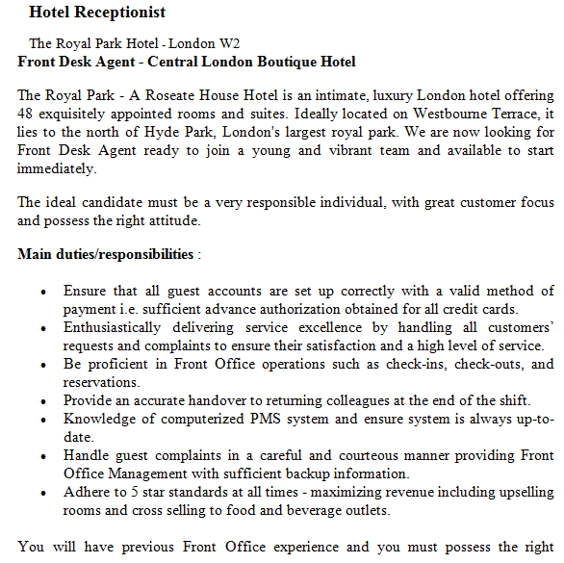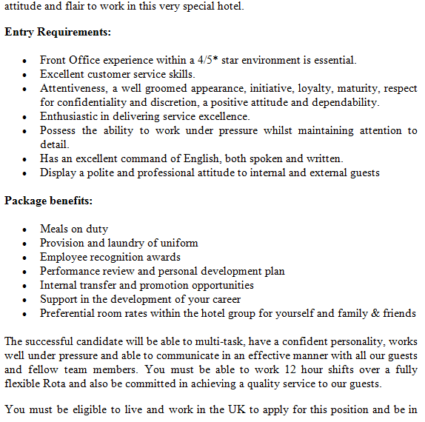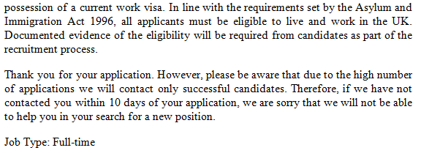

CURRICULUM VITAE
DILOWAR HOSSAIN
Ranelagh Road, Stratford
E15 3DP

OBJECTIVE
As a Hotel Receptionist, my objective is to provide the customers with excellent services. I can fulfill it by welcoming the guests on their arrival, ensuring smooth checking out and managing reservations of rooms. Promoting the facilities for the guests in more informative and polite way, building my career as a hotel receptionist in one of the biggest hotel chains in the UK and also getting a supervisory post in future are a part of my objective.
EDUCATIONAL QUALIFICATIONS
A Levels in French, Spanish, Travel and Tourism
Bracknell and Workingham College, Bracknell
September, 2009- June, 2011

GCSE’s in Maths, English Language, English Literature
Dwight School London, Barnet
September, 2004- June, 2009

SKILLS
- Ability to speaks in two languages ( English and Spanish)
- Have keen eye for detailed information
- Ability of prioritizing and organizing tasks efficiently
- Friendly personality
- Outstanding interpersonal skills
- Ability to behave with customers in polite and friendly ways
- Independent working ability
- Willing to work for long time
- Working ability under pressure
WORK EXPERIENCE
Hotel Receptionist
Premier Inn, Sutherland
November, 2012- Current

Duties
- Welcoming and greeting customers showing great courtesy
- Setting the accounts of guests correctly
- Managing reservations of room applying computerized systems
- Ensuring that the guests feel comfortable in rooms and ensuring adjustment where needed
- Ensuring services with their necessities
- Helping getting transport for them
- Preparing bills, processing checks and taking payments
- Maintaining staff to provide possible quality services to the customers
- Handling complaints of guests and responding fast
- Proving better solutions to the problems

Hotel Receptionist
Puma Hotels, Argyllshire
October, 2011- November, 2012

Duties
- Supervising the on the arrival of all the guests coming to the hotel
- Monitoring reservations applying appropriate reservation procedures
- Administering all guests and allocating room among the guests
- Providing training to the staffs at the front office and monitoring their performance
- Taking payments and determining appropriate credit checking procedures
- Handling complaints of the customers
Reference
Available on request

Task 3
From personal experience and the applying the STAR model, writing a statement for team working and time management competencies
STAR is considered to be a technique of gathering relevant information about specific capability in accordance with the requirements of job. The acronym stands for Situation, Task, Action and Result.
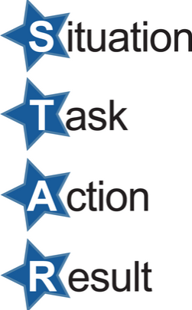
Figure: STAR Model
Source: (Taylor, 2014)
Team Working
I worked in the hotel Premier Inn as a hotel receptionist. I was involved in a team with junior level colleagues and I was responsible for leading and directing the team. Now, applying the STAR Model, a statement is written in the following from my personal experience.
Situation: in Premier Inn, there was a team under my leading and supervision. Sometimes, there gathered a lot of jobs such as receiving guests, filling their form up, making their bills, showing room to the guests. In that situation, I had to direct the team members in effectively.
Task: performing these tasks in more efficient ways by the team members and getting a fruitful result and also satisfying the guests coming to the hotels.
Action: as a lot of tasks were gathered and I was directing a team. I allocated all these tasks among the members of the team who used to work in different categories. The team members worked on these tasks efficiently. Some of the members were present to welcome the guests, some were involved in filling their forms, and some were showing rooms for the guests.
Result: as all the tasks allocated among the team members, these tasks were performed timely and efficiently. Thus the guests were satisfied with our services. All was possible because of working in team.

Time Management
I used to work in the Puma Hotels. During working there, sometimes I had to get many works to be done within very short time. I had to manage time properly applying different strategy. Now a statement from my experience on time management applying STAR model is given below.
Situation: once, during working in the Puma Hotels. A lot of work gathered such as supervising the guest on their arrival, reserving rooms for them, preparing bills that could have done within short time. All these happened because of my colleague was absent.
Task: performing all the tasks, provide better services to the customers in order that they feel comfortable in staying at the hotels and also avoiding any troubles in serving them that they can fell bored.
Action: as the time was short and I had to manage time to do all tasks effectively within the short time. For this, first of all, I planned for performing tasks. I prioritized the tasks in according with the importance of work. Then I allocated times for each of the tasks.
Result: as I could adapt these strategies and I could manage my time for each job. Finally I came with success in performing all these tasks in efficiently and effectively.
Conclusion
Finally it can be said that recruitment and selection process is very much important to find and appoint the right people for the right job at the right time. Job description and person specification can be very much effective in this regard. Job description and person specification let the people know about the required skills and requirements. CV has also importance in the respect. The recruiters can know the qualifications of individuals from their CV within very short time. Jobs performed by the team become more successful and also management of time is very much important to perform tasks before deadline.

Bibliography
Bratton, J. and Gold, J., 2007. Human Resource Management: Theory and Practice. 2nd ed. London: MacMillan
Dessler, G. and Varkkey, B., 2008. Human Resource Management. 11th ed. Pearson Prentice Hall
Guion, R. M., 2011. Assessment, measurement and prediction for personnel decisions. London: Taylor and Francis
Newell, S., 2005. Recruitment and Selection. Journal of Managing Human Resource: Personnel Management in Transition. pp. 115-147. Wiley-Blackwell
Philips, S. and Gully, C., 2009. Strategic Staffing. New Jersey: Pearson Education
Taylor, S., 2014. Recruitment and Selection. Journal of Strategic Human Resource Management: An International Perspective. Vol. 10 (6). Pp. 139-144. Sage
Torringtoon, D., Hall, L., Taylor, S. and Atkinson, C., 2011. Human Resource Management. 8th ed. London: FT/ Prentice Hall
Wilton, N., 2013. An Introduction to Human Resource Management. 2nd. London: Sage Publications

