

Mark and Spencer Strategic Analysis Report

Janeth Catherine Mosquera Restrepo
Student Number:1908748

Module:
Strategic management
LCMB7003

Lecturer:
Amare Desta

10/05//2023

TABLE OF CONTENTS
EXECUTIVE SUMMARY 3
INTRODUCTION 4
MARK AND SPENCER BACKGROUND 5
MARKS & SPENCER MISSION AND OBJECTIVES 6
MACRO-ENVIRONMENT ANALYSIS 7
PESTEL ANALYSIS 7
Political Factors 7
Economic Factors 8
Social Factors 8
Technological Factors 9
Legal Factors 10
MICRO-ENVIRONMENT ANALYSIS 10
INDUSTRIAL LIFE CYCLE 10
PORTER’S FIVE FORCES ANALYSIS 11
Competitive Rivalry 11
Threat of New Entry 11
Threat of Substitutes 12
The Power of Buyers 12
The Power of Suppliers 12
INTERNAL ANALYSIS 12
MARK AND SPENCER STRATEGIC RESOURCES AND CAPABILITIES 12
VALUE CHAIN ANALYSIS 14
Primary Activities 15
Secondary Activities 15
VRIO ANALYSIS OF DISTINCTIVE RESOURCES AND CAPABILITIES 17
Mark & Spencer People Management and Competitive Advantage 17
Mark and Spencer’s Physical Capabilities and Competitive Advantage 18
Mark and Spencer’s Financial Capabilities and Competitive Advantage 18
SWOT ANALYSIS 18
STRATEGIES TO SUSTAIN COMPETITIVE ADVANTAGE 21
PORTER’S GENERIC STRATEGY 21
Strategies 21
GROWTH STRATEGIES 21
ANSOFF MATRIX 21
Market Penetration 22
Product Development 22
Market Development 22
Diversification 23
INTERNATIONAL 23
GREEN STRATEGY AND CSR 23
CONCLUSION 25
RECOMMENDATIONS 25
REFERENCES 27

EXECUTIVE SUMMARY

This report analyses the strategies used by Mark and Spencer to be competitive. Analysis methods include the PESTEL, SWOT, Porter's five forces, value chain, and VRIO to identify the company's resources, capabilities, and external and internal environment. In addition, generic porters’ strategy, Ansoff matrix, internationalisation, and CSR strategies were analysed to see how they were using them and what benefits they were getting. This analysis shows some weaknesses in the strategies used, and recommendations are given to improve them. However, more research is needed to tackle strategies to overcome weaknesses and create a more robust company.

INTRODUCTION

Organisations must review their environment to adjust their strategy to the changes it presents. The strategies should state clear goals using the resources and capabilities to a competitive advantage. However, according to research by Treasure Data, on 500 chief executives in the UK. The pandemic brought a volatile environment for businesses, making decisions difficult since that could affect the profits, reputation and, lastly, the company's life (Stephenson, 2022). Thus, it is essential to analyse and collect data on the environment where an organisation is, reducing indecision and applying strategies for the company's benefit.

Not all strategies are adequate, so strategic management (SM)help leaders manage competitors' threats, opportunities, and weakness. Also, Becas -Santander (2022) highlight that the strategy is necessary after analysing the industry and a plan to execute it.

This report discusses the strategies used by Marks & Spencer to achieve their competitive advantage. In the beginning, the report will discuss the background of the organisation and its mission and objectives. Then, the author will analyse the macro environment using the Pestel tool, following the microanalysis with the industry life cycle and Porter's five forces tool. After that, the Internal analysis of their resources and capabilities, using the value chain, VRIO and swot tools. Then, the presentation of some strategies to sustain competitive advantage, growth, and corporate social responsibility. Finally, a conclusion ad recommendation will be added stating the importance of creating strategies that align objectives, mission, and resources to maintain a position in the market.

MARK AND SPENCER BACKGROUND

The company discussed in this report is Marks & Spencer. It is a family retail company created by Michael Marks in 1884 in Leeds. He started solo, selling home furnishing, which increased with the association of Tom Spencer. The name was born "Marks & Spencer", as the market knows it. The retail is based in England, with 1035 stores around the United Kingdom (UK) and 452 stores globally (Annual Report M&S, 2022).

Through the years, the company saw opportunities. It started to expand its portfolio, and now they offer the market food, clothing, household products, bank facilities, Energy programs, property, and opticians' products. Also, with more than 65000 people running the store, support centres and operations to present the best of their products and services to their customers (M&S, 2023).

According to Coppola (2023), in 2020, clothing and household are the products that are most sold online. Also, the grocery market is valued at £212 billion (Bedford, 2023). So, this shows that Marks & Spencer has a portion of that market, and their revenue was £10.9 billion. The revenue improves due to new strategies to attract customers providing more touchpoints and benefits, such as the spark card and online shopping, compared to previous years, where the sales were lower due to lockdowns and disruptions in the chain supply (Annual report M&S, 2022).

With nearly 139 years, the company must adapt to new customers' behaviours, needs and threats in the market. The new strategies (fixing the basics, shaping the future, and making M&S unique) to compete in the market are the pillars to continue growing and gaining market share.

MARKS & SPENCER MISSION AND OBJECTIVES

Whittington et al. (2020, p. 9,) define the mission as representing what a company does and why it is in the market. Also, they add that objectives are the perceptible goals that the company wants to obtain in their life. In other words, mission and objectives help the organisation to put focus, direction, and resources towards the benefit of stakeholders and shareholders.

Marks & Spencer's mission shows the initiative to be sustainable with the "Net Zero" statement. The company is working to reduce and abolish carbon emissions in their raw and final products, contributing to a better natural environment. Therefore, their objectives are aligned with that mission. Some of their objectives are to reduce the use of plastic, waste, and carbon emissions. Increase more range of ecologically friendly products and participate in the current trends’ consumers require (Marks & Spencer, 2023).

In addition, their strategy, "Plan A", highlights three phases. Its overall focus is customer-centric, working and developing innovative technologies to improve the supply chain, systems, and stores (Annual report M&S, 2022).

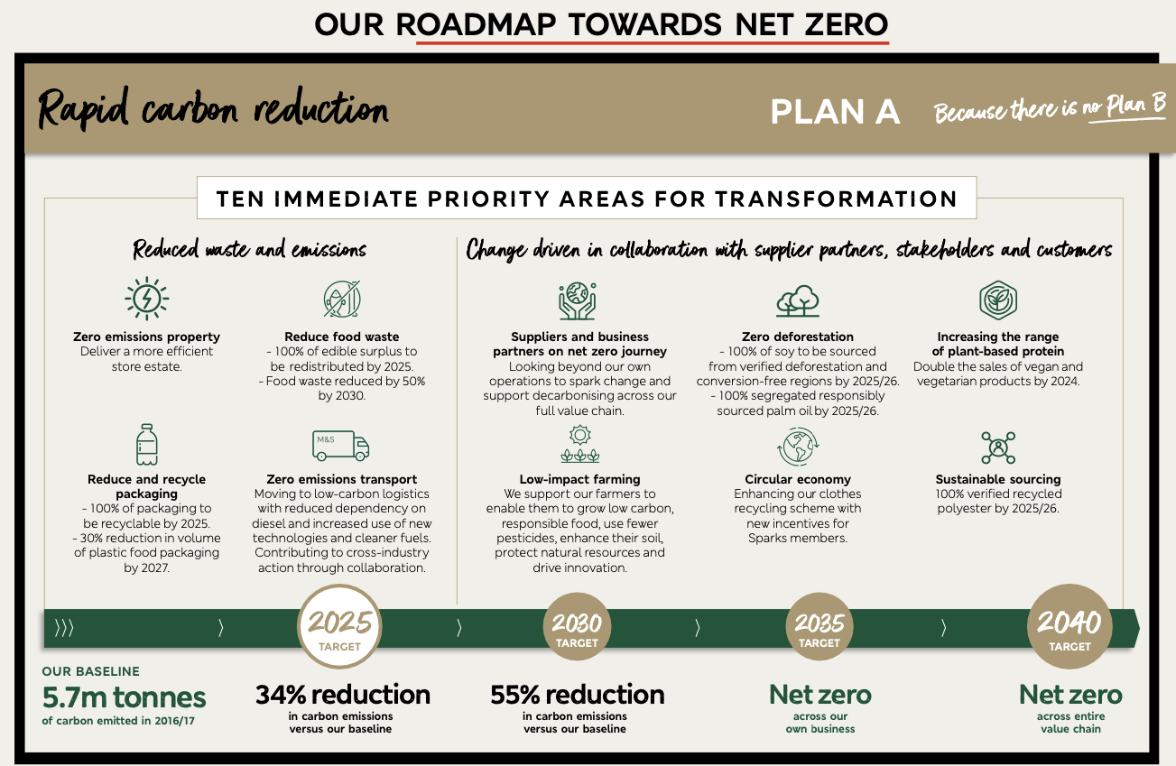
Source: Annual Report M&S, 2022

MACRO-ENVIRONMENT ANALYSIS

The business environment of a business differs according to its industry, products, place, strategies, and perception of its customers. Two primary environments affect the organisation directly: the macro and microenvironment. Macro is something significant or whole (Cambridge Dictionary, 2023). Help to contextualise the term macro environment as a range of circumstances (policies, trends, that affect the company positively or negatively. To analyse this circumstance is helpful to use PESTEL analysis.

PESTEL ANALYSIS

It is a tool to analyse the company's external environment that will help increase awareness of the threats that could affect its stability in the market (Lynch, 2018, 75). Consist of political, economic, social, technological, environmental, and legal factors.

Political Factors
The population experimented with a stable political environment in the United Kingdom (UK). The war in Ukraine, Brexit, and the pandemic (covid-19) brought disturbance in the life of citizens and businesses. As forecasted, Graziano et al. (2020) research assumes that between the European Union EU and UK will be difficult due to the new policies where costs will increase. At the time of the research, the only issue was Brexit, not the pandemic or war in Ukraine. The situation has changed, and the country has experienced the effects of a volatile business environment where restrictions on Ukraine and Russian products affect the cost of living and business in the UK.
However, the UK has signed a new agreement to freeze the trade cost of products from Ukraine to establish their economy and reduce the price increase in the UK environment (GOV. UK, 2023). The cost of importing and exporting products will increase. It will be an unfavourable environment for M&S because their supply chain and regional diversification will be affected. Also, as their annual report (2022) mentioned, some outlets were closed, decreasing profits. Suggesting that it will take more work for M&S strategies to obtain the maximum benefit from their objectives, increasing the cost of their products and affecting their customers.

Economic Factors
The United Kingdom (UK) inflation has risen to 10.4% (Bank of England, 2023). It is over the limits that the Bank of England forecast. In addition, the primary reason for this was the increase in food prices, housing and bills and restaurants. In other words, it is a vicious circle where high interest increases the prices of transport, food, and houses. Also, it limited the amount of inversion that businesses should make, leading them to reduce their cost and profits.
The stagflation that the world is living in now (McLannhan, 2023) could severely affect the food industry and the clothing industry. Since M&S products are in this industry, its profits could be affected by reducing their profits. However, the advantage is that food is a primary necessity; loyal customers will keep supporting the brand despite their soaring prices (zhang et al., 2018). Also, continuing with their functional strategies, such as marketing, talent attraction, and technology development, is the best option to go through this time, creating stability.

Social Factors

Social behaviour is a factor that affects the strategies created by a company. According to Xu et al. (2022), consumers react differently according to the perceived stimulus. So, companies' focus now is to be customer-centric to satisfy their needs creating touchpoints that help them interact quickly and efficiently with the company. M&S being in the market for so long has left M&S with products that consumers need to be more attractive to the new consumer. However, the company has tried to motivate the new generation with a new line of sportswear and ecological products such as cotton (Annual Report M&S, 2022). They are showing to their customers that their needs are essential to M&S.

Technological Factors

Technological advances have helped societies to improve their daily activities in many industries. The increase in technologies, such as mobile phones with 5g, has made accessible to society many services that they did not have (Mendonca et al., 2022). Increasing these devices among the population makes business products and services easily accessible. M&S is now investing in renovating their outlet and improving their website, a fashion app (personalised to customers' needs and trends) and attracting people with data knowledge. So, M&S has much competence in the market because many big brands have their website where they offer their clients the best deals. However, the company has acquired a 50% share of Ocado to sell and deliver its products (Ocado, 2023). They demonstrate that M&S has noticed the new technological changes that help businesses compete in a closed market. They integrated into their processes to improve the quality of their products and services, creating a differential point in the market.

Environmental Factors

Consumers' and governments' concern toward sustainable methods has increased the legislation to create environmentally friendly products in The Environmental Plan, with new regulations from the Fishes, agriculture, and Environment Act (GOV, UK, 2023). This plan focuses on reducing gases in the air, motivating the population to change the kind of transport they use. Also, reduce the waste to help the environment cope with the landfills of waste affecting the air. This legislation affects business because, of cost of modern technologies to comply with the government is not cheaper. In the case of M&S, they are working towards Xero emissions, where they recycle and use Fairtrade products to help the workers with fair pay. (M&S, 2023). revealing why M&S is doing their part, as stated by Nguyen and Dsouza (2021), to create a better environment and the strategies they are using to keep and attract customers with green beliefs.

Legal Factors

In the United Kingdom, businesses must follow regulations, policies, and guidelines to provide the best protection to consumers. One of those is the General Product Safety Regulations 2005 (GPSR), which enforces the security of the products, and the Food Standard Agency (FSA), which compels a business to follow food regulations produced in the country or imported (GOV. UK, 2021; Food Standards Agency, 2023). In addition, to this regulation, the Health and Safety policy, where businesses write the procedures dealing with the risk associated with the work environment (Health and Safety Executive, 2023). For M&S, this represents a favourable factor since they tend to comply with government law to avoid fines and bad reputations.

MICRO-ENVIRONMENT ANALYSIS

INDUSTRIAL LIFE CYCLE

Almost every industry can be compared with humans’ life cycle, such as born, childhood, teenager, adulthood, and death. However, in an industry, the phases and outcomes are different. For Michael Porter, in strategic management by Lynch, the industry life cycle (ILC) can be used to forecast an industry through the years. So, industries change gradually, and business should adapt their strategies according to their industry cycle, known as the industry life cycle (Lynch, 2018, p.81). Industries in their beginnings are uncertain due to the low profit and the competition; however, in the second stage, there are more players in the market, increasing the competition and variety of products or services (O’Sullivan, 2020). She also states that in the maturity phase, an industry slows its extension, reducing the companies that can compete with products and gain profits. Considering the above industry life cycle, the grocery and retail industry could be in the maturity stage, however the online ecommerce in the growing stage.

PORTER’S FIVE FORCES ANALYSIS

A company's revenue depends on the industry's five forces (buyers, suppliers, substitutes, rivalry, and new entrants) operating in the industry (Whittington et al., 2020, p.66). Porter's five forces framework can be used to analyse the industry. This tool helps analyse the forces processes in the industry, building a strategy to grow or stabilise a business.

Competitive Rivalry

In the United Kingdom (UK), the food and fashion(apparel) industry has grown. Since 2013, according to Smith (2022), the apparel industry has grown with an estimated revenue of £65.63billions by 2026. Moreover, the grocery market has increased by an estimated £ 242 billion by 2027 (Bedford, 2022). So, this shows the industry's high competition, by which M&S already form part.
Showing stores with a low-cost strategy (Aldi, Lidl, Tesco) and economy of scale (Tesco) and competitive price strategy (Sainsbury's and Morrison) that the M&S grocery market should find unique characteristics to be more competitive in this industry. Mark & Spencer's competitors in the food industry were Aldi, Lidl, Tesco, Sainsbury's, and Morrison (Bedford, 2023). In the fashion and apparel industry, competitors such as Zara, Asos, Primark, and even grocery retailers such as Tesco and Sainsbury's sell clothes. These competitors can lower their prices using a cost leadership strategy, which gives a competitive advantage in the market. As stated by Park-Poaps, et al., (2021), cost leadership, where labour is cheap, helps reduce costs in the supply chain and increase profitability.

Threat of New Entry

The threat of new entrants in the fashion industry is medium because big companies compete with economies of scale and offer lower prices to their customers. According to Statista (2022), The e-commerce market revenue was $44.2m, and Asos, M&S and Boohoo were the most popular websites.
Moreover, the food industry has a medium threat because big companies such as Tesco, Aldi, Lidl, Morrison, Sainsbury’s, and Asda are significant players. However, M&S has increased sales through their new website and touchpoints; Also, the cost of living makes consumers look for lower prices with quality. M&S being retail with product premium, offer lower prices with their offer prices lock and remarkable and sparks loyalty card. For example, they lock prices to specific products until January 2023 (M&S, 2023).

Threat of Substitutes
The food and Cloth industry is highly threatened because the companies offer lower prices, quality, and fast services. In addition, the online market gives customers excellent advantages in finding the right products by searching through various platforms in a couple of hours. In M&S, this threat is high due to lower prices from online retailers such as ASOS and Amazon and supermarkets such as Tesco, Lidl, and Aldi.

The Power of Buyers

The buyers of any company are essential because they are the ones who increase or decrease their profits. The power in the Food and apparel industry is high because they can buy according to their needs and income (MarketLine, 2022; 2023); M&S depend on buyers to be in the market, but higher precious to their customer could reduce their sales. As stated, the business environment needs companies to be customer-centric and create products accessible to their needs (quality, price, ethics).

The Power of Suppliers

In the food and fashion industry, the power of suppliers is lower to medium because many manufacturers are offering their products. However, it depends on the brand, the type of customers, and how the raw materials have been transformed into their final products. They promote environment and workforce standards such as eco-friendly processes with their raw materials, food, and standard living wages.

INTERNAL ANALYSIS

MARK AND SPENCER STRATEGIC RESOURCES AND CAPABILITIES

There are many organisations in an industry, but what makes them a unit is their internal resources and capabilities. Resources that can be physical and non-physical are what an organisation has, and capabilities can be defined as how resources are managed (Whittington et al., 2020, p.96). while most companies have resources and capabilities, not all are unique to give them an advantage over the competitors. As illustrated in Table 1, which shows the resources and capabilities of the company, there are not extraordinary, but how they deliver customer satisfaction is the factor that has helped them increase their revenue to £10.9 billion.

Table 1. Resource and Capabilities Analysis of Mark & Spencer
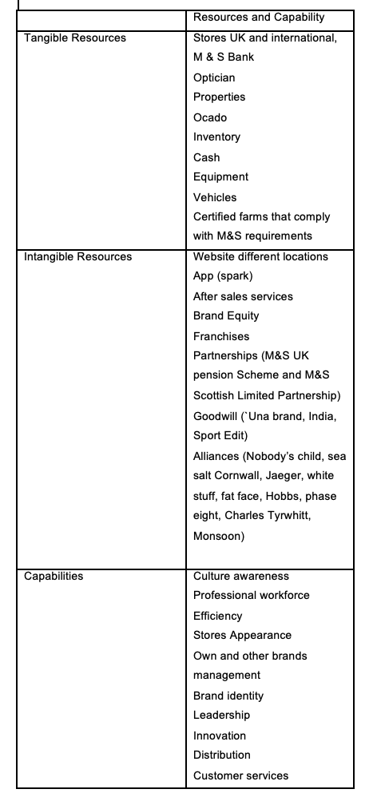

VALUE CHAIN ANALYSIS

The value chain is defined as a group of steps a company undertakes to create, manufacture, and sell its products (Barney and Hesterly, 2018, p,91). The framework is a chain because it links from one process to the other to give value to the customer through the services and products (Cookey et al., 2022, p.4). Both authors agreed that analysing the value chain is essential for companies established in the market and create competition. Thus, the value chain can be used and modified according to the organisation's function, objective, and resources. Also, using the value chain, a firm can understand and improve the activities done throughout the various stages. The value chain divides companies' activities into two groups, primary and secondary, as shown in Figure 2.

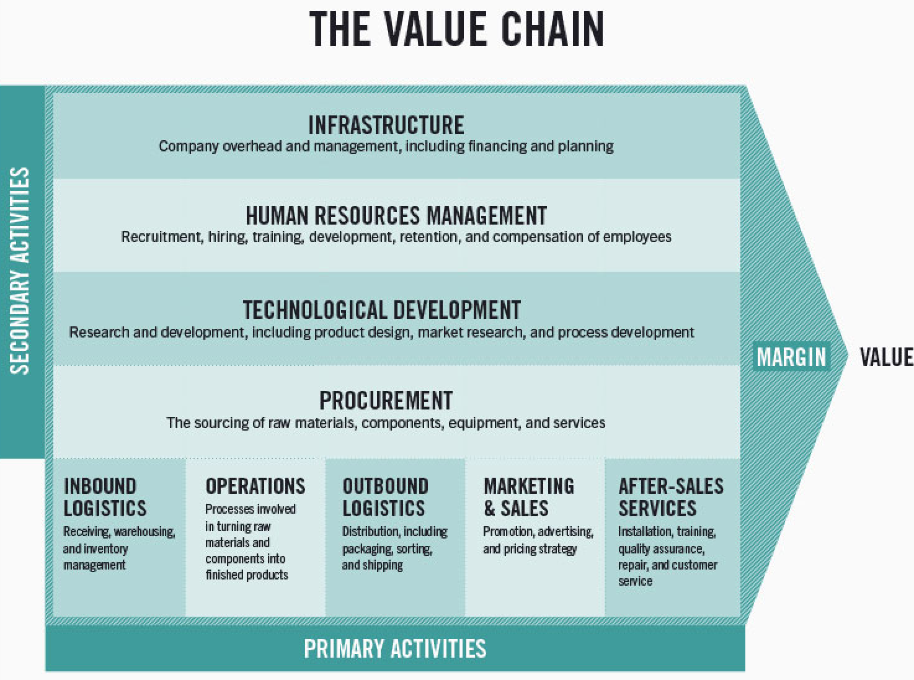
Figure 1. The value chain (Stobierski, 2020)

Primary Activities

Primary activities are related to the product and services. Figure 2 of the value chain shows that the primary activities are inbound operations, outbound planning, marketing and sales and services. In general, M&S has a system that helps them to deliver the product to their customers. they do not own any farms or factories, according to (M&S, 2023), which makes the products transported and delivered in the best conditions. Their great competitive advantage is that all their suppliers should comply with the requirements to be part of their network. Offering coupons and discounts for spending a certain amount, per example a customer spends £250 and obtain a 10% off. Their discounts are not on all the products in some selections. Delivery is made by Ocado, one of the latest acquisitions (50% of ownership).

Secondary Activities

As Michael Porters dissect the firm in activities, the secondary ones support the primary ones. The secondary activities are procurement, human resources, technology, and infrastructure. However, it is essential to resalt the technology and infrastructure of their stores are in the process of improvements due to the need for it. One of the uses of the sustainability plan is shown in its Cheshire Oaks store, where most of their material is environmentally friendly and being a megastore gives them space to have biodiversity of plants (M&S, 2023). plan A is helping the company look for new talent, invest in technology, and change the locations of their stores and helping them to reduce the cost of inefficient stores and invest strategically in ones with good locations. Nevertheless, the company will face criticism because it will close over 100 stores in the UK (Express UK, 2023).

Table 2. Value Chain of M&S Farmed Fish and Shellfish
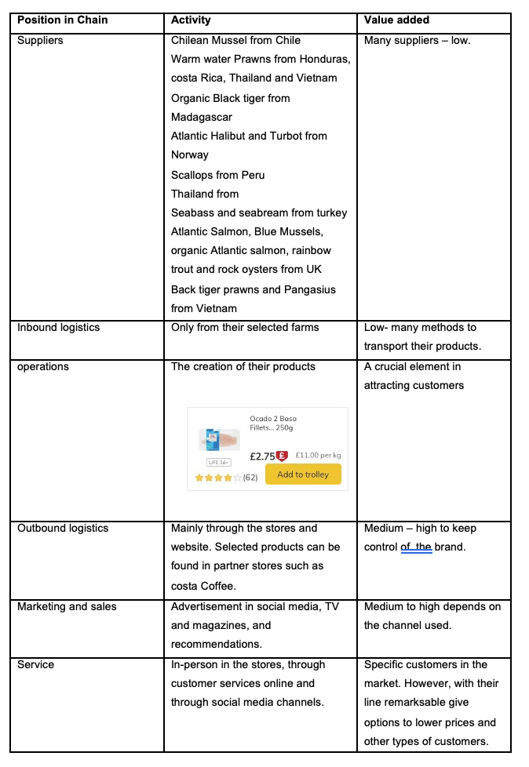
Source: M&S interactive supplier Map

Table 2 shows the value chain of M&S Farmed fish and shellfish, where the product starts with the suppliers they work with and finish with their after-service. Even if not a detailed value chain analysis, some details can be highlighted, such as the marketing and outbound. The company is not sharing their products with others, afraid of losing brand control. Something reasonable because they need to manage the final stages of marketing and after-sales services. However, they have created more affordable precious of certain products to attract and maintain customers due to the inflated cost of living. As mentioned before, Marketing could be expensive, but with the right talent, this could lower tag their campaign to the right customers

VRIO ANALYSIS OF DISTINCTIVE RESOURCES AND CAPABILITIES

Organisations need to know if their resources and capabilities represent an advantage or disadvantage to their competitors. VRIO analysis determines what level and how competitive are they resources/capabilities in the market (Lynch, 2018, p.153). The VRIO analysis stands for value, rare, inimitable, and organised. As shown previously, M&S have valuable resources not exploited to the maxim, leaving them with a partisan advantage in the industry. In Table 3, M&S VRIO analysis can be seen, where the advantage is shown.

Table 3. VRIO analysis M&S
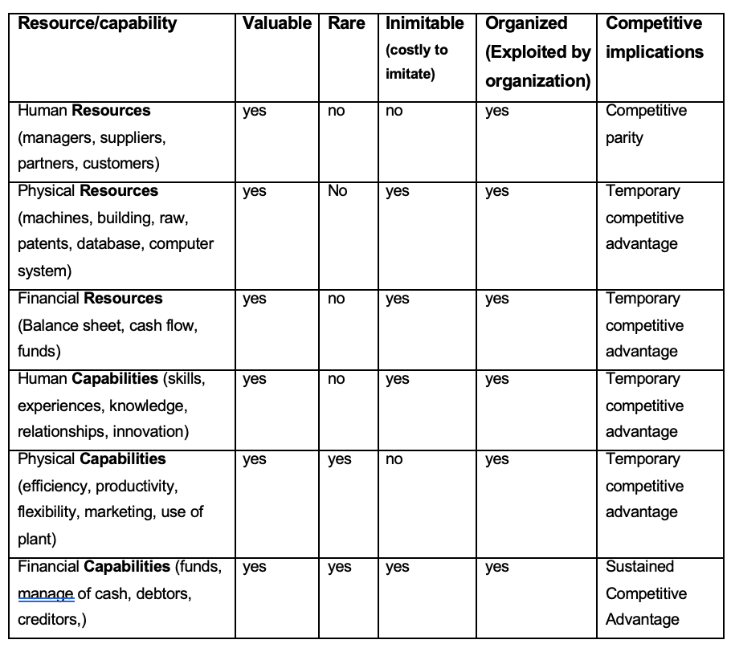

Mark & Spencer People Management and Competitive Advantage

In M &S, managing their workforce is demanding work due to being a company with more than 66000 employees worldwide. The company focuses on good talent that contributes to the innovation of new products and a new process to understand and retain customers and continue the brand's good name. Suppliers are part of their supply chain, and working closely with them has helped the company keep standards such as prices and quality that make them desirable to consumers. Their workforce gives them an advantage over other companies because of their continued work toward sustainability, equality and responsibility to their community and the natural world.

Mark and Spencer’s Physical Capabilities and Competitive Advantage

Their stores sell not only food but also home appliances and clothes that people find convenient. The new strategies in their outlets include bringing products made more sustainably and refilling food products, fresh meat, dairy and fruits. The location of their stores is in shopping centres and high streets, increasing their visibility and attracting customers. Now, their website has created facilities for customers to buy anywhere and receive their products at home. Also, the company has a presence in Europe, Asia, and the Middle East, expanding its products to new geographical locations. Even though these strategies sound great, they produce temporary advantages because their consumer could find a better brand that offers better prices for the same product, reducing the profits of M&S.

Mark and Spencer’s Financial Capabilities and Competitive Advantage

Throughout the history of M&S can, be seen innovation and compromise toward their beliefs and values that help them create and maintain their brand in society. They are strategic alliances, partnerships, and franchises to increase revenue and motivate its shareholder to believe in their value and ‘Plan A.’ Their shareholder has not received dividends since 2020, first due to the pandemic and high losses, and second to the new restructuring of their stores and payment of their debts. Thus, the increase in revenue is due to the changes adapted to it but could change at any minute.

SWOT ANALYSIS

The swot analysis is a tool that helps organisations to identify their internal strengths and weakness and what threat and opportunities are present to use the resources and capabilities (Whittington, 2020, p.112). According to Phadermrod et al., (2021), in their research about the importance of swot and its relationship with customers satisfaction, where they found that there are factors that the organisation can be in control of and some that not SWOT analysis can help plan strategies to benefit customers and company obtain their goals. Mark and Spencer are a company that values its customers, and it is the motive that they are changing its strategies to stay in the market for a long time.
This analysis will show the internal factors affecting M&S in planning an adequate strategy

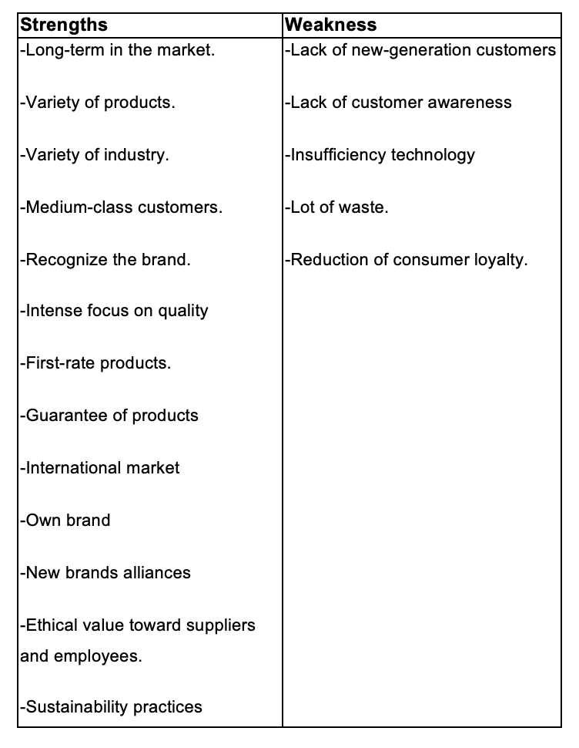
As can be seen, the strengths of M & S are their knowledge of their competencies, brand reputation, and premium quality. Nevertheless, they need to attract more talent to redesign their cloth line and their use of data. Improving their outboarding and inboarding process to help new and old employees keep up to date with the needs of their job positions and what the environment demands.

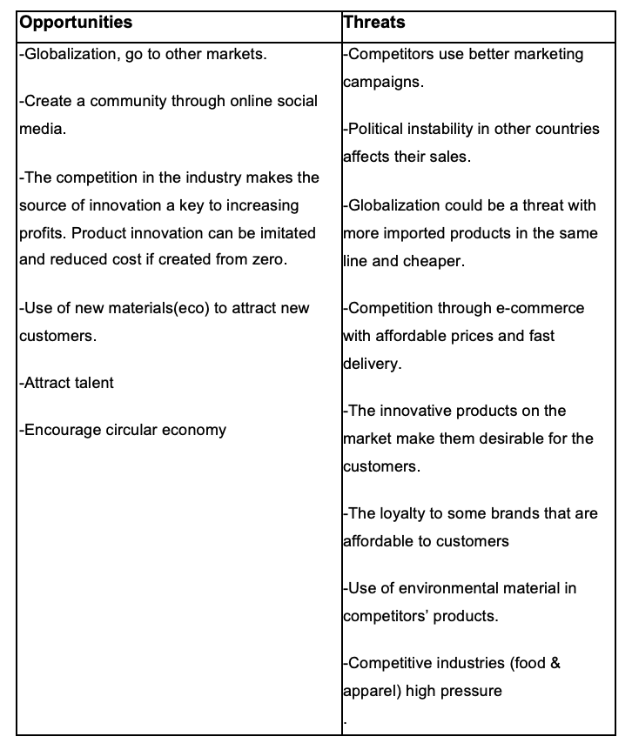

M&S is in a stage where they have discovered the market's and customers' needs. In the table, e-commerce is an excellent opportunity to extend its services to new and current customers. While most e-commerce uses talent and data to create customer-centric services, companies such as M&S need to focus and invest to be competitive. Food and clothing are necessary, and consumers want to spend on these products and services. An implication of this is the possibility of reducing the threats and taking advantage of the market's opportunities.

STRATEGIES TO SUSTAIN COMPETITIVE ADVANTAGE

PORTER’S GENERIC STRATEGY

To be competitive in the market after the pandemic, Brexit, the war in Ukraine, and other conflicts in the world is challenging for companies. One way to face this challenge is to apply strategies to the business level as Porter’s generic strategy. According to Lynch (2018, p. 269), the theory has two aspects, competitive advantage (low cost and differentiation) and target market (niche and mass), to compete in the market, aggreging value and attracting customers. However, this theory is criticised because Porter only advises working with one strategy. Alnoor et al. (2022) stated that one strategy failed many organisations during the pandemic and that the combination made them gain an advantage in the market.

Strategies

In businesses, the environment determines the strategies to use. In the case of Mark and Spencer, they use the focus differentiation strategy. For many years, it has given them an advantage and profits over their competitors, but with the change of recent technologies, globalisation, and consumer behaviours, their market share has reduced. However, since they saw it, they changed implementing the strategy to attract consumers into customers. Since the pandemic, they have started using a new line of products called 'remarksable' targeting the needs of their market. Its strategy is the focus cost strategy, providing lower prices to that specific small market. According to Alnoor et al (2022) a hybrid strategy produces better results in the retail industry. M&S are doing the same but in a segment of the market niche. Moreover, its sales have increased, gaining a position in the market. According to Sabanoglu (2022; 2023), M&S's position was between ten retailers according and in 2021 was in the ten worldwide to their sales. M&S shows that their strategy is working with the right partnership with farms and factories to lower prices and maintain customer quality.

GROWTH STRATEGIES

ANSOFF MATRIX

Companies' visions are created with the idea of a future and being in business for a long time. Business existence is not only to generate revenue but to continually create profit to be sustainable in time through the value that gives to their customers (Bhat et al., 2020). There are many strategies according to the objective; for growth, the Ansoff matrix can be used at the corporate level. The strategies are Market penetration, product development, market development and diversification. According to Johnson et al. (2017, p.244), this framework is helpful because it analyses existing products and markets against new products or markets.

Market Penetration

The main objective is to gain sales in the same maker with the same products. Increasing sales, publicity, and new customers expand the share in the market with lower risk (Alvarado Martinez et al., 2022). In other words, investing strategically in the same market does not produce significant losses due to the knowledge of the customers. In M&S, this strategy has been used to expand their supplier network and determine their customers' wants. Online sales on their website and partnership, such as Ocado, increase. Nevertheless, that created a mass recognition of the brand in the UK and internationally.

Product Development

Knowing the market and creating products using existing resources and capabilities is an advantage. According to Johnson et al. (2017) is the development or modification of a new product with the help of technology in the same market. Technology cost is high, but having employees who know how to use that technology takes time, increasing costs and being late in the market with new products. The new sport line by Goodmove with some advances technological in their products (M&S, 2020). Creating their Spark programme for loyal customers, a digital app with offers, rewards, gifts, and surprises. The company offers to spread a product's cost through economic alliances. Grocery products are growing with online deliveries. Even though there are new products and services, their technology, resources, and knowledge still need to be improved, creating a disadvantage for them in the market.

Market Development

One less risky option is using the same products and services in different markets. In businesses, expansion could be in another geographical location and segmentation (Alvarado `Martinez et al., 2022). In other words, they are expanding to unknown markets using the best product or services that could work in the market. However, this brings a disadvantage if the new customer's needs are unknown and if they use the same strategies that work in existing markets. M&S is experimenting with a phase of growth but with modifications, and one of those is closing some stores due to poor sales. However, now the modern line, such as sports for women, attracts new customers. They increase in plant-based foods. They have franchises around the world where the product can be found. They have around 450 stores around the world. However, some franchises in France and Russia are close to reducing their profits.

Diversification

Diversification requires capital to acquire or create new products, businesses, or services. Increasing risk in one market could mean increased profits (Thomas et al., 2022). There are two types of diversification unrelated and related. Related diversification is expanding the business with other products and services in the same line as existing ones in new markets. In the case of M&S, their unrelated diversification includes opticians, energy, and bank, which gave them variety in their portfolio and brand recognition covering the needs of other market segments. M&S-related diversification is Ocado, delivery services to their products (groceries and clothes), new lines in their clothing (children, teenagers, women, and men), perfumes and restaurants. Garden products are another option that they offer to their customers. As can be seen, they have diversified their business. Diversification also knows the gaps in the market to fill with new or improved strategies, such as acquisitions or mergers, reducing the competition.

INTERNATIONAL

There are many ways of going international such as global, international, multi-domestic, and transnational. Going international for a company is challenging by many factors that must be considered before going abroad. According to Whittington (2020, p. 272), international strategy is doing business in another country different to where the business is operating or created. Internationalisation requires knowledge of the market, the competitors, the legal requirement, and the cost of operating in that country. The centre of their business is economy of scale with standard products, assuming the customers' needs in all markets are the same (Whittington, 2020, p.282). M&S operate a global strategy with more than 98 websites for their international market and franchises with more than 1400 stores worldwide. The company implements their business in each country, using local languages, currencies, and websites (Rigby, 2021). Despite that, the company should adapt their products and services to compete with the local market to avoid what happened in China market, where it failed due to adaptation to the customers' needs.

GREEN STRATEGY AND CSR

Organisations search for their benefit but think about the people who work with them and their customers, creating an environment of trust and fair actions. Corporate social responsibility (CSR) is the organisation’s purpose of acting morally, promoting prosperity, and enhancing the lives of its staff, loved ones, neighbours and society (Whittington, 2020, p.145). According to the European Commission (2023), the impact is significant to improve work, health, education, and the environment. Societies worldwide have changed the way of doing business and have understood that making profits requires the collaboration of all in the community to get customers and raw materials continually.
Mark and Spencer are a company that has changed its mission to a more responsible one towards the environment and society. According to their sustainability report of 2022, they are working towards environment, social and governance. The initiative is a circular economy, with a “let us showoop” campaign where people swoop their M&S clothes and get a voucher—also working with other partners such as Hirestreet, which offers rental clothes. To spark customers, give them tips about vegetarian recipes and reducing food waste.
Mark and Spencer compromised with stakeholders through many small actions that benefit not only them but their employees, suppliers, and customers. Furthermore, the employees in the supply chain are treated equally and rightfully with the minimum payment. Recycling is still one of their programmes, reducing the packaging and putting loose fruit and vegetable options, working with suppliers for better opportunities, and investing in recruitment through various resources. Most of Their food products are now like UK government standards in reducing salt, sugar, and fat.

CONCLUSION

Management strategies are essential to an organisation's efficient use of its capabilities in an environment that could be volatile and risky. Every company must analyse their environment to know the competitors and decide the best method to face them. The co-creation, collaboration and creation are approaches that help with specific strategies for a specific market.

This analysis has highlighted the strategies used by Mark and Spencer and their results. One of the findings shows a need for more technology in their process and workforce, reducing their capabilities against other competitors in the market. With plan A, the company shows that challenges and change are possible if there is a compromise towards the benefit of all (community). Besides, innovation is critical to implement and create new products, services, and processes to compete in the market. The analysis shows that the company is moving toward increasing its market share. However, it is not cheaper and quicker. The grocery and cloth industries are market essential to consumers. However, due to the aftermath of the pandemic, Brexit and war, the sensitivity to prices has increased, forcing companies to create new strategies.

Mark and Spencer should be implemented strategies in other countries to pass from a global to a more centric customer organisation. Moreover, companies' strategies in another country should be done by analysing the competitors and needs of that country. This analysis will maximise the return on sales and gain brand recognition in the country.

RECOMMENDATIONS

The market is demanding new products and agile processes. Mark and Spencer have made a significant effort to comply with these new demands in the market; however, there is space for improvement.
In this report, Mark and Spencer are working with his Plan A, emphasising the compromise with the environment, the people, and the business. There are some recommendations to enhance their strategies to gain more in this new path they are building.
First, the mission and values are a point of attraction for generations focused on ESG (environment social governance) products. A study by Mckinsey and NielsenIQ (2023) for five years between 2017 and 2022 found sales growth with ESG products. However, this only shows if consumers prefer buying ESG-label products. In another study, Mckinsey (2020) determined that sustainability materials are a factor at the time of buying. Consumers are now conscious of their buying behaviours. So buying is consciously supported by the product's claims and users' (family, friends, and others) comments. M&S should improve this point through mass advertisement. Campaigns should include the product behind it, meaning the process that made that product possible and its effect on the environment, added to their supply chain interactive map.
Second, the focus strategy in the grocery industry helps them establish their presence in the market, brand recognition and attract new customers. Adding new products to the value line, "remarkable is essential to cover the needs of their existing customer and give opportunities for new ones to come. Also, Partnerships should expand to other target groups by catering their product to executives of firms or educational events. The cloth industry should attract more customers to their initiatives, such as adding pop-up windows on their website to announce second-hand and swooping alternatives.
Third, the refilling option of their product should be in most of their stores. If consumers do not know what a company offers, they do not buy from them. So, stores, websites, and advertisement announcements are essential to increase and attract customers.
The fourth global strategy should be adapted to local products to maximise sales. The CSR should focus on the community that M&S is, creating plans to help them. Also, adding local partnerships in the host countries could increase consumer confidence and trust.
Most strategies mentioned are in place now; however, they should be vigilant to the consumer's changes in behaviours and market factors that could provoke a decline in performance.

REFERENCES

Alnoor et al., (2022) The hybrid strategy based on miles and show and porter’s strategies: and overview of the current state of the art of research. International Journal of Engineering Business Management, 14, pp. 1-18. Available at: https://journals.sagepub.com/doi/pdf/10.1177/18479790221080214 (Accessed: 26 April 2023)

Alvarado Martínez et al., (2022) La matriz de Ansoff Herramienta estratégica para incrementar la competitividad de los productos de hidalgo. AgEconSearch, pp. 255-266. Available at: https://ageconsearch.umn.edu/record/330092/ (Accessed: 27 April 2023)

Bank of England (2023) Inflation and the 2% Target. Available at: https://www.bankofengland.co.uk/monetary-policy/inflation (Accessed: 7 April 2023)
Bar Am et al., (2023) Consumers care about sustainability – and back it up with their wallets. Available at: https://www.mckinsey.com/industries/consumer-packaged-goods/our-insights/consumers-care-about-sustainability-and-back-it-up-with-their-wallets (Accessed: 28 April 2023).

Barney, J. and Hesterly, W. (2018) Strategic Management and competitive advantage: Concepts and cases, Global edition. 6th edition. Harlow: Pearson Education Limited. Available at: https://library.oapen.org/handle/20.500.12657/57562 (Accessed: 26 April 2023)

Bhat et al., (2020) Sustainable business model in B2C online retailing: and Indian consumer perspective. In Geetika et al., Technological innovations for sustainability and Business growth, pp.147-185. IGI global. Available at: https://www-igi-global-com.ezproxy.uwtsd.ac.uk/gateway/chapter/full-text-html/238933 (Accessed:27 April 2023)

Becas-santander. (2023) Strategic management: agile solutions in a VUCA environment. Available at: https://www.becas-santander.com/en/blog/strategic-management.html (Accessed: 29 March 2023).
Bedford, E. (2021) UK: leading supermarket chains 2020. Available at: https://www.statista.com/statistics/1135764/most-popular-supermarkets-in-the-uk/ (Accessed: 29 March 2023).
Bedford, E. (2022) Grocery Market in the UK 2004-2027. Available at: https://www.statista.com/statistics/330171/grocery-retail-market-value-in-the-united-kingdom-uk/ (Accessed 11 April 2023).

Bedford, E. (2023) Most popular supermarket chains in the UK q4 2022. Available at: https://www.statista.com/statistics/1135764/most-popular-supermarkets-in-the-uk/ (Accessed 11 April 2023).

Cookey et al., (2022) Integrated functional Sanitation Value chain: the role of the sanitation economy. London: IWA publishing

Coppola, D. (2023) Online retail sales in the United Kingdom 2012-2019. Available at: https://www.statista.com/statistics/315506/online-retail-sales-in-the-united-kingdom/ (Accessed: 29 March 2023).
Dictionary Cambridge (n.d.) MACRO: meaning in the Cambridge English Dictionary. Available at: https://dictionary.cambridge.org/dictionary/english/macro (Accessed: 29 March 2023).
European Commission (2023) Corporate social responsibilities & responsibilities business conduct. Available at: https://single-market-economy.ec.europa.eu/industry/sustainability/corporate-social-responsibility-responsible-business-conduct_en (Accessed: 28 April 2023)
Express UK (2023) Mark and Spencer accelerate plans to close stores across UK- full list of locations. Available at: https://www.express.co.uk/life-style/life/1736377/Marks-and-Spencer-store-closures-full-list-new-foodhalls (Accessed: 26 April 2023).

Feber et al.(2020) Sustainability in packaging: Inside the mind of US consumers. Available at: https://www.mckinsey.com/industries/paper-forest-products-and-packaging/our-insights/sustainability-in-packaging-inside-the-minds-of-us-consumers (Accessed: 28 April 2022).

Food Standards Agency (2023) Homepage. Available at: https://www.food.gov.uk (Accessed 11 April 2023).
GOV.UK. (2021) Office for product safety and standards. Available at: https://www.gov.uk/guidance/product-safety-advice-for-businesses (Accessed: 11 April 2023).

GOV.UK. (2023) Ambitious roadmap for a cleaner, greener country. Available at: https://www.gov.uk/government/news/ambitious-roadmap-for-a-cleaner-greener-country (Accessed: 11 April 2023).
GOV.UK. (2023) UK signs historic trade deal with Ukraine as part of enhanced support. Available at: https://www.gov.uk/government/news/uk-signs-historic-trade-deal-with-ukraine-as-part-of-enhanced-support (Accessed: 7 April 2023).
Health and safety executive (2023) Prepare a health and safety policy. Available at: https://www.hse.gov.uk/simple-health-safety/policy/index.htm (Accessed 11 April 2023).

Johnson et al.(2017) Exploring Strategy. 11th edition. Harlow: Pearson education Limited. Available at: https://r4.vlereader.com/Reader?ean=9781292145136# (Accessed: 27 April 2023).

Lynch, R. (2018) Strategic Management.8th edition. Harlow: Pearson

McLannahan, B. (2023). Global economy will be mired in stagflation in 2023. Available at: https://www.cib.barclays/our-insights/3-point-perspective/global-economy-will-be-stuck-in-the-muck-of-stagflation-in-2023.html (Accessed: 7 April 2023).
MarketLine Advantage (2022) Apparel Retail in the United Kingdom November 2022. Available at: https://advantage-marketline-com.ezproxy.uwtsd.ac.uk/Analysis/ViewasPDF/united-kingdom-apparel-retail-165946 (Accessed 13 April 2023).

MarketLine Advantage (2023) Food & Grocery retail in the United Kingdom January 2023. Available at: https://advantage-marketline-com.ezproxy.uwtsd.ac.uk/Analysis/ViewasPDF/united-kingdom-food-grocery-retail-171209 (Accessed 13 April 2023).

Marks and spencer (2014) Our Sustainable future. Available at: https://jobs.marksandspencer.com/plan-a (Accessed: 29 March 2023).
Marks and Spencer Group plc (2022) The next phase of M&S’ transformation Shaping the FUTURE. Available at: https://corporate.marksandspencer.com/sites/marksandspencer/files/marks-spencer/m-and-s-ar22-full-ar-report.pdf. (Accessed: 29 March 2023).

Marks & Spencer (2023.) Our approach to sustainable fashion. Available at: https://corporate.marksandspencer.com/our-approach-sustainable-fashion (Accessed: 7 April 2023).
M&S (2020) M&S kicks off 2020 with its new womenswear activewear range-Goodmove. Available at: https://corporate.marksandspencer.com/media/press-releases/ms-kicks-2020-its-new-womenswear-activewear-range-goodmove (Accessed: 27 April 2023).

M&S Annual Report (2022) Our year in review 2022. Available at: https://corporate.marksandspencer.com/investors/our-performance-updates/2022-annual-report (Accessed: 1st April 2023)

M&S (2023) Cheshire Oak Store. Available at: https://corporate.marksandspencer.com/ms-cheshire-oaks-store#:~:text=Opened%20in%20August%202012%2C%20M%26S,award%20winning%2C%20biggest%20greenest%20store. (Accessed: 26 April 2023)

M&S (2023) Interactive supplier Map. Available at: https://interactivemap.marksandspencer.com/?loc=62dea024af2200b88eb6b580&cat=62bc79bb1d4c1ff1c6202a54&lay=62dea007af2200b88eb6b54f (Accessed: 26 April 2023)

M&S (2023) M&S food announces prices lock extension and guaranteed trusted value for customers. Available at: https://corporate.marksandspencer.com/media/press-releases/ms-food-announces-price-lock-extension-and-guarantees-trusted-value-customers (Accessed 13 April 2023).

M&S (2023) Responsible sourcing and Human right in clothing and home. Available at: https://corporate.marksandspencer.com/sustainability/human-rights-our-supply-chain/supporting-our-clothing-home-supply-chain#:~:text=We%20don%27t%20own%20any,India%2C%20Turkey%20and%20Sri%20Lanka. (Accessed: 26 April 2023)

Mendonca et al. (2022) The rise of 5G technologies and systems: A quantitative analysis of knowledge production. Telecommunications Policy, 46(4). Available at: https://www-sciencedirect-com.ezproxy.uwtsd.ac.uk/science/article/pii/S0308596122000301 (Accessed: 7 April 2023).

Nguyen, H. and Dsouza, R. (2021). Global: Consumer willingness to pay for environmentally friendly products. Available at: https://yougov.co.uk/topics/consumer/articles-reports/2021/04/29/global-willingness-pay-for-sustainability (Accessed: 7 April 2023).
O’Sullivan, M. (2020) Industrial life cycle: relevance of national markets in the development of new industries for energy technologies – the case of wind energy. Journal of Evolutionary Economics. 30(4), pp. 1063-1107. Available at: https://www.proquest.com/docview/2471900651?accountid=130472&parentSessionId=1Oq0hUfBoQHXV7uJg4%2B6dABGYWC51U2DzzwPDL3WUsg%3D&pq-origsite=primo (Accessed: 18 April 2023)

Park-Poaps et al. (2021) Bangladeshi clothing manufactures’ technology adoption in the global free trade environment. Journal of fashion Marketing and Management, 25(2), pp. 354-370. Available at: https://www.proquest.com/docview/2533678184?accountid=130472&parentSessionId=8Eka4IS6WxkQixgNN6htSHIfglKENLiCssNQBz2zrCM%3D&pq-origsite=primo (Accessed 13 April 2023).
Phadermrod et al. (2021) Importance -performance analysis-based SWOT analysis. International Journal of Information Management, 44, pp. 194-203. Available at; https://doi.org/10.1016/j.ijinfomgt.2016.03.009 (Accessed: 25 April 2023)
Pehrsson, A. (2021) Competitive International Strategy: Key Implementation issues. New York: Routledge.
Rigby, C. (2021) M&S expands its international ecommerce business to 100 markets as global customers shift online. Available at: https://internetretailing.net/ms-expands-its-international-ecommerce-business-to-100-markets-as-global-customers-shift-online-22834/#:~:text=M%26S%20says%20it%20is%20taking,range%20of%20currencies%20than%20previously (Accessed: 28 April 2023).
Sabanoglu, T (2022) Leading 10 retailers in the United Kingdom (UK) 2022. Available at: https://www.statista.com/statistics/462863/leading-ten-retailers-by-sales-uk/ (Accessed: 27 April 2023)
Sabanoglu, T (2023) Leading UK retailers ranked worldwide sales 2021. Available at: https://www.statista.com/statistics/438358/leading-10-retailers-united-kingdom-uk-based-on-sales/ (Accessed: 27 April 2023)
Smith, P. (2022) Revenue of the apparel market in the UK 2013-2026. Available at: https://www.statista.com/forecasts/1156059/apparel-market-revenue-in-the-united-kingdom (Accessed 11 April 2023).

Smith, P (2023) Retail sales value monthly in textile, clothing, and footwear stores in Great Britain from January 2017 to January 2023. Available at: https://www.statista.com/statistics/288014/retail-sales-value-monthly-for-clothing-footwear-textile-stores-great-britain/ (Accessed 11 April 2023).

Statista (2022) Fashion e-commerce in the United Kingdom (UK) statistics and facts. Available at: https://www.statista.com/topics/8759/fashion-e-commerce-in-the-united-kingdom/#topicOverview (Accessed 13 April 2023).

Stephenson, A. (2022) C-Suites suffering decision-making paralysis post-pandemic | Available at: https://www.thehrdirector.com/business-news/covid19/confidence-crisis-48-of-c-suite-less-confident-in-decision-making-post-pandemic/ (Accessed: 29 March 2023).
Stobierski, T. (2020) What is a value chain analysis? 3 steps. Available at: https://online.hbs.edu/blog/post/what-is-value-chain-analysis (Accessed: 29 March 2023).
Thomas et al. (2022) Role of emerging markets vis-à-vis frontier markets in improving portfolio diversification benefits. International Review of Economics & Finance, 78, pp. 95-121. Available at: https://www-sciencedirect-com.ezproxy.uwtsd.ac.uk/science/article/pii/S1059056021002422 (Accessed: 27 April 2023)

Whittington et al. (2020). Exploring Corporate Strategy: Text and Cases. 12th ed. Harlow: Pearson Education.
Xu et al. (2022) How gamification drives consumer citizenship behaviour: The role of perceived gamification affordances. International Journal of Information Management, 64. Doi: https://doi.org/10.1016/j.ijinfomgt.2022.102477 (Accessed: 7 April 2023).
Zhang, D. et al. (2018) Eco labelling and Retailer pricing strategies: the UK. Haddock Market. Sustainability, 10(5), p. 1522. Available at: https://www.proquest.com/docview/2108741431?accountid=130472&parentSessionId=XLJ6WS4reORWhfWTiKjxvVehB1Ll%2FMAvnmZ78hLBE%2FM%3D&pq-origsite=primo (Accessed: 7 April 2023).

APPENDICES

