LCMB7003- Strategic Management Assessment 100%
Submitted By- Suraj kumar

Student Name- Suraj kumar
Student ID- 2126818
Module: - Strategic Management 100%
Lecturer Name:- Gladious Kulothungan
Course Name:- Masters of Business Administration General
Submission Date:- 5th January 2023
Pages:-22

Table of Contents
Table of Contents 2
INTRODUCTION 3
MAIN BODY 3
Overview of the Organization 3
Organizational structure 4
Organizational culture 4
Innovation 5
Social role 6
The strategy of the company 7
Competitive advantage 7
Marketing Techniques 8
Corporate social responsibility 10
Strategic management analysis 10
Pestle analysis 11
Porter's five forces 12
SWOT analysis 13
CONCLUSION 15
REFERENCES 17
Books and Journal 17

INTRODUCTION
Strategic Management is a very crucial concept in the Organization through which managers of the Organization make and execute planning at the workplace, and along with that, they effectively analyze the operations at the workplace so that they can achieve their long-term as well as short-term targets (Rosenbaum-Elliott, 2020). In other words, strategic Management can be referred to as setting up the goals and objectives of the Organization. After setting up the goals, they analyze the actions of the competitors as well, and accordingly, they change their strategies so that they can hold their position in the market for a longer period of time. It is a very important concept because it helps in providing direction to the plans and policies that have been formulated by the upper level of Management, and it also helps in allocating the resources through which they can be used in an efficient manner. Tesla is an American multinational company that carries out its operations in the automobile sector. This Organization designs and produces electric vehicles, and with that, they also provide battery solar panels and various kinds of energy storage products to the customers. This Organization was founded in the year 2003 and was founded by Elon Musk (Teece, 2018). In this report, there will be an analysis of the Strategic Management of Tesla organizations and how they manage to analyze their central issues. There will be the applicability of various types of theories and frameworks through which it will be analyzed by how a company has achieved a competitive advantage in the marketplace.
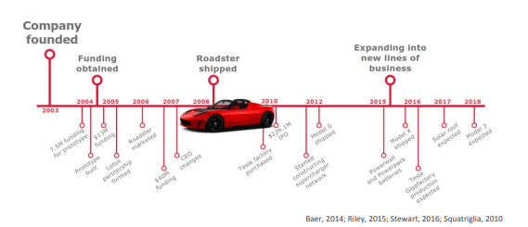
Figure 1 Strategic Management in TESLA
(Source: Parekh, et. al., 2020)

MAIN BODY

Overview of the Organization
Tesla is a very well-known and established automotive Organization that was founded in the year 2003. Tesla has completely introduced electric vehicles into the marketplace with the updated technology. They have followed the focused differentiation strategy and have made their product different from the market. Tesla has provided great designs in cars with renewable sources of energy, and along with that, they are also providing solar roof charging, which automatically converts energy into electricity. Elon Musk is the CEO of the Organization, and he has great entrepreneurial qualities and attributes through which you always focus on building the brand value of the Organization. Their first product that was shipped into the marketplace was named roadster. Tesla has grown to a very great extent across the globe. They have shown a great increase in revenues around the year 2015 because of their model S, that have shown great success in the marketplace. This has helped the Organization to give tough competition to the other Organization, which can easily be seen in the case study (Akakpo, et. al., 2019)
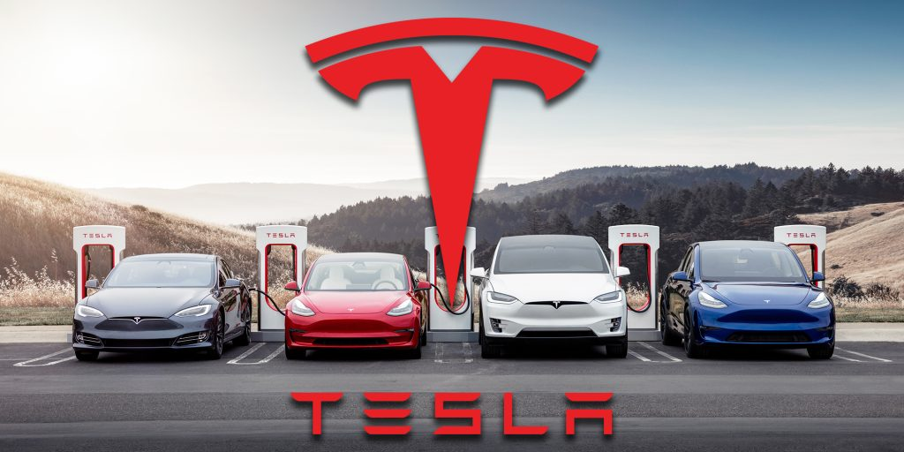
Figure 2: Tesla Company
(Source: Lambert, 2022)

Organizational structure
Tesla is able to exert tight control over the firm because of its functional organizational structure. Tesla's Organization consists of different functional departments, which are engineering, manufacturing, design, human resource, business development, etc. Tesla has become able to manage their operation activities effectively and to implement new policies and plans to a great extent because of the chosen organizational structure.

Tesla also keeps only a few regional divisions, namely four that are United States, China Norway, and catch-all sections for operations elsewhere. With the help of these divisions, Tesla is able to adjust its strategies, marketing initiative, and financial reporting to suit the needs of various geographic reasons with various consumer populations and regulatory restrictions. Apart from keeping regional divisions, Tesla places a strong focus on global centralization, which can be referred to as decisions made by a professional team or group of people who control the working of the whole Organization (Connell and Menon, 2019). The chief executive officer of each and every office in Tesla's globe hierarchy is located in the business's central headquarters. Tesla is opposite the autonomy power of their regional offices that are present across the world. Apart from that, the majority of operating activities and choices for Tesla's overseas operations are being made at the corporate level.

Organizational culture
It can be expressed that the organizational culture of Tesla organization is so much influenced by the organizational structure of the Organization. From the given case study, it can be seen that Tesla follows six core features that make their culture more attractive and efficient and that also help in contributing in order to make Tesla a more knowledgeable organization that makes the environment more significant.
From the given case study, it can also be seen that the upper department of the Organization always focuses that their employees should think out of the box and generate innovative ideas for the Organization, and those who help them in this process are awarded for their valuable contributions. This makes the culture of the Organization positive and healthy. CEO Tesla consists of various leadership attributes that have the employees share a common vision and which ultimately reduces the chances of conflicts.
Tesla also executes training and development events for their employees so that they can develop more skills themselves. From the given case study, it can be seen that people who are working in Tesla organizations are more compatible and skillful than other organizations because their knowledge and skills are updated from time to time (Perkins, and Murmann, 2018). Apart from that, it can also be seen that their roots in the Silicon Valley's software programs that develop cultures and practices help Tesla to produce more value in the teams in order to do group tasks.
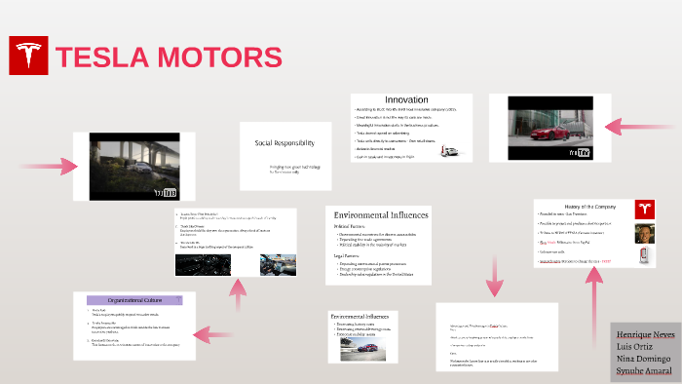
Figure 3: Organizational Structure of Tesla
(Source: Ortiz, 2017)

Innovation
Tesla's culture is women with integrated innovation, and apart from that, one of the most famous magazines that is Forbes, has also stated that Tesla is one of the most innovative organizations present across the world.

It can be seen in this case that Tesla differs from other companies in terms of its culture, the structure of its Organization, and day-to-day operations.
- Tesla is an idealist organization that wants to make the world greener and a healthier place to live in. The business address this objective by combining degrees of study on sustainable energy from several sectors into a workable form.
- From the given case study, it can be seen that Tesla focuses on innovative new products in the market place and they have introduced connected cars that have the ability to self-drive. Along with that, their cars can also be monitored and given commands by the Smartphone. They have built their cars electric, and through charge, it can be run for free they also implemented superchargers around the road so that people can charge their Tesla cars easily.
- It has been seen that Tesla has always played a major risk in regard to technology. Along with that, it can be expressed that it was a startup and a new innovative idea in the automotive industry (Jugend et al., 2020). Employees of the Organization are being asked to broaden their minds in order to achieve the goal of the Organization. The CEO of the Organization always keeps on motivating their employees not to set the deadline for themselves. They always motivate them to generate new ideas for the Organization.
- In the case study, it has been seen that Tesla, in the initial stages, has collaborated with their competitors in order to form effective strategies for the battery recycling programs. This has helped them to offer innovative products into the marketplace when they get full knowledge of how to use the batteries in their car vehicles.
- The innovative strategies of Tesla organizations are unique from other companies because they take financial resources from their customers before delivering the car. Organizations always focus on design over promotional techniques.
The offering of completely electric vehicles into the marketplace created history in the automotive industry, and this innovation of the Organization has been appreciated in the marketplace.

Social role
Tesla is a great example which consists so much potential that can affect society in a positive manner. In relation to the automotive industry, Tesla organization is very focused on its innovation, and because of that, it can ignore the losses that occur in the short term. They are working hard to fulfill the needs of the people in society in order to develop more effective technology in their vehicles. Sometimes organizations also criticize the CEO of Tesla because he spends too much on research and development procedures. Apart from that, this R&D has held the Organization in order to make the quality of the innovation by the applicability of charging and energy storage.
The innovation of Tesla is well recognized by the public, and it has proven to be a problem-solving innovation for the customers. CEO of the organization analyses that electric vehicles are not so common in the automotive industry, and yet it produces so much carbon emission in the environment that it is almost dependent upon fossil fuels. It takes the patent in order to produce electric vehicles in the marketplace and execute innovative technology in the vehicles so that they can become able to maintain the quality of the environment by eliminating carbon emissions. From the given case study, it can be seen that it is one of the major social roles that has played by Tesla in order to save the environment. People have appreciated their innovation to a very great extent, and for that purpose, they have become one of the top organizations across the globe. They have implemented effective technology in their vehicles through which the source of electricity is renewable, and it can generate energy again and again, which can directly convert into electricity. They have followed two aspects in order to save the environment that is energy conservation and environmental protection (Thomas, and Maine, 2019). Both these concepts have helped them to achieve their social goal.

The strategy of the company
Tesla not only developed software development cars in the automotive industry, but apart from that, it is also known as an IT company as well.
- When planning function and controlling function is conducted at the workplace and for that purpose requirement management system and resource planning system is used.
- In the given case study, it has been seen that Tesla uses asset management software in order to produce their car and to run operations effectively at the workplace.
- Along with this software, Tesla also rates its retail counter to online stores that are also being operated by an E-Commerce system.
- Tesla has developed various types of programs for their vehicle, and one of the main IT technologies is the geographical information system that enhances the customer experience.
- Like other companies, Tesla also relies on other Organizations in order to get the software, but when they fail to provide active ERP solutions to them, then they have a team of engineers at their workplace who help them to build their own software (MacDuffie, 2018). This shows how Tesla shows itself as an information technology company because they have the capability and flexibility to produce software and to achieve the goals towards the commitment they have made. This technique of producing software has helped the Organization to give tough competition to other competitors in order to produce the desired products that customers wanted.

Competitive advantage
Competitive techniques are highly used by the Tesla Organization in order to make their brand more valuable in the eyes of the customer. They are carrying out their operation in the automotive industry where a large number of competitors present the Organization, but they are different from other organizations because they are providing innovative products in the marketplace. From the given case study, it can be evaluated that Tesla organizations use competitive models in order to stay ahead of their competition. They use Porter's generic competitive strategies, which are mentioned below:
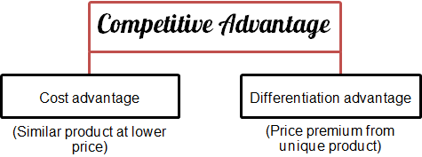
Figure 4: Competitive Advantage
Source: Jurevicius, 2021
Differentiation: It is the first competitive strategy that Tesla organization undertakes from this model. It helps them to maintain the comparative advantage in the marketplace and to grow their Organization more. Undertaker has this strategy by differentiating its products from the other companies in the industry because they have advanced its technology in order to make the product more environmentally friendly. They have executed effective technology in their vehicles, which can be run automatically, and they use electricity and are not based on petroleum which ultimately reduces the spread of carbon emissions into the environment. This strategy of porter's genetic model helps the Organization to attract those potential customers in the market who are more concerned about the environment because they are targeting their needs and wants. This strategy facilitates the Organization to stand out from the competition because it also helps in enhancing the brand image as their make efforts to save the environment and to make the operation activities more sustainable.
Focus: From the given case study, it can be seen that it is the second strategy that is undertaken by the administrative department of the Organization. This straightening facilitates them to emphasize the uniqueness of their product as they're caring for their operations in producing the electric vehicles, which is the first focused strategy of the Organization. After implementing this strategy, the company has become more popular in the market because their products are being liked by the customers as it is different from the other company products because their cars can run automatically and they do not consume petroleum, and can run on electricity. The cost of the cars has also declined, and their brand popularity enables the Organization to enlarge its target customers in the automobile sector. So it can be expressed that this strategy of water models has helped the Organization to give tough competition and to take comparative advantage to a great extent.

Marketing Techniques
Tesla is a very well-established automotive brand in the marketplace that specializes in producing electric vehicles. This Organization is famous worldwide because of its $0 marketing techniques (Kim, H., 2020). From the given case study, it has been seen that till now, Tesla does not have to spend funds on promotional techniques and marketing apart from the launching of the vehicle. This marketing strategy comes out to be strange, but this can be effectively understood with the help of the marketing mix of the Organization: The marketing mix of Tesla is described below:
Product strategy: Tesla organization provides its vehicles in three models that are named S, X, and 3. Each model has developed with so much research and development, and all have been created electric, which can be charged easily. They also focus on executing Sun powered innovation in their electric vehicles as a significant energy framework in order to give a better product to the customers.
Place strategy: Talking about the place strategy, Tesla does not have any franchises in the marketplace. Apart from that, they are operating an online-based organization store which has them to eliminate the interaction of third parties with the customer (Erfan Arefin, 2021). They believe in direct connection with the ultimate consumer in the marketplace as they do not sell different kinds of vehicles, which can create challenges to fulfilling the needs of the customers. So, therefore, they maintain a segmented group of customers to whom they give their electric vehicle products.
Pricing strategy: The marketing cost of the Tesla vehicle is far higher than other automotive organizations that are present in the market. As they are implementing the electric technique in their cars so, for that purpose prices of their products are higher than the market. They wanted to maintain luxury customers with their brand, and because of that, they are producing cars that are of higher price and not of the medium range.
Promotion strategy: Talking about the advertisement strategies of the Organization, they do not spend many funds on promotional techniques because they believe in word of mouth, which directly helps in enhancing the Goodwill of the Organization. They always believe in providing the best customer experience by providing quality cars to them with high-tech technology. This automatically turns out to be the promotional technique for the Organization because people generally advertise their product to other people after using it.

Corporate social responsibility
In regards to the corporate social responsibility of Tesla motors, they inherit a proactive approach. They have undertaken two stages of corporate responsibilities that are environmental protection and energy conservation.
The upper department of the Tesla organization has taken responsibility for protecting the environment by changing its organizational strategies. They have reduced dependence on transportation that was being carried out on petroleum, and they have started to manufacture their own electric vehicles, which do not produce carbon commission in the air. They have installed batteries in the vehicle products which can be charged, and they also implemented a loop in the battery that recycles its lead acid in the batteries that can be used again and again. This proves to be an act of environmental protection by Tesla.
Another method they have implemented at the workplace is to conserve energy in order to protect the environment. In the initial stages, they were only installing batteries in their vehicles, but they were not creating the technology which could provide clean energy in the community. So now they have enlarged their vision in order to provide clean energy to the people who buy their product.
They have carried out the energy conservation process by introducing solar power in electric vehicles, and in this, they are also providing a facility to store the energy. A solar roof has been installed in the vehicles, which directly converts the energy from the sun into electricity. In recent times they also purchased a Solar City in order to increase the capability to strengthen their electric vehicles (Wang, Duan, and Liu, 2021). So that is how they carry out their corporate social responsibility in order to save the environment.

Strategic management analysis
Strategic management analysis can be referred to as the evaluation of the working environment of the Organization. The working of the Organization defines how a particular organization carries out its activities. In relation to the Tesla organization, strategic management analysis will be done by using different kinds of models. Some of the static management tools have been undertaken below, which help in analyzing the position of the Organization in the marketplace. These tools of strategic Management also provide benefits to the Organization in analyzing the level of competition and opportunities for the Organization that they can grab in order to increase profitability. These models are discussed below:

Pestle analysis
Pestle analysis helps the Organization to analyze the external factors of the Organization. From the given case study, Pestle's analysis of the Tesla organization is given below:

- Organization factors: from the given case study, it can be analyzed that this factor is beneficial for the Tesla organization because they have an opportunity to strengthen their financial performance and results through various incentives of government. The management department of the Organization is also planning to take their business to environmentally friendly places like Norway. This factor is beneficial for them because they can increase their sales.
- Economic factors: from the given case study, it can be analyzed that they were facing issues in maintaining the profitability of the Organization. But now they have managed because they take benefits from the lower battery cost as they have executed batteries in their vehicles which makes their products more attractive for the customers (Wang, Duan, and Liu, 2021). They implement the use of renewable energy sources, which will have them in earning a good amount of revenue from selling out their vehicles.
- Social factors: From the given case study, it can be analyzed that Tesla has grabbed the opportunity to consider the social factors because now people are showing interest in renewable sources of energy. As of now, Tesla is the only automobile organization that is providing the best electric vehicles, and their four have the potential to boost their financial performance through which they can fulfill the needs of those groups of people who tend towards low-carbon lifestyles.
- Technological factors: It has been seen in the case study that the effective technology changes that are present at the workplace in Tesla have become an opportunity for them to enhance their product quality (Matthew et al., 2020). The technological advancement of the Organization and the increasing popularity of the automobile sector the customers have directly helped Tesla organization to increase their revenues and profits, and along with that, they are focusing on reducing cost by implementing high-tech equipment in their vehicles. From the given case study, it can be evaluated that various new techniques of production keep on introducing on a daily basis at the workplace.
- Environmental factors: One of the main reasons for introducing the electric vehicle in the marketplace is the environmental factor which can easily be seen in the case study. This offering has two advantages for the Organization because they have the basis to promote their electric vehicles on different points, such as concerns about the climate and decreasing quality of the environment. Apart from promoting the products for these reasons, another reason is that it also costs lower than the other vehicles' production.
- Legal factors: From the case study, it can easily be seen that the legal factors of the Organization are very important for them because they want that their brand value should be maintained overseas. They have the opportunity to effectively and safely grow their business in the international market by following international patent law. In between, they have also faced problems in expanding their business in the international markets, but they manage to solve these issues by effectively implementing the policies of different countries.

Porter's five forces
Porter's five forces is a very effective framework that helps the Organization to identify and analyze the level of competition in particular industries which can affect the operational activities of the Organization. It facilitates the Organization and the industries to determine their corporate strategies so that they can give tough competition to their competitors. This strategic management tool has been undertaken for Tesla in order to find out the level of competition for them. This model is mentioned below:
- Competition in the industry: From the given case study, it can be effectively analyzed that there are a small number of major competitors that are carrying out their operations in the automotive market. Apart from that, it has been seen that these organizations generally give cutthroat competition to the Tesla organization because they are innovative and promote their products in the marketplace. These kinds of factors increase the level of competition for the Tesla organization.
The power of industry competitors is a strong factor for the Organization in order to face various kinds of challenges.
- Power of suppliers: It can be stated that the Tesla suppliers whom they have contacted have a low level of power integration. It has been seen in the case study that this factor of the analysis means control over the raw material, and it has been seen that they have limited control over the sales of their product. In the initial stages, they faced challenges in order to manage the raw material at the workplace (Wang, Duan, and Liu, 2021)v. Now they are collaborating with different kinds of suppliers from whom they take the raw material for their electric vehicles.
- Power of Buyers: Particularly, this part of the model cannot be determined effectively because, in a general way, if we talk about electric vehicles, they cost lower than the other vehicles, and generally, buyers have considerable power to bargain with the suppliers or the sellers. So it can be stated that this factor is different in the case of each and every customer that deals with the Tesla organization. So the power of customers is a moderate factor for the Organization, which does not affect the operational activities to a great extent.
- The threat of Substitutes: Tesla is carrying out their operations by providing electric vehicles to customers in the marketplace. From the given case study, it can be seen that they have come up as the value brand for the customers, and there is moderate availability of their substitute product in the marketplace because they have influential power over their suppliers. Many organizations are competing with Tesla in order to provide substitute products, but they are only producing a moderate level of performance in the marketplace. So this factor produces a moderate risk for the Tesla organization.
- Potential of new entrants: It is a very weak sector for the new organizations which come into the marketplace in order to give competition to Tesla. Because Tesla has set up a very strong brand image in the marketplace, which provides difficulties in challenges to the new entrants; apart from this point, another major issue that has to be faced by the new Organization is that manufacturing costs for electronic vehicles are so high which ultimately comes out as a barrier for the new firms.

SWOT analysis
SWOT analysis can be referred to as the framework that provides an opportunity for the Organization to analyze the internal factors that can affect the functioning of a business organization. Along with that, it also provides the opportunity for the Organization to set goals and for the military of the objectives in order to smooth the functioning of the Organization. SWOT analysis on Tesla has been highlighted below:
Strengths
- Effective leader: As in the current scenario Elon Musk is the CEO of the various other companies with Tesla, through which Tesla becomes able to get ideas for carrying out the operations. Outstanding leadership comes out to be the greatest strength of the Organization (Wang, Duan, and Liu, 2021).
- First mover advantages: one of its main strengths is that it is the first company that has introduced and produced totally electric cars in the marketplace. This offering of the Organization helps them to secure a superior brand image and customer loyalty in the market.
- Good communication: The CEO of the Organization continuously motivates each and every person in the workplace, such as employees, shareholders, and suppliers. He always communicates with the staff members so that they can feel more motivated towards achieving impossible goals.
Weaknesses
- Limited profits level: from the given case study, it can be evaluated that they have faced challenges in production delays. Because from the start, they do not have experience in car manufacturing, and they also have implemented expensive battery technology in their vehicles which costs them so much. It comes out as the main weakness of the Organization in the initial stages.
- Less Target market: It has been seen in the case study that Tesla is providing electric cars to only luxury customers and people who come from the upper middle class (Mas, 2018). So it can also be expressed that it comes out to be the weakness for the Organization because, in the current situation, the current target market of the Organization is very less.
Opportunities
- Increasing Environmental concerns: They are providing electric vehicles in the market, and they have the opportunity to promote their electric cars on the basis of environmentalism. Because the quality of the environment is gradually decreasing day by day and they are providing vehicles that can run on battery so for that reason they should take the help of the environmental concern problems in order to promote their vehicles.
- Entering into global markets: Tesla has now performed very well in the local markets by providing electric vehicles to customers. From the case study, it can be seen that they have the potential to increase their sales in the countries such as China and India because they have already received pre-orders from the country of China.
Threats
- High level of competition: Tesla is now facing a high level of competition in the market, which comes out to be the biggest for the Organization because now other auto manufacturers are producing their own environmentally friendly vehicles. Volkswagen is producing electric vehicles in the market place which can be tough competition for Tesla.

- Particular Regulations: One of the main threats that have been faced by the Tesla organization is that they have to follow dealership regulations in the country of America which they do not want to accept. If they want to sell their electric vehicles in the market of America, they have to win this particular legislation (Wang, Duan, and Liu, 2021).

CONCLUSION
From the above report, it can be evaluated that the strategic Management concept consists of various benefits for the Organization. There are different kinds of advantages that are present of this concept, and the main benefit for the Tesla organization is that it provides the manager to effectively analyze the activities at the Organization so that they can move in a single direction. In the above report, it has been analyzed that managers of the Organization face challenges in carrying out the operations and how they manage to solve the central issues at the workplace. Along with that, it has also been evaluated that various kinds of strategic management tools have been used by the Organization in order to become more successful in the marketplace. There has been an evaluation of the organizational structure and as well as the organizational culture of how they carry out the work. Along with that, it has also been evaluated how organizations achieve a competitive advantage in order to stay in the market for a longer period of time. Apart from those corporate social responsibilities of the Organization have also been undertaken into account. After that very, strategic management tools have been undertaken into account in order to analyze the competitive advantage techniques of the Organization. First of all, Pestle analysis has been undertaken through which it has been analyzed how a company follows various factors at the workplace. After that, porter's five forces and SWOT analysis were undertaken into the account in order to analyze the various kinds of opportunities and threats of the Organization.

REFERENCES

Books and Journal
Akakpo, A., Gyasi, E.A., Oduro, B. and Akpabot, S., 2019. Foresight, organization policies and management strategies in electric vehicle technology advances at tesla. In Futures Thinking and Organizational Policy (pp. 57-69). Palgrave Macmillan, Cham. https://doi.org/10.1007/978-3-319-94923-9_3
Connell, I.R. and Menon, R.S., 2019. Shape optimization of an electric dipole array for 7 Tesla neuroimaging. IEEE transactions on medical imaging, 38(9), pp.2177-2187. https://ieeexplore.ieee.org/abstract/document/8672209
Erfan Arefin, S., 2021. Second Hand Price Prediction for Tesla Vehicles. arXiv e-prints, pp.arXiv-2101. https://ui.adsabs.harvard.edu/abs/2021arXiv210103788E/abstract
Jugend, D and et.al., 2020. Public support for innovation: A systematic review of the literature and implications for open innovation. Technological Forecasting and Social Change, 156, p.119985. https://doi.org/10.1016/j.techfore.2020.119985
Kim, H., 2020. Analysis of How Tesla Creates Core Innovation Capability. International Journal of Business and Management, 15(6), pp.42-61. https://doi.org/10.5539/ijbm.v15n6p42
MacDuffie, J.P., 2018. Response to Perkins and Murmann: Pay attention to what is and isn't unique about Tesla. Management and Organization Review, 14(3), pp.481-489. https://doi.org/10.1017/mor.2018.32
Matthews, T and et al., 2020. Tesla Energy. In Innovation Management in the Intelligent World (pp. 233-249). Springer, Cham. https://doi.org/10.1007/978-3-030-58301-9_15
Perkins, G. and Murmann, J.P., 2018. What does the success of Tesla mean for the future dynamics in the global automobile sector?. Management and Organization Review, 14(3), pp.471-480. https://doi.org/10.1017/mor.2018.31

Teece, D.J., 2018. Tesla and the reshaping of the auto industry. Management and Organization Review, 14(3), pp.501-512. https://doi.org/10.1017/mor.2018.33
Thomas, V.J. and Maine, E., 2019. Market entry strategies for electric vehicle start-ups in the automotive industry–Lessons from Tesla Motors. Journal of Cleaner Production, 235, pp.653-663. https://doi.org/10.1016/j.jclepro.2019.06.284
Wang, J., Duan, Y. and Liu, G., 2021. A study of specific open innovation issues from perspectives of open source and resources—The series cases of tesla. Sustainability, 14(1), p.142. https://doi.org/10.3390/su14010142

