BMIH4003
Hospitality and Guest Services

Assignment 2: Report - The importance of effectively monitoring guest service approaches

Executive Summary
The significance of delivering exceptional guest service in the hospitality sector and the impact of effective guest service on the reputation of businesses have been highlighted through the study considering the case of the hospitality sector. As per the findings collected, the essential principles of good guest service include listening to the needs of the guests and understanding them, thanking the guests, and promoting a friendly, positive, and helpful environment to leave a long-lasting impression in the minds of the guests. When the service is delivered in the hospitality sector considering these principles guests, the guests end up advocating the brand positively. Also, a proactive approach to address the several problems, needs, and expectations of the guests has been recommended for the hospitality businesses in the study to derive positive reputation.
Table of Contents
Introduction 3
Main Findings 3
Conclusion 6
Recommendations 7
Reference List 8

Introduction
The given study has been conducted to evaluate the significance of delivering exceptional guest service in the hospitality sector and the impact of effective guest service on the reputation of businesses in the hospitality sector. In addition, the study aims to highlight the various approaches as adopted by businesses in the hospitality sector, to deliver exceptional guest service. According to Ali et al. (2021), service quality is considered the key factor in achieving a sustainable competitive advantage in the case of the hospitality industry. Organisations in the hospitality industry have been suffering from a hard rivalry for many decades and the competition will only get stronger in the coming years (Walker, 2021). The competition is getting stronger with the increasing importance of the tourism and hospitality sector and a large number of businesses entering the sector. Therefore, it has become immensely important for managers within the hospitality industry to ensure quality service for the customers in order to remain competitive (Irungu, 2022).

Main Findings
Significance of effective guest service for reputation management in the hospitality industry
Effective guest service is about managing and delivering the expectations of the guests in the best possible manner and deriving maximum guest satisfaction (Queensland Government, 2022). The essential principles of good guest service in the hospitality sector include listening to the needs of the guests and understanding them, thanking the guests, and promoting a friendly, positive, and helpful environment to leave a long-lasting impression in the minds of the guests. In the hospitality sector, the experience of the guests is considered to be the main indicator of quality service as delivered by the businesses/companies (Gold, 2023). The positive experience gathered by guests through their customer mapping journey encourages them to return to the new ones by engaging with the same brand while the negative experience gathered by them becomes the indicator for further improvements as required.
When the guests are happy with the service, they tend to spread their good experiences via word of mouth or online which also adds up to the positive reputation of the brand at a larger scale. If the service delivered is capable of meeting the expectations of the guests, they end up advocating the brand positively (Fehrmann, 2020). Hence, the significance of delivering effective customer service can be seen from the perspective of the positive reputation management of the brand.
According to Xiang et al. (2016), from a managerial point of view, it is important for managers associated with the hospitality industry to understand the key components of guest satisfaction which involve validity. The guests’ validity of the service is inversely proportional to the experiences they receive through the various service levels. One of the most common methods that are adopted by hospitality managers to monitor the guests’ validity involves the use of customer reviews online which helps them to generate consumer-generated content to understand guest behaviour and their subsequent attitudes and behavioural interaction. The customer reviews reveal how the consumers describe and share their experiences on public platforms, which greatly affects the brand’s image in a wider consumer market.
The various approaches adopted by businesses in the hospitality sector to deliver exceptional guest service, considering the company examples
As important as the delivery of exceptional guest service is in the hospitality sector, it requires a continuous effort from the managers’ end and the employees to put in efforts and work towards it. There is a wide array of strategies that are currently being incorporated in the hospitality businesses in the outlook of ensuring maximum comfort for the guests while creating a positive perception of the brand in their minds. One such strategy includes the use of emerging technologies such as Big Data Analytics to predict the behaviour of the guests and their perception of the service by accessing the information on their repeated spending on the same service. Further, the technology is utilised by companies in the sector to stay relevant in the competitive landscape of the hospitality industry through the delivery of personalised customer service (EHL Insights, 2023). Companies such as Accor, which is also a major player in the industry, have been utilising these emerging technologies in their service area to ensure outstanding customer offerings.
A huge part of effective customer service involves understanding the various needs and requirements of the customers. Some of the popular hotel brands such as Hilton Inn in the UK which belongs to the hospitality industry have implemented the use of Machine Learning, AI, and advanced analytics to identify the needs and requirements of the guests and also to learn from the service delivery strategies as applied by the other similar companies or competitors. The understanding is further utilised to create a personalised service for the guests to develop better guest engagement through effective service delivery (Global Data, 2022). The other most commonly used strategies involve the use of a customer-centric approach to service delivery. The customer-centric approach in the hospitality sector is applied to use, with the main focus on fostering a positive guest experience through the different stages of the customer journey. The ultimate goal of using the approach is to build customer advocacy and loyalty. In a customer-centric approach, every decision is taken within the company or by the brand by thoroughly and deeply considering the implications of the decision on the customers (Johnson, 2022). The various strategies as applied to understand the customers in a customer-centric approach include anticipating the customer needs, customers’ valuable feedback, customer surveys, onboarding and other such strategies. The application of the customer-centric approach supports the hospitality businesses in prioritising customer relationships and generating maximum value for the guests which further ensures the delivery of good and effective customer service (IFP Insights, 2021). A few of the companies that actively utilised the strategy include Mariott International Inc., Hilton Inn, and other such popular hotel brands.
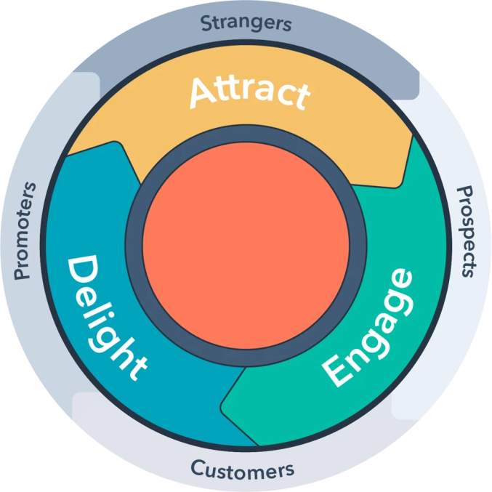
Figure 1: A customer-centric approach to service delivery in the hospitality sector
(Source - Johnson, 2022)
Marriott International Inc.’s customer-centric approach to effective service delivery encompasses frequent interactions with the guests via adopting an omnichannel communication strategy or through the mobile application, during contactless check-in and check-out, mobile key, chatting, service requests, and more, to develop a better understanding of the guests’ and then use the information to make further service development or service innovation decisions (Global Data, 2022). On the other hand, the Hilton Inn’s customer-centric approach encompasses prioritising the culture of respect, hospitality, and inclusion, offering interesting loyalty schemes, and coming up with a special reward system to benefit the customers and derive their positive perception of the brand (Gilliland, 2019).
The service delivery approaches in the hospitality industry also include the use of KPIs to measure the satisfaction level of the guests and their experience of the service. Two of the most used KPIs as utilised in the hospitality sector for the same include the NPI (Net Promoter Score), and Customer Satisfaction Score (CSAT), followed by the retention rate and churn rate (Customer-alliance, 2023). The other most effective way to trace the guest experiences is by conducting a usual survey on service experience.

Conclusion
Based on the study conducted above, the essential principles of good guest service in the hospitality sector have been identified as listening to the needs of the guests and understanding them, thanking the guests, and promoting a friendly, positive, and helpful environment to leave a long-lasting impression in the minds of the guests. As per the findings, effective or good guest service involves managing and delivering the expectations of the guests in the best possible manner and deriving maximum guest satisfaction so that they are able to contribute to the positive reputation of the brand by developing a positive brand perception and communicating about their positive service experiences.
In addition, the most common strategies that are widely adopted in the hospitality sector for effective service delivery have been identified as the use of emerging and advanced technologies to identify the needs and requirements of the guests and also to learn from the service delivery strategies as applied by the other similar companies or competitors. They also involve the active utilisation of the customer-centric approach.

Recommendations
One of the ways that can be adopted by businesses in the hospitality sector to deliver effective customer service is by adopting a proactive approach to address the several problems, needs, and expectations of the guests. The proactive approach involves taking action at the very first sign of the guests’ inconvenience wherein the data on the guest inconvenience can be gathered by installing modern techs and tools through the service delivery area (Forbes, 2023).

Reference List
Ali, B.J., Gardi, B., Jabbar Othman, B., Ali Ahmed, S., Burhan Ismael, N., Abdalla Hamza, P., Mahmood Aziz, H., Sabir, B.Y., Sorguli, S. and Anwar, G., 2021. Hotel service quality: The impact of service quality on customer satisfaction in hospitality. Ali, BJ, Gardi, B., Othman, BJ, Ahmed, SA, Ismael, NB, Hamza, PA, Aziz, HM, Sabir, BY, Anwar, G.(2021). Hotel Service Quality: The Impact of Service Quality on Customer Satisfaction in Hospitality. International Journal of Engineering, Business and Management, 5(3), pp.14-28.
Business. Qld. gov. Au, 2023. Improving your customer service. Available at: <https://www.business.qld.gov.au/running-business/marketing-sales/customer-service/improving#:~:text=phone%20or%20online.-,Principles%20of%20good%20customer%20service,is%20likely%20to%20spend%20more.> [Accessed October 15 2023].
Customer-alliance. Com. 2023. Customer Satisfaction KPI and why you need to focus on one or two. Available at: <https://www.customer-alliance.com/en/resources/article/customer-satisfaction/#:~:text=The%20Net%20Promoter%20Score%2> [Accessed October 15 2023].
Gilliland, N, 2019. Five examples of customer-centric companies. Available at: <https://econsultancy.com/examples-customer-centric-companies/> [Accessed October 15 2023].
Fehrmann, A, 2020. How To Be Remarkable: Brand Reputation, Customer Experience And Purpose. Available at: <https://www.forbes.com/sites/forbescommunicationscouncil/2020/03/31/how-to-be-remarkable-brand-reputation-customer-experience-and-purpose/?sh=4a2bf8ebd793> [Accessed October 15 2023].
Forbes. Com, 2023. 9 Effective Ways To Be Proactive About Customer Service. Available at: <https://www.forbes.com/sites/allbusiness/2023/01/09/9-effective-ways-to-be-proactive-about-customer-service/> [Accessed October 15 2023].
Globaldata. Com. 2022. Hilton Worldwide Holdings Inc (HWHI) – Digital Transformation Strategies. Available at: <https://www.globaldata.com/store/report/hilton-worldwide-holdings-inc-enterprise-tech-analysis/> [Accessed October 15 2023].
Globaldata. Com. 2022. Marriott International Inc – Digital Transformation Strategies. Available at: <https://www.globaldata.com/store/report/marriott-international-enterprise-tech-analysis/> [Accessed October 15 2023].
Gold, C, 2023. What Is Guest Experience in the Hospitality Industry? Available at: <https://www.hotelminder.com/what-is-guest-experience-in-the-hospitality-industry#:~:text=to%2Dday%20operations.-,Why%20Is%20Guest%20Experience%20Important%20in%20Hospitality%3F,of%20what%20needs%20to%20improve.> [Accessed October 15 2023].
Hospitalityinsights. Ehl. 2023. What is the Hospitality Industry? All your questions answered. Available at: <https://hospitalityinsights.ehl.edu/hospitality-industry> [Accessed October 15 2023].
Ifp. com. 2021. Customer-Centricity is What Makes or Breaks it in the Hospitality Industry. Available at: <https://www.insightsforprofessionals.com/marketing/digital-marketing/customer-centricity-hospitality-industry> [Accessed October 15 2023].
IRUNGU, J., 2018. FACTORS AFFECTING SERVICE DELIVERY IN THE HOSPITALITY INDUSTRY IN KENYA: A CASE STUDY OF SAROVA PANAFRIC HOTEL (Doctoral dissertation, MUA). Available at: <https://core.ac.uk/download/pdf/220096784.pdf> [Accessed October 15 2023].
Johnson, B, 2022. 8 Tips for Becoming a Customer-Centric Organization. Available at: <https://blog.hubspot.com/service/customer-centric> [Accessed October 15 2023].
Walker, J.R., 2021. Introduction to hospitality. Pearson.
Xiang, Z., Schwartz, Z., Gerdes Jr, J.H. and Uysal, M., 2015. What can big data and text analytics tell us about hotel guest experience and satisfaction?. International journal of hospitality management, 44, pp.120-130.

