

Student Name: Meetkumar Sureshbhai Vaghasiya
Student ID: 2432237
Module Name: International Business Concepts
Module Code: LCMB7034
Title: Report- Toyota
Lecturer’s Name: Hoang Dang Nguyen

Term: June 2025
Course: MBA
Submission Deadline: 15th December 2025

Contents
1. Introduction 2
2. Benefits and Challenges of International Operations 3
2.1 Why Toyota Can Be Designated an MNC 3
2.2 Nature of Toyota’s Global Operations and Value Chain 4
2.2.1 Research and Development (R&D) 5
2.2.2 Production and Sourcing 5
2.2.3 Sales and Distribution 6
2.2.4 Finance and Shareholder Value 7
2.2.5 Innovation in Production and Sustainability 7
2.3 Entry Modes into International Markets 8
2.3.1 Wholly Owned Subsidiaries 8
2.3.2 Joint Ventures 9
2.3.3 Strategic alliances 9
2.3.4 Dominant Mode 10
2.4 Key Benefits from International Operations 10
2.5 Challenges of International Operations 11
3. OLI Factors 14
3.1 Ownership Advantages 14
3.2 Location Advantages 16
3.3 Internalisation Advantages 18
4. Cultural Differences and Their Impact 19
4.1 Power Distance and Individualism–Collectivism 19
4.2 Uncertainty Avoidance and Long-Term Orientation 20
4.3 Masculinity, Performance Orientation, and Human Resource Practices 20
4.4 Indulgence, Communication, and Consumer Behaviour 21
5. Adjustments to Standard Operating Procedures (SOPs) 23
5.1 Hierarchical Decision-Making and Management Adaptation 23
5.2 Production and Supply Chain SOP Localization 23
5.3 Human Resource and Cultural Adaptation in SOPs 24
6. Conclusion 26
References 27

1. Introduction
One of the top multinational automakers in the world, Toyota Motor Corporation was founded in 1937 and has its headquarters in Toyota City, Japan. Toyota is a prime example of a genuinely global company, with operations in more than 170 nations and a sophisticated global value chain that includes R&D, sourcing, production, sales, and financing (Statista, 2025). The Toyota Production System (TPS) and "The Toyota Way" embody the company's key values of quality, efficiency, and innovation, which serve as the foundation for its worldwide success.
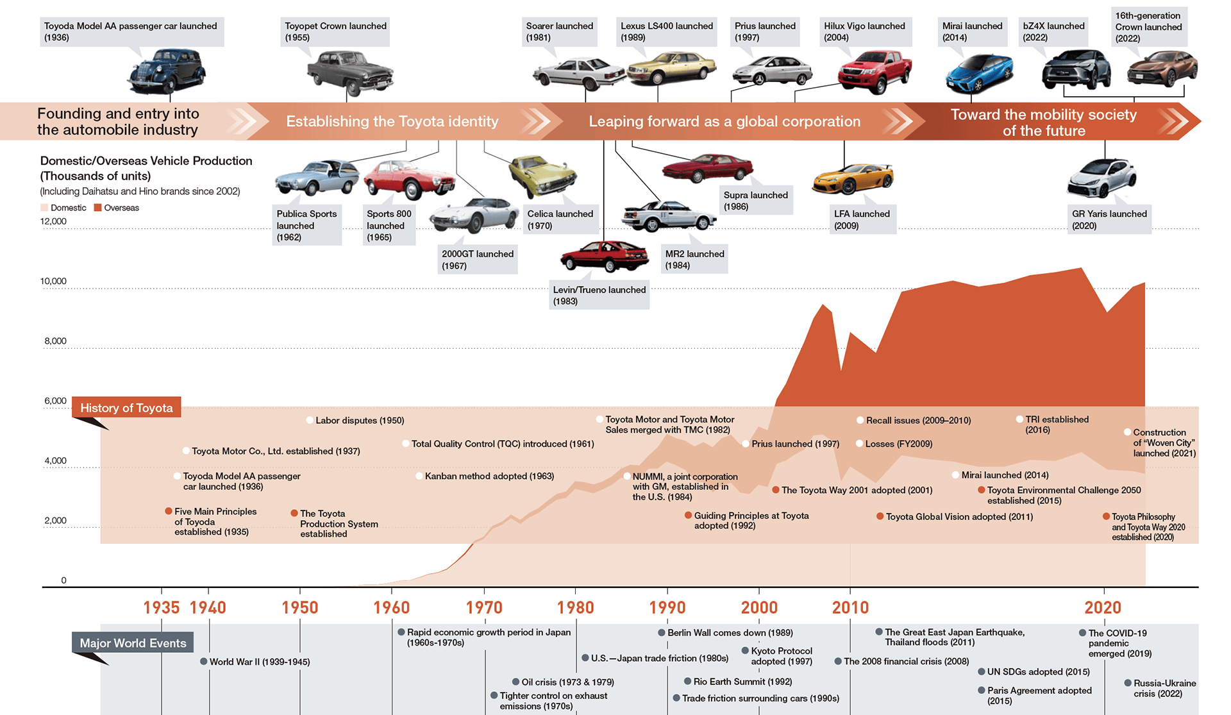Source: https://global.toyota/en/company/trajectory-of-toyota/history/
This report investigates Toyota's status as a multinational company by looking at the advantages and disadvantages of its global operations, the strategies it uses to enter new markets, and the benefits of globalization. In order to secure long-term global success, the report also assesses the cultural differences influencing Toyota's operations in emerging markets, critically examines how Ownership, Location, and Internalization (OLI) factors impact Toyota's entry strategies, and suggests significant strategic changes to its Standard Operating Procedures (SOPs).

2. Benefits and Challenges of International Operations

2.1 Why Toyota Can Be Designated an MNC
Because of its extensive global reach, integrated value chain, and diverse ownership structure, Toyota Motor firm (TMC) satisfies the requirements for being classified as a multinational or transnational firm. Toyota was founded in 1937 and now has 165 equity-method affiliates and 577 consolidated subsidiaries operating in more than 170 countries (Statista, 2025).
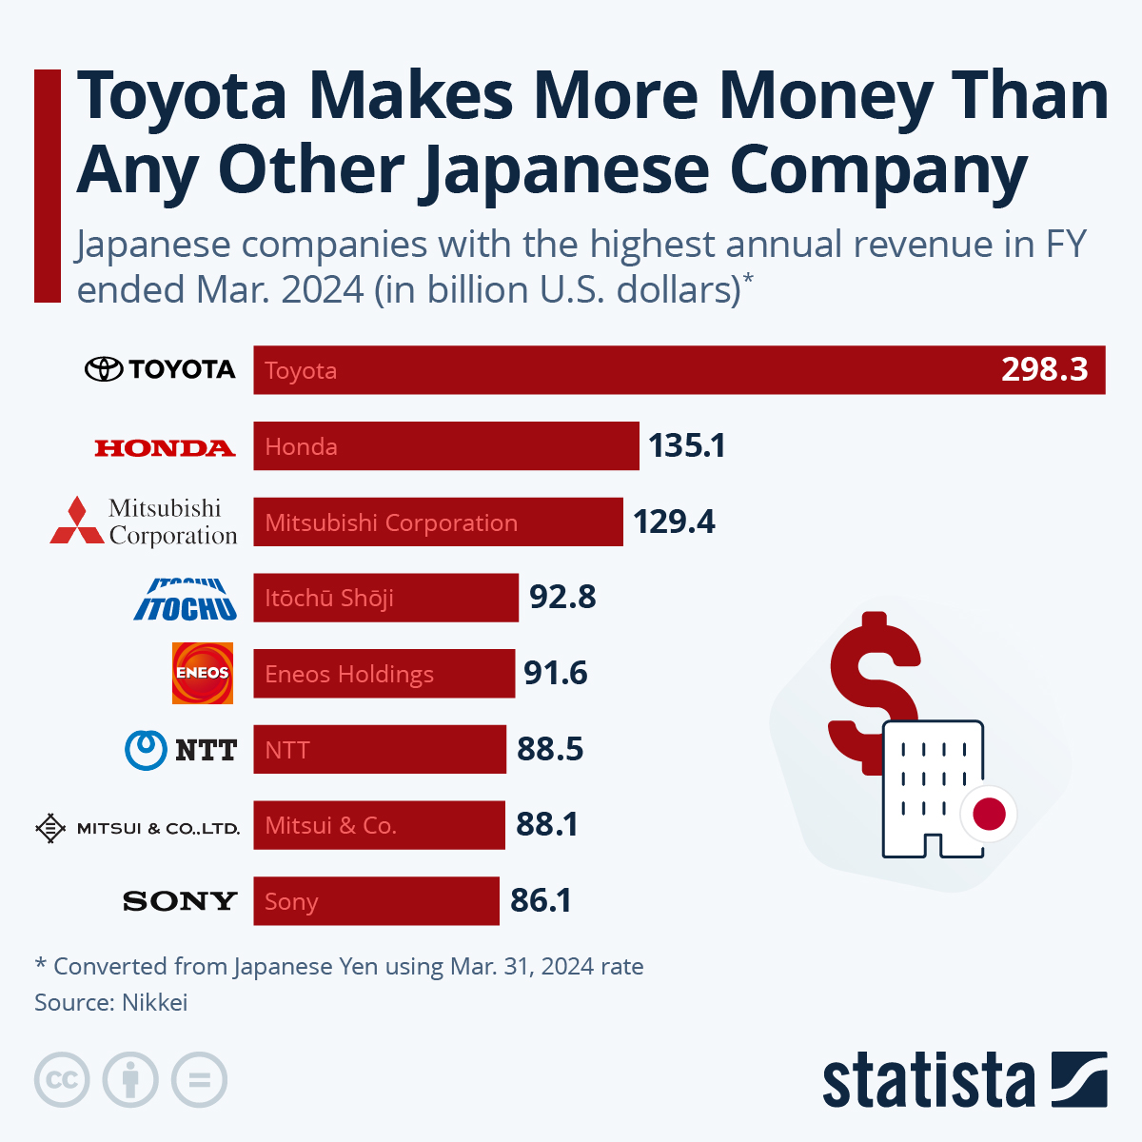
Source: https://www.statista.com/chart/33445/japanese-companies-with-the-highest-annual-revenue-per-fiscal-year/?srsltid=AfmBOoqz0-SAQJK9GGbf5y8UGvF67wGVyu2XFfayRv4m5_kSGDUBKqTn
The corporation had 380,793 employees worldwide as of March 31, 2024 (70,224 in Japan alone), produced 9.26 million cars, and sold 9.44 million of them in various regions. It generated a net margin of 11% with a fiscal 2024 consolidated sales revenue of ¥45.1 trillion (about US$300 billion), operating income of ¥5.35 trillion, and net income attributable to shareholders of ¥4.94 trillion (Toyota Motor Corporation, 2025).
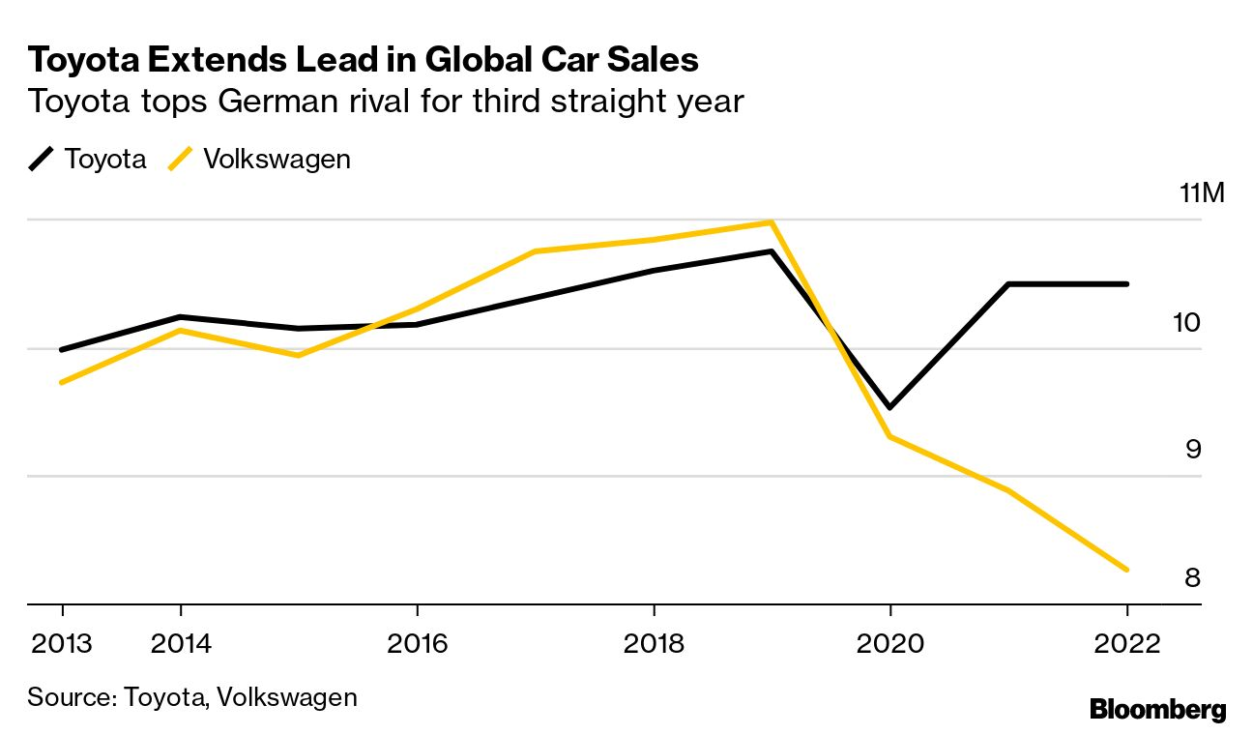
Source: https://www.bloomberg.com/news/articles/2023-01-30/toyota-keeps-title-as-no-1-carmaker-for-third-straight-year
With approximately 25% of its 16.3 billion issued shares held by foreign investors, Toyota's shares are openly traded on the Tokyo, Nagoya, New York, and London Stock Exchanges, demonstrating its global capital base. Toyota Industries Corporation, JP Morgan Chase Bank, and The Master Trust Bank of Japan are significant institutional investors (Toyota Motor Corporation, 2025). Toyota is classified as a top-tier MNC/TNC with substantial global decision-making autonomy and localized adaptability across areas due to its international finance, ownership, and integrated operations.

2.2 Nature of Toyota’s Global Operations and Value Chain
Toyota's global value chain, which is centred on its well-known Toyota Production System (TPS) and directed by its corporate philosophy, The Toyota Way, is among the most intricate and effective in the automobile sector (Toyota Motor Corporation, 2025). Its operations integrate research and development (R&D), sourcing, manufacturing, sales, and financing across multiple continents.

2.2.1 Research and Development (R&D)
Toyota makes significant investments in research and development (R&D) in order to maintain its position as a leader in technology. Approximately 2.7% of total revenue, or ¥1.2 trillion, was spent on research and development in fiscal 2024 (Toyota Motor Corporation, 2025). The corporation runs 27 research and development facilities across the globe, including the Frontier Research Centre and specialist divisions like the Hydrogen Factory and BEV Factory.
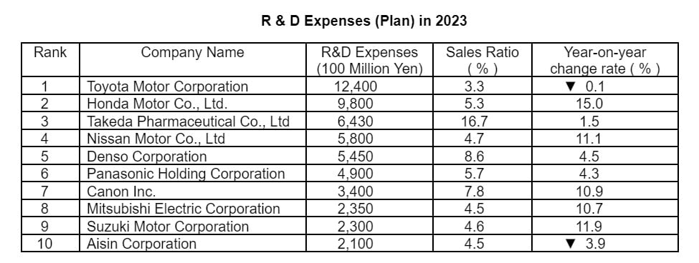
Source: https://www.mreport.co.th/en/news/statistic-and-ranking/101-14-years-of-r-and-d-growth-toyota-tops-with-1-24-trillion-yen
Its research is increasingly focused on autonomous mobility technologies, hydrogen fuel cells, and battery electric vehicles (BEVs). In 2023–2024, Toyota revealed a ¥5 trillion investment plan for BEVs and batteries by 2030, which included a ¥730 billion investment in batteries in Japan and the U.S. and a US$1.4 billion expansion of U.S. BEV production (Toyota Motor Corporation, 2025).

2.2.2 Production and Sourcing
Toyota has 67 manufacturing firms spread throughout Japan, North America, Europe, Asia, and other regions that make up its production network. 13 production bases in North America, 27 in Europe, 16 in Asia (excluding Japan), and 7 in Japan (Toyota, 2025).
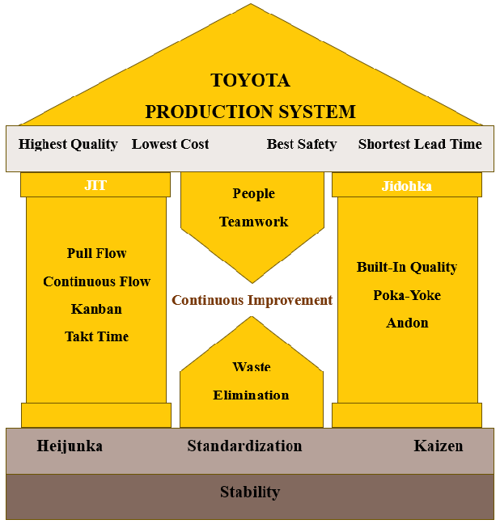
Source: https://www.researchgate.net/figure/Toyota-Production-System-TPS-House_fig2_383877470
The company's sophisticated localization approach is seen in the 9.26 million automobiles it produced in 2024, more than 60% of which were made outside of Japan (Toyota Motor Corporation, 2025). With the help of its worldwide purchasing system and the Basic Purchasing Policies, which support sustainability compliance, quality assurance, and mutual trust, Toyota has a highly integrated network of suppliers.

2.2.3 Sales and Distribution
In FY2024, Toyota sold 9.44 million vehicles worldwide, with the following regional distributions: North America accounted for 26%, China for 18%, Japan for 15%, Asia (excluding China) for 14%, Europe for 11%, and other regions for 15%. The Corolla (1.7 million), RAV4 (1 million), Yaris (878,000), and Hilux (629,000) were the company's best-selling models (Toyota Motor Corporation, 2025).
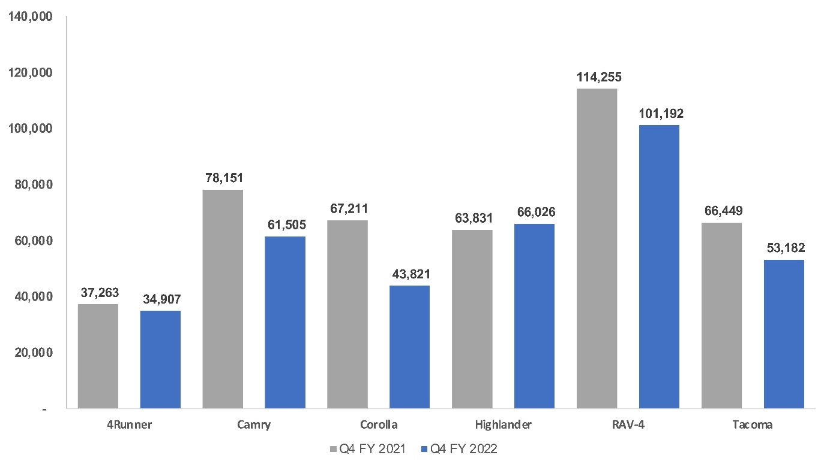
Source: https://www.coxautoinc.com/insights-hub/cox-automotive-analysis-toyota-quarterly-u-s-market-performance-fy2022/
With 37% of global sales being hybrid electric (HEV), 1.4% being battery electric (BEV), and 1.1% being plug-in hybrid (PHEV), the proportion of sales that were made up of electric vehicles was increasing.

2.2.4 Finance and Shareholder Value
With over 30 companies, mostly in North America, Europe, and Asia, Toyota's global financial services division supports dealer operations and retail sales. Toyota delivered ¥2.11 trillion in total shareholder payouts in 2024, including dividends and share repurchases, while maintaining ¥15.08 trillion in liquid assets (Toyota Motor Corporation, 2025). It is less reliant on any one market thanks to its robust balance sheet and diverse global financing base.

2.2.5 Innovation in Production and Sustainability
The digitalization of monozukuri (manufacturing) improves Toyota's production efficiency. The company is working on next-generation BEV production lines that use self-propelling assembly technologies and modular vehicle chassis to reduce the number of processes by half and cut lead times by 50% (Toyota, 2023).
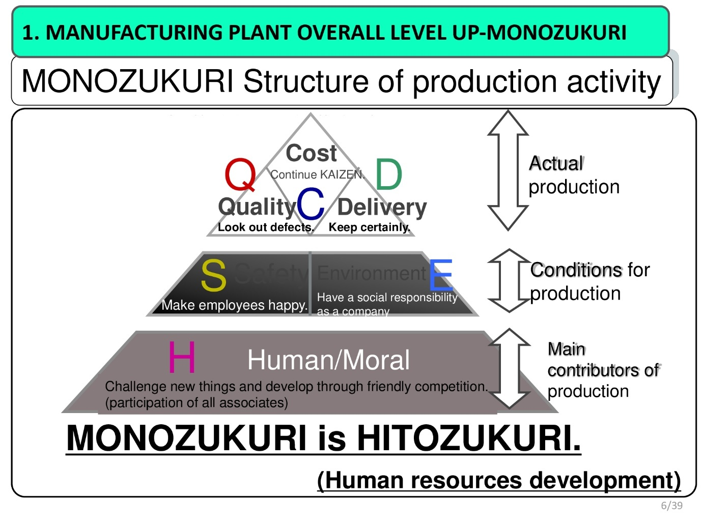
Source: https://sansokeihatsu.com/manufacturing-structure-strengthening-monozukuri/
Aiming for a ¥5 trillion fuel cell market by 2030, the corporation also runs the Hydrogen Factory (approx. 2023) to coordinate hydrogen production and commercialization worldwide.

2.3 Entry Modes into International Markets
Depending on the competitive environment, local laws, and market maturity, Toyota uses a variety of international entry techniques. Its key modes include wholly owned subsidiaries, joint ventures, strategic alliances, and local manufacturing partnerships.

2.3.1 Wholly Owned Subsidiaries
Direct control over production and distribution is made possible by Toyota's wholly owned subsidiaries, which are present in developed markets including the US (Toyota Motor North America, Inc.), the UK, Belgium, and Australia (Toyota Motor Corporation, 2025).

2.3.2 Joint Ventures
Toyota regularly uses joint ventures in emerging and strategically sensitive markets. For instance, in order to adhere to local ownership regulations and incorporate into local supply networks, Toyota conducts business in China through joint ventures with FAW Group and Guangzhou Automobile Group (GAC) (Toyota, 2020).
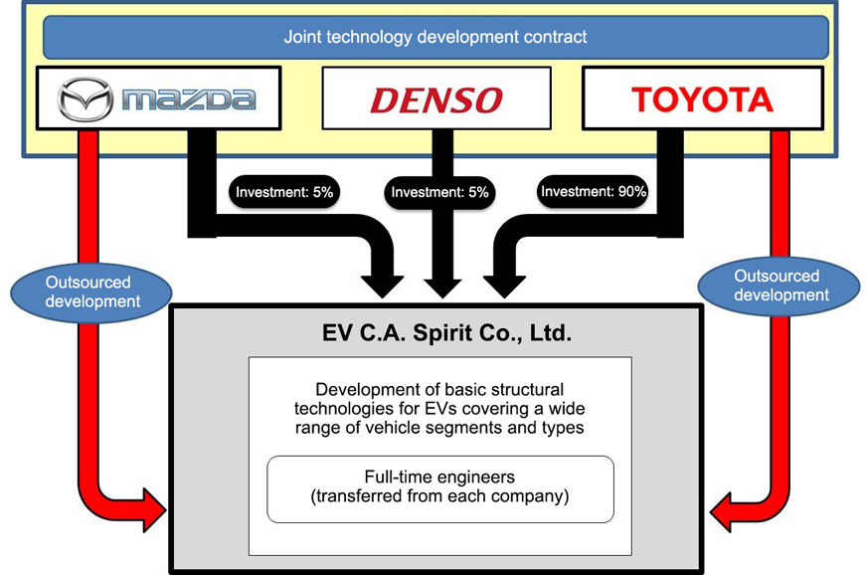
Source: https://www.autocarindia.com/car-news/mazda-and-toyota-jv-to-produce-evs-406131
Additionally, from August 2024, Toyota started to produce hydrogen fuel cells domestically in partnership with Beijing SinoHytec Co., Ltd (Fuel Cells Works, 2024). In 2023, Toyota partnered with Siam Cement Group and Charoen Pokphand Group in Thailand to advance connected mobility and electrification.

2.3.3 Strategic alliances
To control R&D expenses and spur innovation, Toyota actively collaborates with other manufacturers on technology development. The development of next-generation small engines that are designed for electrification was jointly announced by Toyota, Mazda, and Subaru in May 2024 (Mazda, 2024). Additionally, it works with Hino Motors, Mitsubishi Fuso, and Daimler Truck Holding AG on CASE and hydrogen technology (Daimler Truck, 2025).

2.3.4 Dominant Mode
While Toyota employs a variety of entry strategies, joint ventures are the most common tactic in highly regulated and rapidly expanding areas like China, India, and Southeast Asia. These collaborations promote improved local market penetration, cost-sharing in technology, and adherence to regional regulations. Toyota, on the other hand, favours complete ownership in industrialized nations in order to preserve quality and brand management.

2.4 Key Benefits from International Operations
Toyota's global operations offer numerous operational, financial, and strategic benefits that have strengthened its standing as one of the top automakers in the world. Toyota offers unmatched economies of scale in both production and procurement, as seen by its global sales of over 9.4 million vehicles and fiscal year 2024 total revenues of almost ¥45 trillion (Toyota Motor Corporation, 2025).
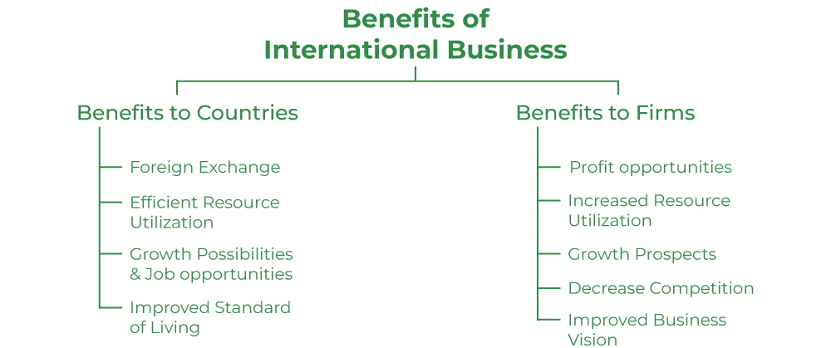
Source: https://www.geeksforgeeks.org/business-studies/international-business-meaning-reason-scope-and-benefits/
Since no market accounts for more than 26% of worldwide revenues, its extensive and diverse geographic portfolio lessens reliance on any one area, enabling the business to successfully manage risk and maintain stability even during market or regional economic downturns (Toyota Motor Corporation, 2025).
Toyota's capacity to create technological innovation and synergy through a globally integrated research and development (R&D) network is a key advantage of its multinational operations. By combining hybrid, plug-in hybrid, battery electric (BEV), and hydrogen fuel-cell technologies, its multi-pathway electrification approach helps reduce technological risk while expanding its product line.
In order to speed up the implementation of new vehicles, facilities like the BEV Factory and Hydrogen Factory serve as centralized innovation hubs, combining design, development, and manufacture. As part of the Science-Based Targets project (SBTi), Toyota has committed to reducing CO2 emissions by 33% by 2030 and becoming carbon neutral across all plants by 2035 Gupta (2024).
With more than 60% of its cars made outside of Japan, Toyota's localized production strategy is another important asset. This strategy promotes local employment and economic development while reducing import duties and currency concerns. Toyota's growth in BEV and hybrid vehicle production in developing nations like Thailand and Indonesia promotes national sustainability objectives and improves ties with the local population. Its "region-centred management" tenet guarantees that business operations continue to be sensitive to regional market dynamics and social demands.
Toyota's worldwide diversification offers substantial stability and shareholder value from a financial perspective. The corporation recorded an operating margin of 11.9% in FY2024 and distributed ¥2.11 trillion to shareholders in the form of stock repurchases and dividends (Toyota Motor Corporation, 2025).
Additionally, Toyota's global organization promotes the growth of people and knowledge while facilitating interregional cooperation. To improve operational coherence, governance, and group learning throughout its global network, the corporation held leadership meetings across 24 components and distribution companies in 2024 and extended internal audits to 17 subsidiaries (Toyota Motor Corporation, 2025).

2.5 Challenges of International Operations
Even with its enormous success, Toyota still has to deal with a number of issues that come with doing business internationally. Because the business must constantly adjust to changing safety, pollution, and trade regulations in several jurisdictions, regulatory risks are still substantial. Different regulatory frameworks, especially when it comes to recalls and environmental requirements, can cause production cycles to be disrupted and necessitate expensive compliance efforts.
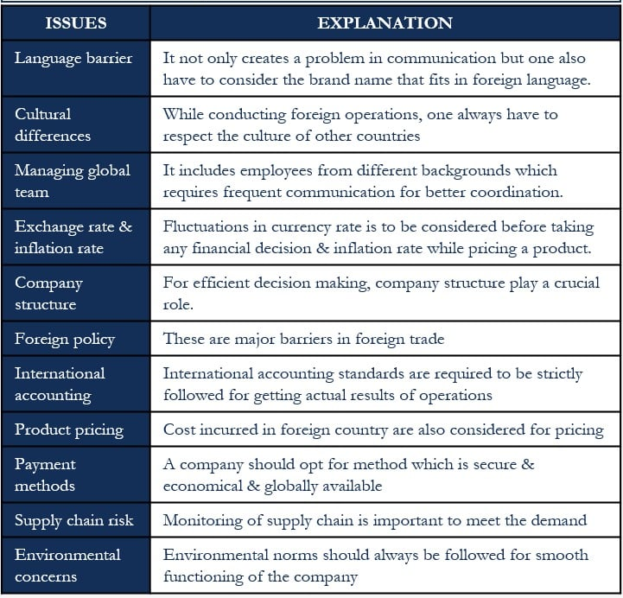
Source: https://efinancemanagement.com/international-financial-management/international-business-issues-and-challenges
Supply chains and the effectiveness of global logistics are still at risk due to geopolitical and economic instability, which includes wars like the one between Russia and Ukraine, growing protectionism, and currency fluctuations (Sarwar and Rye, 2025).
Toyota also faces growing demands related to sustainability and the climate. Its dedication to reaching carbon neutrality entails significant financial outlays, with an estimated ¥5 trillion needed by 2030 for the development of BEVs and batteries, as well as inherent technological uncertainties (Reuters, 2021).
Additionally, there are continuous operational risks due to labour shortages and supply bottlenecks, particularly in skilled manufacturing and semiconductor availability (McKinsey & Company, 2022). The business also has recognized supplier dependence and cybersecurity flaws as major issues that could compromise output and brand recognition.

3. OLI Factors

3.1 Ownership Advantages
In the United Arab Emirates (UAE), Toyota Motor Corporation has a robust portfolio of ownership-specific advantages that support foreign direct investment (FDI). Toyota maintained a global workforce of 380,793 employees across more than 170 countries as of fiscal year 2024, with consolidated revenues of ¥45.1 trillion (about US$300 billion) and net income of ¥4.94 trillion (Toyota Motor Corporation, 2025). These numbers demonstrate Toyota's size and capacity to use firm-specific assets in international marketplaces.
Toyota's patented Toyota Production System (TPS), which combines Just-in-Time (JIT) manufacturing, Kaizen (continuous improvement), and Jidoka (automation with human control), is a key component of its ownership advantage (Orca Lean, 2025). By constructing cars in about 21 hours as opposed to 25–29 hours for rivals like Ford and General Motors, Toyota is able to achieve greater efficiency while keeping defect rates below 0.1% thanks to TPS. Toyota would be able to completely internalize these procedures, safeguarding process integrity and guaranteeing constant worldwide quality standards, by establishing an assembly or manufacturing facility in the United Arab Emirates.
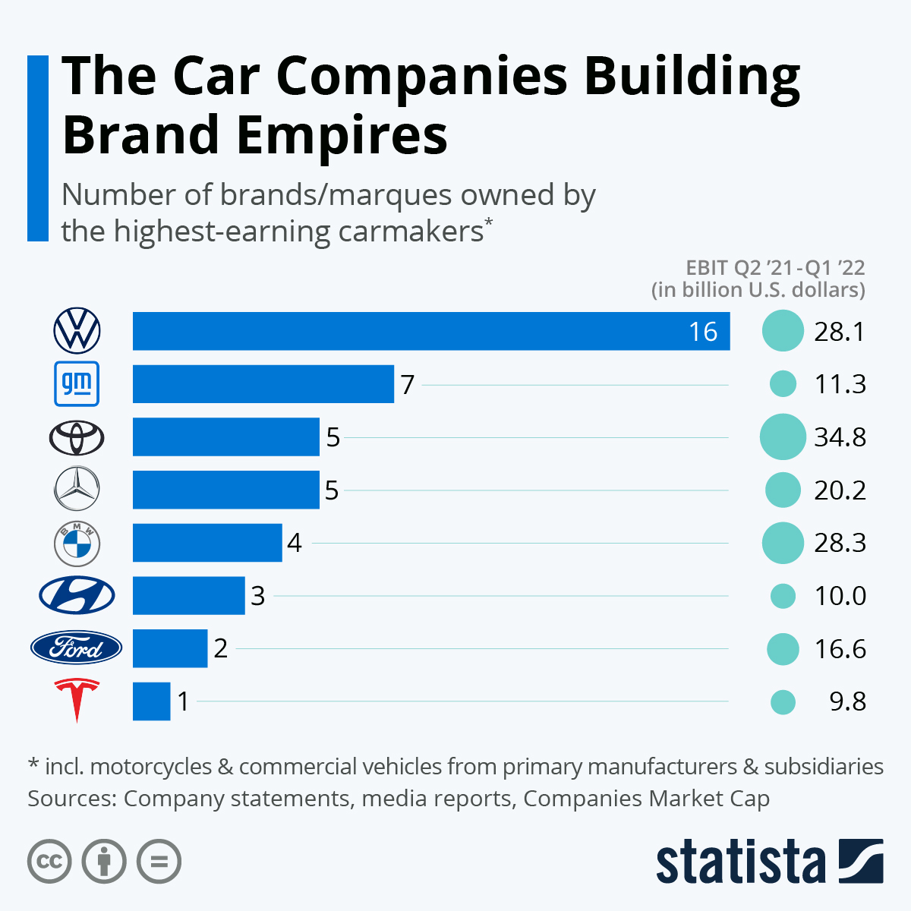
Source: https://www.statista.com/chart/27836/number-of-brands-marques-owned-by-the-highest-earning-carmakers/
Another important ownership advantage is Toyota's strong brand. Toyota has a commanding market position in several places and is ranked as the most valuable car brand in the world in 2024, with an estimated worth of about US$52 billion (Mallory, 2025). Toyota is already the most popular car brand in the United Arab Emirates, with about 30% of passenger car sales in 2024 (Statista, 2024). The brand's reputation for dependability, affordability, and fuel efficiency fits perfectly with Gulf Cooperation Council (GCC) consumers' tastes, because the region's severe environment makes maintenance effectiveness and durability important considerations when making purchases.
Furthermore, Toyota's broad worldwide research and development capabilities, strengthened by ¥1.2 trillion in fiscal 2024 spending annually, enhance its capacity to adjust to new markets (Toyota Motor Corporation, 2025). With specialized research and development facilities in Japan, the United States, and Europe that concentrate on hydrogen fuel cells, autonomous systems, and battery electric vehicles (BEVs), Toyota is well-positioned to match its technologies with the environmental and innovative objectives of the United Arab Emirates.
Toyota has the chance to use its exclusive R&D expertise to gain a competitive edge by implementing its hybrid and hydrogen car technologies under local production arrangements in response to the UAE's goal of having net-zero emissions by 2050 (UAE Government, 2025). Instead of licensing or contract manufacturing, these firm-specific organizational and technological characteristics offer an entry option that keeps Toyota in control, such a majority joint venture or wholly owned subsidiary.

3.2 Location Advantages
The United Arab Emirates provides access to nearly 2 billion consumers due to its strategic location between Asia, Africa, and Europe. With top-notch facilities like Dubai's Al Maktoum International Airport and Jebel Ali Port, the largest artificial harbour in the Middle East.
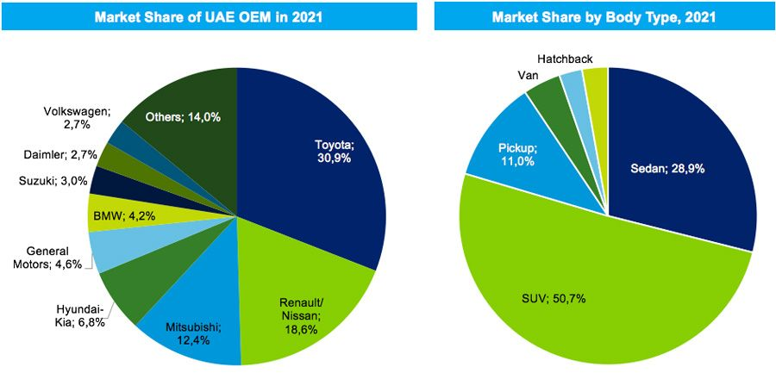
Source: https://www.consultancy-me.com/news/5251/uaes-passenger-car-market-on-path-of-recovery-and-robust-growth
Its logistics infrastructure, which was ranked 9th in the world by the World Bank's Logistics Performance Index, allows for smooth import-export operations (Peace Global Logistics, 2025). These resources can improve lead times for vehicle delivery throughout the MENA area while drastically lowering Toyota's transportation expenses when compared to exporting from Europe or Japan.
Notably, the UAE removed traditional barriers to foreign direct investment (FDI) by permitting 100% foreign ownership in designated Free Zones, allowing Toyota to maintain complete managerial control and the opportunity to repatriate profits (Bird & Bird, 2024). Large-scale manufacturing investment is also encouraged by the UAE's advantageous tax structure, which includes zero corporate tax in Free Zones and low import customs taxes.
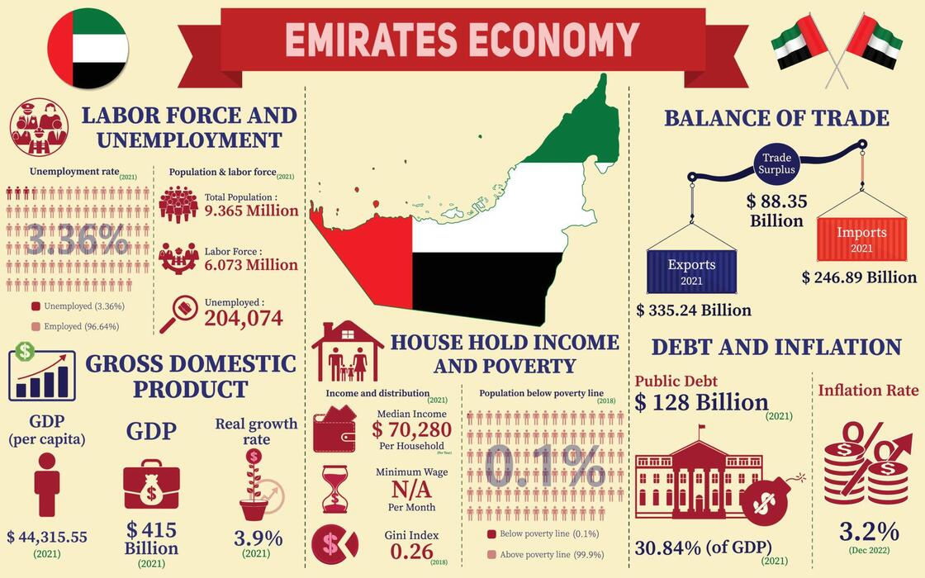
Source: https://www.vecteezy.com/vector-art/18833976-united-arab-emirates-economy-infographic-economic-statistics-data-of-emirates-charts-presentation
The benefits of energy and infrastructure are equally important. With more than 900 kilometres of first-rate roadways and extensive access to renewable energy, the United Arab Emirates is one of the countries with the best infrastructure in the world. More than 2,000 MW of clean power are produced annually by the nation's solar projects, like the Mohammed bin Rashid Al Maktoum Solar Park, which might assist Toyota in achieving carbon-neutral manufacturing in accordance with its objective to eradicate CO2 emissions from all production facilities by 2035 (Bojarajan et al., 2024).
The UAE's consumer and commercial dynamics enhance the allure of the location. About 260,000 passenger cars were sold in the UAE in 2024, with Toyota accounting for the majority of sales in the SUV and sedan segments (Statista, 2024). Free parking, toll exemptions, and more than 700 public charging stations across the country all support the growing government push for electric and hybrid vehicles, which shows a strong policy alignment with Toyota's battery-electric vehicle (BEV) and hybrid product lines.

3.3 Internalisation Advantages
The success of the Toyota manufacturing System depends on the complex coordination of supply networks, logistics, and manufacturing; internalized operations, as opposed to external partnerships, are the best way to maintain this process. Toyota can guarantee rigorous adherence to TPS concepts, such as JIT delivery, Heijunka (production leveling), and Andon (quality control signaling), by continuing to own and operate a facility in the United Arab Emirates (Orca Lean, 2025).
Protection of intellectual property (IP) is a key factor in internalization in the United Arab Emirates (International Trade Administration, 2025). Strict control over unique designs and production techniques is required to maintain Toyota's competitive edge in hybrid, plug-in hybrid (PHEV), and hydrogen fuel cell technology, which is backed by more than 24,000 active worldwide patents (Toyota Motor Corporation, 2025).
Toyota is also able to integrate its global supply chain and use digital production technologies like AI-based predictive maintenance and smart manufacturing thanks to internalization. These developments support the adoption of Industry 4.0 and are consistent with the UAE's Smart Industry Strategy 2030 (UAE Government, 2024). By implementing internal control, Toyota would be able to digitize local operations and guarantee cost savings through automation and real-time data analytics
Additionally, Toyota would strengthen its ability to withstand disruptions in the global supply chain by internalizing its activities in the UAE. The significance of regional self-sufficiency has been highlighted by events like the COVID-19 pandemic and the Russia–Ukraine conflict, which have exposed flaws in just-in-time logistics approaches (Bas, 2025). By lowering dependency on long-distance imports and lowering geopolitical risks, a production plant situated in the United Arab Emirates might act as a regional buffer.

4. Cultural Differences and Their Impact

4.1 Power Distance and Individualism–Collectivism
The UAE scores 74 on the power distance scale, suggesting a culture that accepts centralized authority and expects leaders to make important choices, whereas Japan scores 54, reflecting a moderate hierarchy with a leaning toward participative management (Culture Factor, 2025). Similar to this, Japan's individuality score of 62 shows a balance between personal responsibility and group harmony, but the UAE's score of 36 emphasizes a collectivist culture where networks, loyalty, and relationships serve as the cornerstones of governance and commerce.
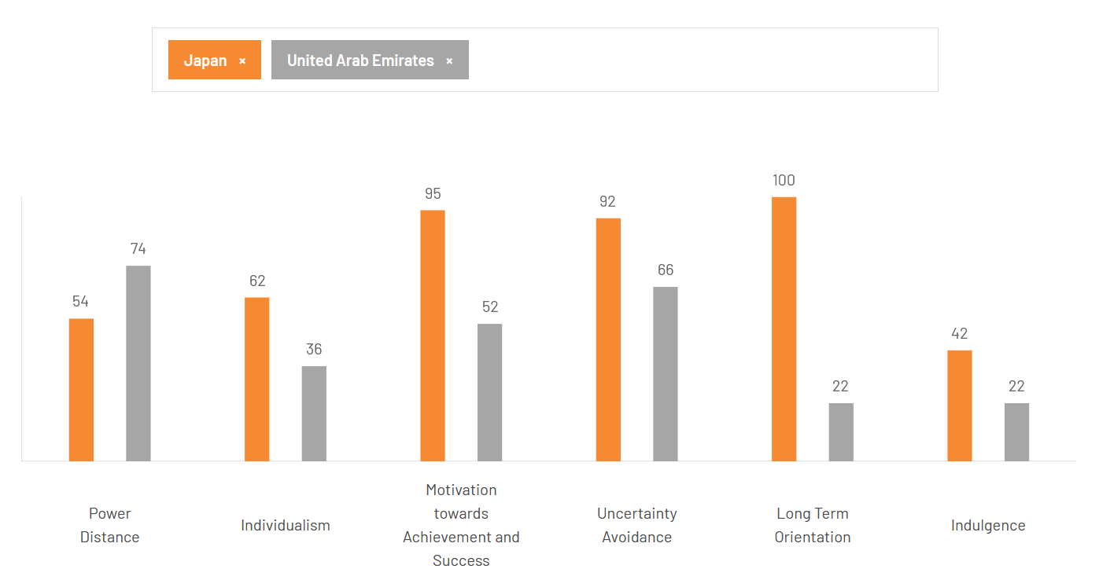
Source: https://www.theculturefactor.com/country-comparison-tool?countries=japan%2Cunited+arab+emirates
These variations suggest that Toyota's Japanese management style, which emphasizes group accountability and consensus (ringi system), needs to be modified to accommodate the hierarchical corporate structure of the United Arab Emirates (Sagi, 2015). Decisions are usually determined at senior levels in the UAE, but in Japan, they are decided by bottom-up consultation. Therefore, direct interaction with local decision-makers, such as Emirati executives, government representatives, and family-owned enterprises, must be a top priority in Toyota's entry and operations plans.
The collectivist culture of the United Arab Emirates also suggests that enduring connections and personal trust are key factors in economic success (Culture Factor, 2025). This approach is in line with Toyota's global emphasis on supplier partnerships and mutual trust under the Toyota Production System (TPS). Nonetheless, Toyota needs to strengthen its local ties by establishing long-lasting alliances with significant local players like the Al-Futtaim Group, which has served as Toyota's distributor in the United Arab Emirates for many years.

4.2 Uncertainty Avoidance and Long-Term Orientation
With scores of 92 and 66, respectively, Japan and the UAE both demonstrate high levels of uncertainty avoidance, suggesting a mutual desire for stability, predictability, and organized procedures (Culture Factor, 2025). Because Toyota's production and management philosophy under the TPS mostly relies on uniformity and error prevention, this similarity gives the company a cultural edge. However, the institutional framework in the UAE frequently necessitates adaptability to quickly changing market and regulatory situations, such as changing localization requirements and energy transition targets.
Although Toyota's well-organized procedures promote effectiveness and quality, a full imitation of Japan's strict control systems can restrict flexibility (Culture Factor, 2025). As a result, Toyota should uphold its quality standards while giving local subsidiaries the latitude to make decisions in response to shifting market conditions. In line with the country's changing sustainability and diversification objectives, this can involve giving local management the authority to modify procurement frameworks or logistical operations to suit the demands of the UAE market.
The UAE's score of 22 indicates a more short-term, results-focused attitude, whereas Japan's score of 100 indicates a strong commitment to tenacity, innovation, and future-oriented planning (Culture Factor, 2025). Toyota's public relations and investment communication strategy is impacted by this discrepancy. Toyota has historically placed a strong emphasis on intergenerational advancement and slow innovation, but in order to meet UAE requirements, it must also provide immediate advantages including quick job creation, technology transfer, and observable sustainability results.

4.3 Masculinity, Performance Orientation, and Human Resource Practices
Japan and the UAE both have high masculinity rankings, indicating that both societies place a high importance on accomplishment, rivalry, and material success (Culture Factor, 2025). But these characteristics show up in different ways. In the UAE, success is frequently linked to outwardly visible status, recognition, and prestige, whereas in Japan, group cohesion and consensus minimize competitiveness. Therefore, Toyota's HR strategy needs to consider the UAE's value of recognition and career advancement.
Career growth in Japan is built on long-term employment systems and promotions based on seniority. Organizations in the UAE, especially those in the private sector, on the other hand, frequently reward achievement and performance (Zeffane and Melhem, 2017). When multinational firms (MNCs) in the United Arab Emirates incorporate tangible rewards and public recognition into their HR frameworks, their workforces are more motivated. By providing career development programs that prioritize achievement-based promotions, recognition prizes, and chances for overseas deployments, Toyota may increase its appeal to Emirati and expatriate workers.
Additionally, Toyota has to deal with Emiratization, the UAE's nationalization program that promotes the employment of Emirati citizens (CERT, 2025). Respecting this principle improves Toyota's standing and credibility. Toyota can foster the growth of Emirati talent and enhance its reputation as a conscientious employer by establishing regional training academies and leadership initiatives.
Moreover, gender inclusion is becoming more and more prevalent in UAE business (Consultancy-me, 2025). Although the cultures of the UAE and Japan are both historically male, the UAE has made great strides toward encouraging women to participate in governance and business. Toyota ought to follow this trend by endorsing leadership initiatives and programs that promote gender diversity. In addition to improving a company's reputation, such measures support the UAE's progressive goals of equality and economic diversification.

4.4 Indulgence, Communication, and Consumer Behaviour
Japan has a fairly restrained culture, as indicated by its score of 42 on the Hofstede Indulgence dimension (Culture Factor, 2025). People in Japanese society tend to control their desire satisfaction by prioritizing responsibility, social conventions, and long-term planning over spontaneous or leisurely actions. Consumption is frequently intentional, and individual pleasure is weighed against group obligations. This constraint is demonstrated by workplace habits that impact management and operational styles in foreign expansions, such as putting efficiency first, working long hours, and adhering to corporate norms.
Despite being known around the world for its luxury and high standards of living, the United Arab Emirates might be seen as exhibiting low cultural indulgence, which suggests a controlled approach to societal fulfilment (Culture Factor, 2025). People are more inclined to control their wants in such a setting and prioritize long-term planning, social norms, and obligations over instant gratification or relaxation. Companies entering the UAE market need to understand that social expectations, reputation, and conformity to standards have a greater impact on consumer behaviour than just hedonistic incentives.
Toyota's strategy of established corporate governance and rigorous operating procedures in the UAE can be supported by the moderate to low indulgence orientation shared by both cultures when compared under the IVR dimension (Culture Factor, 2025). There are some minor distinctions, though: UAE restraint is strongly impacted by social and religious values, whereas Japanese restraint places an emphasis on individual and corporate diligence.

5. Adjustments to Standard Operating Procedures (SOPs)

5.1 Hierarchical Decision-Making and Management Adaptation
Toyota needs to make a significant change to its SOPs on managerial authority and decision-making. The Toyota Production System (TPS) incorporates a collaborative, consensus-driven paradigm that serves as the foundation for Toyota's operations in Japan. The UAE's business culture, which receives a high score on Hofstede's power distance index, stands in stark contrast to this structure, which guarantees quality and operational excellence (Culture Factor, 2025). This suggests a significant tendency for top-down decision-making and centralized authority. If SOPs in the Japanese model are maintained without alteration, there may be regulatory conflict, a delayed operational response, and misalignment with local partners.
Toyota's SOPs need to reevaluate how to strike a balance between empowered UAE-based leadership and centralized Japanese oversight. Local executives should have the freedom to decide on operational and strategic matters on their own, especially when it comes to government compliance, production scheduling, and supplier selection. In order to guarantee that TPS principles, such as Just-in-Time production, lean manufacturing, and quality assurance, are strictly implemented, Japanese management must simultaneously maintain a supervisory role (Orca Lean, 2025).
Protocols for internal communication must also be addressed. In order to prevent confusion in a high-power distance setting, UAE operations could need a more directive approach, even if Japanese SOPs rely on bottom-up reporting for problem detection (Jidoka) (Orca Lean, 2025). Formalized escalation procedures that allow UAE managers to report problems straight to regional directors instead of going through several levels of consensus could be one example of this. Without this modification, SOPs run the risk of causing conflict between Emirati expectations and Japanese operational culture, which might lower production and damage Toyota's reputation in the market.

5.2 Production and Supply Chain SOP Localization
SOPs for production and the supply chain are the subject of a second significant change. Although the UAE poses particular difficulties due to its harsh desert climate, significant reliance on SUVs and luxury cars, and expanding market for electric and hybrid vehicles, Toyota's globally standardized processes are tailored for predictable situations. Unaltered use of Japanese SOPs would probably result in inefficiencies in supplier coordination, vehicle durability, and inventory management.
Crucially, Toyota's SOPs need to include region-specific contingencies. TPS's core kanban and JIT systems need to be revised to incorporate buffer stocks for components that are susceptible to climate change and longer lead times for imported parts (Orca Lean, 2025). Without adaptable supply chain SOPs, businesses entering the GCC run the danger of frequent production delays and quality problems, which can harm a brand's reputation. To guarantee dependability in the UAE, SOPs must also incorporate stringent testing for off-road capability, desert dust filtration, and high-temperature resilience.
Furthermore, local environmental compliance and government incentives must be explicitly included in SOPs for hybrid and electric vehicles. Vehicles must, for example, adhere to UAE emissions regulations, and manufacturing teams should be guided by SOPs when incorporating solar or alternative energy infrastructure into assembly processes (IGARR, 2024). This is not just a technical change; rather, it represents a crucial strategic convergence between the regulatory environment unique to the UAE and Toyota's OLI internalization advantage.

5.3 Human Resource and Cultural Adaptation in SOPs
Workforce management and SOPs for human resources make up the third crucial change. In line with Japan's moderate individualism (score of 62) and long-term orientation (score of 100), Japanese SOPs place a strong emphasis on teamwork, long-term employment, and a culture of constant improvement (Culture Factor, 2025). The UAE, on the other hand, has a workforce that is made up of both Emirati citizens and a sizable expat population, demonstrating low individualism (score of 36) and high power distance. There is a risk of cultural misalignment, increased personnel turnover, and decreased operational effectiveness when Japanese SOPs are applied without modification.
SOPs must incorporate procedures that uphold hierarchical authority and support Toyota's culture of continual improvement. For instance, training SOPs should emphasize respect for authority and collectivist work attitudes while fusing culturally relevant management techniques with Japanese lean manufacturing ideas (Pakdil and Leonard, 2016). SOPs must also specify training programs, professional development pathways, and recruiting quotas for national personnel in accordance with UAE labour laws and Emiratization plans.
Additionally, SOPs for performance evaluations need to be recalculated. Employees in the UAE might react better to outcomes-based incentives that represent status, recognition, and performance in hierarchical systems, but Japanese SOPs typically reward process adherence and small improvements (Zeffane and Melhem, 2017; Brunet and New, 2003). To combine local talent development with expatriate experience, SOPs must explicitly outline mentorship programs, promotion tracks, and appraisal criteria.

6. Conclusion
Toyota's possible entry into the United Arab Emirates highlights how crucial it is to match local market realities with global capability. A solid basis for entering the UAE market is provided by the company's ownership advantages, which include sophisticated manufacturing methods, technological know-how, and a strong reputation as a brand. To maintain efficiency and compliance, operations must be carefully adjusted to location-specific elements including the strong demand for luxury and hybrid cars, harsh environmental conditions, and a complicated regulatory framework.
Toyota's strategy is further impacted by the cultural distinctions between Japan and the United Arab Emirates, as revealed by Hofstede's dimensions. Japan's emphasis on consensus, long-term orientation, and group cohesion contrasts with the UAE's high-power distance, low individualism, and collectivist workforce. If these distinctions are not properly considered, they may have an impact on employee engagement, supply chain coordination, and managerial decision-making. Therefore, it is crucial to adjust to local culture in order to lower operational risks and increase market acceptance.
In order to overcome these obstacles, three significant changes to Toyota's SOPs have been suggested. In order to reconcile local authority structures with Japanese efficiency, hierarchical decision-making must first be modified. Second, in order to satisfy commercial, legal, and environmental requirements, production and supply chain operations had to be localized. Third, in order to inspire workers and guarantee output, HRM procedures must be culturally compatible.
In conclusion, combining local knowledge with international experience is essential to Toyota's success in the United Arab Emirates. The corporation may strengthen its position as a global leader in the automotive sector by achieving good market performance, regulatory compliance, and operational efficiency by putting these SOP improvements into practice.

References
Bas, T.G. (2025) 'Globalization vs. Glocalization: Learn Lessons from Two Global Crises, Such as the Russia–Ukraine Conflict and the COVID-19 Pandemic, for the Agro-Food and Agro-Industrial Sector,' Agriculture, 15(2), p. 155. https://doi.org/10.3390/agriculture15020155.
Bird & Bird (2024) FDI regime in the United Arab Emirates. https://www.twobirds.com/en/insights/2024/fdi-regime-in-the-united-arab-emirates (Accessed: November 10, 2025).
Bojarajan, A.K. et al. (2024) 'A holistic overview of sustainable energy technologies and thermal management in UAE: the path to net zero emissions,' International Journal of Thermofluids, 23, p. 100758. https://doi.org/10.1016/j.ijft.2024.100758.
Brunet, A.P. and New, S. (2003) 'Kaizenin Japan: an empirical study,' International Journal of Operations & Production Management, 23(12), pp. 1426–1446. https://doi.org/10.1108/01443570310506704.
CERT (2025) A Comprehensive Guide to Emiratization Programme: Insights from the Ministry of Human Resources and Emiratization. https://www.cert.ae/comprehensive-guide-to-emiratization-programme/ (Accessed: November 10, 2025).
Consultancy-me (2025) UAE businesses consider inclusive leadership a social and strategic advantage. Consultancy-me. https://www.consultancy-me.com/news/10675/uae-businesses-consider-inclusive-leadership-a-social-and-strategic-advantage (Accessed: November 10, 2025).
Culture Factor (2025) Country comparison tool. https://www.theculturefactor.com/country-comparison-tool?countries=japan%2Cunited+arab+emirates (Accessed: November 10, 2025).
Daimler Truck (2025) Daimler Truck affiliate Mitsubishi Fuso and Hino Motors with updates on the integration. https://www.daimlertruck.com/en/newsroom/pressrelease/daimler-truck-affiliate-mitsubishi-fuso-and-hino-motors-with-updates-on-the-integration-53230624 (Accessed: October 27, 2025).
Fuel Cells Works (2024) SinoHytec, Toyota Co-Invest ¥1.9B in Fuel Cell Venture | Fuel Cells Works. https://fuelcellsworks.com/2024/12/17/clean-technology/sinohytec-toyota-co-invest-1-9-billion-yen-in-joint-fuel-cell-venture-in-china (Accessed: October 27, 2025).
Gupta, S. (2024) Shifting gears to carbon neutrality: Toyota’s Multi-Pathway Approach to Sustainable Mobility - ALSAYER Group. https://www.alsayergroup.com/news-media/shifting-gears-to-carbon-neutrality-toyotas-multi-pathway-approach-to-sustainable-mobility/ (Accessed: October 27, 2025).
IGARR (2024) Vehicle regulations in United Arab Emirates. https://igarr.com/vehicle-regulations-in-united-arab-emirates/ (Accessed: November 10, 2025).
International Trade Administration (2025) United Arab Emirates - Protecting intellectual property. https://www.trade.gov/country-commercial-guides/united-arab-emirates-protecting-intellectual-property (Accessed: November 10, 2025).
Mallory, R. (2025) Toyota is the world’s most valuable auto brand, while Tesla continues to lose brand value. https://brandfinance.com/press-releases/toyota-is-the-worlds-most-valuable-auto-brand-while-tesla-continues-to-lose-brand-value.
Mazda (2024) Subaru, Toyota, and Mazda commit to new engine development for the electrification era, toward carbon Neutrality. https://newsroom.mazda.com/en/publicity/release/2024/202405/240528a.html (Accessed: October 27, 2025).
McKinsey & Company (2022) Semiconductor Shortage: How the automotive industry can succeed. https://www.mckinsey.com/industries/semiconductors/our-insights/semiconductor-shortage-how-the-automotive-industry-can-succeed (Accessed: October 27, 2025).
Orca Lean (2025) Toyota Production System: Evolution, Principles & Impact. https://www.orcalean.com/article/toyota-production-system-an-in-depth-analysis-of-its-evolution-principles-and-impact (Accessed: November 10, 2025).
Pakdil, F. and Leonard, K.M. (2016) 'Implementing and sustaining lean processes: the dilemma of societal culture effects,' International Journal of Production Research, 55(3), pp. 700–717. https://doi.org/10.1080/00207543.2016.1200761.
Peace Global Logistics (2025) Global Logistics & Car Shipping Services - Peace Global Logistics. https://peacegl.com/en/latest_news/27 (Accessed: November 10, 2025).
Reuters (2021) Toyota commits $70 bln to bolster electrification, shares rally. https://www.reuters.com/business/autos-transportation/toyota-says-have-30-battery-electric-line-up-vehicles-by-2030-2021-12-14/ (Accessed: October 27, 2025).
Sagi, S. (2015) '‘Ringi System’ The decision making process in Japanese management Systems: An overview,' SSRN Electronic Journal [Preprint]. https://papers.ssrn.com/sol3/Delivery.cfm/SSRN_ID2597083_code2388644.pdf?abstractid=2597083&mirid=1.
Sarwar, D. and Rye, S. (2025) 'The impact of the Russia-Ukraine war on global supply chains: a systematic literature review,' Frontiers in Sustainable Food Systems, 9. https://doi.org/10.3389/fsufs.2025.1648918.
Statista (2024) Market share of best-selling cars UAE 2024, by selected brand. https://www.statista.com/statistics/673325/uae-car-sales-market-share-by-brand/?srsltid=AfmBOoo8bMJUstZ8DivJuo3CMb6zd814HIkZs4y6dEsRwnneP78Phgn3 (Accessed: November 10, 2025).
Statista (2025) Toyota Motor Corporation. https://www.statista.com/topics/1893/toyota/?srsltid=AfmBOooxJGV9Ma9FtV3f4U4e7NpmLn2mW4GxTIkdGhf0SevYPTw5Nnvy#topicOverview (Accessed: October 27, 2025).
Toyota (2020) Six companies establish R&D joint venture for commercial vehicle fuel cell systems for the creation of a hydrogen-based society in China. https://global.toyota/en/newsroom/corporate/32732372.html (Accessed: October 27, 2025).
Toyota (2023) Monozukuri technology to support the future. https://global.toyota/en/newsroom/corporate/39758451.html (Accessed: October 27, 2025).
Toyota (2025) Global Operations. https://global.toyota/en/company/profile/facilities/manufacturing-worldwide/japan.html (Accessed: October 27, 2025).
Toyota Motor Corporation (2025) Integrated Report 2024, Toyota. https://global.toyota/pages/global_toyota/ir/library/annual/2024_001_integrated_en.pdf (Accessed: October 27, 2025).
UAE Government (2024) Dubai Industrial Strategy 2030. https://u.ae/en/about-the-uae/strategies-initiatives-and-awards/strategies-plans-and-visions/industry-science-and-technology/dubai-industrial-strategy-2030 (Accessed: November 10, 2025).
UAE Government (2025) The UAE’s Net Zero 2050 Strategy. https://u.ae/en/about-the-uae/strategies-initiatives-and-awards/strategies-plans-and-visions/environment-and-energy/the-uae-net-zero-2050-strategy (Accessed: November 10, 2025).
Zeffane, R. and Melhem, S.J.B. (2017) 'Trust, job satisfaction, perceived organizational performance and turnover intention,' Employee Relations, 39(7), pp. 1148–1167. https://doi.org/10.1108/er-06-2017-0135.

