

Programme: | BA (Hons) Business Management
Module: | Leadership and Management Theory and Practice
Module code: | LCBB6022 | Contribution to  Overall Module  Assessment (%): | 50%
Module  Leader/Lecturers: | Piyumika K. Gamage  Faizu Edu | Internal Verifier: | Dr Anupam Mazumdar
Assignment Title: | Component 2: Coursework: Essay | Word count (or equivalent): | 2000 words (+/- 10%)

Student Name: Roxana Zegheru
Student ID.: 2218047

Table of Contents
Introduction 3
Main Body 3
Conclusion 7
References 8
Appendix 11

Introduction
Organisational management can be understood to be the process of leading a company and using its resources and assets efficiently (Vitasek, 2024). This process goes beyond the corporate structure of the company and needs leaders to have methods in place which can effectively address issues and provide a lasting competitive advantage. During the course of this study, the importance of controlling, how it varies in organisations, challenges which can be faced and recommendations for the same will be provided. According to Al-Shuwaikhat (2026), contemporary companies have to implement decentralised architectures and agile frameworks to promote a lasting competitive advantage.
For this, some of the steps which have to be undertaken include strategic planning and adaptability, operational efficiency, change management, financial management and so on. On this note, it can be asserted that the point of management in a contemporary organisation is to make sure that there is effective alignment with the goals of the company. Through this, the organisations can make sure that they mitigate any risks which they face in the market and take proper decisions based on data. The effective management of operations is highly important in organisations to ensure that they remain innovative and the workforce remains efficient. The process requires the leaders to control the tasks and operations of the organisation to manage the quality of the same.

Main Body
Managerial functions are some of the core responsibilities of companies, including activities like planning, organising, staffing, directing and controlling. Leadership competencies is essential for motivating and inspiring teams (Trunov, 2024). Planning includes setting out the goals and objectives which have to be achieved and then providing the necessary resources for establishing the plan. Staffing includes assigning the right workers to the right tasks to ensure maximum efficiency. Directing includes the process of motivating and influencing employees to achieve their goals. Finally, controlling includes monitoring the performance of the company and then identifying areas of improvement and addressing the same.
According to Hasanbegović (2024), controlling is a key function in modern businesses, as it focuses on analysing, planning and managing both the non-financial and the financial performance of organisations. Some of the methods of controlling which exist in companies include financial controlling, operational controlling, strategic controlling and non-financial controlling. Vranakova, Gyurak Babelova and Santava (2024) have mentioned that controlling manages the quality of production through making sure that all the relevant information to meet the goals is provided and any weaknesses in the process are identified. The functions of controlling and management bridge the gap between the actual execution and planned objectives. Due to this, the organisations tend to monitor progress, ensure that their resources are optimised and that a steady discipline is maintained.
As per Kobrin (2022), all organisations tend to scan their external environment and focus on analysing the information which would be relevant to them. On this note, it can be understood that the external environment of the organisations tends to have a considerable impact on organisations. Elements like political stability, inflation, labour market and emerging technologies affect the decisions being taken in organisations. However, Fazil, Lee and Tamyez (2022) have mentioned that poor management leads to a rise in costs and a rise of complexity within the organisation. Hence, these are some of the notable challenges which have to be taken into account. The external environment of companies can be unfavourable, which would lead to them having issues with controlling their internal operations. On the other hand, poor skills on the part of the managers of the company would lead to the profitability of the organisation being compromised. Through effective controlling, the workers can be appropriately motivated to meet the standards of the organisation and the market.
For example, the British Chamber of Commerce has reported that 62% of the organisations in the UK have experienced labour shortage during 2024 (The Access Group, 2026). At the same time, retailers like Morrisons, Asda, Tesco and Sainsbury’s have appealed to the government of the UK to address the issue of youth unemployment (Kollewe, 2026). The issue of labour shortage and unemployment has been causing considerable issues with sourcing an efficient workforce. The challenge which is faced during the process includes a rise in the costs of operations and the possibility of the companies losing control over their production and service delivery processes due to the lack of efficient labour. For small organisations, it includes resource management, strategising and gaining market visibility, while for medium organisations, it includes expanding further while scaling operations. Finally, for large organisations, controlling is essential for sustaining growth.
As per Yuwono and Rachmawati (2024), Henri Fayol's management principles state that some of the main principles which have to be taken into account include initiative, division of work, remuneration, discipline and so on. The principles aim to make sure that organisational structures are efficient. The primary limitations of the theory include its being considerably rigid. As per the principles of this theory, it can be asserted that organisations have to make sure that they implement these policies to effectively control their organisational processes. Through this, they can maintain a lasting competitive dominance in the market and ensure that the loyalty of the customers and employees is retained.
However, in response to this, the retailers of the UK have been implementing methods like artificial intelligence (AI), in-store digital tools, omnichannel integration and so on. Through these methods, the brands have been focusing on overcoming the challenges they have been facing by streamlining their workflow. The 48% of retailers have mentioned that cost pressures are a considerable challenge, 40% state better decision-making as driving AI adoption (Retail Economics, 2026). Overall, the process of controlling organisations can be quite challenging, and to ensure the continuity of businesses and maintaining competitive advantage, finding the right solution to each of the issues is critical.
Some of the common challenges which are also faced during operations management and control include inflexible systems, time-consuming processes and a considerable amount of employee resistance. Some of the issues which are faced during operations management include declining consistency and quality, misalignment of focus, growing operational complexity and so on (Forbes, 2025). Issues like this can lead to a considerable amount of inefficiency in organisations, thereby leading companies to lose their competitive advantage in the market. For example, retailers like ASOS and Boohoo have been facing a considerable amount of market competition, which has resulted in a decline of their position in the retail segment of the UK (Butler, 2025). One of the main causes of this process includes dissatisfaction with the customer services, product quality and so on (Trustpilot, 2026a). The customers of Boohoo have had similar opinions about poor customer service, quality of products and so on (Trustpilot, 2026b). Hence, it is evident that this is a notable challenge which is being faced during the process of controlling the operations of companies.
According to Tompkins (2023), the theory of scientific management aims to place every aspect of task performance on an efficient and rational basis. This theory works on the policy of breaking down tasks into simpler formats to ensure that there is consistent productivity in organisations. The limitations of this theory lie in the treatment of workers like machines and not taking into account their social and psychological needs. On this note, for effective control of the operations of the retail sector, ensuring that they hire the right people for the right work can make sure that the quality of services and products improves considerably.
By ensuring that the workers have the resources and support they need to perform the tasks of the company, the brand can ensure that the quality of its operations can be enhanced considerably. Through this, the organisations of the retail segment of the UK can effectively reduce their operational issues and enhance the satisfaction of the customers. To maintain a lasting competitive advantage in the competitive retail segment, ensuring that the confidence of the customers is maintained is essential. The index of customer confidence of the UK has been recorded at -23, which has remained unchanged since May (Trading Economics, 2026). Through this, it is evident that the confidence of the consumers of the UK is not good, and poor services and products tend to deteriorate even more. Hence, it is essential to make sure that the customers are provided with the best services.
As per the principles of Henri Fayol’s 14 Principles of Management, organisational efficiency can be maintained through following a top-down structure. The theory of scientific management, on the other hand, focuses on the development of standardised processes and job specialisation to enhance productivity. Both theories have proposed that for the effective management of organisations, it is essential to make sure that there is a systematic and structured process. It can make sure that the operations have a profitable result, which would result in them being able to maintain a lasting competitive dominance.
For mitigating the challenges of the external environment, the leaders of the organisation need to be dynamic. Leadership in a rapidly changing, fast-paced and high-stakes context can be understood to be the essence of dynamic leadership (Cubbage, 2024). The application of dynamic leadership can be effective when the external environment of the company is unstable, the employees require motivation and so on. For example, Google DeepMind’s employees are guided with a dynamic leadership style (Bouttell, 2025). Through the application of proper leadership, companies can ensure that they guide their workers effectively. It can also ensure that the overall management of change triggered by external or internal factors is managed better. Additionally, leaders can also make effective decisions during times of crisis, which is essential for maintaining a competitive advantage in the organisation.
Nicolescu and Tudorache (2022) mention that customer service can be understood as the interactions between a company and customers regarding the tasks linked to the company. To ensure that the customers of a company are properly satisfied, the quality of customer service they receive has to be controlled. For example, John Lewis & Partners customers have reported that they are satisfied with the customer service, with the staff having a positive attitude, being helpful and having extensive knowledge (Trustpilot, 2026c). Through this, the companies can make sure that they can solve the issues of declining consistency and quality. In this way, companies can make sure that they can retain their competitive advantage. When the customers are satisfied, they would focus on being loyal to the company, hence, ensuring that the profits of the company would increase considerably.
The market of AI in the UK has been recorded at $23,364.9 million as of 2025, and it is expected to grow to $180,797.5 by 2033 at a CAGR of 28.2% (Grand View Research, 2026). For example, John Lewis has been investing in AI-powered shopping (John Lewis Partnership, 2026). Through the integration of AI tools, companies can easily control the experiences their customers have, as well as their internal operations. Additionally, the brands can also integrate AI tools for other operational aspects, ensuring that they can enhance their automation, optimisation and forecasting. It would allow them to prepare for any external issues or address any internal issues like misalignment, complexity, and so on, effectively.

Conclusion
This study has been an analysis of the impact of managers in organisations and how they have to control the operations. It has been understood that their main tasks include planning, organising, staffing, directing and controlling the operations of a company. However, during this process, managers tend to face a considerable number of challenges. These include the dissatisfaction of the customers, issues with the internal and external environment and so on. Due to these issues, the revenue of the company tends to be compromised. To ensure that the workers can focus on providing a lasting competitive advantage. The managers have to focus on regulating the internal operations with the aim of satisfying the requirements of the customers and ensuring that their workforce is managed effectively. During this process, managing changes effectively is also an essential consideration to be made. To overcome the challenges, it has been recommended to focus on having dynamic leadership practises. Additionally, it has been suggested that brands should focus on their customer service and improving the same and integrate AI tools for optimising and automating operations. Through this, companies can make sure that their operations are controlled in a manner which promotes the growth of the companies.

References
Al-Shuwaikhat, H. (2026) ‘Harnessing Artificial Intelligence for Smarter Decisions: Shapping the Future of Contemporary Management for Modern Busines’, SBS Journal of Applied Business Research, pp. 13-42.
Bouttell, L. (2025) What Leadership Style Does DeepMind Use? Inside Google's AI Lab. Available at: https://quarterdeck.co.uk/articles/what-leadership-style-does-deepmind-use/ (Accessed: 09 July 2026).
Butler, S. (2025) Fast fashion’s quick decline: Asos and Boohoo have that post-Covid feeling. Available at: https://www.theguardian.com/business/2025/sep/05/fast-fashion-quick-decline-asos-boohoo-have-post-covid-feelling (Accessed: 09 July 2026).
Cubbage, A. (2024) Dynamic Leadership: An Approach For Managers To Navigate Uncertainty. Available at: https://www.forbes.com/councils/forbescoachescouncil/2024/01/30/dynamic-leadership-an-approach-for-managers-to-navigate-uncertainty/ (Accessed: 09 July 2026).
Fazil, M.W., Lee, C.K. and Tamyez, P.F.M. (2022) October. ‘The moderating effect of project complexity on the relationship between organizational controls and cost estimation performance: A conceptual model’, In IOP Conference Series: Earth and Environmental Science (Vol. 1067, No. 1, p. 012045). IOP Publishing.
Forbes (2025) 19 Common Challenges Businesses Face When Trying To Scale Operations. Available at: https://www.forbes.com/councils/forbesbusinesscouncil/2025/05/02/19-common-challenges-businesses-face-when-trying-to-scale-operations/ (Accessed: 09 July 2026).
Grand View Research (2026) UK Artificial Intelligence Market Size & Outlook, 2026-2033. Available at: https://www.grandviewresearch.com/horizon/outlook/artificial-intelligence-market/uk (Accessed: 09 July 2026).
Hasanbegović, E. (2024) ‘CONTROLLING AS A KEY SUCCESS FACTOR IN BUSINESS OPERATIONS’, Nauka i tehnologija, 12(1), pp. 26-32.
John Lewis Partnership (2026) John Lewis invests in future of retail with AI-powered shopping and TikTok Shop launch. Available at: https://www.johnlewispartnership.co.uk/media-centre/latest-news/2026/23871 (Accessed: 09 July 2026).
Kobrin, S.J. (2022) Managing political risk assessment: Strategic response to environmental change. Univ of California Press.
Kollewe, J. (2026) UK’s biggest retailers urge government to act on youth unemployment. Available at: https://www.theguardian.com/business/2026/jun/09/uk-top-retailers-government-jobless-young-people (Accessed: 09 July 2026).
Nicolescu, L. and Tudorache, M.T. (2022) ‘Human-computer interaction in customer service: the experience with AI chatbots—a systematic literature review’, Electronics, 11(10), p. 1579.
Retail Economics (2026) Retail workforce reimagined: The transformative power of AI. Available at: https://www.retaileconomics.co.uk/retail-insights/thought-leadership-reports/retail-workforce-reimagined-transformative-power-of-ai (Accessed: 09 July 2026).
The Access Group (2026) Skills shortage in the UK: what that means for your organisation. Available at: https://www.theaccessgroup.com/en-gb/hr/resources/employee-talent-skills-development-skills-shortage/ (Accessed: 09 July 2026).
Tompkins, J.R. (2023) Organization theory and public management. Waveland Press.
Trading Economics (2026) United Kingdom Consumer Confidence. Available at: https://tradingeconomics.com/united-kingdom/consumer-confidence (Accessed: 09 July 2026).
Trunov, I. (2024) How Can A Manager Maintain A Balance Between Technical And Managerial Skills? Available at: https://www.forbes.com/councils/forbesbusinesscouncil/2024/04/01/how-can-a-manager-maintain-a-balance-between-technical-and-managerial-skills/ (Accessed: 09 July 2026).
Trustpilot (2026a) ASOS. Available at: https://www.trustpilot.com/review/www.asos.com (Accessed: 09 July 2026).
Trustpilot (2026b) boohoo. Available at: https://www.trustpilot.com/review/www.boohoo.com (Accessed: 09 July 2026).
Trustpilot (2026c) John Lewis. Available at: https://www.trustpilot.com/review/www.johnlewis.com (Accessed: 09 July 2026).
Vitasek, K. (2024) Organizational Management: What It Is And Why It (Really) Matters. Available at: https://www.forbes.com/sites/katevitasek/2024/09/16/organizational-management-what-it-is-and-why-it-really-matters/ (Accessed: 09 July 2026).
Vranakova, N., Gyurak Babelova, Z. and Santava, E. (2024) ‘Incorporation of Controlling into the Organizational Structures of Industrial Enterprises’, Administrative Sciences, 14(12), p. 321.
Yuwono, M.A. and Rachmawati, D. (2024) ‘Development of Henri Fayol's Principles of Management on the Implementation of Governance in the Banking Industry in Indonesia’, International Journal of Management, Accounting & Economics, 11(6).

Appendix
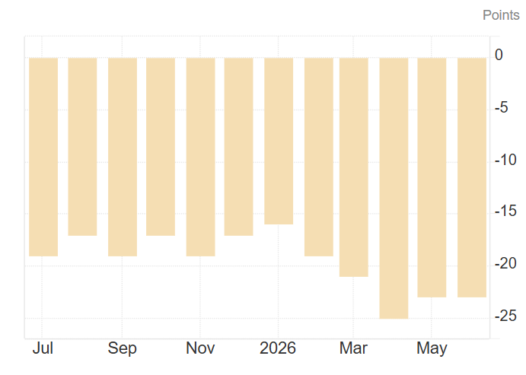
Figure 1: Consumer Confidence of the UK
(Source: Trading Economics, 2026)
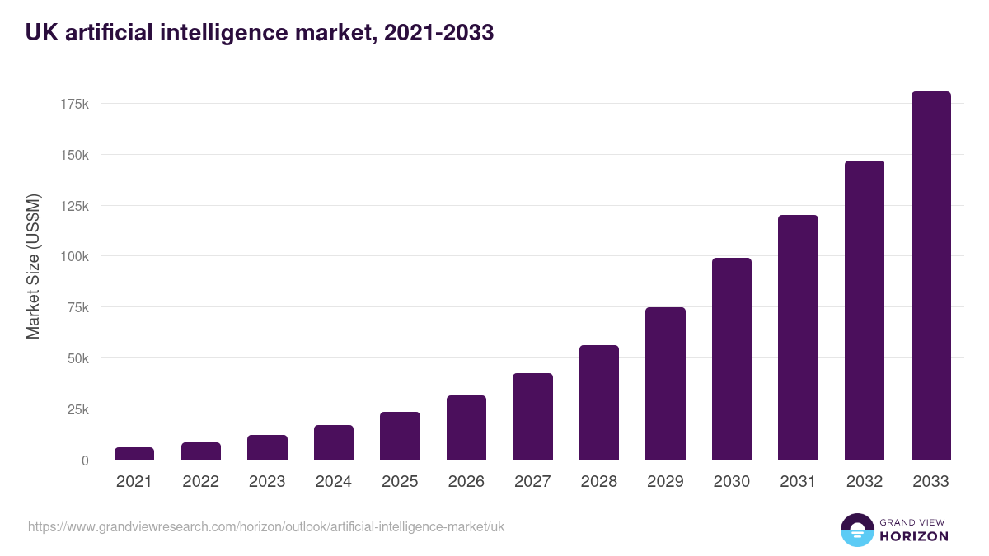
Figure 2: UK AI Market
(Source: Grand View Research, 2026)

