

Optimizing Digital Transformation Strategies for Small and Medium-sized Manufacturing Enterprises: A Path to Strengthening Competitive Advantage, Enhancing Operational Performance, and Building Resilient Supply Chains

DBA CANDIDATE:
Yu Ding
2023-01-23
Content
Abbreviation 4
1 Introduction 5
2 Literature Review 5
Research question 12
3 Theory and Conceptual Framework 12
3.1 Theory Framework 12
3.1.1 Dynamic Capability Theory 12
3.1.2 Resource-Based View Theory 13
3.2 Conceptual Framework 13
4 Research Paradigm 14
4.1 Paradigm 14
4.2 Four Philosophical Assumptions 15
4.2.1 Axiology 16
4.2.2 Ontology 17
4.2.3 Epistemology 18
4.2.4 Methodology 19
5 Qualitative research 19
6 Five qualitative research method 21
6.1 The case study 21
6.2 Narrative Research 22
6.4 Ethnographic Research 23
6.5 Phenomenology Research 23
7 Ethical Considerations 24
8 Reliability and validity 26
8.1 Reliability 26
8.2 Validity 26
9 Research Plan 27
10 Conclusion 27
10.1 Contributions 27
10.2 Limitations 27
11 Reference 28

Abbreviation
Digital Transformation(DT)
Cyber-Physical Systems(CPS)
Internet of things(Iot)
Artificial Intelligence(AI)
Small and Medium-sized Enterprises (SMEs)
digital supply chain (DSC)
Knowledge Ambidexterity (K-AMB) capabilities
sustainable development (SD)
blockchain technology (BT)
Technology Acceptance Model-Technology-Organization-Environment (TAM-TOE)
Radio-Frequency Identification RFID
Cloud Computing Utilization (CCU)
linear regression (LR)
Quadratic regression (QR)
Machine Learning (ML)
Least Squares Structural Equation Modeling (PLS-SEM)
Fuzzy Set Qualitative Comparative Analysis (fsQCA)
Data-Information-Knowledge-Wisdom model (DIKW)
Predictive Analytics (PA)

1 Introduction
This report critically analyses the fundamental research ideas involved in investigating digital transformation strategies for small and medium manufacturing enterprises (SMEs) in China. It scrutinizes prior academic theories and perspectives related to technological integration in the manufacturing context to reveal gaps in understanding optimal pathways tailored specifically to this vital industry segment. By adopting a qualitative methodology, the report takes a deeper interpretivist dive into the meaningful realities of SME leadership through case studies and executive interviews. It aims to build more contextually grounded theoretical models explaining transformation success factors relative to an SME’s operational maturity level.
Moreover, the fundamental assumptions in existing literature are challenged regarding universal applicability of digitalization performance impacts and implementation frameworks across industrial backdrops. The report formulates an alternative conceptual model contextualized to Chinese manufacturing SMEs based on findings from comparative cross-case analysis. It also critically examines methodological limitations of the qualitative approach in balancing depth versus breadth of analysis. From foundational philosophical perspectives, the subjective nature of experiential data is acknowledged while still upholding the value of rich insights revealed. Therefore, an interplay of inductive and deductive reasoning guides analysis.
In summary, while assessing the most viable pathways forward, the report critically evaluates established theoretical paradigms and research conventions. It construes digital transformation research specifically for the SME sphere as still emergent and in need of contextual adaption. The intended outcome is a more relevant and actionable research basis for this vital sector to build capabilities enhancing competitiveness and resilience.

2 Literature Review
Since the introduction of the Industry 4.0 concept, the importance of technology has been redefined involving production, manufacturing, warehouse and logistics in the form of a Cyber-Physical System (CPS) network(Pfeiffer, 2017). This technological innovation is expected to result in a new industrial revolution, which can help companies to change the process manufacturing and management. With the development and maturation of technologies such as Artificial Intelligence (AI), the Internet of Things (IoT), and Cloud Computing, an increasing number of technologies are applied to help enterprises carry out digital transformation. Digital transformation is defined as a fundamental process in which organizations strategically change by integrating digital technologies to reshape resources and capabilities, creating value for their stakeholder(Gong & Ribiere, 2021). Similarly, Mergel et al.(2019) have offered an experiential definition and conceptual framework for digital transformation in the public sector. Digital transformation is an ongoing process that requires frequent adjustments to its processes, services, and products based on external demands.
Iot in Digital Transformation
In the past decade, numerous studies have explored digital transformation as it relates to technology development and the performance of organizations in various industries. In particular, the COVID-19 pandemic has highlighted the importance of digital transformation in helping enterprises manage and mitigate crisis risks.
The Internet of Things (IoT) has been identified as a highly promising technology for manufacturing. It can lead to more efficient decision-making for logistics planning and even spur business model innovation. Manufacturers can improve their agility, efficiency, and overall competitiveness. According to Jachimczyk et al.(2021), the application of IoT can enhance the transparency of the digital supply chain (DSC), improving transparency and efficiency. A study by Zhong et al. (2015) point out that RFID data can extract frequent trajectories of workshop logistics, which can support further decision-making processes of logistics planning. Similarly, Min et al.( 2019)assert that the integration of IoT, data mining, and machine learning technologies can enhance the petrochemical industry's agility and intelligent capabilities. Separately, Hu’s case studies uncovered vaccine supply chain management during the pandemic, which addresses vaccine management issues. However, the investigation of Paiola et al. (2022) uncovered that the application of IoT plays a crucial role in the interaction between resources and customer-related capabilities improving the process of business model innovation. Likewise, research by Saratchandra & Murray (2022) suggested that cloud computing can help SMEs foster employee-driven innovation.
Artificial Intelligence in DT
Research by Di Vaio et al.(2020) uncovered the relationship between artificial intelligence and sustainable development (SD). The study indicates that artificial intelligence can assist businesses in organizational decision-making, process optimization, understanding market and user preferences, and enhancing employee capabilities. Through these objectives, sustainable development can be achieved. However, some research believe that AI can enhance business performance. Chowdhury et al.(2022)investigated the impact of effective collaboration between humans and AI on business performance. Fosso(2022) indicated that Artificial Intelligence Assimilation is a significant predictor for organizational agility and customer agility, with a stronger influence on organizational agility. Analysis conducted by Guan et al. (2023) proposed that using blockchain technology (BT) and machine learning can enhance the accuracy of supply chain forecasting. According to Rekabi’s study (2023), linear regression (LR) and quadratic regression (QR) machine learning (ML) algorithms can predict demand and reduce the likelihood of shortages in the Perishable Supply Chain for Non-Durable. Similarly, research by Benzidia and Bentahar, (2021) uncovered the benefits of Big Data Analytics and Artificial Intelligence (BDA-AI) in the supply chain integration process and its impact on environmental performance. However, Chatterjee et al. (2021) demonstrate that managers adopting artificial intelligence technology can establish a network for sharing knowledge and resources to meet customer needs, and provides various recommendations for managers.
DT in various industries
The development of digital platforms has accelerated the digital transformation in different industries, which create new value and improve competitive to business performance. For example, Veile and Voigt (2022) identified platform types and roles in industrial marketing by studying 11 platform cases from the United States and Germany. Wei (2022) analyzed how medium-sized enterprises (SMEs) can integrate AI technologies by utilizing AI platforms. Additionally, Chatterjee and Kumar Kar (2020)investigated the business implications by assessing business performance, sales, customer engagement, understanding customer needs, and the creativity of employees. Costa et al.(2020) identified detailed requirements and functionalities of digital platforms tailored to the specific organizational environment, aiming to enhance the internationalization level of SMEs.Social Media Marketing (SMM) play a significant role in improving business impact of SMEs. Furthermore, a recent study investigated the crucial role played by social factors within platform companies, which investigated the complex interdependencies coming from interactions among platform participants. This interdependency can lead to leveraged growth and modularity of offerings(Kapoor et al., 2021). An increasing number of businesses are using these platforms to innovate and expand their business models. One study by Martín-Rojas et al. (2020) examined that the strategic use of social media can help businesses identify innovation opportunities by investigating 201 technology companies. Empirical findings demonstrate that social media enhances company performance and contributes to creating business value. Similarly，Xie et al.(2022)constructed a conceptual framework to explain how digital platforms, through capability restructuring, influence business model innovation in SMEs. Through the study of platform-based business model innovation, researchers proposed three value co-creation models including reducing internal operating costs, customer-centric experiences, and collaborative value co-creation (customized products or services). The research also indicated that external pressure and management cognition are two main drive of platform business model innovation(Jia et al., 2023).Separately, Zhang 's (Zhang et al., 2021) research indicates that the fundamental aspect of collaboration between digital platforms and participants is to cultivate strategic alliances for open value co-creation. On a different note, Cenamor et al. (2019)investigated how entrepreneurial SMEs enhance performance through digital platforms. Digital platform can reshape the relations between business to business.
Digital Platform in DT
The adoption of digital technology and platforms has accelerated digital transformation across various industries, including e-publishing, remote work, automotive, hospitality, and retail. For example, Vendrell-Herrero et al (2017) determines the optimal pricing strategy for digital services which create additional value through digital services by analyzing demand of e-books in publishing industry. Driven by the pandemic, Information Technology (IT) facilitated the digital transformation of knowledge work. Such as the development of the remote work (Zeuge et al., 2023).In the automotive industry, the digital transformation is giving rise to new value streams through the establishment of vehicle data-driven services and their sharing. This transformation is leading to the emergence of new participants and ultimately shaping new market configurations(Kaiser et al., 2021).Others have highlighted the relevance of digital transformation and electricity consumption, Empirical results indicate a significant reduction in both the quantity and intensity of electricity consumption due to digital transformation, with a more pronounced effect observed in the industrial sector compared to the residential sector(Wang et al., 2022). In contrast, Busulwa et al.(2022)analyzed and summarized the specific digital transformation and digital business management capabilities required in the hotel and tourism management industry. The research points out that the lack of specific capabilities or insufficient depth in these capabilities may potentially limit the performance of the management team. Furthermore, one study suggests that in the digital era, the retail industry can indirectly enhance consumer loyalty to supermarkets by implementing digital strategies based on consumer experience(Cuesta-Valiño et al., 2023). In the same Annosi et al.(2021) investigated the impact of digitalization on organizational and food supply chain processes. By conducting a triangulation, the research examined the barriers and driving factors of collaborative practices for preventing food waste in the food supply chain. It provides new insights into how to utilize digital technologies to reconceptualize supply chain design. The study explores how technologies such as the Internet of Things (IoT), cloud computing (CC), and predictive analytics (PA) facilitate the service transformation of industrial companies, Which shows that the Internet of Things serves as the foundation for any service transformation, and predictive analytics is crucial for transitioning into a performance provider(Ardolino et al., 2018).Likewise, Eling and Lehmann (2018) analyzed the impact of digital transformation on the insurance industry, which show that digital transformation of insurance sector can increase competition in term of enhancing customer experience, improving business processes, introducing new products. Bickauske et al.(2020)evaluate the digital maturity of the manufacturing industry in Lithuania ,and investigated significant impact of digital transformation on the manufacturing industry.
Cloud Computing in DT
Several studies have been conducted to identify obstacles in the application of Cloud Computing and AI technology, along with proposed solutions to address them. Specifically, Hosseini et al.(2019)explore obstacles of the effectiveness of Cloud Computing Utilization (CCU) faced by SMEs in Emerging Market-Countries (EM-SMEs), and also provided a serious solution to help SMEs use cloud computing. Kaymakci et al. (2022) proposes a four-step process for SMEs to select machine learning (ML) cloud services including decision problem, service evaluation, criteria weighting, and decision making. This provides a systematic selection process and reduces barriers to adopting machine learning cloud services and supporting the digital transformation of SMEs. Likewise, research of Chen et al.(2023) proposed 12 decision factors influencing the adoption of cloud computing services by SMEs. The Least Squares Structural Equation Modeling (PLS-SEM) result show that security issues, management support, IT capabilities, competitive pressure, trade partner pressure, and provider support impact SMEs' decisions to adopt cloud computing. Fuzzy Set Qualitative Comparative Analysis (fsQCA) revealed seven configurations leading to advanced cloud computing adoption and eight causal pathways leading to the denial of cloud computing adoption. While, Baabdullah et al.(2021),based on the Technology-Organization-Environment (TOE) theoretical model, investigated that B2B SMEs' acceptance of AI practices hinges on two primary prerequisites. The study employed structural equation modeling to validate the close relationship between AI practices and relational governance factors. The result shows that the driving factors for AI practices, including technological road mapping, professional expertise, and attitude, must be in place. The readiness of the enterprise, encompassing infrastructure, technicality, and awareness, is crucial.
Current research of DT in SMEs
In the past few years, an increasing number of researchers have been investigating the benefits of digital transformation and its practical applications in small to medium-sized businesses. Their studies cover a wide range of topics, including the factors that influence and drive digitalization, the extent to which digitalization has been adopted, and the impact of dynamic capabilities on business model innovation.Skare et al., (2023) indicate that digital transformation can enhance the ability and flexibility of SMEs in Europe When facing critical business challenges. By empirical investigation on 321 European SMEs, Bouwman et al.(2019)show that SMEs have various business models options for business management innovation such as Social Media Utilization, Big Data Analytics, Information Technology Integration.From the Impact of Customer Value Creation, researchers investigated the digital transformation in small and medium-sized firms (SMEs) of Italy basing on dynamic capability. Digital tools (social media, applications, chatbots, and big data analysis) could change the process of consumer value creation and bring new distribution channels. The research also highlight that owners of SMEs possess the ability to accelerate sensing and learning capabilities, which plays a crucial role in digital transformation (Matarazzo et al., 2021). Especially during the pandemic, researchers study digital technology to improve business and operational models in SMEs of India. Khurana et al.(2022).constructed the resilience capability model including entrepreneur, organizational, and entrepreneurial ecosystem. In the same, Zahoor et al.(2022)studied the dynamic capabilities and strategic agility of Business-to-Business (B2B) high-tech SMEs in Finnish. The result indicated that the utilization of digital technology is an effective way to address the negative impact caused by the epidemic.
Impact factors of DT in SMEs
SMEs require greater digitalization to enable digital transformation. Based on a framework of dynamic capabilities, North, Aramburu, and Lorenzo(2019)evaluated and discussed the digital maturity of SMEs. This study provides insights that Owners and managers of SMEs will be better equipped to understand which factors need to be consciously managed for digitally enabled growth. Similarly, Denicolai et al.(2021) research the maturity and preparation of digital transformation in SMEs. The study indicated that digital transformation is a central driver for innovation and business renewal in matured SMEs. It also highlights the positive impact of digital transformation on the international performance of these enterprises. Different stages of digital transformation in SMEs were analyzed by researchers to identify research directions at each stage. Some authors have mainly been interested in the level of digitalization, which is a crucial factor for maintaining competitiveness. Analyzing 43 European SMEs across five industries, Canhoto et al. (2021) conducted a study on the digital strategic adjustments of SMEs from the perspective of dynamic capabilities, which constructed a digital alignment model consisting of five phases(passive acceptance, connection, immersion, fusion, and transformation). It mainly emphasized micro-behaviors and leadership in the digital transformation of SMEs. In contrast, Gao et al.(2023)Investigated the level of manufacturing SMEs in China, which indicated the ability of SMEs in the manufacturing sector to assimilate the impacts of digital transformation on service-oriented levels varies based on their industry types.
Some studies have analyzed the potential factors that can impact the digital transformation of SMEs These factors include technology, organizational culture, and resource investment. For instance, Lutfi et al., (2022) investigated the driving factors for the adoption of big data analysis, including technological, organizational, and environmental in SMEs of Jordan, which indicate management support and government policies are the primary influencing factors. Similarly, Eller et al. ( 2020)indicated that information technology, employee digital skills, and digital strategy are there the main drivers of the digital transformation of SMEs. The application of digital technologies, such as data analysis, cloud computing, mobile technology, and social media networks, can improve marketing and have a positive impact on financial performance. From the internal factors, Birkel and Wehrle (2022)investigated the main barriers to digital transformation such as such as high uncertainty, lack of infrastructure, and the absence of a well-defined digital transformation process. It also indicated how to conduct supply chain digital transformation from management of organization and strategy. While Pingali et al. constructed a conceptual framework from internal factors (leadership factors, strategic focus factors, and resource factors) and external factors (customer factors and market factors), The level of digitalization has a positive effect on the management and policies of e-commerce SMEs.
Digitalization is widely recognized for its key role in enhancing the efficiency and performance of companies, particularly concerning AI, IoT, cloud computing, and the third platform. Digital transformation has attracted considerable research attention in various industries such as hospitality, retail, automotive, and food. However, most studies have focused on large or global companies. SMEs often face challenges in adopting new technologies due to a variety of reasons, such as financial inadequacy, technological deficiency, and resistance to change (Teng et al., 2022). Most of them emphasized the development of technologies. There is a research gap in determining the best strategies for DT of small and medium-sized manufacturing companies. Existing research on the digital transformation of SMEs has mainly focused on developed nations such as Germany, Italy, and Lithuania(Bickauske et al., 2020; Kaiser et al., 2021).
By exploring this phenomenon in China's small and medium-sized manufacturing sector, this study offers a distinct geographical and industrial perspective to analyze the challenges and barriers of DT in SMEs. This research aims to introduce a new research framework to guide SMEs towards effective digital transformation.
Research Objectives:
To examine the key barriers and challenges SMEs face in adopting emerging digital technologies across supply chain and media operations.
To identify the most beneficial digital technologies and initiatives that SMEs should prioritize to drive organizational goals related to competitive advantage, performance, and resilience.
To investigate best practices and critical success factors for SMEs undertaking digital transformation tailored to their operational contexts.
To develop frameworks and guidelines to assist SMEs in strategically implementing digital technologies that strengthen capabilities while overcoming transformation barriers.
To assess the impact of digital transformation on achieving key SME objectives including competitive differentiation, operational efficiency, revenue growth, flexibility, and risk mitigation.
To evaluate how advanced digital capabilities can bolster SME resilience during disruptions across supply chain and media operations.

Research question
My research questions are:
How can small- and medium-sized enterprises effectively leverage digital transformation to enhance competitive advantage, operational performance, and supply chain resilience?
What are the best choices for these small medium-sized manufacturers when start digital transformation?
What are the main barriers and drives of digital transformation in mall medium-sized manufacturing?
How it will improve the business performance of small and medium-sized manufacturing.
What is the impact of supply chain resilience on SMEs when using the digital transformation?

3 Theory and Conceptual Framework

3.1 Theory Framework
The theoretical framework is a critical part of the research process as it provides the foundation for constructing theory knowledge (Anfara & Mertz, 2015). The theoretical framework not only provides structure and support for research design, but it also guides the research questions themselves. Most importantly, it offers foundational support for the research methods and the analysis process, which is like the blueprint for a house (Grant & Osanloo, 2014).

3.1.1 Dynamic Capability Theory
The dynamic capabilities of an enterprise are that the companies can rapidly adapt and integrate both internal and external resources to address new challenges and opportunities in a constantly changing external environment (Teece et al., 1997).In the digital transformation of SMEs, Dynamic Capability Theory emphasizes the ability of businesses to perceive and identify opportunities and threats in a rapidly changing market and technological environment.
This requires them to quickly adapt and transform, including rapidly learning new technologies and processes, as well as adjusting business models or strategies when necessary. In digital transformation, research indicated that businesses should effectively utilize and reconfigure resources including technology, finance, and talent. Additionally, strong leadership and an organizational culture are key factors of success in supporting innovation and digital transformation(Barney, 1991; Eisenhardt & Martin, 2000).

3.1.2 Resource-Based View Theory
In resource technology views, internal resources play an important role in acquiring and maintaining competitiveness as they are scarce, irreplaceable and valuable (Wernerfelt, 1984). In the digital transformation of SMEs, enterprises rely on high-value and scarce resources (such as advanced technology platforms, professional technical personnel, and innovative business strategies)to get great performance in the intense market competition . (Elia et al., 2021).

3.2 Conceptual Framework
The conceptual framework is a significant part of the research design. It includes a collection of theories, concepts, beliefs, expectations, and hypotheses that provide support and guidance for the research. The framework helps the researcher to evaluate and improve the objectives of the research. it also helps the researcher with their research question design and brings them to realization. Therefore, an appropriate research methodology can be selected to help researchers identify and adapt their research question (Maxwell, 2013, pp. 65–67). The purpose of the conceptual framework is to gather, collate and illustrate concepts which are relevant to the study and also to explain the interactions among these concepts (Rocco & Plakhotnik, 2009). Therefore, based on the previous literature review, the previous research findings will be utilized to show the different relationships among different phenomenon. (Rocco & Plakhotnik, 2009).
The impact of digital transformation in SMEs comes from Technologies and organizations, it will impact the performance of organizations. Therefore, the conceptual framework of this study is illustrated as follows(Fig1).
Maturity of technology in SMEs
Application of Technology including AI, Cloud Computing, IoT Application of Third-Platform: Mobile app, Management Software, Digital Management Platform
Impact of Organization: Digital ability and background of Manager and employee
Organization Performance: Business performance, Marketing Performance, Business Innovation, Financial Performance
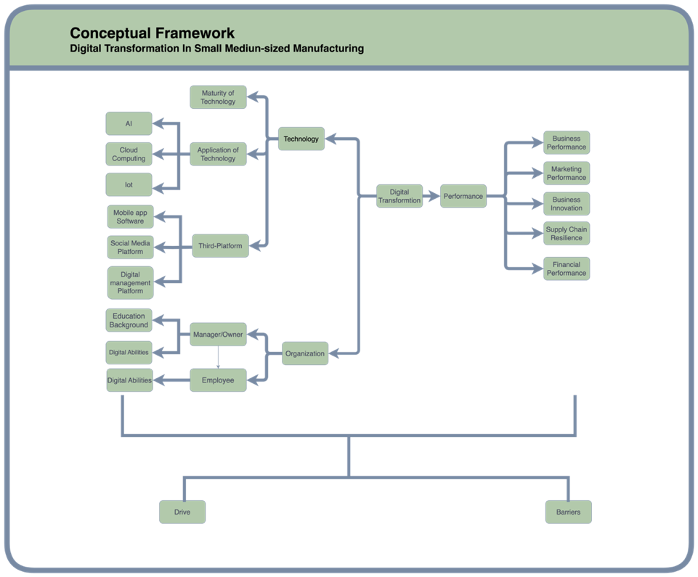
Fig1: Research concept framework of DT in SMEs

4 Research Paradigm

4.1 Paradigm
Paradigm is important for us to understand the assumptions in research, which helps us in how we construct questions and how we seek information to answer those questions (Creswell, 2013). Moreover, it is essential to have a thorough understanding of different research paradigms to develop appropriate research designs (Given, 2008).
Paradigm is considered the common worldview held by scientists, guiding their understanding and approach to research. It is essential for "normal science" attracting a group of loyal followers for unresolved questions. (Kuhn & Hacking, 2012). A paradigm serves as a framework for assessing the worth of research and evaluating the work of peer researchers in "normal science.”(Barker & Kitcher, 2014).
Paradigms bring various perspectives and approaches to research, which are defined based on different philosophical assumptions such as ontology, epistemology, and methodology. Guba & Lincoln (1994) Outlines the four significance paradigms (positivism, post-positivism, critical theory, and constructivism) in qualitative research from the perspectives of ontology, epistemology, and methodology. In contrast, Heron & Reason (1997) criticized the constructivist approach for neglecting empirical cognition. The study discussed a worldview based on four philosophical assumptions ranging from ontology (“subjective-objective”), epistemology (“four knowing of experiential, presentational, propositional and practical”), methodology (“collaborative forms of action inquiry”) to axiology (“intrinsically worthwhile”). Crotty(2015) indicated that scientific investigation is strictly conducted by paradigm matrixes established by the parameters and boundaries of scientific inquiry, in "normal science". Lincoln et al. (2018) have introduced the participatory paradigm besides the paradigms of positivism, post-positivism, critical theory, and constructivism, which reflect researchers' worldviews according to their interest in ontology and epistemology. Mertens(2007) emphasizes the advantages of mixed methods and highlights that the transformative paradigm focuses on ontological and epistemological issues. Although it does not provide specific research guidelines, it offers a valuable framework for researchers to the enhancement of human rights. Burrell and Morgan (2019) indicated that Ontology and epistemology, as two fundamental philosophical assumptions, guide us in how to perceive (regulation or radical change) and study (objectivism or subjectivism) the world. The matrix’s four paradigms(radical humanism, radical structuralism, functionalism, and interpretivism) represent four different ways of viewing the social and organizational world. While, Creswell(2013)indicated that interpretive frameworks include positivism, post-positivism, interpretivism, constructivism, hermeneutics, feminism(s), racialized discourses, critical theory, Marxist models, cultural studies models, queer theory, and postcolonialism.
The interpretive paradigm seeks to understand the fundamental nature of the world from the perspective of the individual. It focuses on people's personal feelings and thoughts, attempting to understand things from their point of view rather than from that of an external observer(Burrell & Morgan, 2019).When researching the deep meanings behind events in organizations, the interpretive paradigm seeks to explore the different perspectives and experiences of individuals, rather than just the superficial logic of the situation. This type of research may lead to a deeper understanding of the internal politics and power plays within the company. Throughout this process, researchers become involved and observe like insiders to better understand what is the real world instead of changing the status. (Saunders et al., 2019).

4.2 Four Philosophical Assumptions
Qualitative research is guided by four philosophical assumptions: ontology(what's real), epistemology (how to get knowledge and facts), axiology(the values in research), and methodology (the process of research), which form the foundational framework and assist scientists in distinguishing and implementing various research paradigms and methods. (Creswell, 2013).
According to Saunders (2019), research philosophies are the outer of the research onion’s layers(Fig2), which are important and require understanding and explanation rather than mere peeling and discarding. All research paradigms make at least three major types of philosophical assumptions: ontological, epistemological, and axiological.Different paradigms can be distinguished according to the differences in philosophical assumptions. Similarly, Easterby-Smith et al.(2015) suggested that “Research Tree Trunk” transports nutrients from roots to leaves and fruits, which is essential for process of research. The cross-section of the trunk represents the four philosophy assumptions (Fig3). While Brown & Dueñas (2020) indicated that the composition of a paradigm is represented by several "building blocks"(Fig 4), with the first set representing philosophical assumptions (axiology, ontology, epistemology, methodology).
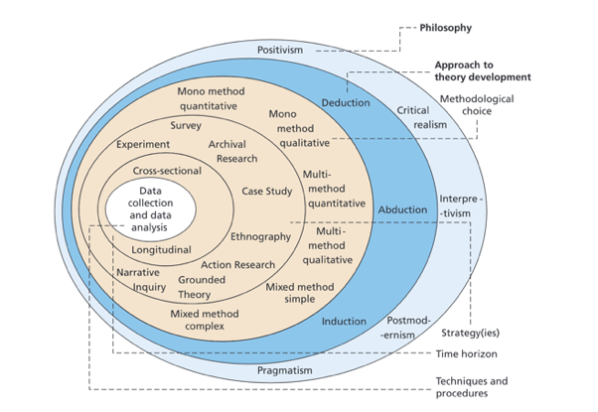  Fig2: The “Research Onion”  (Saunders et al., 2019) | 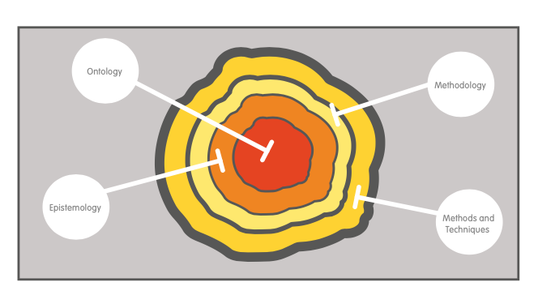  Fig3: Cross-Section of “Research Tree Trunk” (Easterby-Smith et al., 2015)

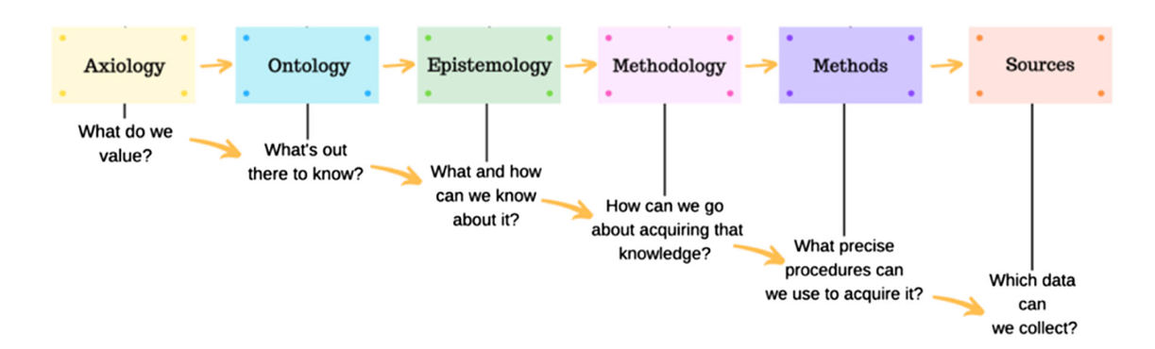
Fig4: Paradigm blocks of “Research Building” (Brown & Dueñas, 2020)

4.2.1 Axiology
Axiology plays a key role in shaping the direction and ethical considerations of scientific studies (Brown & Dueñas, 2020). Axiology is a core belief in research, focusing on values, ethics and value judgments.(Biddle & Schafft, 2015; Saunders et al., 2019). Axiology influences not only the choice of research questions, methods, and data analysis but also affects how researchers’ and participants' values impact the research process, emphasizing the need for methodological rigor and ethical considerations in research (Saunders et al., 2019).
Different research paradigms reflect varied axiological concepts. For instance, positivist research adopts a value-neutral approach, while interpretivist research integrates values as an intrinsic part of the study. Pragmatist values merge objective and subjective viewpoints, which highlights inductive, constructive and interpretive methodologies (Bryman et al., 2019; Creswell, 2013).
Research can be strongly influenced by the researcher’s axiology. Many factors (eg. social economy changes, technological progress, and epidemic impact )can accelerate the digital transformation of SMEs. (Ardolino et al., 2018; Matarazzo et al., 2021; Münch & Hartmann, 2023). The Stakeholders in SMEs also have a great influence on data collection and analysis. The shareholder’s personal experiences and values are very crucial to understand the impact of digital transformation. Furthermore, Mertens(2007) indicated the importance of the ethics of the research. These include respect, benefits, and justice. Ethical research needs to highlight the importance for researchers to be aware of ethical issues. Data sensitivity, privacy and fairness in their research should be taken into consideration. Moreover, during the entire research process, should be transparent and their values should be reflected.

4.2.2 Ontology
Ontology is concerned with the nature of existence and the real-world structure. It is considered the fundamental philosophy of the science of existence(Crotty, 2015; Saunders et al., 2019). Ontology helps define the essence of the world, the individual's position within it, and potential relationships with various parts of the world, often accepted on faith due to the impossibility of determining ultimate truthfulness(Guba, E.G. & Lincoln, Y.S., 1994).
Ontological perspectives vary across different paradigms. Scientific realism views ontology as an objectively existing world, unaffected by human cognition. Critical realism acknowledges the real world's existence but admits human limitations in fully understanding it(Guba, E.G. & Lincoln, Y.S., 1994; Shiping Tang, 2011). Nominalism focuses on language and concepts, denying a "real world," while objectivist ontology sees the world as an objective existence, independent of observers. In contrast, constructionist ontology posits that reality is shaped by human activities and observers (Bryman et al., 2019).
In transformative paradigm ontology, reality is defined by social, political, cultural, economic, and other factors, influencing varied perspectives of reality among participants and researchers (Mertens, 2007). Ontology in business research shapes researchers' views and approaches, influencing decision-making in research design (Saunders et al., 2019). In qualitative research, ontology refers to the nature of reality, embracing multiple realities presented through studies (Creswell, 2013).
The digital transformation in SMEs is widely considered an objectively and complicated social phenomenon. It can be significantly influenced by the stakeholders’ understanding, according to their culture, organizational structure, and social contexts. Organizational, technological, and environmental aspects of an enterprise are regarded as objectively real and can be observed and analyzed to understand them. In the area of digital transformation of SMEs, ontological assumptions consist of both objective and subjective viewpoints. On the objective side, technology plays an important role in the performance and structure of an organization because it is considered an observable and quantifiable tool. On the subjective side, the organization is deemed as a system which is formed by the (Chowdhury et al., 2022; Cuesta-Valiño et al., 2023; Matarazzo et al., 2021).

4.2.3 Epistemology
Epistemology is considered a crucial philosophical concept which helps researchers to understand the facts of the world and how we know things. (Saunders et al., 2019). This concept mainly includes the theory of knowledge, which can guide researchers to acquire knowledge based on the understanding of the nature of the world (ontology). It emphasizes the methodology we acquire knowledge is built on our comprehension of reality (Bryman et al., 2019).
Epistemology is important in defining the domain of perceiving and understanding the world. It emphasises the importance of constructing and understanding knowledge. At the same time, it requires respect for culture and understanding of power structures in the pursuit of knowledge.(Mertens,2007). In qualitative research, the assumptions of epistemology usually highlight that researchers can deeply acknowledge the participants’ personal experiences by immersing in the participants’ environment. This allows the researcher to bridge the barrier between the researcher and the participant, to obtain authentic and detailed information. (Creswell, 2013).
In the social science research area, epistemology (especially in positivism and social constructionism) is mainly involved in the rules for the definition and identification of knowledge to determine what is acceptable, effective, and legal. It explores the relationship between those seeking to understand the world and the world itself, influenced by our perception of the world's nature (ontology)(Guba, E.G. & Lincoln, Y.S., 1994; Bryman et al., 2019; Easterby-Smith et al., 2015).
In the digital transformation of SMEs, epistemology focuses on understanding the process and associated knowledge of digital transformation. It includes various approaches to understanding how organizations adapt to and integrate digital technologies. Researchers investigate different stakeholders' perceptions and influence on digital transformation using methods like interviews, observation, and content analysis (Benitez et al., 2022; Hinings et al., 2018; Weber et al., 2022). They focus on internal factors like culture, leadership, and employee attitudes, as well as external factors like market competition and regulatory changes, to understand how SMEs adapt to and shape digital change and offer suggestions for enhancing competitiveness and innovation (Klein, 2020).

4.2.4 Methodology
Methodology is the plan and guiding principle of research, referring to a set of assumptions, rules, and methods followed by researchers. (Denzin & Lincoln, 2018). Shiping Tang (2011)pointed out that the real world may never be fully understood, but knowledge can be acquired through various research methods. Methodology not only guides researchers on how to understand rules and methods but also involves how to choose and apply the method depending on the view of the nature of the research subject and epistemology(Bryman et al., 2019). How to obtain reliable knowledge dependent on researchers' views on authenticity and objectivity, as well as the nature and objectives of the research, that different research methods can be chosen (Guba, E.G. & Lincoln, Y.S., 1994).

5 Qualitative research
Qualitative research methodology is mainly considered as an ideal method for answering questions such as "why", "who" or "what". Whereas a case study is better for testing the effects of specific interventions (Given, 2008). Researchers adopt a variety of methods to gain an in-depth understanding of how people see and feel the world around them. (Bryman & Bell, 2019). Qualitative research methodology is often described as an inductive approach, which means that it is formed while collecting and analyzing data through the researcher's experience. The researcher is not limited by any preconceived theories or ideas, with the researcher exploring from the ground up, the research questions posed will change with the research progress, and the methods and strategies of data collecting might be required to be adjusted. Through careful analysis of the data, the researcher gains a deeper understanding of the topic at hand.(Creswell, 2013).Qualitative research methodology involves a series of essential steps: first, selecting a core concept for the study; then identifying the research questions to be explored; next, creating a conceptual model to aid in understanding the research topic; determining the study's location, participants, and sample; specifying the methods and tools for data collection; and finally, outlining the steps for data analysis and interpretation. By following these systematic steps, researchers can conduct thorough and reliable qualitative research(Denzin & Lincoln, 2018).
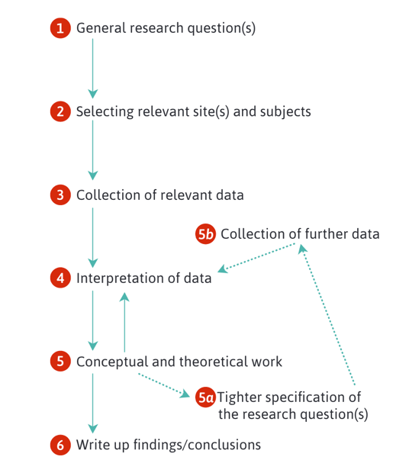
Fig5: qualitative research steps (Bryman & Bell, 2019)
Qualitative research involves a deep and comprehensive understanding of the world through observation. It transits from competitive paradigms, such as positivism, post-positivism and constructivism and instead focuses on interpretive forms like feminism, critical race theory, indigenous theory, critical pedagogy and cultural studies.
Social science researchers utilize different research strategies, such as case studies, phenomenology, ethnography, interpretive practices, grounded theory, and triangulation to conduct qualitative research. Qualitative research aims to comprehensively and deeply reveal the complexity of human behaviours and social phenomena by using methods such as storytelling, statistics, and observation of everyday life(Denzin & Lincoln, 2018). At the same time, qualitative research is also a method which collects data by adopting inductive and deductive methods of analysis and identifies complex patterns or topics which are relevant to the problem being studied. This method can provide a comprehensive description and explanation for the problem, it can also reflect the researcher's perspectives and viewpoints. Due to its nature of exploration, qualitative research is especially useful in areas where the topic is not well known. As a result, it is a useful tool for obtaining an in-depth understanding of complicated problems and creating efficient solutions (Creswell, 2013).
In digital transformation of SMEs, qualitative methods such as interviews and case studies, can provide a more comprehensive understanding of the aspects of digital transformation that are involved. It is important to consider the views and experiences of different stakeholders, including employees, management, and consumers, to gain a deeper understanding of the complex layers of digital transformation. (Chatterjee et al., 2022).

6 Five qualitative research method

6.1 The case study
A case study is conducted by conducting an in-depth examination and analysis of the activities or processes involving one or more individuals within a single case. Researchers will specify the specific time and place where this event occurred, and then they will use various methods to collect a large amount of detailed information over a period. This allows for a better understanding and study of the event or situation(Baxter & Jack, 2015; Eisenhardt, 2023; Stake, 1995).
Case studies typically focus on a small number of cases but delve deep into the details of each case. They are suitable when we want to answer how and why questions. Case studies use evidence from various sources such as documents, artifacts, interviews, and observations to provide a comprehensive understanding. They concentrate on a few individuals or cases but go into greater depth. There is less control over variables in case studies. In case studies, the aim is to compare or replicate different research organizations systematically to explore various research questions(Rowley, 2002).
The case study method focuses on an in-depth understanding of phenomena within their real-world context. It allows for the examination of specific strategies, processes, challenges, and outcomes of digital transformation initiatives undertaken by individual organizations as exemplary cases. Cases can be strategically selected to provide diversity in variables such as company size, industry sub-sector, and level of digital maturity. Various data sources, including documents, interviews, observations, and artifacts, can then be collected and triangulated. This will provide a multifaceted view of how digital transformation unfolds in each case. The research findings may elucidate patterns and variations in SMEs' digital transformations, which strategies succeed and fail, as well as key barriers and drivers. Contextual analysis is also central, as digital transformation depends on many internal and external contextual factors.
Case study research allows for a rich investigation of how digital transformation unfolds in the real SME environment, aligning well with the stated objectives. Other methods have key weaknesses for this focus on organizational technological transformation. Therefore, the case study method is most suitable.

6.2 Narrative Research
Narrative research involves one or more participant’s sharing stories about their lives. Subsequently, researchers typically rearrange or organize these stories into a chronological narrative. Eventually, this kind of narrative often integrates the participants' life experiences with the researcher's observations to create a story of collaboration. This methodology helps researchers to have a greater understanding of the participant's individual life and experiences and how their views are weaved with the researcher's(Daiute & Lightfoot, 2004; Josselson & Hammack, 2021).
Although there are advantages of narrative research, it can gain a deeper insight into individuals' experiences and cultural aspects, its methodology may not meet the research requirements of digital transformation in SMEs. First, digital transformation has multiple aspects, including technological, organizational, and environmental factors, and it needs a more multidimensional and systematic methodology. Narrative research focuses deeply on personal stories and experiences, usually stresses individual rather than organization or system perspectives, and it may be unable to fully grasp the width and complexity of digital transformation. Furthermore, in the research of digital transformation in SMEs, practicality is often prioritized on the front line. In contrast, narrative research usually needs to collect and analyze experiences and stories in detail, which is time and resource-consuming.

6.3 Grounded Theory
Grounded theory is a type of research method in sociology. according to participants' opinions and perspectives, the researcher creates a general abstract theory of a particular process, action, or interaction. For creating this theory, the researcher experiences many stages of data collection and continuously improves and connects information categories. This helps the researcher to understand and explain the relevant phenomena related to the research topic (Urquhart, 2023).
Although there is a remarkable advantage of grounded theory in the areas of theoretical innovation and in-depth insights of specific phenomena, it may not be the best methodology to study digital transformation in SMEs because of their special needs of resources, time, utility, and generalizability. First, grounded theory tends to start from zero to create new theories, rather than to apply existing theories and models for rapid problem solving. SMEs undertaking digital transformation may be more focused on practical and achievable solutions and strategies rather than developing new theories. Second, there is usually limited resources in SMEs, and the control of time and cost is strict. However, grounded theory is an expensive and time-consuming methodology, it might be beyond the scope of what is practicable for SMEs.

6.4 Ethnographic Research
the method of ethnographic research means that, in the natural environment, the researcher observes an entire cultural group for a long period of time, and acknowledges the different cultural groups' lifestyles and customs according to their behaviors, languages, and actions in a common pattern. Information is usually collected through observation and interviews (Creswell & Creswell, 2023).
Although ethnographic research is unique in its value in revealing the deeper cultural and social dynamics, it may not be the most appropriate methodology for the needs of digital transformation in SMEs. First, ethnographic research usually requires the long-term involvement of a researcher in a particular community or organization to both observe and participate in it. This in-depth research requires large amounts of time and resources. Second, ethnography focuses on understanding the deep cultural and social structures, emphasizing on revealing the deeper meanings behind human behavior. However, the underlying digital might more focus on the specific technology application, management transformation, or market strategy but not on the factors of the deeper culture. for SMEs undergoing digital transformation. Finally, ethnographic studies usually focus on smaller groups or communities, it limits their research perspectives and may not be able to capture the diversity and breadth involved in digital transformation.

6.5 Phenomenology Research
Phenomenology is a type of research methodology. The researcher studies an individual's lived experience of a phenomenon. This description finally gathers into the essence of the phenomenon through the experience of many people. This approach usually requires interviews (Giorgi, 2010; Padilla-Díaz, 2015).
First, phenomenological research focuses on the subjective experience and structure of consciousness of individuals, it will discuss thoroughly how individuals’ sense and experience the world. Secondly, in contrast, enterprise digital transformation is deemed as a complicated process, which involves many aspects and needs to consider factors beyond individual experience. It includes technology implementation, organizational restructuring, and market strategy. Furthermore, it needs in-depth interviews and analysis to carry out a phenomenological study, it is time and resource consuming. Enterprises which are in the process of digital transformation usually prioritize efficiency and practicality and may not be able to undertake the time and cost of phenomenological research. Finally, phenomenology is considered a highly personalized experience, and it may be challenging to apply it to an enterprise's extensive digital transformation strategy in a general way.

7 Ethical Considerations
Research ethics means that the researchers should follow the ethical standards and principles that should be followed during scientific research. It states that the participant should participate voluntarily and should not be harmed during the research. At the same time, participants' identities should be securely kept, the necessary information should be provided, and the data should be analyzed and reported honestly and transparently. In addition, it is required that researchers review their inherent privileges and prejudices, hear, and respect participants' voices, and take the ethical principles to heart. Compliance with research ethics is crucial for ensuring the integrity and credibility of scientific research, preventing unethical conduct and data manipulation, and upholding the reputation and norms of the scientific community(Bhattacherjee, 2012).
The "Seedhouse Grid" is a structured tool used by healthcare professionals to navigate complex ethical decisions, offering a multi-layered approach for comprehensive problem analysis.It guides them through various perspectives and considerations, leading to informed and thoughtful decision-making in challenging situations(Narut Pakunwanich & Bjørndal, 2020).
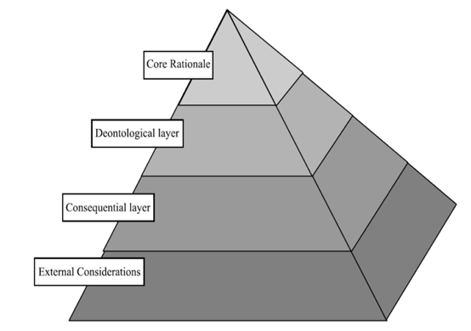  Fig6: A pyramidal representation of Ethical grid  (Narut Pakunwanich & Bjørndal, 2020)  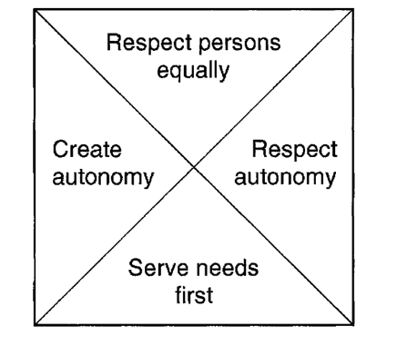  Fig8: The core rational of the Ethical Grid(Seedhouse, 2000) | 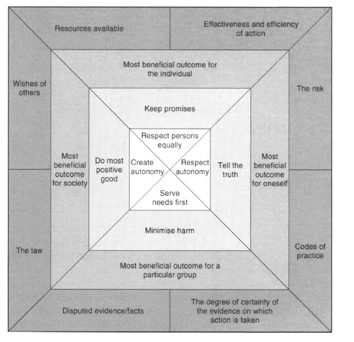  Fig7: Subdivisions of the Ethical grid  (Seedhouse, 2000)
Create autonomy: During digital transformation, businesses should enhance the autonomy of employees or teams by changing management strategies, work processes, or technology applications.
Respect autonomy: In digital transformation, respect and maintain the decision-making capabilities and rights of the internal individuals of the enterprise(employees, management, the enterprise itself).
Respect persons equally: In the decision-making, implementation, and evaluation of digital transformation strategies, It should be ensure that all employees, stakeholders, and customers are given equal consideration and respect.
Serve needs first: When planning and implementing digital transformation measures, SMEs should first identify and address the issues that are critical to business operations, employee well-being, and customer satisfaction.
In the research on digital transformation in SMEs, several ethical considerations should be emphasized. It must ensure the proper protection of sensitive data and business secrets of the companies, taking appropriate security measures to prevent data leaks or misuse. Then it should provide a clear project plan and research objectives, ensuring that participating companies understand that their involvement is voluntary and that they sign informed consent forms. Additionally, It should clearly outline how they plan to use the data provided by the companies and whether they will share data with third parties, requiring the consent of the companies and ensuring data anonymization to protect their identities. It should establish positive feedback mechanisms with participating companies to ensure that their voices are heard and that research results can provide actual value to the companies, thereby building cooperation and trust. These ethical considerations contribute to ensuring the legitimacy of digital transformation research, respecting the rights of participating companies, and fostering positive research relationships.

8 Reliability and validity
Social scientists use various tools and methods, such as surveys, experiments, or statistical data, to observe and record people's behavior, emotions, or opinions, and convert these observations into quantifiable data. This helps researchers uncover patterns of human behavior, formulate theories, and deepen the understanding of how society operates(Drost, 2011). Quantitative research considers the social world as a measurable object, emphasizing measurement and quantity. On the other hand, qualitative research, from an epistemological perspective, sees the social world as constructivist and interpretivist, focusing on understanding and meaning(Bapir, M.A., 2012).In quantitative research, the focus is primarily on what is being measured and how it is analyzed(“construct validity”). In contrast, qualitative research emphasizes understanding issues from the participants' perspective. (Bryman et al., 2019)

8.1 Reliability
Reliability is ensuring the stability and consistency of measurement results(Drost, 2011). It indicates whether the same results of the study can be consistently replicated multiple times. The trustworthy research method and tool can lead to consistent results.(Bryman et al., 2019). Internal reliability focuses on the consistency among multiple observers, while external reliability addresses the extent to which a study can be replicated(Fitzner, 2007).
There are several ways to enhance the reliability and consistency of the research processes and findings in the digital transformation of SMEs. For example, using consistent data collection procedures and questions across all manufacturing SME cases. Ensuring uniform frameworks/codebooks for systematically analyzing data. Cross-checking data interpretations between researchers to minimize subjective bias. Thoroughly documenting all research procedures to enable transparency and reliability.

8.2 Validity
Validity refers to whether the conclusions are true and accurate. It focuses on whether the researcher's findings truly represent their study. (Bryman et al., 2019).To ensure validity in qualitative research, researchers typically use various methods and techniques to help validate their research results. These may include techniques such as member checking, peer review, and triangulation. Triangulation involves using different data sources, research methods, researchers, or theoretical perspectives to study the same issue(Golafshani, 2015). Various methods can be used to improve validity of research. For example, Member checking - sharing interview transcripts and preliminary findings with participants to check for accuracy. Data source triangulation - collecting data from interviews, documents, reports etc. to enable corroboration Peer examination - leveraging input from experts familiar with the research domainProviding rich, detailed descriptions of cases to support the validity of findings.

9 Research Plan
This research will go through several steps. Firstly, The existing maturity assessment of small and medium-sized manufacturing enterprises (SMEs) will be investigated. Different stages of digital transformation require different strategies. Secondly, the technological applications of enterprises that have undergone digital transformation will be examined. digital transformation methods will be compared. These methods include machine learning, cloud computing, big data analytics, and third-party digital platform applications. Thirdly, The impact of different digital transformations on business performance, innovation capability, and organizational flexibility will be analyzed. Finally, The influence of different technological applications on the supply chain resilience of enterprises will be empirically analyzed using Structural Equation Modeling (SEM) and fuzzy-set Qualitative Comparative Analysis (fsQCA) methods.

10 Conclusion

10.1 Contributions
Through the field study, the research of "Digital Transformation in China's Small and Medium-Sized Manufacturing Industries" provides empirical data on the specific applications and challenges of digital transformation in the manufacturing industries. The theoretical model of digital transformation will be examined based on a practical case study. It provides the creative theory of digital transformation in practice. Besides, considering the uniqueness of Chinese enterprise culture and the special market environment, the study will provide new theoretical prospects for understanding the gaps in the digital transformation of small and medium-sized manufacturing industries of different regions in China. It is worth mentioning that this study offers guidance and suggestions for decision-making in the process of digital transformation of SMEs in China's manufacturing industry. In addition, the study also gives valuable suggestions and guidelines for the practical implementation of digital transformation in China's SMEs in the manufacturing industry.

10.2 Limitations
Because the sample size of qualitative is usually comparatively small, the research results are insufficient to represent the current situation of the entire digital transformation of SMEs. The research study may be over-focus on a specific region or the enterprise’s cultural background of a specific region, therefore, it may be not adaptable to other regions or the other enterprise’s cultural background.
Qualitative data analysis (such as interview records) can be complicated to explain and also difficult to quantify, it perhaps will influence the objectivity and accuracy of the research result. The long-term effect of digital transformation may be difficult to predict and evaluate.

11 Reference
Annosi, M.C. et al. (2021) ‘Digitalization within food supply chains to prevent food waste. Drivers, barriers and collaboration practices’, Industrial Marketing Management, 93, pp. 208–220. Available at: https://doi.org/10.1016/j.indmarman.2021.01.005.
Ardolino, M. et al. (2018) ‘The role of digital technologies for the service transformation of industrial companies’, International Journal of Production Research, 56(6), pp. 2116–2132. Available at: https://doi.org/10.1080/00207543.2017.1324224.
Baabdullah, A.M. et al. (2021) ‘SMEs and artificial intelligence (AI): Antecedents and consequences of AI-based B2B practices’, Industrial Marketing Management, 98, pp. 255–270. Available at: https://doi.org/10.1016/j.indmarman.2021.09.003.
Benzidia, S., Makaoui, N. and Bentahar, O. (2021) ‘The impact of big data analytics and artificial intelligence on green supply chain process integration and hospital environmental performance’, Technological Forecasting and Social Change, 165, p. 120557. Available at: https://doi.org/10.1016/j.techfore.2020.120557.
Bickauske, D. et al. (2020) ‘Analysis and perspectives of the level of enterprises digitalization (Lithuanian manufacturing sector case)’, Independent Journal of Management & Production, 11(9), pp. 2291–2307. Available at: https://doi.org/10.14807/ijmp.v11i9.1404.
Birkel, H. and Wehrle, M. (2022) ‘Small- and Medium-Sized Companies Tackling the Digital Transformation of Supply Chain Processes: Insights From a Multiple Case Study in the German Manufacturing Industry’, IEEE Transactions on Engineering Management, pp. 1–16. Available at: https://doi.org/10.1109/TEM.2022.3209131.
Bouwman, H., Nikou, S. and De Reuver, M. (2019) ‘Digitalization, business models, and SMEs: How do business model innovation practices improve performance of digitalizing SMEs?’, Telecommunications Policy, 43(9), p. 101828. Available at: https://doi.org/10.1016/j.telpol.2019.101828.
Busulwa, R., Pickering, M. and Mao, I. (2022) ‘Digital transformation and hospitality management competencies: Toward an integrative framework’, International Journal of Hospitality Management, 102, p. 103132. Available at: https://doi.org/10.1016/j.ijhm.2021.103132.
Canhoto, A.I. et al. (2021) ‘Digital strategy aligning in SMEs: A dynamic capabilities perspective’, The Journal of Strategic Information Systems, 30(3), p. 101682. Available at: https://doi.org/10.1016/j.jsis.2021.101682.
Cenamor, J., Parida, V. and Wincent, J. (2019) ‘How entrepreneurial SMEs compete through digital platforms: The roles of digital platform capability, network capability and ambidexterity’, Journal of Business Research, 100, pp. 196–206. Available at: https://doi.org/10.1016/j.jbusres.2019.03.035.
Chatterjee, S. et al. (2021) ‘Understanding AI adoption in manufacturing and production firms using an integrated TAM-TOE model’, Technological Forecasting and Social Change, 170, p. 120880. Available at: https://doi.org/10.1016/j.techfore.2021.120880.
Chatterjee, S. and Kumar Kar, A. (2020) ‘Why do small and medium enterprises use social media marketing and what is the impact: Empirical insights from India’, International Journal of Information Management, 53, p. 102103. Available at: https://doi.org/10.1016/j.ijinfomgt.2020.102103.
Chen, M. et al. (2023) ‘Net and configurational effects of determinants on cloud computing adoption by SMEs under cloud promotion policy using PLS-SEM and fsQCA’, Journal of Innovation & Knowledge, 8(3), p. 100388. Available at: https://doi.org/10.1016/j.jik.2023.100388.
Chowdhury, S. et al. (2022) ‘AI-employee collaboration and business performance: Integrating knowledge-based view, socio-technical systems and organisational socialisation framework’, Journal of Business Research, 144, pp. 31–49. Available at: https://doi.org/10.1016/j.jbusres.2022.01.069.
Costa, E., Soares, A.L. and De Sousa, J.P. (2020) ‘Industrial business associations improving the internationalisation of SMEs with digital platforms: A design science research approach’, International Journal of Information Management, 53, p. 102070. Available at: https://doi.org/10.1016/j.ijinfomgt.2020.102070.
Creswell, J.W. and Creswell, J.W. (2013) Qualitative inquiry and research design: choosing among five approaches. 3rd ed. Los Angeles: SAGE Publications.
Cuesta-Valiño, P. et al. (2023) ‘Strategic orientation towards digitization to improve supermarket loyalty in an omnichannel context’, Journal of Business Research, 156, p. 113475. Available at: https://doi.org/10.1016/j.jbusres.2022.113475.
Denicolai, S., Zucchella, A. and Magnani, G. (2021) ‘Internationalization, digitalization, and sustainability: Are SMEs ready? A survey on synergies and substituting effects among growth paths’, Technological Forecasting and Social Change, 166, p. 120650. Available at: https://doi.org/10.1016/j.techfore.2021.120650.
Di Vaio, A. et al. (2020) ‘Artificial intelligence and business models in the sustainable development goals perspective: A systematic literature review’, Journal of Business Research, 121, pp. 283–314. Available at: https://doi.org/10.1016/j.jbusres.2020.08.019.
Eling, M. and Lehmann, M. (2018) ‘The Impact of Digitalization on the Insurance Value Chain and the Insurability of Risks’, The Geneva Papers on Risk and Insurance - Issues and Practice, 43(3), pp. 359–396. Available at: https://doi.org/10.1057/s41288-017-0073-0.
Eller, R. et al. (2020) ‘Antecedents, consequences, and challenges of small and medium-sized enterprise digitalization’, Journal of Business Research, 112, pp. 119–127. Available at: https://doi.org/10.1016/j.jbusres.2020.03.004.
Fosso Wamba, S. (2022) ‘Impact of artificial intelligence assimilation on firm performance: The mediating effects of organizational agility and customer agility’, International Journal of Information Management, 67, p. 102544. Available at: https://doi.org/10.1016/j.ijinfomgt.2022.102544.
Gao, J. et al. (2023) ‘Influence of digital transformation on the servitization level of manufacturing SMEs from static and dynamic perspectives’, International Journal of Information Management, 73, p. 102645. Available at: https://doi.org/10.1016/j.ijinfomgt.2023.102645.
Given, L.M. (ed.) (2008) The Sage encyclopedia of qualitative research methods. Los Angeles, Calif: Sage Publications.
Gong, C. and Ribiere, V. (2021) ‘Developing a unified definition of digital transformation’, Technovation, 102, p. 102217. Available at: https://doi.org/10.1016/j.technovation.2020.102217.
Guan, W. et al. (2023) ‘Do supply chain related factors enhance the prediction accuracy of blockchain adoption? A machine learning approach’, Technological Forecasting and Social Change, 192, p. 122552. Available at: https://doi.org/10.1016/j.techfore.2023.122552.
Hosseini, S. et al. (2019) ‘Cloud computing utilization and mitigation of informational and marketing barriers of the SMEs from the emerging markets: Evidence from Iran and Turkey’, International Journal of Information Management, 46, pp. 54–69. Available at: https://doi.org/10.1016/j.ijinfomgt.2018.11.011.
Jachimczyk, B. et al. (2021) ‘IoT-based Dairy Supply Chain - An Ontological Approach’, Elektronika ir Elektrotechnika, 27(1), pp. 71–83. Available at: https://doi.org/10.5755/j02.eie.27612.
Jia, Y. et al. (2023) ‘Platform business model innovation in the digitalization era: A “driver-process-result” perspective’, Journal of Business Research, 160, p. 113818. Available at: https://doi.org/10.1016/j.jbusres.2023.113818.
Kaiser, C. et al. (2021) ‘Conceptualising value creation in data-driven services: The case of vehicle data’, International Journal of Information Management, 59, p. 102335. Available at: https://doi.org/10.1016/j.ijinfomgt.2021.102335.
Kapoor, K. et al. (2021) ‘A socio-technical view of platform ecosystems: Systematic review and research agenda’, Journal of Business Research, 128, pp. 94–108. Available at: https://doi.org/10.1016/j.jbusres.2021.01.060.
Kaymakci, C. et al. (2022) ‘A Systematic Selection Process of Machine Learning Cloud Services for Manufacturing SMEs’, Computers, 11(1), p. 14. Available at: https://doi.org/10.3390/computers11010014.
Khurana, I., Dutta, D.K. and Singh Ghura, A. (2022) ‘SMEs and digital transformation during a crisis: The emergence of resilience as a second-order dynamic capability in an entrepreneurial ecosystem’, Journal of Business Research, 150, pp. 623–641. Available at: https://doi.org/10.1016/j.jbusres.2022.06.048.
Kuhn, T.S. and Hacking, I. (2012) The structure of scientific revolutions. Fourth edition. Chicago ; London: The University of Chicago Press.
Lutfi, A. et al. (2022) ‘Factors Influencing the Adoption of Big Data Analytics in the Digital Transformation Era: Case Study of Jordanian SMEs’, Sustainability, 14(3), p. 1802. Available at: https://doi.org/10.3390/su14031802.
Martín-Rojas, R., Garrido-Moreno, A. and García-Morales, V.J. (2020) ‘Fostering Corporate Entrepreneurship with the use of social media tools’, Journal of Business Research, 112, pp. 396–412. Available at: https://doi.org/10.1016/j.jbusres.2019.11.072.
Matarazzo, M. et al. (2021) ‘Digital transformation and customer value creation in Made in Italy SMEs: A dynamic capabilities perspective’, Journal of Business Research, 123, pp. 642–656. Available at: https://doi.org/10.1016/j.jbusres.2020.10.033.
Mergel, I., Edelmann, N. and Haug, N. (2019) ‘Defining digital transformation: Results from expert interviews’, Government Information Quarterly, 36(4), p. 101385. Available at: https://doi.org/10.1016/j.giq.2019.06.002.
Min, Q. et al. (2019) ‘Machine Learning based Digital Twin Framework for Production Optimization in Petrochemical Industry’, International Journal of Information Management, 49, pp. 502–519. Available at: https://doi.org/10.1016/j.ijinfomgt.2019.05.020.
North, K., Aramburu, N. and Lorenzo, O.J. (2019) ‘Promoting digitally enabled growth in SMEs: a framework proposal’, Journal of Enterprise Information Management, 33(1), pp. 238–262. Available at: https://doi.org/10.1108/JEIM-04-2019-0103.
Paiola, M. et al. (2022) ‘The process of business model innovation driven by IoT: Exploring the case of incumbent SMEs’, Industrial Marketing Management, 103, pp. 30–46. Available at: https://doi.org/10.1016/j.indmarman.2022.03.006.
paradigm, n. meanings, etymology and more | Oxford English Dictionary (no date). Available at: https://www.oed.com/dictionary/paradigm_n?tl=true (Accessed: 20 December 2023).
Pfeiffer, S. (2017) ‘The Vision of “Industrie 4.0” in the Making—a Case of Future Told, Tamed, and Traded’, NanoEthics, 11(1), pp. 107–121. Available at: https://doi.org/10.1007/s11569-016-0280-3.
Rekabi, S., Sazvar, Z. and Goodarzian, F. (2023) ‘A machine learning model with linear and quadratic regression for designing pharmaceutical supply chains with soft time windows and perishable products’, Decision Analytics Journal, 9, p. 100325. Available at: https://doi.org/10.1016/j.dajour.2023.100325.
Saratchandra, M., Shrestha, A. and Murray, P.A. (2022) ‘Building knowledge ambidexterity using cloud computing: Longitudinal case studies of SMEs experiences’, International Journal of Information Management, 67, p. 102551. Available at: https://doi.org/10.1016/j.ijinfomgt.2022.102551.
Skare, M., De Las Mercedes De Obesso, M. and Ribeiro-Navarrete, S. (2023) ‘Digital transformation and European small and medium enterprises (SMEs): A comparative study using digital economy and society index data’, International Journal of Information Management, 68, p. 102594. Available at: https://doi.org/10.1016/j.ijinfomgt.2022.102594.
Veile, J.W., Schmidt, M.-C. and Voigt, K.-I. (2022) ‘Toward a new era of cooperation: How industrial digital platforms transform business models in Industry 4.0’, Journal of Business Research, 143, pp. 387–405. Available at: https://doi.org/10.1016/j.jbusres.2021.11.062.
Vendrell-Herrero, F. et al. (2017) ‘Servitization, digitization and supply chain interdependency’, Industrial Marketing Management, 60, pp. 69–81. Available at: https://doi.org/10.1016/j.indmarman.2016.06.013.
Wang, Q., Hu, A. and Tian, Z. (2022) ‘Digital transformation and electricity consumption: Evidence from the Broadband China pilot policy’, Energy Economics, 115, p. 106346. Available at: https://doi.org/10.1016/j.eneco.2022.106346.
Wei, R. and Pardo, C. (2022) ‘Artificial intelligence and SMEs: How can B2B SMEs leverage AI platforms to integrate AI technologies?’, Industrial Marketing Management, 107, pp. 466–483. Available at: https://doi.org/10.1016/j.indmarman.2022.10.008.
Xie, X. et al. (2022) ‘Digital platforms and SMEs’ business model innovation: Exploring the mediating mechanisms of capability reconfiguration’, International Journal of Information Management, 65, p. 102513. Available at: https://doi.org/10.1016/j.ijinfomgt.2022.102513.
Zahoor, N. et al. (2022) ‘The role of dynamic capabilities and strategic agility of B2B high-tech small and medium-sized enterprises during COVID-19 pandemic: Exploratory case studies from Finland’, Industrial Marketing Management, 105, pp. 502–514. Available at: https://doi.org/10.1016/j.indmarman.2022.07.006.
Zeuge, A. et al. (2023) ‘Crisis-driven digital transformation as a trigger for process virtualization: Fulfilling knowledge work process requirements for remote work’, International Journal of Information Management, 70, p. 102636. Available at: https://doi.org/10.1016/j.ijinfomgt.2023.102636.
Zhang, L. et al. (2021) ‘Value co-creation and appropriation of platform-based alliances in cooperative advertising’, Industrial Marketing Management, 96, pp. 213–225. Available at: https://doi.org/10.1016/j.indmarman.2021.06.001.
Zhong, R.Y. et al. (2015) ‘A big data approach for logistics trajectory discovery from RFID-enabled production data’, International Journal of Production Economics, 165, pp. 260–272. Available at: https://doi.org/10.1016/j.ijpe.2015.02.014.

