
Skills for the Workplace
Module Assignment Submission
Student Name: | Louise Puresevic
Student Number: | 2005324
Module No: | BMSK4001
Module Title: | Academic and Employability Skills

Statement of Confirmation of Authenticity
By the act of making this submission, the student declares that this is the work of the student named above. The work has not, in whole or in part, been knowingly presented elsewhere for assessment, or where assessment has been built on a previous assessment, this has been identified. Where materials have been used from other sources it has been properly acknowledged. If this statement is untrue, the student acknowledges that an assessment offence has been committed.
Attention is drawn to the plagiarism and unfair practice policies of both the University and of ILM.

Table of Contents

Introduction 3
Part 1 Employability 3
1.0 Explore ‘Leadership Employability Skills’ in general 3
1.2 Evaluate own Leadership Employability skills 6
1.2.1 Current Employability skills 7
1.2.2 Action Plan for Improvement 9
Part 2: Academic Skills 11
2.0 Reflection on Academic Skills required for University Level Study 12
2.1 Evaluate own Academic Skills 12
2.1.1 Current Academic Skills 13
Gap Analysis to identify ‘gaps’ in knowledge/skills 20
2.1.2 Action Plan for Improvement 21
Conclusion 22
References 23
Appendix 25

Introduction

BMSK4001 – For this assignment, I will focus on both Academic and Employability Skills. I will study how people utilise their skills and how they can gain new knowledge for career progression. I will be looking at employability skills, analysing what employers look for, and how employees utilise relevant skills and learn new ones. Are skills transferrable from one role to another? If so, what skills are transferrable, and how would one determine the interchangeability and transfer between skills within certain tasks and delegations.
Therefore, through this assignment, I will be analysing research methods and skills - both social and digital – and determining the functionalities of both throughout the world of employability. Further methods I will assess further will be the KEYS test, Skills Audit and SWOT Analysis. Moreover, I will be researching current management roles and positions, and analysing their descriptions and comparing and applying my own skills I have chosen against the positions I choose, thus enabling me to more thoroughly compare by using Gap Analysis. With these Gaps established, I can determine and produce a Personal Development Plan (PDP), outlining goals through the means of SMART objectives. Where necessary or relevant, I will be utilising charts, graphs and tables to outline my findings.

Part 1 Employability

1.0 Explore ‘Leadership Employability Skills’ in general

As an individual looking to enter a new workplace, the work skills that could be implemented are vital to getting that job. They can be the most basic of skills, to the skills gained along the way, in a previous workplace for example. This knowledge can be offered and utilised to the benefit of all those involved.
For employers, it is a similar process. A good manager looks for not only the basic skills, in how a recruit can present themselves, but how they can bring a new quality and dimension to the workplace. Skills such as communication, IT, team working and problem solving, all have a huge part to play in any job interview.
Becoming an asset to an employer demands many skills. Cottrell (2015) determined that creating a formatted list of skills and experiences as being a profound idea, as this would allow an employer to immediately see and assess what you believe to be your focal skills to be, and from there, they have a basis to build off when assessing both your credibility and your suitability towards the role in question. Often, experiences are nearly forgotten by people, or merely shadowed by the skill which they have attained – addressing what the achievement was and what experience gave them the skill they can use now, can highlight or surface any other skills that though one may deem irrelevant, the employer may find favour towards – this can therefore easily be a mistake as it can result in perfectly valid and nonetheless valuable skills being transferrable, if not directly relevant. Cottrell (2015) analyses personalities; before coming to any concrete conclusion, there is the acknowledgement of a manner of contributing factors which have either lead or could further lead towards personal successes and developments, what or who could influence a person’s behaviour? A question, for which, there is an array of possibilities – one possible basis being culture, beliefs and values. One culture, for example, may uphold certain withdrawals from others, which may align in such a way that there may be self-conflict in the wake of being situated in an environment where these requirements are not properly adapted to, nonetheless respected. The values and beliefs of others are ultimately the basis of their personality – the way you address something, be it a person or a task, will be down to the values and traits one upholds. Often, faiths and religions are instilled in people from a young age, typically by their communities and families – it is ultimately a part of what has made them the person they are. Therefore, these traits should be accepted and respected, and it would certainly be advantageous if they were adhered to and utilised in a positive manner.
This coincides, then, with something else Cottrell (2015) addresses – personal choice. For as long as humanity has been around, the prospect of personal choice has always been the route for which one would approach a situation – there is always an opportunity cost to something; one simple action could carry with it an unlimited amount of possibilities to occur hereafter one’s next move, thus personal choice is the basis for which someone chooses what direction to follow.
Trought 2017, suggests that being able to address yourself, is the first step towards your career development. You must know yourself. From how you work around others, what do you like/dislike about yourself or your role. It is also a good idea to determine where you are best placed in the workplace. Do you like being in an office environment, or do you prefer to be around customers or the general public? Would you cope under stress, either environmentally or workload? What are your strengths and weaknesses?
An excellent way to plan your strengths and weakness for a suitable role, is to conduct a simple test, a SWOT Analysis. It is a brilliant way to simply focus at a glance, what you know are strong “positive” aspects and what are the weaker points, which become a focus on things that could then be improved on. It is so easy to compile a CV or complete an application form, but it isn’t until a SWOT Analysis is completed, do you realise just how much you do and don’t know.
Various other methods to evaluate situations are available to use. However, the SWOT Analysis is by far one of the best methods. I have carried out a SWOT Analysis on myself, and I have set this out below, as follows:

And what will make you stand out from the crowd when you go for that job? According to Trought (2017), conducting a self-analysis of yourself, gives you an indication of how you can sell yourself to a potential employer. Look at your skills, your personality, your vision, against your colleagues for example. Draw up a visual assessment on how you compare to those around you. What do you have that they don’t? What do they have that you don’t?
Companies continuously strive to seek ways in which to meet their employees needs regarding a few aspects. Not only their work/life balance, but also their workplace learning. Basic skills are offered today as a routine; however, extended learning can be offered to those who require it. It can also be offered to those looking to move into a new post. Technology is rapidly changing daily, and it is vital for companies/organisations to keep up (Gravells) 2010.

1.2 Evaluate own Leadership Employability skills

It is so important to take each day as a new opportunity. A new opportunity to learn. To research, gain new knowledge, to seek inspiration and to inspire others.
David Benton, Nursing Standard (through 2013) explains networking, it’s concept, and how you can successfully carry this out. Networking offers benefits, such as new opportunities through referrals, obtaining information that is specific to the job role and further afield. Feedback can be generated, both encouraging and critical. Using a networking process will allow you to identify your role and will enable you to progress with positivity knowing that you are maintaining a suitable balance in your workplace.
To use networking in my workplace would mean that I would use my colleagues to offer feedback in other departments within the hospital, perhaps being able to advise of any potential job roles that may become available. I would also have to be realistic with my knowledge, and how I could utilise current skills, and how new skills would have to be obtained in order to be able to apply for those roles.
Leadership effectiveness can be an important factor in the workplace. Whoever is leading the organisation can provide the foundation for the whole establishment, and its workforce, as suggests Luria, Gil ; Kahana, Allon ; Goldenberg, Judith ; Noam, Yair (2019). Making that critical decision to source a great leader can determine many results and how the effectiveness of the team or workforce can continue over the years.

1.2.1 Current Employability skills

My role in my workplace is one of a Patient Pathway Coordinator. I work in Trauma & Orthopaedics, and therefore I work with many areas of my hospital, and several various staff members.
It is mostly a role dealing with a list of patients awaiting Orthopaedic surgeries of various kinds, and this can be challenging on times. There can be an element of frustration at times, so it is vital to have that there is a continuity of friendship and trust between myself and my teams. They are my friends and my colleagues, and thus, we must work continuously to ensure we offer the best care and attention to patients, visitors, and to one another.
For this assignment, I have identified a job role of interest, were I to have the relevant qualifications. I have researched various job roles currently available on the NHS website. The role is a Band 5 post, one band higher than my current role. The role is that of an Education & Training Resource Coordinator, working for the Welsh Ambulance Service NHS Trust. It holds a salary of £24,214 to £30,112 per annum.
Following the SWOT analysis, I have identified specific skills. Skills that I currently hold, skills that are required for the role, and action that is required in order to consider this to be both a suitable and manageable role for me.
My current role is a relatively new role, and therefore at present it would not be the ideal position for me to go straight into. However, with the continuation of experience in my current role, and taking my role further, I could keep developing new skills and trying to be able to take leadership whenever possible. Along with any staff training that is offered to me and also the continued progression of this course, I would hopefully be able to seek to be a suitable candidate for such a role.
Based on this information, I have put together a Gap Analysis. I realise that as I do not currently hold all of the skills required for the Ambulance Trust role, however with a Gap Analysis laid out on paper, I can see at a glance how and where I would need to improve my skills.
The skills required for the role and those that are going to be essential for the role, will be considered and worked on. They have been identified as skills that are vital before going forward to making any decision into applying for such a post. The diagram is set out below:
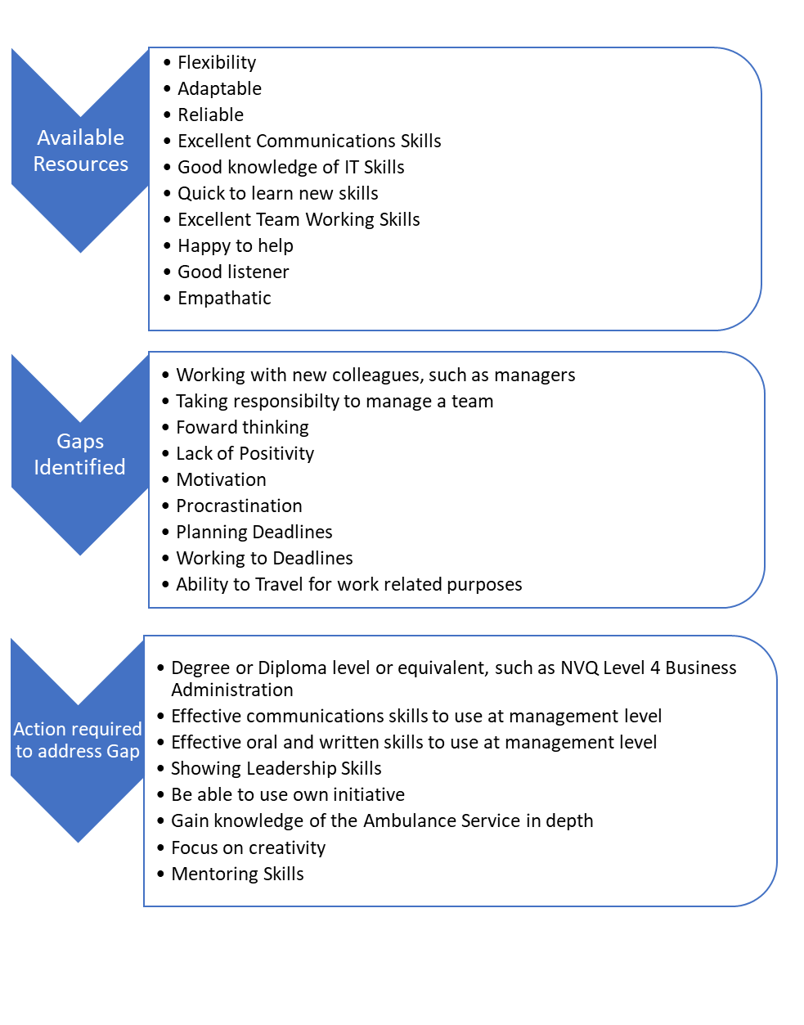

1.2.2 Action Plan for Improvement

Taking into account the Gap Analysis, using my present skills and how I would need to improve on these, I have addressed and processed the information for further review.
Using the information based on my current skills and taking my knowledge forward, I would be able to look at this job role again in a few years’ time, knowing that I would be confident to undertake such a role.
I have demonstrated my current situation in a table below and also a Pie Chart, shown on the next page. I have also demonstrated how these skills may be improved upon, in order to consider this role at a later stage.

Objectives | Tasks | Success Criteria | Time Frame | Resources
List your Goals | What do you need to do to achieve these goals? | How will you identify your success? | When do they need to be done by? | Who or what do you need to help you?
Supervisory role | Qualifications  (Degree level) | Assigning to various courses | 1-2 years | My team & managers
Management level role | Experience | Expanding on everyday knowledge in the workplace | 3 years | Family
 | Networking |  |  | Friends

Pie Chart to show Gap Analysis – Current Situation
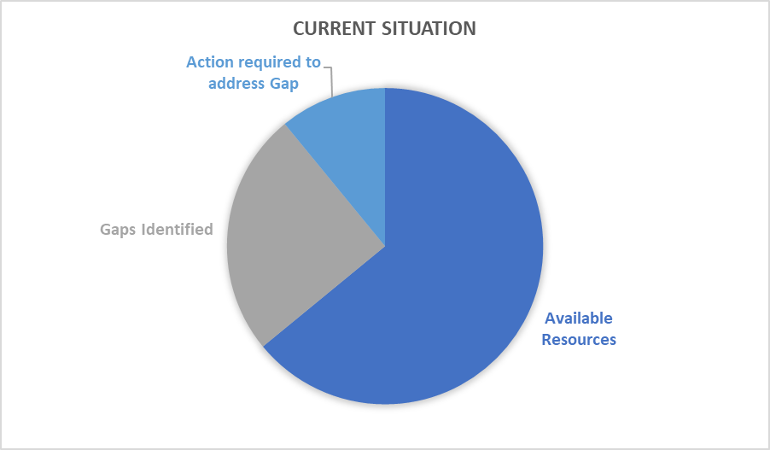

Pie Chart to show Gap Analysis – Three years’ time, with degree gained
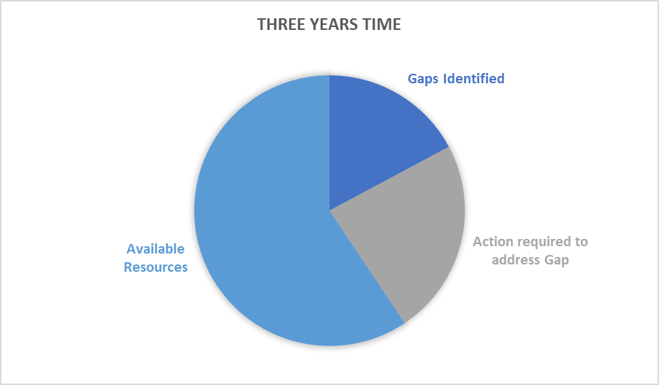

Part 2: Academic Skills

2.0 Reflection on Academic Skills required for University Level Study

2.1 Evaluate own Academic Skills

An example of how one would look at skills in the workplace, perhaps problem solving, has been detailed below. From the book Historical Reflections at the Intersection of past and future: Celebrating 50 years of Management learning, Cunliffe suggests the following:
While reflection implies looking back to solve problems and correct errors, reflexivity is about situating oneself and one’s research as an outcome of past decisions and opportunities with consequences for the future (Cunliffe, 2016b). The value of reflexivity lies in its capacity to foster thinking critically about the role and impact of values, beliefs and actions on our resultant research. Reflexivity is intrinsic to management learning per se, since it is only by reflecting on past actions that we can recalibrate and retune actions and behaviour in the future.
At the basis of reflexivity is an awareness that all knowledge is socially constructed, relational and situated (Cunliffe, 2016a). While relationality implies that our knowledge of the social world is mediated through our interactions with others, our past and how we imagine our futures, situated knowledge implies that it is always produced in and influenced by a specific geographic location and time with resultant implications for the type of knowledge (ideology, ontology and epistemology) produced (Cunliffe, 2003).
I believe being totally open-minded regarding job roles. Training and development affect us greatly as a workforce. Annual work appraisals in a one-to-one meeting with line managers, look at the performance of the employee. Targets can be discussed; have they been met, and also new targets can be set out for the following year. It is also a time to discuss issues, and a time to offer praise whenever it is deserved. This way, your relationship with your manager and your colleagues can be addressed. It opens the door to share best practice between you and them. It can make you feel valued as an employee, and it will show your manager that they wish to continue to invest in your future, meaning staff are less likely to leave, and help to grow a more experienced work force.
I also believe that a work life balance is becoming more important within every job role. There is a great understanding of mental health these days, along with the need for employee wellbeing. Employees need to feel valued in the workplace, and thus need to take the opportunity to relax when not in work. The need to be refreshed when returning to work from a holiday for example, encourages motivation and productivity.
For the business owner, this would result in fewer staff sicknesses and a lower staff turnover. And of course, from a networking point of view, this would make people want to work there and improves the talent pool of the people applying for the roles.

2.1.1 Current Academic Skills

Here, I have provided information from my current Curriculum Vitae information as detailed on my NHS web page. It provides my current Academic skills, my personality, and what am looking to achieve in a role.
I am an efficient and hard-working individual, with extensive administrative experience gained from private and health sectors, specialising in reception/front office operations.
An enthusiastic and committed team player with a high capability of working across projects and with excellent customer facing and people skills. Flexible, self-motivated and conscientious, with a strong ability to work under pressure and to deadline whilst maintaining attention to detail.
During my time with the NHS, I have gained a vast amount of knowledge of systems, procedures and policies, including work-related courses including Manual Handling, Fire Safety, Violence and Aggression. I have also completed the European Computer Driving Licence (ECDL award.
In August 2019 I took the decision to take a new job role with a different health trust. This was a move that meant I was able to utilise my administrative skills and to take on board a very different role, which has already progressed to a promotion, giving me additional responsibilities and a salary increase.
From the above details, I can reflect on this using the Learning Cycle according to Kolb (Kolb, D.A) 2011.
Using the Kolb diagram, I have been able to determine my current status and how it can move forward into a future venture.

From this, I can determine the following:
Having an experience
- I will use this first assignment as my experience. I have been able to use so many of my current skills, such as written and IT. I have also used research and communication skills.
Reflecting on the experience
- In particular, I was unaware of the amount of time that is actually needed to sit and complete this assignment. Therefore, going forward into future assignments, it has become apparent that I should dedicate specific time to study. This can be difficult to weigh up, with a full-time job and also home life. But in order to succeed, you have to make this a priority.
Learning from your experiences
- Being able to put time aside to study is vital, in order to be able to study.
- I have learnt so much so far from just one assignment. Feedback from myself, and from those on my course has been positive. It can be a very rewarding result long term, and it can benefit my working and personal life.
Planning your next step/Put what you have learnt into practice
- I do need to concentrate on putting time aside to study. In particular, my research time. I did not realise just how much time was needed to put this together. I would also look to continue working on my communications skills.
- I did think that IT skills were good, however, I have come across many new computer packages and apps that I was not aware of.
Planning your work life and home life can be a major factor. Ménard, Julie ; Brunet, Luc (2011) explains that wellbeing amongst employees is a huge factor for organisations. A work/life balance is so important in bringing employers and their staff together to function effectively, and to maintain a healthy mind.
I have researched an item from the Certificate in Higher Education: Skills for the workplace student handbook by Andrew Maund; Michaela Schriek; Paul K. Tinkler (2017). In the book, I have considered the KEYS process. In this process, the steps in the table explain how you should:

K - Know yourself – Think about yourself, how do you interact with others? How do you think you come across to them? Do you have negative feedback as well as positive feedback?
E - Evaluate the professional content – Consider what is expected of you, always show professionalism. Your behaviour speaks volumes and is remembered…always!
Y - Your communication interaction with others – Be aware of your actions around others. Verbally or non-verbally, inappropriate behaviour can be seen as threatening, perhaps bullying.
S - Step back and reflect – Consider your actions, whether good or bad. Continual reflection of how you present, both in the workplace and in your personal life, and should always be considered . It doesn’t cost anything to be considerate and kind.

An article taken from the International Journal of Training & Development - The Personal Development Plan Practice Questionnaire: the development and validation of an instrument to assess the employee's perception of personal development plan practice, Authors Beausaert, Simon, Segers, Mien and Gijselaers, Wim
In this article, the authors suggest that there has been a significant surge in companies and professions worldwide, competing for business and always striving to be the best, thus wishing to employ the best.
Employers realise that by using a Personal Development Plan (PDP), a hugely popular and exceptionally effective form of employee review practice, they can continue an effective employee review.
As an example, I have detailed below my PDP from my previous employer, prior to leaving for my new role.

Gap Analysis to identify ‘gaps’ in knowledge/skills

Looking over the information that I have produced within this assignment, I have concluded that there are several skills that I currently lack within the Academic field.
I am sure that throughout the learning process of this course, and over the following years, I will gain a vast amount of knowledge, and thus will benefit immensely from my achievements. In particular, the experience of this learning will encourage me to consider moving forward in my workplace, and hopefully reach an achievable goal.
I have listed below the objectives in order to reach this goal:

Objective | Current Position | Deficiency | Action
What do I want to do? | What can I already do? | What am I lacking? | How do I fix this?
Move forward within the workplace, or within the NHS Trust | Current role consists presently of essential IT skills for my current role.  Customer/patient service skills I believe are my strong point. | Leadership skills, as this is currently not a requirement for my role. | Continuing with my role, being able to assist my colleagues wherever possible, offering my knowledge.
Gain my degree qualification | Initial assignment has a challenge, however very enjoyable. Meeting new people and learning new information. | I realise how potentially difficult this course may be, if I do not put the time and effort in. | By allowing time, effort and learning, I will be able to accomplish this. A huge achievement for me.

2.1.2 Action Plan for Improvement

Jung, Lee Ann (2007) writes that everybody should be setting a list of their goals and what they are looking to achieve. Objectives should be specific, and it should be apparent from the outset to all on the team, what is expected.
As an example of my improvement goals, I have decided to use the format of a SMART diagram. I will list Objectives, Tasks, Success Criteria, Time Frame and Resources in the form of the SMART table, as detailed:

Conclusion

This, my first assignment on this course, has been a very enjoyable one. It has been particularly challenging to take up an education task at the age of 49. However, never say never. It is something that I never contemplated to do, but I am glad I am doing it.
Breaking down the Leadership skills and the Academic skills has given me the opportunity to gain a better understanding on exactly what is required in any job role, and how it can reflect on an individual to be able to succeed in getting the best out of themselves. Having the ability to transfer skills between workplaces is also a big asset, and by carrying out processes such as SWOT analysis, Gap Analysis and PDP, it gives me the opportunity to focus on the skills I currently hold, and how I should expand on new skills in order to achieve a successful goal.
Being able to research and dissect information on this scale, has given me a much wider outlook on how I should and could reflect on my current working situation. It gives me an idea on what skills I currently hold, and what I am capable of, in order to progress and to get to my ultimate goal.
I currently hold quite a vast amount of knowledge, gained throughout the years, mostly in the NHS. There is, however, a lot to learn. This is mostly knowledge to gain on a supervisory level.
Being able to set myself a goal and to stick to it, will give me the positivity and aspirations to continue to work to the best of my ability and hopefully see the reward.
I have been able to access and utilise many research techniques mostly that are new to me in using this student website. I have realised that there is a lot of technology that was very new to me, even the most basic Microsoft 365 package had been hugely updated since my last purchase of a computer. The world is moving and evolving at a significantly fast rate, and it is so important that we are able to keep up with this.

References

Historical reflections at the intersection of past and future: Celebrating 50 years of Management Learning. 2020. Management Learning, 51(1), pp. 3-17.
BENTON, D., 1999. Networking. Nursing Standard (through 2013), 13(31), pp. 58.
COTTRELL, S., 2015. Skills for success : personal development and employability. 3rd ed. edn. Basingstoke: Basingstoke : Palgrave Macmillan.
GRAVELLS, A., 2010. Delivering employability skills in the lifelong learning sector. Exeter: Exeter : Learning Matters.
JUNG, L.A., 2007. Writing SMART Objectives and Strategies That Fit the ROUTINE. Teaching Exceptional Children, 39(4), pp. 54-59.
KOLB, D.A., 2011. The Experiential Learning Theory of Career Development. NABU Press.
LURIA, G., KAHANA, A., GOLDENBERG, J. and NOAM, Y., 2019. Leadership Development: Leadership Emergence to Leadership Effectiveness. Small Group Research, 50(5), pp. 571-592.
MAUND, A., SCHRIEK, M., TINKLER, P.K., UNIVERSITY OF WALES TRINITY, SAINT DAVID, UNIVERSITY OF WALES, L. and TRINITY COLLEGE (CARMARTHEN, W., 2017. Certificate in higher education : skills for the workplace student yearbook. London: London : Sage.
MÉNARD, J. and BRUNET, L., 2011. Authenticity and well-being in the workplace: a mediation model. Journal of Managerial Psychology, 26(4), pp. 331-346.
TROUGHT, F., 2017. Brilliant employability skills : how to stand out from the crowd in the graduate job market. Second edition. edn. Harlow, England : Pearson.

Appendix



Education & Training Resource Coordinator Job Reference: 020-AC002-0120-A
Employer: Welsh Ambulance Service NHS Trust Department: Education & Training Resource Coordinator
Location: National Ambulance Training College, Swansea
Salary: £24,214 to £30,112 per annum

Applicants are advised to apply early as we reserve the right to close a vacancy prior to the closing date if a high number of applications have been received. If you are successful and short listed for interview you will be contacted by email using the address with which you registered. Therefore, please ensure you check your email account regularly
We have an exciting opportunity for an enthusiastic and motivated individual to join the Learning & Development Team as a Resource Coordinator, at the National Ambulance Training College, Swansea.
The post holder will support the Senior Education and Training Team to ensure the effective operation of the computerised staff and training programme allocation system, including technical and administrative support, where necessary.
The post holder will engage with managers throughout the Trust to ensure effective communications at all levels. The post holder will also liaise with the relevant providers in the ongoing development of the computer based system, ensuring optimum performance is achieved at all times.
This is a permanent full-time contract, the successful candidate will be required to adopt a flexible approach to meet the business needs of the service and may be required to travel within the Trust as the need arises.

The ability to speak Welsh is desirable for this post; English and/or Welsh speakers are equally welcome to apply.
Job Type: Permanent
Working pattern: Full Time 37.5 hours per week
Pay Band: 5
Staff Group: Administrative & Clerical
Specialty/Function: Education & Training Resource Coordinator



