I began creating this main castle that could be used for animatics and block out animations in 3D.

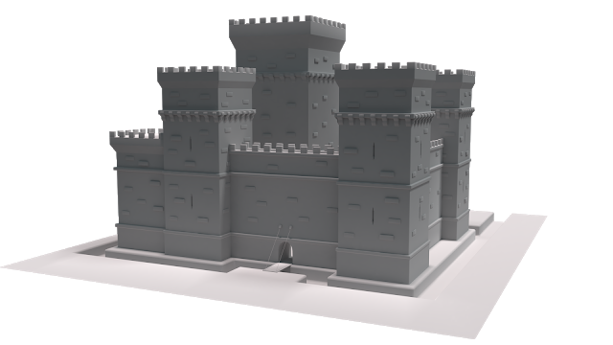
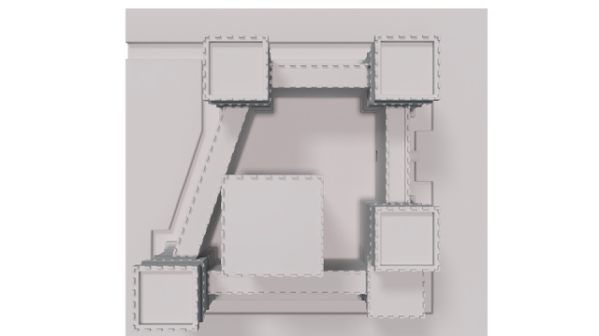
While creating this I was trying to keep in mind the amount of space I will need inside the main structure of the castle in order to have the animation how I would like it without the camera clipping inside a building or another structure.
I made this quick animation in preparation for the real animation, doing this will help me time and visualise the final animation.



The main animation is about Liam and his adventures, therefore I felt it fitting to have the the 3D work stylized as it would better portray how Liam as a child sees the world as a bright, colourful, exciting place.
The main style is very similar to fortnite with a cartoony feel and simple colours. I sculpted these bricks in Zbrush until they looked like the type of style I was going for.

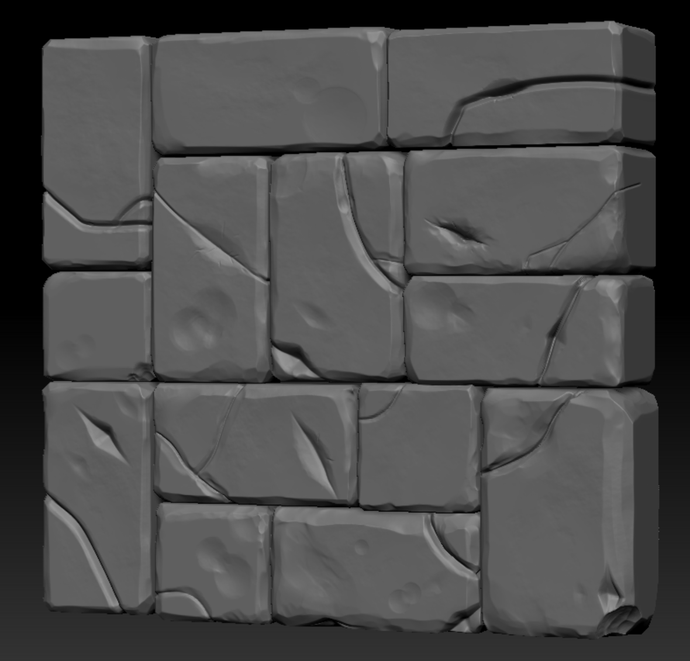

I then turned them into a seamless texture with Substance Painter and Photoshop. These will be the main bricks on “Earnside Keep”.

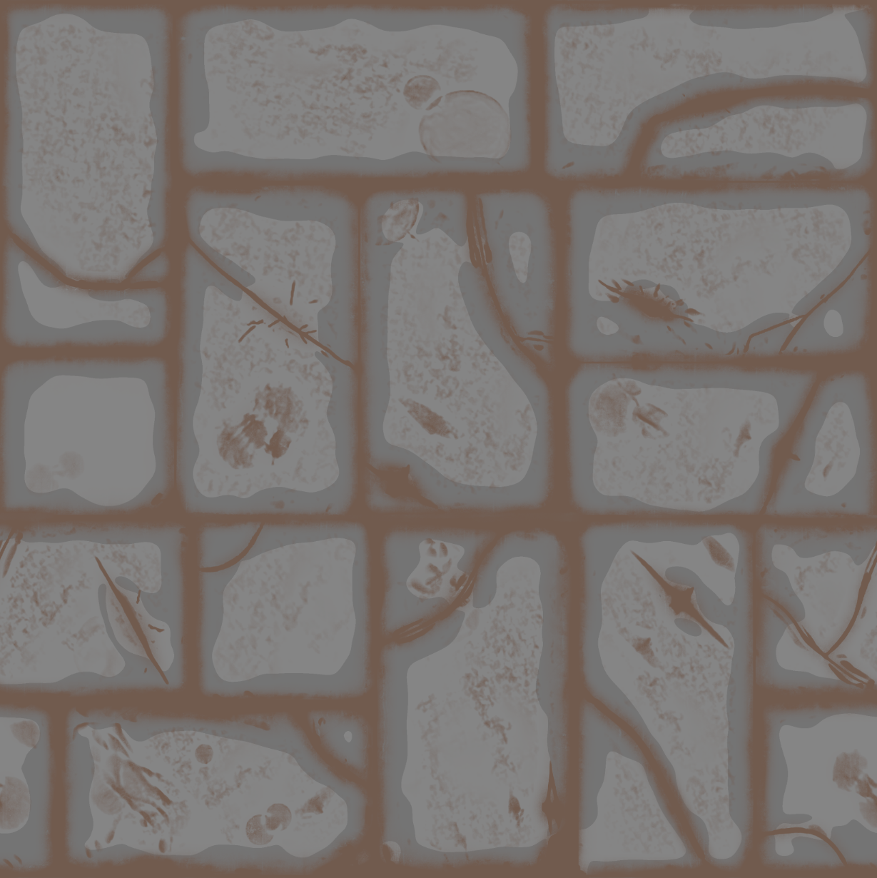

I will be using these bricks as a guide for the rest of the textures as models, so I am able to keep everything in the same style

I began using the images I had drawn before to create a 3D version of Liam Bennet, I created this using Zbrush. I had a lot of trouble getting him to look 11 years old, he either looked too old or too young, but after some work I thought I had him looking the correct age, I asked some friends to guess the age of Liam and when they said "10 or 11" I was happy with how he looked.

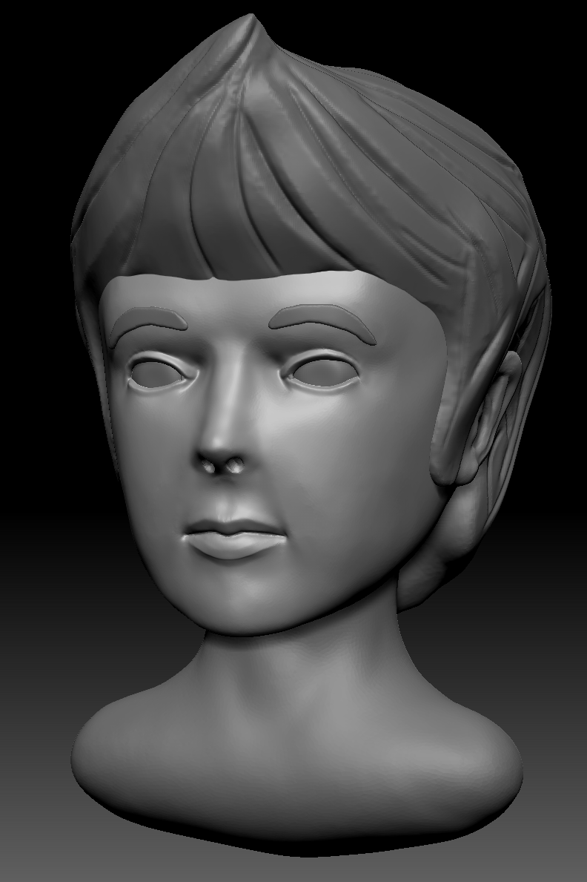

I then started working on the clothes, at this stage I changed my mind with the clothing a bit, I really liked the yellow raincoat from the younger liam design that I drew, so I decided that I would give Liam a yellow raincoat instead of a red jacket, I think that this was a good change, as it almost makes him appear more like a kid out to have some innocent fun, i'm not entirely sure why this is. I think it may be to do with the colour more than the clothing itself, red normally being a colour of anger and yellow a colour of innocence.

I first made a high poly version of the clothes with all of the creases and stitches that could be used for a normal map once the low poly has been created.

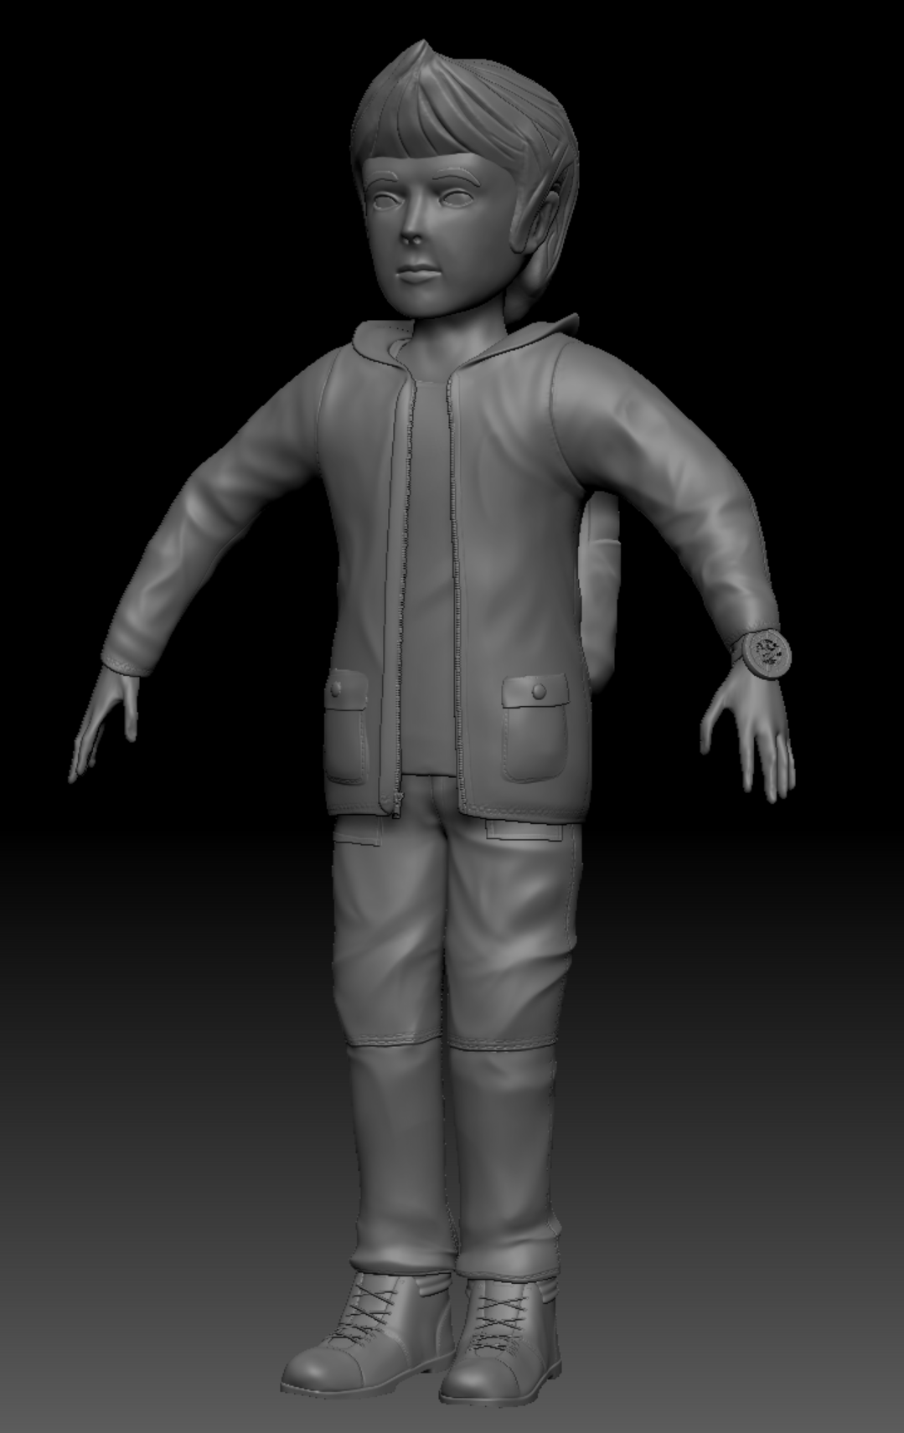

I then retopologize this mesh by hand creating a mesh with only 27791 faces.

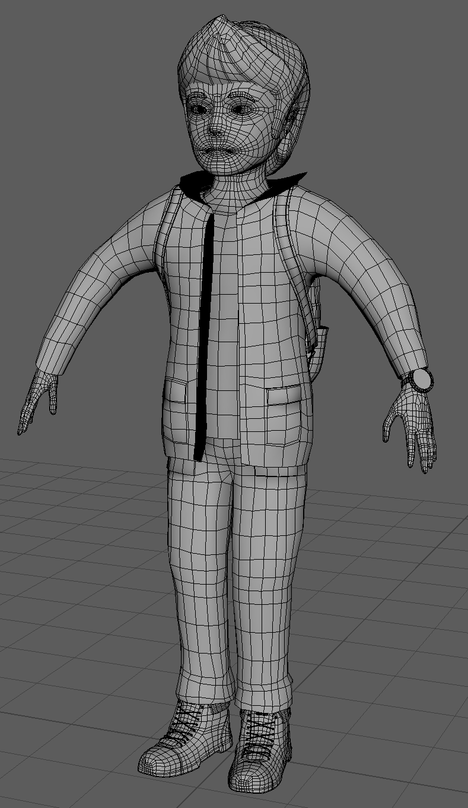

The retop came to 27791 faces, which most of that are the shoes, I know that this is way too high compared to the rest of the body, but I wanted to make sure that I could make the foot roll look good and not be able to see the faces.

This is the watch that Liam will use to travel back and forth, he will turn the watch and the front panels will open revealing the inner workings
This is just a quick animation test of what it will look like, one thing that needs I still need to do is make all of the cogs and hands move in a "stepping" manner, to better emulate how a watch actually moves

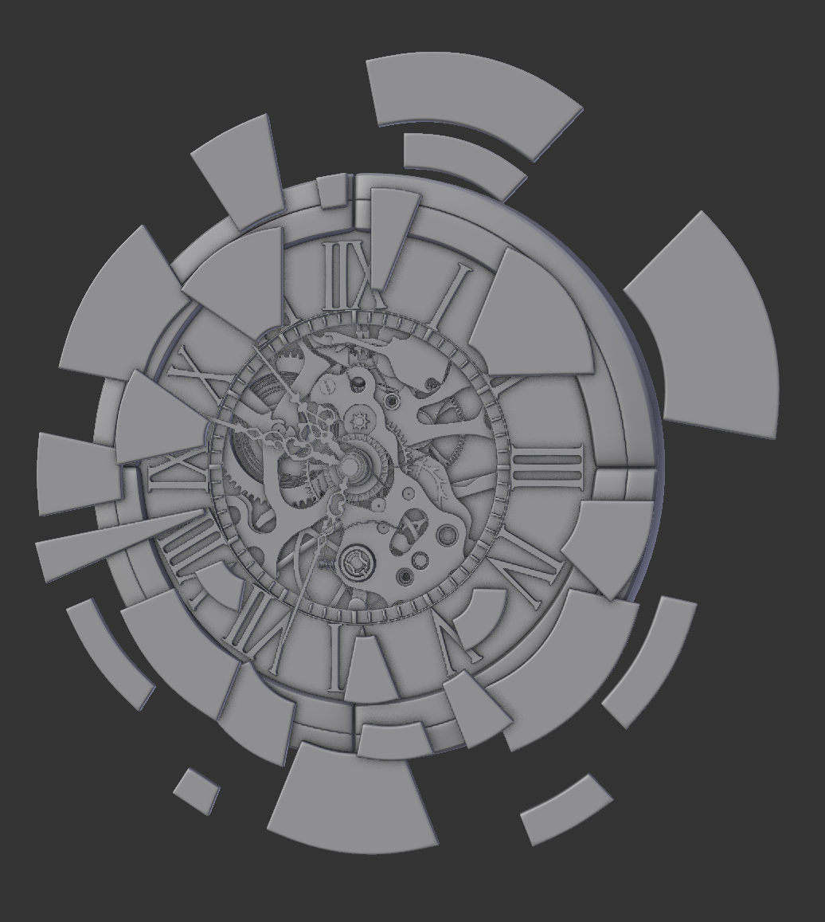

Before I could texture Liam I had to UV Unwrap him, this wasn't too long of a process and didn't really have many issues.

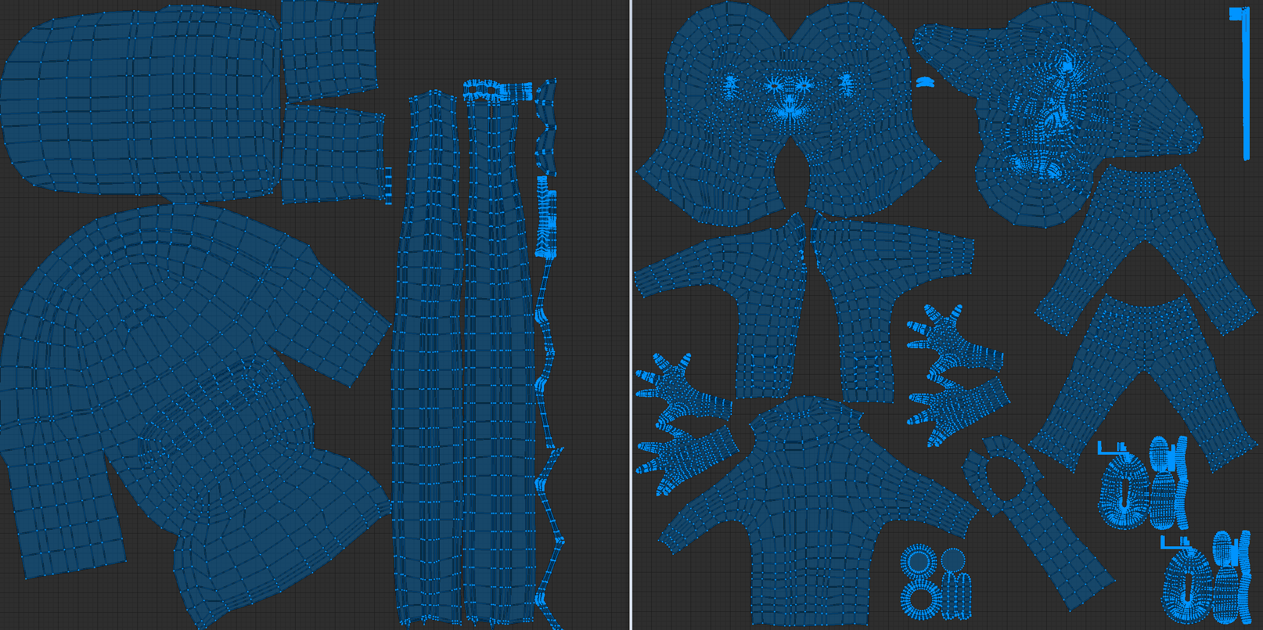

I had 3 separate UV grids/materials for Liam, I had one for the Liam himself, one for his eyes so I am able to get a lot of detail in his eyes, and one for the backpack that he wears.

I think a better idea would have been to have some Liams UV's on the backpack material, as the backpack really didn't need UV's this big and liam could have done with some more detail. This being said, I think this works well.

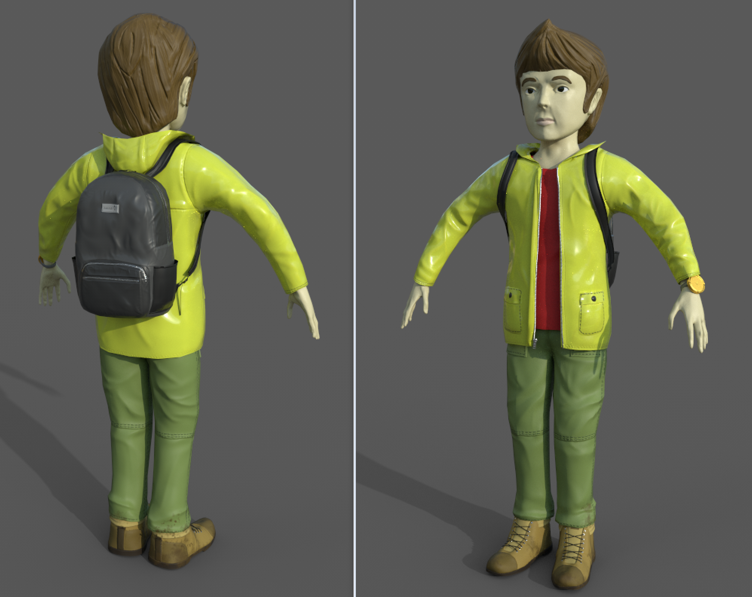

I will probably update these textures and change a few things, the eyes are very basic in this version of the textures and I want to put more detail into them in the future

This was my first time ever time properly rigging something and wanted to learn how to do it properly so I will know for the next time.
I found a lot of videos on youtube going through the process but they all seemed to cause problems and didn't explain a lot of things.

I found a "Game Character Rigging Fundamentals" course on pluralsight and this was what I used for 80% of my rigging process.

Before creating the rig I took note of everything that I would need the rig to do.
To finish my animation without any issues I would need;
- Full limb movements on IK's
- Jaw movement
- Eye movement including blinking
- Finger movements
- Some subtle hair movements
- Backpack movements

Knowing that this is what I would need I first created the joint skeleton for Liam following those needs, also making sure to name all the bones at the same time, making my scene very organised for when I come to animate in the future.

I found my problems came when adding the IK handles to the arms and legs, the bones would snap out of place and not match the mesh. After many many attempts at fixing this there was no hope, I deleted the arm and hand bones and made them again.
Doing it a second time made me realise what I had done wrong, when I was placing the elbow joint the rotation was slightly off and not matching the shoulder rotation. Keeping the rotation the same on my second attempt worked, and the bones no longer snapped out of place.

I then spent a day or two weight painting. During this process I had to remove the zip of the raincoat as the weight painting would have taken way to long and way to much of a difficult process. Later thinking about this I could have just made bones just for the zips and the nearby fabric and parent it to the spines, however I think this way works fine and I can just texture the zips onto the coat later on when I update the textures.
The weight paints will probably need to be adjusted in the future, but it will be more clear what needs to be changed once I start animating

I then used curves to make handles which are easy to grab, and began setting up the drivers. I had driven keys for blinks, finger movements and foot rolls, which I believe is everything I need.

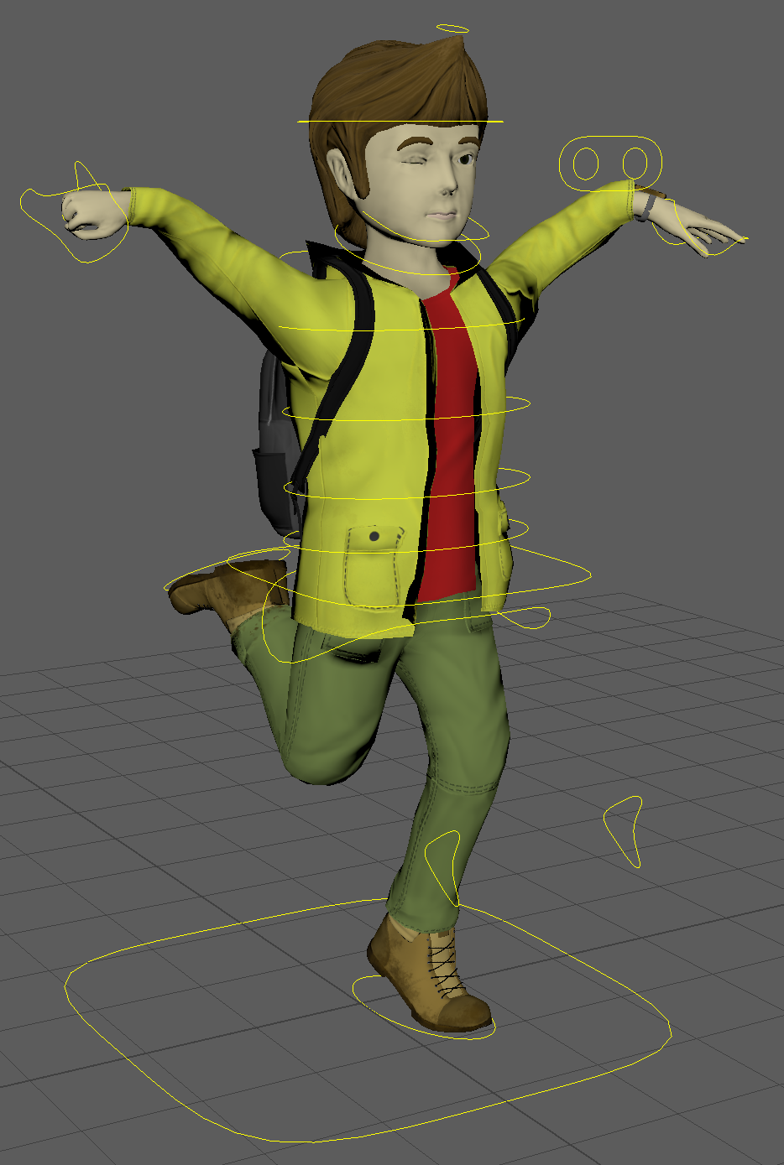

I looked into 3 other animators which all related to my animation in some way.

These 3 were:
- Alexandra Petrov
- Illuminated Films
- Isu Patel
Alexandra petrov was an animator who used planes of glass and watercolours to create his images.
I specifically asked this because everything looked organic and natural, which worked perfectly in his most famous animation "The old man and the sea" as it made the sea look very "swishy" and natural.

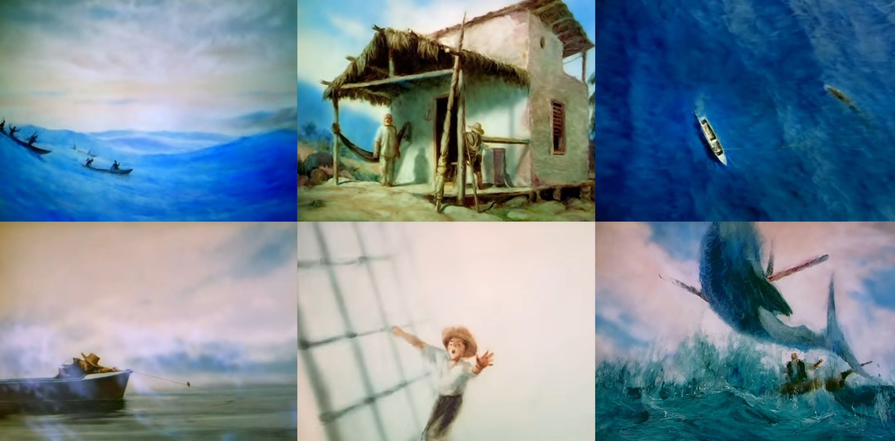

I was thinking of ways to incorporate this style into my animation, and I was thinking about the actual time travel effect and how that would be a sort of natural "swooshy" design so could take a lot of inspiration from Alexandra Petrov.

I also looked at Alexandra Petrov's "The old man by the sea" from a storytelling perspective. I was concerned with how I would achieve the story telling without any voices, but when watching this animation, I couldn't understand the language, and yet still knew what was going on. This is something that I really need to learn from and it will make my animation ten times more powerful of a story!

I also looked into Illuminated films, I found this particularly interesting to look into as their work is very stylized and childlike, this is the sort of idea I was going to implement into my animation, to show that we're looking through the eyes of a child exploring for the first time.

Although my style is very different it was still good to look into to see the differences and what they affect.

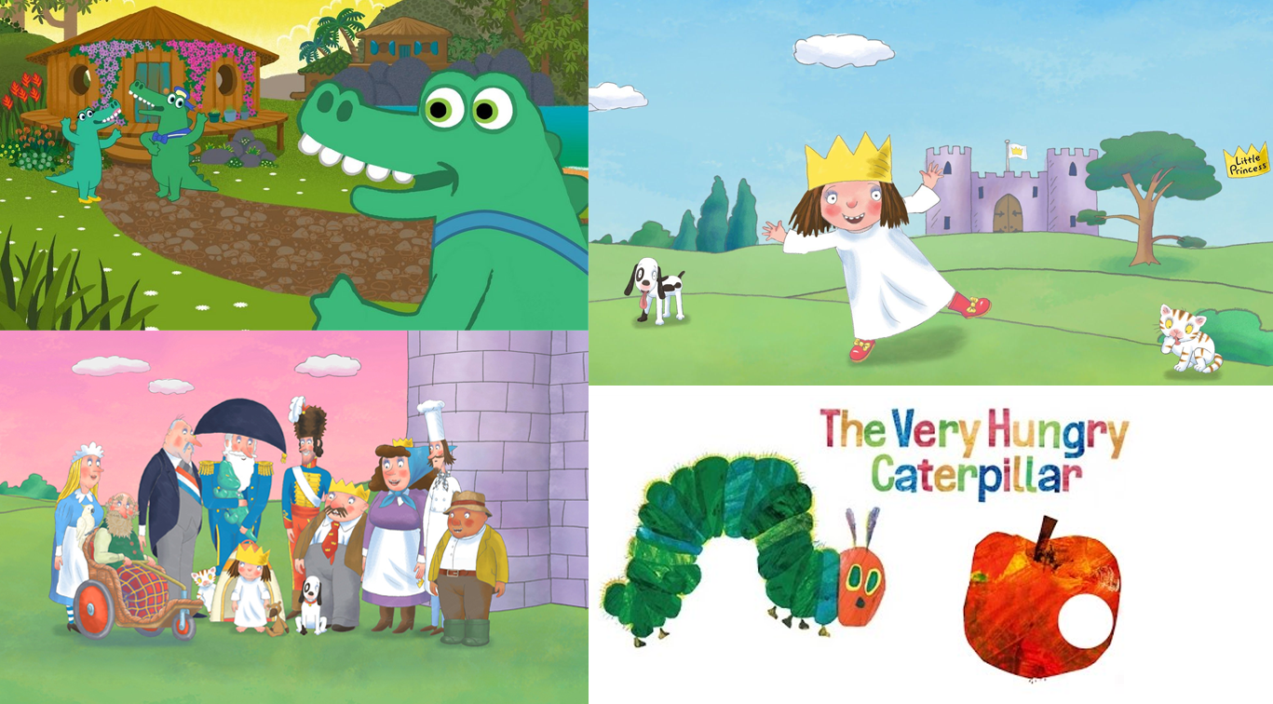

Lastly, I looked into an animator/Photographer known as "Ishu Patel"

His animations are very weird but look very interesting, he uses some geometric shapes to make very intricate and interesting patterns.
I think that the time travel part of my animation could be inspired heavily by this sort of style.

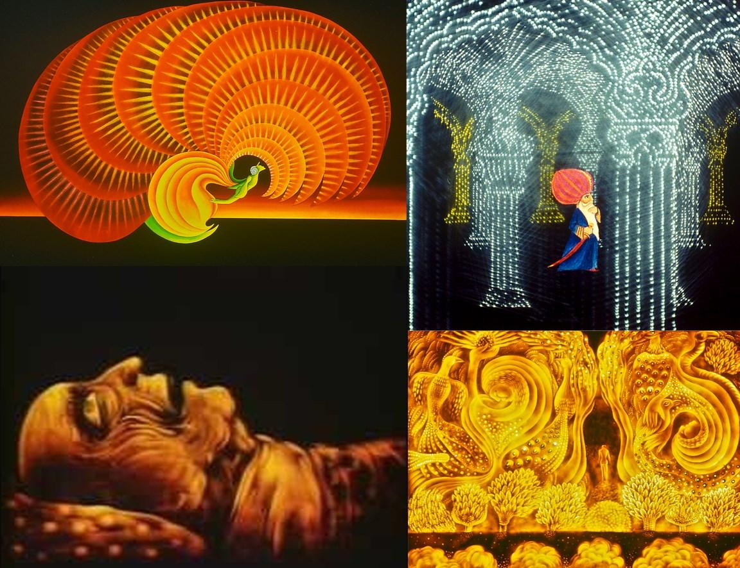

This was a quick walking animation I made to test the weight painting of my character, the animation isn't great, and Liam looks like he weighs 5 ton and he is a robot, But overall this animation has helped me discover where I need to change the weight painting.
Liam_Walking

I had figured out the type of style that I desired but the way I created the bricks, although good, would have taken far to long to complete for all the textures required.
So I turned to Substance Designer.
I had never used substance painter before and it was quite fun to learn.
Substance painter was node based which thankfully I have had experience with in the past.

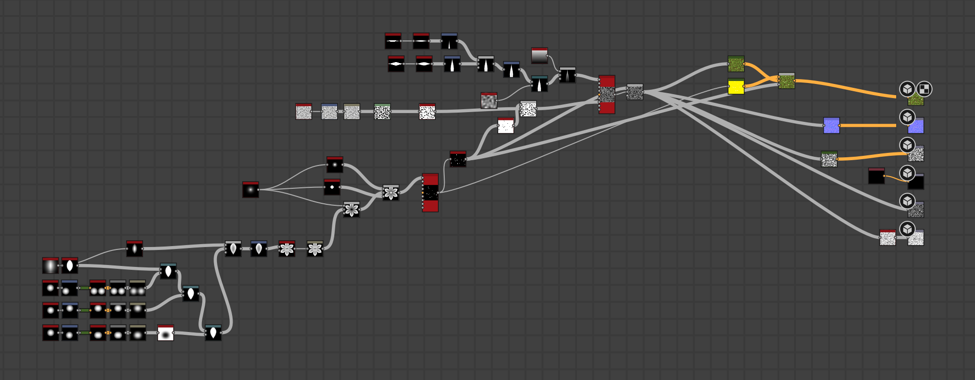

(These are the nodes used to create the main grass texture for my environment)

After a couple hours I had the basics learnt and started to make all the materials I would need.
I think they all turned out very well considering this is the first time I was ever using this software and will definitely use it again.

It really allowed me to create the exact texture that I was looking for, allowing me to keep the theme consistent and allow me more freedom in my style and story.

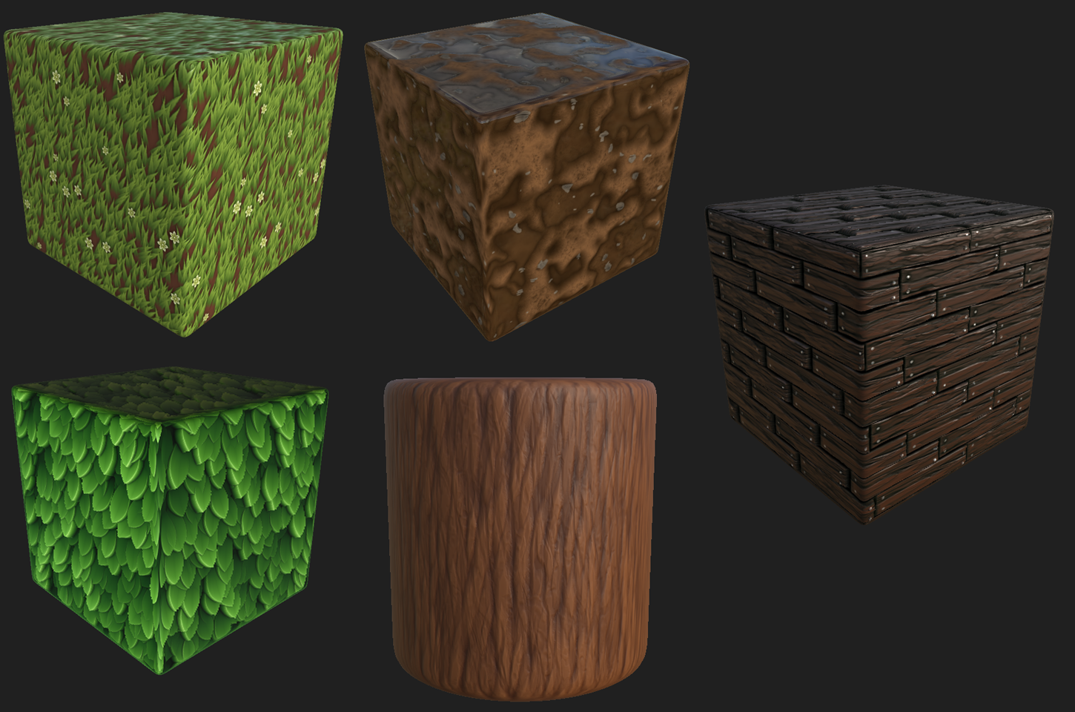
These are the textures that I had created in substance painter that will be used in my environment.

I have always found animating tricky and not my strong suit, so when beginning to animation I was worried how the end result would look.
I started with the easiest ones and moved onto the harder ones as I got more confidant.
To followed the "Work smarter, not harder" quote, I decided it would be a good idea to create one loop of of Liam walking that could be looped for as long as I chose.
This turned out to be a huge help however I didn't want the loop incredibly visible which it was at this time.
I decided to not loop parts of liam and animate those sepeare to the loop, the main part here was the head, moving the head separate to the walk cycle helped solve my issue drastically.
It also helped give Liam some personality as I added mouth movements and blinking periodically throughout the animation.

Looking back I wish I spent more time on the weight painting than I did as I ended up going back and amending it multiple times, I never did quite get it right, as the blinking looks rather odd along with the wrist areas, but these issues were small and not really noticeable so I decided to move on without fixing these issues.
Looking back I wish I had fixed them, no one will ever see these issues but it bothers me that they're there and if someone were looking for it, they would see.

I also found the time constant of 45 seconds difficult to work with as I would have liked a lot more story details to be in the short animation.
I was also worried that the audience wouldn't fully take in what was happening as everything was slightly rushed to have the whole story in.
I think it was important to realise this in the end as I will never make this mistake again. I would have liked a simpler story that fit nicely into 45 seconds, instead of everything being rushed.

Because I felt that the story was rushed, I ended up not doing an effect for the time travel at all, as I was much more interested in making the story work, and having a long time travel effect, although it would have looked cool, it would have taken away from the story of the animation and make the whole thing a lot less memorable.

When I came to rendering this I started panicking as I didnt think it would be rendered in time.
Luckily in the end it was.
However, the render is nowhere near good enough for me to be happy with it.
The noise is the main issue as I had to bump the samples right down for the render to be done in time. Even though this is what it will be like handing in, I am going to render it out properly again just to have and show to people.

The environment was very basic in this animation, but I think it works okay as you don't actually see too much of it.
I ended up having to really do one and a half environments as although it was the same place, it was two different times and therefore had to look different.

To do this wasn't that difficult.
I first created the new 2019 version of the environment, it had nice green grass and green trees, I also made the drawbridge broken to show the reason for the time travel moment.
From this I then created the 11th century environment.
I didn't actually change much for this, I removed all of the grass and some of the trees. I then changed all of the floor to be mud and dirt and added some hill in the background.
The audience only ever see the outside of the castle in the 11th Century for a couple of seconds. so it wasn't too vital to get this perfect.

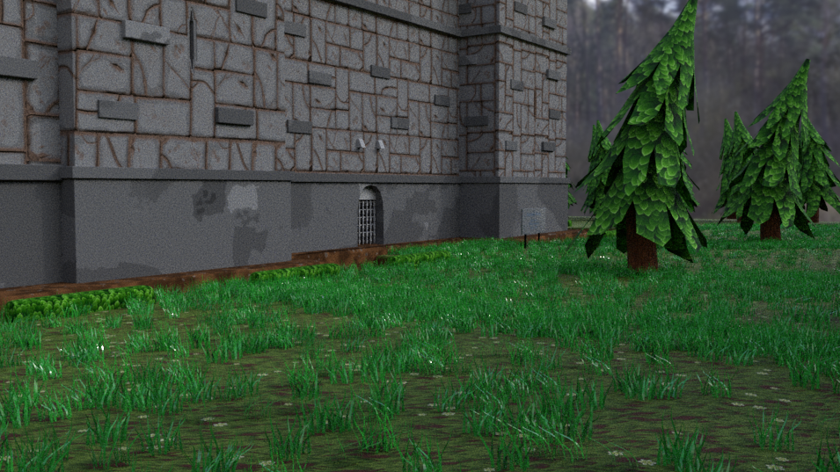
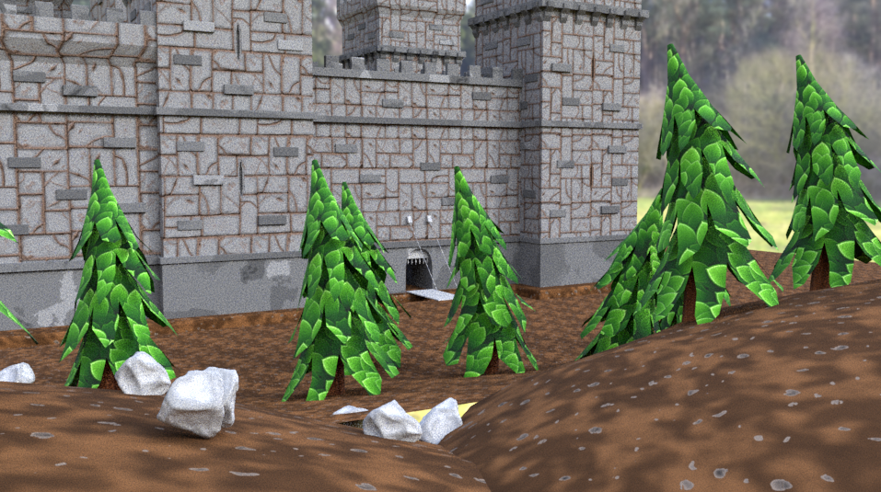

I then created a corridor with a room at the end for Liam to run to in a panic before giving up.

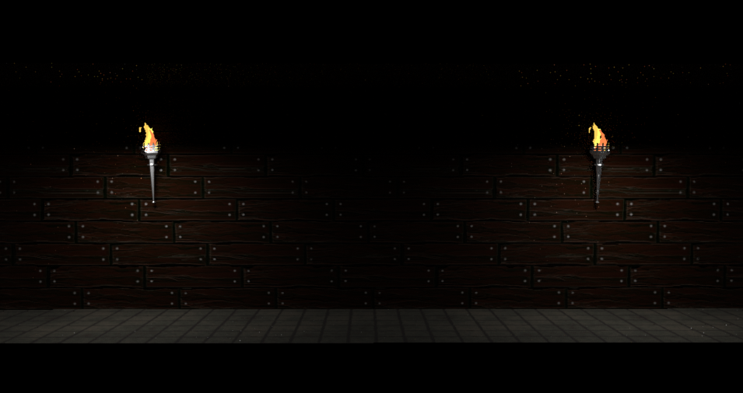

Something which I tried to implement into my animation was Liam's lateral movement across the screen.
A study from Cleveland State University showed that people were more comfortable when a character was moving from left to right on the screen and was discomforted when something moved from right to left.
They believe that this is because the vast majority of people were brought up reading from left to right, and that is the natural way of looking at things, so if something doesn't follow this it becomes discomforting.

Link to Source

Using this idea, when Liam is comfortable in his own time with a working time travel watch, he is walking from left to right.
But when the watch breaks and he starts running in a panic, he runs from left to right down the corridor, subconsciously making the audience feel discomfort for Liam

