

Programme: BSc Health and Social Care
Module: Protecting and Supporting Families in Health and Care
Module code: BMHP5021
Assignment Title: Component 2: Written Report
Title of Task: An examination and analysis of how the ‘Early Help’ system is signposted to UK
families by their local authority website
Student Name [Sohail Akram]
Student Number [2328491]
Inctitute Name [Mumtaz Goolam]

Executive Summary
Supporting children as well as families by early intervention is the main focus within the safeguarding framework of the UK. The report analyses how Early Help System is communicated to the families by three websites that are Leicester City Council, Norfolk County Council, and Staffordshire County Council. The main strengths and weaknesses of these three websites are explained in this report. The findings highlighted that Leicester provides the most effective website that provides user friendly information. However, following a better accessibility system, service signposting and navigation are important for developing the current support provided by all the local authorities.

Table of Contents
a) Introduction 4
b) Explanation of the Early Help System 4
c) Explanation of multi-agency working 5
d) An evaluation of each of your three local authority websites 6
e) A comparative analysis of the main strengths and weaknesses 9
f) Conclusion and recommendations 10
Reference List 12

a) Introduction
Children and families sometimes face a range of emotional, social, health related and educational challenges which require support on time for preventing issues from escalating. In the UK, the Early Help system plays an important role in determining the requirements at an early stage as well as providing coordinated support by collaboration between different agencies. The Early Help System Guide highlights that Early Help refers to a network of services designed for developing family resilience as well as outcomes by early interventions. The report discussed how the local authority websites communicate and share information about early help. Along with that, the report will compare the main strengths and weaknesses of the websites for understanding most effective and user friendly information to get families seeking support.

b) The Early Help System
The Early Help System is a collaborative and preventative approach to supporting children, young people and families, to avoid needing to access statutory services when there are concerns about a child, young person or family. The Early Help Systems Guide (2022) describes Early Help as "The total support necessary to improve the resilience and outcome of a family or to reduce the likelihood of that family experiencing a problem becoming serious." The Early Help System is not just one service, it consists of many services, professionals and community resources that work together to help to identify early needs and provide appropriate support (Department for Education, 2022).
The purpose of the Early Help System is to help children and families achieve positive outcomes by identifying and responding to emerging issues as soon as they arise. These issues may include parenting issues, mental health issues, education difficulties, domestic violence, homelessness, financial difficulty or behaviour issues (Roy, 2023). Early intervention by professionals can prevent issues from worsening and reduce the need for more intensive social care intervention. The Early Help System takes a whole family approach. This means that practitioners take the needs of the whole family into consideration and do not just concentrate on the child. The Early Help System recognises that challenges a parent or carer may be facing can have a direct impact on the wellbeing and development of children (Tollan et al. 2023).
Thus, the support plans are created for developing the family as a whole and improve their long term resilience. According to the Early Help System guide, the offer is given by 3 interconnected components that are community support, universal services and targeted specialist services (Bolton et al. 2023). The universal services include early year settings, schools, GP surgeries, family hubs, youth services and health visitors. The community support consists of voluntary organisations, family networks, local businesses, faith groups and community resources (Morse et al. 2022). The specialised and targeted services include social care teams, family support workers, housing support, mental health services, substance misuse programs and domestic abuse services. All these services together provide a coordinator to support powerful feelings of family requirements.
The main feature of the Early Help System is its focus on partnership working and accessibility (Roy, 2023). The families must be able to determine the available services and understand how to access support and home to co-ordinate for getting the care. The guides are also beneficial for representing the importance of ensuring families only need to tell their story once with the professionals sharing information in an appropriate way and working together by using a single plan. Hence, early help systems play a crucial role for safeguarding children as well as promoting family well-being by providing coordinated, kindly and family centre support (Boothby et al. 2026). The early intervention as well as effective partnership working is beneficial for the family to overcome the issues, achieve better outcomes and build resilience.

c) Multi Agency Working
The multi-agency working is the collaboration of multiple organisations, professionals and services for safeguarding children as well as promoting their health. It is a major principle of the safeguarding framework in the UK and it represents working together to safeguard children 2023. The guidance explains that a successful outcome for children relies on effective partnership between families, practitioners with all the agencies sharing responsibility for determining the requirements, protecting children from harm and providing support (UK Government, 2026).
The motive of multi-agency working is to ensure that families and children get coordinated and holistic care. This is also important to know that no single organisation or professional can possess a complete understanding of the family circumstances hence appropriate communication and information sharing is crucial. Multi agency working allows professionals to combine their expertise, create comprehensive understanding of the family requirements and provide timely interventions (Alfandari and Taylor, 2022). This strategy is beneficial for preventing duplication of services, minimising gaps in support and ensuring that the families get the right help at the correct time.
The wide range of professionals might be involved in multi-agency work that include health visitors, social workers, GPs, police officers, school nurses, teachers, housing officers, mental health practitioners and voluntary sector firms. The early help system is beneficial for guiding the focus that the practitioners must work together by a “team around the families” strategy. This is important for coordinating the activities under a shared plan which ensures high quality care. This also ensures that the families only need to explain their circumstances once and get support in the consistent manner from all the involved agencies. Appropriate multi agency working depends on information sharing (Purcell et al. 2025). However, working together to safeguard children explains that the practitioners must proactively share the information to determine the challenges, analyse needs and respond in an appropriate way regarding the concerns about child welfare.
Timely information sharing is important for helping the professionals to determine the patterns of needs, make informed decisions and prevent escalation of problems regarding the support as well as safeguarding (Cowley et al. 2024). The guidance also highlights the expectations for collaborative methods. The frontline practitioners, strategic leaders and managers are expected to work together, challenge improper practice, share resources, learn from one another and maintain child centric strategies (Edwards-Fapohunda and Adediji, 2024). The families and the children must remain at the centre of the decisions with their voices informing the support plans and assessments (Chalmers and Cartmel, 2025). Hence, multi-agency working is crucial for the success of early help systems. Communication, cooperation and shared responsibilities are beneficial for the agencies in order to provide effective support for the children and the families as well as strengthen safeguarding practices within local communities.

d) Evaluation
Leicester City Council
Leicester City Council provides an abundance of easy-to-understand and well-organized information on its website regarding Early Help services. The site allows families to find out exactly what Early Help consists of, along with who is eligible for assistance and how to refer to themselves or someone else for assistance. In addition to all information being written in plain English, it provides lots of examples of when Early Help might be helpful, including: A parent struggling with parenting skills, facing domestic violence, needing assistance with housing, or requiring assistance with their emotional well-being (Leicester City Council, 2026). The website also provides a variety of methods to contact the Early Help services and clearly explains what the assessment and support process entails. Another example of how Leicester City Council demonstrates transparency in its multi-agency collaborative working with families is by including the "Team Around the Family" approach on its website.
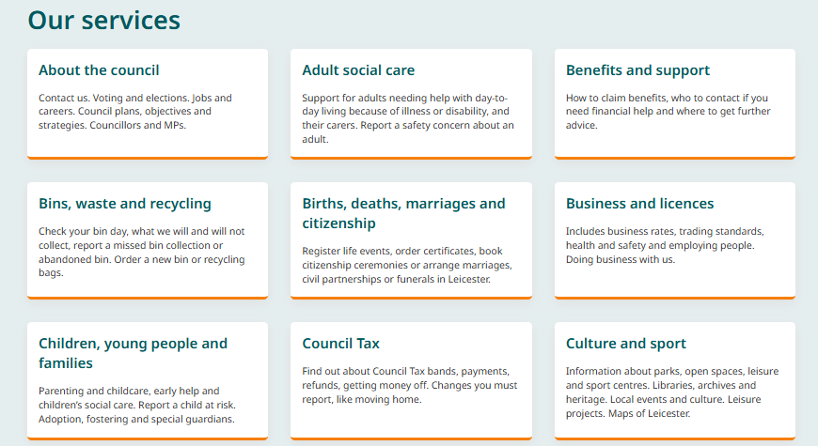
Figure 1: Leicester Website
(Source: Leicester City Council, 2026)
Norfolk County Council
Norfolk Country Council presence early help information within an accessible and family friendly format (Norfolk Country Council, 2026). The website clearly represents the purpose of early help and focuses on providing support before the complexity is becoming more serious. A notable strength is its family hubs approach that offers both face to face and online support. The site acknowledges that adult issues like financial difficulties and mental health challenges can impact children and their four follows are whole family perspective. Moreover, compared with Leicester there is less detailed data regarding the assessment procedure, referral pathways and specific support services available (Norfolk Country Council, 2026). The families might be required to navigate the additional pages in order to gain a complete understanding about all the support activities.
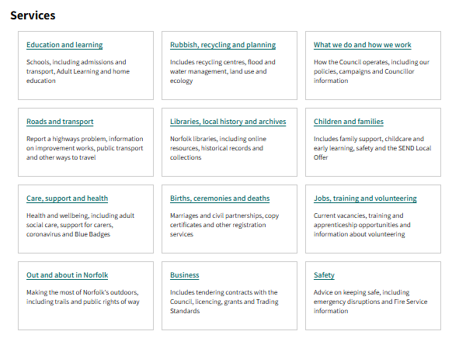
Figure 2: Norfolk Website
(Source: Norfolk Country Council, 2026)
Staffordshire County Council
Staffordshire County Council uses its "Families First" and Family Hubs service's websites to inform families of Early Help services available to them. Staffordshire County's website provides families with the information they need related to Early Help service's early intervention objectives, in addition to how Early Help Teams support families before issues become more severe. The website includes multiple directories of community-based resources available to families. However, it has a much more complex way of organizing its information compared to Leicester City Council's website. Therefore, families may take much more time to locate detailed information about eligibility for assistance and the referral process on the Staffordshire County Council's website than they would on the Leicester City Council's website (Staffordshire Country Council, 2026).
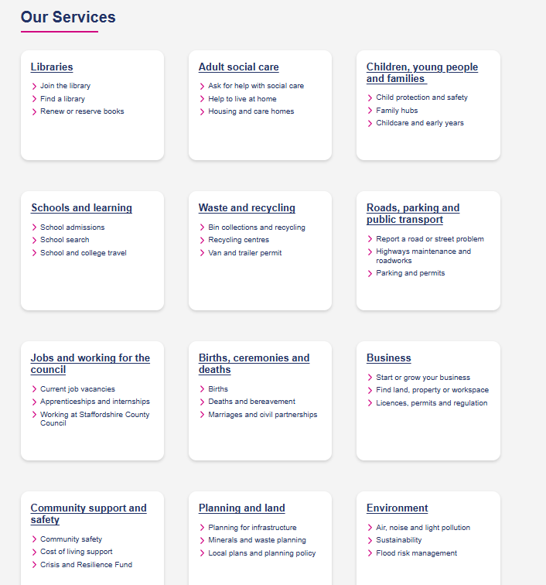
Figure 3: Staffordshire Website
(Source: Staffordshire Country Council, 2026)
Moreover, all the three websites provide valuable information about early help services. Leicester offers more structure than detailed guidance while Norfolk gives highly accessible as well as family centred strategy. Staffordshire offers a lot of resources but needs more navigation for getting the key information.

e) A comparative analysis of the main strengths and weaknesses
A comparison of the three local websites highlights both the strengths and the weaknesses in how early help information is shared to the families. The major strength involved in all the three websites is their commitment for promoting family support and early intervention. Individual authority clearly explains that early help is designed for addressing the difficulties before they become serious concerns. The three websites follow a whole family approach in order to provide information regarding accessing support services.
Leicester City Council shows the strongest overall communication strategy. The website provides eligibility information, clear definitions, contact details, referral procedures and explanation of the assessment processes in one location (Leicester City Council, 2026). The content is organised in a well-defined manner which is easy for the family to understand what kind of support is available and how to get it. The major strength of community support platforms is transparency about the multi-agency working as well as the role of the main practitioners (Davies et al. 2023). However, the volume of the information could appear overwhelming to some of the users. Hence, basic guidance is also required for accessing information from the website.
Norfolk County Council has the strength of user friendly presentation and accessibility. The information is supportive, concise and written in a language which families can easily understand (Norfolk Country Council, 2026). The family hub model is mainly promoted which inspires families to get the local support networks. However, the main weakness of the website is the Limited details about the specific intervention processes, assessment pathways, and reference.
Staffordshire County Council provides a broad range of linked support services as well as resources. The website is connecting early help with the family hub, specialist support and community services (Staffordshire Country Council, 2026). This shows the comprehensive support network for the families. Moreover, the information is categorised across different webpages which is creating a less streamlined user experience. Hence, the families who are unfamiliar about the local authority services can find navigation issues while searching for the specific support choices.
According to the comparison, Leicester is the most effective communication for getting information about early help due to its detailed explanation, clarity and straightforward referral guidance (Leicester City Council, 2026). However, the effectiveness of the early help website is dependent not only on the quantity of the information but also how the users can easily understand, locate an act upon the information while seeking help (Ma et al. 2024).

f) Conclusion and recommendations
The Early Help System plays an important role for supporting children as well as families by multi agency collaboration and early intervention strategies (Sapiets et al. 2023). The overall evaluation of the three local websites that are Leicester City Council, Norfolk Country Council and Staffordshire Country Council websites shows that all the three authorities provide important information regarding early help services but their effectiveness varies. Among all the websites, Leicester provides accessible and comprehensive information. In order to improve accessibility the local authorities must ensure that the key information is effectively shared, available in different formats and language and written in plain language. The websites must provide the clear referral pathway, visible explanation of the multi-agency working and include interactive support directories for helping the families to get support confidently and quickly.

Reference List
Alfandari, R. and Taylor, B.J., (2022). Community-based multi-professional child protection decision making: Systematic narrative review. Child Abuse & Neglect, 123, p.105432. https://pure.ulster.ac.uk/files/93347163/Cty_CP_DM_SNR_2021H_2_.pdf
Bolton, P., West, J., Whitney, C., Jordans, M.J., Bass, J., Thornicroft, G., Murray, L., Snider, L., Eaton, J., Collins, P.Y. and Ventevogel, P., (2023). Expanding mental health services in low-and middle-income countries: A task-shifting framework for delivery of comprehensive, collaborative, and community-based care. Cambridge Prisms: Global Mental Health, 10, p.e16. https://www.cambridge.org/core/services/aop-cambridge-core/content/view/43537788DF743160294EE33C618B4D9F/S2054425123000055a.pdf/expanding-mental-health-services-in-low-and-middle-income-countries-a-task-shifting-framework-for-delivery-of-comprehensive-collaborative-and-community-based-care.pdf
Boothby, N., Balster, R.L., Goldman, P., G Wessells, M., Zeanah, C.H., Huebner, G. and Garbarino, J., (2026). Coordinated and evidence-based policy and practice for protecting children outside of family care. https://curate.nd.edu/articles/journal_contribution/Coordinated_and_evidence-based_policy_and_practice_for_protecting_children_outside_of_family_care/31427387/1/files/62203052.pdf
Chalmers, J. and Cartmel, J., (2025). The importance of listening to children's voices in family law: A framework for practice. Children Australia, 47(2), pp.1-13. https://search.informit.org/doi/pdf/10.3316/informit.T2025112900011401641718825
Cowley, L.E., Bennett, C.V., Quinn‐Scoggins, H.D., Nuttall, D., Wilkins, D. and Kemp, A.M., (2024). Factors influencing clinicians', health visitors' and social workers' professional judgements, decision‐making and multidisciplinary collaboration when safeguarding children with burn injuries: a qualitative study. Child Abuse Review, 33(1), p.e2862. https://doi.org/10.1002/car.2862
Davies, P., Barlow, C. and Fish, R., (2023). The hard and complex work of implementing new multi-agency risk assessment approaches to policing domestic abuse. Crime Prevention and Community Safety, 25(2), p.148. https://pmc.ncbi.nlm.nih.gov/articles/PMC10073790/pdf/41300_2023_Article_175.pdf
Department for Education, (2022). Early Help System Guide, Available at: https://assets.publishing.service.gov.uk/media/628de13be90e071f5f7e1bd2/Early_Help_System_Guide.pdf (Accessed: 01 June 2026)
Edwards-Fapohunda, M.O. and Adediji, M.A., (2024). The impact of the educational journey of special needs children on the employability, sociability, and economy of working-class parents in the UK. Iconic Research and Engineering Journals, 8(1), pp.421-436. https://www.researchgate.net/profile/Michael-Edwards-Fapohunda/publication/387946632_The_Impact_of_the_Educational_Journey_of_Special_Needs_Children_on_the_Employability_Sociability_and_Economy_of_Working-Class_Parents_in_the_UK/links/6783742d32c79152e3cde1c3/The-Impact-of-the-Educational-Journey-of-Special-Needs-Children-on-the-Employability-Sociability-and-Economy-of-Working-Class-Parents-in-the-UK.pdf
Leicester City Council, (2026). Early Help A Guide for Schools, Available at: https://www.leicester.gov.uk/sites/default/files/2026-01/early-help-a-guide-for-schools.pdf (Accessed: 01 June 2026)
Leicester City Council, (2026). Our Services, Available at: https://www.leicester.gov.uk/ (Accessed: 01 June 2026)
Ma, Z., Mei, Y. and Su, Z., (2024), January. Understanding the benefits and challenges of using large language model-based conversational agents for mental well-being support. In AMIA Annual Symposium Proceedings (Vol. 2023, p. 1105). https://pmc.ncbi.nlm.nih.gov/articles/PMC10785945/pdf/406.pdf
Morse, D.F., Sandhu, S., Mulligan, K., Tierney, S., Polley, M., Chiva Giurca, B., Slade, S., Dias, S., Mahtani, K.R., Wells, L. and Wang, H., (2022). Global developments in social prescribing. BMJ global health, 7(5), p.e008524. https://gh.bmj.com/content/bmjgh/7/5/e008524.full.pdf
Norfolk Country Council, (2026), Services, Available at: https://www.norfolk.gov.uk/ (Accessed: 01 June 2026)
Norfolk Country Council, (2026). Early help for children and families, Available at: https://www.norfolk.gov.uk/article/40407/Early-help-for-children-and-families (Accessed: 01 June 2026)
Purcell, C., Baginsky, M. and Steils, N., (2025). No quick fixes: Multi-agency working to improve information-sharing on men and keep children safe. The British Journal of Social Work, p.bcaf249. https://academic.oup.com/bjsw/advance-article-pdf/doi/10.1093/bjsw/bcaf249/65310289/bcaf249.pdf
Roy, J., (2023). Parental substance misuse and statutory child protection in England: Risk factors and outcomes. Child Abuse Review, 32(2), p.e2786. https://doi.org/10.1002/car.2786
Sapiets, S.J., Hastings, R.P., Stanford, C. and Totsika, V., (2023). Families’ access to early intervention and supports for children with developmental disabilities. Journal of Early Intervention, 45(2), pp.103-121. https://journals.sagepub.com/doi/pdf/10.1177/10538151221083984
Staffordshire Country Council, (2026). Our Services, Available at: https://www.staffordshire.gov.uk/ (Accessed: 01 June 2026)
Tollan, K., Jezrawi, R., Underwood, K. and Janus, M., (2023). A review on early intervention systems. Current Developmental Disorders Reports, 10(2), pp.147-153. https://pmc.ncbi.nlm.nih.gov/articles/PMC9937857/pdf/40474_2023_Article_274.pdf
UK Government, (2026). Working Together to Safeguard Children 2026, Available at: https://assets.publishing.service.gov.uk/media/69fb1c28d0e316a40f269a5b/Working_together_to_safeguard_children_2026_a_guide_to_multi_agency_working.pdf (Accessed: 01 June 2026)

