Module Title – Introduction to Health and Social Care
Module Code – LCHS4003
Assignment Title – Portfolio – Two Tasks
Student Name – Romeenah Akhtar
Student Number- 2433755
Lecturer’s Name – Mumtaz Gulam
Date- 20th October 2025

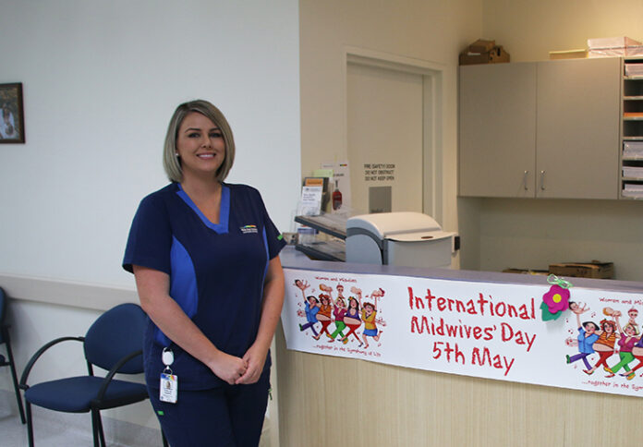
Component 1- Task 1
This Photo by Unknown Author is licensed under CC BY
🩺What The service is & who uses it?
Community antenatal midwifery services support women throughout pregnancy, birth, and shortly after the baby is born. Midwives provide health checks, screening, and emotional and practical support to help mothers stay healthy and confident (NHS, 2023). The service is used by pregnant women, new mothers, and their families, including those with additional needs such as teenage pregnancies, high-risk pregnancies, or social challenges. Midwives work closely with GPs, health visitors, and hospitals to ensure women get the right care at the right time (Public Health England, 2021).

👩‍⚕️Who provides it & where it happens?
Community antenatal care is delivered by qualified midwives, supported by maternity support workers and healthcare assistants. Care takes place in community clinics, GP surgeries, children’s centres, or at home. Women can self-refer to a midwife directly or through their GP. Some services also offer digital appointments and online maternity notes through platforms like Badger Notes for easier communication (NHS Digital, 2022).

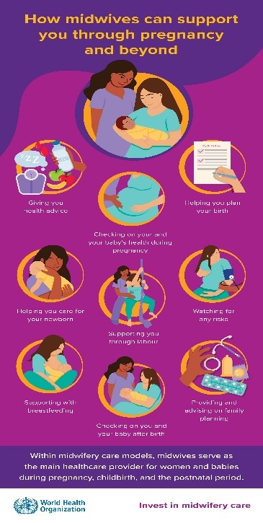
🌍Why the service is important?
Community midwifery plays a vital role in keeping pregnancy care safe, accessible, and personal. It helps identify health problems early, reduces hospital pressure, and improves outcomes for both mothers and babies.
Midwives also support public health, offering guidance on mental wellbeing, healthy lifestyles, breastfeeding, and stopping smoking. This service is especially important in Birmingham, where there is a large and diverse population, helping reduce health inequalities and ensuring all families receive equal care (Knight et al., 2021).

⚙️Function of the service
What it does:
Conducts regular check-ups, screenings, and health education. Provides emotional support and advice on birth and parenting. Refers women to hospitals or specialists when needed. Offers postnatal home visits to check on mothers and newborns.

Who delivers it:
Qualified midwives and maternity support workers (RCM, 2022).
Works closely with obstetricians, GPs, and social care when necessary.

How it’s funded and managed:
Funded by the NHS and managed locally by Birmingham and Solihull ICS.
Guided by the national Better Births (2016) framework, which focuses on continuity and personalised care (NHS England, 2016).

1️⃣ Staffing Shortages
The UK faces a shortage of midwives, with over 2,500 more needed to meet demand (Royal College of Midwives, 2024). This leads to heavier workloads, less one-to-one care, and staff burnout. In Birmingham, the growing population and higher birth rates add extra pressure on community services.
2️⃣ Health Inequalities
women in UK may face barriers to accessing antenatal care, such as language difficulties, transport costs, and digital exclusion. These factors can cause delays in booking appointments or missing key checks, especially in deprived areas (Public Health England, 2021). Services are working to improve outreach and inclusivity for all communities.

Challenges

Task 2
The Origin and Current Structure of the NHS
Introduction
The National Health Service (NHS) is one of the most respected public institutions in the United Kingdom. It provides healthcare that is free at the point of use and available to everyone. This essay will discuss the origins of the NHS, including its historical background and key principles, and then examine how the NHS is currently structured and how it functions today.
Historical Context and Founding of the NHS
The NHS was founded after the Second World War when the country was recovering from years of hardship and inequality. Before 1948, many people could not afford medical care, and healthcare was provided by a mix of private doctors, charities, and local councils (Webster, 2017). The Beveridge Report (1942) was very influential because it identified five major problems facing Britain—want, disease, ignorance, squalor, and idleness—and called for a new welfare system to protect people from these “Five Giants” (Turner, 2005).
Aneurin Bevan, who was the Minister of Health, managed the creation of the National Health Service Act 1946, which made it possible to bring hospitals, doctors, and public health services under one national organisation (The National Archives, 2023). The NHS officially started on 5 July 1948, offering free healthcare to everyone in the UK. It was one of the biggest social reforms in British history, based on the idea that good healthcare should be available to all, not only those who could afford it (Marwick and Webster, 2017).
Key Principles of the NHS
The NHS was founded on three key principles that still guide it today. These are:
- It should meet the needs of everyone.
- It should be free at the point of delivery.
- It should be based on clinical need, not on ability to pay (NHS Constitution, 2019).
These principles reflected a belief in fairness and equality. They helped make healthcare universal, ensuring that all citizens could receive medical care when they needed it. Over time, the NHS has changed and modernised but continues to uphold these original values (Nuffield Trust, 2024).
The Current Structure and Functioning of the NHS
Today, the NHS is one of the largest publicly funded health systems in the world. It is financed through general taxation and National Insurance contributions (House of Commons Library, 2023). In England, the NHS is overseen by NHS England, which manages budgets, sets priorities, and monitors performance.
Healthcare is organised at several levels. Primary care includes GPs, pharmacists, and dentists, while secondary care involves hospitals and specialist services. There is also community and mental health care, which provide services outside hospitals (BMC Primary Care, 2023). In 2022, the NHS introduced Integrated Care Systems (ICSs), local partnerships between NHS organisations, councils, and other agencies to plan and deliver services more effectively (The King’s Fund, 2023).
However, the NHS faces constant challenges. Demand for services is increasing due to an ageing population and long-term conditions. Workforce shortages and long waiting times have also become serious issues (Thomson and Chatterjee, 2024). Although digital technology and integrated care aim to improve efficiency, more investment and reform are needed to make these changes successful (Turner et al., 2023).
Conclusion
In conclusion, the NHS was created in 1948 to provide free and equal healthcare for all. It grew out of post-war social reform and the belief that health is a human right. The NHS still holds its founding principles of universality, fairness, and free access, but it now operates in a more difficult and challenging environment. To secure its future, the NHS must continue to modernise, increase its workforce, and protect the core values that have defined it for more than seventy-five years.

Reference List
- NHS (2023) Your Pregnancy and Maternity Care. https://www.nhs.uk/pregnancy/your-pregnancy-care
- NHS Digital (2022) Digital Maternity Records and BadgerNet. Avhttps://digital.nhs.uk
- Public Health England (2021) Health Inequalities in Maternity Care https://www.gov.uk/government/publications/health-inequalities-in-maternity-care
- Royal College of Midwives (2024) Midwives Give 100,000 Hours of Free Labour to the NHS Per Week. https://rcm.org.uk/media-releases/2024/06/midwives-give-100000-hours-of-free-labour-to-the-nhs-per-week-to-keep-englands-maternity-services-safe-says-rcm/
- Royal College of Midwives (2024) How to Fix the Midwifery Staffing Crisis. Available at: https://rcm.org.uk/media-releases/2024/02/rcm-tells-politicians-how-to-fix-the-midwifery-staffing-crisis-with-new-pre-election-guide/.
- BMC Primary Care (2023) ‘Primary care services in the English NHS: are they a thorn in the side of integrated care systems?’, BMC Primary Care, 24, 2124. Available at: https://bmcprimcare.biomedcentral.com/articles/10.1186/s12875-023-02124-3
- House of Commons Library (2023) The structure of the NHS in England. Briefing Paper No. 7206. https://researchbriefings.files.parliament.uk/documents/CBP-7206/CBP-7206.pdf
- Marwick, A. and Webster, C. (2017) ‘Founding principles of the NHS’, Journal of Health Services Research & Policy, 22(3), pp. 149–156. https://www.ncbi.nlm.nih.gov/pmc/articles/PMC2405823/
- NHS Constitution (2019) The NHS Constitution for England. London: Department of Health and Social Care. https://www.gov.uk/government/publications/the-nhs-constitution-for-england/the-nhs-constitution-for-england
- Nuffield Trust (2024) The history of the NHS. https://www.nuffieldtrust.org.uk/health-and-social-care-explained/the-history-of-the-nhs
- The King’s Fund (2023) Integrated care systems: explained. Available at: https://www.kingsfund.org.uk/publications/integrated-care-systems-explained
- The National Archives (2023) The foundation of the NHS. Available at: https://www.nationalarchives.gov.uk/explore-the-collection/stories/the-foundation-of-the-nhs/
- Thomson, L. J. M. and Chatterjee, H. J. (2024) ‘Barriers and enablers of integrated care in the UK: a rapid evidence review’, Frontiers in Public Health, 11, 1286479. Available at: https://www.ncbi.nlm.nih.gov/pmc/articles/PMC10794528/
- Turner, S. (2005) ‘Planning of the UK’s National Health Service’, International Journal of Integrated Care, 5, e20. https://www.ncbi.nlm.nih.gov/books/NBK316274/
- Turner, S. et al. (2023) ‘The development of Integrated Care Systems in the English NHS’, International Journal of Integrated Care, 23, 1–12. https://ijic.org/articles/10.5334/ijic.ICIC24238/

