Programme: Master of Business Administration
Module: Marketing Management
Module code: LCMB7024
Assignment Title: Marketing Environment Analysis
Lecturer: Laila Maazouz Taonga Kaonga Sobere Snithers
Student Name:shivang narshibhai kalasriya
Student ID:2532573
Table of Contents

Task 1: Marketing Environment Analysis 3
1.1 Overview of Tata Steel: Scale, Carbon Footprint, and Net-Zero Commitment 3
1.2 The Natural Environment as a Core Marketing Environment Actor 4
1.3 Regulators and Government Publics as External Marketing Environment Actors 7
1.3.1 European Union Emissions Trading System (EU ETS) 7
1.3.2 Carbon Border Adjustment Mechanism (CBAM) 7
1.3.3 UK Government Transition Funding 9
1.3.4 Indian Government Policies Supporting Decarbonisation 9
1.3.5 Critical Evaluation of Regulatory Pressures 10
Task 2: Strategic Growth and Competitive Positioning 11
2.1 Application of the Ansoff Matrix: Product Development Strategy for Low-Carbon Steel 11
2.2 Competitive Advantage Through Electric Arc Furnace (EAF) Adoption: A Porter's Generic Strategies Perspective 13
Critical Recommendation 14
Task 3: Critical Reflection on AI Usage 15
3.1 AI Tool Disclosure 15
3.2 Critical Evaluation & Error Correction 15
3.3 Contribution Analysis 15
3.3.1 AI Contribution 15
3.3.2 Original Contribution 16
3.3.3 Ethical and Professional Reflection 16
References 17

Task 1: Marketing Environment Analysis

1.1 Overview of Tata Steel: Scale, Carbon Footprint, and Net-Zero Commitment
Tata Steel is one of the leading steel manufacturers in India and the world with operations across India, Europe and Southeast Asia. The company is engaged in a wide range of sectors such as Automotive, Construction, Engineering and Infrastructure and plays a key role in economic development and the growth of industry. India's CO₂ emissions per tonne of globalised steel are estimated to be 2.65 tonnes per tonne of steel, about 32% higher than the world average, largely due to India's reliance on blast furnace production from coal sources (Reuters, 2026a). With the ongoing growth of the steel industry in India, the companies are focusing on sustaining their growth while prioritising the environment and its conservation. Down To Earth (2026) reported that the global steel produced using coal has seen a 5% rise in 2026, and a significant part of the new production capacity investments came from India, thus pointing to the challenge of reducing emissions even in the face of increasing demand for steel that uses coal.
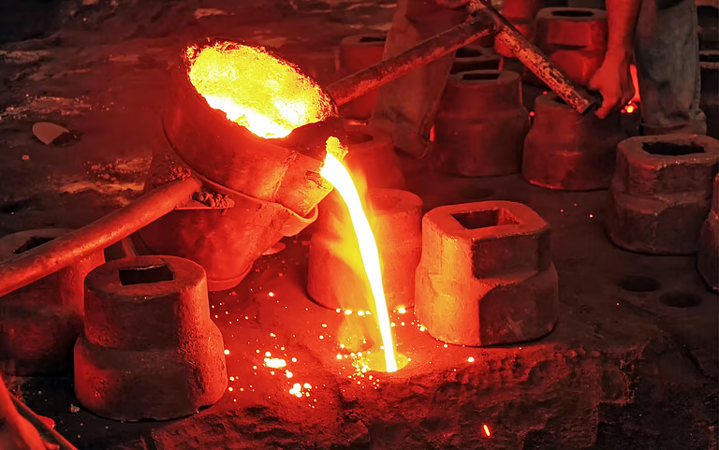
Figure 1: Molten Steel Pouring During the Steel Casting Process
(Source: Down To Earth, 2026)

1.2 The Natural Environment as a Core Marketing Environment Actor
In Kotler's Marketing Environment framework, some of the external environment actors include the natural environment, which refers to ecological conditions and natural resources that impact the business, such as climate change, greenhouse gas (GHG) emissions, energy availability, and the scarcity of natural resources (Kotler et al., 2024).
Depletion of Finite Resources: Dependence on Metallurgical Coal
The availability of finite metallurgical coal adds to the scarcity of resources and the long-term production risks for Tata Steel. As a result, the company is putting resources into hydrogen energy technology, clean cooking stoves, and Electric Arc Furnaces (EAFs) that use only scrap steel in electric arc melting to lower dependency on virgin raw material and boost resource sustainability (Tata Steel, 2026a).

Greenhouse Gas Caps and Carbon Emission Pressures
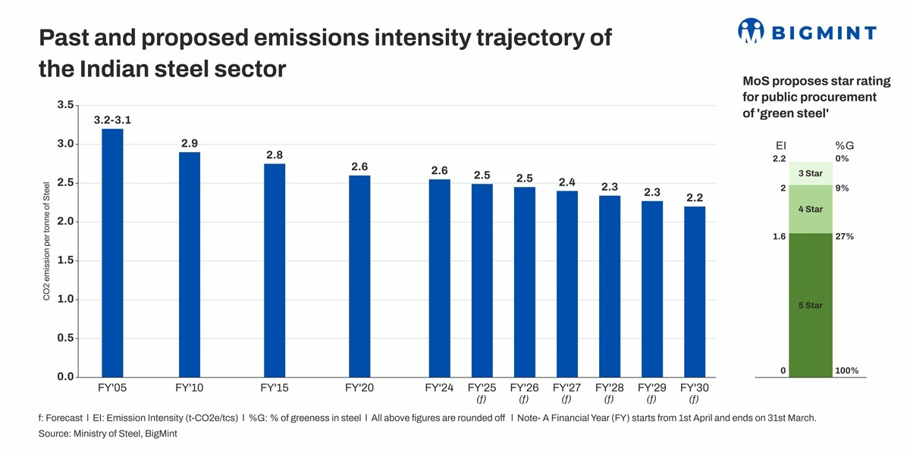
Figure 2: Past and Proposed Emissions Intensity Trajectory of The Indian Steel Sector
(Source: BigMint, 2026)
Lowering greenhouse gas caps and tougher carbon regulations are speeding Tata's low-carbon journey.It is noteworthy to mention here that as per study of European Commission India steel industry holds the top spot in CO2 emission as it generates 2.6 tons of CO2 per ton of finished steel (Vadim, 2024).While only about half of the world's promised green steel projects were put on hold during 2026 due to the scarcity of green hydrogen, low demand, and funding difficulties, the difficulties of industrial decarbonisation illustrate the challenges confronting the industry (Reuters, 2026b).
Physical Risks
Tata Steel's physical threat is driven by climate change, such as supply chain disruption and operational uncertainty. The fact that these challenges are likely to impact production continuity and decarbonsation efforts in the steel industry with increased investment in resilient infrastructure and cleaner technologies is needed for sustainable production in the long term (Tata Steel Limited, 2026b).
The Push Towards a Circular Economy
The transition towards a circular economy helps Tata Steel to limit its reliance on the earth's scarce and limited mineral resources by incorporating and utilizing scraps, EAFs, renewable energy and sustainable value chains for supporting its resource efficiency, environmental protection and competitiveness in the international steel market (Tata Steel, 2026a).
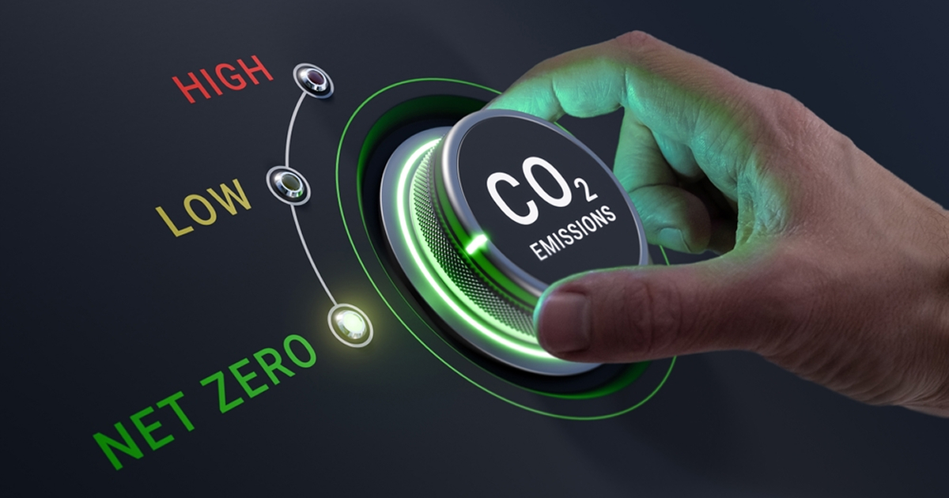
Figure 3: The steel industry is concerned about the slow progress of green steel projects
(Source: GMK Centre, 2026)

1.3 Regulators and Government Publics as External Marketing Environment Actors

1.3.1 European Union Emissions Trading System (EU ETS)
The European Union Emissions Trading System (EU ETS) is a carbon emission trading system that forces high emitters (steel firms) to buy carbon emission permits, thus himping up the cost of carbon-intensive production. The EU ETS also promotes investments in cleaner technologies, like Direct Reduced Iron (DRI) and Electric Arc Furnaces (EAFs) to lower emissions and compete within the European steel industry. As such, the scheme offers much encouragement for manufacturing low carbon steel and for facilitating environmental compliance and market competitiveness within the longer-term (Business Line, 2026).

1.3.2 Carbon Border Adjustment Mechanism (CBAM)
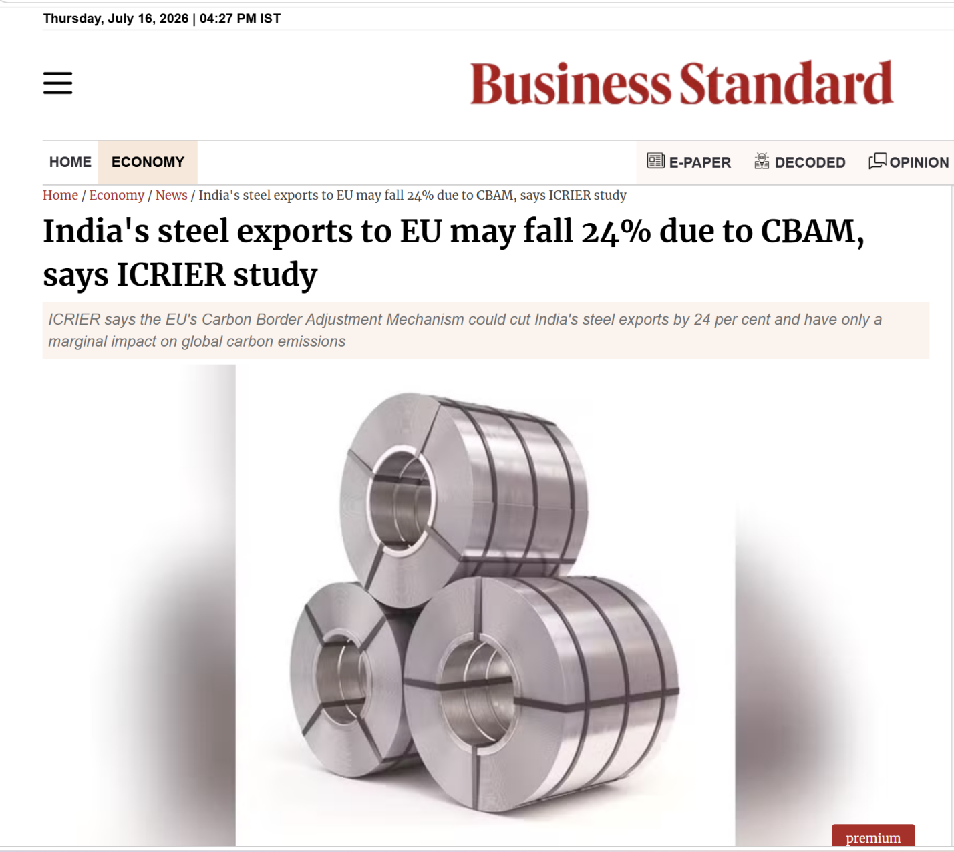
Figure 4: Loss in India’s Steel exports due to EU Strict Policy Regulations
(Source: Business Standard, 2026)
The Carbon Border Adjustment Mechanism (CBAM), in principle, applies a carbon price to imported carbon-intensive goods, like steel, helps to prevent ‘carbon leakage' and thus ensures fair competition. This policy imposes additional requirements for compliance on Indian steel exporters and promotes lower carbon production. An ICRIER study had estimated that the CBAM would create an additional competitive challenge to India as the country could expect a loss of 24% of its exports to the European Union. Thus, to avoid losses in export markets and enhance its international competitiveness, Tata Steel has to speed up the process of decarbonisation (Business Standard, 2026).

1.3.3 UK Government Transition Funding
The UK government funds transitions in sequestration to "model" sustainable investments in the technology of industrial decarbonisation.This Public Policy advocates EAF (e.g., Electric Arc Furnace) technology to promote sustainable manufacturing. One of its most notable examples is Tata Steel UK's conversion to the heavy-end route via a 3.2 MTPA EAF in the UK, closing their heavy end assets in 2024 to reduce carbon emission in the UK by 1.5% (Reuters, 2024). The funding models facilitate companies in handling high expenses for compliance and it stimulates innovation and allows them to build their global competitiveness over time.

1.3.4 Indian Government Policies Supporting Decarbonisation
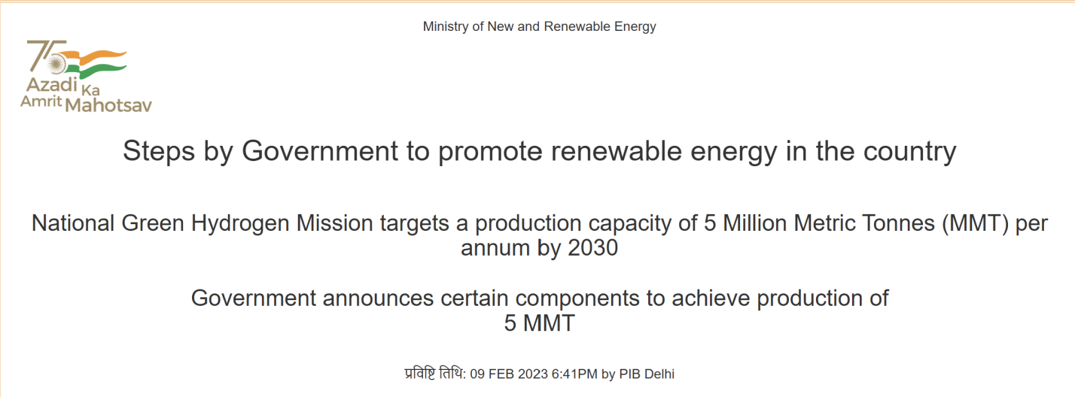
Figure 5: India’s NGHM Mission Target
(Source: PIB, 2023)
In India, decarbonisation involves incorporating market mechanisms and technology missions. Efficiency is driven through the PAT Scheme and Carbon Credit Trading Scheme (CCTS) through tradable certificates. As per the Ministry of New and Renewable Energy (2023), and Balasubramanian and Sarma (2024), The National Green Hydrogen Mission plans to get to 5 MTPA range by 2030, replacing coal for steel production. On the other hand, the Steel Scrap Recycling Policy (SSRP) helps the adoption of circularity, while limiting emissions by as much as 58% (Kumar Chaudhary, 2026d). This is why The Standing Committee on Coal, Mines and Steel re-emphasised on faster transition towards scrap based steel production and developing a scrap based market and making it an organised sector (PRS Legislative Research, 2026d). Such frameworks are crucial to India's 2070 net zero goal and to keep its industries competitive

1.3.5 Critical Evaluation of Regulatory Pressures
Innovation, establishing a strong sustainable brand and becoming more competitive in international markets are made possible with the pressure from regulations that push Tata Steel to do more and achieve less harmful steel production. Nevertheless, there are also challenges to the business and cost implications during the transformation of the company towards the low carbon economy, as harsher environmental standards lead to higher costs of compliance, requirements for new capital investments and complexity of implementation (Tata Steel Limited, 2026a).

Task 2: Strategic Growth and Competitive Positioning

2.1 Application of the Ansoff Matrix: Product Development Strategy for Low-Carbon Steel
The Ansoff Matrix is a strategic tool that can be used to determine the potential for the growth of an organisation based on the matrix formed by combining current and new products and current and new markets. There are 4 growth strategies: Market Penetration, Market Development, Product Development, and Diversification.
Market Penetration
Market Penetration aims at raising the sales of current steel products in current markets. Tata Steel's footprint is already good in the automotive, construction, engineering and infrastructure areas. While more promotion and customer relationship management may be helpful to share the market, this is not enough to meet the rapid growing demand of customers for sustainable and low-carbon steel products. This Automotive & Special Products business experienced its best-ever year in terms of annual sales of approximately 3.4 million tonnes and has proved to be a fantastic foundation on which to launch premium green steel products (Tata Steel Limited, 2026c).

Market Development
The second strategy is called Market Development and this means selling the established products into new geographical or industrial markets. Tata Steel has already been operating in India along with its presence all over the globe, which gives a great exposure in the international market (Tata Steel Limited, 2026).While exploring further potential in new markets can help to increase revenues, it is unlikely to meet rising international environmental standards and sustainability demands when steel products are simply introduced as such.
Product Development
The third one is Product Development – Giving existing customers a new product, and best fits Tata Steel. This helps the company connect with its existing customer base by adding new low-carbon steel products, such as Zeremis Carbon Lite, green construction steel, hydrogen-based steel and automotive-grade green steel. These products are specific responses to the rising demand for sustainable materials and to Tata Steel's decarbonisation goals. The establishment of the country's first scrap-based Electric Arc Furnace (EAF) in Ludhiana with an annual production capacity of 0.75 million tonnes of low-carbon steel underscores product innovation and cleaner steel production at the company (Tata Steel, 2026a). Moreover, Tata Steel spent about ₹3,200 crore in this facility, which shows its long-term dedication to the development of eco-friendly products.
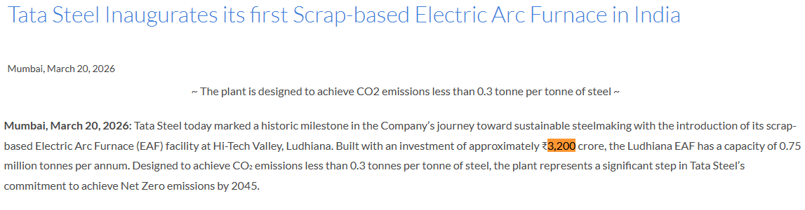
Figure 4: Tata Steel Inaugurated Scrap-Based EAF Plant with 3,200 Cr
(Source: Tata Steel Limited, 2026a)
Diversification
The fourth approach is called Diversification and will see the creation of new products for new markets. While diversification might present growth prospects for the future, it is also the riskiest form of strategic and financial investment, as it entails a significant amount of funds, considerable knowledge of the new market and the deployment of new operational strengths. In an environment where Tata Steel is already diversified, spreading its portfolio across its current strengths of steel was more fitting than foraying into diversification.
Justification
Hence, Product Development would offer Tata a best fit with respect to strategy as it would fit well with the current existing customer base, operational capability and sustainable goals of the company. In FY2026, Tata Steel produced approximately 23.4 million tonnes of crude steel, marking its highest ever production, crucial for a robust manufacturing base along with sustainability objectives including Net Zero by 2045 that enabled the introduction of innovative low-carbon steel products to existing industrial client base (Tata Steel, 2026c).

2.2 Competitive Advantage Through Electric Arc Furnace (EAF) Adoption: A Porter's Generic Strategies Perspective
Porter's Generic Strategies suggest that organisations can gain a competitive advantage via cost leadership, differentiation or focus (Porter, 1985). Tata Steel's Product Development strategy is best suited for Differentiation as the firm makes unique and value-added products of low-carbon steel, which are not the only ones based on competitive prices. Tata Steel Limited is unique in its approach to providing sustainable steel solutions through innovative products like Zeremis® green steel and investing in Electric Arc Furnace (EAF) technology, which aids industrial customers in their journey to environmental, social, and governance (ESG) goals while steering clear of carbon emissions (Tata Steel Limited, 2025).
Cost leadership focus on offering a standardised product at minimum cost using economies of scale and efficiency of operations (Ali and Anwar, 2021), whereas differentiation focuses on creating an offering that is unique, provides superior value, and fulfils an unmet need for customers. Initial investments to be made in cleaner technologies, renewable energy, hydrogen-powered steelmaking and carbon capture are prevalent in Tata Steel's journey to low-carbon steel. Thus, the firm benefits from the fact that the product quality or environmental aspects outweigh the price, not because of low prices. As an example, in 2026, the customer can buy verified steel with up to 30% recycled content, which support differentiated products and improving sustainability performance (Tata Steel, 2026f). In addition, Tata Steel enjoyed a strong customer base in India, having sold over 20 million tonnes of steel to the country, and the pattern holds true when it comes to differentiated low carbon steel going to the automotive, construction and manufacturing industries (Tata Steel, 2026d).

2.3 Critical Recommendation
Porter (1985) added these two approaches as generic ways to gain competitive advantages: cost leadership and differentiation. However, as Tata Steel moved towards being a lower-carbon business, the company needs to merge both strategies, leading to the reduction of its long-term operating costs and providing premium sustainable steel products (Tata Steel, 2026e).
The hydrogen steelmaking and carbon reduction technologies reduce the future risk of carbon taxes and compliance costs. This long-term cost-effective production approach is seen in Tata Steel's 0.75 million tonnes per annum scrap-based EAF at Ludhiana (Tata Steel, 2026b).
At the same time, Tata Steel differentiates its products by further diversifying the steel range of certified low-carbon steel products such as Zeremis® green steel which carves out a way for automotive, construction and engineering customers to lower their Scope 3 emissions and comply with growing ESG standards. This gives the company the opportunities to sell premium products, have long-term customer relationships and get sustainable supply contracts, as well as ensuring a good brand image as a green leader (Tata Steel, 2025). Tata Steel uses cost effective production process with differentiated green products, therefore gaining a sustainable competitive advantage hard to replicate by traditional blast furnace competitors.

Task 3: Critical Reflection on AI Usage

3.1 AI Tool Disclosure
No artificial intelligence (AI) tools were used to generate the content, analyse data, develop arguments, or structure this report. The research, critical analysis, interpretation of evidence, and recommendations were completed independently by author using credible academic and industry sources. AI has only been used for proofreading, correcting grammatial errors, and fine-tuning the language to ensure clarity and readability throughout the content. In compliance with the institution's academic integrity policies, this use of AI has been disclosed in the AI Use Acknowledgement.

3.2 Critical Evaluation & Error Correction
While AI was limited to proofreading and grammar correction, every factual statement, statistic, and reference mentioned in this report was kept updated independently before submission. The information was cross-checked with authoritative publications such as Tata Steel's Annual and Integrated Report, Government of India publications, Reuters, Business Standard, and Tata Steel's website. In fact, AI automations during proofreading occasionally provided speculation, non-working links to websites, and data that was subject to administrative disclosures and not based on authoritative sources or numbers during the review process. These were carefully verified from the sources and either corrected as per the latest official publications or eliminated from the source list altogether. During this verification process, it was ensured that the report of a study is academically accurate, reliable, transparent and abides by the academic integrity requirements of the institution.

3.3 Contribution Analysis

3.3.1 AI Contribution
The use of AI in drafting this report has been limited and has only provided support in language enhancement. The document has only been edited for grammatical and spelling error corrections, sentence clarity, and academic and proper writing style using AI Was not used to make the report content, search, analyse data, shape conclusions and arguments.

3.3.2 Original Contribution
The author independently selected Tata Steel as the case company and determined the focus on the Natural and Political/Regulatory marketing environment actors. From the evaluating the credible academic and industry source to the application of Kotler's Marketing Environment, Ansoff Matrix,recommendations based on Porter's Generic Strategies and the interpretation of evidence along with the development of arguments, was critically drawn by the researcher through his own perspective and critical-thinking approach.

3.3.3 Ethical and Professional Reflection
Benefits
This report underwent AI-assisted proofreading and grammar corrections to ensure its language accuracy and clarity, boosting the overall quality and readability. It also boosted the speed and efficiency within the editing process, was helpful in organising written content, and cut down on manually proofreading. All research, analysis, interpretation and academic decisions however were my own and maintained the originality and academic integrity of the report.
Ethical Issues
Ethical concerns and consequences of AI usage include the possibility of misinformation, hallucinated content, bias, copyright, and academic disintegrity. There It is important to use AI responsibly by checking facts with credible sources, citing sources carefully, explicitly stating that AI has been used or not to uphold academic integrity. The practices help guarantee that the finished product is both correct and honourable, and that it is free of plagiarism and adheres to the academic standards. It is also found that Ai given dara are mostly unauthorised or assumptive which also strengthens the human-AI integration to ensure the data used are correct and have valid source to support the data and pieces of information.

References
Ali, B. J. and Anwar, G. (2021) ‘Porter’s Generic Competitive Strategies and its influence on the Competitive Advantage’, International Journal of Advanced Engineering, Management and Science, 7(6). Available at: https://ijaems.com/
Balasubramanian Sambasivam and Sarma, R.N. (2024). India’s national green hydrogen mission: An analysis of the strategies, policies for net-zero emissions and sustainability. Environmental Research Energy. doi:10.1088/2753-3751/ad8fb2.
BigMint (2026) More than 60 mills receive green steel certificates but policy delay slowing down investments. Available at: https://www.bigmint.co/events/7th-india-international-dri-summit-2026/more-than-60-mills-receive-green-steel-certificates-but-policy-delay-slowing-down-investments
Business Line (2025) Tata Steel eyes hydrogen-ready steelmaking at Netherlands plant in green push. Available at: https://www.thehindubusinessline.com/companies/tata-steel-eyes-hydrogen-ready-steelmaking-at-netherlands-plant-in-green-push/article69818679.ece
Business Standard (2026) India's steel exports to EU may fall 24% due to CBAM, says ICRIER study. Available at: https://www.business-standard.com/economy/news/india-s-steel-exports-to-eu-may-fall-24-due-to-cbam-says-icrier-study-126062601055_1.html
Down To Earth (2024) India drives global coal-based steel expansion as new blast furnace projects rise. Available at: https://www.downtoearth.org.in/energy/india-drives-global-coal-based-steel-expansion-as-new-blast-furnace-projects-rise-5
GMK Center (2026) The steel industry is concerned about the slow progress of green steel projects. Available at: https://gmk.center/en/news/the-steel-industry-is-concerned-about-the-slow-progress-of-green-steel-projects/
Homaio (2024) CBAM: Europe sets its first carbon border price at €75.36 / tCO2. Available at: https://www.homaio.com/post/cbam-europe-sets-its-first-carbon-border-price-at-eu75-36-tco2
Kumar Chaudhary, A. (2026). Steel scrap recycling: India’s strategic opportunity to build a circular economy. [online] ET Edge Insights -. Available at: https://etedge-insights.com/industry/manufacturing/steel-scrap-recycling-indias-strategic-opportunity-to-build-a-circular-economy/ [Accessed 16 July 2026].
Ministry of New and Renewable Energy (2023). Steps by Government to promote renewable energy in the country. [online] Pib.gov.in. Available at: https://www.pib.gov.in/pressreleaseiframepage.aspx?prid=1897778&reg=48&lang=2 [Accessed 16 July 2026].
Ministry of Steel (2025) Greening the Steel Sector in India: Roadmap and Action Plan. New Delhi: Ministry of Steel, Government of India. Available at: https://steel.gov.in
Ministry of Steel (2026) Final Annual Report 2025-26. New Delhi: Ministry of Steel, Government of India. Available at:https://steel.gov.in
PRS Legislative Research(2026d). [online] CommitteeReports. Available at: https://prsindia.org/policy/report-summaries/steel-scrap-recycling-policy [Accessed 16 July 2026d].
Reuters (2026a) India aiming to cut steel emissions by 25%, double capacity, document shows. Available at: https://www.reuters.com/sustainability/climate-energy/india-aiming-cut-steel-emissions-by-25-double-capacity-document-shows-2026-04-09/
Reuters (2026b) Steel industry sounds alarm over slow progress on green steel. Available at: https://www.reuters.com/business/environment/steel-industry-sounds-alarm-over-slow-progress-green-steel-2026-06-19/
Tata Steel (2025) Tata Steel recognised as 2025 Steel Sustainability Champion by worldsteel for the eighth consecutive year. Available at: https://www.tatasteel.com/newsroom/press-releases/india/2025/tata-steel-recognised-as-2025-steel-sustainability-champion-by-worldsteel-for-the-eighth-consecutive-year/
Tata Steel (2026a) Tata Steel inaugurates its first scrap-based Electric Arc Furnace in India. Available at: https://www.tatasteel.com/newsroom/press-releases/india/2026/tata-steel-inaugurates-its-first-scrap-based-electric-arc-furnace-in-india/
Tata Steel (2026b) Tata Steel partners with SMS group to deploy world-first EASyMelt decarbonisation technology. Available at: https://www.tatasteel.com/newsroom/press-releases/india/2026/tata-steel-partners-sms-group-to-deploy-world-first-easymelt-decarbonisation-technology/
Tata Steel (2026c) Tata Steel reports consolidated EBITDA of Rs 34,848 crores and Profit After Tax of Rs 10,886 crores for the twelve months ended March 31, 2026. Available at: https://www.tatasteel.com/newsroom/press-releases/india/2026/tata-steel-reports-consolidated-ebitda-of-rs-34-848-crores-and-profit-after-tax-of-rs-10-886-crores-for-the-twelve-months-ended-march-31-2026/
Tata Steel (2026d) Tata Steel 4QFY2026 and FY2026 production and delivery volumes (provisional). Available at: https://www.tatasteel.com/newsroom/press-releases/india/2026/tata-steel-4qfy2026-and-fy2026-production-and-delivery-volumes-provisional/
Tata Steel (2026e) ESG Indicators Factsheet. Available at: https://www.tatasteel.com/sustainability/esg-indicators-factsheet/
Tata Steel (2026f) Zeremis Recycled. Available at: https://products.tatasteelnederland.com/services/sustainable-solutions/zeremis/recycled
Tata Steel Limited (2025) Integrated Report 2024-25: Financial Capital. Available at: https://www.tatasteel.com/investors/integrated-report-2024-25/financial-capital.html
Tata Steel Limited (2026a) Integrated Annual Report 2025-26. Available at: https://www.tatasteel.com/media/25904/tatasteel-iar-2025-26.pdf
Tata Steel Limited (2026b) Press Release and Analyst Presentation. Available at: https://www.tatasteel.com/media/25704/press-release-and-analyst-presentation.pdf
Tata Steel Limited (2026c) BSE/NSE Filing. Available at: https://www.tatasteel.com/media/25615/bsense-signed.pdf
Vadim Kolisnichenko (2024). Indian steel industry leads the world in CO2 emissions. [online] GMK. Available at: https://gmk.center/en/news/indian-steel-industry-leads-the-world-in-co2-emissions/ [Accessed 16 July 2026].
Young, S. and Suleiman, F. (2024). Tata Steel to close UK blast furnaces with loss of up to 2,800 jobs. Reuters. [online] 19 Jan. Available at: https://www.reuters.com/business/tata-steel-cut-up-2800-uk-jobs-2024-01-19/ [Accessed 16 July 2026].

