

Module: - Managing Engineering Projects
M7X01374/ACEA7009
Author: - Adrian Devonald
Student Number: - 0450573

Content
Introduction……………………………………………………………………………………………………………………………………...4
Valero-Berth 6-Loading Arm Project…………………………………………………………………………………………………5
Projects GANTT Charts and Critical Path activities……………………………………………………………………………6
-Using GANTT Charts…………………………………………………………………………………………………………….6
-Projects-Critical Path…………………………………………………………………………………………………….....7,8
- GANTT-Critical Path Activities……………………………………………………………………………………………..9
Communication-Project Management …………………………………………………………………………………………..10
PERT Analysis and Risk Management……………………………………………………………………………………………..11
-PERT Formula…………………………………………………………………………………………………………………….11
-Advantages of PERT……………………………………………………………………………………………………………11
-Disadvantages of PERT…………………………………………………………………………………………..............11
-Risk Management…………………………………………………………………………………………......................11
-FMEA…………………………………………………………………………………………………………………….12
-SWOT……………………………………………………………………………………………………………….12,13
Project Activity Costings………………………………………………………………………………………………………………….14
-Total Project Cost……………………………………………………………………………………………………………….15
-GANTT-Project Costings……………………………………………………………………………………………………..16
- Project Break Down Costs- Pipework / Loading Arm Disinvestment………………………………….17
-GANTT-Critical Path Costings……………………………………………………………………………………………..18
-Disinvestment of Loading Arm Info…………………………………………………………………………………….19
Crash Costing…………………………………………………………………………………………………………………………………..20
-Critical Path- Pipework / Loading Arm Disinvestment………………………………………………………..20
- Original Costing…………………………………………………………………………………………………………………21
- Additional Labour Costing…………………………………………………………………………………………………22
-Overall Project Time and Costings-Reduced by 7 days...…………………………………………………….23
Resource Scheduling Smoothing…………………………………………………………………………………………………….24
Project Handover-Potential issues………………………………………………………………………………………………….25
-Customer Acceptance………………………………………………………………………………………………………..25
-Training Handover to operations……………………………………………………………………………………….25
-Communication………………………………………………………………………………………………………………….25
-Completion Packs/Sign Over………………………………………………………………………………………………25
Conclusion……………………………………………………………………………………………………………………………………….26
References…………………………………….………………………………………………………………………………………………..27

Introduction
Within this paper I aim to critically analyse and discuss a range of project management techniques which would need to be considered when running a project from a management team’s point of view. The aim is to discuss key factors that are involved with the disinvestment and re-installation of a jetty, tanker loading arm on a petrochemical site. I will discuss a number of key factors in which are critical during the project and how tasks are managed accordingly, keeping within the given time scale and budget as per client’s set requirements.
Certain applications can be applied to control the overall cost and timescale of the project, looking at critical path activities and resource scheduling and smoothing to allow the project to progress as originally definite on the issued plan. I will demonstrate the projects activities and time frame using a GANTT chart highlighting and discussing key techniques that can be applied to achieve the required outcome.

Valero-Berth 6-Loading Arm Project
Within this paper, I aim to look at a project in which Altrad carried out on Valero, Pembroke Refinery. The project was to disinvest and re-install a loading arm onto one of their current berths that is operational for the use of loading and unloading products to tanker freight.
Image- Berth 6-Valero Refinery, Pembroke
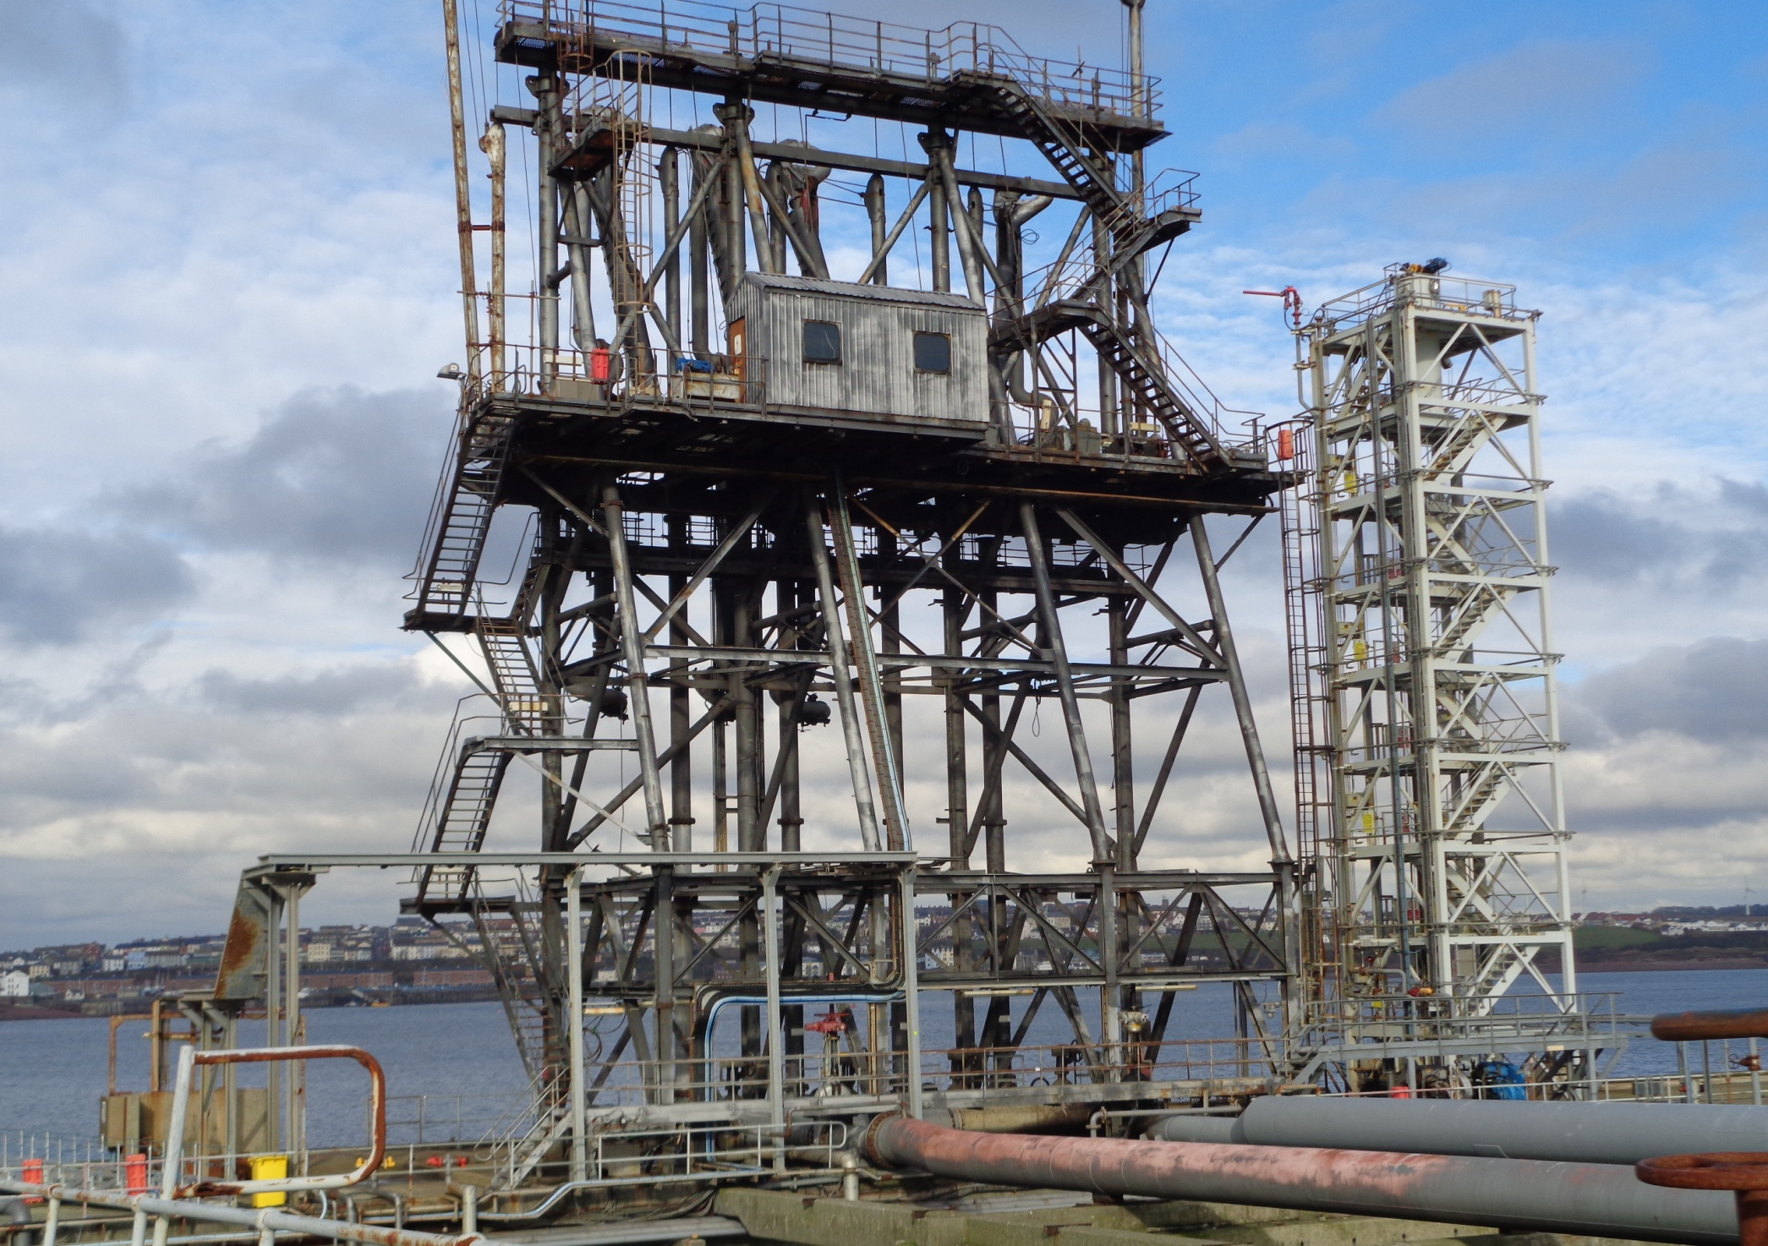

My aim is to discuss and demonstrate applications in which can be utilised to make managing the project and key activities within it successfully.
Using the GANTT chart provided, there are a number of key activities that contribute to the overall project outcome, into which I aim to talk in more detail within this paper. I will be discussing key activities such as critical path activities, crash costings and resource smoothing to demonstrate how the project outcome can managed using key techniques making the outcome more efficient to the user and client.

Project GANTT Charts and Critical Path activities
A GANTT Chart is a project management tool that can illustrate activities that are to be under taken during a project, stating durations, labour requirements, critical path works and any specific tasks/resources that may be required during a project. GANTT charts are useful to keep tasks on track, keep all involved aware of critical dates and activities which need to be abided too and making sure the client know exactly what’s going on and at what stage of the project.
As it’s in a bar chart format it is possible to check on progress with a quick glance. You can easily see:
- A display of the overall project and requirements
- Fixed timelines and deadlines of all tasks/operations involved
- Relationships and dependencies between various activities
- Project phases
1-(Apm.org.uk, 2020)
Using GANTT Charts
“Once all activities within the project are defined, this is where a GANTT chart can be drafted to allow a visual of the required durations, labour/resources required to achieve the given tasks. In addition to this, the project manager can get a clear understanding of the costing required to achieve the end goal also.” 1-(Apm.org.uk, 2020). The budget for the project is a major factor to all parties. The project manager and the team will see the budget as the most critical and would benefit from sing GANTT charts to help visualise the requirements for addition labour/ resources to speed up certain process, therefore could downsize the team where the labour pools are not required the fore reducing the costs at certain stages of the project. The projects manager will be driving to make sure budgets are adhered too s set in the tender and planning stages.
Although, once a project has been finalised on the planning stages and project plans distributed to contractors, clients and alike, the various stages within the planned installation can change or overlap. This could be down to a number of factors be it human errors, not enough man power, resources available, or simply down to natural disasters such as bad weather, and unforeseen incidents in which may delay any specific personnel or materials required for the project being available on the given dates.

Critical Path Activities
Critical path is a key factor to consider for a project manager. The critical path activities could have a massive impact of the overall plan and outcome of the project, therefore pushing the original timeframe of completion out along with the original set budget. The project manager would determine what tasks are critical and non within the project to make sure the non-dependant tasks have enough slack in them to be determined as non-critical.
Non-Critical- Not every task is dependent on those preceding it, therefore would not qualify being classed as critical path activities.
Critical- The sequence of tasks on the critical path are all connected, if one task is delayed, it will have a knock-on effect for the remaining items on the critical path and the overall project outcome.

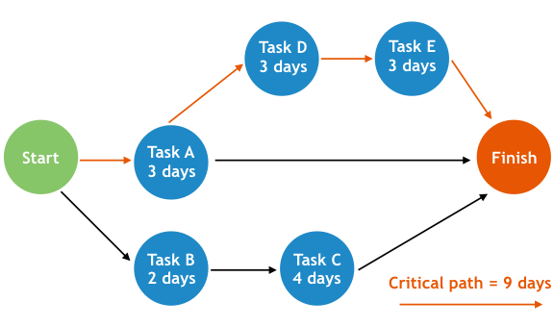
2-(O&#039;Loughlin, 2020)

“Any slippage in tasks on the critical path will result in slippage of the project as a whole. Delays in tasks outside the critical path won’t result in slippage of the whole project unless those delays become so acute that these tasks become the new critical path.”- Steve Chong, chief operating officer and product manager for projector PSA- 2-(O&#039;Loughlin, 2020).

Once a project is well underway, it is good practice for the project managers to revisit the program to keep and eye on the critical path activities within. There may be items on the original plan that are complete prior to the stated date, therefore this would release further resources to work on critical path activities pulling the whole projects completion date forward.
As I have used an example GANTT chart using Microsoft Projects, this program allows me to generate a network diagram in which allows the users to get a visual of the activities and the critical path works. Diagrams are useful tools to allow users to assign relevant tasks of a project within a certain given timeframe. A network diagram is a set of interconnected nodes. Tversky, Zacks, Lee, and Heiser (2000) found that circles tend to be used to represent enclosed spaces. Objects clearly lend themselves to representation by circles because they occupy a closed, finite space. A network diagram is a set of interconnected nodes. Tversky, Zacks, Lee, and Heiser (2000) found that circles tend to be used to represent enclosed spaces. Objects clearly lend themselves to representation by circles because they occupy a closed, finite space. 3-(Hurley and Novick, 2010).
As per figure 1 below and the documents attached and, you can see the clear critical path activities highlighted in red (Task 31 through to 39) and how each activity is linked within the project. Each activity is key to allow the next to follow on accordingly. F there is a break in any of the critical path activities, it will have a knock-on effect to the following task and running alongside the project during this period.

Figure: GANTT Chart- Critical Path Activities-31 to 39

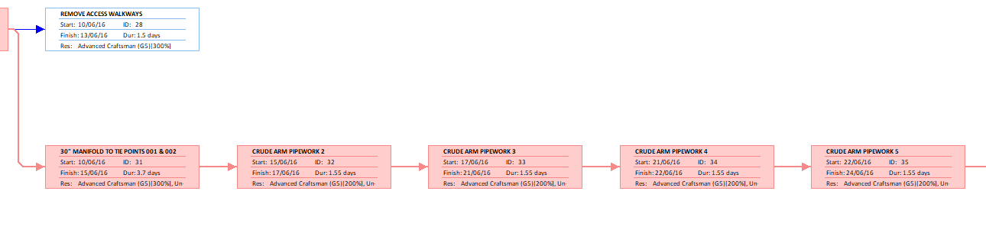
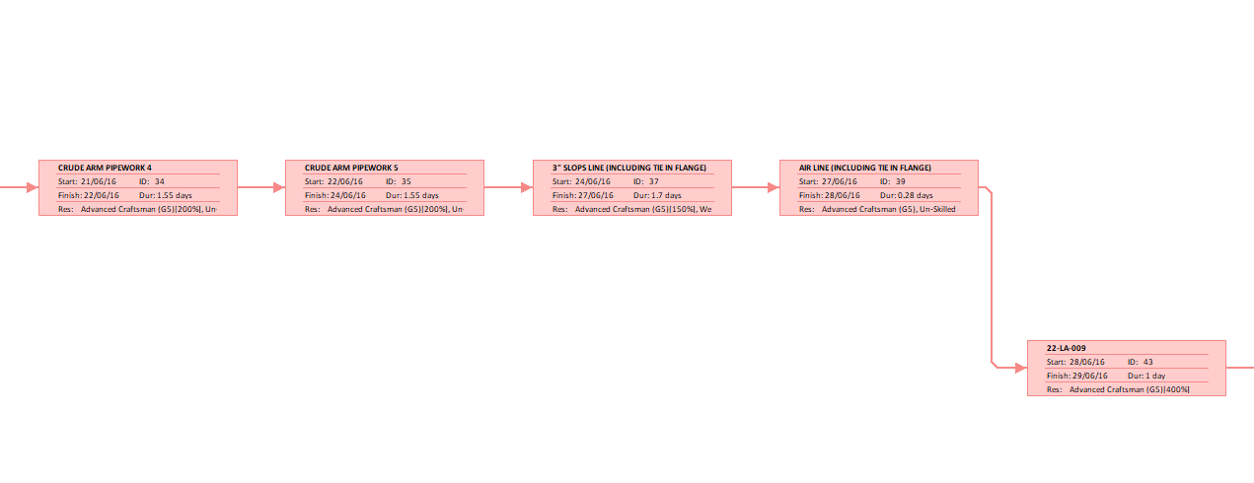

Communication-Project Management
Communication is a key factor for all parties involved in a project. Using tools such as GANTT charts and PERT analysis can allow all parties to be aware of the activities ongoing within a project and making sure they are aware of critical works within the given timeframe. Positive communication is usually described as effective in achieving its aim. “It is necessary to point out though that success in communication can be seen in two ways: first, as getting the message through to the addressee and second, achieving satisfaction by all the parties involved” 4-(Leontovich, 2014).
As above, communication plays a key part when running a project. The way in which information is communicated to all involved is critical. Total transparency with the client is key, where as if any issues arise that could affect the initial work scope and plan, that they are recorded and address accordingly so as the project plan and durations are not affected unannounced. If issues occur, they can be placed into the plan accordingly, stating work scope and durations for all to see.
As demonstrated further on in this paper, prior to any works starting on site, Altrad invited the client to a presentation on a project break down, stating how each stage would be managed. This would detail labour, plant and equipment and any third-party organisations that would be required to carry out the given tasks.
Transparency through the project is key for all parties. If any aspects of the project where withheld from the client which resulted in a downfall regarding the require works, this could have a massive impact not only on the project itself, but the organisations reputation for all future works.

PERT Analysis and Risk Management
Project Evaluation Review Techniques is used to identify the time it takes to carry out specific activities or tasks within a project. It is a system that helps with the scheduling and coordination of tasks throughout the project. 5-(Corporate Finance Institute, 2020). A project should have a defines beginning and a completion date. Knowing the overall duration of a project can help factor in a number of aspects such as budgets and resources required. Using PERT will help determined a realistic project plan, rather that try and estimate durations and resources required.
Here are several terms used in a PERT chart:
- Float/Slack – Refers to the amount of time a task can be delayed without resulting in an overall delay to other tasks or the project
- Critical Path – Specifies the longest possible continuous path from start to finish or event
- Critical Path Activity – Refers to an activity without slack
- Lead Time –The time needed to finish a task without affecting subsequent tasks
- Lag Time – The earliest time by which another task can follow on from a task underway
- Fast Tracking – Refers to handling tasks or activities in parallel
- Crashing Critical Path – Shortening the amount of time to do a critical task
5-(Corporate Finance Institute, 2020).
PERT FORMULA
To conduct PERT Analysis, three-time estimates are obtained (optimistic, pessimistic, and most likely) for every activity along the Critical Path. Then use those estimates in the formula below to calculate how much time for each project stage:
PERT Formula = P + 4M +O
6
Optimistic Time (O): the minimum possible time required to accomplish a task, assuming everything proceeds better than is normally expected.
Pessimistic Time (P): the maximum possible time required to accomplish a task, assuming everything goes wrong (excluding major catastrophes).
Most likely Time (M): the best estimate of the time required to accomplish a task, assuming everything proceeds as normal.
Advantages of PERT
There are many advantages to using PERT in a project: -
- It helps to utilize the resources to its maximum capacity effectively
- It makes the project more manageable
- It can help sort um scheduled activities out during the project
- It enable managers to determine an exact date for completion
Disadvantages of PERT
Like any tool, there are some downside that can occur when using PERT: -
- It can be tedious, and is time consuming to modify or adapt
- It can entail a subjective time analysis therefore effect the projects planned schedule

Risk Management
When it comes to project, there are many risks that can become apparent prior to, during and after the project has finished. This could be from the initial design / concept stage, to installation issues and then to handover and commissioning of the system installed. I aim to talk further about project handover further on in this paper but want to discuss tools that can be utilised to mitigate or reduce the risk during a project. FMEA, SWOT and 5’Ys are a number of tools that could be used, “Projects involve participants from different specialties working together which makes the cooperation among them designed around extensive, disparate and interrelated processes”. 6-(Irlayici Cakmak and Tezel, 2019)
FMEA
FMEA (Failure Mode and Effects Analysis) is a systematic method to map failure modes, effects and causes of technical systems [1]. It is an inductive and bottom-up method, since the analysis starts at the component level where the possible component failure modes are identified, and it is examined what the consequences are on a higher level. Usually, the FMEA is carried out with a diverse team of people with various backgrounds (e.g., mechanical design, software, operations, maintenance) since this increases the probability that all possible failures are identified and the effects properly estimated [2]. 7-(Peeters, Basten and Tinga, 2018)
SWOT
Strengths, weaknesses, opportunity and Threat (SWOT) is another tool that could be utilised to assess how a project could affect the business and be a risk.
Strengths-
  - What are the advantages of the project?
  - What are the factors supporting the project?

Weaknesses-
  - What could be improved?
  - What should be avoided?
  - What obstacles hinder progress?
  - Which elements need strengthening?
Opportunities-
  - What benefits may occur to contractors and client?
  - What changes in usual practice may occur?
  - What changes in Government policy may occur?
  - What changes in standardization may occur?
Threats-
  - Do the relevant stakeholders show their willingness and interest to support the project from concept to completion?
  - What external obstacles does the project face?
  - Is the changing technological and economic environment threatening the project market success?
8-(Reißmann, Thrän and Bezama, 2018)
“Project Management Institute (PMI) defines project risk as “an uncertain event or condition that, if it occurs, has a positive or negative effect on a project objective. … there will be a consequence on the project cost, schedule, or quality” 6-(Irlayici Cakmak and Tezel, 2019)-9
Further to the tools mentioned above being utilised to help asses the project risk, there are other factors that many effects the project due to the location and nature of the project. Being on a jetty, natural hazards, such as tidal and weather issues may be unforeseen and unpredictable. These issues would affect the work force on the jetty, permits not being issued as to unsafe due to weather conditions, through to wind having an effect on all lifting activities which all could affect the overall project timescale and outcome. Although project managers may plan the project to suit a season where these conditions are relatively, there may be natural conditions that can’t be predicted.

Project Activity Costings
Project costings can vary, but there will be a budget as set by the client for the specific works to be carried out. Projects aren’t supposed to last forever, nor should they consume every available resource. Every project has limited resources of some kind, such as a price set by the client, a limited number of available resources, the number of work house that can be utilised between the start and finished date. For a given scope of works, the below figure could be applied, choosing two of the given values will then determine the value of the third.
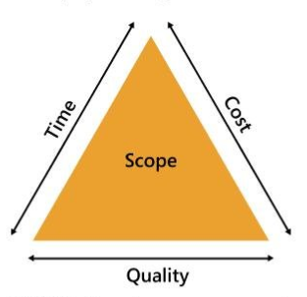
9-(Biafore, 2011)
As the GANTT chart for the project shows, the overall cost is £205,930.60. This is generated taking all the activities, durations and costs into consideration. Every year Altrad will agree fixed prices or NORMS as they are called within the business so both parties are aware of the costing for the works that arise on the refinery.
Included in the agreed rates (NORMS): -

Labour-Per Trader -Un-skilled, craftsman, advanced craftsman, charge hand, supervisor, welder and alike

Working Hours-Normal working hours and premium time working rates

Plant and Equipment Hire- Crane hire, hiab hire, weld set hire etc.

Sub-Contractors- Rates of any specific 3rd party works to be carried out

All the above will be agreed on a yearly basis with commercial mangers for both parties. Once agreed this is applied to any enquires that are received from the client. Further to this, with regards to fabrication, there is a further set of agreed rates into which each activity such as weld set up, welding (Inc. size and SCH pipe) NDT requirements, pressure testing allows I’ll be included and broke down stating ach price for each activity.

Project Costings
There are a number of costs associated with the overall price of a project. As noted below, final costings where agreed by both parties and written into the final contract of works agreement.
Figure 1: Valero Tender Document-22-EME-SOW-001
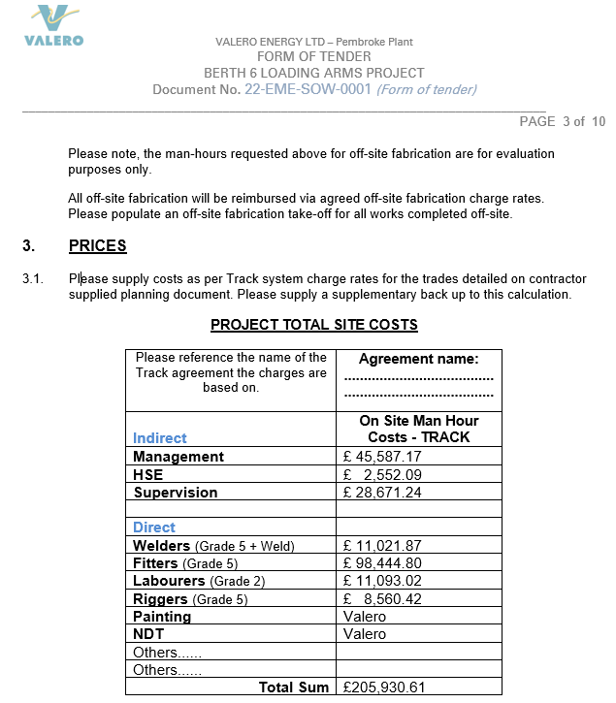
Reference external documents- 22-EME-SOW-0001
Two types of costs:
a) direct (variable) – those calculation items which can be identified on the calculation object (product, service, work, phase, activity, function etc.), since the planning stage, carrying out of consumption and post calculation analysis. The following are included in this category: raw materials and direct materials, energy consumed for technological purposes, direct manpower etc. Direct costs are characterized by fluctuations which are proportional to the evolution of the production volume. 10-(Bîrle, 2015)
b) indirect – refer to the consumptions or expenses which are not clearly or directly identified on the calculation object. Usually indirect costs are in relation to the activity that is adjacent to the basic economic process, being necessary and often indispensable. Indirect consumptions are also called fixed expenses or overheads and are relatively constant in relation to the fluctuation of the production volume. 10-(Bîrle, 2015)
Extracting information from the GANTT chart, as below it generates a total number of working days, hours, predicted start and finish date and the overall total cost of the project.

Figure 2: Valero Tender Document-22-EME-SOW-001-Overall Labour Hours and Costs
Task Name | Duration | Start | Finish | Work | Resource Names | Cost
BERTH 6 PROJECT | 109.98 Days | Fri 01/04/16 | Fri 02/09/16 | 6,966.39 hrs | N/A | £206,394.70

All the items above can be amended to suit project’s needs, be it allocating additional resources to specific activities within the project, to working additional hours to.
As noted below, the overall duration of the project was planned to 109.98 days. From disinvestment to re-investing the berth loading arms and pipework.

Figure 2: GANTT Chart- Project Durations and Costs

Project Break Down Costs- Pipework / Loading Arm Disinvestment
For the purpose of this section of the paper, I will talk about a specific activity within the project and break down certain aspects to get an understanding of costings. I have decided to talk about the disinvestment of the loading arms and pipework that are required to be removed. These are all critical path activities which play a massive part and can impact the overall project status and cost if the works are delayed or effected in any way.
Figure 3: Valero Tender Document-22-EME-SOW-001
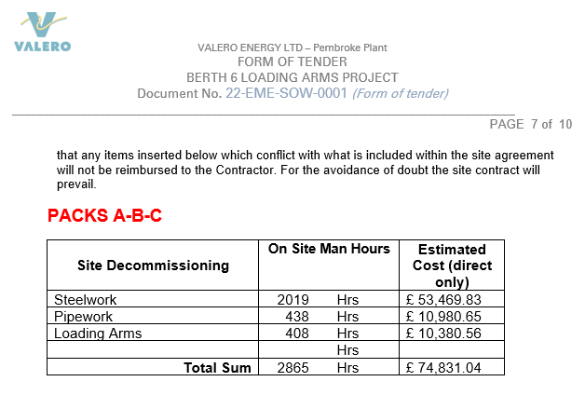
As Figure 1 states, once all documentation has been submitted to the client regarding costings, labour, plant and alike, a total project cost of works was generated and stated in the contract of works document (22-EME-SOW-0001). As noted from the off, any items added to this original agreed price would not be reimbursed to the contractor carrying out the works, therefore the project manager would have to manage it accordingly.

Figure 4: GANTT Chart Pipework/Loading Arm Disinvestment Costs And Durations
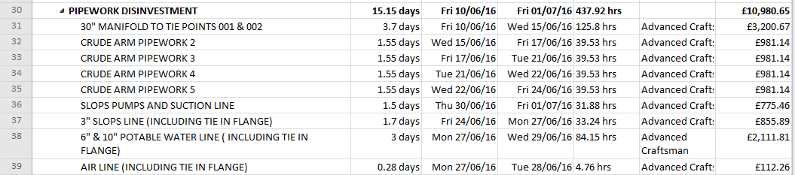

As noted above, I have extracted the specifc tasks from the GANTT Chart which state the overall cost for the disivvesment. Originally noted, 51.15 days and at a cost of £10.980.65 was the outcomne generated using the infomration provided and inputted into the project GANTT.

Figure 5: Pipework/Loading Arm Disinvestment Costs
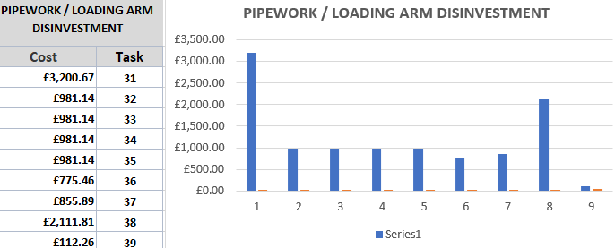

Further on in this paper I aim to look at crash costing these specific tasks and resource smoothing to pull the overall project duration in by seven days. This may result in higher daily rates as further labour and resources will be a requirement and additional working hours, but overall will draw the project to completion sooner.

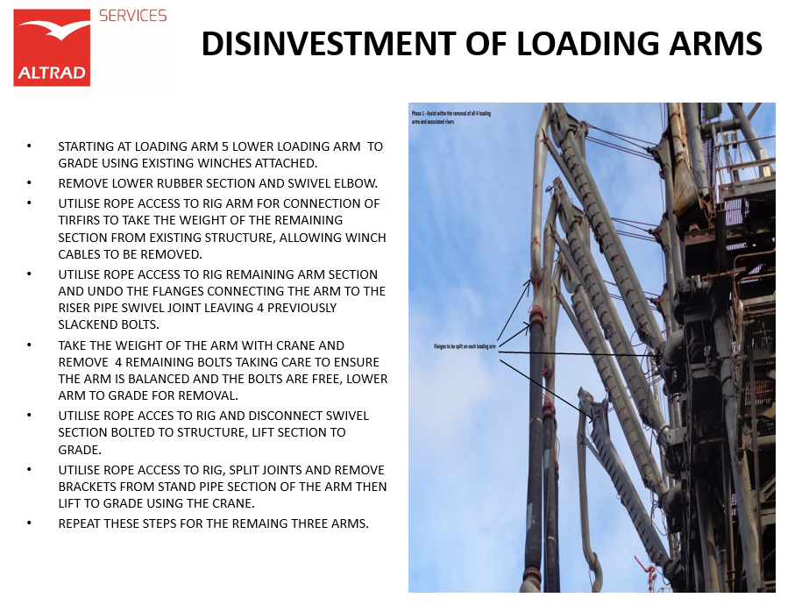

Crash Costing
“Crash costing during a project is applied to minimize the required project cost while meeting a specified deadline. In practice, this problem may be of great complexity because industrial professionals often encounter nonlinear, discrete, or even piecewise discontinuous activity time–cost functions”.11-(Yang, 2007)-6
A project can be defined by a set of activities into which are applied to achieve the end goal set by a client. Once works is under way, there will be opportunities for the project manager to review activities and try and find ways to pull the project completion date forward. Crash costing is a way to compress the schedule and deliver the project sooner than planned.
Allocating additional labour to specific activities or setting additional working hours for activities to be undertake, there are many ways on which the project can draw to completion sooner than planned.
Following on from the example previously in this paper, I will continue to discuss the disinvestment task as they are critical path and what can be applied to reduce the overall timescale.

Figure 6: GANTT Chart Stating Original Planned Hours
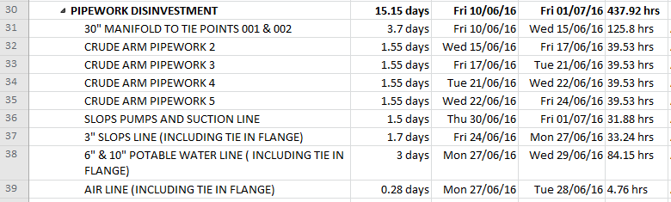

As per the examples above and attached, allocating additional labour to activities within the plan will have a knock-on effect to all other works within the project, and the project overall. Although the additional labour will increase the cost for that one activity, it will reduce the time required to complete that given task therefore reduced the overall project timescale consequently reduce the overall costings.
If the additional labour is allocated to critical path activities, then other tasks around it should follow suit, and will allow labour to be allocated to task sooner than planned, therefore allowing activities to start and finish earlier. This will be depending on tasks being complete prior that are dependent of one task following another.

As an example I have highlighted activty 31 (critial path) which states the original planned hours and labour assigned to the task. This is a indication for all involved in the project of the minimum requirments to carry out this task.
Figure 7: Original Planned Hours To Carry Out Task 31.
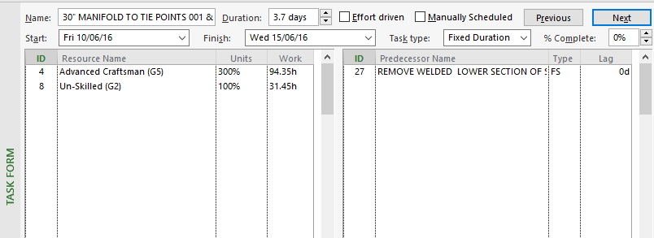

As illustrated below, to reduce the duration of activity 31, I have allocated additional labour to the activity. This will allow the activity to be carried out and complete sooner than originally planned.

Figure 8: Additional Labour To Reduce The Days Required To Carry Out Task 31.
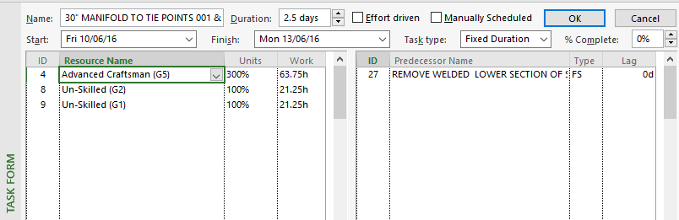

Although bringing the task in sooner will look good to project managers and the client, there will be a cost implication on this change. The overall project cost will increase due to the increased workforce and the premium time working hours.
Applying this approach to a number of critical paths activities within the plan will reduce the project significantly. I will demonstrate the over all effect this can have on the project later on in the paper after discussing resource smoothing.

As additional labour and working hours have been added to the critical path activites, you can now see the benefit and the knock on effect it has had on the activities around. One of the aims of this assignment was to reduce the overall duration of the poriject by seven day sin wihc is visallble celar in the extract below.
Figure 10:Additional labour to reduce the days required to carry out task 31.
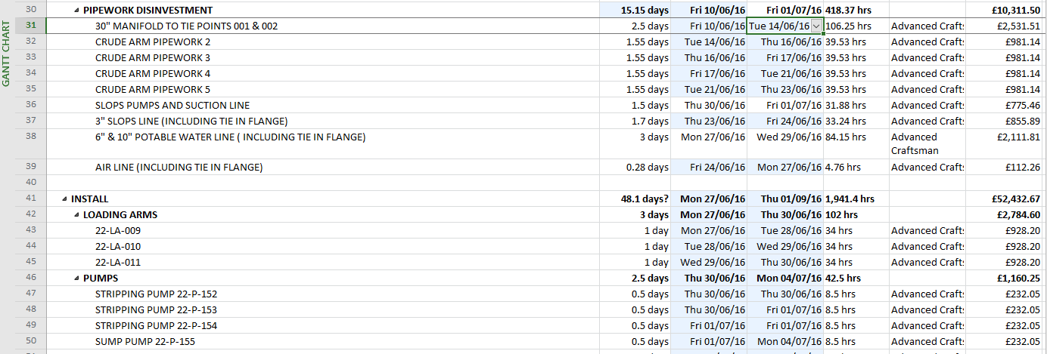

As mentioned above, allocating additonal labour to a specific critical path activites will have an impact of the overall cost and timescale of the project. By adding additional labour to specific activities within the project, you are reducing the labour on another activites, as discussed in resource smoothing. As noted below (Figure 9) demonstrations the original project hours and costing, along with the new projected cost of the porject after resource smoothing has been impimneted (Figire 10).
Figure 9: Original Planned Hours and Cost

Figure 10: Resource Smoothing- Working Hours and Cost

As the above figures show and as the examples show previously in the paper (Figure 7 and 8), the cost of the project will increse by £7,933.94 due to the additonal/premium time hours working that will generate such costs. But by doing this, it ill enable the project to come in 8.73 days prior to the originally agreed date.

Resource Scheduling Smoothing
Resource smoothing is a project management technique that can be utilised to maximise the workforce within a project timescale. It ensures that the requirements for the allocated resource on the project do not go beyond or exceed the pre-defined resource limits. Thus, the project’s critical path remains the same thus the completion date may not be delayed. 12-(Project-management-knowledge.com, n.d.).
It is a tool which can be used when time constraints are an important priority within a project. When taking resources from one task and placing them into another, this can have an effect on tasks, delaying them so that critical path activities can keep within the program, or getting them ahead. Project managers can take resources from critical path activities, they can only add further to critical works.
“Smoothing- Objective To produce a feasible schedule within the time constraints with a uniform level of resource requirement or planned usage. Method- In the allocation routines it is very difficult to produce a schedule which is time limited where the resource requirement does not suddenly explode into unacceptable dimensions. The smoothing procedure looks at the total project and works within the time frames of the project that has been set by the user. There are four steps in the cycle which repeats until all activities have been scheduled: 1. Schedule any critical activities. 2. Find the most important activity yet to be scheduled. 3. Find the best place to schedule this activity and do so. 4. Adjust the early and late times of the unscheduled activities to take account of this newly scheduled activity”. 13-(Gordon and Tulip, 1997)
When resource smoothing, no labour can be redirected from critical path activities. Resources can only be taken form noncritical path works.

Project Handover-Potential issues
“A project is a temporary organisation, which means that at the end of the project the project manager will move onto another project, possible in a different location with a new group of employees and a different client. The project manager will need to be focused on the new project. So, what they would not want, is constant stream of interruptions from people using the previous project they have just completed. So, this would mean the project manager completing a full comprehensive handover to all involved in the running and maintaining of the system installed”. 14-(Billigham, 2008)
There are many factors that have to be in place on multiple projects that have been handed over successfully from transition to business-as usual.
Customer/ Commercial Acceptance
Once all works have been carried out, the project team will carry out all quality and commissioning check making sure that the project meets the specification as stated by the client. If there are nay deviations from the original scope, then this should all be documented and accepted by the client prior to moving on to the next stage.

Training Handover to operations
All end users must be trained accordingly to run the new system accordingly. Engaging them in the installation and commissioning stages would allow them to gain valuable experience and knowledge of the plant/system into which they will manage in the future. Training will improve productivity and performance. And when executed well, it does just that. It provides your employees with the expertise they need to fulfil their role and make a positive impact on your business. 15-(LearnUpon, 2020)

Communication
Transparent communication through the whole project is key. The projects team must be honest with the client when any issues or any change from the original design occur. This will allow any change to be noted therefore would not cause any long-term disruptions when the system is commissioned and on-line.

Completion Packs/Sign Over
Once all commissioning and quality checks have been carried out, the handover of work instruction, manuals and quality dossiers to the client are critical. Documentation must be written for the end users. It may require different sets of documentation for different users but for documentation to support knowledge transfer it needs to be meaningful, applicable and relevant to the end users. 16-(Apm.org.uk, 2020). Making sure all relevant documentation s submitted during handover is critical to allow end users to obtain any information

Conclusion
This paper has allowed me to discuss critical aspects of a project undertake by Altrad Services on the Valero Refinery, Pembroke. I have constructed and utilised a GANTT chart and extracted key aspects in which have been discussed in further detail to enable more of an understanding to project management. Using the GANTT I have discussed critical path activities, project costings, crash costing and resource smoothing to enable the project to run as effectively as reasonably practicable. Further to this, I have then gone onto to discuss other aspects of the projects which involve communication within a Project and how its key, Risk management and the tools that could be utilised to mitigate such risks (PERT, SWOT and 5y’S) techniques that can be utilised to make the project a success. Finally, project handover issues where researched and discussed on how critical a successful project handover is key to all parties involved. From the installation projects team, making sure all aspects of the project where undertake from concept to completion as per client’s instruction, to handover and commissioning, making sure all operators are sufficiently trained and competent to use the installed system and to where all completion and handover documents are submitted to the client.

References
1-Apm.org.uk. (2020). What is a Gantt chart? | APM. [online] Available at: https://www.apm.org.uk/resources/find-a-resource/gantt-chart/ [Accessed 16 Jan. 2020].
2-O&#039;Loughlin, E. (2020). What Is Critical Path? Knowing Can Drive Project Success. [online] Software Advice. Available at: https://www.softwareadvice.com/resources/what-is-critical-path/ [Accessed 17 Jan. 2020].
3-Hurley, S. and Novick, L. (2010). Solving problems using matrix, network, and hierarchy diagrams: The consequences of violating construction conventions. Quarterly Journal of Experimental Psychology, 63(2), pp.275-290.
4-Leontovich, O. (2014). Positive Communication: Definition and Constituent Features. Vestnik Volgogradskogo gosudarstvennogo universiteta. Serija 2. Jazykoznanije, (5), pp.121-126.
5-Corporate Finance Institute. (2020). Project Evaluation Review Technique (PERT) - Overview & Components. [online] Available at: https://corporatefinanceinstitute.com/resources/knowledge/other/project-evaluation-review-technique-pert/ [Accessed 17 Jan. 2020].
6-Irlayici Cakmak, P. and Tezel, E. (2019). A Guide for Risk Management in Construction Projects: Present Knowledge and Future Directions. 1st ed.
7-Peeters, J., Basten, R. and Tinga, T. (2018). Improving failure analysis efficiency by combining FTA and FMEA in a recursive manner. Reliability Engineering & System Safety, 172, pp.36-44.
8-Reißmann, D., Thrän, D. and Bezama, A. (2018). Techno-economic and environmental suitability criteria of hydrothermal processes for treating biogenic residues: A SWOT analysis approach. Journal of Cleaner Production, 200, pp.293-304
9-Biafore, B. (2011). Successful Project Management. Applying best practices and real world techniques with Microsoft Project, [online] 1(1), pp.1-415. Available at: https://www-dawsonera-com.ezproxy.uwtsd.ac.uk/readonline/9780735661905 [Accessed 17 Jan. 2020].
10-Bîrle, V. (2015). OPTIMIZING INDIRECT COSTS IN PROCESSING CENTERS USING THE MHR METHOD. Vol. 24(Issue 2,), pp.p485-492. 8p.
11-Yang, I. (2007). Performing complex project crashing analysis with aid of particle swarm optimization algorithm. International Journal of Project Management, 25(6), pp.637-646.
12-Project-management-knowledge.com. (n.d.). Resource Smoothing - Project Management Knowledge. [online] Available at: https://project-management-knowledge.com/definitions/r/resource-smoothing/ [Accessed 26 Jan. 2020].
13-Gordon, J. and Tulip, A. (1997). Resource Scheduling. [online] Available at: https://pdf.sciencedirectassets.com/271951/1-s2.0-S0263786300X0018 [Accessed 7 Feb. 2020].
14-Billigham, V. (2008). Project Management. Planning and Delivering a successful Project, 1(1), pp.115-117.
15-LearnUpon. (2020). The Importance of Training Employees for your Business | LearnUpon. [online] Available at: https://www.learnupon.com/blog/importance-of-training-employees/ [Accessed 8 Feb. 2020].
16-Apm.org.uk. (2020). 12 factors for the successful handover of projects. [online] Available at: https://www.apm.org.uk/resources/find-a-resource/project-handover/12-factors-for-the-successful-handover-of-projects/ [Accessed 8 Feb. 2020].

