

Module: Strategic Management
Module Code: LCMB 7003
Assignment Title: Assessment 1 (Strategic Management)

Student Name: Taruna Sewani
Student ID: 2124613

Executive summary
Netflix is one of the best video streaming company that provides good quality of streaming facilities to entertain its subscribers. Having good quality of video and customization, the company yet to fulfil its target at the market of India. The business entry of the company to the market of India is mainly analysed through a case study in this report. For instance, different kinds of internal and external business environmental factors are identified and analysed their impact on the organisation. The demand pattern of the customers at the market and the response of Netflix are also analysed to this report. The challenges behind growth fast at the market of India are identified and effective strategies for Netflix are designed in this report so that the company can increase its number of subscribers at the market of India and capture more values of its customers. After conducting different level of analysis, the recommendations are also given for Netflix to secure its strategic position at the market.
Contents
Executive summary 2
1 Introduction 4
2 Industry analysis 5
3 Business model of Netflix 6
4 Internal business environment 8
4.1 Financial analysis on Netflix 8
4.2 SWOT analysis 10
4.3 Value chain analysis 12
5 External business environment 14
5.1 PESTLE analysis for Netflix 14
5.2 Porter’s five forces model on Netflix 17
5.3 Mendelow’s stakeholder matrix 19
6 Strategic options for sustainable competitive advantage 21
6.1 Ansoff Matrix 21
6.2 BCG growth matrix 23
7 Conclusions 24
8 Recommendations 24
9 References 25

Introduction
Netflix is a worldwide internet based entertainment service network that offers TV series, movies to the subscribers with commercial free and unlimited viewing facilities to the internet connected screen. The subscription fees of Netflix are affordable to the customers but not monthly commitment fee. The case study of Netflix to enter into Bollywood at the market of India is mainly analysed in this report and different kinds of organisational strategies are analysed so that Netflix can fulfil its predetermined goals at the market of India. The market of India is very price sensitive and there are large number of online video streaming companies existed to the market of India. For instance, the internal and external business environment at the streaming video on demand (SVOD) sector intends to analyse in this report. To conduct the internal and external analysis, the organisational business model, its stakeholders, financial data, SWOT analysis, PESTLE analysis, Porter’s five forces analysis and various types of tools tend to be discussed. In order to adopt the value added strategy for Netflix, the opportunity for the organisation tend to be identified by conducting the environmental analysis. The strategies to grab the competitive advantage from the market of India aims to be designed so that Netflix can strengthen its competitive advantage and capture the competitive advantage.

Industry analysis
The market value of the global video streaming sector is about $59.14 billion at the fiscal year 2021. This value is increasing as the interest of the people on online based video streaming is increasing day by day. In past, the contents of entertainment and entertainment time was determined by the broadcasters but this trend is changing day by day. As many kinds of video streaming companies are emerging, the availability of online based contents with more flexibility is also increasing. It allows the people to view the movies, TV series and various content at once. The sustainable innovations are main focus by the companies in this sector so that the good quality of video can be ensured o the subscribers and the organisational values can be enhanced by this way. For instance, the artificial intelligence (AI) and block chain technology are used by many kinds of companies in the market to improve the quality of video.
The market share in video streaming market is divided among many companies as there are various kinds of companies at the market. For this reason, the competition among them is very high. The healthy competition among the companies tends to improve the quality of this sector and the customers get superior services from the companies (Collier, 2018). The market share analysis at the global video streaming market are analysed as follows:
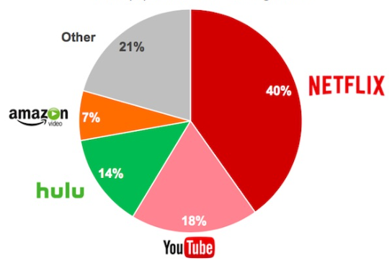
Figure: Market share (%) of global video streaming industry
Source: (Manish Singh, 2019)
Netflix is captured about 40% of the market share at international video streaming industry. For instance, the company is the market leader in this sector. Hence, about 14% and 7% market share are grabbed by Hulu and Amazon prime video respectively. About 20% of market share is grabbed by other kinds of companies at the market (Fernando, 2021). On the basis of the market share distribution of the companies, the Hulu and Amazon prime video are the direct competitors of Netflix at the international market and they have also unique offering towards customers. YouTube is also plays vital role at the international video streaming industry as many kinds of people of the world are the subscribers of YouTube.

Business model of Netflix
Netflix runs subscription video on demand (SVOD) model to offer movies, TV series and various kinds of entertaining contents to the subscribers. The preferences and demands of the customers are mainly valued by the top management of Netflix to offer them various types of video contents. The model subscription of demand allows the subscribers to entertain various videos a per their demand (Netflix, 2021). Here, the monthly subscription fees are less effective in this business model and real time demand of customers are mainly focused. The business model of Netflix is highly effective to capture the interest of young and middle aged people. This business model is also cost effective which is very effective to the market of India as the purchasing power of the customers at the Indian market is moderate.
Netflix started its business activities by its founder Marc Randolph and Reed Hastings. At the outset of the company, the DVD rental service is only service provided by the organisation at the market about only a few subscribers of the organisation. After that, the demand pattern of the people has been changed gradually and the company has changed itself a video streaming organisation that is considered as the market leader in this sector. Netflix didn’t enter the large library contents rather it has focus on the niche market. For this reason, the international news and games are broadcasted by the organisation and movies and TV shows are the only contents of the company towards its customers in different corners of the world.
The organisational culture of Netflix is very inclusive and democratic. The top management values the employees as their thoughts at the decision making criteria of the company. In recurring the employees, the top management focuses on the cultural fit of the candidates above their merits and intellectuals (Collier, 2018). From this, the importance of organisational culture at the policy making of Netflix can be perceived. The avoid the bureaucracy at the workplace, the top management of Netflix define the organisational culture to the employees and make the inclusive workplace to ensure the job stratification of the stuffs. The truthfulness and ethics of the stuffs are values in effective manner by the company. Hence, the internal information is shared openly with all of the stuffs so that the mutual distrusts can’t be arisen and all level of employees can concentrate at their roles at the organisation.

Internal business environment

Financial analysis on Netflix
The financial statements of Netflix have been analysed in this context so that the key financial data can presented and organisational ultimate position can be described in the optimal standard. The financial data of Netflix are presented as follows:
Descriptions | 2021 ($’million) | 2020  ($’million) | 2019  ($’million)
Revenue | 29,698 | 24,996 | 20,156
Gross income | 12,365 | 9,720 | 7,716
Earnings Before Interest and Tax (EBIT) | 6,195 | 4,585 | 2,604
Net Income | 5,116 | 2,761 | 1,867
On the basis of the income statement of Netflix, it has been determined that the revenue of the organisation at 2021 is $29698 million. The sales of the company have been increased by 18.81% at the fiscal year 2021 in compared to 2020. Moreover, the gross income generated by Netflix at 2021 is $12365 million which is the 13.46% higher than that of 2020. Hence, the earnings before interest and tax and net income of the company are $6195 million and $5116 million for the fiscal year 2021. All types of income of the organisation has been increased in 2021 at the global market as the demand of the subscribers on the services of Netflix has been enhanced rapidly (Botten, 2019). The flexible subscription fees, good quality of video and commercial free video streaming services of Netflix are really effective than of competitors at the market. For this reason, the financial improvement has been seen on Netflix gradually.
The ratio analysis is considered another financial analysis on the company that reflects the actual scenario of the organisation and its internal capability (Botten, 2019). The profitability, gearing, liquidity and various kinds of organisational capacity of the company can be analysed on the basis of ratio analysis. Different kinds of ratio of Netflix are analysed below:
Profit margin ratio:
(EBIT/ Sales) *100 = 20.86%
The profit margin ratio is a key indication about how the organisation earns as per its sales at the market. Hence, the profit margin ratio of Netflix is 20.86%. It means about 20.86% earning have achieved by the organisation on its sales. On the basis of the profit margin ratio, the performance of Netflix is good to generate profit on the margin.
Current ratio:
Current assets/ Current Liabilities = 1.05
Current ratio is an effective indication that represents the organisational capacity to repay its current debt to the market. For this reason, the current portion of current asset on the organisational current liabilities is calculated at the context of current ratio. Hence, the current ratio of Netflix has been calculated as 1.05. From this perspective, it can be concluded that Netflix has capacity to repay is current liabilities through its current asset and the performance of the organisation is quite well.
Debt equity ratio:
Long term borrowing/ Capital and reserves = 0.7461
The portion of debt of the organisation on its total capital is calculated as per the application of debt equity ratio. Hence, the debt equity ratio of Netflix is 0.7461 which is about 74%. From this context, it is overt that most portion of organisational capital of Netflix are borrowed from third parties (Botten, 2019). It remains a major threat on the organisation as majority portion of organisational capital is borrowed which have huge interest expense for the organisation.
P/E ratio:
Price per share/ Number of shares = 20.80
The price earnings ratio is applied to assess the earnings from share as per their price. Hence, the price earnings ratio of Netflix is 20.80. This ratio is also applied to determine whether the share of the organisation is overvalued or undervalued. Based on the outcome of price earnings ration, it can be concluded that the value of the share of Netflix is valued well.
Earnings per share:
Net profit margin/ Number of shares = 11.24
The actual earnings from the shares of the organisation is determined by the earnings per share ratio analysis. The net profit of the organisation and the number of share outstanding to the market are considered to determine the earnings from per share. The EPS of Netflix is calculated as 11.24 which denotes the share of Netflix are profitable to the stockholders and the organisational share have positive return to the owners.

SWOT analysis
As the management of Netflix is facing some challenges in entering the market of India, the SWOT analysis on the company needs to analyse so that the ultimate strengths and weakness of the company can be identified in the effective manner. The opportunity and threats of Netflix are also identified in this context. The SWOT analysis on Netflix is conducted below:

Source: (Graham, 2021)
Strengths: The exponential growth of Netflix is considered it’s one of the key strength at the market. In last 10 years, the brand of Netflix has been grown so fast at the market than that of the competitors. The close competitors of Netflix are Disney, Amazon Prime video, Hulu and so on. The brand reputation of Netflix is another strength as the brand name of Netflix is now a household name (Fernando, 2021). The global customer base of the organisation is also source of competitive advantage and it is regarded as organisational strength as about 167 million subscribers are directly associated with Netflix. Growing fast at the video streaming sector, the organisation has incurred a huge fixed costs. The huge fixed cost of the company generates the economies of scale and consolidated its strength at the market.
Weakness: The company doesn’t stream large library contents and it maintains the focus strategy to the market so that the organisation can create its strategic position rapidly in different corners of the world. The limited scope of the organisation at the market is considered its key weakness (Graham, 2021). The limited copyrights of Netflix are another level of weakness as most of the contents are not owned by Netflix that its streams to the subscribers. The rights of the contents from the studio of Netflix are expires over time and they are presented to other studios. It can affect the company negatively. Portion of debt of Netflix is also increasing gradually and the organisational weakness to collect required capital is overt here.
Opportunity: So far, the internet based streaming services of Netflix is commercial advertisement free. But, the competitors of the organisation collect huge benefits from commercial ads. In this context, the management of Netflix has opportunity to add the commercial ads to the video streaming of the company and collects huge benefits. The low price mobile streaming options are very popular at the Asia market. The Indian market is also very price sensitive (Lampel et al., 2021). For instance, the low cost mobile streaming video option can be launched by the management of Netflix to the market of India to capture the demand of the people and secure its strategic base. By this way, the designed 100 million subscriber target can be fulfilled by the company in the effective manner.
Threats: The competitive pressure on Netflix from Hulu, Amazon, YouTube, HBO, Disney and many kinds of competitors is intense. From this perspective, the threat on the organisation is very high from its competitors. The government regulations about on streaming the foreign context of India is regarded another threat for Netflix as it can limit the streaming option for the management of Netflix along with its value addition at the market. The treat of piracy and account hacking are another level of threat on Netflix as the subscribers of the company can be affected by these kinds of offense (Lampel et al., 2021). The market saturation at the global market is also regarded as major threat for Netflix as the company is not enable to meet its target subscribers from the market. Due to the market saturation, this kind of deviation is facing by the company at the global market.

Value chain analysis
The model of value chain analysis describes visually different kinds of activities of the business and process to assess the organisational competitive advantages. The complete lifecycle of creating the services of Netflix can be presented through the value chain analysis. The overall discussions are divided into two phases. They are primary activities and secondary activities. The value generated by Netflix at different level of activities are explained as follows:
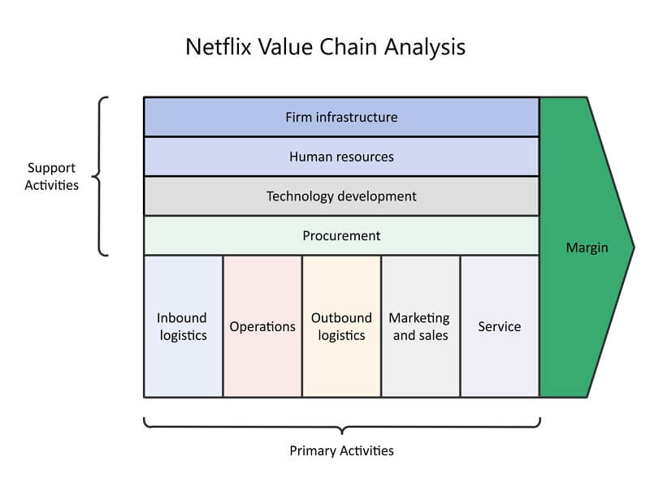
Source: (Lampel et al., 2021)
Primary activities:
Inbound logistics: The inbound logistics of at the value chain of Netflix are associated with receiving, disseminating and storing of contents. As the services of Netflix are revolved at the digital media, the company has strong relationship with content developers and broadcasters (Smith and Mounter, 2018). The content developing companies provide their contents at the optimum costs to Netflix and Netflix provides these services to the customers with a specific profit.
Operations: The operations of Netflix are cost effective and efficient. After collecting different kinds of contents from the contents developers, the management of Netflix stored these kinds of context at the organisational servers (Nyay Bhushan, 2018). By this way, the company manages the quick search, stability and security of the contexts and provide streaming facilities to the subscribers.
Outbound logistics: The outbound logistics of Netflix are related to serving the subscribers with different contents. Hence, the outbound logistic services of Netflix are download of different contents and streaming.
Marketing and sales: The marketing of the services and sales are considered effective activities at the workplace of Netflix that create the superior values for the company. Netflix depends on the online media to conduct the marketing activities of its services towards the customers and the sales of the streaming is based on demand of the customers (Smith and Mounter, 2018). By choosing effective techniques of marking and sales, the management of Netflix gains huge benefits.
Services: Netflix provides the services at the online media and the subscribers of the company can get entertainment through the video streaming. The support team of Netflix helps the customers by responding their queries and issues (Nyay Bhushan, 2018). The payment issues and languages problems are also solved by the support team of Netflix.
Support activities:
Infrastructure: The infrastructure of Netflix consists of different kinds of division including the general services, planning, quality management, legal services, finance and so on. Hence, the diversification and distributed management is existed at the central point of Netflix that associate the organisational activities to serve the value added services at the market.
Human resource management: The human resource management of Netflix is very inclusive to the organisational decision making. Based on the performance of the employees, the company allows rewards to the employees and proper recognition. The excellence incentives are provided by the top management of Netflix as per the performance of the employees at the workplace (Smith and Mounter, 2018). The employees respond various kinds of queries of the employees and some decisions are taken by them at this context.
Technology development: The advanced technologies are used to provide the video streaming services to the customers at the market. Hence, the management of Netflix is committed to provide the most advantage and best user experience (Nyay Bhushan, 2018). The quality of videos is focused effectively by the top management of the company so that the use of technology can add values to its customers at the market.
Procurement: The procure of Netflix at the value chain analysis is the copyright license of the digital contents that are streamed by the company towards different kinds of customers. Hence, the management of Netflix make sure that the organisation access to the original context that are provided to the customers and the values of the content can be increased by this way.

External business environment

PESTLE analysis for Netflix
The video streaming market of India is highly competitive and there are some environmental issues that can affect the operations of Netflix at the business environment of India. To formulate the effective strategy for the organisation, the macro environment analysis is also needed so that the impact from various kinds of environmental factors can be identified and responded in the proper manner. Different types of external environmental factors are explained as follows:
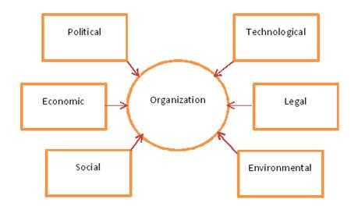
Source: (Fernando, 2021)
Political: The political factors are the influence and policies of the movement on the business that must be complied by the business organisations. For instance, the management of Netflix must maintain the policies provided by the government for carrying out the business activities at the market of India. Hence, there are some limitations of streaming the foreign contexts and it can arise threats for Netflix service the subscribers (Graham, 2021). Hence, the censorship of the contents is directly maintained by the government of the country. For this reason, Netflix needs to respond to the government rules in different countries in where it operates its business. By the impact of government rules, all kinds of context of Netflix are not shown in every countries and it can limit the number of contents at the market. The stability of the political situation is another factor at the political environment that can affect the business operation in different countries of the world.
Economic: The economic growth, exchange rate, income level of the people, inflation, employment and various factors are the key elements of the economic environment. The fluctuation of exchange rate affects the buying of the customers of different contents in video streaming. Due to the inflation, the rate of some premium contents have been increased by the management of Netflix. For this reason, some of the loyal subscribers of the company have complaints this issue (Fernando, 2021). At this context, the good quality of service can be the ultimate salutation for Netflix to fulfil the customer demand. The income level of the customers can also affect the overall consumption at entertainment.
Social: The social demand and values need to be responded effectively by the organisation to create the close connection with the people at the society. For instance, Netflix tends to make the inclusive culture and customer support team to response different kinds of queries of the customers and solve their issues. Moreover, the top management of Netflix believes that the generous nature and gesture of the organisation affects its social value. From this perspective, about 2% of the total income of Netflix is donated to the charity organisations and the company fulfils its corporate social responsibility (Graham, 2021). The people at the market of India demands low cost video streaming services and the management of Netflix can consider this issue at the market. To increase the number of subscribers at the market, the low costs services can be launched at the market and fulfil the organisational goals in effective ways.
Technological: The innovation and use of modern technology are highly required to the business so that the good quality of services can be given to the customers and fulfil the organisational target at the competitive market. The companies at the video streaming sector in India are highly associated with modern technology to provide good quality of video and offer the subscribers with a lot of customization. For example, Netflix offers high quality video with minimal use of data (Fernando, 2021). This kind of service is very demandable at the market and it is costs effective for the users. Netflix offers its subscribers with automatic translating software named Hermes. By this way, the customers can entertain the video steaming services with lot of flexibility and it is very popular at the market.
Legal: The legal factors associated with the laws of the government regarding the video streaming service is linked with Netflix. The health and safety act, labour laws, employment act, discrimination law, copyrights are many kinds of legal provision of the government must be complied by the company so that the organisational activities can be valid. Hence, the legal factors directly uphold the organisational activities valid at the market. For example, the organisation can’t increase the subscription fees due to the fluctuation of price as the customers have right to file suit against the organisation (Lampel et al., 2021). Hence, Netflix needs to maintain all kinds of legal provision and maintain the equality at the workplace so that the participation of all employees and their health and safety issues can be valued in optimum ways,
Environmental: As Netflix is an online based business organisation, the company has less carbon footprint. In fact, the company is a green organisation the range of the services of the company is environment friendly. However, the electricity consumption of relating to the services produced by Netflix is so high and it has negative impact on the environment (Lampel et al., 2021). To increase the awareness of the people, different kinds of environment friendly approaches are already taken by the management of Netflix.

Porter’s five forces model on Netflix
The range of competition for Netflix at the market has been analysed as per applying the Porter’s five forces model. The competitor analysis on Netflix are explained as follows:
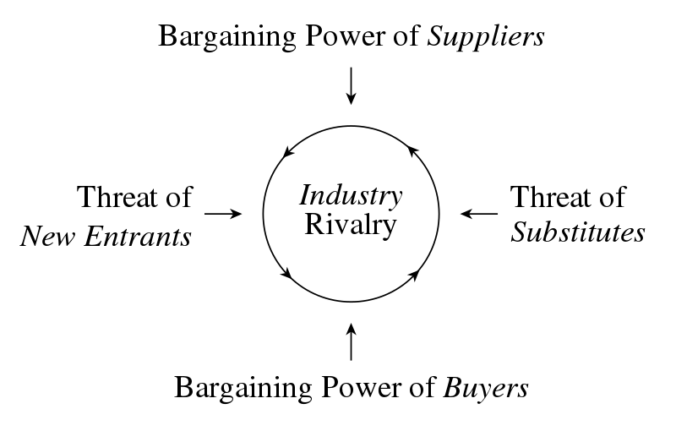
Source:
Threat of new entrants: The threat of new entrant depends on the level of entry barriers at the market. Hence, the threat of new entrant is moderate for Netflix as any company can enter into the online based video streaming sector as per facing some challenges. Although, there are some barriers that can be faced by the new comers at the online based video streaming sector, the new companies can offer to the customers and create the strategic position. At the dynamic industry, the threat of new entreats re basically high but internet based video streaming industry is less dynamic. The network circulation and number of subscribers of Netflix is very high at the global market (Johnson, 2014). It is not possible for the new company replace the market share of Netflix overnight. From this perspective, the threat of new entrants for Netflix at the Indian video streaming market is moderate.
Threat of substitutes: The leisure activities, sports streaming and other kinds of entertainment opportunities for the people are regarded as threat of substitutes. Hence, the threat of substitutes for Netflix is high as there are many kinds of sports streaming and leisure entertaining companies at the market. The video streaming of Facebook and YouTube are also considered as the substitute services of Netflix at the market (Lampel et al., 2021). As there are many types of substitute services available in the market, it can reduce the market share of Netflix and switch some of the subscribers of the company. For this reason, the threat of substitute products is high for Netflix.
Bargaining power of subscribers: The bargaining power of subscribers at the internet based video streaming industry depends on the switching costs. The switching costs in this sector is very low and the subscribers can easily switch one company to another. For this reason, the bargaining power of the subscriber is very high. They can easily choose the video service of any kind of company on the basis of their flexibility (Kearns, 2018). Hence, the price, quality of video, flexibility and various factors are determinant of customer choose. As many kinds of alternatives are available at the market, the subscribers can easily get the video streaming services from any kind of company.
Bargaining power of suppliers: The contents provides are the main suppliers to Netflix and same kinds of companies. Though there are many content providers at the market, the scarcity of good quality of content providers is seen at the industry. For this reason, the bargaining power of the suppliers is moderate. In reality, the management of Netflix finds the contents that are unique, the availability of unique contents re rare at the market (Johnson, 2014). For example, recently the friends show is removed from the studio of Netflix in favour of HBO. Hence, the bargaining power of suppliers is seen that has affected the interest of Netflix to the market. For this reason, the company needs to evaluate the bargaining power of suppliers and maintain copyright effectively.
Industry rivalry: The industry rivalry is very high at the market of India many kinds of video streaming giants are existed to the market. For example, Amazon Prime video, Hulu, HBO, SonyLiv and many types of companies offering the video streaming to the subscribers. Some types of organisations have commercial advertisement while the service of Netflix is commercial free (Kearns, 2018). The price flexible subscription packages by different kind of companies make intense competition to the market as many customers demand the price flexible offers from the companies.

Mendelow’s stakeholder matrix
The stakeholders are regarded as a key part of the business model of Netflix. For this reason, the management of the stakeholder is a part and parcel behind the organisational growth and secure its strategic base at the market. To manage the stakeholders of Netflix, the stakeholder matrix of Mendelow is followed in this case so that the stakeholder can be managed by the company in effective manner. The ways to manage different kinds of stakeholders are described as follows:
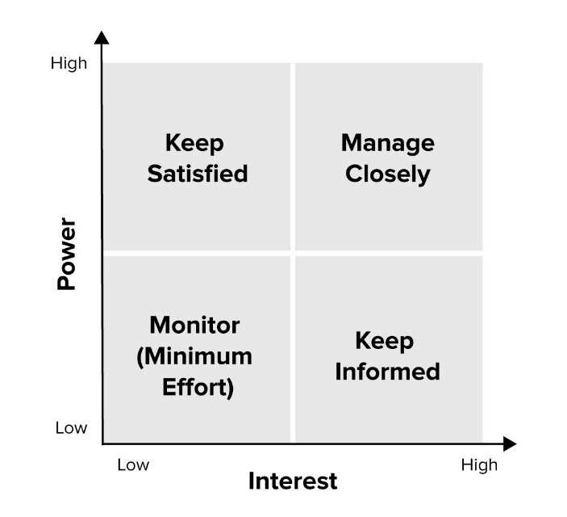
Source: (Kearns, 2018)
Keep satisfied: The communities need to be satisfied by Netflix to increase the organisational social image and its potential customers. Hence, the communities denote to the people who are indirectly linked with the organisation. For example, the people who want a Netflix account and people who use some borrowed the Netflix accounts (Nyay Bhushan, 2018). The management of Netflix can motivate the communities with its value added streaming services to increase the potential customers and secure its financial base in the effective manner.
Manage closely: The customer, suppliers and media need to be managed close as they are the key stakeholders in the business model of Netflix. The customers of Netflix are the only source of income as their subscription fees are regarded as organisational revenue. For this reason, the demand and queries of the customers need to be managed closely (Sears, 2013). Mover, the good quality of content providers need to be managed in effective manner as their unique contents can add large extent of values for Netflix at the global market. The media is another stakeholder that also needs to be managed closely as the marketing campaign of Netflix are conducted through different types of media.
Monitor: The distributors, employees and competitors of Netflix need to be monitored effectively to capture the targeted values from them. The employees perform their duties at the workplace of the organisation and organisational target are mainly fulfilled by the direct participation of the employees (Nyay Bhushan, 2018). For instance, the demand and satisfaction level of different kinds of employees to the workplace of the company need to be monitored by the top management to engage them in more extent. The competitors need also be monitored in effective manner so that the rival policy can be assessed by the organisation and unique strategy can be formulated at the market.
Keep informed: The investors, analysts and relations are considered as one of the important stakeholders of Netflix. For this reason, the organisation should keep inform these level of stakeholders. Hence, the investors have less influence on the organisation but their interest on the company is very high. So, the organisational polices should be inform them by the directors. The analysts of the company monitor which show can be effective at the market and fulfil the demand of the customers (Sears, 2013). To get more watch by the subscribers, the information from the analyst need to be considered by the top management of Netflix. Besides, the regulators have interest on the operations of Netflix and the organisation should keep inform the regulators in high extent.

Strategic options for sustainable competitive advantage

Ansoff Matrix
The interest based video streaming market is highly competitive. For instance, Netflix can adopt the Ansoff matrix to consolidate its competitive base to the market and add more values than that of competitors. The required strategies are explained as follows:
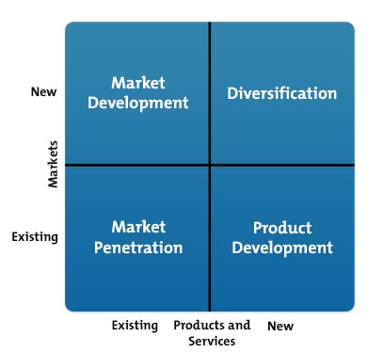
Market penetration: The market penetration strategy is about to carry out the business strategy where the activities of the business already operating. As Netflix is operating is business at the international market, the company can focus on the current market with good quality of services for the customer satisfaction. The demand level of the customers at the niche market can enable the organisation to design the value added strategy for the customers and capture the values from the customers in the effective manner (Smith, 2010). Thus, the organisation can capture competitive advantage in high extent.
Market development: In this strategy, Netflix can enter into the new market with the current level of services of the organisation. For example, the entry of Netflix with current services is denoted as market development strategy for the company. By this way, Netflix has chance to capture the demand of the customers at the market of Netflix and create its strategic base in competitive market. Hence, the premium TV series and unique shows can be offered by the company towards the subscribers so that they can be satisfied with the company and take more services.
Service development: The new service can be launched by Netflix to the current market. Apart from the DVD rentals and video streaming services, some new services can be launched to capture more values from the market (TRACY, 2019). In this context, of Netflix the service development strategy may not be effective as the organisation needs to incur the fixed costs to develop its new services at the market and create the strategic position.
Diversification: This strategy in Ansoff matrix is about to launch new services at the new market by the management of Netflix. Currently, the company doesn’t cover the large library contents and sports events (Smith, 2010). But there has opportunity for the company to add these kinds of events to the service portfolio of the organisation at the international market. By this way, the diversification of the services can be ensured and wide range of values can be grabbed by the company from the market than that of competitors.

BCG growth matrix
The BCG growth matrix is applicable to analyse the value addition of the organisation through different kinds of products. On the basis of growth options from different products, they are divided into four segments. All of them are analysed as follows:
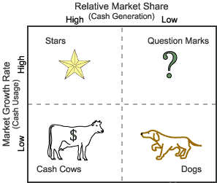
Stars: The starts products of Netflix those package which have high number of sales at the market. As Netflix has different types of services available for the customers, the international stringing is regarded as start services produced by the company to the market. Thanks to the quality to he products, the international streaming of the company is enabled to capture the values of the customers from the market (TRACY, 2019). As international video streaming service of the company has many number of customers, it has high extent of contribution on the organisational growth.
Cash cows: Though Netflix has large number of subscription in DVDs, it is not the main service provided by the company and it has less growth to the company. For this reason, the DVD subscription services of the company is regarded as cash cow (Johnson, 2014). There has limited growth in this kind of service of the company but the value is still positive for the company.
Question marks: The service having high sales growth at the market but low growth are denoted as question mark. As per analysing the services of Netflix, there are no kind of question mark services provided by the company at the video streaming sector of the global market.
Dogs: At the market of India, the initial plan of v was to offer the premium streaming package to the high income level of people. But the demand in flexible pricing is very high at the market of India (Johnson, 2014). For instance, the premium package with high costs at the Indian market is considered as dog types of service of the organisation that has low growth as well as growth market share.

Conclusions
It can be concluded that the Netflix follows a value added business model to secure its base at the global market and focus on the satisfaction level of the subscribers. The case study of business activities of Netflix to Bollywood is critically analysed in this report and organisational strategies are formulated so that the target subscribers can be captured by the company in effective ways. For this reason, the internet based video streaming industry of India is analysed at the outset of the report. After that the internal and external environment of the Indian video streaming industry are analysed so that the influential factors can be identified and their impact can be assessed in proper manner. After that the strategies for Netflix are designed so that the company can add competitive advantage from the market. The service diversification and launching the costs effective services can be the best strategic decision for the company to grab competitive advantage from the market.

Recommendations
To grab more values and competitive advantage from market, the following strategies are recommending for Netflix:
- Netflix should include the commercial ads in this video streaming services as different kinds of commercials ads can give boost to its overall income and the financial base of the company can be secure in more extent.
- The cost effective subscriptions should be launched to the market by the company to fulfil the demand of common subscribers.
- Along with TV series and movies, the Sports and wide range of streaming services can be added to the service portfolio of the company so that it can cover the interest of many people.
- The value based marketing should be adopted by the company at the global market to inform the stakeholders about the values of its services.

References
Botten, N., 2019. Management accounting. Oxford, U.K.: CIMA Publishing/Elsevier.
Collier, M., 2018. Business planning for digital libraries. Leuven: Universitaire Pers Leuven.
Fernando, A., 2021. Business Environment. Pearson India.
Graham, L., 2021. Internal controls. Hoboken, N.J: John Wiley & Sons.
Holbeche, L., 2022. Aligning Human Resources and Business Strategy. Milton: Taylor & Francis Group.
Johnson, G., 2014. Exploring corporate strategy. Harlow: Pearson.
Kearns, P., 2018. HR strategy. Amsterdam: Butterworth-Heinemann.
Lampel, J., Shamsie, J. and Lant, T., 2021. The business of culture. Hove, East Sussex, Eng.: Psychology Press.
Manish Singh, 2019, “Netflix launches Rs 199 ($2.8) mobile-only monthly plan in India”, TechCrunch, July 24.
Nyay Bhushan, “Netflix CEO Reed Hastings on Why the “Next 100 Million” Subscribers Will Be “Coming From India,” The Hollywood Reporter, February 26, 2018.
Sears, D., 2013. Successful talent strategies. New York: American Management Association.
Shuchi Bansal, “We will get into vernacular Indian content step by step: Netflix CEO,” LiveMint, December 9, 2019.
Smith, J., 2010. Business strategy. Cambridge (Mass.): Basil Blackwell.
Smith, L. and Mounter, P., 2018. Effective internal communication. London: Kogan Page.
TRACY, B., 2019. BUSINESS STRATEGY. [S.l.]: AMACOM.

