ACCA7005 – Web Services Assignment

Liam Kelly - 2222134 – 2222134@student.uwtsd.ac.uk
MSc Software Engineering (Web Development)

Table of Contents
Liam Kelly - 2222134 – 2222134@student.uwtsd.ac.uk 1
Database Design and Entity Relationships 3
Endpoints 4
Keycloak 4
Suggested improvements on system design 5
Works Cited 6

GitHub Repo: https://github.com/Lez-Dev/Restful_TaxService

This brief report will outline the design and implementation decisions of the Road Tax Management Service (RTMS), concluding with a short evaluation of potential improvements to the service.

Database Design and Entity Relationships
The system adopts five entities; four of which are the required entities stipulated in the brief; Tax Information, Car Owner, Car Registration and Tax Payment, with Tax Rate being added as an addition to normalise data from the Tax Information table (Fig.1). Each entity is atomic with primary keys which indicate a functional dependency. Transitive dependencies were minimised but are still present in the Car Owner table in the form of address details. Even so, the entity design allows for the segregated storage of data within the system, with minimal vulnerabilities concerning data integrity [1].
When considering the design of the RTMS, entity relationships and the database structure were considered first. Endpoint provisions of what the service should manifest were considered along with the baseline requirements outlined in the brief.
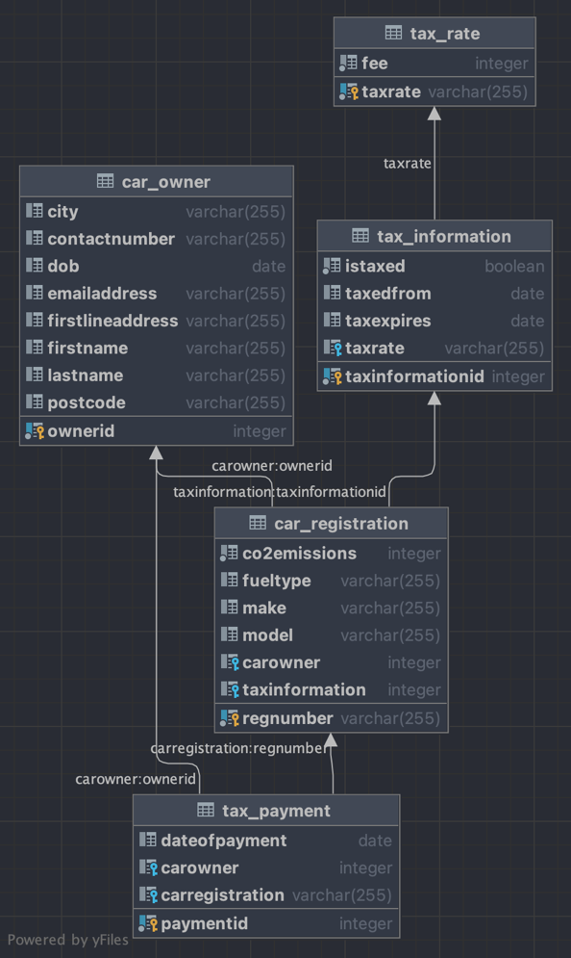
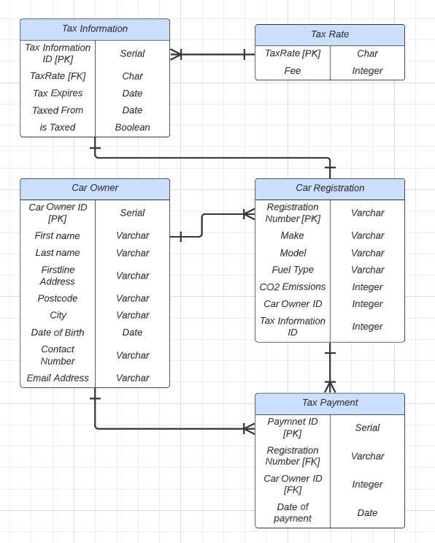
Figure 1: Entity Relationship diagram from Datagrip (left), relations between entities are more clearly defined with arrow notation in diagram (right).
I evaluated that the Car Registration entity would act as a bridge between the Car Owner entity and the Tax Information entity as well as holding information, which in turn, determines the vehicle’s tax code - CO₂ emissions and fuel type. These values would be input by the service user, translating to a tax code upon registration through the Spring application using the Tax Rate table as a key for conversion. Car Registration and Car Owner both feature as foreign keys in the Tax Payment table. Although the owner could be accessed through the Car Registration entity these foreign keys were compounded as vehicles, even registrations can change ownership over the course of their use, so for the purposes of data auditing these were stored together under a common payment entity. The Tax Information entity was also chosen to associate directly to Car Registration with a one-to-one relationship, as the vehicle is the taxable entity in this service. Tax Information stores data concerning its Car Registration parent such as; Boolean taxable status as well as its data ranged tax period, this along with the foreign key to Tax Rate allows for a detailed but normalised structure to a vehicle’s tax information. By structuring this in such a way it allows for the application to filter endpoints by tax status or by date range.

Endpoints
The endpoints in the service were designed for entity information to be accessible and available for manipulation with basic CRUD operations. Furthermore, several endpoints were designed to add additional functionality to the service.
The pay tax endpoint was designed to incorporate the scenario where a user would wish to pay the tax on their Car Registration. It takes the Car Owner’s email and the Car Registration number and creates a new tax payment instance. From the email and registration number, the fee and date are processed as well as the Car Registration’s tax information being updated including; tax expiry date, taxed from date and is taxed Boolean.
Similarly, to pay tax, add new vehicle is another post method where a user can add a new vehicle to the tax database for processing. Posting a JSON object in its request body the Car Owner’s email and the car registration details. From these entities, and the subsequent information accessed, a new Car Registration instance is created as well as updating the Car Registration’s tax information. These custom endpoints and others such as, displaying untaxed vehicles and vehicles that will become untaxed within a date catchment allow the system to perform in a way that would be expected from a road tax management service. In addition, for usability two common sets of information – payment details and vehicle details were defined under data transfer objects to provide the utility of viewing useful and related information for admins or users.
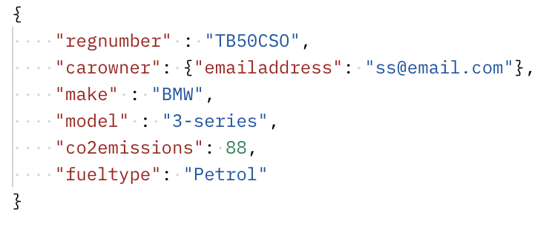
Figure 2: Example of a JSON object request body for the /addnewvehicle endpoint

Keycloak
Keycloak is implemented as the security service for defining the access role when implementing the Spring Representational State Transfer (REST) Application Programming Interface (API) [2]. In the service, three roles were implemented through the roadtax-service client; basicuser, adminuser, manageruser, all of which conditionally grant JSON Web Tokens through OAuth2.0. By implementing three roles in software such as Keycloak it allows the segregation of duties as well as access [2]. Multiple roles allow for specific access control within the application. Different roles can be assigned to different users or user groups, granting them different levels of access to endpoints. This ensures that only authorised users can perform certain actions or access sensitive data within the service (Fig.3). For example, the only role that can perform a delete HTTP Request within the service is a manageruser, thereby adding a layer of protection to the data integrity of the service. To manage the PostgreSQL database, the SpringBoot service and the Keycloak authorisation access, three docker containers were created to deploy the application within a stack (Fig.3).

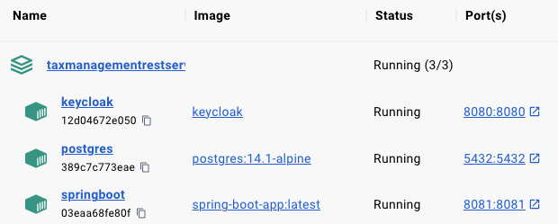
Figure 3: Docker Stack as displayed in Docker Desktop when service is running

Suggested improvements on system design
As mentioned, the entity design allows for expansion of the service over the long term but does fall short in some respects. The database is not normalised to third normal form entirely, with entities such as Car Owner and its address attributes. This would be a prime candidate for a separate address entity in a future iteration. Furthermore, although historic data is captured and accessible through the tax information and tax payment entities, incorporating a dedicated audit table would enhance data efficacy, enabling tracking and analysis and optimising performance and scalability [1].
With regards to endpoints, an expansion of these within the service, such as the provision of tax refunds or the additional functionality of paying tax on a monthly, 6-monthly, or annual basis, would significantly enhance the service's usability for users. Finally, Keycloak offers the option to group users within group roles [3]. A potential improvement for future development is to incorporate service user email and login details into the Keycloak service, grouping them under a unified user-group. Presently, although basic users are limited to GET requests only, they can perform such requests on other users' data, posing a significant data protection violation risk in a live system. Ideally, users should be restricted to making POST and GET requests solely for their own data, ensuring compliance with data protection standards and expectations.

Works Cited

[1] | S. Roman, Access Database: Design & Programming, Sebastopol, CA: O'Reilly Media Inc., 2007.
[2] | A. B. Kretarta and H. Kabetta, “Secure User Management Gateway for Microservices Architecture APIs Using Keycloak on XYZ,” in International Seminar on Research of Information Technology and Intelligent Systems , Bogor, 2022.
[3] | Keycloak, “Keycloak Documentation: Server Administration Guide,” Keycloak, 2023. [Online]. Available: https://www.keycloak.org/docs/latest/server_admin/. [Accessed 10 May 2023].

