
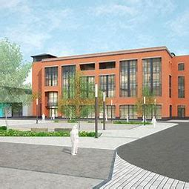

School of Applied Computing | Title of Coursework  Research into Robotics in a Lego Mindstorms Setting (Alternative Assessment) | Code M4X01506
 | Module Integrating Project
Student:  Theresa Darzins  Student number: 1909721 | 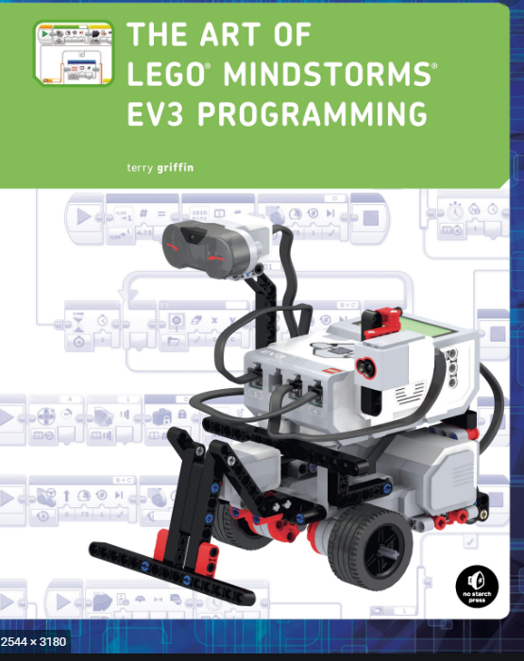 | Lecturer:  Sue Maw  Date: April 2020
Table of Contents
1 INTRODUCTION 1
1.1 Overview 1
1.1.1 Task 1 1
1.1.2 Task 2 2
1.2 Plan 3
1.2.1 Gantt Chart 3
1.2.2 Report Plan 4
1.3 Design 5
1.3.1 Sensor Problems 5
1.3.2 Tools 6
1.3.3 Colour Detection 7
1.4 Program 8
1.4.1 Gyro, Colour and Ultrasonic Sensors 9
2 TASK 1 10
2.1 Overview 10
2.2 Line Follow 11
2.2.1 Follow the Middle Is Easy for Humans but Difficult for Robot 11
2.2.2 When Robot Programmed to Follow Centre of Curved Line it Wanders Off 11
2.2.3 Right or Left Configuration 14
2.2.4 Line Follower Steering Calibration 14
2.2.5 Right Side Follow the Line 15
2.2.6 Problems Navigating Lines Crossing Over/Tight Angles 15
2.2.7 Alternate More Accurate Type of Line Follower: PID 16
2.2.8 Stopping 18
2.3 Colour Sensor 19
2.3.1 Reflected Light Intensity 19
2.3.2 Ambient Light Intensity 19
2.3.3 Colour Calibration Method 20
2.4 Block Avoidance 21
2.4.1 Either Navigate, Mow Over or Pick Up 21
2.4.2 a) Navigate Around 22
2.4.3 b) Mowing Over 24
2.4.4 c) Pick Up Block 25
2.5 Advantages and Disadvantages of Block Avoidance Methods 26
2.5.1 Which Rated Best and Why 26
2.5.2 Reason Why b) Mow Over Rated Best 26
2.5.3 On Condition of Block Lightness – Otherwise a) Go Around Rated Best 26
3 TASK 2 27
3.1 Overview 27
3.2 Maze Navigation 27
3.2.1 Right Hand Rule Path Through Maze 27
3.2.2 Robot Moving with Wall to its Right 28
3.2.3 Robot Turns Left at the Corner 28
3.2.4 Robot Turning into Opening on the Right 29
3.2.5 Robot Turning Right Instead of Straight 29
3.2.6 Robot Turning Right Instead of Left at T Junction 30
3.2.7 Play Tune Once Red Block Detected at End of Maze 31
3.3 Tools 32
3.3.1 Sensors: Ultrasonic 32
3.3.2 Sensors: Touch 32
3.3.3 Sensors: Light/colour facing down 32
3.3.4 Sensors: Light/colour facing forward 32
3.3.5 Line following 32
3.3.6 Wall following 32
3.3.7 Gyro sensor 32
3.4 Advantages and Disadvantages of Tools 33
3.4.1 Tools Ranked 34
3.4.2 Reason Right or Left Wall Following with Ultrasonic Sensor Best Rated 34
3.4.3 Reasons Others Not as Good 34
4 SUMMARY 35
4.1 Task 1 35
4.1.1 Taped Line Following 35
4.1.2 Colour 35
4.1.3 b) Block Avoidance by Mowing Over - Rated Best 35
4.2 Task 2 35
4.2.1 3D Maze Wall Follower and Ultrasonic – Rated Best 35
5 FLOW CHARTS/PSEUDO CODE 36
5.1 Table 1 - Overview 36
5.1.1 Part A Sourced 36
5.1.2 Part B Compiled 36
5.2 Table 2 – Flow Chart Taped Line Following 37
5.3 Table 3 - Pseudo Code for Colour Calibration 38
5.4 Table 4 – Flow Chart Block Avoidance by Navigation Around 38
5.5 Table 5 – Pseudo Code Pick Up Object 38
5.6 Table 6 – Flow Chart 3D Maze 39
5.7 Table 7 - Pseudo Code for Navigation of Maze 40
5.7.1 Straight Wall 40
5.7.2 Turning Corner 40
5.7.3 Moving Through Opening 40
5.8 Table 8 – Flow Chart Compiled for Whole Task 41
5.8.1 Sub Program Black Line Follow 41
5.8.2 Sub Program Avoid 42
5.8.3 Sub Program Maze 42
5.8.4 Sub Program Play Song 43
5.9 Table 9 – Draft Pseudo Code Compiled for Whole Task 44
5.10 Table 10 - Pseudo Code Compiled for Whole Task 45
6 REFERENCES 47
7 METHODOLOGY 48
7.1 Structure 48
7.1.1 Read Requirements of Exam 48
7.1.2 Structure Report into Chapters 48
7.1.3 Compile Gantt Chart 48
7.2 Research 49
7.2.1 Line Following, Colour Sensors, Block Avoidance, Maze Negotiation 49
7.2.2 Design 49
7.3 Write 49
7.3.1 Slot Material into correct sections ensuring references congruent 49
7.4 Review 49
7.4.1 Fine Tune 49
7.5 Experiment 49
7.5.1 Overview 49
7.5.2 Building the Robot 52
7.5.3 Colour Recognition 52
7.5.4 Black Line Following 53
7.5.5 Object Avoidance 55
7.5.6 Maze 55
7.5.7 Sound 56
7.6 Revise the Report 56
7.7 Submit 56
7.7.1 Submit Draft for comments 56
7.7.2 Submit final on time (7th May) 56

INTRODUCTION

The purpose is to investigate Lego Mindstorms Settings, using research, to carry out Tasks 1 and 2.

Overview
Table 1 – Task Diagram
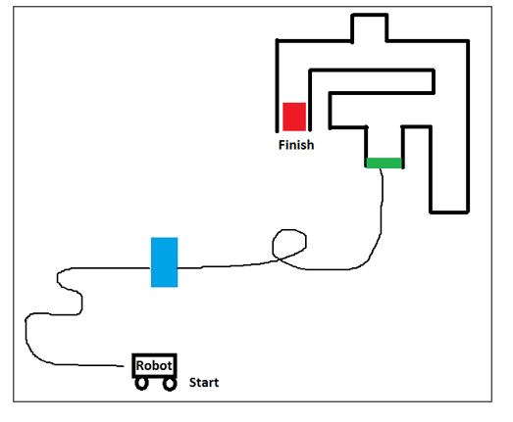

Task 1

Black line is taped on the floor which includes a circular section. Robot needs to:
- follow line
- Negotiate blue block
- Re-join line and progress on to green line maze entrance

Research Taped Line

- Explain problems to be solved.
- Research:
- Line Following; how robot detects line.
- Avoiding the Block: by either:
- navigation
- mowing over or
- picking up
- Advantages and disadvantages of 3 avoidance tactics.
- Explain which best for this task and why.

Task 2

Robot needs to:
- Enter and follow through to the end of the maze
- Reach the red block
- Stop and play a tune to indicate finished

Research 3D Maze

- Explain problems to be solved.
- Research:
- Maze negotiation
- Outline advantages and disadvantages of these methods.
- Explain which most suitable for this task, and why.

Plan
 |  | Gantt Chart
 | Actions |  | Week Ending Friday |  |  |  |  |  |  | Deadline
 |  |  | 20/03 | 270/3 | 03/04 | 10/04 | 17/04 | 24/04 | 01/05 | 07/05
 |  |  | 1 | 2 | 3 | 4 | 5 | 6 | 7 | 8
1 | Overview
2 | Structure
3 | Research
4 | Write
5 | Review
6 | Experiment
7 | Revise
8 | Submit

Report Plan
Pt 1  60% | - INTRODUCTION
Pt 1  60% | - Overview of 2 Tasks  - Plan  - Design  - Program
Pt 1  60% | - TASK 1 - LINE FOLLOW, AVOID BLOCK, CONTINUE ON TO GREEN LINE
Pt 1  60% | - Overview  - Line Follow  - Colour Sensors  - Block Avoidance  - Advantages/Disadvantages of Avoidance Methods
Pt 1  60% | - TASK 2 - NAVIGATE MAZE TO RED BOX, STOP, THEN PLAY TUNE
Pt 1  60% | - Overview  - Maze Negotiation  - Tools  - Advantages/Disadvantages of Tools
Pt 1  60% | - SUMMARY
Pt 1  60% | - Task 1  - Task 2
Pt 2  40% | - FLOW CHART/ PSEUDO CODE
Pt 2  40% | - Overview  - FC Taped Line Following  - PS Colour Calibration  - FC Block Navigation Around Object  - PC Block Pick Up  - FC Maze  - PC Maze  - FC Compiled Whole Program  - PC Compiled Draft Whole Program  - PC Compiled Whole Program
Pt 1 | - REFERENCES
Pt 1 | - METHODOLOGY
Pt 1 | - Overview  - Structure  - Research  - Write  - Review  - Experiment  - Revise  - Submit

Design
Robot would have to possess the ability to see/sense both:

- 2D - lines on the ground
And detect whether that line is Black or Green plus if background White
- 3D objects in front:
And detect whether that object is Blue or Red

Also needs to do accurate 90⁰ turns for:
  - Avoiding block
  - Navigating maze

Sensor Problems
Bearing in mind that:

- Ultrasonic Sensor
(Goggles)
Only detects objects - but not colours

- Colour/Light Sensor
(Used Like a ‘Ground Sniffer’ until turned upwards)
Only identifies colours - but can’t detect objects

Tools
Summary of tools robot needs:

- A Gyro to enable accurate 90⁰ turns to avoid object and navigate maze.

- 2 Ultrasonic Sensors to be used for ‘Block Detection’ and ‘Maze’ Programs
For High View Front and Side

- A Colour/Light Sensor
With Default Set to Low View Like a ‘Ground Sniffer’

but also needs to be programmed to be able to pivot up after obstacle encountered, to look up to identify whether objects Blue or Red.

  - Default Low View (2D)
for ‘Line Follower’
For floor Lines needs to identify whether Line is BLACK, or GREEN and Background White
And Whilst on BLACK Line or White Background do ‘Line Follow’ Program
Upon encountering GREEN Line: do ‘Stop Line Follow and Start ‘Wall Follower Maze’ Program

  - Pivot Up View (3D)
ONLY After Ultrasonic Obstacle Detection:
When Ultrasonic Sensor detects block, the Colour Sensor needs to pivot upwards to identify whether colour of block is BLUE or RED.

IF BLUE detected: do ‘Avoid’ Program
IF RED detected: do ‘Stop and Play Song’ Program

Colour Detection
Whenever Ultrasonic Sensor Detects Object
Positioned either up or down
- With Colour Sensor Up: looks to see IF OBJECT Colour Red or Blue?
- With Colour Sensor Down: looks to see IF LINE Colour Black, or Green?
And the background White
 |  | Sensor | Overview of Pseudo Code |  | Colours/  Conditions
 | 1) | ↓ | With Sensor Down  - Start Black Line Follower Program  Until meets BLUE Obstacle |  | Is it on Black Line ?  or White Background?
 | 2) | ↑ | Sensor goes Up  - and looks to see if Blue or Red? |  | Is OBJECT  Blue or Red?  IF Blue Avoid
 | 3) | ↑ | Stop Black Line Follower Program
 | 4) | ↑ | Start Block Avoidance Program  - Until Back on Black Line |  | IF on back on Black Line  Continue Line Follower
 | 5) | ↓ | Start Black Line Follower Until Reach Green Line |  | IF Green Line detected  STOP Line Follower
 | 6) | ↓ | Stop Line Follower Program
 | 7) | ↑ | Colour Sensor goes Up and Wall Follower Maze Program Starts until |  | START MAZE
 | 8) | ↑ | Sensor Detects Red Block |  | Is OBJECT  Blue or Red?  IF Red
 | 9) | ↑ | Stops Maze Program |  | STOP Maze
 | 10) | ↑ | Starts Song Program |  | START Song

Program
 | Order of Play
 | A |  | CONFIGURE BLACK, White, GREEN, BLUE and RED COLOURS
 |  | 1 | Configure Robot colour recognition for: BLACK, White, GREEN, BLUE and RED
 | B |  | START BLACK LINE FOLLOWING PROGRAM
 |  | 2 | Place Robot on Top of Black Line (When on black forward, when on white back to black)
 |  | 3 | START ‘Black Line Follow’ Program (to Follow EITHER Left or Right Side)
 |  | 4 | UNTIL Ultrasonic Sensor Senses Obstacle so Robot STOPS
 | C |  | START OBJECT AVOIDANCE PROGRAM
 |  | 5 | Colour Sensor Raises Up to Check Whether Obstacle Blue or Red?
 |  | 6 | IF Blue, Colour Sensor Goes Back Down
 |  | 7 | AND Avoid Program Does Sufficient Turns to Avoid Block UNTIL it re-joins Black Line
 | D |  | AS SOON AS ROBOT GETS BACK ON BLACK LINE RE-START LINE FOLLOW
 |  | 8 | Once Robot Back on Black Line RESTART ‘Line Follow’ Program UNTIL
 |  | 9 | Reaches Green Line
 | E |  | AS SOON AS ROBOT ENCOUNTERS GREEN LINE
 |  | 10 | Robot STOPS
 | F |  | START WALL FOLLOWER MAZE PROGRAM
 |  | 11 | START ‘Wall Follower Maze’ Program (Right or Left Wall)
 |  | 12 | UNTIL Reaches Obstacle in Front, so Robot STOPS
 | G |  | AS SOON AS ENCOUNTERS RED OBJECT – START SONG PROGRAM
 |  | 12 | Colour Sensor Raises Up to Check Whether Obstacle is Blue or Red?
 |  | 13 | IF Obstacle Red, ‘Play Song’ Program

Gyro, Colour and Ultrasonic Sensors
Sensor Types
And Specific Jobs Each is Needed Carry Out

A | 1  2 | For the Gyro:  - WHEN BLUE object detected START Object Avoidance Program; 3 x 90⁰ Turns UNTIL return to BLACK Line  - WHEN GREEN line detected START Wall Follower Maze Program
B | 3 | For the Colour Sensor:  Black Line Follower (Black and White zig zag)
 | 4 | - WHEN Sensor is DOWN  Follows a Black Line UNTIL reaches Green Line then Robot STOPS  And STARTS  Wall Follower Maze Program (11)
 | 5 | - WHEN is Sensor UP  Detects Colour (Blue or Red)
 | 6 | - IF Blue Sensor goes Down and ‘Avoid Program’ Goes ON
 | 7 | - UNTIL re-joins Black Line
 | 8 | - IF Red ‘Play Song’ Program Goes ON
C |  | For Ultrasonic Sensor:  Obstacle Detector
 | 9 | WHEN Obstacle Detected: Robot STOPS and Raises Colour Sensor
 | 10 | Results in either 3 or 5 (LOOP)
 | 11 | WHEN Green Line Reached it is end of Line Follower Program and START of Wall Follower Maze Program

TASK 1

Overview
- Follow the black taped line from ‘start’

- When meeting the blue block, overcome it by either:

a) avoiding, go around
b) mowing over or
c) lifting up the blue block

- Then continuing on the black line up to the Green Line maze entrance.

Line Follow

Follow the Middle Is Easy for Humans but Difficult for Robot
[1]
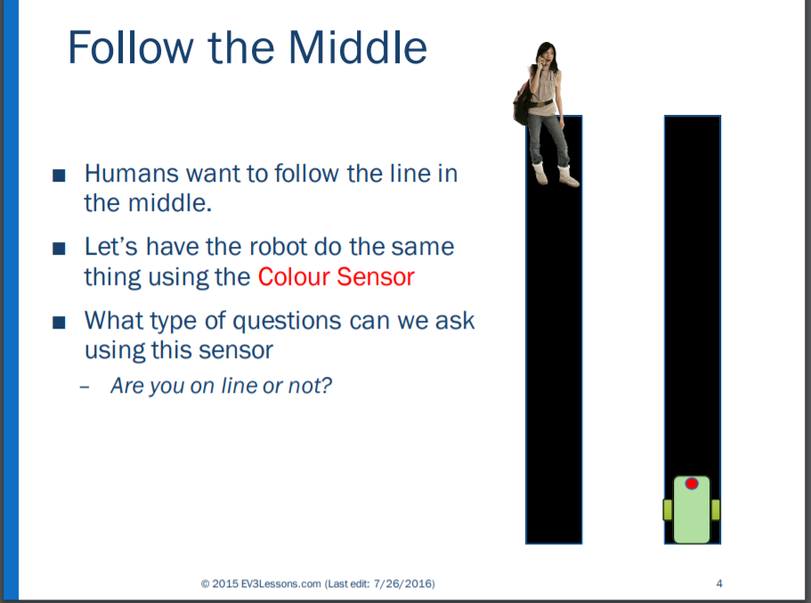

When Robot Programmed to Follow Centre of Curved Line it Wanders Off
This example is programmed to centre of the line but as soon as the line curves the robot will wander off the line so is not feasible.
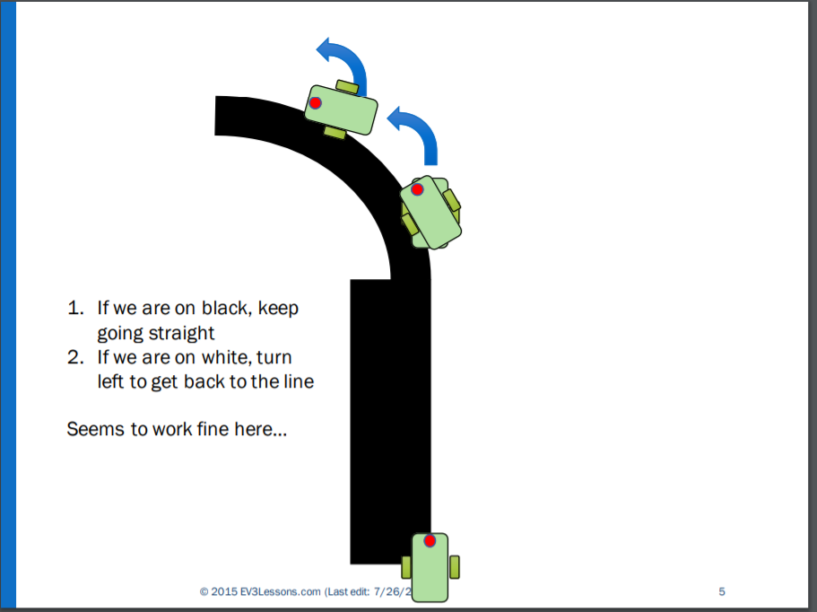
However, when the line curves to one side it no longer works.
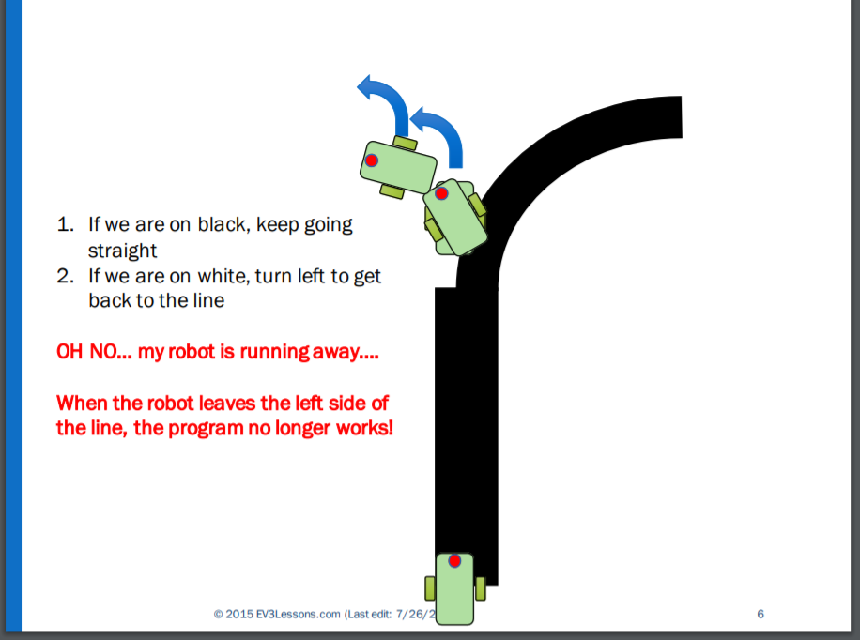
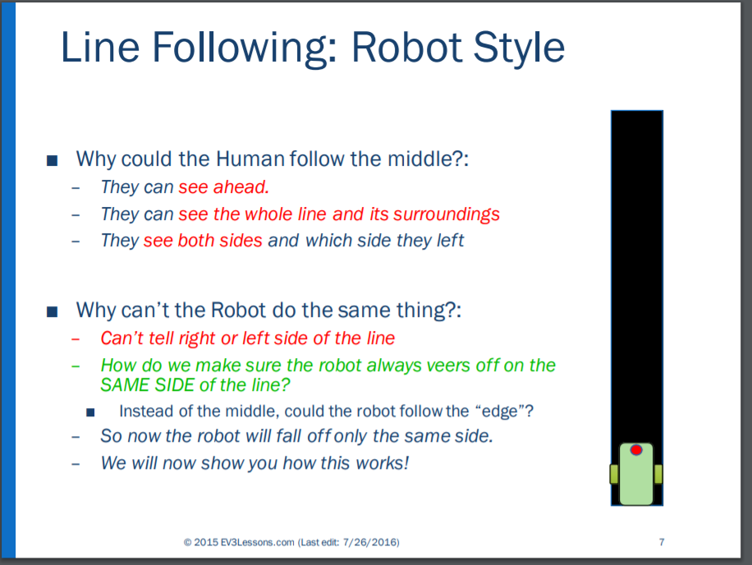

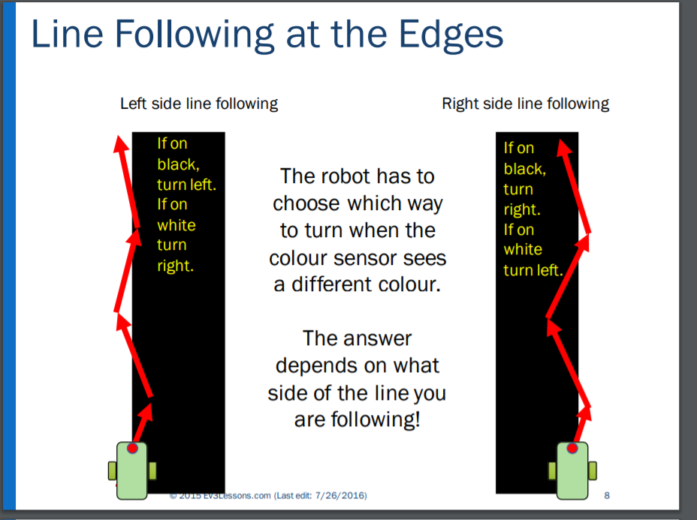
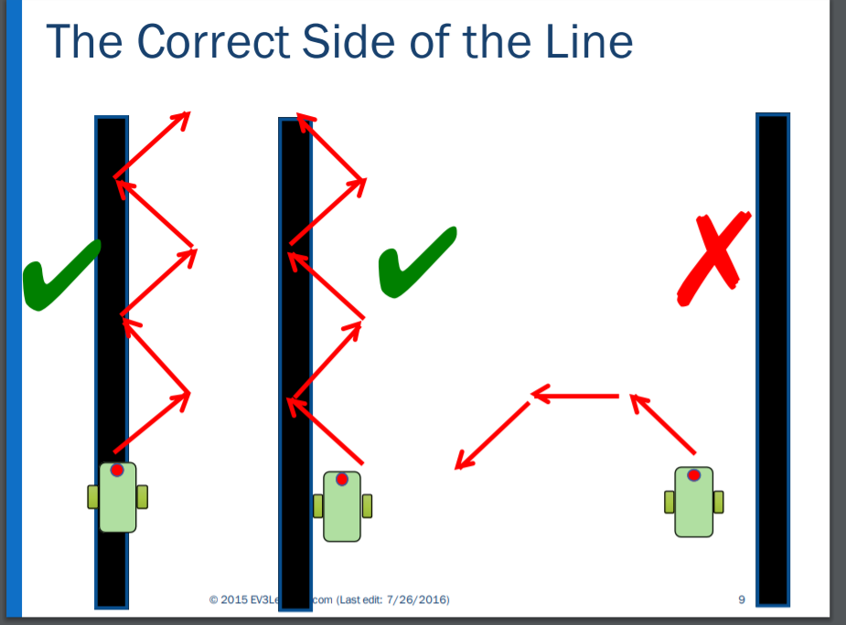
It should be noted that to begin the programme, the robot must first be placed upon the line. The robot only knows if it is ON or OFF the line, so it needs to be programmed to follow one side or another correctly (as below).

Right or Left Configuration
When configured to follow Black:

- If the robot is configured to follow the LEFT side of line: it is programmed thus:
If on Black turn left, or if on White turn Right
- OR if robot is configured to follow the RIGHT side of the line: it is programmed thus:
If on Black turn right, or if on White turn Left
(opposite rules to above).
- Steering also needs calibration to alter the angle to mitigate wobble.

Line Follower Steering Calibration
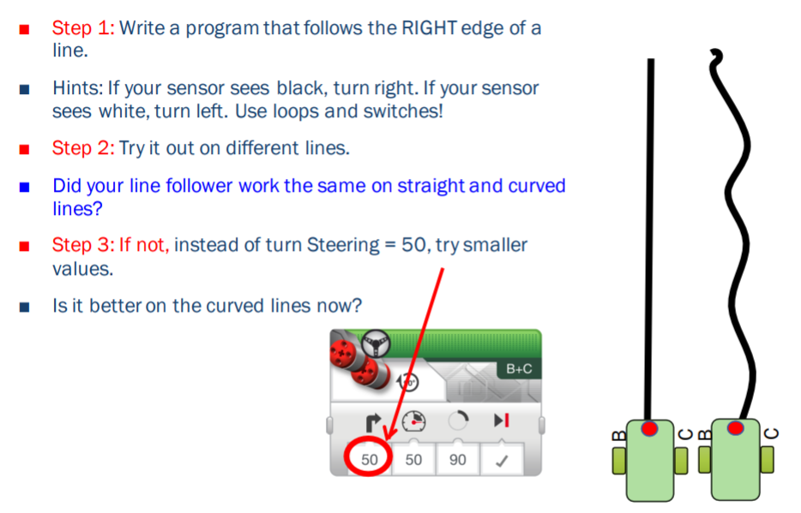

Right Side Follow the Line

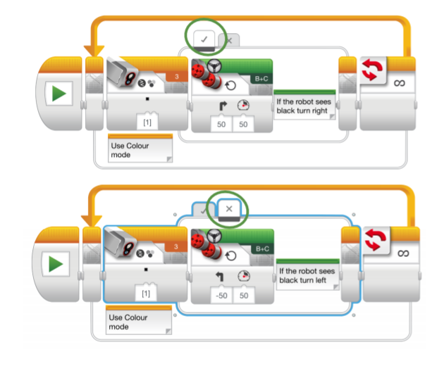

Problems Navigating Lines Crossing Over/Tight Angles
BLACK line path incorporates a circular line that crosses over itself. Whenever lines overlap, or have tight turns causes problems.

- Thinner taped lines help when lines overlap,
- but thicker help when going straight.
- Reducing speed enables better Threshold readings on curvy path.
- Adjusting Directional Steering to bigger differential (-40/+40) helps to navigate circular path
- but if too big a differential programmed, could continously traverse circle.

Directional Steering needs to be tested and re-adjusted to take into account how sharp angle is, to reach a balance of zig zagging sharp, enough to get round the curvy bits, but not so sharp as to miss the cross over, enabling robot to continue on path. Calibration to tailor to line angles essential.

Alternate More Accurate Type of Line Follower: PID
This programming more accurate but more difficult to do. Avoids all the above problems when crossing over lines or circling.
[2] Proportional Integral Derivative (PID)
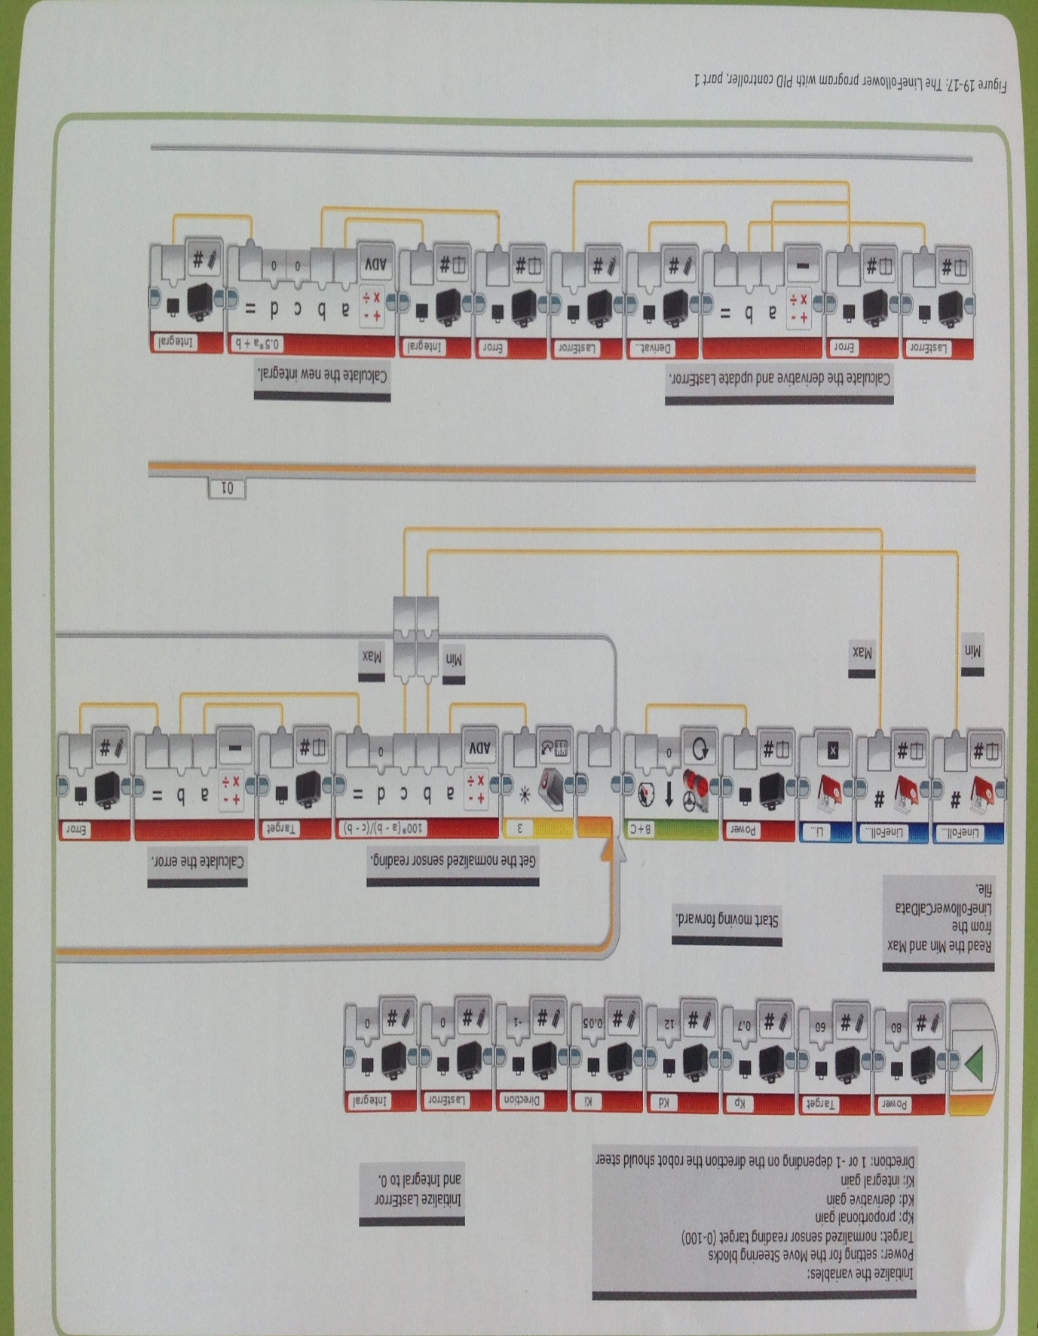
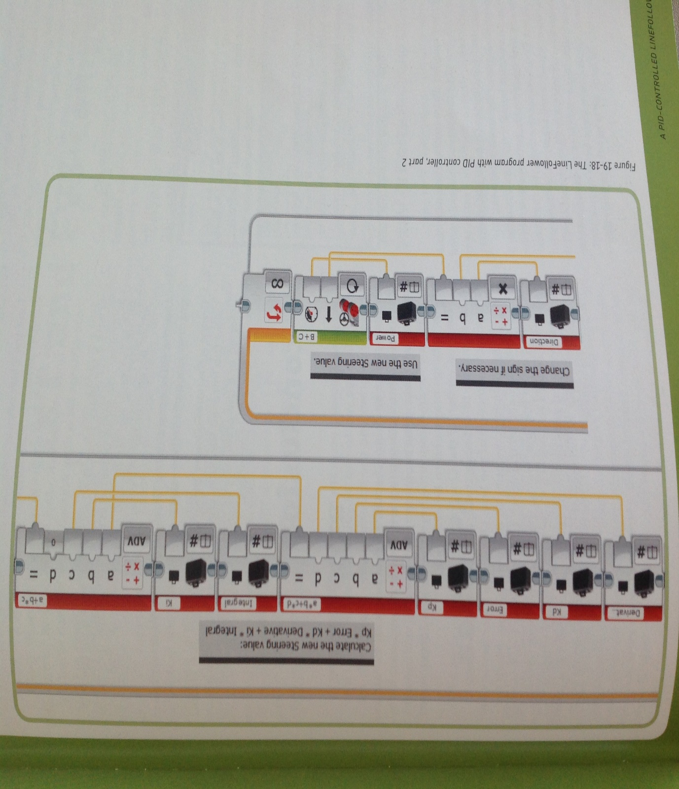

Stopping
[1] Cont’d
The program below goes on forever, but example below this one stops at a pre-programed colour.
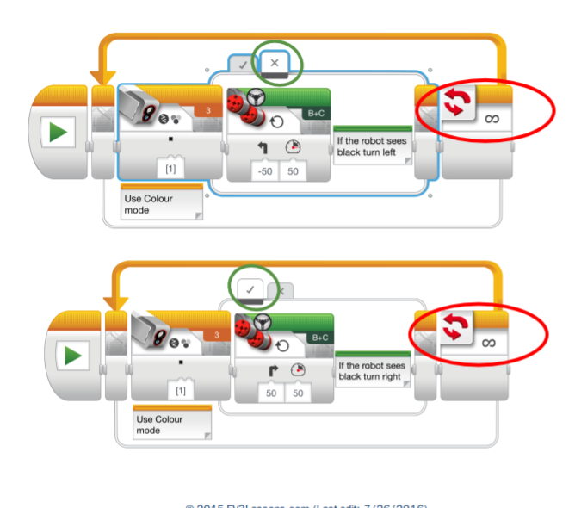
Useful for instance if programming the robot to stop at blue (loop exit condition).

Colour Sensor
[3] The colour mode is not as accurate as one might assume; for instance, the orange sensor may read ‘red’, ‘yellow’ or ‘no colour’ as it depends upon the light. To overcome this place the sensor close to the object (without touching it). This reduces the incidence of other sources of light. There are ‘Wait’ and ‘Compare’ or ‘Change’ modes. In Compare mode the block awaits until sensor detects a colour pre-selected from a list (white box with red line through it represents ‘no colour’).

Reflected Light Intensity
In Reflected Light Intensity the sensor turns red and measures light reflected back from object. 0 is dark and 100 is bright. This is used for line following. As before position sensor close to the object to block other light sources that could interfere with the reading. Configure this with ‘Compare Type’ and ‘Threshold Value’.

Ambient Light Intensity
The mode the colour sensor is using will be indicated from the LED on front of sensor; If you have chosen the wrong light intensity the dim Blue Ambient Light Intensity mode will show to alert you to change the number. In Colour Mode a bright multicoloured light shows and Red is Reflected Light Intensity.

Colour Calibration Method
[4] Pseudo Code for this Program displayed in Chapter 5
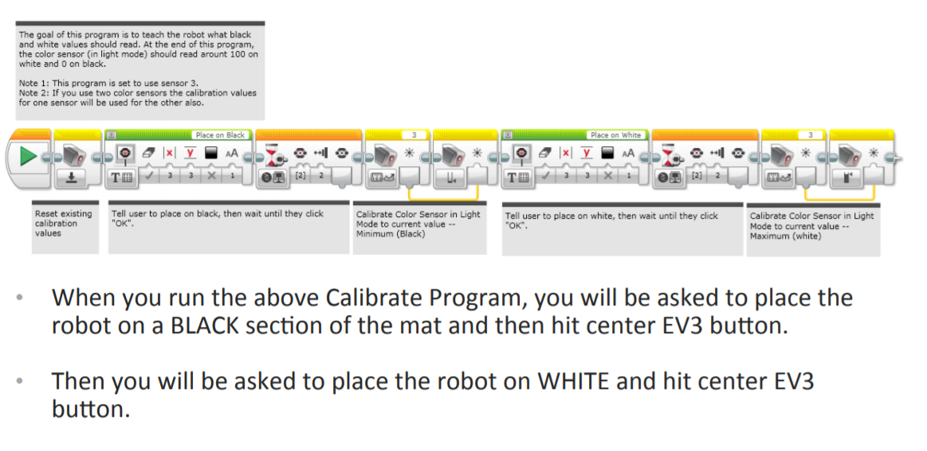

Block Avoidance

Either Navigate, Mow Over or Pick Up
3 methods investigated to find out which is the best:

a) Navigation Around – Using Sensors; Touch/Colour/IR/US
b) Mowing Over - Ignoring
c) Pick up Block – and either Toss Aside or Carry Forward

Factors to consider are:
- the method of block removal depends on the volume, weight and shape of the obstacle to be overcome,
- speed of robot.
- the complexity of programming required; ease of use/simplicity being the more highly rated.

a) Navigate Around

[1] Cont’d
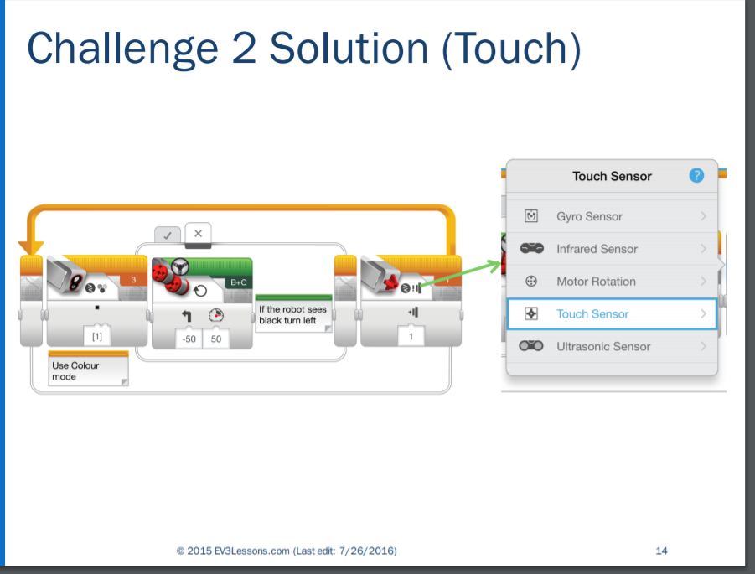
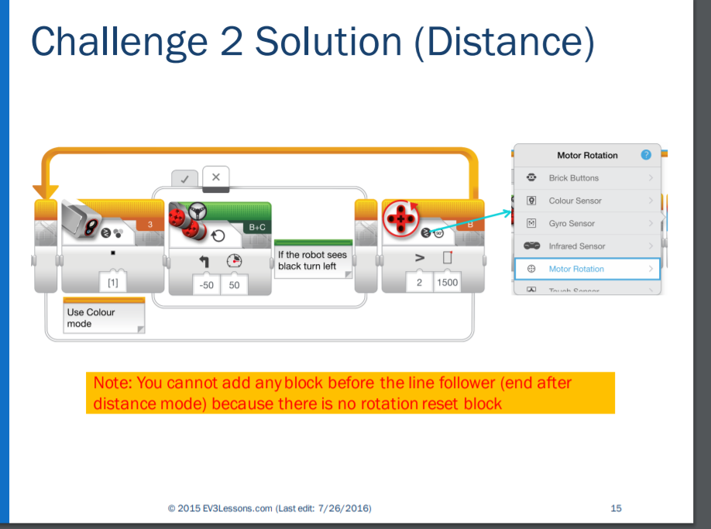

[5]
Touch sensor used when robot bumps into an object.
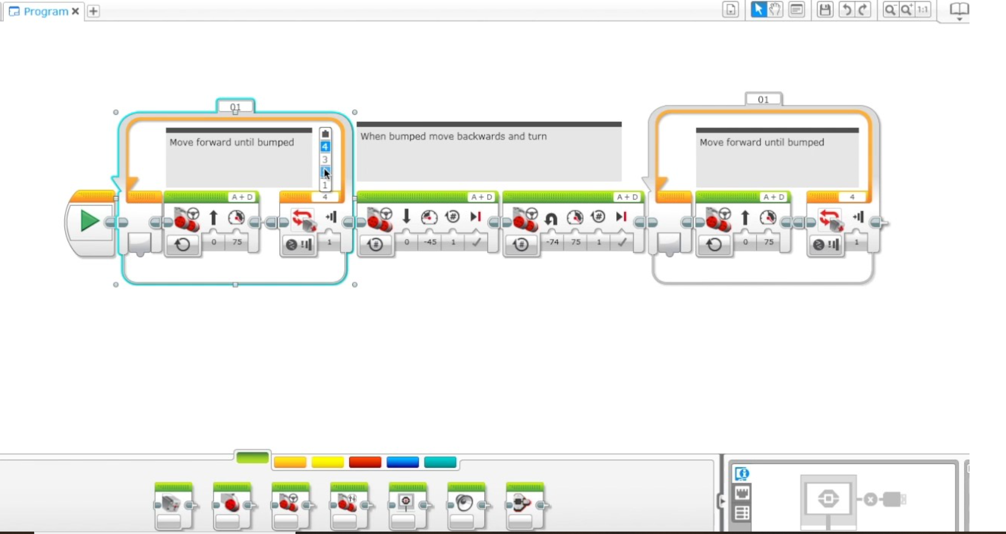

[6]
These are different types of sensors and explanation of how they function
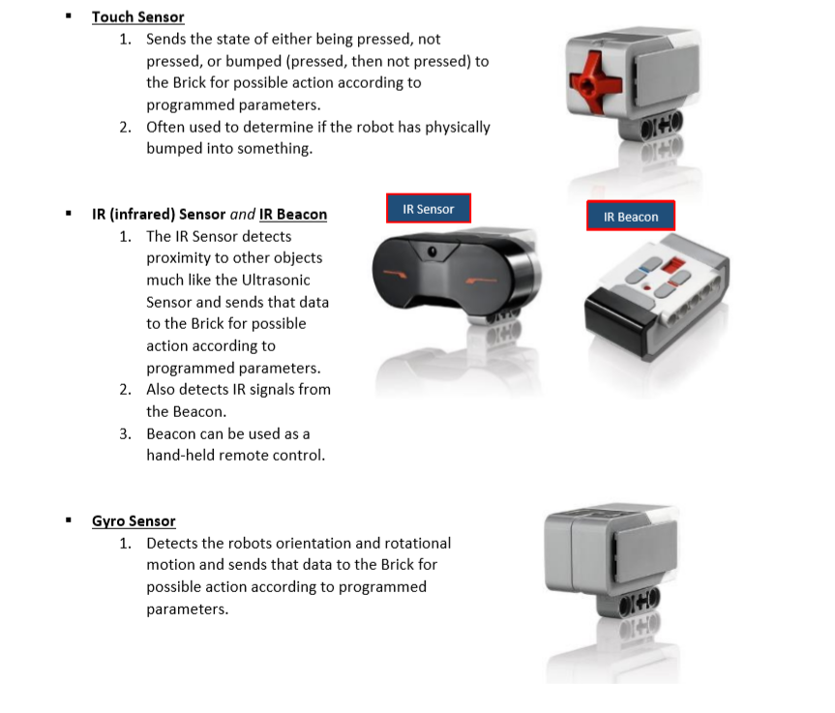
Note:
In the case of IR Sensor:
- Included with the Retail kit,
- Education kit includes an Ultrasonic Sensor which is more accurate

b) Mowing Over
This seems the easiest method, with the condition:

- Is the object small and/or light enough to be shifted with ease? The robot would have to be programmed to travel at sufficient pace to be able to disregard the obstruction.

As robot stays on the line, can continue on.

c) Pick Up Block

[7] Stage 1 Stop in front of object (below)
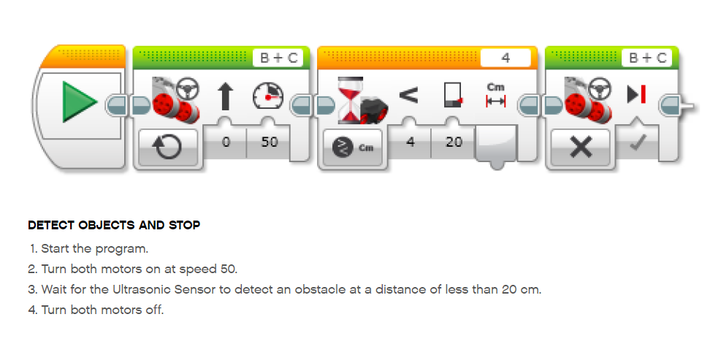
[8] Stage 2 Pick Up Object Pseudo Code (repeated under Section 5)
Below is pseudocode for programming the robot to pick up object


Advantages and Disadvantages of Block Avoidance Methods
 | Go Around  a) | Mow Over  b) | Pick Up  c)
ADVANTAGES | Less Complicated than c) | Simplest, so better than both a) and c)  on condition block is not heavy. | If object is too big or heavy to mow over is better than b)
DISADVANTAGES | Not as good as b) | If block too heavy will fail to shift it out of the way | More complicated to program than a) and b)

 | Which Rated Best and Why
RATED |  | FIRST | SECOND | LAST
Method |  | Mow Over  b) | Go Around  a) | Pick Up  c)
 | Reason Why b) Mow Over Rated Best
 | - On condition that object is light enough to be shifted the Mow Over b) best.
 | On Condition of Block Lightness – Otherwise a) Go Around Rated Best
 | - If object cannot be shifted Go Around a) moves upwards

TASK 2

Overview
From the Green Line navigate through the maze right the way through to the Red Finish Line.

Maze Navigation
[9] Can choose to use either ‘right’ or ‘left ‘hand rule (both work equally well)

Right Hand Rule Path Through Maze
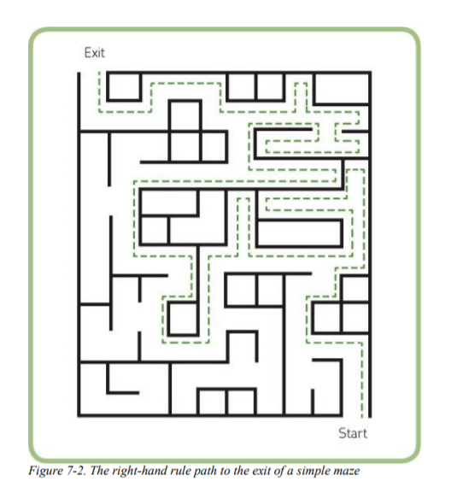

Robot Moving with Wall to its Right
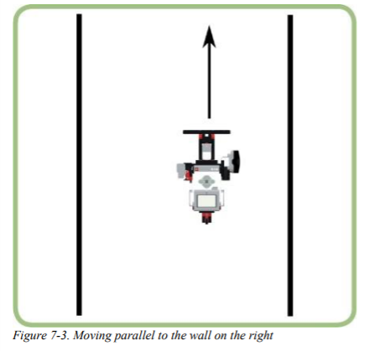
When the robot meets a corner with a wall to the right and front of it as shown in Fig 7-4 the robot should turn to the left and continue forward.

Robot Turns Left at the Corner
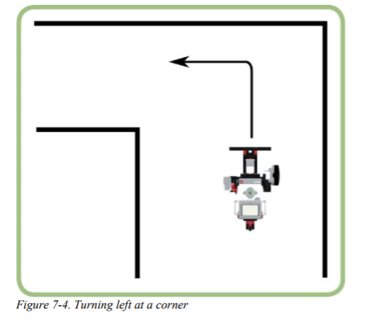
Opening to the right Fig 7-5 robot turns into the opening. To follow right hand rule robot should always turn right, even when it can go ahead as in Fig 7-6, or when it can go left as in Figure 7-7.

Robot Turning into Opening on the Right
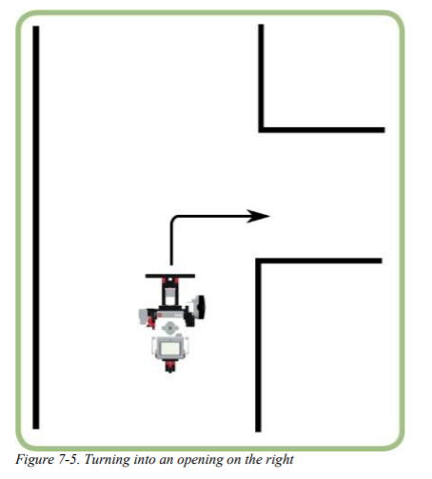

Robot Turning Right Instead of Straight
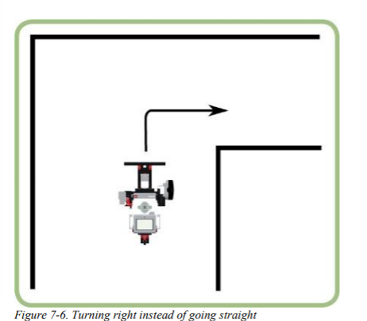

Robot Turning Right Instead of Left at T Junction
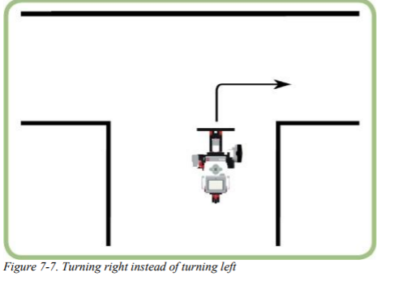
Program can be summarised:
- Robot should move forward along the wall on its right staying close to wall
- If the robot finds a wall in front and to the right it should turn left 90⁰ and then follow the new wall.
- If the robot comes to an opening in the wall on the right it should turn right 90⁰ and go through opening.

Play Tune Once Red Block Detected at End of Maze
- Colour sensor could be configured to trigger a tune at the end once red is detected.
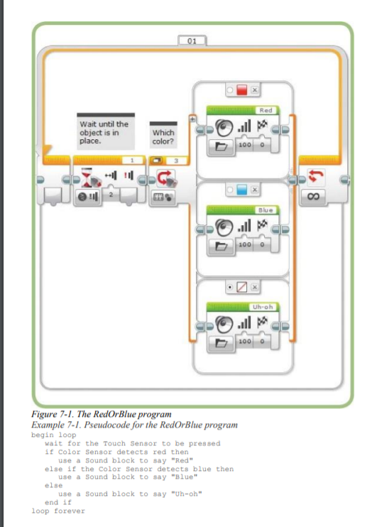

Tools
[10]

Sensors: Ultrasonic
Use the “wait for distance” to drive forward until it comes within a certain distance from the wall, and then turn. Need to calculate distance that will give the robot sufficient space to pivot and not crash against the wall.

Sensors: Touch
Only suitable if walls are stable enough. The challenge is to work out how to turn if your robot is touching the wall and whether “pushed” or “push/release” mode works best.

Sensors: Light/colour facing down
Add tape to the maze floor so robot can use the “wait for light/colour” mode. Always place the tape lines at the inside corners of the maze not the middle space. The robot has to be programmed to know where to turn in relation to where the line is and where they have space to turn. It means that robot will have to move forward past the line and then turn.

Sensors: Light/colour facing forward
Add colour to walls and use the light/colour sensor to sense the walls.

Line following
Add a line that will travel all the way through the maze.

Wall following
Can use the ultrasonic sensor to follow along the wall (either right or left) to navigate around the maze.

Gyro sensor
Calculate perfect 90-degree turn. Have to use a “gyro reset” block to zero out the counter. Look for “gyro sensor calibration/reset.”

Advantages and Disadvantages of Tools
 |  | Advantages | Disadvantages | Ranked
1* | Sensors: Ultrasonic | More accurate than Infrared *in conjunction with 6 | Need to calculate distance that will give the robot sufficient space to pivot and not crash against the wall. | Joint 1
2 | Sensors: Touch |  | Only suitable if your walls are stable enough | 4
3** | Sensors: Light/colour facing down | **in conjunction with 5 | Linked to 5 - Taped Line; the robot has to be programmed to know where to turn in relation to where the line is and where they have space to turn. | Joint 2
4 | Sensors: Light/colour facing forward |  | Need to add colour to walls and use the light/colour sensor to sense the walls. | 3
5** | Line following | Fairly simple  **in conjunction with 3 | Linked to 3 - have to add tape to the maze | Joint 2
6* | Wall following | Simplest and most suitable  *in conjunction with 1 |  | Joint 1
7 | Gyro sensor |  | Have to use a “gyro reset” block to zero out the counter. Look for “gyro sensor calibration/reset.” | 5

 | Tools Ranked
Ranked in order | 1st | 2nd | 3rd | 4th | 5th
 | Nos. 1 & 6 Linked | Nos. 3 & 5 Linked | No. 4 | No. 2 | No. 7
 | Wall Following/  Ultrasonic | Line Following/  Light/Colour Down | Light Colour Forward  Face | Touch | Gyro

Reason Right or Left Wall Following with Ultrasonic Sensor Best Rated
1 and 6, most efficient. Whether left or right Wall Following, this algorithm used with an Ultrasonic Sensor best.

Reasons Others Not as Good
- Nos 3 & 5: Line Following/Colour Down Sensor entails the need to tape the entire maze.
- No. 4 Light Colour Forward Face entails colouring of the walls.
- No. 2 Touch can only be used with robust maze walls
- No. 7 Gyro measures rate of rotation so placed last as least useful compared to above for this particular task. Although if using in conjunction with Light Colour Forward Face however, after 10 or more turns the turns less accurate as shifts very slightly.

SUMMARY

Task 1

Taped Line Following
Programming to one side has to be configured carefully for curvy and circular or crossing over paths. PID method is better but hard to do, however once done pays off as more accurate.

Colour
Not as simple as programming Black, White, Blue, Green, etc. as light interference has to be taken into account; hold robot next to colours to obtain readings to program. Found putting shade round sensor helps when pointed to ground but didn’t help forward facing.

b) Block Avoidance by Mowing Over - Rated Best

Task 2

3D Maze Wall Follower and Ultrasonic – Rated Best

FLOW CHARTS/PSEUDO CODE
 |  | Table 1 - Overview
 |  | Part A Sourced
 |  | Researched to source items 1-5. Items 3 and 5 highlighted as part of process, but no research included.
 |  |  | Table 1 - Overview
 |  |  |  |  | Flow Chart | Pseudo Code
 | A |  |  | Sourced
 |  |  | 1. | Line Follow | Table 2
 |  |  | 2. | Colour ID |  | Table 3
 |  |  | 3. | Object Detection
 |  |  | 4. | Object Avoidance | Table 4 | Table 5
 |  |  | 5. | Maze | Table 6 | Table 7
 |  |  | 5. | Sound
 |  | Part B Compiled
 | B |  |  | Compiled
 |  |  | 6. | Whole Program | Table 8 | Table 9 & 10
 |  |  |  | - Line Follow
 |  |  |  | - Avoid
 |  |  |  | - Maze
 |  |  |  | - Song

Table 2 – Flow Chart Taped Line Following
[11]
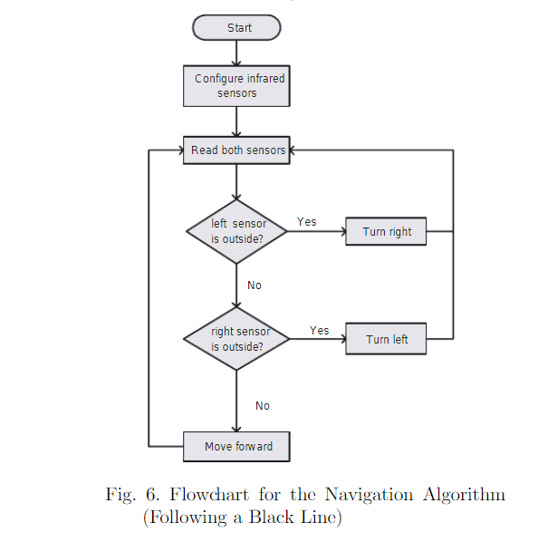

Table 3 - Pseudo Code for Colour Calibration
[4] Cont’d
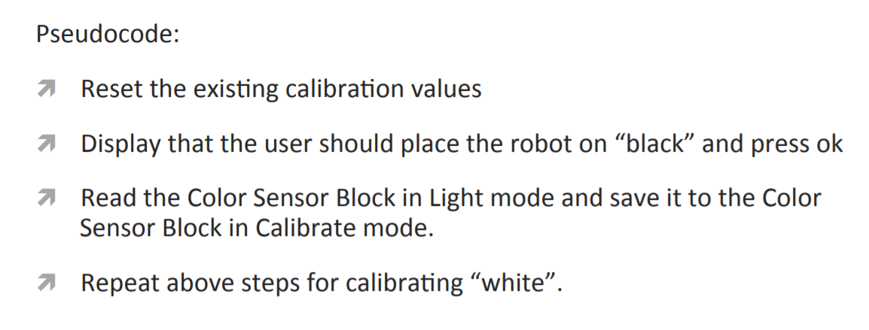

Table 4 – Flow Chart Block Avoidance by Navigation Around
[11]
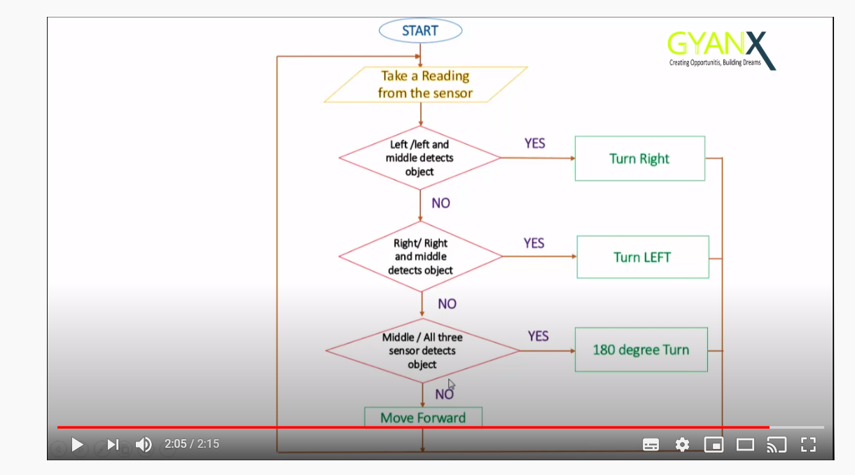

Table 5 – Pseudo Code Pick Up Object
[8] Cont’d

Table 6 – Flow Chart 3D Maze

[10] Cont’d – Note, although titled ‘find Green Circle, the same Program is used to traverse through a maze.
LEARNING MOBILE ROBOTICS USING LEGO
MINDSTORMS
Paulo Leit˜ao, Jos´eGon¸calves, Jos´eBarbosa
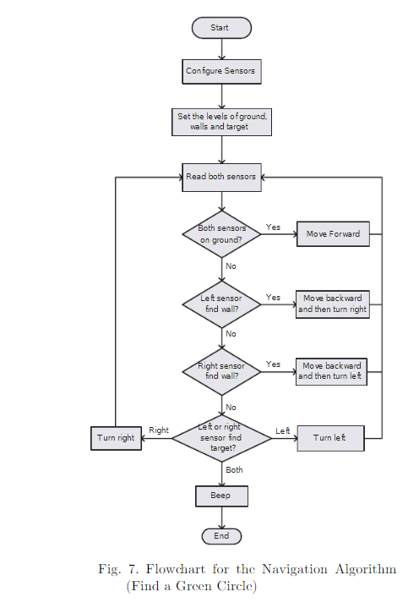

Table 7 - Pseudo Code for Navigation of Maze
[9] Cont’d

Straight Wall
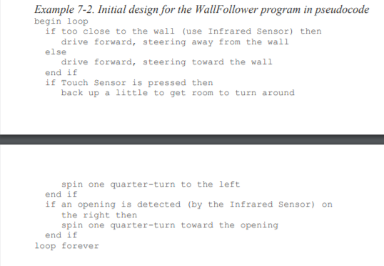

Turning Corner
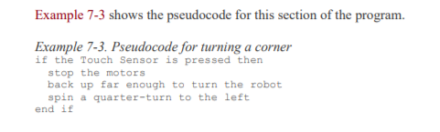

Moving Through Opening
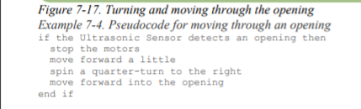

Table 8 – Flow Chart Compiled for Whole Task
0 Overall |  | 1 Black Line Follow | 2 Avoid | 3 Maze | 4 Play Song
0 |  | A | B | C | D
 | Table 8 – Flow Chart Overall
 | 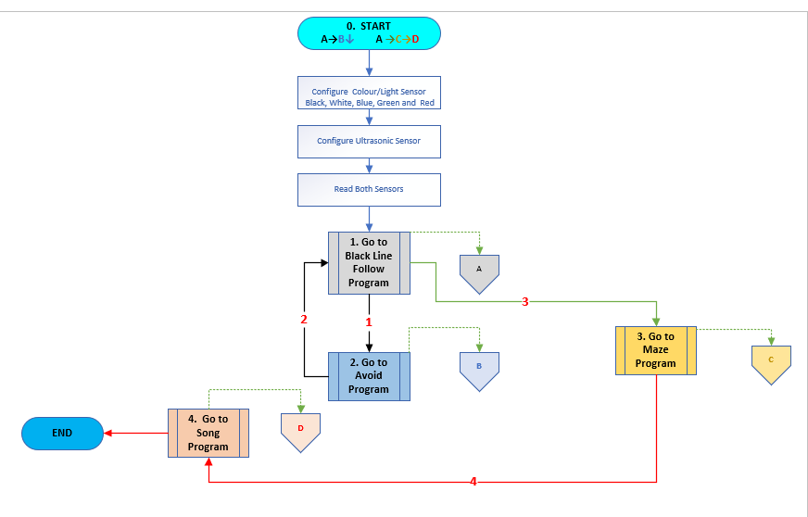
 | Sub Program Black Line Follow
 | 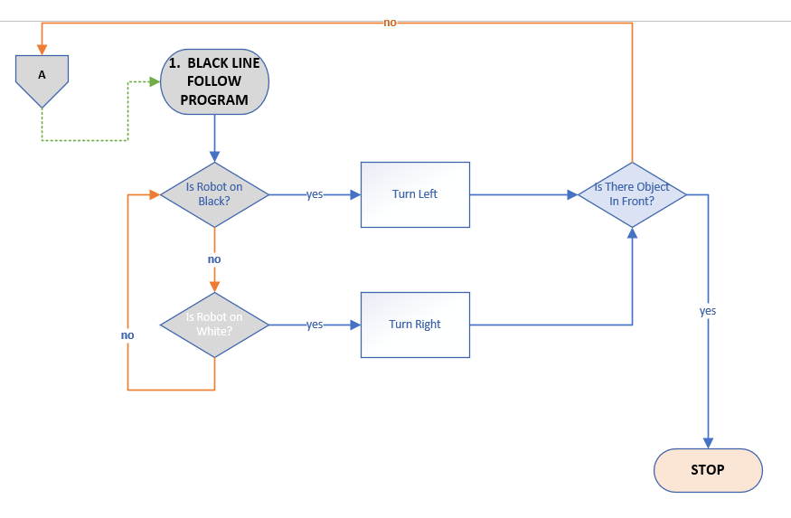

Sub Program Avoid
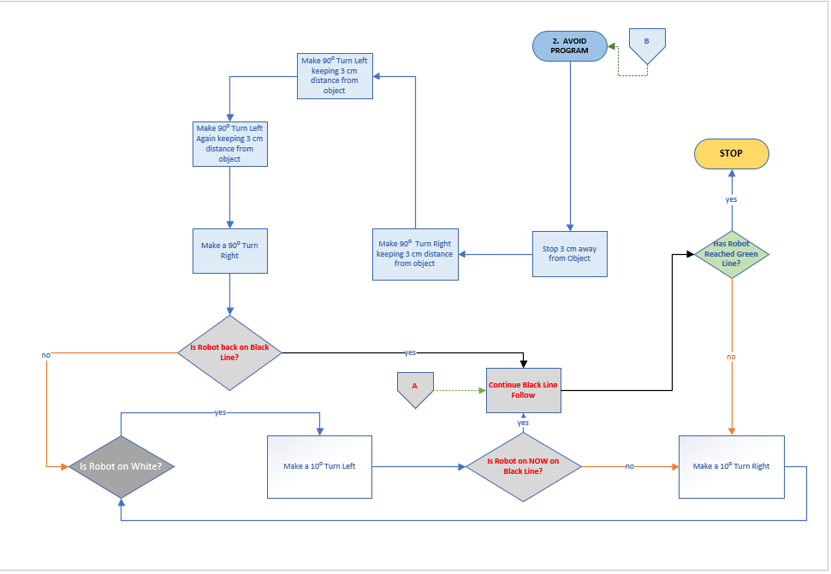

Sub Program Maze
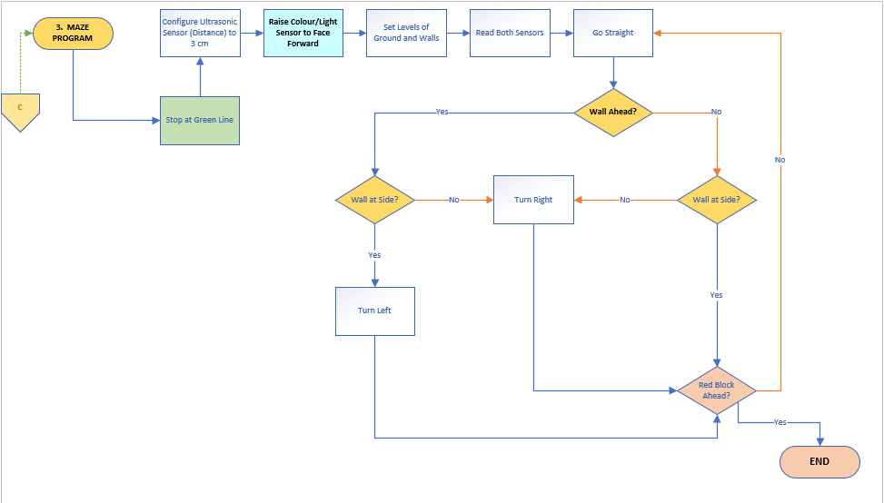

Sub Program Play Song
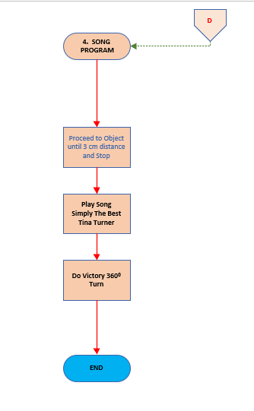

Table 9 – Draft Pseudo Code Compiled for Whole Task
Overview

- Line Follow (Colour Sensor DOWN) and Colour ID Black White Green

- Object Detection (RAISE Colour Sensor UP) and Colour ID (Blue Red)

- Object Avoidance (Blue)

- Maze (Green)

- Sound (Red)

 | CONFIGURE: Colour Recognition for: BLACK, WHITE, GREEN, BLUE and RED
1 | Line Follow: IF on Black go forward (either left or right edge following)
2 | - IF on White go back on Black
3 | - IF on GREEN Do Stop, and Instigate Wall Follower (Maze)
4 | - Wall Follower Maze
5 | Object Detection and Colour ID: Do Stop, Raise Colour Sensor UP, And
6 | - IF BLUE detected Do Avoid
7 | - IF RED detected Do Song
 | Pre-Pseudo Code DRAFT
1 | START: Place Robot on Top of Black Line
2 | Start Black Line Following Program
3 | UNTIL Ultrasonic Sensor Senses Obstacle, so Robot STOPS
4 | Colour Sensor Raises Up to Check Whether Obstacle Blue or Red?
5 | IF Blue, Colour Sensor Goes Back Down
6 | AND Avoid Program Does Sufficient Turns to Avoid Block UNTIL it re-joins Black Line
7 | Once Robot Back on Black Line Follow Program re-starts UNTIL
8 | Reaches Green Line
9 | Robot STOPS
10 | START ‘Wall Follower Maze’ Program (Right or Left Wall)
11 | UNTIL Reaches Obstacle in Front, so Robot STOPS
12 | Colour Sensor Raises Up to Check Whether Obstacle is Blue or Red?
13 | IF Obstacle Red, ‘Play Song’ Program
 | END

Table 10 - Pseudo Code Compiled for Whole Task
START
INPUT: Colour Values for Black White, Blue Green Red
SET, INIT: Values
IF Object in Front:
---- Raise Colour Sensor ID 45⁰
Sound Block ID Colour
ELSE Lower Sensor back down
INPUT: PROGRAMS:
Black Line Follow
Avoid
Maze
Song
PROGRAMS:
Black Line Follow
IF Right on Black and Left on Black
---- Go forward
Else if on White
--- Turn Right
Else if on Black
--- Turn Left
Else if on Green
--- STOP
Else if Object
--- STOP
END IF

 |  |  |  | Avoid
 |  |  |  | Colour Sensor Raises 45⁰
 |  |  |  |  | Object Blue Sound Block says ‘Blue Avoid’
 |  |  |  | --- Colour Sensor Goes Back Down
 |  |  |  |  |  | --- Turn 90⁰ Right, 8 CM
 |  |  |  |  |  | --- Turn 90⁰ Right, 8 CM
 |  |  |  |  |  | --- Turn 90⁰ Left 8 CM
 |  |  |  |  | --- STOP
 |  |  |  | Maze
 |  |  |  | WHILE not at goal:
 |  |  |  |  | IF there is a wall in front
 |  |  |  |  | --- Turn Right a little
 |  |  |  |  |  | Else IF there is a wall on the Left:
 |  |  |  |  |  | Drive Straight a little
 |  |  |  |  |  |  | Else: turn Left a little
 |  |  |  |  | Else IF Object
 |  |  |  |  |  | --- STOP
 |  |  |  |  | END IF
 |  |  |  | EXIT WHILE at goal
 |  |  |  | Song
 |  |  |  | Object Red Sound Block Says ‘Red Yipee’
 |  |  |  |  | --- STOP
 |  |  |  |  |  | --- Play Simply the Best by Tina Turner
 |  |  |  |  |  | ----Turn 360⁰
ONCE ABOVE PROGRAMMED:
START
1 | START Black Line Follow END
2 | START Avoid END
1 | START Black Line Follow END
3 | START Maze END
4 | START Song END
END

REFERENCES
[1] | Power Point Slides  Seshan, A, and S. (2016) Ev3 Lessons  http://ev3lessons.com/en/TabletLessons/beginner/BasicLineFollower.pdf  Accessed 15th March 2020
[2] | PID Line Following Code  Griffin, T. (2014) The Art of Lego Mindstorms EV3 Programming, pages 240-1
[3] | Colour Sensors  Griffin, T. (2014) The Art of Lego Mindstorms EV3 Programming, page 54
[4] | Colour Sensor Calibration (also repeated in Pseudo Code)  https://stemrobotics.cs.pdx.edu/sites/default/files/calibrate.pdf
[5] | Avoiding Object Code  https://i.ytimg.com/vi/2hH8NOQXiGQ/maxresdefault.jpg  Accessed 15th March 2020
[6] | Different Sensor Types  file:///E:/4%20%20Integrating%20Project/legomindstormsev3programmingbasics.pdf  Accessed 15th March 2020
[7] | Stop in front of object  https://education.lego.com/en-us/lessons/mindstorms-ev3/object-detection#Planitem2  Accessed 15th March 2020
[8] | Now pick up (also repeated in Pseudo code section)  https://www.sos.wa.gov/_assets/library/libraries/projects/youthservices/legomindstormsev3programmingbasics.pdf  Accessed 15th March 2020
[9] | Right hand maze wall following (also repeated in Pseudo Code)  https://magbuhatrobotics.files.wordpress.com/2017/05/aol-chapter-7.pdf  Accessed 15th March 2020
[10] | Maze Navigation Tools  http://www.legoengineering.com/the-maze-challenge-great-for-all-levels-and-ages/  Accessed 15th March 2020
[11] | LEARNING MOBILE ROBOTICS USING LEGO  MINDSTORMS  Paulo Leit˜ao, Jos´eGon¸calves, Jos´eBarbosa  LEARNING MOBILE ROBOTICS USING LEGO  MINDSTORMS  Paulo Leit˜ao, Jos´eGon¸calves, Jos´eBarbosa  Tables 1 (5.1) and 3 (5.4) (2015) Learning Mobile Robotics Mindstorms  Leitao, P, Goncalves, J. and Barbosa, J. (2015)  https://www.researchgate.net/publication/228975600_Learning_mobile_robotics_using_lego_mindstorms  Accessed 15th March 2020
[12] | Table 2 Block Avoidance  https://www.youtube.com/watch?v=J09wCblOHA4  Accessed 15th March 2020

METHODOLOGY
Order of work:

- Structure
- Research
- Write
- Review
- Experiment
- Revise Report (as necessary)
- Submit

Structure

Read Requirements of Exam
To choose which of two alternative questions to address and partition the questions into separate sections.

Structure Report into Chapters
List Chapter Headings these questions could come under:
1 Introduction
2 Task 1
3 Task 2
4 Summary
5 Flow Charts/Pseudo Code
6 References
7 Methodology

Use this to plan the report adding and moving sub headings around to flow.

Compile Gantt Chart
Use the above headings to list sub tasks under relevant Chapter and refer to calendar to spread the work over evenly, listing rough target dates to complete each Chapter.

Research

Line Following, Colour Sensors, Block Avoidance, Maze Negotiation
Power points, PDF’s and websites copied and saved.

Design
Robot structure and how tools fit on robot’.

Write

Slot Material into correct sections ensuring references congruent
- Choose which best parts of saved material,
- slot into appropriate section and shorten and re-word to suit
- Some research was used in two sections, so when adding more, updating carefully was crucial to ensure no mistakes

Review

Fine Tune
Where research looks weak, supplement research by building and programming robot in order to correct any misunderstandings in report.

Experiment

Overview
Research is a poor substitute for play! It is similar to trying to learn to cook by reading books only (never baking). Therefore, experiments carried out on:
- Program Structure
- Building the Robot
- Colour Recognition Configuration
- Black Line Following
- Object Avoidance; sensor
- Down for Black White, and Green,
- Up for Blue and Red
- Maze
- Sound
- The Code Required to achieve above

Order of the Program Required
- Colour Recognition (3) BLACK BLUE GREEN RED
- Follow Black Line (4)
- Avoid Blue Object (3)
- Re-join Black Line (4)
- Arrive at Green Line (3)
- Start Maze (6)
- Stop at Red Object (3)
- Play Tune (7)

 | Overview of Order of Play
 | A |  | CONFIGURE BLACK, WHITE, GREEN, BLUE and RED COLOURS
 |  | 1 | Configure Robot colour recognition for: BLACK, WHITE, GREEN, BLUE and RED
 | B |  | START BLACK LINE FOLLOWING PROGRAM
 |  | 2 | Place Robot on Top of Black Line
 |  | 3 | START ‘Black Line Follow’ Program (to Follow EITHER Left or Right Side)
 |  | 4 | UNTIL Ultrasonic Sensor Senses Obstacle so Robot STOPS
 | C |  | START OBJECT AVOIDANCE PROGRAM
 |  | 5 | Colour Sensor Raises Up to Check Whether Obstacle Blue or Red?
 |  | 6 | IF Blue, Colour Sensor Goes Back Down
 |  | 7 | AND Avoid Program Does Sufficient Turns to Avoid Block UNTIL it re-joins Black Line
 | D |  | AS SOON AS ROBOT GETS BACK ON BLACK LINE RE-START LINE FOLLOW
 |  | 8 | Once Robot Back on Black Line RESTART ‘Line Follow’ Program UNTIL
 |  | 9 | Reaches Green Line
 | E |  | AS SOON AS ROBOT ENCOUNTERS GREEN LINE
 |  | 10 | Robot STOPS
 | F |  | START MAZE PROGRAM
 |  | 11 | START ‘Wall Follower Maze’ Program (Right or Left Wall)
 |  | 12 | UNTIL Reaches Obstacle in Front, so Robot STOPS
 | G |  | AS SOON AS ENCOUNTERS RED OBJECT – START SONG PROGRAM
 |  | 12 | Colour Sensor Raises Up to Check Whether Obstacle is Blue or Red?
 |  | 13 | IF Obstacle Red, ‘Play Song’ Program

Various loops and switches, as well as calibration for speeds and colours were required.

Building the Robot

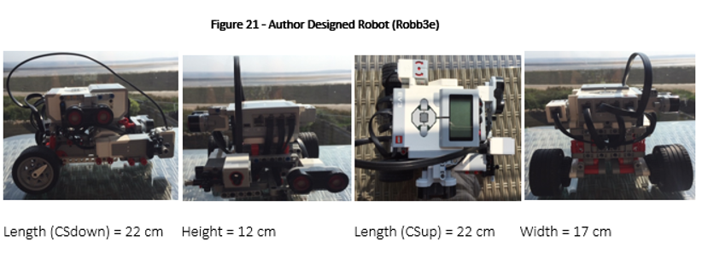

Mechanical
If robot won’t go despite programming, check wheels mechanism not obstructed and if so adjust.

Add-On Sensors
Three Sensors added;
- two Ultrasonic (Goggles) to detect objects one on front and other on RIGHT hand side for maze
- and other Colour/Light to identify colours which is raised when encountering object to ID colour (as opposed to ground).

Colour Recognition
Experiment making up a chart of colours with Colour/Light Sensor UP and DOWN necessary to achieve accurate recognition of colours.

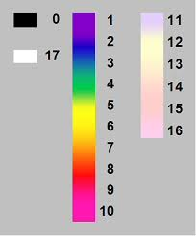

Sensor Up
- The closer Colour/Light Sensor gets to object, the better it can recognise which colour it is.
- The robot needs to be programmed to slow down when nearing obstacle, and then get very close to read the colour
- Identify Object is in path of robot at 5cm away
- Slow speed and creep up to see colour at 2 cm away from it

Colour Recognition with Sensor Down
Enclose the sensor in a ‘box’ when down to negate interference of light.

Black Line Following
A Black Line Follow course was constructed in order to better understand the problems encountered.

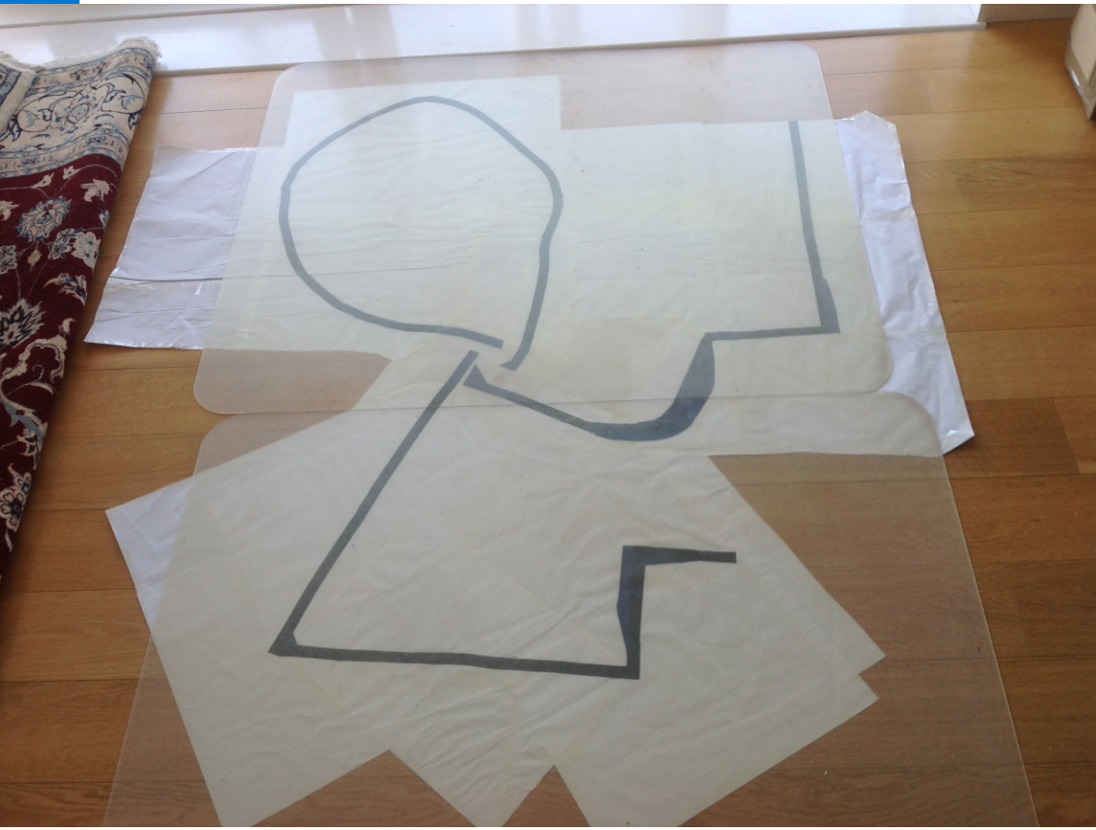

Threshold Value
To calculate using colour sensor in reflective light intensity mode:

Example: all black = zero all white = 100 therefore 50/50 = 100 divided by 2 = 50. When you place the sensor on right hand side of the line any readings over 50 need to turn robot left and any readings under 50 need to turn the robot right. The robot will perform in zig zag method.
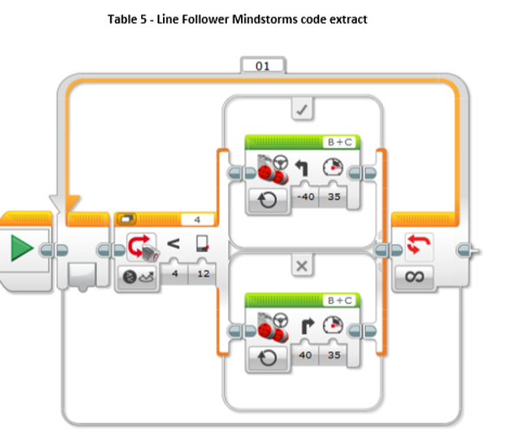

Loop 2 Conditions
To program the robot to carry out this instruction use a loop block into which you place a switch block. In the switch block you place a move steering block in each of the two conditions. The condition for the switch block is based on your threshold value in this case 50 so for the condition to work you have to choose the less than option on the switch condition – anything less than 50 it is going to do true or false condition true in this case less than 50 turns right and false if its greater than 50 it will turn left. It is important to state starting on the left-hand edge; if right other way round.

Speed/Sharp Corners
Sharp corner navigation: speed is important (slow it down). Sharp corners can also be circular as well as right angles. If using cross overs have them thinner so robot can keep going straight.

Object Avoidance
Experiments carried out using robot to see the form and order needed
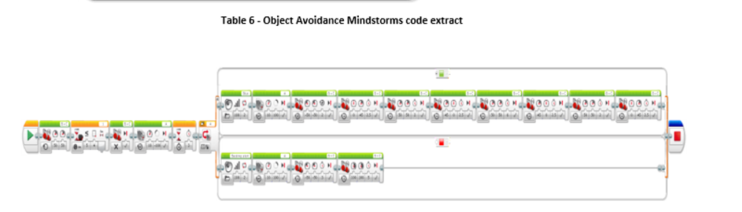

Maze
Experiments carried out using maze constructed. Note this is sourced code.
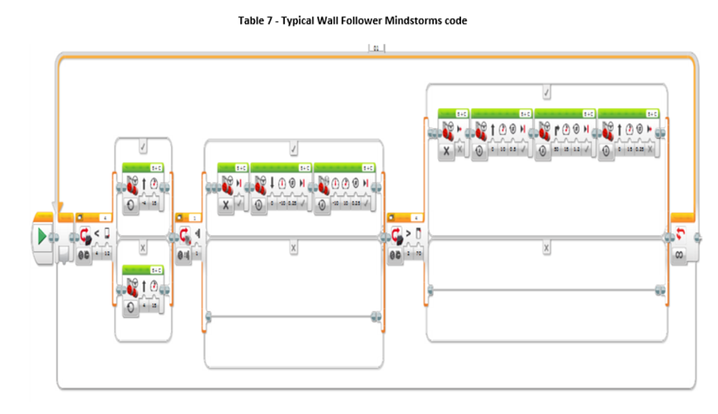

Maze constructed
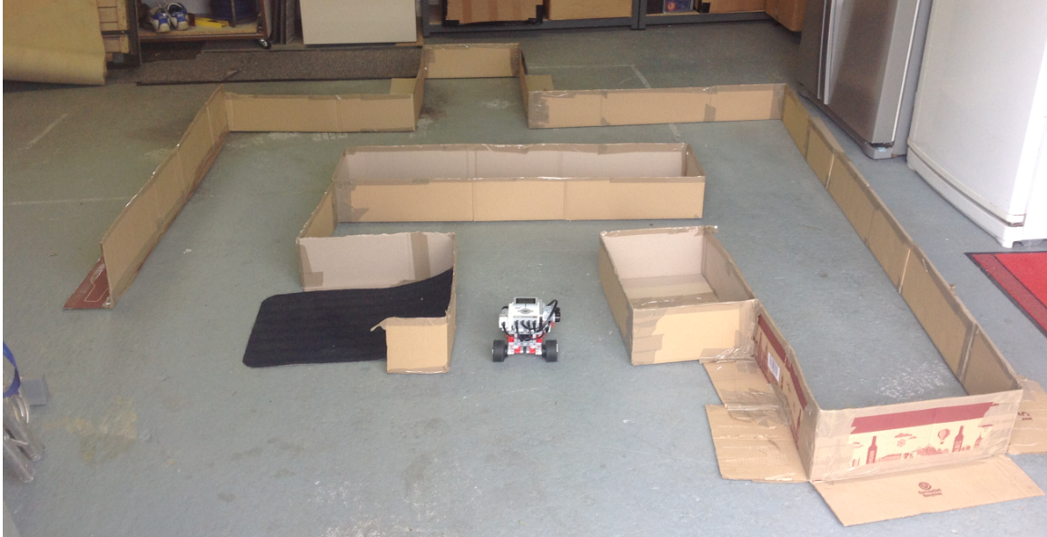

Sound
Experiments carried out to produce sounds.

Revise the Report
Make revisions as necessary.

Submit

Submit Draft for comments
Make appropriate alterations necessary.

Submit final on time (7th May)

