LEVEL 4 STUDENT NAME:

SEMESTER 2

MODULE CODE: M4X00386
Engineering Science 2

aSSESSMENT TYPE: COURSEWORK

Assessment/Component: 2 / 2

COMPONENT WEIGHTING: 30 %

MODULE TUTOR: Dr G Owen + Dr A Marotin

Attempt all questions

SUBMISSION DETAILS:

Date set:

Date to submit:

QUESTION ONE (25 marks):

A 12V battery has an internal resistance of 4Ω.
- If this battery is connected to a 8Ω load, calculate the power dissipated by the load. [2]

- Draw a graph showing how the terminal voltage of the battery and the current it can supply vary with load. [4]

- What load resistance should be applied to the battery to deliver maximum power. Derive an expression to show how to find this maximum power. [4]

Pure unstressed platinum wire is the preferred material for making a precision temperature sensor. A standard in common use says that a sensor must have a resistance of 100Ω at 0 °C. The resistivity of platinum is 9.81 x 10 ⁻⁸Ωm at 0 °C. The wire to be used has a diameter of 0.1 mm.

    - How long should the wire be? [2]
    - What is the volume of the platinum in the wire? [2]
    - The density of platinum is 21.45 x 10³ kg m⁻³ and platinum is about £10,000 kg⁻¹. Find the cost of the amount of platinum used in the sensor. [2]
    - Detectors can also be made by printing a fine track of platinum on to a ceramic substrate. The element must have a resistance of 125Ω. The track is 3.5.0 x 10⁻⁴ cm wide and 75 cm long.
    - How thick will the film of platinum need to be? [2]
    - Estimate the cost of the platinum used in this sensor. [2]

- A cable used in high-voltage power transmission consists of six aluminium wires surrounding a steel wire. A cross-section is shown below.
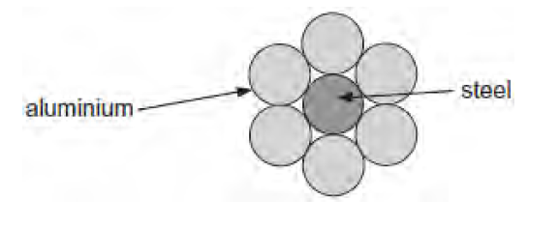

The resistance of a length of 1.0 km of the steel wire is 3.3 Ω. The resistance of a length of 1.0 km of one of the aluminium wires is 1.1 Ω.

                - The steel wire has a diameter of 7.4 mm. Calculate the resistivity of steel. State an appropriate unit. [2]
                - Explain why only a small percentage of the total current in the cable passes through the steel wire. [2]
                - The potential difference across a length of 1.0 km of the cable is 75 V. Calculate the total power loss for a 1.0 km length of cable. [1]

QUESTION TWO (25 marks):
- Most types of microphone detect sound because the sound waves cause a diaphragm to vibrate. In one type of microphone this diaphragm forms one plate of a parallel plate capacitor. As the diaphragm plate moves. the capacitance chances. Moving the plates closer together increases the capacitance. Moving the plates further apart reduces the capacitance.
This effect is used to produce the electrical signal. The circuit shown below consists of a 3 V supply, an uncharged capacitor microphone C. a resistor R. and a switch S.

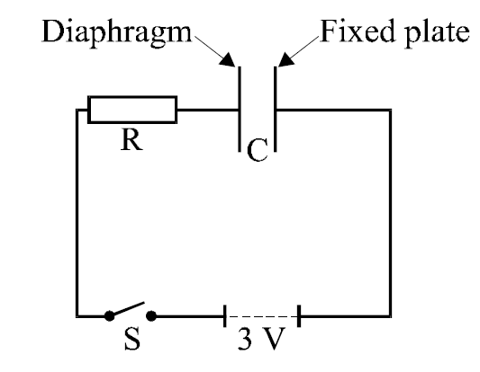

- The switch S is closed. Sketch a graph of the voltage across the capacitor microphone against time. Assume that the capacitor microphone is not detecting any sound. [4]

- Explain why movement of the diaphragm causes a potential difference (the signal) across R. [4]

- The circuit below models a single pixel of a CCD device. The photocell generates a voltage which depends on the intensity of light falling on it. When information about light intensity is required, the switch is opened. The voltage across the capacitor at that instant can be read out into an electronic circuit (represented by the voltmeter) at a later time.

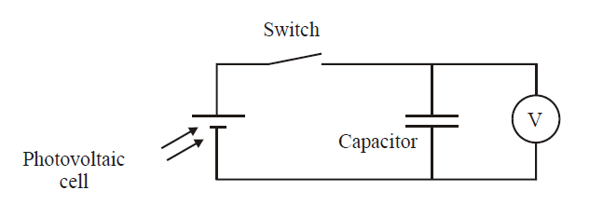

The capacitor has a value of 0.22 F. In an experiment the voltmeter reads 95 mV after the switch is opened. Calculate the charge on the capacitor. [3]

iv. This voltmeter reads 95 mV for some considerable time. State what this tells you about this voltmeter.
[2]
v. The student doing the experiment changes the voltmeter for another. With the new voltmeter the voltage changes with time according to the table below.
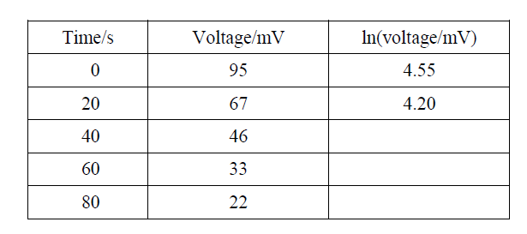

The student thinks the voltage is falling exponentially. To test this he makes a third column in his table to calculate values for ln(voltage/mV). Complete the table [3]

vi. Plot the points from the table on the graph below. Join the points with an appropriate line. [4]

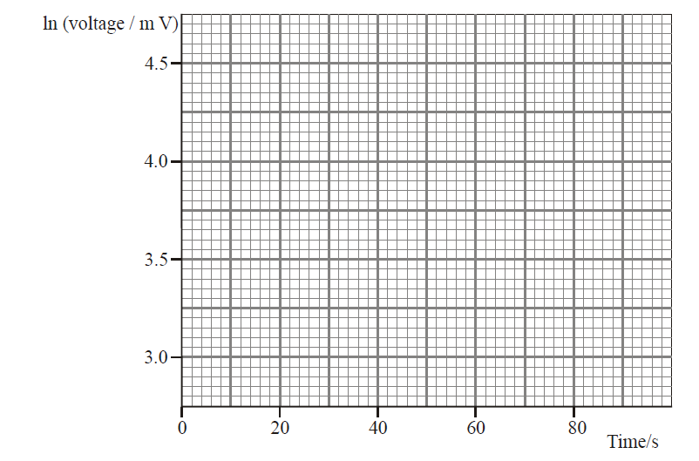

vii. Explain how the graph shows that the voltage decreases exponentially [3]

viii. Find the approximate value for the resistance of the second voltmeter. [2]

