

Synthesize a solution to a potential real-life scenario
Author: Luke Akerman (3404201)
Email: 2404201@student.uwtsd.ac.uk
Module: Computer forensics
Lecturer: Assoc. Prof. Carlene Campbell

Computer forensic tool analysis and comparison

Abstract: Computer forensics is a crucial part of cybersecurity. It focuses handle a cyber related incident after it happened by using investigation tools and methods to identify how the incident took place, by who and how it can be prevented. While this concept doesn’t change and the methods used may slightly change, the tools used always change. Some of these may be open source or commercial however they all have different uses depending on the case they are being used for. This paper aims to provide a evaluation for 4 of these tools with two of them being an open-source tool and two of them being commercial use. I will compare based on cost, features, supported file systems and evidence it analyses. This paper will also analyse how these tools can by used in the phases of the CHFI (Computer hacking forensic investigator).

I. Introduction
Computer forensics is an important aspect of cyber security, policing and private company incident response. Computer forensics is used to help these entities understand how a cyber security incident happened, who was behind it, and how it can be prevented. It follows a structed process of acquiring evidence and preserving the evidence, analysing the evidence and reporting the outcome of the investigation. While this process remains unchanged the tools used to carry out the investigation are constantly changing and evolving due to constant innovations and improving technologies such as improvements in cloud computing, operating systems and encryption.

II. brief overview of the CHFI process
CHFI or ‘computer hacking forensics investigator’ is a certification from the EC- council that teaches students how to effectively respond to a cyber crime incident by teaching evidence handling, the chain of custody, acquisition, preservation, analysis and reporting [1] [2]

III. Comparison of FTK Imager, Magnet AXIOM, Autopsy and Cellebrite UFED

FTK imager
FTK imager is a Widley used free digital forensic imaging and preview tool with an optional paid version for £375 per year. It is used by digital forensic specialists to create an exact copy of evidence in its exact condition from a drive and preserves it perfectly for investigations. FTK imager works by being connected to the suspicious drive and reading the entire disk and writing all data found to an image file such as an E01 and RAW file. [3] An important aspect of using FTK imager is that it generates cryptographic hashes (for example MD5 SHA-1 and SHA-256) for both the image file and original source which allows the user to prove the evidence they have collected is original and unaltered. Ensuring that these hash values are kept is crucial for keeping the chain of custody as this prevents the evidence found from becoming dismissible in an investigation.
FTK imager also has a feature that allows for the digital forensic examiner to preview the content on a disk drive before creating a full image. This allows the examiner to preview if there is any evidence to collect and stops them from capturing any data that is not needed for the investigation to save time for this investigation. [3]
However, FTK imager does not have an advanced analysis tool built into the application. This means its primary function imaging evidence and capturing evidence. Once evidence has been captured, it should be analysed in Autopsy or Magnet AXIOM as they are designed for analysis and reporting. [4] Because of this, FTK imager should only be used in the data acquisition stage of the CHFI process allowing for an admissible accusation of data creating verifiable images of data. Another disadvantage of FTK imager is that it does not work with mobile phones or does not have cloud support. This means the examiner is limited to what evidence can be collected using FTK imager as they can’t search across multiple devices.

Magnet Axiom.
Magnet Axiom is another digital forensic that is an all-in-one suite used for analysing digital evidence on multiple different platforms such as computers, Mobile devices and cloud services. Unlike FTK imager, Magnet AXIOM is used for analysis and reporting not accusation [5]. Magnet AXIOM is a useful tool for analysis because unlike FTK imager, AXIOM breaks down data found such as browser history, communication app logs (such as WhatsApp) and cloud synchronization logs [6] This makes it effective in modern day investigations as data now is often synched across different devices and services and using this tool will allow forensic specialists to track where the data has been sent around to.
A major strength of Magnet AXIOM is that it tracks evidence from multiple sources which allows investigators to build a timeline of events and identify patterns that the suspect displayed. This allows for betting reporting features to allow the forensic examiner to create a well-structured report of what was found and order of events ready for a possible trial. [7] These digital forensics tool is also vert efficient as it supports a wide range of different file systems and is can be customized to suit the needs of the case. [7] However, this software is very expensive and can cost nearly £2000 for a licence making it inaccessible to smaller companies with less money. This software also requires more training as it has a lot of features that examiners need to learn. Despite these drawbacks, Magnet AXIOM is one of the most powerful and efficient digital forensic tools available. Because of its analysis and reporting capabilities, Magnet AXIOM is usually used in the analysis and reporting phase of CHFI

Autopsy
Autopsy is a similar tool to Magnet AXIOM with the main difference being that Autopsy is an open-source free tool that doesn’t require a licence to own and use. It has some of the same features that can be found in paid forensic tools such as being able to create and analyse a timeline of events, hash filtering and analysing emails sent from the suspect device and file system analysis for file formats such as NTFS, FAT, EXT, HFS. [8]
Autopsy is effective for analysing disk images, recovering deleted files and analysing systems files. As it is open source it is a great alternative to Magnet AXIOM for smaller companies with less money or for people learning how to use forensic software. Some other advantages over Magnet AXIOM are that Autopsy does not require as much resources as AXIOM allowing it to run on less powerful machines. However, Autopsy does not work on mobile devices or cloud services making it extremely limited for some use cases. Another disadvantage of Autopsy over Magnet AXIOM is that it requires more manual configuration compared to AXIOM. While autopsy can create reports its not as high standard as axiom meaning more manual input is needed costing more time. Because of this drawback, Autopsy is not generally suited for a large enterprise case as its automation and case management is not as good and Magnet AXIOM. [8] [9] Autopsy is mainly used in the analysis phase of the CHFI process for examining disk images captured by FTK Imager and is commonly used for training by students as there are no costs for running Autopsy. Despite the drawbacks, Autopsy is a strong forensic analysis tool especially for smaller companies or students.

Cellebrite UFED
Cellebrite UFED is a digital forensics tool used by specialists to extract and analyse evidence from a mobile phone. [10] using this tool, investigators do both logical and physical extractions depending on the phone model allowing them to view a wide range of evidence such as call logs, app data, geolocation information and any messages on the phone. [10] A major strength UFED has is that it can bypass certain encryption and locks on a phone allowing investigators to have full access to the device to get the evidence needed for trials. It can bypass a phones lockscreen and gain access to apps that would usually have encryption such as WhatsApp and Telegram. This gives UFED a significant advantage over other mobile extraction tools as it can also bypass disk encryption unlike Magnet AXIOM. [11] UFED also has Cellebrite inspector which can be used by investigators to provide a better analysis and perform advanced searches and filtering making the investigation easier and more organised [10]
Cellebrite has very useful reporting capabilities to allow the investigators to form a structured report ready for possible court cases by allowing investigators to create timelines and put patterns together which is extremely important in investigations.
However, UFED has s major disadvantage as it costs around £15000 for a licence to use making it one of the most expensive forensic tools you can use and the most expensive out of my comparison. Because of this, UFED is only used by law enforcement and large enterprise companies. This tool also requires specialist training for it to be used. UFED also requires constant updates as smartphone companies are constantly improving their security making this tool more difficult to use.
As mentioned before, this tool can be used for both extraction and analysis meaning it can be used at both stages of the CHFI framework.

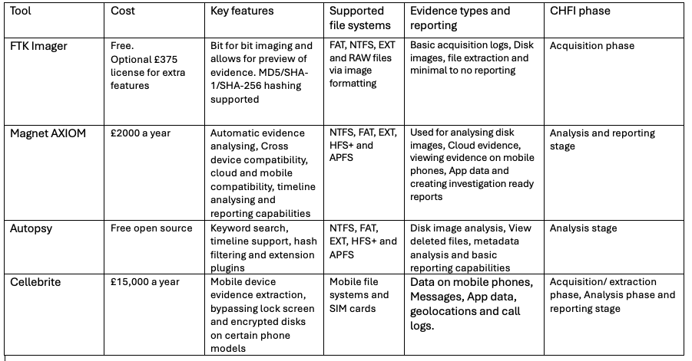

Conclusion
I have compared four different digital forensic tools. FTK imager and autopsy which are both free or open source, and Magnet AXIOM and Cellebrite UFED which both require a licence and are made for large enterprise corporations or law enforcement. In this comparison, I demonstrated that you can’t use a single tool for all requirements in an investigation but rather must use a variety of tools to cover all bases.
FTK imager is useful for acquiring reliable and important information of disk evidence. While autopsy provides a free way to analyse a disk and deleted data recovery in detail. Or use Magnet AXIOM for better automated evidence analysis and cross device compatibility or if the investigation is for a large enterprise company or law enforcement and requires more sophistication. If an investigation requires data acquisition and analysis from a mobile phone, then using Cellebrite UFED as it offers features such as bypassing lock screens and disk encryption that other tools don’t offer. Balancing the use of these tools ensures companies can have good evidence integrity and maintain the chain of custody and balance cost while having court ready reporting.
Cost is a huge factor when deciding what tools to use along with training. Using a commercial paid tool would be more costly and require additional training but require less manual configuration saving time for investigators.

Case study: Sabotage
Forensic methodology
The digital forensic investigation into Rich Daley’s workstation needs to follow a set of digital forensic standards to ensure that all evidence found in the investigation is acquired and analysed are done so in a legal manner and to ensure that evidence is not dmissible in a court. In this case, I will follow the CHFI methodology along with the ACOP principles. These are widely accepted practices in UK digital forensic practice. The ACPO principles state that the original state of the device being investigated must be kept the same as it was when the investigation began. If access to the data is needed, the investigator must be competent and needs to justify their actions. An audit trail must be maintained that a third party can examen and have the same outcome when following ACPO principles to maintain the chain of custody. Finaly, the investigator examining the evidence is responsible for making sure that all these principles are met and followed correctly. [12] If these principles are not followed it can lead to the evidence collected becoming dismissed in a court.
The CHFI methodology starts with identifying the evidence that is going to be used such as Rich Daley’s Windows 11 workstation. The next phase of the CHFI process is ensuring that the evidence is seized and preserved to prevent any loss of potential evidence and maintaining the chain of custody, Extracting the evidence from the seized device is the next phase of CHFI process which in the case of Rich Daley would involve using FTK imager to capture and image the device’s encrypted drive ready to be analysed. The next and final stage is analysing the evidence on the disk image and identifying anything that can be used as evidence and examining deleted disk space for any evidence the suspect tried to get rid of. Creating a report ready a potential court case or to provide feedback to the client is the final stage of the CHFI process. [2] It is important that all documented evidence is clear and follows the principles and stages stated to ensure it is legal.

Investigation plan
The first step in this investigation is to extract required evidence from an encrypted BitLocker windows 11 machine. If the device is still powered on, the keys required will still be available in the devices RAM meaning RAM capture software such as Magnet RAM capture which works with Magnet AXIOM can be used to find a potential key. [13] [14] If the device has been powered off however, Then the recovery key can often be recovered from the Active Directory Domain Services in CMMC’s system. [15] [16] Once this process is complete, FTK imager can be used to create a bit by bit image of the suspects drive allowing for the forensic investigators to have an exact copy of the disk drive for data to then be analysed by a Magnet AXIOM. FTK Imager is the best tool for this process as it creates cryptographic hash values such as MD5, SHA-1 and SHA-256. These cryptographic hashes are very important for the investigation as they demonstrate that the collected evidence has not been tampered with, and the chain of custody has been maintained.

Tools such as Magnet AXIOM or autopsy can be used to investigate whether any anti forensic activity took place such as deleting files. These tools can identify any evidence that’s been left behind by the file wiping applications and view event logs and find gaps in the filesystem metadata. [17] Magnet Axiom would be the best tool to use for this case as it has better automation and reporting capabilities than Autopsy. Meaning it can automatically analyse and find the ant forensic activities without as much manual input. Another reason to use Magnet AXIOM for this case is because CMMC is a large enterprise company and therefore will require more sophisticated tools.

This investigation also needs to determine if Rich Daley uploaded information to his personal Google Drive cloud storage. While we may not be able to access the Google Drive account directly, Magnet AXIOM can be used to view activity on the web browser such as search history, cookies and login tokens to view if any data has been uploaded to his Google Drive account. [6] While Autopsy can also be used to analyse browser data, Magnet AXIOM is better at automatically analysing the data making it easier for the investigator top analyse the finding whereas Autopsy would require more manual configuration which will take more time and can lose CMMC money.

I have chosen each tool based on their strengths found in independent research. FTK imager has been chosen as it’s a great free tool that can be used for the extraction phase of CHFI. FTK imager also ensures that the evidence collection complies with ACPO principles as it creates images of disk data without causing any interference with the original data allowing for the chain of custody to be followed. Magnet Axiom has also been chosen for the analysis and reporting stage of the forensic investigation as it allows for the investigators to detect any anti forensic activity such as deleting data. Magnet AXIOM can also be used to view and analyse cloud synchronization due to its advanced evidence analysis tool. Autopsy can also be used for viewing deleted information and analysing evidence manually for more accuracy in the investigation ensuring no data is missed.

Forensic Report

Summary
The CEO of CMMC Ms Ker Walters requested for this investigation to take place to identify if Rich Daley sabotaged confidential files and designs that belonged to CMMC intentionally to sell the designs to their competitors. At the first stage of the investigation, we used FTK imager to gather a forensic image of the information on his Disk and look for any evidence of files being deleted. An analysis of this data extracted using Magnet AXIOM showed that files were deleted of the disk using a file wiping software such as Eraser. Traces of deleted the Autodesk Maya project files were found on the computer along with web browser logs showing that Google drive was accessed within the time frame of the files being deleted. This strongly indicates that the project was stolen and deliberately destroyed on company computers.

Steps taken in the investigation
The first step that was taken in this investigation was to seize the workstation and make sure it was not powered off to reduce the risk of potential data in the RAM being lost. This followed the CHFI process and the ACOP principles as it ensured that the evidence was not tampered with. [2] [12] By doing this we were able to find the Bit Locker key by using RAM capture software from Magnet which allowed us to access the encrypted drive. Using FTK imager, we created a forensic image of the disk for analysis and cryptographic keys were also created to ensure that the chain of custody was maintained. Magnet Axiom and Autopsy was then used to analyse the data that FTK imager was able to capture were we searched for evidence of deleted data and browser information that would indicate that Google drive was accessed and uploaded to. Evidence of a file wiping tool was identified on the workstation and bits of data from the Autodesk Maya Project were found along with space that was overwritten but unallocated showing evidence of anti-forensic activity. [18] Evidence from the browsers cookies, cache and search history shows that a documents were uploaded to Google Drive withing the timeframe of the files being deleted. All these finding were then reported correctly while maintaining chain of custody ready for presentation to a potential court.

Findings.
Similar to what I’ve stated previously, the evidence that was extracted and imaged for investigation and analysis showed evidence that Rich Daley used a file wiping tool like Eraser shortly before he left CMMC. Analysis of the prefetch files showed that the wiping tool had been run and was recorded in event logs. [19] Magnet AXIOM and Autopsy also showed large sections of unallocated space on the disk which indicates there was data that had been deleted of the drive. [18] File carving using autopsy showed that there were some fragmented data still on the disk that were related to the Galaxy Z Flip 6 design file names. Finaly, an analysis of the data found on the browser such as search history, cookies, and cache data, showed that Rich Daley had accesses a personal Google Drive account and had uploaded files within the timeframe of the Disk data being deleted.

Conclusion
The evidence that has been identified in this investigation show clearly that Rich Daley had sabotaged CMMC’s design intentionally and saved himself copies for malicious use. This is shown by the evidence of files being deliberately wiped using a file wiping tool like Eraser. An analysis from Magnet Axiom showed clearly that data had been uploaded to a personal Google Drive account by Rich Daley. From all the evidence that has been gathered in this investigation, its shown that Rich Daley was committing Espionage and that all of his actions were intentional had was done with the purpose of harming the company.

Invoice

Investigator: Luke Akerman
Company: LA Digital Forensics Specialist
London UK.

What was done
I acquired evidence showing Rich Daley’s actions were intentional by using digital forensic imaging software, file carving, deep analysis of the workstation showing evidence that Google Drive had been accessed and that anti forensic action had been taken by Rich Daley by using tools to deleted possible evidence. At a rate of £200 per hour for 20 hours in total, the final cost of this investigation is £4,000

Appendix:

A simulated hash log from FTK Imager:

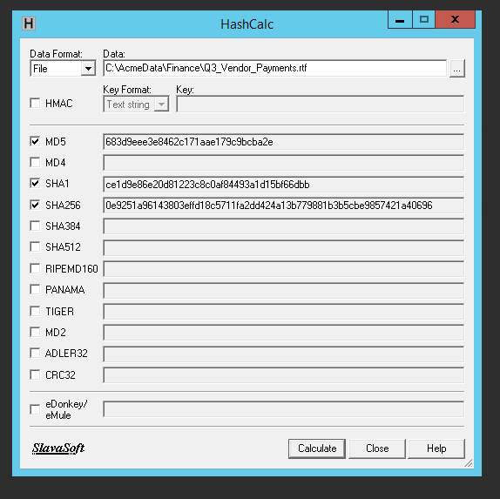
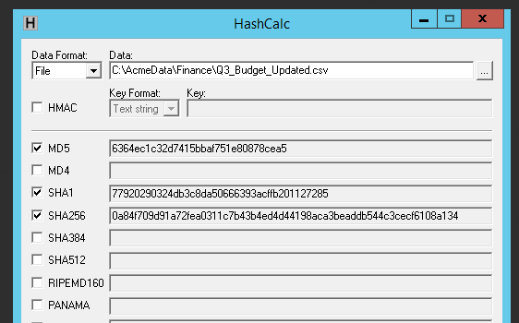

References

[1] | EC-Council, “EC-council,” [Online]. Available: https://www.eccouncil.org/train-certify/computer-hacking-forensic-investigator-chfi/.
[2] | Global knowledge, “globalknowledge.com,” Skillsoft, [Online]. Available: https://www.globalknowledge.com/en-gb/courses/ec-council/forensics_and_incident_response/chfi/E.
[3] | Exterro, “Exterro.com,” [Online]. Available: https://www.exterro.com/digital-forensics-software/ftk-imager.
[4] | InsaneCyber, “insanecyber.com,” [Online]. Available: https://insanecyber.com/how-to-use-ftk-imager-to-take-disk-and-memory-images-for-free/.
[5] | Magnet Forensics , “magnetforensics.com,” [Online]. Available: https://www.magnetforensics.com/products/magnet-axiom/.
[6] | Magnet forensics, “magnetforensics/blog,” [Online]. Available: https://www.magnetforensics.com/blog/how-to-uncover-web-browser-activity-artifacts-for-mobile-device-investigations/.
[7] | Salvation Data, “salvationdata.com,” [Online]. Available: https://www.salvationdata.com/knowledge/magnet-forensics/.
[8] | K. Libby, “eForensics magazine,” [Online]. Available: https://eforensicsmag.com/autopsy-the-digital-forensics-toolkit/.
[9] | Cyber Triage, “cybertriage.com,” [Online]. Available: https://www.cybertriage.com/blog/computer-forensic-tools-comparison-chart-2026/.
[10] | Cellebrite, “Cellebrite.com,” [Online]. Available: https://cellebrite.com/en/products/ufed/.
[11] | R. Purita, “Sherlock Forensics,” sherlockforensics.com, [Online]. Available: https://www.sherlockforensics.com/blog/cellebrite-vs-magnet-axiom-2026.html.
[12] | Forensic control , “forensiccontrol.com,” [Online]. Available: https://forensiccontrol.com/guides/acpo-guidelines-principles-explained/.
[13] | Magnet Forensics , “magnetforensics.com,” [Online]. Available: https://www.magnetforensics.com/resources/magnet-ram-capture/.
[14] | O. Afonin, “Elcomsoft Blog,” [Online]. Available: https://blog.elcomsoft.com/2022/05/live-system-analysis-extracting-bitlocker-keys/.
[15] | Microsoft, “microsoft.com,” [Online]. Available: https://learn.microsoft.com/en-us/windows/security/operating-system-security/data-protection/bitlocker/recovery-process#helpdesk-recovery.
[16] | R. Fisher, “serverspace.io,” ServerSpace, [Online]. Available: https://serverspace.io/support/help/bitlocker-active-directory/.
[17] | J. Mcquaid, “YouTube,” Magnet Forensics , [Online]. Available: https://www.youtube.com/watch?v=0MW_A_uH3d8&t=742s.
[18] | J. Jamieson-Mane, “7 data recovery experts,” [Online]. Available: https://help.7datarecovery.com/unallocated-hard-drive/.
[19] | Magnet Forensics , “Magnet Forensics,” [Online]. Available: https://www.magnetforensics.com/blog/forensic-analysis-of-prefetch-files-in-windows/.

