Managing people
Assignment 1
Student number : 1905633
Student name : Rdau Neata

Table of Contents
Introduction 3
Overview of NHS 4
Task One 5
CIPD Profession Map 5
Task Two 6
Organisational objectives of NHS for planning for employees and responsibility of HR function for delivering. 7
Organisational objectives of NHS for recruitment for employees and responsibility of HR function for delivering. 9
Organisational objectives of NHS for selection for employees and responsibility of HR function for delivering. 10
Concoction 13
Reference 14

Introduction
HR professional in business organisations needs to perform diverse activities to create values for the organisations and to impact other business activities. HRM activities need management and leadership skills as it needs to manage employees at the same time need to work to increase employee motivation. In this report, we will see different knowledge and behaviours which are needed for HR professional and their values for an organisation.

Overview of NHS
National Health Service is the publicly funded healthcare systems of the UK which are working to ensure the health and social care service comprehensive, universal and free for all in the UK. All of its four systems work to bring the best employees by arranging training program and to use the best strategy to make them effective and efficient. There are more than 2,165,043 staffs from which 691,000 are nurses and NHS is the fifth biggest employer in the world (England, 2019).

Vision
The vision of NHS is to ensure best care service for all by arranging the best care practice in the overall UK.
Mission
The mission of NHS is to ensure best care service with the lowest cost for all the people of the UK.

Task One
In the viewpoint of CIPD profession successful recruitment depends upon finding employees with the right skills, expertise and qualifications who will able to bring the best values for the organisation. In a care setting, it is very important to bring skilled, professional and efferent employees for which NHS use CIPD model on their selection activities. In this part, we will use the CIPD Profession Map to evaluate the HR professional.

CIPD Profession Map
NHS ensure various aspects of people management work together for which it needs a skilled and effective HR professional. As this organisation has its unique strategy all the employees need to have skills and experience to reach the aims and objectives of it (Beatty, and Queen’s, I2019).
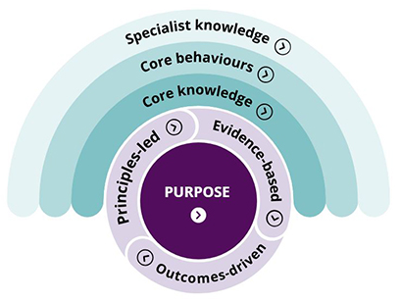
Figure- CIPD model for the HR professional (Beatty, and Queen’s, I2019).
Outcome-driven: HR professional in NHS need to work to bring specific outcome which is to ensure best cares service to the people. So, they need to use the best selection process to bring the most valuable candidates for internal operations.
Evidence-based: One of the main principles of NHS is to ensure evidence-based practices so, employees in this sector need skills of participating in research and data storing. So, HR professional needs to select those people who have diverse skills (Greenfield, et al. 2019).
Principals based: NHS need to follow principals and guideline from the government and other authority. So, HR professional needs to care and have knowledge about those principals and need to use in their regular activities.
Core knowledge: Core knowledge means selection process, implementing and developing SHRM, training and development activities and so on. So, we see most of the HR professional in NHS are related to care service providing.
Core behaviours: HR professional need to use a unique strategy of NHS so, it needs to ensure the use of best HR practise for the internal and external selection process. As they need to arrange a training program they also need to have emotional intelligence.
Specialised knowledge: HR professional in NHS not only perform their regular HRM activities but also they need to participate in various specialised areas. Like they need to conduct research, evidence-based practice, need to work with the privacy of care data and in most of the cases, they need to work with the government for reaching particular aims and objectives (Pariona‐Cabrera, Cavanagh, and Bartram, 2020).
So, for working as an HR professional in NHS we need to have diverse skills and capacities for creating values for care service taker. And they also need good behaviour which will make them more caring in the selection and recruitment process. But in future, this professional will require more diverse skills and responsibility as care setting is changing day by day (Greenfield, et al. 2019).

Task Two
The HR function in NHS is responsible for diverse activities so, besides regular recruitment and selection activities, they need to undertake various other rules and responsibilities. NHS some objectives regarding the quality of service and HR functions try to reach those aims and objectives with their regular activities. Here are some objectives related to HR activities…
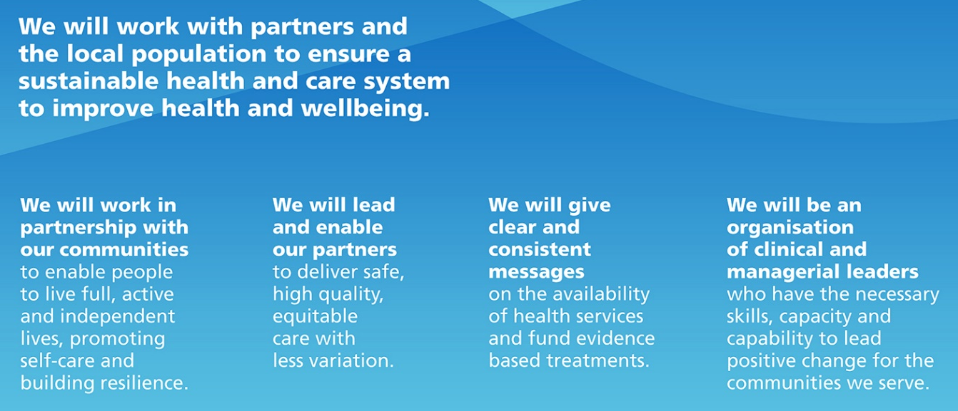
Figure-Objectives of NHS (Signorelli, et al. 2020).
- Undertaking activities by partnering with communities so, employees need to have teamwork skills and ability to work in a collaborative platform.
- NHS implement better policy and service level to ensure high quality and safe service for all the service taker.
- Evidence-based practices need to ensure in all care setting so, NHS need staffs who are like to work with IT equipment for storing and retrieving evidence (Fattore, 2019).
- NHS need both clinical and managerial leaders so, it needs an expert who has multiple skills and capabilities for maximising the values of customers.

Organisational objectives of NHS for planning for employees and responsibility of HR function for delivering.
HR function needs to bring more than 20000 employees in NHS and during ACovid-19 it needs to manage and worked with almost all the employees of NHS. NHS also need to arrange a training program and need to participate in government health policy development. Here is the planning for employees used in the NHS (Fattore, 2019).
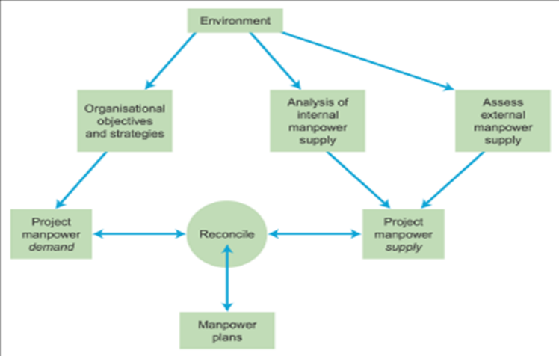
Figure-Employee planning in NHS (Valabhji, and others 2020).
Organisational objectives: First of all NHS has objectives to serve the people in a better way so, it wants to bring skilled employees in all the sectors. But like other profit-making organisations, it does not concentrate on cost minimisations activities for which it invests a good amount of money in the selection and recruitment process (Valabhji, and others 2020).
Internal manpower supply: NHS exercise talent management and its wand to bring expert employs in most of the position of it. Beside this for motivating employees NHS manage some manpower from internal sources like job rotation, special responsibilities are this type of manpower planning.
External manpower supply: Objectives of NHS to bring highly skilled and efficient employees from different part of the UK for which it concentrates on external recruitment and selection process. But all are not allowed to apply in these organisations as there are some specific job positions in it (Valabhji, and others 2020). Like for example, here is a list of HR-related job position in NHS...
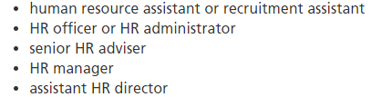
Figure- HR staffs position in NHS (HR in NHS, 2020).
NHS implement Integrated HR/management strategy for which it evaluates supply and demand of people like during Covid-19 it needs to bring many new employees although sully of people was low. HRM action plans like for example, resourcing, reward, development, employment relations is monitor and control by upper management (Majeed, Maile, and Bindman, 2020).

Organisational objectives of NHS for recruitment for employees and responsibility of HR function for delivering.
Objectives of NHS in terms of employee researching is having the right person, in the right place, at the right time. So, it wants to implement best resourcing techniques but in most of the cases it uses external researching and in this part, we will evaluate external resourcing of NHS.
Key rules and responsibility: NHS use paper-based advertisement and over the year job candidate can drop their CV on the website of it. But there are some entry requirements which need to fulfil by all the candidates (Majeed, Maile, and Bindman, 2020). It specifies key roles and responsibilities of the job positions like here is the list of responsibility of HR functions...
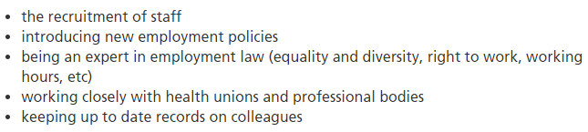
Figure-Responsibilities of HR functions
Job location: HR staffs need to work in hospitals and headquarters buildings as it has separate HRM division. Main work of HR staffs is to implement SHRM in all over the organisation and to implement best HR practices in all over the organisation. As NHS has a hospital in a different part of the UK newly recruited staffs need to reedy to work in nay parts of the UK (Ghafur, et al. 2019).
Entry requirements: These requirements vary depending on what level one join the NHS like is anyone want to work as HR assistant they need to have GCSEs including English and maths, or equivalent. Alternative qualifications help to get promotions and special responsibility but those who are related to training and development of staffs need to have a specialised degree (Styliani, 2019). Here are some alternative qualifications for HR staffs in the NHS.
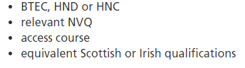
Figure- Alternative qualifications to work in NHS (HR in NHS, 2020).
Personal characteristics and skills: For working in NHS candidates’ need to have diverse skills and capabilities as these are related to total quality management. Beside this NHS wand to implement best care services for the people of the UK. Communication skills are needed to work on the collaborative platform and critical think is needed to undertake the project in the care setting (Kerr, et al. 2019). Here are some personal characteristics and skills needed for working as an HR professional in NHS.
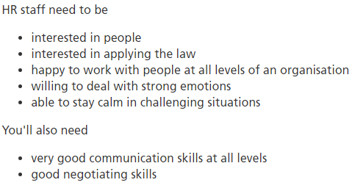
Figure- Characteristics and skills needed for working as an HR professional (HR in NHS, 2020).
By undertaking all of those rules and responsibility all the employees can reach the aims and objectives of NHS. But in most of the cases as staffs of NHS need to cope with new treatment and strategy they need to implement proper continues professional development plan.

Organisational objectives of NHS for selection for employees and responsibility of HR function for delivering.
NHS has aims and objectives to select the most talented persons from different part of the UK so it offers diverse job positions with different responsibilities and opportunities. Like in the figure we see job offering for different positions of HR professionals. For some position, it offers hourly salary and for some positions, it offers yearly income range. NHS use automated selection process beside regular traditional one. An automated selection process offer jobs to new candidates from different parts of the UK (Ghafur, et al. 2019).
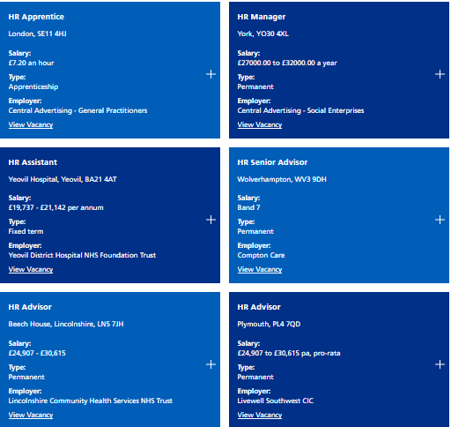
Figure-Job offerings of NHS
For promoting best clinical and business practice NHS exchange information, expertise and best practices among all the partners of it. So, this enables to implement evidence-based practices in NHS which is needed to ensure the best services for all. Even in recruitment, training and retention activities, NHS collaboration with key stakeholders is part of their HR objectives (Kerr, et al. 2019).
This organisation implement new themes of improvements which also bring changes in their aims and objectives. Like in 2020 it has implemented five new themes where it wants to ensure operational performance for which it need highly skilled employees. Here are the five themes of 2020 objectives...
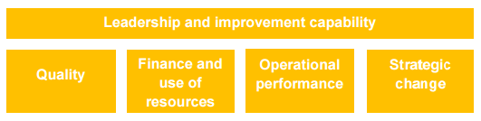
Figure- Themes of NHS 2020 objectives (Styliani, 2019).
NHS also has objectives of implementing patient safety initiatives in priority areas for which it wants to recruit employees who can be trusted and has skills in data security and privacy. NHS use patient’s data but it ensures privacy and security of patients’ data at any cost. This help to increase customers trust and to use those data as evidence. Evidence is used to improve the quality of services and to create more values for the patients (Styliani, 2019).
NHS also encourage to implement continuously improve care quality which is needed to create the safest, highest quality health and care service. And for ensuring it NHS need to bring the most talented employees from different parts of the world. And with the help of best organisational practices, NHS bring most talented care professional and managers in it.

Concoction
Care service greatly depends on the effectiveness of NHS and the total quality of the NHS greatly depends on the quality and skills of employees. So, it will be a better strategy to implement all the activities to bring the most talented personals in this organisation. This report can help NHS to implement better practices on their HR activities.

Reference
Beatty, C.A. and Queen’s, I.R.C., 2019. From HR Practitioner to HR Leader: Competencies Required. Queen’s University Industrial Relations Centre (IRC).
England, N.H.S., 2019. The NHS long term plan.
Fattore, G., 2019. Cost containment and health care reforms in the British NHS. In Health care and cost containment in the European Union (pp. 733-781). Routledge.
Ghafur, S., Grass, E., Jennings, N.R. and Darzi, A., 2019. The challenges of cybersecurity in health care: the UK National Health Service as a case study. The Lancet Digital Health, 1(1), pp.e10-e12.
Greenfield, D., Lawrence, S.A., Kellner, A., Townsend, K. and Wilkinson, A., 2019. Health service accreditation stimulating change in clinical care and human resource management processes: A study of 311 Australian hospitals. Health Policy, 123(7), pp.661-665.
HR in NHS (2020). NHS Job Evaluation Handbook, Responsibilities for human resources. Available at: <https://www.nhsemployers.org/job-evaluation-handbook/chapter-5-factor-plan-and-guidance-notes/responsibilities-for-human-resources>
Kerr, M., Barron, E., Chadwick, P., Evans, T., Kong, W.M., Rayman, G., Sutton‐Smith, M., Todd, G., Young, B. and Jeffcoate, W.J., 2019. The cost of diabetic foot ulcers and amputations to the National Health Service in England. Diabetic Medicine, 36(8), pp.995-1002.
Majeed, A., Maile, E.J. and Bindman, A.B., 2020. The primary care response to COVID-19 in England's National Health Service. Journal of the Royal Society of Medicine, 113(6), pp.208-210.
Pariona‐Cabrera, P., Cavanagh, J. and Bartram, T., 2020. Workplace violence against nurses in health care and the role of human resource management: A systematic review of the literature. Journal of Advanced Nursing.
Signorelli, C., Odone, A., Oradini-Alacreu, A. and Pelissero, G., 2020. Universal Health Coverage in Italy: lights and shades of the Italian National Health Service which celebrated its 40th anniversary. Health Policy, 124(1), pp.69-74.
Styliani, S., 2019. Healthcare professionals’ experience of hr management during brexit-a case study of recruitment and retention within the nhs after the referendum to leave the european union (brexit).
Valabhji, J., Barron, E., Bradley, D., Bakhai, C., Fagg, J., O’Neill, S., Young, B., Wareham, N., Khunti, K., Jebb, S. and Smith, J., 2020. Early outcomes from the English National Health Service Diabetes Prevention Programme. Diabetes Care, 43(1), pp.152-160.

