ECIE5002
Numbers Count

Portfolio

Student Number:
2307229

Table of Contents

Portfolio details 1
Table of Contents 2
Element 1: Essay - Why is good numeracy important 3
Element 1: Reference 4
Element 2: Blog – What can schools do to encourage numeracy? 5
Element 2: References 6
Element 3: Resource – Information Sheet 3
Element 3: References 4
Element 4: Video of resource in action 5
Element 4: References 6
Element 5: Evaluation of the resource 3
Element 5: References 4

Element 1: Good Numeracy - Why It Is Important.
This essay will discuss why good numeracy is important and how it is facilitated in a school setting for children aged 3-7. It will aim to critically analyse theoretical perspectives and key trends in numeracy strategies in education and evaluate links between numeracy and other areas of the curriculum. Numeracy is the term used in education that covers all aspects of mathematical arithmetic and is an essential everyday life skill that benefits the learner and economy. It allows the learner to make informed decisions through critical thinking, analysing and interpreting data and problem solving (National Numeracy, 2014).
It can be said that good numeracy is important due to the world becoming more technologically advanced (Craig and Guzmán, 2018) and so it is an essential skill needed to navigate the new digital age. This technological advancement has required educators to facilitate learning through connectivism, a relatively new theoretical approach that emphasises the role of technology and the internet in the learning process. The ability to find and filter information are key skills required in connectivism (Kop and Hill, 2008). Therefore, the learner’s numerical ability to collect, record, analyse and interpret data is important, such learning requirements can be found in the 4 Strands of Numeracy Framework (Welsh Government, 2018). Furthermore, it means that educators need to use technology and its applications to communicate key knowledge in areas such as numeracy and to perform numerical tasks where appropriate. Curriculum for Wales encourages learning and supports them to become resilient and confident individuals in transferable settings (Welsh Government, 2021). National Numeracy (2014) state that ninety percent of new graduate jobs require good numeracy due to the requirement of the digital skills therefore proving that good numeracy is essential for the learner and their future goals.
Another factor to consider about why good numeracy is important is that it is a transferable skill that seeps into all aspects of the learner’s education, not just a mathematics lesson. UNICEF (2019) states that transferable skills can lead to personal, social and economic benefits and helps facilitate lifelong success for the learner. Numeracy can be linked to many areas of the curriculum and is a mandatory cross-curricular skill within the Welsh Curriculum (Welsh Government, 2023). Numeracy can be found in science in the form of measurements and data, it can be seen in geography through maps and statistics. In art, learning about symmetry and proportions and in music, counting times and beats. Thus, proving that numeracy is not just a mathematical skill but a vital skill for the leaner due to its connections to other subjects. Fox and Surtees (2010) suggest that cross-curricular pedagogy is beneficial to the learner to help develop their mathematical ability and understanding in new situations, allowing the learning to develop problem solving skills. It plays an integral part of the pupil’s daily school and personal life and equips them with the tools needed to achieve their full potential. Numeracy is a transferable skill in the learner’s life outside of education, for example: having the ability to understand time to ensure that they get the correct bus or being knowledgeable about money when going to the shop to buy sweets. This has been seen in the case of the mathematics and numeracy plan 2023 (Welsh Government, 2023) where feedback from students have showed an interest in learning about budgeting and becoming financially literate. Problem solving skills allows the learner to become an informed and confident individual ready to lead a fulfilling life as a member of society.
Additionally, good numeracy is important to help resolve the issue of inequality of learners from socio-economically disadvantaged backgrounds. Bates (2019) draws attention to the economic, social and cultural background of the learner and the need for the educator to facilitate learning that reflect the needs of the society, culture and community in which the learner lives. This will allow for learning that is transferable between school and home. According to PISA (2022) tackling financial literacy in learners with socio-economic difficulties can prevent poor financial choices later in life (OECD, 2024). Bronfenbrenner’s Ecological Systems Theory (EST) (1979) suggests that the educator should encourage parents to be a participate in the learner’s numeracy development, discussing money and encouraging the learner to participate in financial decisions, allows the learner to develop the skills needed. This can be seen in the case of Corneli Primary School who launched a school’s saving scheme in 2015, the school has seen an improvement in problem solving and critical skills and believes that most learners and families now have a better understanding of financial numeracy (Estyn, 2024). Thus, proving the importance of good numeracy, it is essential that learners and their families are numerically informed so that they can avoid financial difficulties further in life.
In summary, this essay has attempted to briefly inform you why good numeracy is important and how it is facilitated in a school setting. It has critically analysed theoretical perspectives and key trends in numeracy strategies in education and has evaluated links between numeracy and other curriculum. Good numeracy is not just about the ability to do mathematical arithmetic but is about the ability to use the skills in a transferable manner in everyday life. Good numeracy is important to ensure that learners can make numerically informed decisions and have the capacity to critically think, and problem solve. Furthermore, being numerically efficient can lead to confidence and a promote self- sufficiency and help promote to wellbeing of the economy.

Element 2: Blog – What can schools do to encourage numeracy?


Numerical anxiety, in an age where numbers count!
By Leah Jones || February 2025 || Blog.

A month ago, while sat in class, we were asked the question, “Are you any good at maths?” Without hesitation, I said, “No.” At to no surprise to me, many others in the room had the same response. This negative response towards maths seems to be a common theme, in the most recent PISA (Programme for International Student Assessment) report it stated that 60% of learners think that some people are just not good at maths (Welsh Government, 2023c). When critically thinking about the question asked and the responses we gave, we questioned why it’s deemed normal to ‘not be good at maths’ when in the twenty-first century it’s a key skill. Thus, began the question “What can schools do to encourage numeracy?”

According to PISA, Wales saw a plummet in their mathematics score of 487 in 2018 to 466 in 2022 (Welsh Government, 2023a). So, what can schools do to help?

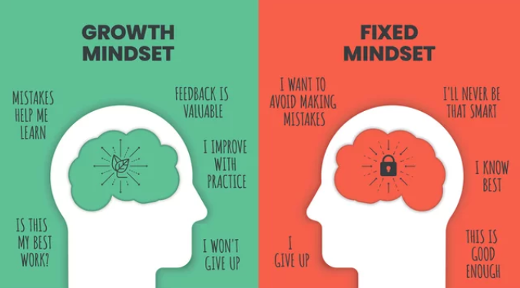
Maths Anxiety and Positive Mindset
(Adobe Stock, 2025)
Maths anxiety is a common problem throughout schools, it can have a negative effect on the learner’s motivation and engagement (Gabriel, 2022). So how do we overcome this? An effective approach to encourage numeracy when dealing with maths anxiety is to help the learner shift to a positive mindset. Educators can do this by facilitating numeracy in a positive can-do manner and within a supportive environment. Dweck (2012) tells us that learners have two beliefs about themselves:
- Fixed Mindset – This is where the learner does not believe that they can improve their abilities.
- Growth Mindset – Where the learner believes that their abilities are increased through the process of learning.
The Organisation for Economic Co-operation and Development OECD (2024) reported that just over half of the learners that said they had growth mindset stated that they had a fixed mindset when it came to maths (Castaneda, 2024). The Welsh Government (2023b) want to overcome fixed mindsets by supporting learners and educators to develop strategies to reduce maths anxiety allowing the learner to reach their full potential. They have introduced a new curriculum that is based on five inter-related mathematical proficiencies that learners are expected to develop as they progress (Welsh Government, 2023). The aim of this is to support educators to design engaging and encouraging lessons that allows for growth of knowledge and skill that will lead to an increase in positive mindset and a decrease in maths anxiety in numeracy. Alongside this new curriculum, educators need to be aware of Hughes’ (2009) point which indicates that encouragement can sometimes feel like pressure. This means that educators need to ensure the tasks set are manageable and within the learner’s capability.
Video: Developing a Growth Mindset with Carol Dweck. (Dweck, 2014).

Numeracy across the Curriculum
Numeracy is an essential skill in a learner’s school and daily life that extends far beyond that of ‘just maths’, it permeates the world around them. Dewey (1963) believed that when a learner can relate what they have learnt to their experiences, that is when development occurs. Therefore, to encourage numeracy, schools should explore all links between numeracy and other curricular areas, and where possible integrate numeracy into said areas to allow for optimal development and creative thinking (Barnes, 2015). Numeracy can be integrated into many subjects, such as, language, literacy, communication, health and well-being, art, humanities and science (Welsh Government, 2022a).

An example of how to use Dewey’s theory of Intelligent Action (1963) is:

Dewey’s Theory of Intelligent Action Stages (1963) | Example numeracy lesson
Design experience | Lesson focus on understanding money
Understand concept | Students learn to recognise each coin and note and the values
Sign posting the relevance of the lesson | Using the knowledge gained in numeracy lessons in other curricular areas
Active participation | Learner applies knowledge to other curricular areas
(Bates, 2019)

Summative and Formative Assessments
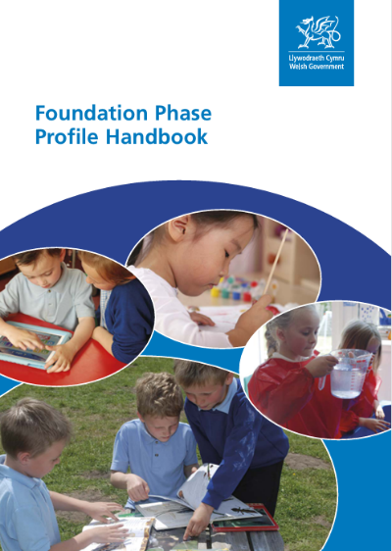
Schools can utilise formative assessments to better support and encourage their learners. These assessments allow educators to understand what a learner can and can’t do and what they may be able to do with some help. The Welsh Government (2022b) tell us that assessments are essential to the curriculum and play a crucial role in challenging and supporting the learner. The Foundation Phase Profile (FPP) employs both summative and formative assessments to monitor the learner’s progress and conduct evaluations, with the aim of setting further targets in the specific area of learning (Welsh Government, 2017). Vygotsky’s (1978) Zone of Proximal Development (ZPD) (McLeod, 2024) is an ideal theoretical approach to use in formative assessments because it utilises the information gained and instructs the educator about how to develop it further. How to use the theory:
(Welsh Government, 2017).
- Understand what the learner can do.
- Know what they can do with the help of a Most Knowledgeable Other (MKO).
- Implement scaffolding in the ZPD.
- Understand what they cannot yet achieve.
- Repeat (Wass and Golding, 2014).

Connectivism – a modern theoretical approach for the digital age
And finally, online education games!! Online games are unavoidable in this day and age and the classroom is no exception. Connectivism, a theoretical approach for the twenty-first century learner looks at the role of learning through technology (Dennis, 2024). Using technology such as educational online games to encourage learners to participate in numeracy lessons is one of the biggest hits in my classroom. Websites such as Top Marks (2025) really help to engage and encourage learners who normally would shy away from a maths lesson. It’s an interactive session that all the learners love, it even has them asking to use it in their free time (how amazing!)
Hopefully, I have been of some use and have given you some ideas on how schools can encourage numeracy So go and give some of these ideas a try and see if you can encourage your learners to be more numerical!

Element 3: Resource – Information Sheet

Play Money Resource Sheet for Autistic Pupils in an Autism Unit.

Play money is a tool that helps facilitate learning to pupils about basic financial literacy and money recognition, it also teaches pupils addition, subtraction and role-playing skills (Learning Resource, 2025). This resource sheet will provide a guide for how to use play money in an educational setting for autistic pupils in a primary setting, you can increase or decrease the challenge for your learner based on their individual needs to help futher their development (Welsh Government 2016).
(Learning Resource, 2025)

Learning Activities Examples with Play Money
Money Recognition
Example: A matching game, set out different values of money for the pupil to match the correct notes and coins to.
Area of learning: Can the pupil point or use play money to match what you have set out, are they able to sort coins by their size, shape or colour (Welsh Government, 2018).
The aim is to work on the pupil’s ability to recognise coins and notes and understand what each one is worth. You can utilise Discovery Learning Theory (1966) to assess what the pupil can do, support them to develop, and at the end find out what they have learnt (Bates, 2019).

Basic Maths
Example: Use play money to do basic math, such as addition and subtraction. Create basic math problems for the learner to solve using money.
Area of learning: Can the pupil use play money to add or takeaway from basic math problems, can they re-count to find the new total (Welsh Government, 2018).
The aim is to use the play money as a physical tool to help the pupil solve the problem. To ensure that the pupil can reach their full potential, you can follow the 6 steps of cognitive domain taxonomy:
1.Knowledge, 2. Comprehension, 3. Application, 4. Analysis, 5. Synthesis, 6. Evaluation (Aubrey and Riley, 2019).

(Merritt College, 2015)
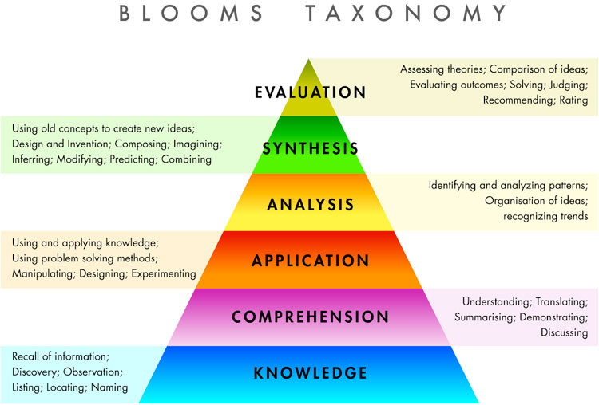
Role Play
Example: Set up a shop where the pupils can practice social interaction by buying selling and work out change (Welsh Government, 2018).
Area of learning: Using combinations of money can the pupil pay for items up to a certain amount and are they able to calculate the change. Is the pupil able to order and compare prices of items, can they make record what they have spent and saved (Welsh Government, 2017).
The aim of Role Play is to help the pupil understand the role of money in everyday life, it allows them to revisit areas of learning independently which leads to further development of their skills (Estyn, 2024). It also helps the learner build transferable skills, allowing them to utilise the skill and use them outside of a classroom setting.

Using play money as a resource allows pupils to have a fun and interactive experience in the learning environment. It helps pupils build confidence in an integral area of learning which will greatly benefit them.

Element 4: Video of the resource in action

Please see video by following the link below:
https://www.canva.com/design/DAGglcPf83U/amfeY6h13VG3H0mlDVtv8w/edit?utm_content=DAGglcPf83U&utm_campaign=designshare&utm_medium=link2&utm_source=sharebutton

Element 5: Evaluation of the resource
Evaluation of Play Money used as a tool to help teach Autistic Pupils Numeracy.

In this evaluation I will be reflecting on the resource play money and its effectiveness as a tool to aid numeracy. I will be reflecting on my experience facilitating this resource in an autistic unit in a class of 6 autistic learners who vary in ages and abilities and have a ratio of 1 teacher to 2 learners. I will refer to the learners I worked with as Learner A and Learner B. Learner A is an ASD and ADHD 7-year-old with a passion for knowledge and Learner B is an ASD 7-year-old who loves to interact with teachers. I will use examples of the policies, theories and my experience throughout. Furthermore, in my evaluation I will look at the possible disadvantages of the resource and the reasoning for it.
The learning process
When implementing a new resource, it is always important to ensure that you know what your learner is capable of before setting any work, to do this I utilised the theoretical approach of Vygotsky’s (1978) Zone of Proximal Development (ZPD). I began by placing the resource in front of Leaner A and Learner B and asked them what they could tell me about the play money in front of them, both learners were able to tell me about the colour, size and shape, meeting the needs set out in the Numeracy Framework (Welsh Government, 2018). I then probed to see if they could tell me anything else, they were able to tell me about the value of each coin and note and demonstrated an understanding of how to add them together to make larger quantities. Notably, having physical play money helped keep both learners engaged and on task throughout the lesson, the effectiveness of such practical materials is described as beneficial to learners in The Cockroft Report (1982). Now that I understood what Leaner A and B were capable of, I could now move onto the next step. I could now choose a suitable work programme for them that is in their ZPD, this is essential to help develop their numerical skills. I chose their work using SMART goals, this allowed for specific and measurable lessons where the learners knew what to do and were able to do so within an achievable timeframe (Bates, 2019). I began with a role play where each pupil exchanged money with myself and each other, this allowed the learners to show their awareness of money (Welsh Government, 2017). I provided support throughout lessons in a collaborative process called scaffolding, helping the learners when they were stuck and encouraging both to reach their full potential (Aubrey and Riley, 2019). Learner A struggled a little at the start and to my delight Learner B became a MKO (Most Knowledgeable Other) and implemented scaffolding to helped support Learner A. This was not only beneficial for Learner A, but also for Learner B as it allowed them to develop their numeracy skills further and build up confidence. I monitored this learning process through formative assessments and was able to adjust my teaching accordingly to meet the needs of the learners (Looney, 2011) ascending in difficulty as their numeracy skills grew in each lesson.

What worked well, what didn’t work so well and the disadvantages of play money
What worked well was the engagement with the resource, not only did the learners use it during our numeracy lessons, but they would ask to use it in downtime to play shop with it. As I watched them play, I could see the learners use problem solving skills and transfer their numerical skills across other areas with confidence (Estyn, 2024). When the learners were confident in what they had learnt they would use that knowledge to act as MKO’s when other pupils were unsure providing them with support and problem-solving skills. What did not work so well was not having enough play money when simultaneously facilitating a lesson to both learners. Learner A struggled with sharing the money when they needed a particular coin or note that was not available to them at the time, this often resulted in a behaviour which then took time away from the lesson. To problem solve this, I would purchase more play money whilst using Skinner’s (1958) theory of positive reinforcement to encourage Learner A to accept and wait for what they need (Bartlett and Burton, 2016) so that there is less chance of a lesson being interrupted due to a behaviour. Furthermore, I would have a backup of independent worksheets so that Learner B may continue with their numeracy work. Although not a disadvantage I saw in my classroom, I could see how play money would not be appropriate for some learners throughout the unit. Students with PICA, an eating disorder that leads the individual to eat non-edible items (NHS, 2023) would almost definitely eat the notes and therefore would not be safe to be around those students.
What I have learned
I have learnt that play money is a very useful resource to use when teaching learners about numeracy, it allows the learners to develop important skills that will help them become independent and confident individuals that can problem solve in real life situations. In this evaluation I have looked at the effectiveness of play money as a tool to aid numerical literacy in autistic learners. I have reflected on my experience facilitating play money and have used examples, policies and theories throughout to critically analyse the process.

