

Programme: Master of Business Administration
Module: Dissertation
Module code: LCMB7035
Research Proposal On: Impact of Digital Branding on Burberry’s Competitive Positioning in the UK Luxury Fashion Market
Lecturer: Mazen jourein (Birmingham)
Student name: Meet Malani
Student ID number: 2504764
Word count: 2540
Submission date: 11/06/2026

Table of Contents
1. Title 3
2. Introduction / Background / Research Problem 3
3. Research aim, objectives, questions 5
4. Preliminary literature search 5
5. Research methodology 9
6. Risks 13
7. Timeline 13
Reference List 14

1. Title
Impact of Digital Branding on Burberry’s Competitive Positioning in the UK Luxury Fashion Market

2. Introduction / Background / Research Problem
2.1 Research Background
The luxury fashion industry has experienced significant changes because of the rapid digitalisation and evolving consumer behaviour. Digital branding is gaining more significance with luxury fashion brands turning to social media platforms, influencer marketing, online storytelling, and digital campaigns to enhance customer engagement and brand image. In 2024, the UK luxury fashion market produced 7.39 billion US dollars and is projected to have a slow further rise (Statista, 2026). The world has become extremely dependent on digital platforms to communicate with brands and make a purchase, and online presence has become a critical parameter influencing the competitiveness of the market. Burberry is known to be among the major luxury fashion brands that have managed to incorporate digital innovation in branding its strategies. Digital marketing and customer engagement campaigns have helped Burberry to update its traditional luxury image and solidify its competitive standing in the UK luxury fashion market (Gupta et al., 2024). As a result, online branding has turned out to be an important determinant of brand presence, customer retention and ultimate competitive edge.
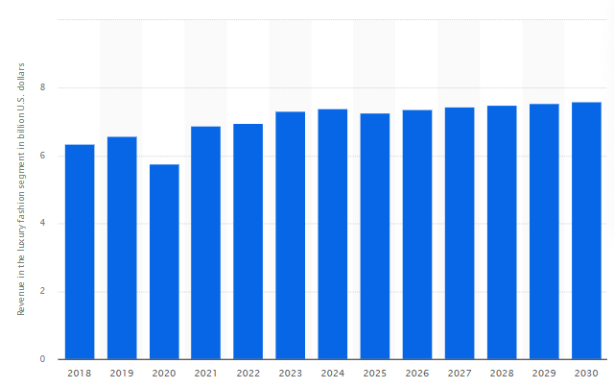
Figure 1: UK luxury fashion market revenue
(Source: Statista, 2026)
2.2 Problem Statement
Despite the fact that digital branding is gaining importance in the luxury fashion industry, a limited academic literature has been conducted to explore the specific role of digital branding in the competitive positioning of the luxury fashion industry in the UK. Current literature has largely concentrated on overall practices of digital marketing or consumer behaviour, whereas little has been done regarding how luxury brands like Burberry employ digital branding in their competitive advantage. Moreover, the fast development of technology and the changing needs of consumers have posed a challenge to the luxury brands on their ability to remain exclusive, yet at the same time to access digitally active consumers (Kim et al., 2026).
2.3 Rationale
The significance of this research is that it focused on assessing how digital branding affects the competitiveness of Burberry as a luxury fashion brand in the UK. The research will offer deeper insights into the effects of digital branding strategies on customer engagement, brand image and competitiveness in the market, in the luxury fashion industry. The results can inform luxury fashion brands about the strategic value of digital innovation to stay competitive in the long term and to cope with the evolving consumer requirements in the digital age.

3. Research aim, objectives, questions
3.1 Aim
The aim of this research is to evaluate the impact of digital branding on Burberry’s competitive positioning in the UK luxury fashion market.
3.2 Research Objectives
- To identify the digital branding strategies used by Burberry in the UK luxury fashion market.
- To examine the impact of digital branding on Burberry’s brand image and customer engagement.
- To evaluate how digital branding contributes to Burberry’s competitive positioning against other luxury fashion brands in the UK.
3.3 Research Questions
RQ1. What digital branding strategies are used by Burberry in the UK luxury fashion market?
RQ2. How does digital branding influence Burberry’s brand image and customer engagement?
RQ3. To what extent does digital branding strengthen Burberry’s competitive positioning in the UK luxury fashion industry?

4. Preliminary literature search
4.1 Digital Branding in the Luxury Fashion Industry
The use of digital branding has become a necessity in the luxury fashion industry as a result of the fast development of digital technologies and evolving consumer behaviour. As stated by Zhang (2022), social media marketing, influencer collaborations, online storytelling, and digital campaigns are becoming more popular among luxury fashion brands as a way of reinforcing brand presence and enhancing customer connection. According to Rocco (2025), more than 50% of affluent social media consumers aged 1839 years subscribed to luxury on social media, with only slightly over 40 years of age, 40+ years old. Digital branding, as opposed to the traditional approach to branding, allows a company to communicate directly with consumers via online media: Instagram, TikTok, and YouTube. These platforms enable luxury brands to convey brand values, present products and establish personalised customer experiences. Digital branding has a positive impact on consumer perceptions, brand loyalty, and purchasing behaviour in the luxury fashion market. Moreover, Leppälä (2025) stated that young shoppers are sensitive to digital content and demand brands to be active online.
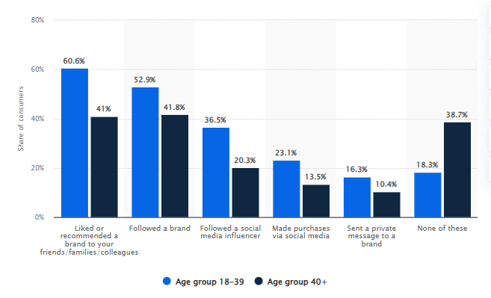
Figure 2: Social media influence on fashion purchasing decisions
(Source: Rocco, 2025)
4.2 Digital Branding and Consumer Engagement
One of the crucial results of an efficient digital branding strategy in the luxury fashion sector is thought to be consumer engagement. Baran and Khammash (2024) further stated that digital branding enables the luxury brands to create a direct contact with customers via social media platforms, websites, and digital campaigns. The strategies assist firms to develop personalised experiences, enhancing customer engagement, and enhancing emotional bonds with the customers. It is shown that consumers prefer to interact with brands offering interactive content, regular communication, and attractive digital experiences. Influencer partnerships, social media campaigns, and online storytelling are some of the digital branding strategies that Burberry has successfully employed to increase the level of customer engagement and appeal to younger consumers. Moreover, Gupta et al. (2024) mentioned that digital branding has a positive impact on brand image, customer loyalty, and purchasing intentions in the luxury fashion market. With the growing and continuous increase in the use of digital platforms by modern consumers, luxury fashion brands need to keep enhancing their online engagement tactics to ensure customer satisfaction and a competitive advantage in the long run.
4.3 Competitive Positioning in the Luxury Fashion Market
Competitive positioning is the capacity of a company to create a strong and unique position in a competitive market. According to Khattak and Khattak (2024), brand reputation, innovation, customer experience, and marketing effectiveness are some of the factors that determine the competitive positioning in the luxury fashion industry. As a result of growing digitalisation, luxury fashion companies are now turning to digital branding strategies to reinforce their position in the market and their differences with their competitors. Successful digital branding assists companies in enhancing brand presence, customer loyalty, and consumer perception, which is critical to remain competitive in the luxury fashion industry. Leppälä (2025) further stated that Burberry is well-known as one of the pioneers that has successfully adapted digital innovation in its branding efforts by using social media campaigns, live-streamed fashion shows, and influencer partnerships.
4.4 Theoretical Background
Brand Equity Theory
The study is supported by a theory, Brand Equity Theory, which describes that branding activities have an impact on consumer perceptions, brand value, and customer loyalty. Brand equity is the value that is attributed to a brand by consumers in terms of their experiences, perceptions, and emotions. It states that effective branding practices have a positive influence on brand awareness, perceived quality, brand association and customer loyalty that ultimately enhance the market standing of a firm (Park et al., 2024). This theory applies to the present study since it is through digital branding strategies that the consumer perception of luxury fashion brands is greatly affected. There is social media marketing, online storytelling, and online customer engagement that will help to develop a positive association with the brand and strengthen customer loyalty. As applied to the situation of Burberry, the theory can be used to explain how digital branding activities can enhance brand image and lead to competitive positioning in the UK luxury fashion market.
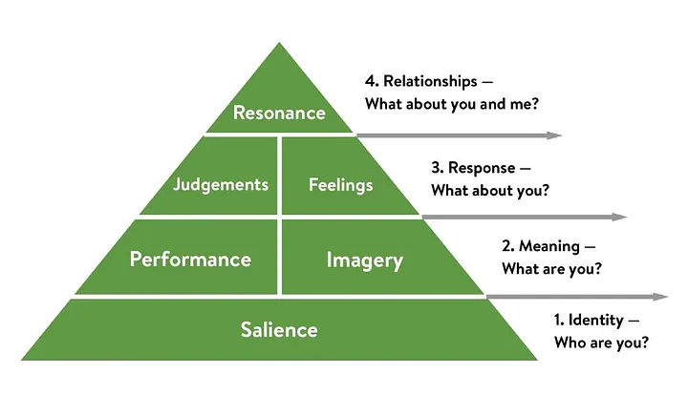
Figure 3: Brand Equity Theory
(Source: Hawker, 2019)
4.5 Literature Gap
The literature on digital marketing and consumer behaviour in the fashion industry mainly discusses general digital marketing and consumer behaviour issues, and there are few studies that investigate how digital branding affects competitive positioning in the UK luxury fashion market. Moreover, the lack of research on the analyses of the digital branding strategies by Burberry and their effect on customer interaction and competitiveness in the market can also be noted.

5. Research methodology
5.1 Research Philosophy
The research philosophy that will be embraced in this study is the interpretivism research philosophy to understand how digital branding has influenced Burberry in terms of its competitive positioning within the UK luxury fashion market. Interpretivism is suitable since the research intends to learn the branding strategies, customer engagement, and consumer perceptions based on the interpretation of the existing literature and information in the industry. The philosophy will enable the researcher to explore subjective meanings and experiences related to digital branding practices in the luxury fashion industry (Saunders et al., 2023).
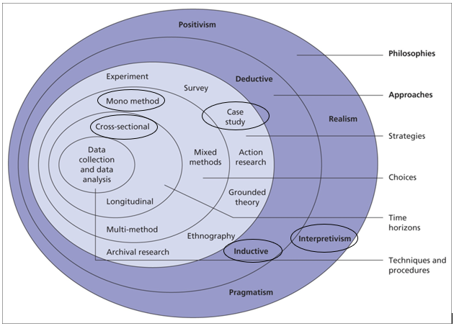
Figure 4: Research Onion
(Source: Saunders et al., 2023)
5.2 Research Approach
The study will be inductive as the researcher focused on aligning with insights and knowledge based on the available academic materials and secondary data, as opposed to testing preconceived notions. The inductive method can be applied to qualitative research because it facilitates the determination of the patterns, themes, and relationships related to the fields of digital branding and competitive positioning (Mazhar et al., 2021).
5.3 Research Strategy
A Systematic Literature Review (SLR) will be used as the main research method in this study. The case study strategy will enable the researcher to critically assess and synthesise the available scholarly sources in connection with digital branding, luxury fashion marketing, customer engagement, and competitive positioning. The plan promotes an organised and open review process, which guarantees the acquisition of valid and pertinent secondary data in the form of academic journals, company reports and industry publications (Mazhar et al., 2021).
5.4 Methodological Choice and Time Horizon
This research will be based on a mono-method qualitative methodological choice. Qualitative research will be appropriate as the research does not involve quantitative analysis of data, but details the strategies of branding, the experience of customers and the positioning of the business against its rivals. The thematic interpretation of the secondary information gathered using different academic and industry sources is supported using the qualitative approach (Ahmed et al., 2025). The study will adopt a cross-sectional time horizon, focusing on current digital branding practices and recent developments within the luxury fashion industry.
5.5 Data Collection Methods
The study will be based on the use of secondary data collection. It will collect data using 10 academic journals, books, industry publications, company reports and effective online databases. The key reason why secondary data collection is suitable is that it will allow reaching the existing scholarly discourse and recent industry trends in the context of digital branding in the luxury fashion market. Secondary research is cheap and can be applied to provide a systematic review of the literature within the time limits of the research (Saunders et al., 2023).
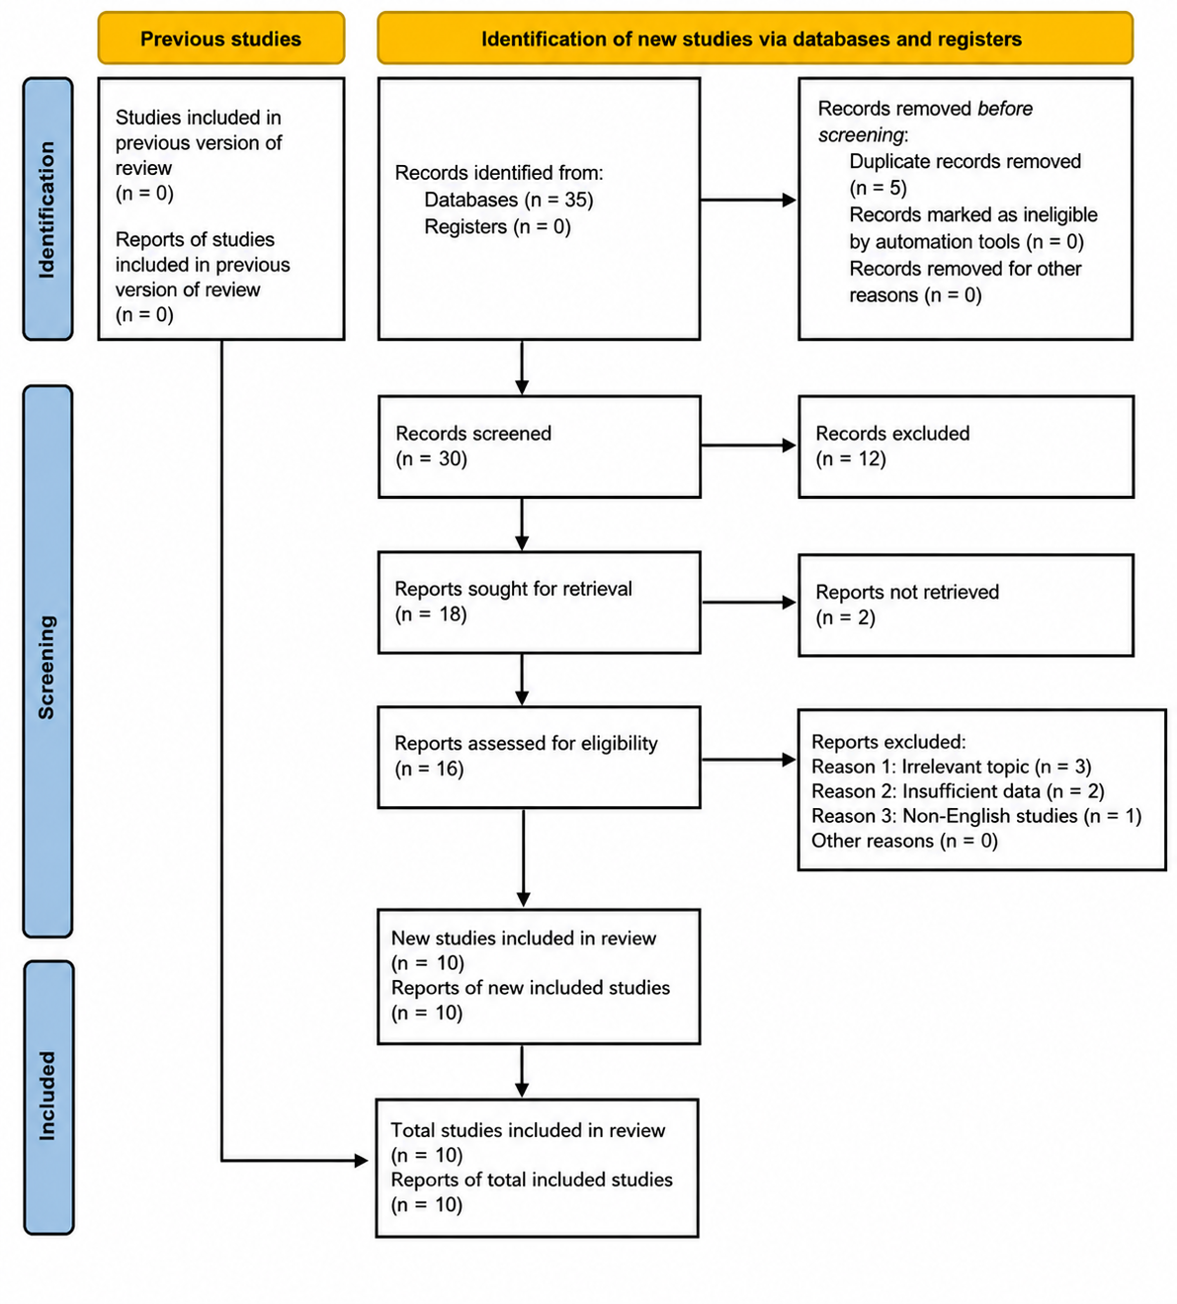
Figure 5: PRISMA Diagram
(Source: Self-created)
Search Strategy
Databases | Boolean operators | Search Keywords
Google Scholar, Scopus, ScienceDirect | “AND”, “OR” | “Digital branding” AND “Luxury fashion”, “Burberry” AND “Competitive positioning”, “Customer engagement” AND “Luxury brands”, “Digital marketing” OR “Digital branding” AND “Luxury fashion industry”, “Social media marketing” AND “Luxury fashion brands”, “Digital transformation” AND “Brand strategy”, “UK luxury fashion market” OR “Luxury consumer behaviour”
Inclusion and exclusion criteria
Inclusion Criteria | Exclusion Criteria
- Studies published between 2021 and 2026.  - English language publications.  - Peer-reviewed journals and credible reports.  - Fully accessible and non-paid sources. | - Studies published before 2021  - Non-English publications.  - Unverified blogs and unreliable websites.  - Paid and doctoral dissertations.
5.6 Data Analysis Methods
Thematic analysis will be used to analyse the data collected. This method will assist in uncovering the recurrent themes, patterns, and ideas in the literature on the topic (Braun and Clarke, 2023). The thematic analysis will enable the researcher to categorise the findings into themes that include social media branding, customer engagement, brand image, and competitive advantage. Review of literature sources, identification of major themes, coding of relevant information and interpretation of findings will be part of the analysis process in relation to the research objectives and questions.
5.7 Ethical Considerations
The research will adhere to proper academic ethics in terms of proper referencing, plagiarism will be prevented, and valid and credible sources will be used (Drolet et al. 2023). As the study will be based solely on secondary sources, there will be no direct human involvement. To ensure academic integrity and transparency during the research process, all sources will be referenced following the UWTSD Harvard referencing style.

6. Risks
Several threats and constraints can impact this research study. The study is purely based on secondary sources and can restrict the availability of recent or secret company data pertaining to the internal approaches of digital branding used by Burberry. Certain scholarly works and commercial reports can be biased by the researcher or have inconsistent results, and this may affect the way of interpreting the results are interpreted. The time limits can limit the possibility of analysing more sources. Moreover, the quickly evolving characteristics of digital marketing and consumer behaviour can influence the long-term applicability of certain findings in the luxury fashion sector.

7. Timeline
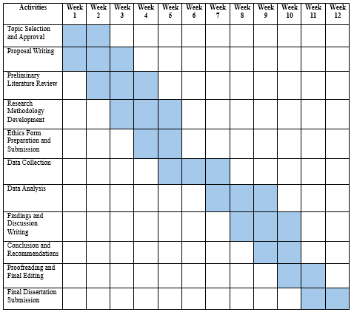
Figure 6: Gantt Chart
(Source: Self-created)

Reference List
Ahmed, S. K., Mohammed, R. A., Nashwan, A. J., Ibrahim, R. H., Abdalla, A. Q., Ameen, B. M. M., and Khdhir, R. M. (2025). Using thematic analysis in qualitative research. Journal of Medicine, Surgery, and Public Health, 6, p. 100198. https://www.sciencedirect.com/science/article/pii/S2949916X25000222
Baran, S. and Khammash, M., (2024). The social media marketing strategies of luxury fashion brands-impact on brand equity. International Social Sciences Studies Journal, 10(6), pp.871-878. https://sssjournal.com/files/sssjournal/8ea76081-c1c6-4254-9929-e25714973aed.pdf
Braun, V. and Clarke, V., (2023). Toward good practice in thematic analysis: Avoiding common problems and be (com) ing a knowing researcher. International journal of transgender health, 24(1), pp.1-6. https://www.tandfonline.com/doi/abs/10.1080/26895269.2022.2129597
Drolet, M.J., Rose-Derouin, E., Leblanc, J.C., Ruest, M. and Williams-Jones, B., (2023). Ethical issues in research: Perceptions of researchers, research ethics board members and research ethics experts. Journal of Academic Ethics, 21(2), pp.269-292. https://indianapublications.com/articles/IJHSS_3(1)_14-20_61f38990115064.95135470.pdf
Gupta, V., Hushain, J. and Mathur, A., (2024). The future of luxury brand management: A study on the impact of new technology and relationship marketing. In AI in Business: Opportunities and Limitations: Volume 1 (pp. 57-68). Cham: Springer Nature Switzerland. https://link.springer.com/chapter/10.1007/978-3-031-48479-7_6
Gupta, V., Hushain, J., and Mathur, A. (2024). The future of luxury brand management: A study on the impact of new technology and relationship marketing. In AI in Business: Opportunities and Limitations: Volume 1 (pp. 57-68). Cham: Springer Nature Switzerland. http://repository.psa.edu.my/bitstream/123456789/4905/1/67.%20AI%20in%20Business%20Opportunities%20and%20Limitations%20.pdf#page=66
Hawker, K. (2019). Keller’s Brand Equity Model — What It Is & How to Use It. [online] Medium. Available at: https://medium.com/@keatonhawker/kellers-brand-equity-model-what-it-is-how-to-use-it-84e42d562299 [Accessed 27 May 2026].
Khattak, K. and Khattak, J., (2024). Market positioning and competitive advantage: A case study of luxury fashion brands. Competitive Research Journal Archive, 2(02), pp.38-49. http://thecrja.com/index.php/Journal/article/view/4
Kim, Y., Kim, Y., Lee, M. J., and Roh, T. (2026). Strategic sustainability in the digital era: signaling theory and consumer responses in luxury fashion. Industrial Management & Data Systems, 1-33. https://www.researchgate.net/profile/Taewoo-Roh/publication/403883833_Strategic_sustainability_in_the_digital_era_Signaling_theory_and_consumer_responses_in_luxury_fashion/links/69e0dcaed2ec9a706ec00a65/Strategic-sustainability-in-the-digital-era-Signaling-theory-and-consumer-responses-in-luxury-fashion.pdf
Leppälä, J., (2025). Building brand authority and exclusivity in the digital era: a strategic study for emerging luxury brands in a hyper-connected market. https://lutpub.lut.fi/handle/10024/170417
Mazhar, S.A., Anjum, R., Anwar, A.I. and Khan, A.A., (2021). Methods of data collection: A fundamental tool of research. Journal of Integrated Community Health, 10(1), pp.6-10. https://www.researchgate.net/profile/Syeda-Ayeman-Mazhar/publication/356269289_Methods_of_Data_Collection_A_Fundamental_Tool_of_Research/links/61fe7e23870587329e943cd1/Methods-of-Data-Collection-A-Fundamental-Tool-of-Research.pdf
Park, J., Park, M. and Yoo, J., (2024). The Effect of Upcycling Fashion Brand Image on Brand Equity and Behavioral Intention-Focusing on Brand Equity Theory and the Moderating Role of Green Peer Influence. The Korean Fashion and Textile Research Journal, 26(4), pp.366-379. https://www.kftrj.org/xml/41992/41992.pdf
Rocco, B. (2025). Luxury brand related social media activity by age 2025| Statista. [online] Statista. Available at: https://www.statista.com/statistics/1310192/luxury-related-social-media-activity-consumers/?srsltid=AfmBOoopugATaKVFzqaCIJnbKG0T5WWhfpPiykLQn84DMcXx-LTeKJb5 [Accessed 27 May 2026].
Saunders, M. N., Lewis, P., and Thornhill, A. (2023). Research Methods for Business Students.-.https://research.birmingham.ac.uk/en/publications/research-methods-for-business-students-3
Statista. (2026). Revenue in the luxury fashion segment United Kingdom| Statista. [online] Available at: https://www.statista.com/forecasts/1435999/revenue-luxury-fashion-luxury-goods-market-united-kingdom/?srsltid=AfmBOoq2BWjppHNR4eu63z75PHVrW6jnYqyIlqWG77f9MLP9mzcsAfK8 [Accessed 27 May 2026].
Zhang, Y. (2022). Burberry's Marketing Activities in the UK and China: An Analysis Based on Cultural and Psychological Differences. ICEMBE, pp. 140-147. http://166.62.7.99/conferences/LNEMSS/ICEMBE%202022/EE023.pdf

