Apply the principles and
practices of Data security,
Governance and Compliance
based on a given scenario.


Wales Institute for Science and Art (WISA)

L7 – Data Security, Governance and Compliance Assessment

Hammada Ballali Ebbi 2308208

03/01/2023

Contents

Abstract 3
1. Introduction: 1
2. TASKS 2
2.1. Task 1: Conduct research into various security frameworks or models with the aid of diagrams, figures and charts example, Information Technology Infrastructure Library (ITIL) and Security model example, International Organization for Standardization; ISO 27000. 2
2.2 TASK 2: Use knowledge and understanding gain from your research to: 6
3. Conclusion 10
4. References 11

Table of Figures

Figure 1. Internal Network Diagram 6
Figure 2. Active Directory Implementation 7
Figure 3. Asymmetric Data Encryption Diagram 8

Abstract

This report assesses the key aspects of Data security, Governance and Compliance principles and practices by analysing the main security frameworks, analysing a particular scenario, and addressing the main key points to cover all the data security aspects.

1. Introduction:

One of the most important challenges of the information age since its inception, and more especially since the advent of the Internet, has been the maintenance of security and privacy of both information stored on devices and information transmitted over the network.

In an era dominated by digital transformation and an unprecedented surge in data generation, organisations find themselves grappling with the complex triad of data security, governance, and compliance. As companies increasingly rely on the collection and storage of data in order to achieve high levels of innovation and better respond to market needs, the need to fortify the fortress around sensitive information has never been more critical. This introduction delves into the application of principles and practices surrounding data security, governance, and compliance in the context of a hypothetical scenario, shedding light on the intricate interplay between these pillars.

Over the past decades, numerous computer security frameworks and protocols have been developed with the aim of continuously improving security levels and implementing protocols that hinder increasingly sophisticated computer attacks, enabling corporations and institutions to acquire and establish robust security structures.

2. TASKS

2.1. Task 1: Conduct research into various security frameworks or models with the aid of diagrams, figures and charts example, Information Technology Infrastructure Library (ITIL) and Security model example, International Organization for Standardization; ISO 27000.

One of the most important aspects in cybersecurity is the application of robust IT practices, which take into account the different risks to which a network infrastructure is exposed and address possible challenges in the most optimal and efficient way.

To achieve this, there are numerous approaches and models that encompass the good practices necessary to establish a highly protected network environment.

One such model is The Information Technology Infrastructure Library (ITIL). This consists of a set of practices and guidelines for IT service management (ITSM). It was initially proposed by the UK Government's Central Computing and Telecommunications Agency (CCTA) in the 1980s. Over the years ITIL has evolved to become an internationally applied framework for organisations seeking to improve their IT services. IT and align them with your business objectives. The main focus of ITIL is to provide efficient, robust and practical IT services that guarantee high levels of security and effectiveness [1].

ITIL is founded on seven guiding principles that have a strong focus on value, urging organisations to consistently prioritise and optimise value creation for both customers and the business. “Start Where You Are” encourages organisations to recognize and leverage existing resources and capabilities when implementing ITIL practices. “Progress iteratively with feedback” emphasises the importance of incremental improvements and continuous feedback loops to refine processes over time. “Collaborate and promote visibility” highlights the need for open communication and collaboration between teams, promoting transparency and shared understanding. “Thinking and working holistically” encourages organisations to view processes, services and practices as interconnected parts of a unified system. "Keep it simple and practical" advocates simplicity in design and implementation, avoiding unnecessary complexities. Lastly, “Optimise and Automate” encourages the continuous pursuit of efficiency and effectiveness through automation and continuous improvement. Together these principles provide a strategic and flexible approach to IT service management, guiding organisations in delivering high-quality services that align with business objectives [1]

Another of the most widespread references worldwide is the ISO/IEC 27000 series. This is made up of a comprehensive set of international standards designed to facilitate effective management of information security within organisations. Central to this series is ISO/IEC 27001, which defines the elements on which to base implementation, establishment and continuous improvement of an Information Security Management System (ISMS). The ISMS provides a systematic framework for organisations to manage and secure their information assets incorporating a risk management approach, which requires continuous assessment and implementation of controls.

ISO/IEC 27002 complements ISO/IEC 27001 by providing a code of practice for information security controls. Provides practical routes and best practices for implementing the security controls defined in ISO/IEC 27001. The series also covers additional standards such as ISO/IEC 27003, which provides guidance for the implementation of ISMS, ISO/IEC 27004 for measuring the security of information and ISO/IEC 27005, which focuses on risk management in information security.

Adopting the ISO/IEC 27000 series brings several advantages to organisations. Promotes a structured risk management approach, assisting in the identification, assessment, and mitigation of information security risks. Recognized globally, especially through ISO/IEC 27001 certification, these standards facilitate compliance with regulatory requirements, instilling confidence in stakeholders, customers, and partners. Additionally, the ISO/IEC 27000 series fosters a culture of continuous improvement by requiring periodic evaluations and audits of the ISMS. Overall, these standards serve as a solid foundation for organisations seeking to establish, maintain and improve effective information security practices, ensuring a high level of confidentiality, while protecting the integrity and availability of your critical information assets in an ever-evolving cyber security landscape..

Another reference model is The NIST Cybersecurity Framework, presented by the National Institute of Standards and Technology (NIST), is a comprehensive set of guidelines, standards and best practices designed to help organisations manage and improve their management processes. of cybersecurity risks. The framework which comprises five main functions: identify, protect, detect, respond and recover, offers a structured approach to strengthening cybersecurity defences. “Identify” involves understanding and managing cybersecurity risks, assets, and processes. “Protect” focuses on implementing safeguards to mitigate potential threats. “Detect” emphasises continuous monitoring and identification of cybersecurity events. “Respond” implies an organised response to address and control the impact of a cybersecurity incident. Finally, “Recover” involves strategies to restore capabilities and services after an incident. The NIST Cybersecurity Framework is widely adopted globally and provides a flexible and scalable framework for organisations to improve their cybersecurity posture and resilience [2].

COBIT, or Control Objectives for Information and Related Technologies, is another globally recognized framework for enterprise IT governance and management. Developed by ISACA (Information Systems Audit and Control Association), COBIT provides a comprehensive set of guidelines, principles, and practices to align IT activities with business objectives, ensure effective risk management and improve overall organisational performance. COBIT is structured around five key principles: meeting stakeholder needs, covering the end-to-end enterprise, applying a single integrated framework, enabling a holistic approach, and separating governance from management [3]. The framework encompasses a set of processes and controls, emphasising the importance of information security, risk management and regulatory compliance. COBIT helps organisations establish clear policies and procedures, ensuring the efficient and secure use of information and technological resources. It is widely adopted for its flexibility, scalability, and adaptability to various industries, making it a valuable tool for achieving effective IT governance and strategic alignment.

Likewise, the Cyber security operations centre (CSOC) is a set of best practices and guidelines designed to help organisations strengthen their cybersecurity posture and defend against cyber threats. Developed by a community of cybersecurity experts, the CSC provides a pragmatic, prioritised approach to addressing and mitigating common cyber risks. The controls are organised into three implementation groups, offering organisations a structured path to incrementally improve their security capabilities. Controls cover areas such as hardware asset inventory and control, continuous vulnerability assessment, data protection, secure configuration, and incident response. By focusing on these critical security measures, organisations can establish a strong defence against cyber threats, reduce vulnerabilities, and improve overall cybersecurity resilience [4]. The CSOC has gained widespread adoption as a valuable framework for organisations seeking to establish a solid foundation for their cybersecurity efforts and protect against the changing cyber threat landscape.

Another widespread model is the Zero Trust model [5], it is a cybersecurity paradigm that challenges the traditional notion of trust within network environments. In a Zero Trust architecture, no entity, whether inside or outside the network, is inherently trustworthy. The model assumes that threats can originate from both external and internal sources. To mitigate risks, Zero Trust requires continuous verification of the identity of users, devices, and systems, regardless of their location or network connection. Access controls are implemented based on the principle of least privilege, granting the minimum permissions necessary for users and devices to perform their tasks. Zero Trust also emphasises rigorous monitoring and inspection of all network traffic, detecting and responding to anomalous activity in real time. By adopting a Zero Trust model, organisations can significantly improve their security posture, reducing the potential impact of security breaches and ensuring a stronger defence against sophisticated cyber threats.

There are also government laws such as the Federal Information Security Management Act (FISMA), which is a United States federal law implemented in 2002 to establish a comprehensive framework to ensure the security of federal government information systems. FISMA requires federal agencies to develop, implement, and maintain information security programs to safeguard sensitive information and support the overall mission of the government. The law requires a risk-based approach, emphasising risk assessments, security controls, and continuous monitoring of information systems. FISMA tasks agencies with creating and maintaining an inventory of their information systems, categorising them based on the impact of a potential security breach, and implementing security controls accordingly. Regular security assessments and audits are conducted to ensure compliance, and agencies are required to report their security status to the Office of Management and Budget (OMB). FISMA plays a critical role in improving the cybersecurity posture of federal agencies, promoting a systematic and proactive approach to information security across the government.

There are also frameworks tailored to specific sectors such as the Payment Card Industry Data Security Standard (PCI DSS) [7] , which is a cluster of security guidelines established to ensure the secure handling of sensitive payment card information. Developed by major credit card companies working in partnership, PCI DSS aims to protect cardholder data and maintain a secure payment card environment. The standard consists of 12 requirements organised into six control objectives, addressing areas such as network security, data protection, access controls and monitoring. Merchants, service providers, and organisations that handle payment card transactions must comply with PCI DSS standards. Compliance involves implementing security measures such as encryption, periodic security assessments, access restrictions, and monitoring for unauthorised activities. PCI DSS certification is essential for organisations to demonstrate their commitment to protecting cardholder data and maintaining the trust of customers and payment card industry stakeholders. Non-compliance can result not only in financial penalties, but also in reputational damage, and loss of business for entities involved in payment card transactions.

2.2 TASK 2: Use knowledge and understanding gain from your research to:
a. design your own approach to meet the need of the company information system security, governance, and compliance. Tables and diagrams may be used in your approach.

Given the scenario, NatureGarden (NG) faces significant challenges in ensuring the security of its network, especially with the increasing pressure to allow personal devices access. To address these concerns and establish a robust information security framework, the company should consider the following steps:

- Develop a Comprehensive Information Security Policy:

Create a detailed information security policy covering all aspects of data protection, including staff personal data, customer data and intellectual property.
Clearly outline guidelines for the use of personal devices on the network and company resources. A clear and robust framework for action and behaviour is one of the most important elements in ensuring information security, as it prevents the implementation of behaviours and uses that could lead to vulnerabilities in the network.

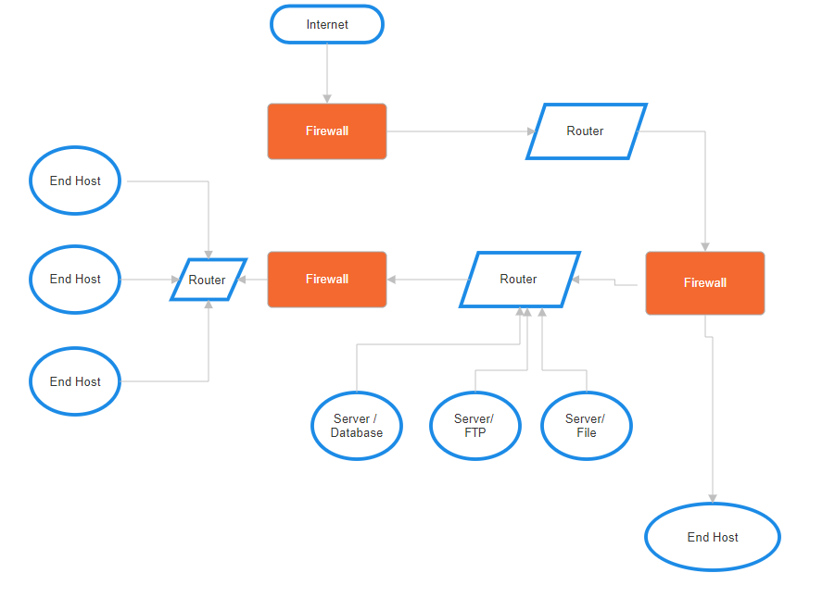
Figure 1. Internal Network Diagram

- Implement Access Controls:

Define and enforce access controls to ensure that only authorised personnel have access to sensitive data. Using methods such as multi-factor authentication, tokenization, one-time passwords, and periodic password renewal are a very effective way to overcome cybersecurity challenges in companies and corporations.

- Network Security:

Strengthen the security of the wireless network to protect it against unauthorized access, through methods such as the use of certificates or access through domain controllers such as Active Directory.
Another crucial factor is the implementation of encryption protocols to protect data in transit through the wireless network, as well as the application of Firewalls and Proxies where necessary to limit network traffic to what is strictly necessary.

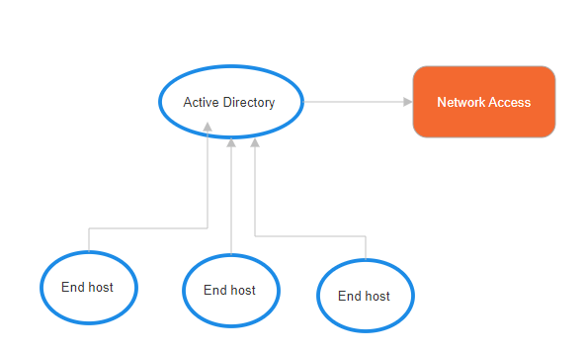
Figure 2. Active Directory Implementation

- Endpoint Security:

Keep anti-malware anti-virus software and systems up to date on devices connected to the enterprise network. This applies to both computers and mobile devices.

- Data Encryption:

Encrypt all data transmissions in transit and at rest to prevent unauthorised access even if a security breach occurs. Techniques as data encryption are well extended.

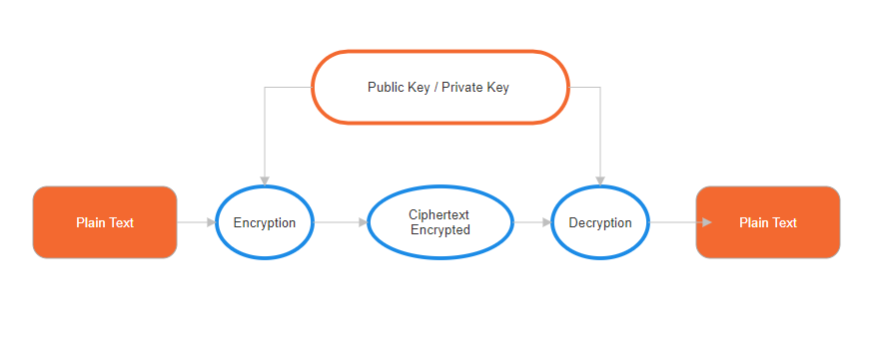
Figure 3. Asymmetric Data Encryption Diagram

- Employee Training and Awareness:

Conduct regular security awareness training for employees will avoid bad practices to be performed within the organisation and will prevent from risks and human caused vulnerabilities.

- Incident Response Plan and Regular Security Audits and Assessments:

Maintain and improve periodically an incident response plan to implement a robust response to security failures. This includes the performing of tests and the definition of roles and responsibilities to address breaches.
By periodically conducting security audits and assessments, vulnerabilities and areas for improvement can be identified.

- Legal and Regulatory Compliance:

Ensure compliance with relevant data protection laws and regulations within the business region to avoid legal consequences and protect customer privacy.

- Collaborate with IT Security Experts:

Seek advice from external IT security experts to conduct a thorough assessment of the current security posture and provide recommendations for improvement.

- Secure Intellectual Property:

Implement measures to protect intellectual property, including restricting access to sensitive documents, using digital rights management, and monitoring for unauthorized activities.

By taking these measures, NatureGarden can establish a strong foundation for information security, mitigate risks associated with personal device use, and protect the confidentiality and integrity of its data and intellectual properties.

b. critique, analyse, and discuss why it is good practice to constantly have new or updated regulations and standards.

The challenges faced by the field of cybersecurity when implementing solid security systems that can achieve high degrees of reliability.
It is, therefore, of vital importance to constantly evolve and update regulations and standards in the field of IT security. This proactive approach is driven by the dynamic nature of technology, the evolving threat landscape, and the imperative to protect sensitive information and systems [8].

Adaptation to Emerging Threats:

The digital landscape is constantly evolving, and cyber threats are becoming increasingly sophisticated. New regulations and standards are essential to adapt to emerging threats, ensuring that security measures implemented are relevant and effective against the latest attack vectors. Additionally, attackers often exploit vulnerabilities unknown to the public, known as zero-day vulnerabilities. The updated regulations urge organisations to adopt practices that address these vulnerabilities quickly, reducing the window of opportunity for malicious actors.

Technology Advancements:

The technology landscape undergoes rapid advancements, introducing new tools, platforms, and communication methods. Updated regulations help organisations align their security measures with the latest technologies, ensuring that they are not left vulnerable due to outdated practices. As organisations increasingly adopt cloud computing and Internet of Things (IoT) devices, regulations must evolve to provide guidelines for securing these technologies. Constant updates in standards help organisations navigate the unique security challenges posed by cloud-based services and interconnected devices.

Globalisation and Interconnectedness:

In an era of globalisation, data often traverses international borders. New or updated regulations help establish guidelines for secure cross-border data flows, addressing privacy concerns and ensuring compliance with various legal frameworks. Organisations are part of complex supply chains that may involve multiple vendors and partners. Updated regulations enable organisations to establish and enforce security standards across their interconnected supply chains, reducing the risk of vulnerabilities introduced by third parties.

Continuous Improvement and Best Practices:

Updated regulations often incorporate lessons learned from past incidents and adopt industry best practices. This iterative process ensures that organisations have access to a continually improving set of guidelines, helping them raise their security posture. New regulations often emphasise the importance of risk management, encouraging organisations to conduct regular risk assessments and tailor their security measures to their specific threat landscape. This approach fosters a proactive mindset in addressing potential vulnerabilities.

3. Conclusion

In conclusion, constantly having new or updated regulations and standards is crucial for maintaining the relevance and effectiveness of cybersecurity measures, aligning with the dynamic nature of the cybersecurity landscape, and ensuring the protection of sensitive information as well as considering the main factors crucial for developing appropriate solutions to address information system security challenges.

Ensure adherence to relevant laws and regulations related to data protection and privacy.
Establish ethical guidelines to govern the handling of sensitive information.
Regularly update security policies to align with changing compliance requirements.
Integrate security governance into overall corporate governance structures.
Develop a strategic plan for information security that aligns with business objectives.
Establish a governance framework to oversee and manage security initiatives.
Formulate and communicate clear and comprehensive security policies.
Include guidelines for employee behaviour, use of personal devices, and data handling.
Regularly review and update policies to address evolving security challenges.
Conduct regular risk assessments to identify and prioritise potential threats.
Implement risk mitigation strategies and controls based on the assessment.
Continuously monitor and reassess risks to adapt to changes in the environment.
Adopt recognized security management models (e.g., ISO/IEC 27001) as a foundation.
Implement best practices for security management, such as the NIST Cybersecurity Framework.

Develop a comprehensive contingency plan for responding to security incidents.
Include incident response procedures, communication plans, and recovery strategies.
Regularly test and update the contingency plan to ensure effectiveness.
Protection Mechanisms:

Implement a layered defence approach, combining technological and procedural measures.
Utilise firewalls, intrusion detection systems, encryption, and access controls.
Regularly evaluate and update protection mechanisms to address emerging threats.
Establish SLAs that define the security expectations for service providers.
Clearly outline security requirements, responsibilities, and performance metrics.
Regularly review SLAs to ensure they align with evolving security needs.
In summary, a holistic solution should integrate these factors, taking a proactive and adaptive approach to information system security.

4. References

[1] A. Hochstein, R. Zarnekow and W. Brenner, "ITIL as common practice reference model for IT service management: formal assessment and implications for practice," IEEE International Conference on e-Technology, 2005

[2] S. Shackelford, A. A. Proia, B Martell, and A. Craig, “Toward a global cybersecurity standard of care? Exploring the implications of the 2014 NIST Cybersecurity Framework on shaping reasonable national and international cybersecurity practices.” Texas International Law Journal, 50(2), 305, 2015

[3] G. Ridley, J. Young and P. Carroll, "COBIT and its utilisation: a framework from the literature," 37th Annual Hawaii International Conference on System Sciences, 2004.

[4] C. Onwubiko, "Cyber security operations centre: Security monitoring for protecting business and supporting cyber defense strategy," International Conference on Cyber Situational Awareness, Data Analytics and Assessment (CyberSA), London, UK, 2015

[5] M. Shore, S. Zeadally and A. Keshariya, "Zero Trust: The What, How, Why, and When," Computer, vol. 54, no. 11, pp. 26-35, Nov. 2021

[6] E. Hulitt and R.B Vaughn,.” Information system security compliance to FISMA standard: a quantitative measure”. Telecommun Syst 45, 139–152 , 2010

[7] Edward A. Morse and Vasant Raval, “PCI DSS: Payment card industry data security standards in context,” Computer Law & Security Review, Volume 24, Issue 6, 2008

[8] Jangirala S., Ashok K. D. and Neeraj K, “Government regulations in cyber security: Framework, standards and recommendations”,Future Generation Computer Systems,
Volume 92,2019

