Title of Report: Problem Solving and Decision Making
Evaluation of Possible Solutions in NHS

Number and name of author: 1706194 Mihai Duca
Name of Host Organisation: University of Wales Trinity Saint David
Date of Report Publication: 15th of December 2017

Executive Summary

The purpose of this report is to apply recognized problem-solving tools and techniques such as: SWOT Analysis and PESTLE, Stakeholder Theory and Fishbone Analysis, to identify and propose solutions to a work-based problem, which is NHS, including an evaluation of possible solutions for it.
This report highlights the waiting time in NHS which is a very discussed topic for a good period of time and there are eventual solutions to solve this problem.
This report concludes that one of the methods to diminish the waiting time in the NHS is by implementing a system of order and discipline.

Table of content

Content Page number
1.0 Title Page 1
2. Executive Summary 2
3. Table of Content 3
3. Introduction 4-5
4. Findings 6-15
5. Recommendation 15
6. Conclusion 16

- Introduction
“I wouldn't be here today if it were not for the NHS. I have received a large amount of high-quality treatment without which I would not have survived.” (Hawking, 2012)
What is NHS?
The NHS comes from the National Health Service. It refers to government funds allocated to the medical and health system that all people living in the UK can benefit from without having to pay for the services offered. One of the services is to receive treatment and help from a hospital if a patient is injured or suffers from symptoms of a disease.
When and who set up the NHS?
The NHS was officially opened by Minister of Health Aneurin Bevan in July 1948 in Manchester. That day marked the start of a new era in medical thinking for UK residents who were given the right to receive services offered by doctors, nurses and orderlies without having to pay for them.
Why was the NHS set up?
It was created in order to put all men, be they rich or poor, women, men or children, under the same protective wing. Breaking the price barriers to the government for the medical services offered brought people a relief and at the same time managed to bring the health service to every person in the UK.
“Nobody need any longer pay doctors’ or hospital bills when they were sick.” (Series, 1948)
The NHS currently faces one of the greatest challenges of its existence.
While on the other day most of the NHS service departments are working perfectly today, you are already seeing signs of foreign the system is under in departments like A&E, Hospital which and GP services. The reason these services reach this crisis point now are many, but below are the main reasons:
- Lifestyle factors:
The way people live nowadays, it has a negative impact on their health. Smoking, drinking too much alcohol, a poor diet without enough fruit and vegetables and the fact that no more price is being put on physical exercise, are major reasons for having a low immunity and needing to appeal to the NHS services. Considering that the number of overweight children in the UK grows, it looks like this problem is currently set to continuous;
- An ageing population:
The NHS was created to treat sick people. Many of the diseases that were deadly decades ago were treated. From here it emerges that people have come to live longer but there is also the likelihood of living with one or more diseases like heart, kidney disease and diabetes, which means that these future patients for the NHS will need treatment and medical care;
- Accident and Emergency Departments:

Increasingly more people visiting A&E departments, which prevents the ability to be communication between departments. several visits are unavoidable, but some visits are due to untreated a particular sign, leading to long-term health condition and inability to make an appointment at GP (because many patients go to A&E department without making an appointment before the GP.) the winter season brings an increase in the number of patients in this Department, and staff cope with this difficult challenge.
“No society can legitimately call itself civilized if a sick person is denied medical aid because of lack of means.” (Bevan, 1996)
- Rising costs:
A current financial crisis may raise the costs of emergency services, and supplements. It is estimated the fact that if there is a radical change in connection with the way the system works, while demand increases, costs are increasing too, the NHS will become unsustainable, with huge debts and financial pressures. If there will be any change in the present system, the NHS will have to endure a hole of £30 billion funding nationally by 2020.
Stakeholders for NHS
“A stakeholder is anyone with an interest in a business. Stakeholders are individuals, groups or organisations that are affected by the activity of the business” (BBC, 2014)
The stakeholder has multiple branches, for example:
- Owners- who are interested in profit that brings company;
- Managers- who are worried about their salaries;
- Workers- who want to earn increasingly more but at the same time want to keep their jobs;
- Customers- those who want to make company quality products at a reasonable price;
- Suppliers- those who want his company continue to continue to buy products from them;
- Lenders- those who want to be paid at the time;
- Company
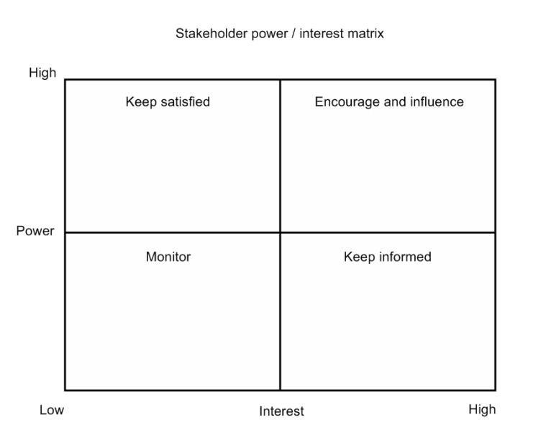
News
IT systems manager
Patients
Medical secretaries
Medical records staff
Adult Social Care staff
Medical Director
Clinical governance lead
Primary Care Trust
Consultant medical staff
Finance Creditor staff
Opinion formers
Health Workers
Finance Director

- Main Findings

The NHS is one of the most valuable and valued institutions in the UK. This does not necessarily mean that this entity benefits from the funds it needs. This can be seen through the high volume of patients who use this service and are forced to wait to be treated because the NHS doctors are priced on the quality of the services offered and do not want to speed up the patient's treatment even if it has already a waiting time.
The number of persons waiting to receive medical care has increased in recent years due to immigrants who have decided to settle on UK territory and because of old people or who have disabilities because they can benefit from priority.
“How can wealth persuade poverty to use its political freedom to keep wealth in power? Here lies the whole art of Conservative politics in the twentieth century.” (Bevan, 1952)

  - The main problem in the NHS
One of the most common problems in the NHS is the question of waiting time, this problem is met in most cases. The NHS Constitution gives patients the right to access services within maximum waiting times, or for the NHS to take all reasonable steps to offer the range of suitable alternative providers if this is not possible.
This right is a legal entitlement protected by law and applies to the NHS in England. The maximum waiting times are described in the Handbook to the Constitution NHS.
What to expect:
- The GP, dentist or other health professional will refer to a specialist via the NHS e-Referrals service or a referral letter;
- The 18 weeks waiting time starts on the day the hospital receives the referral letter or on the day that the patient make the booking for the first appointment, via the choose and book service;
- If the patient is referred by letter the patient will be called or asked to call, to make an outpatient appointment and offered a choice of dates. Or NHS will make a provisional appointment for the patient which can choose to rearrange if the date and time are not convenient for the patient;
- The patient will attend the first outpatient appointment;
- The patient may require a follow-up appointment;
- If the patient need surgery, will be needed to attend a pre-admission appointment;
- The patient may require treatment and a stay in hospital;
- The 18 weeks waiting time ‘clock’ ticks until the patient will receive the first treatment.
The waiting time represents the time interval from processing the information received by the patient until the patient's doctor starts treating it. The amount of this period represents the unique waiting time that can vary from person to person depending on case and importance. After the NHS constitution if the GP decides that the patient's case is an unurgent one, the waiting time can reach up to 18 months. The patient's waiting time ends when the specialist clinic decides that no treatment is needed, when the patient decides that he does not want to receive treatment or when the treatment of a patient already begins.
“Not even the apparently enlightened principle of the 'greatest good for the greatest number' can excuse indifference to individual suffering. There is no test for progress other than its impact on the individual.” (Bevan, 1996)

Because the percentages of patients continue to grow, so does the NHS costs. This is aggravated because of the cost that is increasing new medications. The health service is currently consider capping the amount that one will pay for new drugs at £ 20m each year. 5% of the new treatments coming on the Stream cost more than that.
The UK National Health Service (NHS) is "on the brink of collapse", according to doctors and organizations hospital. The free health system, the fifth largest employer worldwide (1.5 million employees), is a sacred institution. "Our national religion", declared former Conservative minister Nigel Lawson.
The NHS represents a crucial policy stake that decides elections. Brexit supporters made it one of the main themes of the campaign, promising, on the basis of challenging and inaccurate figures, to save the NHS funds with money that will no longer be sent to Brussels, writes AFP.
“What should be the glory of the profession is that a doctor should be able to meet his patients with no financial anxiety.” (Bevan, 1948)
But the NHS is also a crisis model, which faces an ageing population, demographic growth and austerity policies.
Therefore, it is enough the slightest alert, such as this year's flu epidemic, to block the system. Since the fall, the emergency waiting time is exploding: 23% of patients waited more than four hours before seeing a doctor last week. Two patients died on the gurney in a corridor of Worcestershire Royal Hospital this week. There are no beds, ambulances, doctors.
Doctor Richard Kerr, member of the Royal College of Surgeons, said he had never seen such deterioration in 26 years of his career.
The situation is so alarming that the Red Cross has been called to aid. "We are facing a humanitarian crisis," said its CEO, Mike Adamson.
Conservative Prime Minister Theresa May condemned these remarks, which he qualified as "irresponsible and exaggerated".
For the congestion of hospital emergencies, she asked the general practitioners ' offices to be open 7 days out of 7 hours from 08:00-20:00, otherwise they could lose government aid.
“The NHS should be proactively using substantial resources across government to intervene and try to deliver positive improvements in people's standards of living.” (Lansley, 2015)
But for many, the damage is much deeper. "This is not a winter crisis, it is a blizzard in an eternal winter of the NHS. It is required for staff to provide a first-class service with actual and a number of third world-worthy beds, "accusing Doctor Mark Holland, specialized in emergency medicine.
There are two types of standby time when it comes to the NHS, as well as waiting time for appointments at the GP or the more advanced appalments such as ultrasound, appointments for pregnant women, x-ray, and the waiting time when it comes to the ambulance.
The intolerableness of the waiting time to see a GP has become in the last years of national disgrace that can cause people's health. The unacceptable increase in waiting time for an appointment has become a risk because there is a possibility that the disease has not been discovered at the right time.
“The chair of the Royal College of GPs spoke out as NHS figures showed that one in six patients have to wait at least a week before they see a GP or practice nurse.” (Sherratt, 2014)
A total of about 60 million patients in the UK waited for a consultation a week or even more in the year 2014. This analysis, which is based on individual consultations includes patients who faced the waiting times more than twice, is nearly 50% from 40 million who have waited so long in 2012, according to a new RCGP analysis of data from NHS England's six -Monthly GP Patient survey.
“These devastating statistics show that waiting times are now a national disgrace and that the situation is set to get even worse over the year ahead,”. (Baker, 2014)
The NHS is worries about that the patients will start looking for various fake or wrong treatments because the GP cannot cope to see all patients and to detect why the disease suffers every patient, which means it's getting harder to see the disease.
When it comes to this problem, the fault is divided by both parties, namely, patients and the National Health Service. A patient has certain tasks that you must complete before visiting the GP, to make it so that things can go as quickly as possible. Before seeing GP, the patient must write a list of the problems and symptoms that he has, starting with the most important.
“When we give government the power to make medical decisions for us, we in essence accept that the state owns our bodies.” (Paul, 2014)
Moreover, patients will have to endure pain, disability and risk their own lives because the NHS wait time for operations grows more and more. The NHS has officially announced that they will introduce new boundaries which means that patients in certain parts of the country will have to wait at least three months for an operation, cardiac operations.
The maximum waiting time for non-urgent consultant-led treatments is 18 weeks from the day the that patient made the appointment is booked through the NHS e-Referral Service, or when the hospital or service receives the referral letter.

However, your right to an 18-week waiting time does not apply if:
- the patient chooses to wait longer
- delaying the start of the treatment is in the best clinical interests – for example, where stopping smoking or losing weight is likely to improve the outcome of the treatment
- it is clinically appropriate for the patient condition to be actively monitored in secondary care without clinical intervention or diagnostic procedures at that stage
- the patient fails to attend appointments that had chosen from a set of reasonable options
- the treatment is no longer necessary

“The present system of protecting NHS patients was a bit of a shambles.” (Dobson, 2012)
After some research that the researcher did on the Internet, he decided to tell his opinion about the graphics made during the waiting time found.
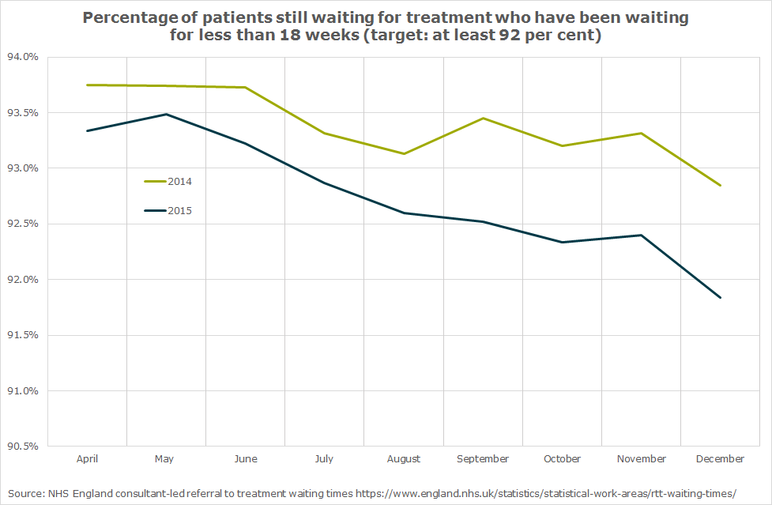

These deteriorations of the calling time are due to that it was not because of the NHS because it treated fewer people, but in the current year, data releases from the NHS showed major increases in the number of the first outpatient presence. Up to 4% over the past year, NHS supply treatments and up to 3.8% in the last year. Similarly, the number of diagnostic tests increased by 5.6% by December last year.
“It looks as if the NHS will gradually fade away, and we shall go back to a great deal of private medicine.” (Rendel, 2016)
“The most important limitation of [clinical] guidelines is that the recommendations may be wrong... Practices that are sub-optimal from the patient’s perspective may be recommended to help control costs, serve societal needs, or protect special interests (those of doctors…or politicians, for example).” (Woolf, 2017)
GP references to the hospital for the year to date quickly to 4.7%. Other recommendations, which includes recommendations between consultants, is also strong up, seeing a 6% increase. This shows the challenge facing the NHS as a whole: With the rising demand at this rate, the NHS must ratchet the task just to keep the waiting times. With the review of spending offering barest of increases in real terms of power expenditures up to 2020/21, this increase in demand must be met from increased efficiency. The faster the demand increases, the greater the efficiency it takes to satisfy it from constant spending.
“I worked in the NHS as a hospital orderly during my national service, and people thought it was a noble service. But over the years it's lost its humanity.” (Hockney, 2015)
  - PESTLE Analysis
“PESTLE analysis, which is sometimes referred as PEST analysis, is a concept in marketing principles. Moreover, this concept is used as a tool by companies to track the environment they’re operating in or are planning to launch a new project/product/service.” (Anon., 2014)
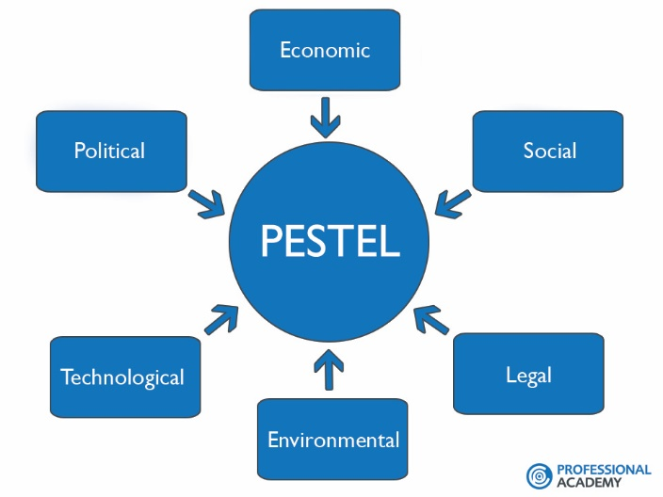
P - Factors affects the organizations in terms of government regulations and legal issues and define both formal and informal rules under which the firm must operate
E - factors affect the business operations and decision making of the organization. For example, the predicted recession is preventing the organizations from increasing the workforce.
S - factors refer to the cultural and demographic aspects of the environment. For example, increase in the health consciousness may affect the demand of the company’s product.
T - factors affect the cost and quality of the outputs. These also determine the barriers to entry and minimum efficient production level.
L - factors influence the company’s operation, its costs, and the demand for its products
E - Factors refer to ecological and environmental aspects such as weather, climate, and climate change. Climate change is a hot topic these days and organizations are restructuring their operations thus giving space to innovation and concept of Green Business.
- Political
- Significant reduction in health inequalities and a changed role for NHS In reducing the current gap
- Care closer to home, less reliance on hospital-based care
- International pressure groups
- Terrorism
- Funding, grants and initiatives
- Patient choice, competition and plurality

- Economical

- NHS Tariff uncertainty and historical volatility
- Taxation changes specific to product/services
- Seasonality/weather issues
- Home economy situation
- Global economic downturn and period of significant UK austerity
- Social
- A more health literate public driving both demands and concerns about healthcare
- Significantly changing local demographic notably in the context of ethnicity profile
- Growing patient expectation of both the quality and experience of care
- Law changes affecting social factors
- Lifestyle changes
- Population shifts

- Technological

- Pharmaceutical progress and reliance upon NHS for adoption and spread IM&T System development and requirements
- Maturity of technology
- Research funding
- Replacement technology/solutions

- Legal

- Very significant increase in litigation claims across NHS
- European/international legislation
- Employment law
- Regulatory bodies and processes

- Environmental

- Areas of the inadequate estate and links to disability access/privacy & dignity
- International
- Environmental regulations
- Ecological

Each factor identified in the pest analysis are very important to identify advanced strategic management. The pest analysis is definitely an analysis that each company must have, on its industry. Definitely every importance of each factor will vary from company to company but nonetheless analysis pest remains a technical analysis that usually belongs to SWOT analysis.

  - SWOT Analysis

“SWOT Analysis is a useful technique for understanding your Strengths and Weaknesses, and for identifying both the Opportunities open to you and the Threats you face.” (Anon., 2018)

SWOT Analysis is usually used for companies because it helps to identify the market and also help to develop career in a way that take advantage of the skills and opportunities.
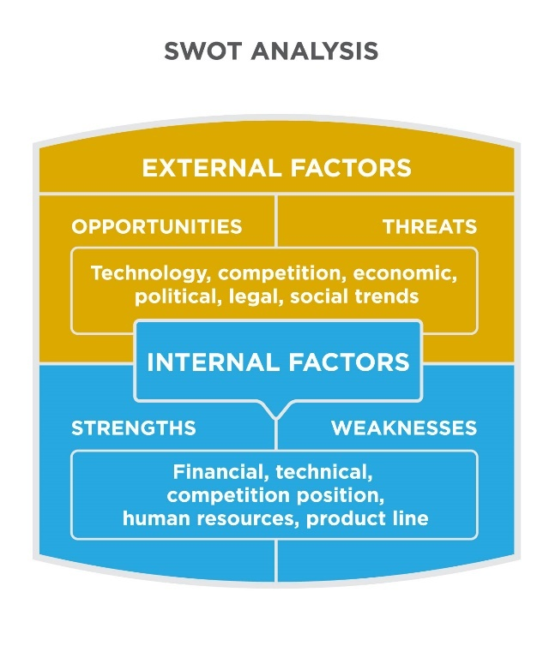

- Strengths

- High clinical quality
- Enthusiastic, professional, skilled and motivated workforce
- Current contribution to reduced A&E attendances through non-conveyance (A&E)
- Current contribution to reduce waiting time for patients
- Mitigated activity in A&E through triage in the clinical hubs
- Good relationship with the employees

- Weaknesses

- Currently not delivering three14 of the 13 Quality Requirements in UCS
- Negative net current liabilities
- Inconsistency in the delivery of patient pathways across all areas of operational
- Variable quality in A&E by PCT area

- Opportunities

- CQUIN, QIPP, Strategic Framework ambitions and commissioner intentions for future services
- Current high performing UCS providers in the Trust area
- Involvement of staff, public, patients and stakeholders in service development Growth opportunities in the Trust’s operational area for UCS and PTS
- Addressing health inequalities
- Planning for the Golden Hour project

- Threats

- The ability of the local health economy to manage future activity growth
- Demographic trends and seasonality driving demand
- Effect of national healthcare strategies
- Wider economic climate
- Impact of health inequalities on clinical demand
- Misinformation and misunderstanding of the aim

  - Fishbone analysis
The Fishbone Analysis is a method that allows the project manager to determine the causes of a problem that affects the project. Once the roots of the problem have been identified it is much easier to find solutions that revolve it.
The diagram works as a map to detect the conflict and the effects it could cause the project.
The fish bone diagram was invented by Japanese doctor Kaoru Ishikawa. It is an analysis tool that provides a systematic way of looking at the effects and causes that contribute or can lead to the emergence of these effects. The drawing looks like a fish skeleton and therefore the diagram is often called the bone Chart of fish. The cause-effect diagram can help identify the reasons why a process does not take place as planned. Often, this tool is used to briefly note the results of the brainstorming process, following which the causes of an unwanted result have been identified. The method helps to identify the underlying causes and ensures the general understanding of these causes.

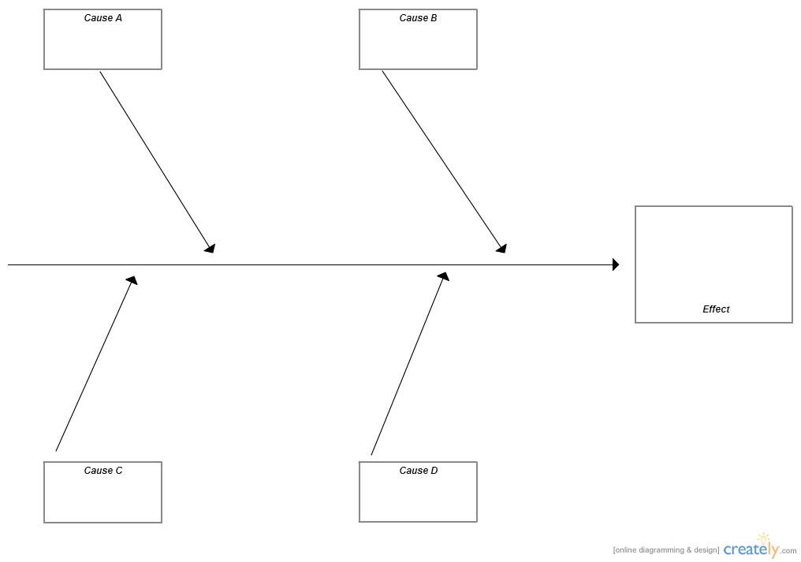
People
Equipment
Environment
Methods

Waiting time

Environment
- Not enough treatment rooms
- Small inner-city premises

Methods
- Transport arrives early
- Poor scheduling
- Corridor blocked
- Lack of automation
- Process takes too long
- Files disorganised
- Too much paperwork
- Targets
- Bureaucracy

Equipment
- Poor maintenance
- Lofts broken
- Wheelchairs unavailable

People
- Incorrect referrals
- Unexpected patients
- Original appointment missed
- Patients queue jumping
- Sickness
- Staff not available
- Lateness

- Recommendations

Given that the NHS is one of the most frequented places in the UK and more and more people need their services, in order to diminish the waiting time, one of the best solutions for reducing the waiting time of in NHS can be taken into account, such as, call for nowadays technology.
One of the best solutions that could save the current situation in the NHS is to implement an operating system that is more organized when it comes to patients. This system can function on the basis of tickets. Every patient who presents himself in the hospital receives a terminated sequence of system, which he will use throughout the circuit and will allow him to keep his order in accessing the medical services.
With the help of technology, hospitals can benefit from effective solutions in order to provide patients with quality medical services. The system's computer system can allow a clear number of people who will benefit from medical services and the type of diseases treated, which are the prerequisites for the realization of statistics and medical research. At the same time, work processes are improved by centralizing information, making an electronic register with patients and printing the patient's recipe in the final phase of the circuit.
This project can be accomplished with the help of a sponsor who wants to help the NHS who can provide the necessary equipment for the development of the computer system patient management. The system can integrate equipment such as: TV monitors, tablets, routers and printers of the latest generation.

- Conclusion

The NHS is one of the largest health systems in the world, which is why it has many advantages, but also disadvantages.
These NHS qualities about the waiting time were identified in this report with the help of the SWOT analysis, which helped in identifying not only the strengths, but also the weaknesses, the NHS opportunities and the threats that the NHS must can bear them and who must face them.
When it comes to one of the highest problems present in the NHS, there’s no culprit because there are many factors that influence this environment.
The factors influencing the NHS most are identified in this report in the form of PESTLE Analysis, with the help of which were discovered the political factors of the NHS, economic, social, technological and environmental. This analysis helps to identify these factors and to better knowledge of the situation of a particular company in the case of this report referring to the NHS, the waiting time.
This analysis is recommended to be done once every six months, for a refresh about where the NHS was at the time, but also to help the NHS to be cautious when it comes to patients and the NHS's political factors.
Once identified the advantages and disadvantages of the NHS, this report refers mainly to the waiting time. An average made from internet searches on this subject, as well as certain books written by certain doctors who were part of the NHS, can find graphs and analyses with the difference between years when it comes to waiting time. Clearly, the difference in high percentages is seen with great ease, which has made more and more people revolt on this subject.
Those who are in charge in the NHS have tried to come up with new ways to diminish the waiting time, in some cases have succeeded with few percentages, and in other cases have failed remarkable.
One of the best solutions for better functioning, organizing and decreasing the waiting time in the NHS is definitely the implementation of the system that is spoken in this report at Recommendations, with which each patient has a ticket with the serial number, so there are no problems or confusion.

Reference list
(BBC, 2014)
(Baker, 2014)
(Bevan, 1996)
(Bevan, 1952)
(Bevan, 1996)
(Bevan, 1948)
(Dobson, 2012)
(Hawking, 2012)
(Hockney, 2015)
(Lansley, 2015)
(Paul, 2014)
(Rendel, 2016)
(Series, 1948)
(Sherratt, 2014)
(Woolf, 2017)
(Anon., 2018)
(Anon., 2014)

