

Manufacturing Design and technology
Assembly Re-design of a Drill Press

Aaron Pritchard
P151481

1. Abstract
A report to identify the issues when a demand in production numbers rise and how a manufacturing company can increase unit numbers while reducing costs and eliminating excess time wastage in both designing areas and production/cycle times. The report considers a new design to save material wastage and therefore elevated costs, new production methods to decrease cycle times and increase production numbers to reach customer demands for an extended period of time.

Table of Contents
1. Abstract 1
2. Introduction 3
3. Product Design Specification 4
3.1 Performance 4
3.2 Cost 4
3.3 Size 4
3.4 Product Life Span 4
3.5 Testing 4
3.6 Timescales 4
3.7 Materials 4
3.8 Quantity 4
3.9 Environmental 4
4. QFD 5
5. Material Selection 6
Nylon 6/10 Material Cost For Original Part 9
Nylon 66 Material Cost For Original Part 9
Nylon 6/10 Material Cost For Concept Part 9
Nylon 66 Material Cost For Concept Part 9
6. Manufacturing Process Selection 14
7. Product Design 19
7.1 Design for Assembly 19
7.2 Modified Drill Press Design Improvement 19
8. Conclusion 22
9. Bibliography 23

2. Introduction
Computer Aided Design (CAD) is a crucial part of modern day manufacturing, specifically three dimensional software packages such as Solidworks or Inventor. These packages enable designers to produce concept parts which can then be assembled on a screen and run through testing procedures such as Mold Flow Analysis (MFA) and stress testing. Packages in the current climate now incorporate the material choice specifics into the test sequences allowing designers and manufacturing departments to test a concept extensively before investing capital into producing a physical part. This report addresses the improvements possible with a current production part to address cost saving, wastage, production numbers and alternative production methods. The author critically appraises the conceptual design and concludes their findings stating all factors considered.

3. Product Design Specification

3.1 Performance
3.1.1 Should be able to take the stress applied while in use without flex
3.1.2 The product should be able to perform the same action repetitively for the life of the part

3.2 Cost
3.2.1 One of the most important factors is reducing cost per part produced as demand is higher at 500 units per week
3.2.2 Cost should play a factor in material selection however the material must not be compromised when considering performance
3.2.3 The cost of batch, production run and main materials/manufacturing processes need to be considered

3.3 Size
3.3.1 The size of the re-designed concept unit must fit the original assembly without modifications needed

3.4 Product Life Span
3.4.1 The concept design must last the same or longer than the original part

3.5 Testing
3.5.1 The part will be tested with a batch material first and then developed and tested with the main material choice

3.6 Timescales
3.6.1 The main batch production requires 500 units produced weekly
3.6.2 The testing periods need to be completed quickly and thoroughly in order to start production of the concept part as soon as possible

3.7 Materials
3.7.1 A material choice for the batch, main and production run needs to be decided
3.7.2 The batch material must be strong enough for testing, but cheap enough to produce and source to make testing cost effective

3.8 Quantity
3.8.1 A testing batch of a suitable amount is needed to test thoroughly
3.8.2 A main batch of 500 units per week is required once testing is complete
3.8.3 Reduce cycle time

3.9 Environmental
3.9.1 The materials used for all production runs must be recyclable
3.9.2 The concept design has a reduced material amount from the original to save on material usage
3.9.3 The material will be used within a manufacturing facility therefore must be resistant to contaminants

4. QFD
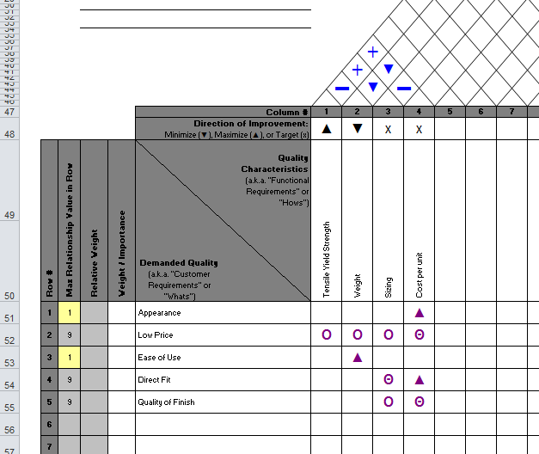

Figure 1.1

5. Material Selection
To ensure the drill press redesigned part would be suitable for its role material research has to take place. Further research could then be undertaken to see if a material with enhanced properties could be used instead, all while aligning it with the manufacturing procedure of injection moulding. Initial material research was broad and varied in order to consider the desired characteristics of the part and which material would help attain those characteristics most. This research is displayed below.
- Polyether ether ketone (PEEK)
  - Advantages – Tensile Strength (14000psi), Excellent Mechanical Strength (Plastics, 2017), outstanding resistance to harsh chemicals, maintain stiffness at high temperatures (170°C),
  - Disadvantages – Water Absorption 24hrs 0.5%, Very expensive (1/2” x 12” x 12” sheet = $608.41) (Plastic, 2017).

- Polycarbonate
  - Advantages – Tensile strength (9000psi), Low water absorption 24hr (0.15%),
  - Disadvantages – Subject to cracking under extreme stress, Low water absorption 24hr (0.15%), Max operating temperature 135°C, Chemical resistance is fair.

- Nylon 66 (Polyamide)
  - Advantages – High Tensile Strength (10000-23000psi), Compressive strength (18000psi), High operating temperature 260°C, 12% harder and 20% more resilient than Nylon 6 (Bonilla, 2017), 7-10% higher cost than Nylon 6 at $1.33 to $1.37 per pound (Bonilla, 2017).
  - Disadvantages - Water absorption high 0.3-0.4%, Requires UV stabilisation, High shrinkage, high notch sensitivity.
- Polyether Imide (PEI) Plastic
  - Advantages – High tensile strength (16500-17000psi), Flame resistance, Chemical resistant, High compressive strength (22000psi), Max operating temperature 170°C, 24hr. Water absorption 0.18-0.3%.
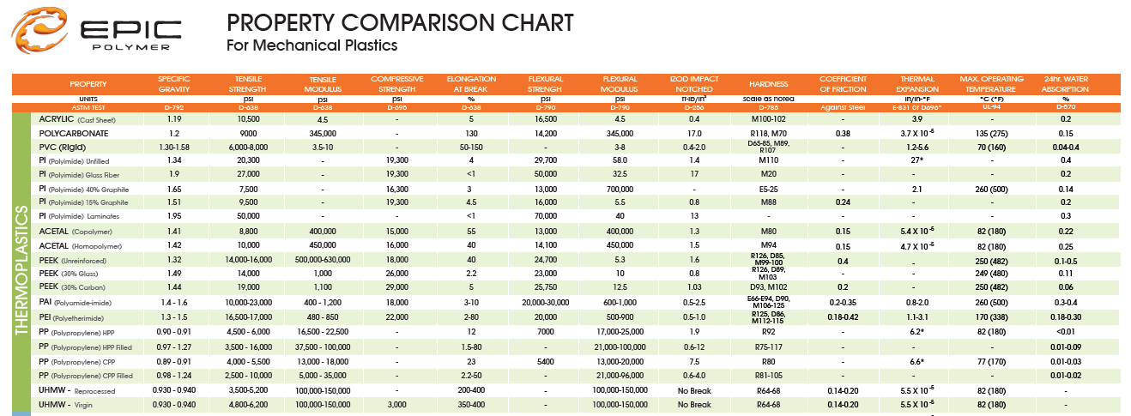
  - Disadvantages – Notch sensitive, High processing temperatures required, Relatively high material and processing costs, Limited colourability
Figure 1.2
Once research had been carried out it was decided that Polyamide (Nylon©) be the chosen material for the main batch run. This was due to it being able to withstand higher temperatures and strength than acetal or UHMWPE, is tougher than PET, has a lower cost than PTFE/acetal formulations, bearing grade PEEK or ULTEM or PPS, and has the ability to be cast in large parts and near net shapes to reduce machining costs and material waste (Bastian, 2017). Following on from this, (Bastian, 2017) then proceeds to expand by stating that:
“Nylon has outstanding mechanical properties which allow it to be used in structural as well as bearing and wear applications. Nylon makes design engineers' jobs very easy. The engineer doesn't have to consider a lot of different engineering plastics when designing parts for low to moderate temperature bearing and wear or structural applications."
After consideration, the two Nylon derivatives that were researched further was Nylon 6/10 and Nylon 66.
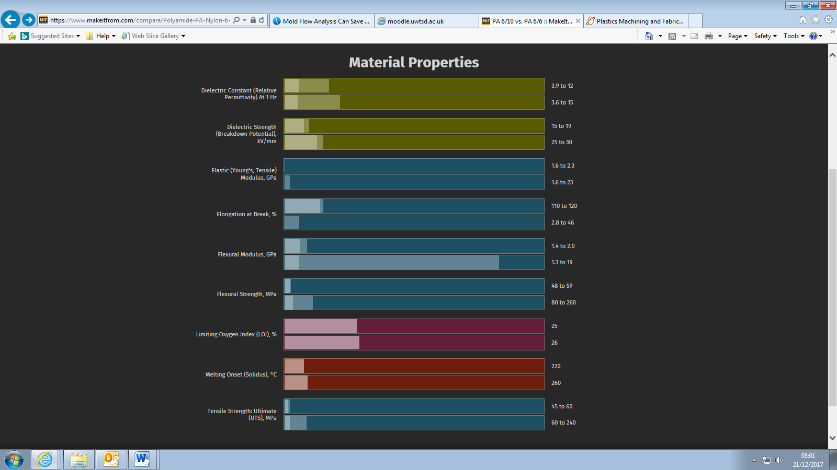
Figure 1.3
Figure 1.3 is a comparison of the two different grades of Nylon in contention. In each category Nylon 6/10 is the top line and Nylon 66 the bottom. The graph created by (MakeItFrom, 2017) shows Nylon 66’s superior qualities in every sector minus Elongation at break %, which is not an essential characteristic for the part being produced so therefore is not a contributing factor to the decision making.
One of the most contributing factors although not the single most decisive to material selection is cost. Figure1.4 and 1.5 show the cost of both Nylon 6/10 and Nylon 66 respectively. It is clear with the superior stats of Nylon 66 that this is reflected in the cost. Using a CAD software package, Solidworks, it is possible to select these two materials, consider the mass of material required per unit, and calculate the material cost for the 500 units required per week.
The cost of material required is calculated using the data obtained from Solidworks which is documented in this report for both Nylon 6/10 and Nylon 66 under Figure 1.8 and 1.9, respectively. To show a comparison of cost saving, there is a breakdown of how much the original part would cost with both materials as the original material has not been stated.

Nylon 6/10 Material Cost For Original Part
Mass of one part = 397.33g
Mass of 500 parts = 198.665kg
Cost of material per 10kg = $592.00
Total Material Cost of 500 parts = $11760.97

Nylon 66 Material Cost For Original Part
Mass of one part = 326.38g
Mass of 500 parts =163.19kg
Cost of material per 10kg = $3530.00
Total Material Cost of 500 parts = $57606.07

Nylon 6/10 Material Cost For Concept Part
Mass of one part = 267.31g.
Mass of 500 parts = 133.66kg.
Cost of material per 10kg = $592.00
Total Material Cost of 500 parts = $7912.67

Nylon 66 Material Cost For Concept Part
Mass of one part = 219.58g
Mass of 500 parts = 109.79kg.
Cost of material per 10kg = $3530.00
Total Material Cost of 500 parts = $38755.87

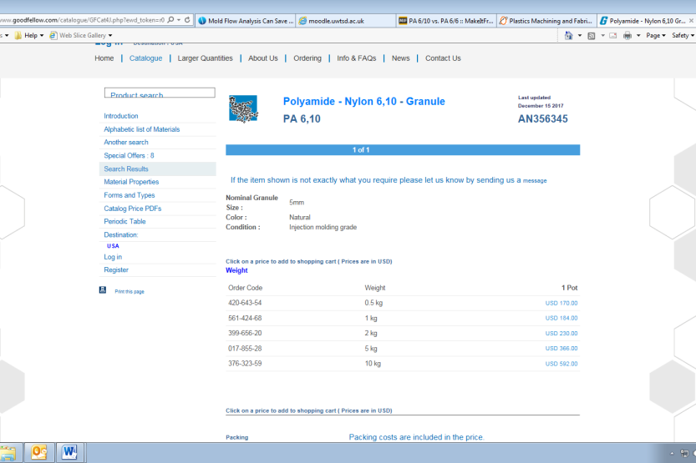

Figure 1.4
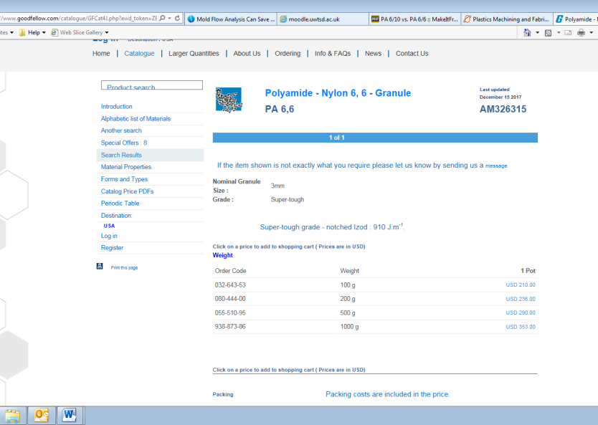

Figure 1.5

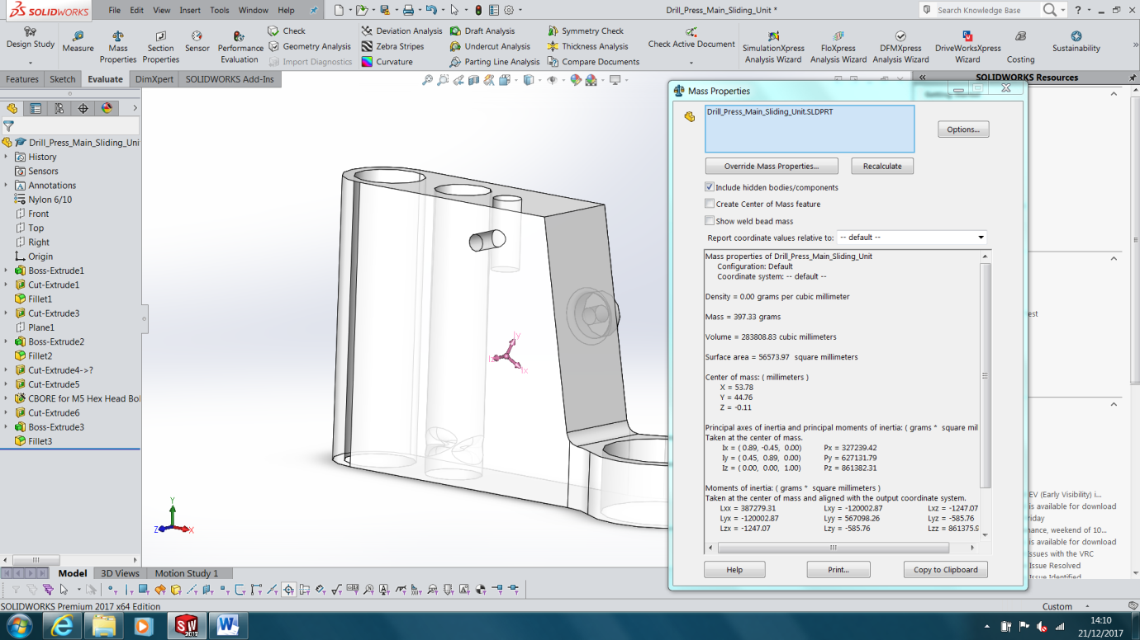
Figure 1.6

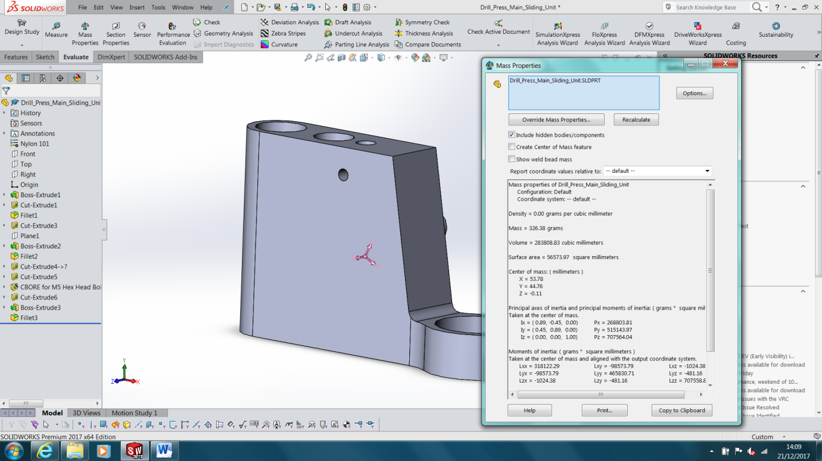
Figure 1.7

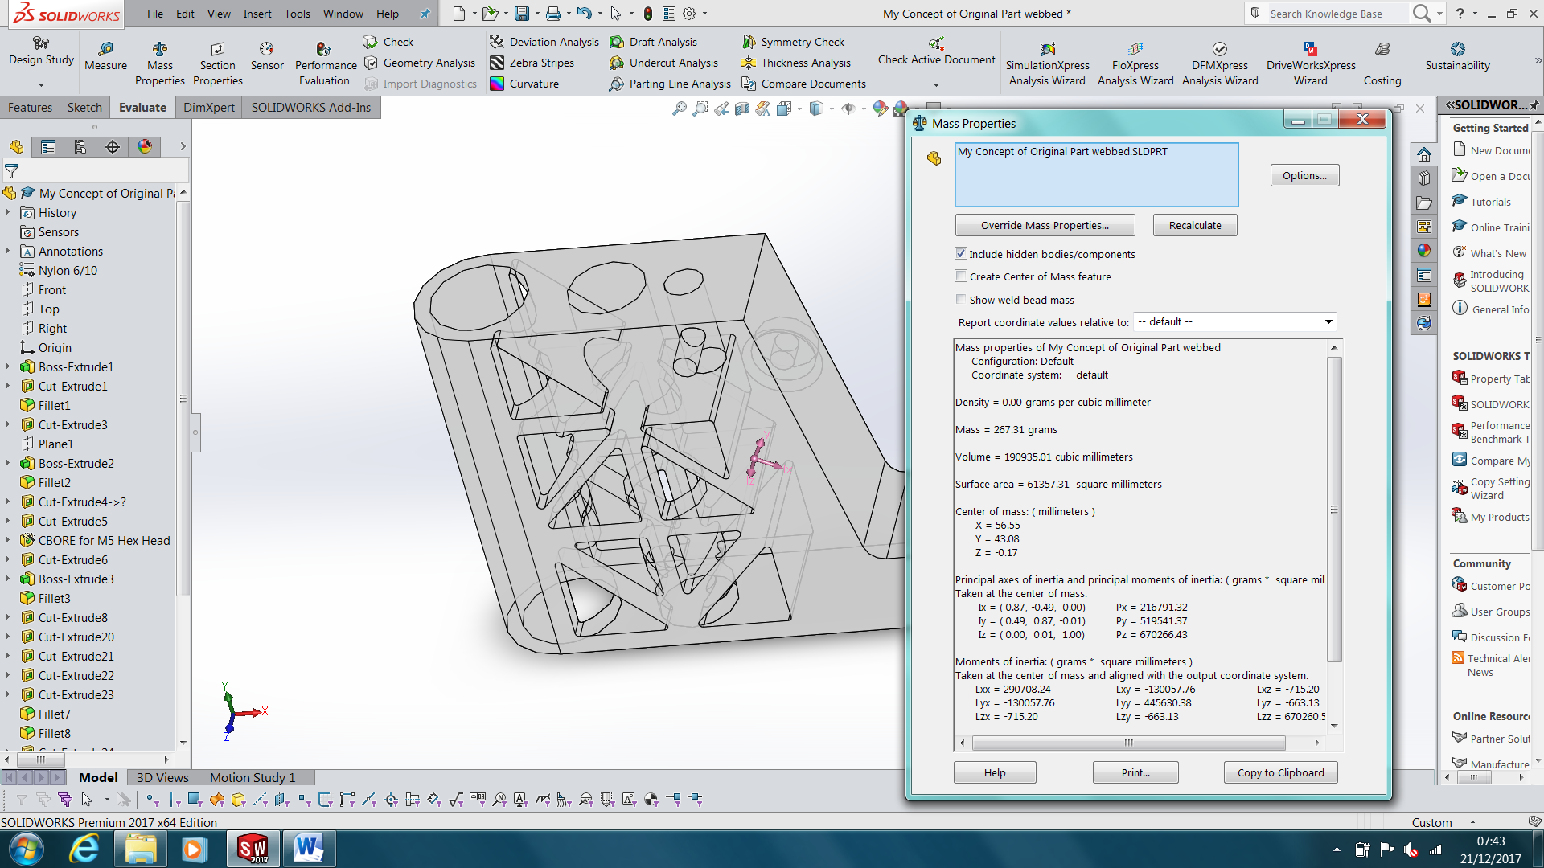
Figure 1.8

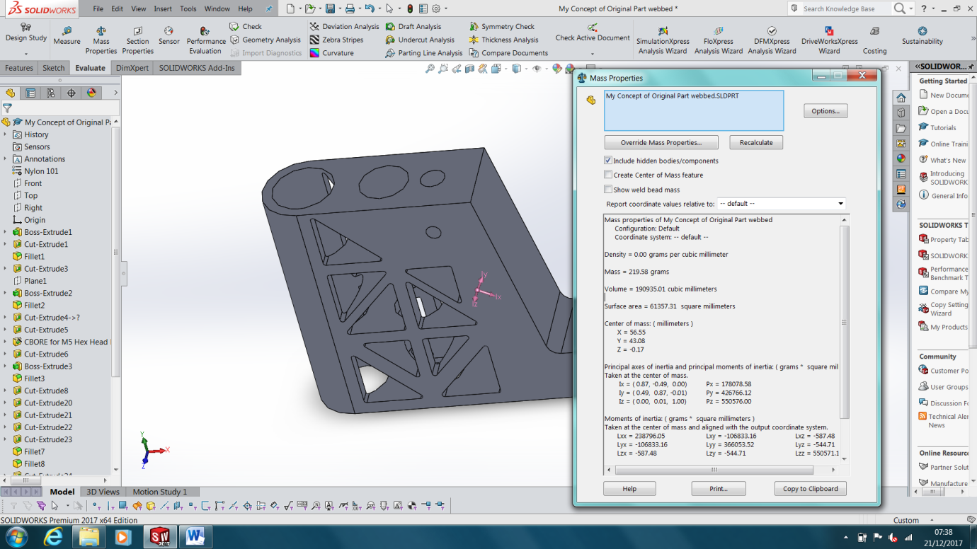
Figure 1.9

After consideration and research it was decided that Nylon 6/10 would be an ideal material for the batch run due to its similar properties to Nylon 66, which would become the main batch material selection. Nylon 6/10 can be machined via CNC and material cost is lower at a ratio of 4.9:1 so therefore a much more viable option for prototypes whereas Nylon 66 is frequently used when high mechanical strength, rigidity, good stability under heat and/or chemical resistance is required (Viers, 1999). Nylon 66 also lends itself well to make 3D structural objects, mostly by injection molding finding broad use (News, 2017) making it perfect for main production.

6. Manufacturing Process Selection
Once the final production material has been decided upon, it is then important to consider the methods in which that material could be manufactured to create the re-designed drill press. During these early design stages, (Bayer, 2017) recommends that the engineering team solicit simultaneous input from the various “players” early in product development, before many aspects of the design have been determined and cannot be changed. This is an effective cost saving tool and reduces the chances of extending the time taken to progress.
Based on Nylon 66 being a thermoplastic polymer product, the manufacturing options include injection moulding, CNC machining or 3D printing. When making this decision it is important to consider the quality of the product, the reliability of it and also the manufacturing time cycle due to a demand of 500 units per week. Based on an average working week of five days, over an eight hour shift, 500 parts would break down to a part being manufactured every 4.62 minutes.

500 units/5 days = 100 units per day
100 units/8 hours = 12.5 units per hour, rounded up to 13.
60 minutes/13 units = 1 unit every 4.62 minutes.

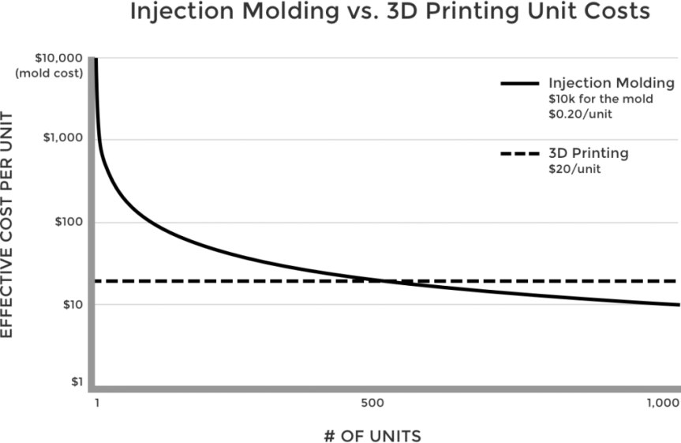
Therefore when considering the previously mentioned manufacturing options, the only process that would not be viable for main production runs would be 3D printing due to the time it takes to produce parts. However, when considering the batch run for testing, 3D printing could be a very viable option due to the ease and low cost demands if a 3D printer is an asset held by a company already. Transferring from a CAD package to a 3D printer is quick and all internal so therefore any changes can be easily made should that be required. This provides the design team with the facility to make amendments during testing prior to main production. Factors that need to be considered with production numbers however are downtime and quality issues. For cost, Figure 1.10 shows how the initial start-up costs of injection moulding are considerably higher than 3D printing, however as parts produced increases the costs balance out and this is why injection moulding is traditionally used for producing high volumes (Schwartz, 2017). These figures are not accurate due to the variables involved such as part size and material usage however it provides a visual aid for the behavioural patterns of starting up these production methods.
Figure 1.10 (Schwartz, 2017)
Usually a quick-cycle process, injection molding can produce large quantities of parts, accommodate a wide variety of part sizes, offer excellent part-to-part repeatability, and make parts with relatively tight tolerances (Bayer, 2017). As for initial costs, it is worth considering the variables such as injection moulding tooling costs to start with. Due to the material being used and the quantities required, initially an aluminium tool with a life cycle of 100,000 parts on average would be a wise choice for batch runs and initial production due to its considerable lower costs to that of a steel tool. However should the design of the unit change in future, the cost of creating a new tool or redesigning the existing one would be great again. Traditional prototype manufacturing requires tooling and machining by people and very expensive equipment. This process takes weeks. Your entire organization is held up waiting for this process to be completed (Products, 2017). Comparing that to the cost involved with 3D printing the newly designed part can begin to be processed immediately as 3D printing takes hours. When your designer is finished the CAD file, they simply send the file to the printer, and the part gets produced with little or no involvement from anyone. If a build is started at the end of the day, the part is fully manufactured, or printed by the next morning (Products, 2017).
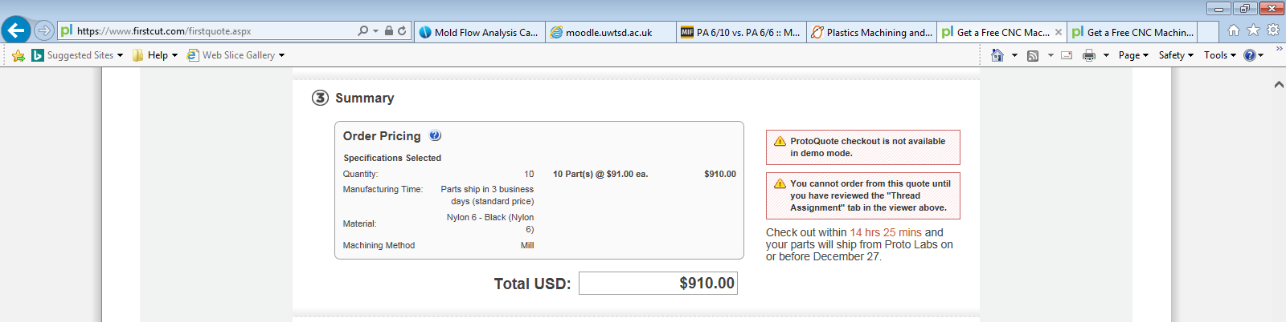
Below is a quotation from an external CNC contractor for production of the 10 test batch run parts in Nylon 6.
Figure 1.11
At a total of $910.00 this is a very reasonable approach for test batch runs. The turn around period before being delivered is 3 working days and therefore the time constraints to consider are minimal considering the cost savings.
Injection molding is the method of production that will be used for the main production batch. It has many positives that make it the ideal method for the task. It involves polymer pellets having moisture removed and then heated to a high temperature and injected at pressure into an empty cavity inside the tool. The polymer melt if heated correctly and injected at the correct pressure will successfully fill the cavity thoroughly. If MFA has been completed to a high standard then the finishing product should be of a strong and high standard. The cycle time of injection molding is very beneficial for mass production. The longest period of the cycle is the cooling stage however this can vary dependant upon the material used and the size of the cavity filled.
The tool itself can be made of a variety of metals however the common practise in industry is aluminum and steel. An aluminum tool provides the benefits of being cheaper, can be sourced and machined in a smaller time scale and is compatible with polymer melts. This material choice is suitable for main production and with its ability to transfer heat from the mold much faster, many OEMs are choosing aluminum, not to mention its ability to transfer heat from the mold much faster (Goldsberry, 2012). On the other hand however if production is set to last for several years, the alternative choice of steel at the higher intial cost may be the better choice. A steel tool will outlast an aluminum one greatly however (Holtz, 2017) states the following,
“If your part volumes don’t stretch into the millions, if you need on-demand production parts within days, and if you’re looking to avoid risky tooling investments before your part design is truly validated, low-volume injection molding with an aluminum tool might be good option.”
With that considered, 500 units a week is the customers demands and therefore this results in 26,000 units annually, so a steal tool would be an unneccesaary cost while demand is at the current level, or even if it was to rise considerably the aluminum tool will suffice. An aluminum tool can be polished to a high standard too resulting in a high standard of surface finish passed onto the final part.
One other benefit to injection molding is its ability to produce multiple parts simultaneously therefore one injection process could produce the minimum 13 parts required per day a lot faster than a CNC that would create them individually. Arguably however, this would result in a complex tool requirement to create multiple parts which may take more time/cost designing efficiently and manufacturing. An argument for such a case however is that an injection molding unit that maximises the number of parts produced per hour reduces the machine overhead costs per part (Bayer, 2017). Injection molding is a completely automated procedure and therefore if the machine is running correctly the sequence is uninterrupted and therefore so is production. This is both faster and safer as workers are not required to be hands on with the dangerous aspects of manufacturing such as high temperatures.
Optimising runner systems will improve waste as the polymer mold required to fill the runners could then be reduced. One consideration when manufacturing the part is if the colour of the part is an important characteristic or not, standard polymer colours will be less costly than custom colours for example. When creating an improvement on any concept part (Bayer, 2017) state that it is important that the design does not over-specify your requirements. Because parts perform as intended, the costs of over specification normally go uncorrected, needlessly increasing part cost and reducing part competitiveness.
Prior to a tool being designed and manufactured it is recommended that Mold Flow Analysis be carried out on the prototype CAD file to simulate the flow of material into the tool cavity by accounting for melt temperature, material properties and pressure for injection. This analysis provides a virtual sneak peek into how the chosen material will fill a mold's cavities and highlights potential areas of concern and digitally simulating this process before cutting the tool allows changes to be made early on, ultimately saving money and optimizing results (Hassiotis, 2016).

7. Product Design

7.1 Design for Assembly
The original design is a clamping unit for a handheld drill. It consists of a clamp that is situated above the chuck of the drill and precision machined holes where it runs up and down the guide pole of the pressing unit. A lever is attached to the clamping unit to allow the user to control the movement of the unit while drilling.

7.2 Modified Drill Press Design Improvement
The modified part concept must expand on the original part and provide benefits to justify to extended cost of a conceptual design and production. Therefore the key areas to address are cost and wastage while maintaining all the original part characteristics the original held. From the concept design it is noticeable that the main cost saving idea implemented is the reduction in use of material due to the webbed design. This design will ensure that the part still has its rigidity should a suitable material be used while reducing wall thickness which directly affects the cost by reducing material requirements. Avoiding thick sections can help to reduce cooling times and therefore cycle times are increased and more parts can be made in a reduced amount of time. This can also be considered as a wastage improvement. The material will be injection molded instead of CNC machined for example, therefore the material will remain in the injection molding unit for the next part whereas it would be machined out of a solid block in CNC production and classed as waste that needs to be recycled, increasing costs furthermore.

The images below show the conceptual part design; the construction incorporates all of the original part features and fittings. When made to the same sizing, it will be compatible with the assembly model as shown in the Figures 1.16 and 1.17 further down.

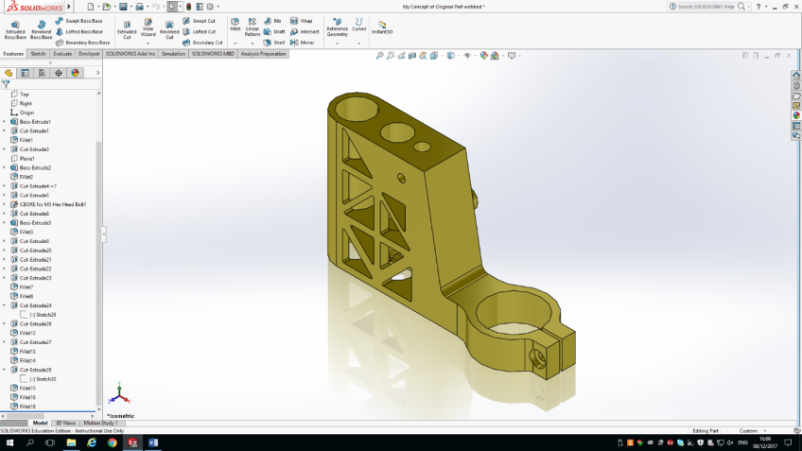
Figure 1.12

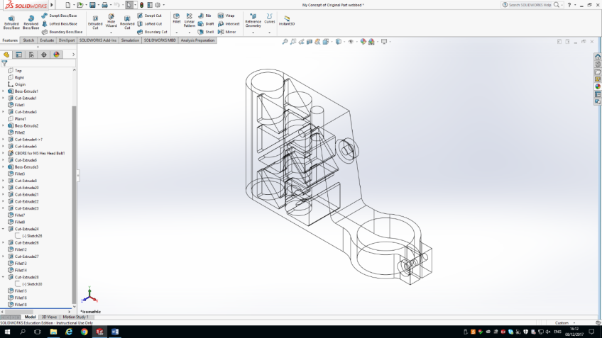

Figure 1.13

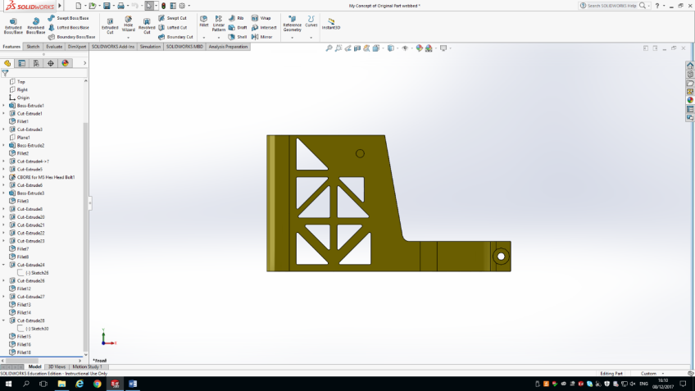

Figure 1.14

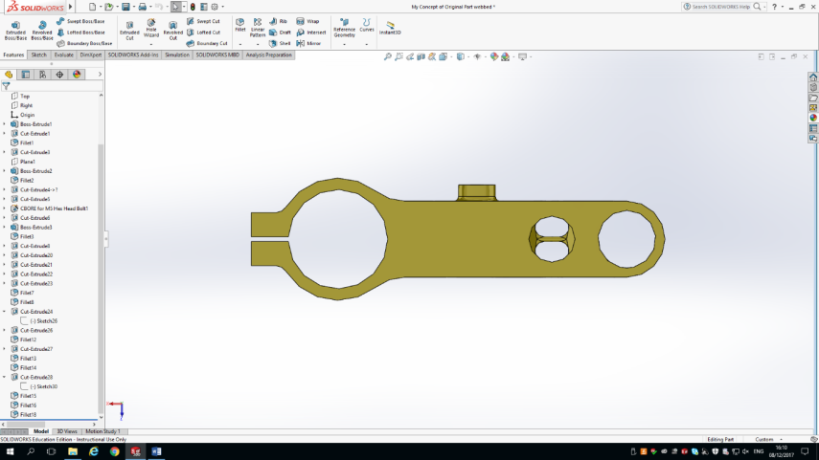

Figure 1.15

The images demonstrate CAD’s ability to recreate the conceptual part with any amendments and visually see how the new features can be incorporated correctly prior to any prototype waste parts being produced. It also allows the designer to size the modifications accordingly to the parts features and characteristics in a short amount of time due to the ease of the software.
Below is CAD images of the conceptual part included into the final assembly design. By using CAD software the part can be implemented and assessed ready for stress analysis with the chosen material and design. It is also visible that the part fits the assembly design and therefore production of the physical parts can begin.

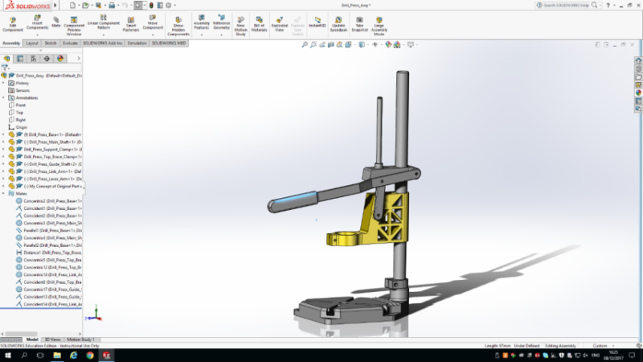
Figure 1.16

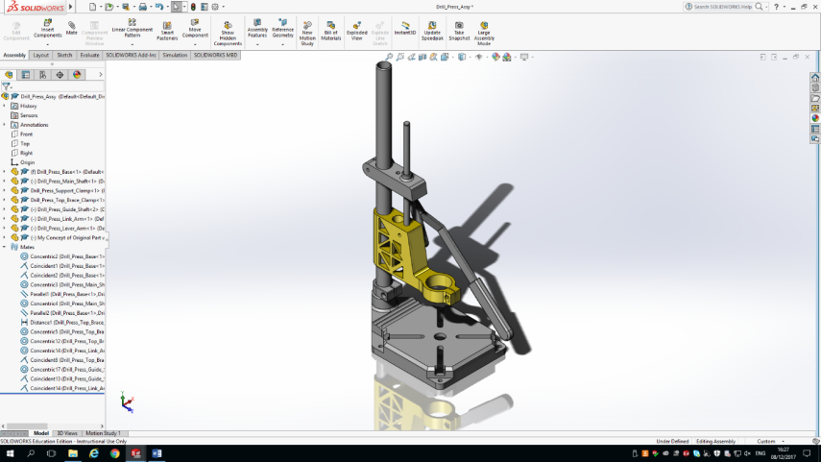
Figure 1.17

8. Conclusion
The redesigning of the drill press unit in this report demonstrates a low risk high cost saving alternative method of production to reduce waste, time and costs while maintaining the quantities and qualities required for customers. The reduction in material while maintaining the original design features and shape provide the low risk. The original design was proven to work and with the use of stress analysis and MFA on modern CAD software the new design could be virtually tested to perform the same.
The materials chosen have characteristics beyond what is expected of the part while keeping costs reduced compared to other polymer alternatives that were considered in this report. The ability to machine these polymers in a variety of ways provide flexibility should alternative methods be required and both Nylon 6/10 and Nylon 66 are easily sourced worldwide as shown in Figure 1.18. This allows production to take place on any continent should that be an option considered in future.
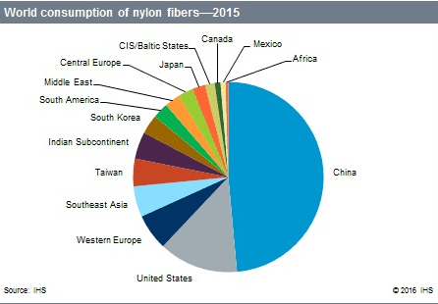

Figure 1.18, The World’s consumption of nylon fibres -2015 (Markit, 2016).

The production methods considered in this report demonstrate the authors knowledge on balancing both practicality to hit specific production goals while also considering the cost and downtime implications. The considered method of 3D printing initial batch testing units will save on cost however the final choice of CNC machining will show cost and time benefits to the production cycle.
When considering the customers demands for the unit in production, as the design has only changed on mass f material required this results in the same demands being met as previously. The new production method also ensures the 500 units required per week is easily achievable even when downtime is considered due to the quick cycle time of injection moulding. This then provides the manufacturing company to take on more clients in future or increase the initial 500 units per week if demand grows and therefore lower the costs involved per unit further.
When all positive and negative aspects within this report are considered, the design and manufacturing stages of production for the drill press part show a substantial positive rise in every area, even when initial start up costs f the injection moulding process are considered, the amount of units being produced will soon see the cost per unit level to a consistently low price and therefore beneficial given the demand the company faces.

9. Bibliography
Bastian, K. (2017). Nylon Takes the Heat. Retrieved from Plastics Molding & Fabricating: http://www.plasticsmachining.com/magazine/199808/nylon.html
Bayer. (2017). Engineering Polymers. In Bayer, Part and Mold Design (p. 7). Bayer.
Bonilla, R. (2017, April 24). Difference between Nylon 6 and Nylon 66. Retrieved from Sciencing: https://sciencing.com/difference-nylon-6-nylon-66-7617480.html
Goldsberry, C. (2012, August 29). Aluminum vs. steel tooling: Which material is right, and how to design and maintain? Retrieved from Plastics Today: https://www.plasticstoday.com/content/aluminum-vs-steel-tooling-which-material-right-and-how-design-and-maintain/7829055817880
Hassiotis, M.-K. (2016, May 12). Mold Flow Analysis Can Save Your Plastic Injection Mold Design. Retrieved from East West Manufacturing: http://news.ewmfg.com/blog/mold-flow-analysis-can-save-your-plastic-injection-mold-design
Holtz, T. (2017, April 14). Injection Molding: Aluminum vs. Steel Tooling. Retrieved from Proto Labs: https://www.protolabs.com/resources/blog/injection-molding-aluminum-vs-steel-tooling/
MakeItFrom. (2017). PA6/10 vs. PA6/6. Retrieved from MakeItFrom: https://www.makeitfrom.com/compare/Polyamide-PA-Nylon-6-10-610/Polyamide-PA-Nylon-6-6-66-Nylon-101
Markit, I. (2016, August). Chemical Economics Handbook - Nylon Fibers. Retrieved from www.ihs.com: https://www.ihs.com/products/nylon-fibers-chemical-economics-handbook.html
News, L. (2017). Oil Pan, Reinforced 66. Retrieved from Material Data Center: http://www.materialdatacenter.com/mb/main/pdf/application/16449
Plastic, U. (2017). Ketron PEEK 1000. Retrieved from US Plastic Corp: https://www.usplastic.com/catalog/item.aspx?itemid=23829&catid=618
Plastics, C. (2017). PEEK. Retrieved from Curbell Plastics Research Solutions: https://www.curbellplastics.com/Research-Solutions/Materials/PEEK
Products, 3. (2017). Benefits of 3D Printing. Retrieved from 3Design Products: http://www.3designproducts.ca/benefits_of_3d_printing.html
Schwartz, J. (2017, February 02). The Voodoo Manufacturing Blog. Retrieved from VoodooMFG: http://blog.voodoomfg.com/2017/02/02/high-volume-3d-printing-vs-injection-molding/
Viers, B. D. (1999). Ocford university Press Inc. Polymer Data Handbook, 189.

