
Applied Computing

Wales Institute of Science and Art (WISA)

Networks and Cybersecurity Essentials (ACCA4024)

Lab 2: Design a Simple Network with 2 PC's connected to a Switch.


n.kaliyamurthy@uwtsd.ac.uk 1

Warm-up
Based on your acquired skills from previous lab works, complete the following.
Build a Simple Network as per the topology given below Configure the IP Address as per the addressing table Use Ping Utility to check if the connection is successful.
(Save the file as Lab2_ Student_ID) and submit it via Moodle Link ONLY Topology:
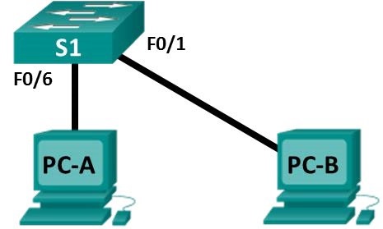
Addressing Table
Device | Interface | IP Address | Subnet Mask
PC-A | NIC | 192.168.1.10 | 255.255.255.0
PC-B | NIC | 192.168.1.11 | 255.255.255.0
Record your outcome: Is the Ping between PC- A and PC- B Successful?

Ping From PCA to PCB
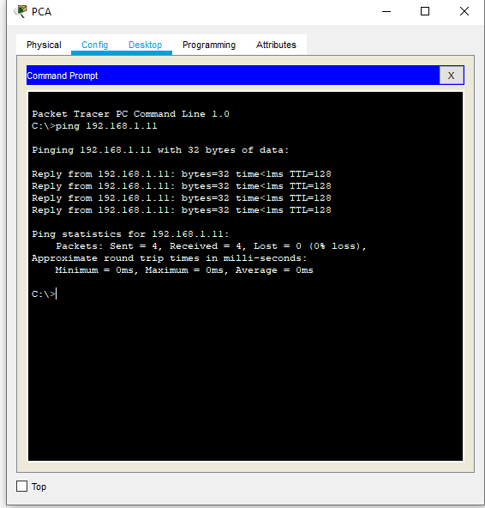

Ping PCB to PCA
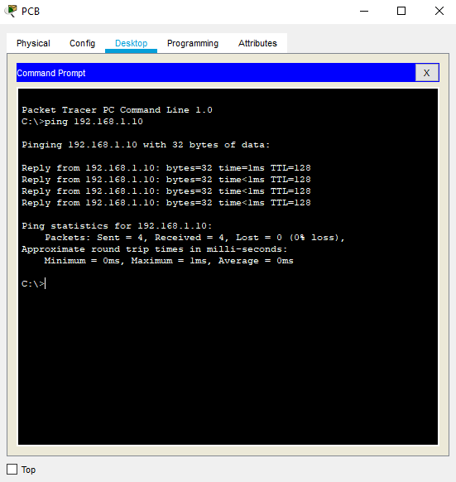

LAB Objectives
Every computer on an Ethernet local network has a Media Access Control (MAC) address that is burned into the Network Interface Card (NIC). Computer MAC addresses are usually displayed as 6 sets of two hexadecimal numbers separated by dashes or colons (example: 15-EF-A3-45-9B-57). The ipconfig /all command displays the computer MAC address.

- Determine the MAC address of a Windows computer on an Ethernet network using the ipconfig /all command.
- Analyze a MAC address to determine the manufacturer.
- Analyze the Wired and Wireless Network connection.
- Analyze Address Resolution Protocol (ARP).
Requirements
  - PC running Windows 10 with at least one Ethernet network interface card (NIC) or the above created Topology in Packet Tracer.
  - Connectivity to the Internet
Task 1: Determine the MAC address of a Windows computer on an Ethernet network using the ipconfig /all command.
(From the previous lab, you should know the step-by-step procedure to execute a “PING”/ “TRACERT” command in a Packet Tracer) – Execute those steps, if you work with Packet Tracer. In your PC
Step 1: Open a Windows command prompt window
Right-click on the Start button and select Command Prompt.
ACCA4024

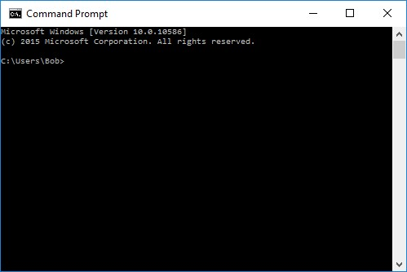
Step 2: Use the ipconfig /all command
Enter the ipconfig /all command at the command prompt. Press Enter. (Typical results are shown in the following figure, but your computer will display different information.)
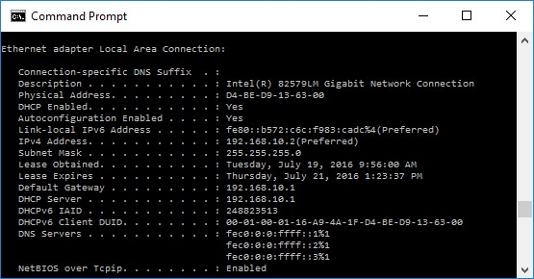
Step 3: Locate the MAC (physical) address(es) in the output from the ipconfig
/all command
Use the table below to fill in the description of the Ethernet adapter and the Physical (MAC) Address:
Description | Physical Address
Intel (R) Ethernet Connection I218-LM | EC-F4-BB-3A-75-59
VirtualBox Host-Only Ethernet Adaptor | 0A-00-27-00-00-29
Bluetooth Device (Personal Area Network) | 7C-5C-F8-DA-2F-AE
Microsoft Wi-Fi Direct Virtual Adaptor | 7C-5C-F8-DA-2F-AB
Microsoft Wi-Fi Direct Virtual Adaptor #2 | 7E-5C-F8-DA-2F-AA
Intel~® Dual Bond Band Wireless-AC 7260 | 7C-5C-F8-DA-2F-AA

How many MAC addresses did you discover in your PC? 3 for Ethernet adapter and 3 for Wireless Lan adapter – total of 6

Task 2: Analyzing the Parts of a MAC Address
Every Ethernet network interface has a physical address assigned to it when it is manufactured. These addresses are 48 bit (6 bytes) long and are written in hexadecimal notation.
MAC addresses are made up of two parts.
One part of the MAC address, the first 3 bytes, represents the vendor who manufactured the network interface. This part of the MAC is called the OUI (Organizationally Unique Identifier). Each vendor who wants to make and sell Ethernet network interfaces must register with the IEEE in order to be assigned an OUI.
The second part of the address, the remaining 3 bytes are the unique ID for the interface. All MAC addresses that begin with the same OUI must have unique values in the last 3 bytes.
In the example shown in the lab, the physical MAC address for the Ethernet LAN interface is D4-BE-D9-13-63-00.
ACCA4024
Manufacturer OUI |  | Unique Identifier for the Interface | Vendor Name
D4-BE-D9 |  | 13-63-00 | Dell Incorporated
Step 4: List MAC addresses discovered by you in Part 1.
List the 3-byte Manufacturer OUI and the 3-byte unique interface identifier. You will fill in the Vendor name in Step 2.
Manufacturer OUI | Unique Identifier for the Interface | Vendor Name
D4-BE-D9 | 13-63-00 | Dell Incorporated
EC-F4-BB | 3A-75-59 | Dell Incorporated
7C-5C-F8 | DA-2F-AB | Intel Corporate

Step 5: Lookup the vendors who are the registered owners of the OUI that you listed in the table.
- Wireshark.org provides an easy to use lookup tool at https://www.wireshark.org/tools/oui-lookup.html. Use this tool, or use the Internet to search for other ways to identify an OUI.
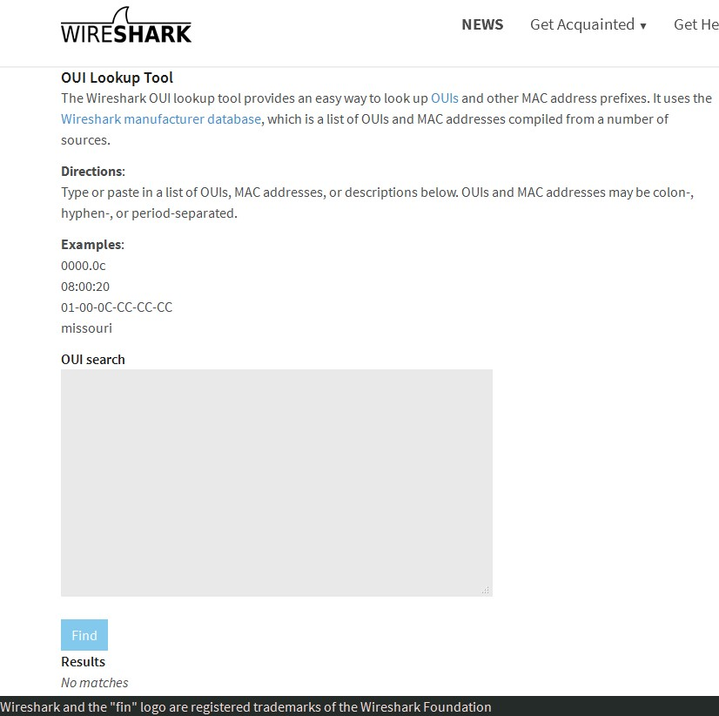
- Use the information that you found to update the vendor column in the chart in
Step 1. How many different vendors did you discover? Dell Inc /Intel Corporate
- 2
Record your Reflection
- Why might a computer have more than one MAC address?
MAC Addresses are NIC (Network Interface Cards) specific. Each Network interface that the computer can access will have its own MAC address. These means that modern computers that are supported for Wired Network (LAN), wireless and other forms of network connectivity will have multiple MAC addresses. One for each of the available network interfaces.
- Try connecting and disconnecting the network cable(s) to your network adapter(s) and use the ipconfig /all again. What changes do you see? Does the MAC address still display? Will the MAC address ever change?
I disconnected from the Wi-Fi then reconnected and I noticed that all the MAC addresses stayed the same. I would not expect the MAC addresses to change as they are hard-coded into my computers network card and can never be changed.
- What are other names for the MAC address?
Physical Address
Hardware Address

Task 3: Wired and Wireless Network Connection.
Step 6: Open the Network Connections window by right-clicking the Windows Start button > Network Connections.
Step 7: The Network Connections window displays the list of NICs available on this PC. Look for your Local Area Connection and Wireless Network Connection adapters in this window.
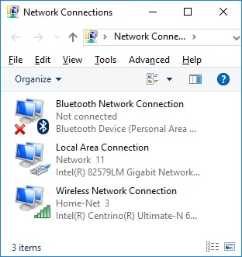
Note: Other types of network adapters, such as Bluetooth Network connection and Virtual Private Network (VPN) adapter, may also be displayed in this window.

Verify the wireless network connection settings
Step 8: Select the Wireless Network Connection option. Right-click on it to display a drop-down list. The first option displays if your wireless NIC is enabled or disabled. Currently, this NIC is enabled which is why the Disable option is displayed. If your wireless NIC is disabled, you will have an option to Enable it.
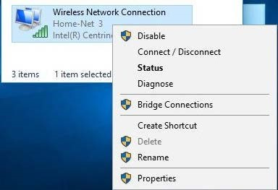
Step 9: Click Status to open the Wireless Network Connection Status window.
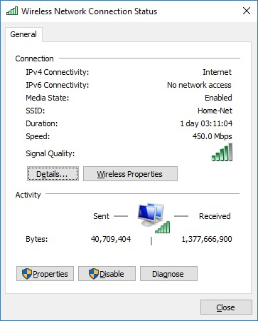
What is the Service Set Identifier (SSID) for the wireless router of your connection?
BTHub6-9QRF
What is the speed of your wireless connection?
468/468 (Mbps)
Step 10: Click Details to display the Network Connection Details window.
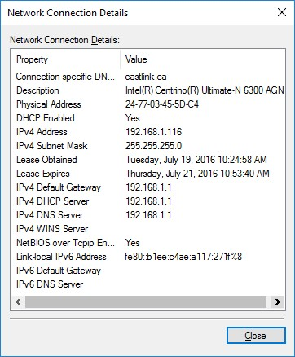
What is the MAC address of your wireless NIC?

7C-5C-F8-DA-2F-AA
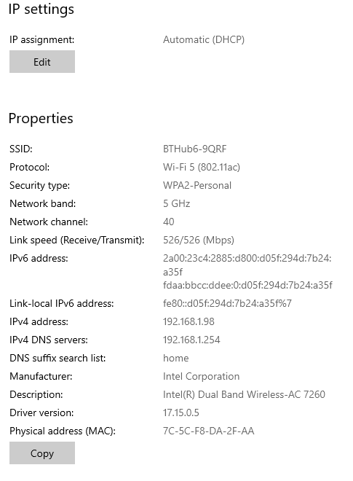
Step 11: Open a command window prompt and type ipconfig /all.
C:\Users\Bob> ipconfig /all
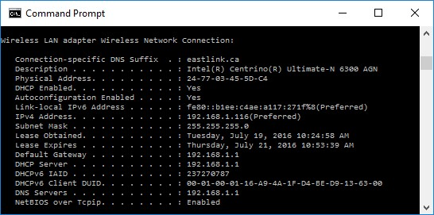
Notice the information displayed is similar to the Network Connection Details window information. When you have reviewed the details, click Close to return to the Wireless Network Connection Status window.
Step 12: Return to the Wireless Network Connection Status window. Click Wireless Properties to open the Wireless Network Properties window of the Home-Net network.
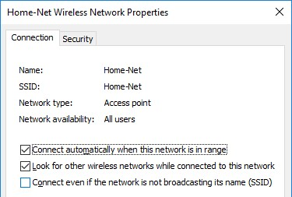
Step 13: You should always use wireless security whenever available. To verify (or configure) the wireless security options click on the Security tab.
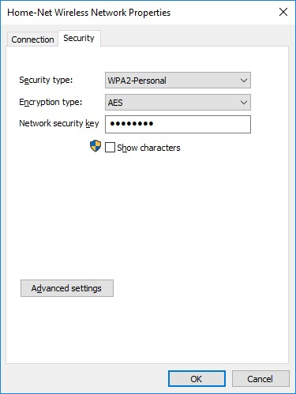
The window displays the type of security and encryption method enabled. You can also enter (or change) the security key in this window. Close all windows.
Work with your wired NIC.
We will now verify the wired network connection settings.
Step 14: Open the Network Connections window by right-clicking Windows Start > Network Connections.
Step 15: Select and right-click the Local Area Connection option to display the drop-down list. If the NIC is disabled, enable it.
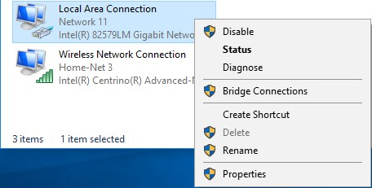
Step 16: Click the Status option to open the Local Area Connection Status window. This window displays information about your wired connection to the LAN.
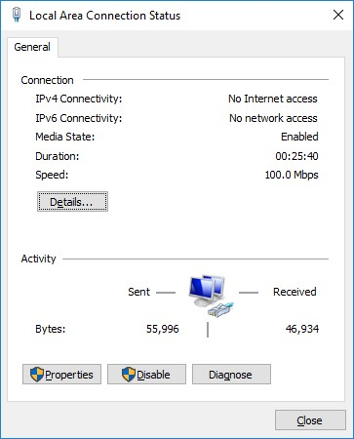
Step 17: Click Details… to view the address information for your LAN connection.
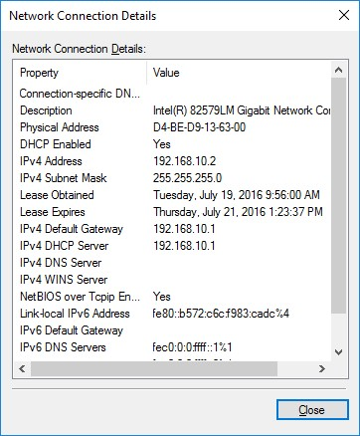
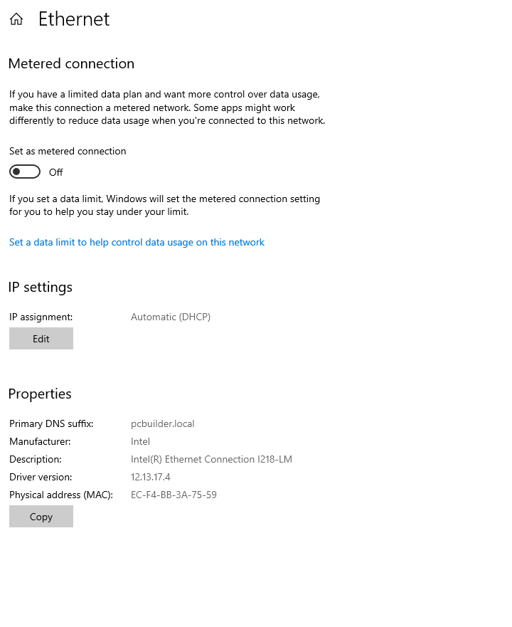
Step 18: Open a command window prompt and type ipconfig /all. Find your Local Area Connection information and compare this with the information displayed in the Network Connection Details window.
Have checked and the MAC address matches – see below
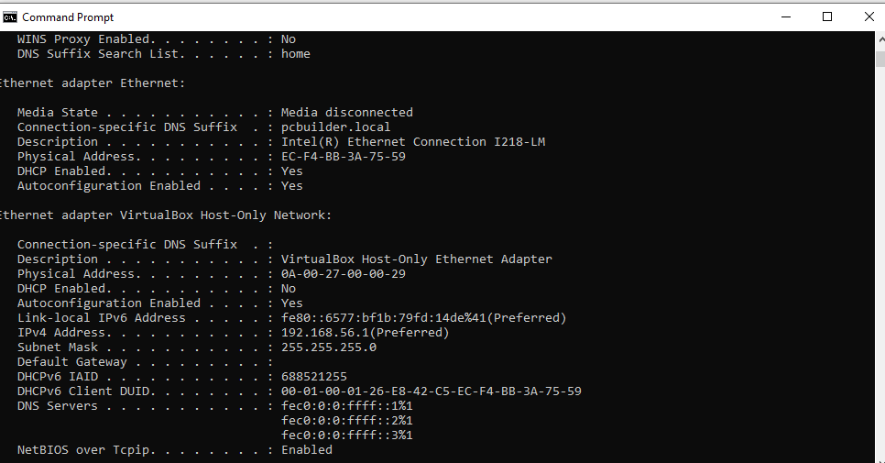
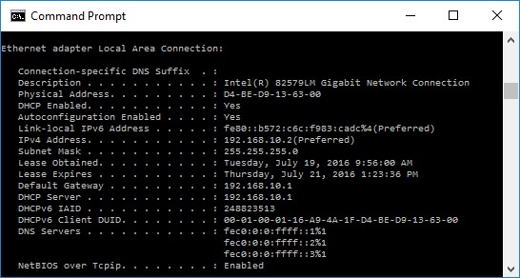

Step 19: Close all windows on your desktop.
Identify and Use the System Tray Network Icons
Use the Wireless Network icon.
Step 20: The bottom right-hand corner of the Windows 10 screen contains the system tray. Move your mouse to display the system tray as shown.

Note: If your wired network is enabled, a different network icon () is displayed in the system tray.

Step 21: In this example, the 3rd icon from the left is the wireless network icon.
If you hover over it, it displays the currently connected networks.
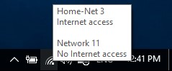
Step 22: Click the wireless network icon, and it displays the wired and wireless network SSIDs that are in range of your wireless NIC.
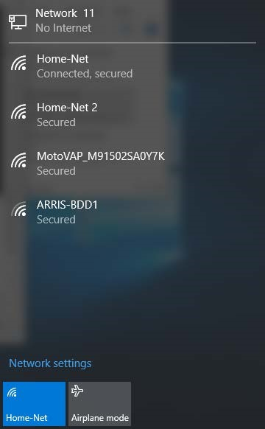
Step 23: Right-click the wireless network icon, and it displays a troubleshooting option and to open the Network and Sharing Center window.
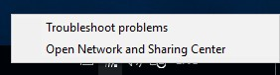
Step 24: Click on the Open Network and Sharing Center option.
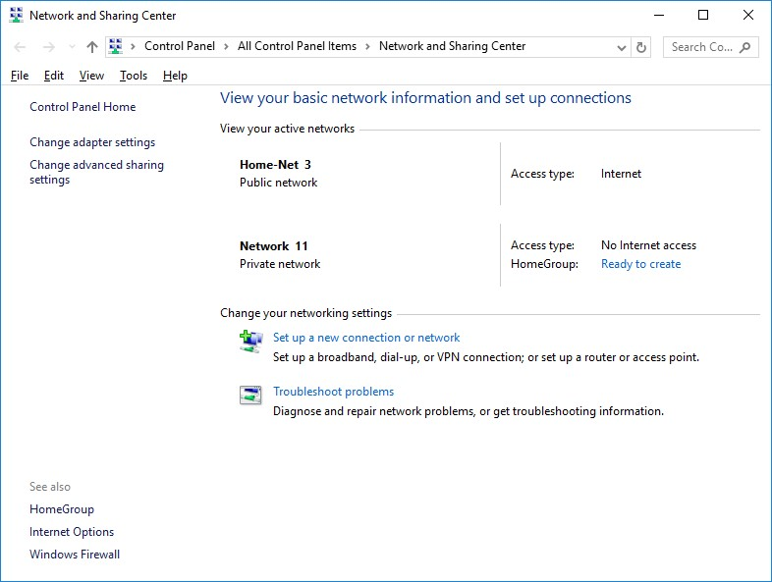
Step 25: The Network and Sharing Center is a central window that displays information about the active network or networks, the network type, the type of access.
Record your Reflection
Why would you activate more than one NIC on a PC?
I would because I need to access more than one type of network – I want my laptop to communicate via Wi-Fi, LAN and Bluetooth – so I will need my laptop to have an NIC for each of these networks. It also is a fail safe encase one NIC fails

Task 4: Address Resolution Protocol (ARP).
Use your PC/ Laptop with Internet Connection to execute this Task.
Objectives
Download and Install Wireshark
Capture and Analyze ARP Data in Wireshark
- Start and stop data capture of ping traffic to remote hosts.
- Locate the IPv4 and MAC address information in captured PDUs. • Analyze the content of the ARP messages exchanged between devices on the LAN.
View the ARP cache entries on the PC
- Access the Windows Command Prompt.
- Use the Windows arp command to view the local ARP table cache on the PC.
Background / Scenario
Address Resolution Protocol (ARP) is used by TCP/IP to map a Layer 3 IPv4 address to a Layer 2 MAC address. When an Ethernet frame is transmitted on the network, it must have a destination MAC address. To dynamically discover the MAC address of a known destination, the source device broadcasts an ARP request on the local network. The device that is configured with the destination IPv4 address responds to the request with an ARP reply and the MAC address is recorded in the ARP cache.
Every device on the LAN maintains its own ARP cache. The ARP cache is a small area in RAM that holds the ARP responses. Viewing an ARP cache on a PC displays the IPv4 address and the MAC address of each device on the LAN with which the PC has exchanged ARP messages.
Wireshark is a software protocol analyzer, or "packet sniffer" application, used for network troubleshooting, analysis, software and protocol development, and education. As data streams travel back and forth over the network, the sniffer "captures" each protocol data unit (PDU) and can decode and analyze its content according to the appropriate protocol specifications.
Wireshark is a useful tool for anyone working with networks and can be used with most labs in the Cisco courses for data analysis and troubleshooting. This lab provides instructions for downloading and installing Wireshark, although it may already be installed. In this lab, you will use Wireshark to capture ARP exchanges on the local network.
Required Resources
• 1 Windows 10 PC with Internet access

Download and Install Wireshark
Wireshark has become the industry standard packet-sniffer program used by network engineers. This open source software is available for many different operating systems, including Windows, Mac, and Linux.
If Wireshark is already installed on your PC, you can skip Part 1 and go directly to Part 2. If Wireshark is not installed on your PC, check with your instructor about your academy’s software download policy.
Step 26: Download Wireshark.
- Wireshark can be downloaded from www.wireshark.org.
- Click Download.

- Choose the software version you need based on your PC’s architecture and operating system. For instance, if you have a 64-bit PC running Windows, choose Windows Installer (64-bit).
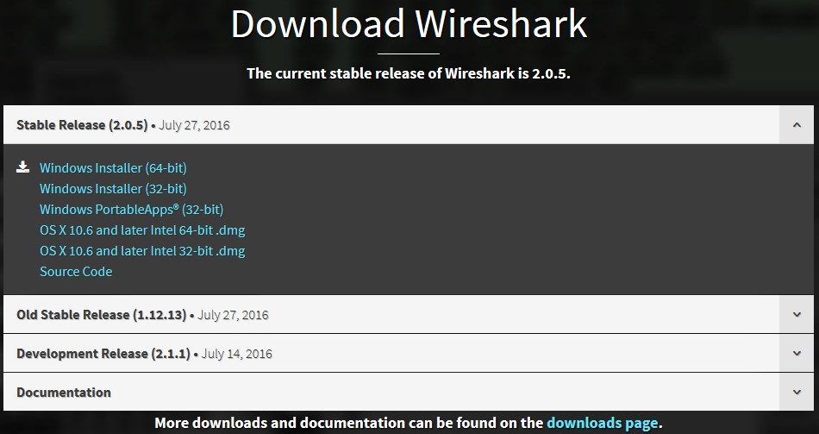
- After making a selection, the download should start. Click Save File if prompted. The location of the downloaded file depends on the browser and operating system that you use. For Windows users, the default location is the Downloads folder.
Step 27: Install Wireshark.
- The downloaded file is named Wireshark-win64-x.x.x.exe, where x represents the version number. Double-click the file to start the installation process. It is version 2.0.5 in this example.
- Respond to any security messages that may display on your screen. If you already have a copy of Wireshark on your PC, you will be prompted to uninstall the old version before installing the new version. It is recommended that you remove the old version of Wireshark prior to installing another version. Click Yes to uninstall the previous version of Wireshark.
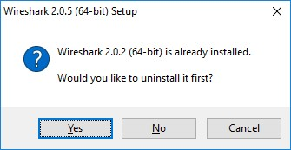
- If this is the first time to install Wireshark, or after you have completed the uninstall process, you will navigate to the Wireshark Setup wizard. Click Next.
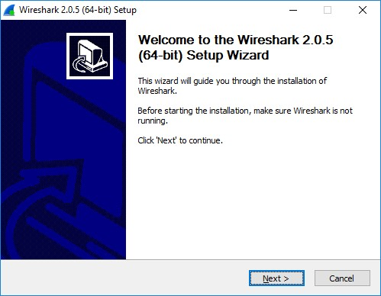
- Continue advancing through the installation process. Click I Agree when the License Agreement window displays.
- Keep the default settings on the Choose Components window and click Next.
- Choose your desired shortcut options and click Next.
.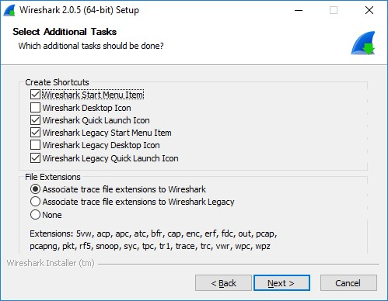
- You can change the installation location of Wireshark, but unless you have limited disk space, it is recommended that you keep the default location.
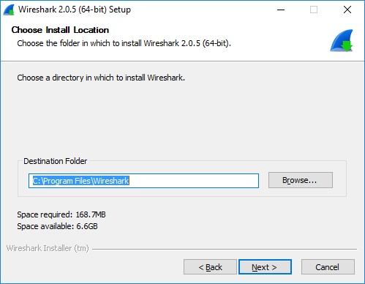
- To capture live network data, WinPcap must be installed on your PC. If WinPcap is already installed on your PC, the Install check box will be unchecked. If your installed version of WinPcap is older than the version that comes with Wireshark, it is recommend that you allow the newer version to be installed by clicking the Install WinPcap x.x.x (version number) check box.
Finish the WinPcap Setup Wizard if installing WinPcap.
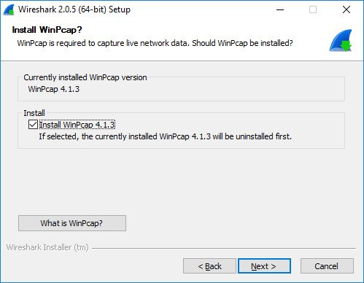
Note: You maybe prompted to install USBPcap. The installation of USBPcap is
optional.
- Wireshark starts installing its files and a separate window displays with the status of the installation. Click Next when the installation is complete.
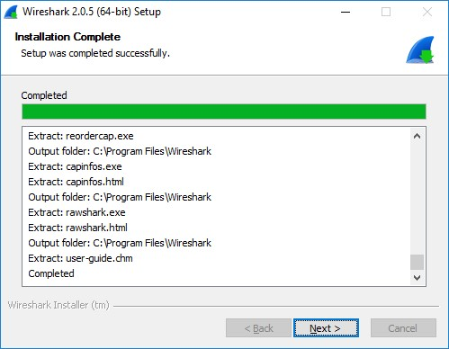
- Click Finish to complete the Wireshark install process.
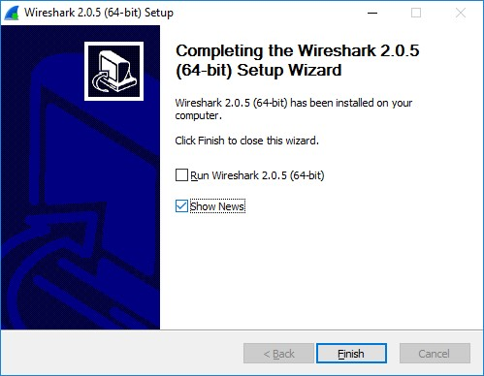

Capture and Analyze Local ARP Data in Wireshark
You will ping another PC on the LAN and capture ARP requests and replies in Wireshark. You will also look inside the frames captured for specific information. This analysis should help to clarify how packet headers are used to transport data to their destination.

Step 28: Retrieve your PC’s interface addresses.
For this lab, you will need to retrieve your PC’s IPv4 address and the MAC address. o. Open a command window, type ipconfig /all, and then press Enter.
- Note which network adapter that the PC is using to access the network. Record your PC interface’s IPv4 address and MAC address (Physical Address).
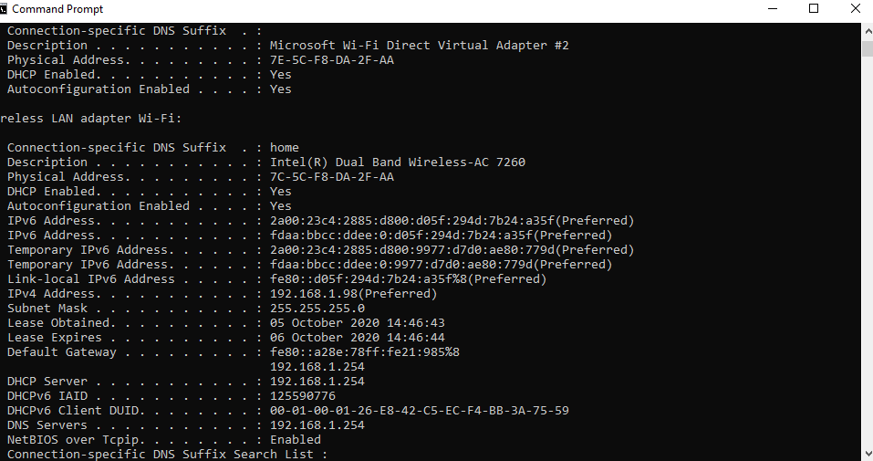
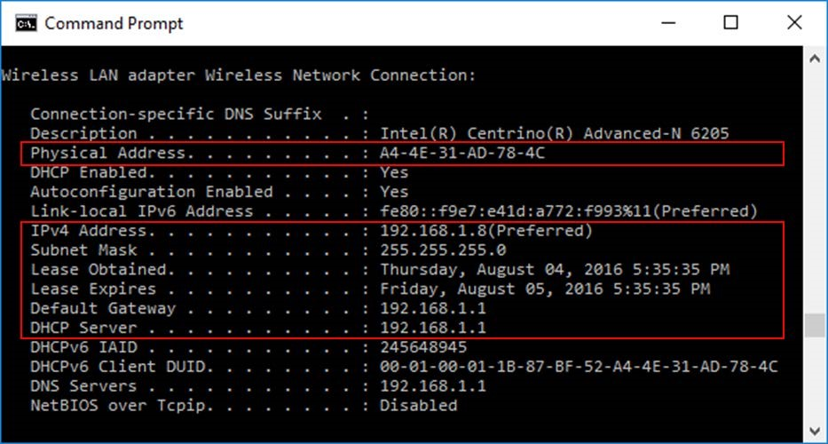
Step 29: Start Wireshark and begin capturing data.
- On your PC, click Start and type Wireshark. Click Wireshark Desktop App when it appears in the search results window.
Note: Alternatively, your installation of Wireshark may also provide a Wireshark Legacy option. This displays Wireshark in the older but widely recognized GUI. The remainder of this lab was completed using the newer Desktop App GUI.
- After Wireshark starts, select the network interface that you identified with the ipconfig command. Enter arp in the filter box. This selection configures Wireshark to only display packets that are part of the ARP exchanges between the devices on the local network.
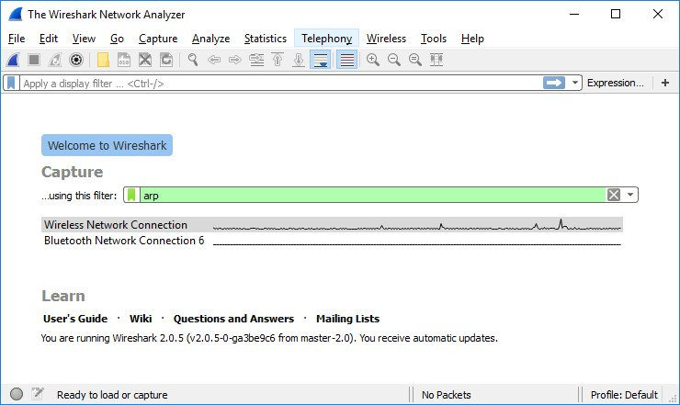
- After you have selected the correct interface and entered the filter information, click Start () to begin the data capture. Information will start scrolling down the top section in Wireshark. Each line represents a message being sent between a source and destination device on the network.
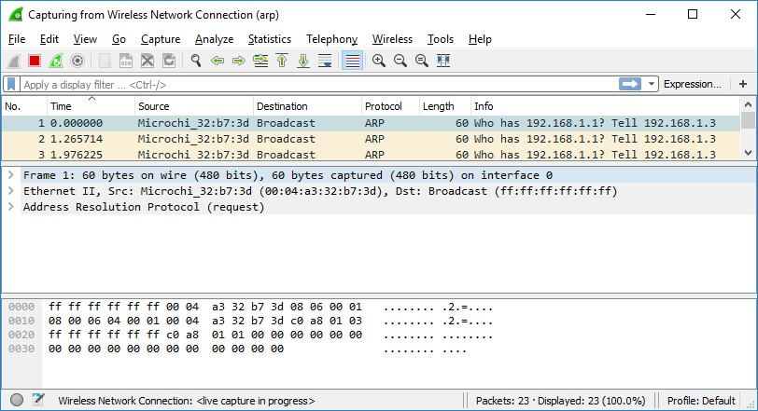
- Open a command prompt window. Use the ping command to test connectivity to the default gateway address that you identified in Part 2, step 1c.
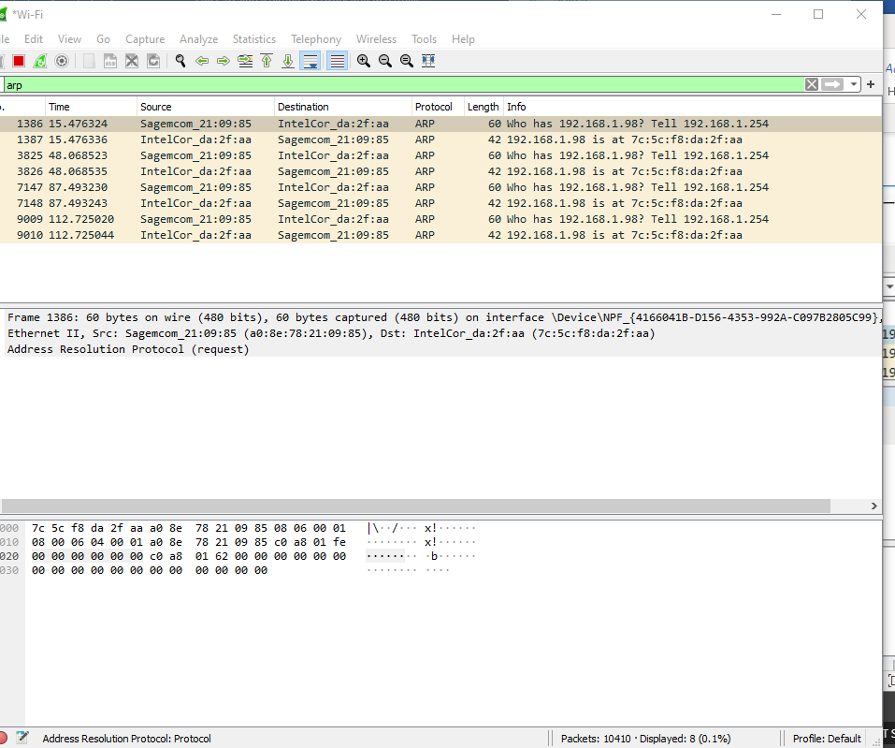

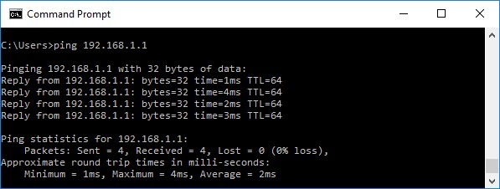

- Stop capturing data by clicking Stop Capture (
)
on the toolbar.
Step 30: Examine the captured data.
In Step 3, examine the data that was generated by the ping requests, Wireshark data is displayed in three sections:
  - The top section displays the list of PDU frames captured with a summary of the IPv4 packet information listed.
  - The middle section lists PDU information for the frame selected in the top part of the screen and separates a captured PDU frame by its protocol layers.
  - The bottom section displays the raw data of each layer. The raw data is displayed in both hexadecimal and decimal form.
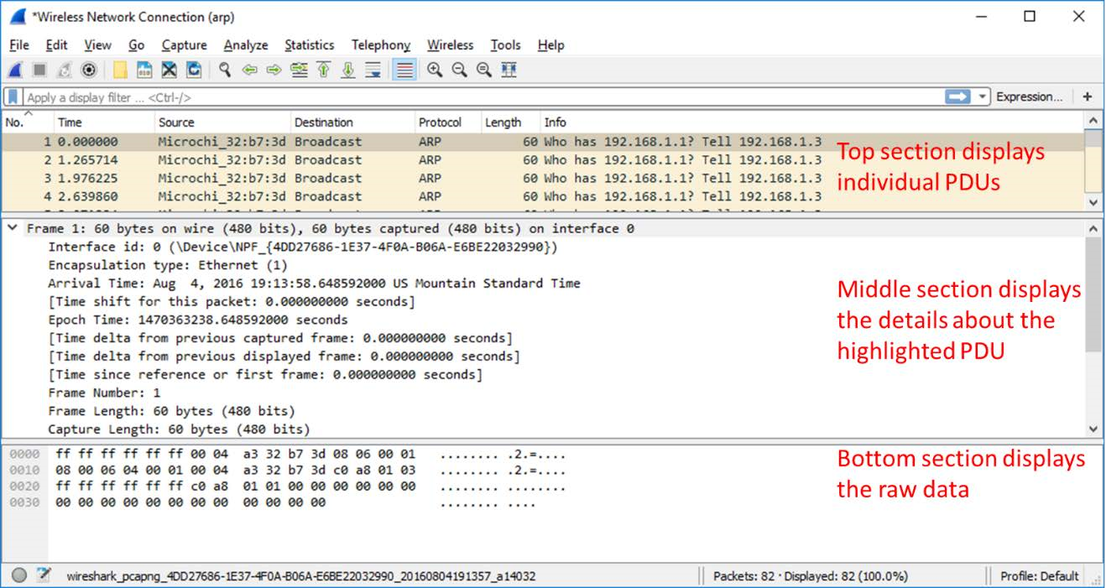

- Click one of the ARP frames in the top section that has your PC MAC address as the source address in the frame and “broadcast” as the destination of the frame.
- With this PDU frame still selected in the top section, navigate to the middle section. Click the arrow to the left of the Ethernet II row to view the Destination and Source MAC addresses.
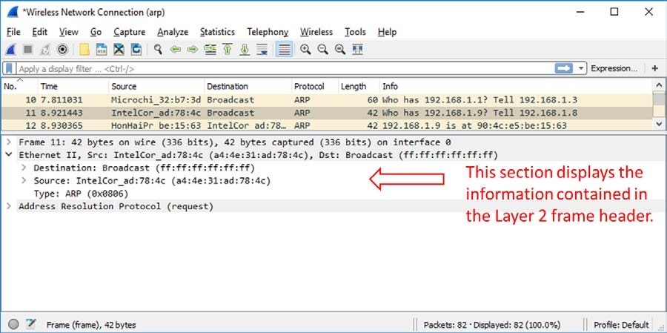

Does the Source MAC address match your PC’s interface?
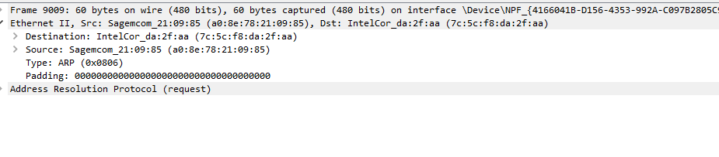
Yes it does my MAC address for my computer is 7C-5C-F8-DA-2F-AA

Click the arrow to the left of the Address Resolution Protocol (request) row to view the content of the ARP request.
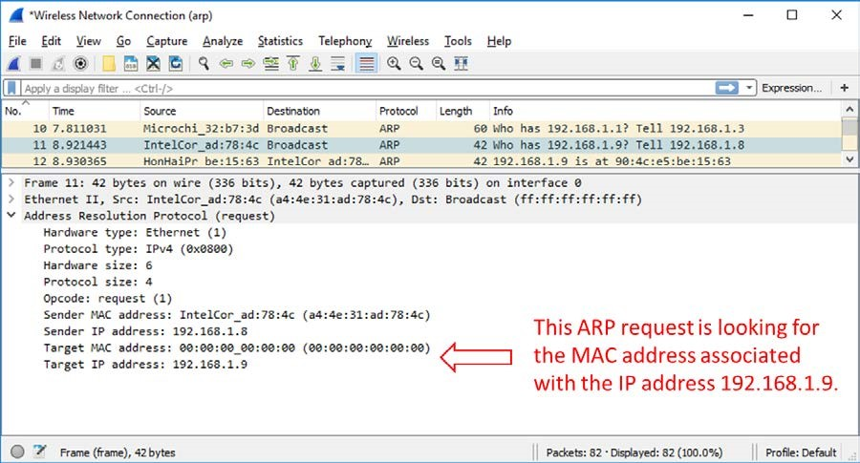

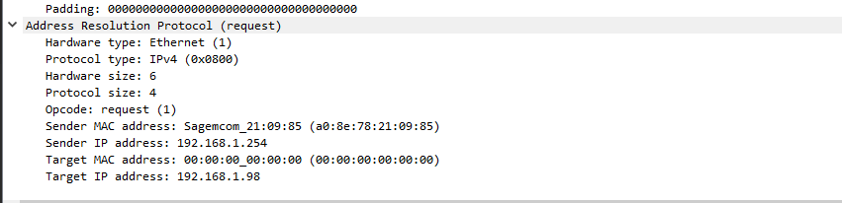

Step 31: View ARP cache entries on a Windows PC.
- Open a command prompt window on the PC. At the prompt, enter arp –a and press enter.
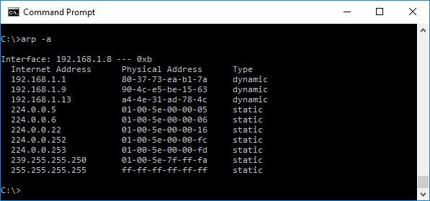
The output of the arp –a command displays the entries that are in the cache on the PC. In the example, the PC has entries for the default gateway (192.168.1.1) and for two PCs that are located on the same LAN (192.168.1.9 and 192.168.1.13).
What is the result of executing the arp –a command on your PC?
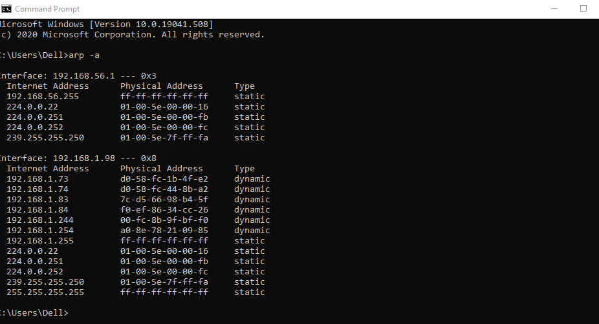

This command displays static and dynamic internet addresses.. with the MAC address and the IPV4 address. Basically
- The arp command on the Windows PC has another functionality. Enter arp /? at the command prompt and press enter. The arp command options enable you to view, add and remove ARP table entries if necessary.
The command lists the known MAC to IPv4 address bindings

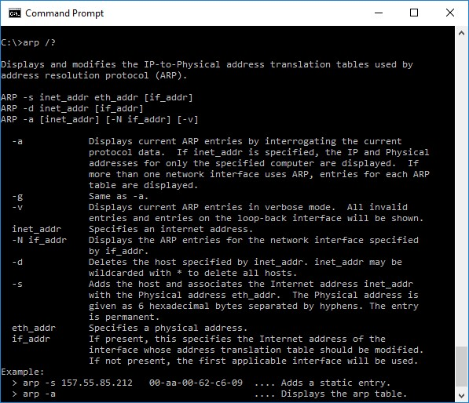
Which option deletes an entry from the ARP cache?
arp -d
What would be the result of issuing the arp –d * command?
Adding the * deletes all the hosts
Record your Reflection
- What is a benefit of keeping ARP cache entries in memory on the source computer?
Your computer always checks its local cache before requesting information from other devices on the network. The ARP cache retains dynamically learned address bindings for a short period of time. When traffic is exchanged often between source and destination, the ARP cache prevents the host from needlessly broadcasting ARP requests.
- If the destination IPv4 address is not located on the same network as the source host, what MAC address will be used as the destination target MAC address in the frame?
The computer will use the MAC address of the default gateway

Learnings from this lab:
  - Build a Simple Network
  - Configure the IP Address
  - Use Ping/ Trace route Utility to check the connection status
  - Use ipconfig /all command to determine the MAC address of a Windows computer on an Ethernet network.
  - Analyze a MAC address to determine the manufacturer.
  - Analyze the Wired and Wireless Network connection. ✓ Analyze Address Resolution Protocol (ARP).

