

Programme: BA International Hotel Management
Module Name: Managing Hotel Administration
Module code: BMIH6004
Assignment Title: Student Learning Log

Student name: Mohammad Arifur Rahman Khan
Student ID number: 2022401
Lecturer: Christopher Wilkin
Word Count: 1363

Reflection of My Work Progress at Premier Inn, East Midlands Airport
The opportunity to improve professionally, personally, and academically while working at the Premier Inn Hotel, East Midlands Airport, has been tremendous. The extensive training, I got has been extremely helpful to my professional development in areas like employee relations, self-awareness, communication, guest journey, crisis management, positive attitude, engaging others, problem-solving, and shift management.

Personal, Vocational, and Academic Growth as well as Lost Opportunities
Self-Development: Because Premier Inn places such an emphasis on self-awareness, I have been able to gain a greater understanding of my attributes, including my strong and weak points, and the areas in which I can improvement. To improve my abilities and boost my self-assurance in my job, self-reflection has been essential. Positive thinking has been emphasised in the training. Premier Inn promotes a pleasant work environment and encourages workers to be enthusiastic and optimistic (Bardi, 2020). I have created a warm and pleasant atmosphere for guests by focusing on optimism. Nevertheless, I have the impression that throughout my time at Premier Inn, there may have been more possibilities for self-assessment and feedback to encourage continual self-improvement.

Vocational Development: From a vocational perspective, the training I received has given me the fundamental skills and knowledge needed in the hospitality sector. The Premier Inn encourages a happy workplace and values its employees. I have learned more about cooperation, collaboration, and workplace harmony through employee relations training. It has boosted my self-awareness and helped me build excellent connections with co-workers and work well in teams. I now know how to interact with guests efficiently, foresee their requirements, and deliver first-rate customer service. This has improved my capacity to collaborate with others as well as my interpersonal abilities. Premier Inn prioritizes guest and employee communication (Casado, 2019). I can give clear guidance, solve difficulties, and provide excellent customer service because of my training. Additionally, problem-solving and crisis management training has proved crucial in addressing difficult situations and guaranteeing the efficient operation of the Premier Inn as it prioritises guest safety and emergency response (Aset, 2020). I have learnt to think critically, stay calm, and respond in crisis circumstances through the training. This experience has improved my problem-solving abilities and given me confidence in managing difficult situations. Despite this, I feel there were lost opportunities to gain further hands-on experience and participate in practical simulations, both of which could have helped to improve even further.

Academic Development: My experience at Premier Inn has given me knowledge of the operational aspects of the hospitality sector, which contributed to my academic growth. I now have a more thorough grasp of how an inn operates, including the guest experience and the value of efficient communication in sustaining customer satisfaction. To complement the practical parts of the profession, I believe that theoretical knowledge and academic viewpoints can have been better integrated into the training programme.
There have been lost opportunities for additional expansion, even though Premier Inn has provided a fantastic foundation for growth. To further build problem-solving and crisis-management abilities, the training should have incorporated more detailed practical scenarios that reflect real-world events (Fallon and Rutherford, 2019). It would have been beneficial for my professional and personal development to attend further training seminars on leadership, advanced communication, and conflict resolution. A culture of continual growth and a route for academic advancement can also be developed by placing more focus on internal learning opportunities and ongoing education (Mohan, 2021).

Management Problem and Solution Along with the Application of Theory
Management Problem: During my placement at the Premier Inn at East Midlands Airport, I observed a management problem concerning the quality of service provided to guests. During busy times or while dealing with a large number of guests, the inn occasionally struggled to keep guests satisfied. This problem needed to be resolved immediately since it could damage the inn's reputation and guest loyalty (Vallen and Vallen, 2020).

Possible Solutions Based on Practical Considerations
An effective guest feedback system can be a solution to this predicament. Guests' opinions can be gathered via a variety of methods, including online questionnaires, feedback cards, and emails sent after their stay (Wood, 2021). By actively collecting feedback, the inn can learn about areas that need improvement and pinpoint any particular problems that might have caused guest disappointment.

The utilisation of a Theory: The management group can use the SERVQUAL model, an established method for evaluating service quality, to back up this option. Reliability, assurance, tangibles, empathy, and responsiveness are the five criteria that make up the model's evaluation of service quality (Johnston et al., 2021). Using these criteria, a hotel can analyse guest reviews to pinpoint problem areas like service, cleanliness, and communication (Baron, 2020). The management team can then take effective measures to address the highlighted areas for improvement. For example, if the feedback identifies problems with employee responsiveness, further training programmes can be implemented to improve communication skills and guarantee fast and effective guest service (Cannon and Gustafson, 2021). It is possible to evaluate and enhance employee performance by providing excellent service by implementing regular performance reviews and coaching sessions.
Additionally, a guest recovery programme can be implemented at the establishment to help solve any problems or complaints from guests in a timely way (Berners and Martin, 2022). To guarantee customer satisfaction, this programme can provide employees with the authority to address issues raised by guests immediately, whether through monetary compensation or other means (Fallon and Rutherford, 2019). This SERVQUAL strategy is in line with the service recovery paradox concept, which suggests that efficiently handling and resolving complaints from customers can result in higher levels of customer loyalty and satisfaction.
Regular staff meetings and training sessions can be held concerning the inn's service standards and guest service goals. Establishing reliable channels of communication between upper management and employees, as well as across various divisions, is crucial for smooth operations (Johnston et al., 2021). This can aid in sustaining a consistent strategy for exceeding guest expectations and delivering on promises of superior service.

Key Skills Development Evidence
Self-Management and Development: I took the effort to define personal goals and objectives to direct my performance and development. I strongly sought input from my superiors and co-workers to pinpoint my areas for growth, and then I worked to strengthen those abilities through chances for self-directed learning and training. My self-awareness and commitment to ongoing growth have made me more effective and productive in my job.

Task Management: I developed the ability to order my tasks according to significance and urgency so that I could meet deadlines and uphold high standards of quality. I was able to contribute to the efficient running of operations and provide outstanding service to guests by efficiently managing my workload.

Initiatives in Workplace Problems: I showed initiative by taking ownership of issues at work and looking for solutions on my own. To identify problems' underlying causes and provide workable and innovative approaches to solve them, I used my critical thinking skills. I was able to contribute to a productive and enjoyable work environment by using initiative to solve problems.

Communication: I was able to convey information simply and properly to guests, co-workers, and managers through efficient communication. I attentively listened to others, followed up with clarification inquiries, and offered feedback as needed. This effective and open communication created a friendly and cooperative work atmosphere.

Application of Knowledge: I was able to use the skills and knowledge I learned via online training and experience right away at the Premier Inn. I skilfully utilised my skills to deliver a seamless and great guest experience, whether it was through comprehending the guest journey, putting crisis management tactics into practice, or using customer service approaches. Along with sharing my knowledge, I helped my co-workers when they needed assistance.
Overall, the Premier Inn, East Midlands Airport experience helped me refine and develop a variety of skills and knowledge. I showed effort in problem-solving, self-management, task management, and good communication, all while taking a proactive stance toward my work. In addition, I used my skills and knowledge effectively in practical settings, which helped the inn overall. The knowledge and skills I have acquired while working at Premier Inn will help me succeed and advance in my chosen profession.

Reference
Aset (2020). A good practice guide for placement and other work-based learning opportunities in higher education. 12th ed. Moorfoot: Aset.
Bardi, J. (2020). Hotel Front Office Management. 10th ed. Hoboken, N.J.: John Wiley & Sons.
Baron, S. (2020). Service Marketing: A focus on customer experience and the changing roles of customers and consumers. 7th ed. Los Angeles: Sage.
Berners, P. and Martin, A. (2022). The Practical Guide to Achieving Customer Satisfaction in Events and Hotels. 5th ed. London: Taylor & Francis.
Cannon, D.F. and Gustafson, C.M. (2021). Training and Development for the Hospitality Industry (AHLEI). 7th ed. London: Pearson Higher Ed.
Casado, M. (2019). Housekeeping management. 7th ed. Hoboken, N.J.: John Wiley & Sons.
Fallon, M. and Rutherford, D. (2019). Hotel management and operations. 6th ed. Hoboken, N.J.: Wiley.
Haag, E. (2019). Internship Guide: Work Placements Step by Step. 5th ed. The Hague: Eleven International Publishing, Cop.
Johnston, R., Clark, G. and Shulver, M. (2021). Service Operations Management: Improving Service Delivery. 9th ed. Harlow: Pearson.
Mohan, J. (2021). Human Resource Development & Management in the Hotel Industry. 11th ed. New Delhi, India: Frank Brothers.
Vallen, G. and Vallen, J. (2020). Check-in check-out: managing hotel operations. 9th ed. Boston: Pearson.
Wood, R. (2021). Key Concepts in Hospitality Management. 11th ed. Los Angeles: Sage.

Appendix

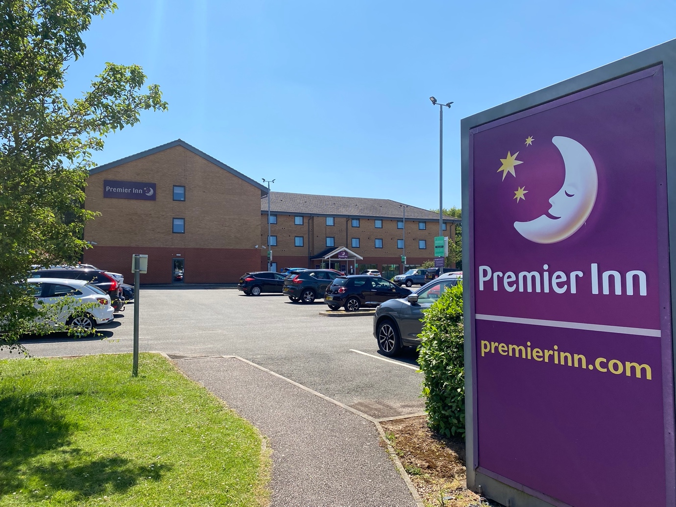
Image by author (M A R Khan)


