

ECEY7010

Dissertation Handbook: Equity, Diversity and Inclusion in Society

DISSERTATION HANDBOOK

Table of Contents

Table of Contents
- Introduction ................................................ 3
- General Information ....................................... 4
- Aims ......................................................... 5
- Contribution of the project to your degree ............ 7
- The project Approval Process & Timescales ........... 8
- Supervision ................................................. 9
- Ethical Practice and Data Storage ...................... 11
- Report Structure .......................................... 13
- FAQs ........................................................ 20
- Dissertation Oral Presentation ............. 21

1. Introduction
The Dissertation is the culmination of your Master's programme and provides an opportunity to undertake an extended piece of independent research within your chosen field of study. It enables you to investigate a topic of professional, academic or personal interest and demonstrate the advanced knowledge, research skills and critical thinking developed throughout your degree programme.

The dissertation is both challenging and rewarding. It requires careful planning, effective time management, critical engagement with literature and evidence, and the ability to work independently whilst making effective use of supervision and support available to you.

This handbook provides guidance on the dissertation process, assessment requirements, ethical responsibilities, supervision arrangements, and submission expectations.

Research can be very rewarding: learning about an area in detail, finding the answers to questions you are interested in as well as contributing to understanding of an area. It also has frustrations that are felt not only by first time researchers, but also by the most experienced investigator.

Firstly, being uncertain is part of the process. This handbook is not going to remove that – every project brings different challenges. And because research is about finding things out yourself, there won’t be anyone who has all the answers for you.

Realistically, the most enjoyable phase, data collection and/or data analysis is a small amount of time relative to the time it will take to submit and receive ethics approval, and recruit participants, if you are carrying out an empirical study. Take care not to underestimate how long it will take to prepare documents to gain the approvals that you need before you can start collecting data.

This guide attempts to anticipate many of the questions you may have and highlight questions you may not have thought of but should ask. Remember though, that for many of these questions there is not a single answer, but it will depend on the project, the target population, and recruitment method, the design etc.

2. General Information

Supervisor Contact Details:

Name | Email
Dr Jessica Pitman | j.pitman@uwtasd.ac.uk
Ken Dicks | k.dicks@uwtsd.ac.uk
Dr Darrel Williams | d.g.williams@tsd.ac.uk

Module Information

Module Title: Dissertation

Credits: 60

Level: 7

Word Count: 15,000 words

Assessment: Dissertation (100%)

The dissertation may take one of two forms:

- Empirical Research Study
- Structured Literature Review

Both routes are expected to demonstrate Master's level criticality, originality, academic rigour and relevance to professional practice.

3. Aims and learning outcomes

The dissertation module has the following aims:

· To enable students to plan and conduct an in-depth investigation of a topic that is relevant to the student’s degree scheme / professional practice context.

· To provide the opportunity to apply an understanding of research methodology and methods to the investigation and allow students to demonstrate their ability to work with relative autonomy in undertaking a sustained, in-depth piece of independent learning

Learning outcomes

Upon the successful completion of this module, the student should be able to:

· complete a significant research project reflecting appropriate skills of assimilation, synthesis, argument, communication and presentation in a chosen field relevant to their degree scheme;

· complete their research and present a completed document within the defined timescale and to agreed standards;

· draw on concepts, principles and practices introduced in other modules and demonstrate linkages and relationships;

· establish the present state of knowledge in a defined area and contribute to that knowledge.

4. Contribution of the Dissertation to your degree

The dissertation consists of 60 credits, and it must be of a suitable standard for the degree to be awarded. It is therefore important to work consistently on the project throughout your course and dedicate time and effort to it.

In the classification of ‘Distinction’, ‘Merit’ or ‘Pass’ as a final grade for your MA degree, your Dissertation mark contributes 100% of our final weighting. A pass mark is 50%

4.1 ASSESSMENT

The dissertation should be approximately 15,000 words in length; this will be in the form of either a literature review or through data collection. Each dissertation will be assessed by an internal examiner - usually a member of the student’s programme team - although in exceptional circumstances another member of staff may be involved. The dissertation will be second marked by a member of the course team. All dissertations will be seen by the external examiner.
Students should submit their dissertation accompanied by the Master’s Dissertation Submission Form under the guidelines provided on Moodle and through your programme manager / dissertation supervisor.

Here is how we assess and grade your work. You can find the Assessment specification template we use to help consider our marks on Moodle here.

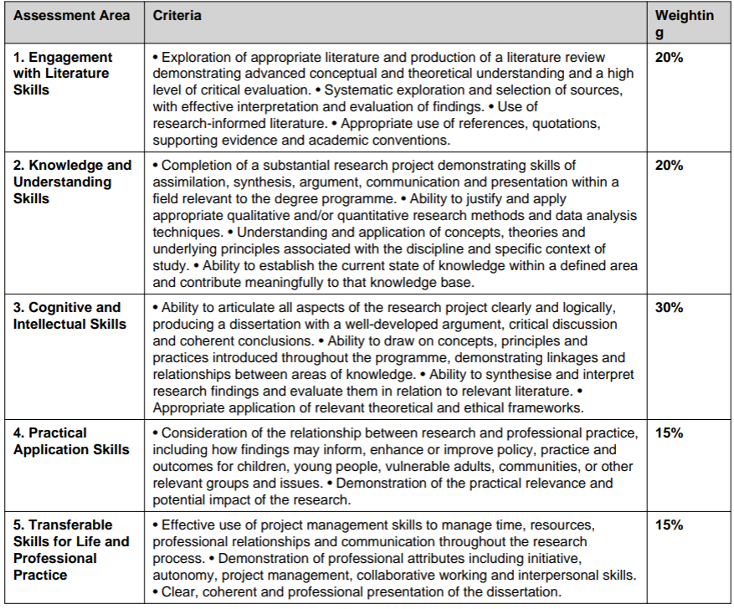

5. The Dissertation Approval Process & Timescales

5.1 Initial Approval/Supervisor Allocation

Dissertation support does not officially start until after the taught modules finishes and the examination board transfers you to the Dissertation module in October. To ensure completion of a robust project by the deadline, you have been given an opportunity to approach the programme lead and agree a broad topic before the end of your final taught module. This then allows you to work on your literature search and review over the summer period.

5.2 Ethical Approval for empirical projects (Link: PG2 ethics form)

You will only need ethical approval for empirical projects. You do not need one for a literature review dissertation, but this does not mean that it should lack complexity and criticality

The Faculty Ethics Committee will announce dates which you should aim to submit your ethics form (PG2) throughout the academic year. It is your responsibility to ensure that you meet the deadlines set out by the Faculty Ethics Committee, as the School has no control over timings of ethics boards. We will send the dates in October.

Based upon your coverage of ethics in the taught element of the programme it is expected that students should recognise the requirements and thoroughness needed for an ethics submission at Faculty level. Whilst your supervisor may provide comments on a draft of the ethics form prior to submission (if submitted to the supervisor in good time) it is the students’ responsibility to produce a sound ethics approval form. Poor quality ethics forms will not be signed off for submission.

5. Dissertation Pathways

5.3 Empirical Dissertation

An empirical dissertation involves the collection and analysis of data using qualitative, quantitative or mixed methods approaches.
Examples include:

- Interviews
- Focus groups
- Surveys
- Documentary analysis
- Case study research

All empirical studies require ethical approval before data collection
begins.

5.4 Structured Literature Review

A structured literature review critically analyses, synthesises and evaluates published literature relating to a specific research question or area of enquiry. You can find a tile on Moodle with a lot of guidance called Research by Literature review here. Please complete the Academic Info Skills training to help you develop your skills before starting your search

Students should clearly describe:

- Search strategy
- Inclusion and exclusion criteria
- Databases searched
- Analytical approach

The purpose is not to describe literature but to identify themes, debates, gaps and implications for future research and practice.

6. Supervision

In accordance with Academic Quality Handbook each student is entitled to a maximum of 10 hours of supervision (which will include taught workshops, individual supervision, and significant email exchange). This should be recorded on the Supervision Record and maintained by the student. This will be in your file. You will receive 4 hours of this supervision record as taught research methods in the first few months of starting your dissertation module. This will leave you with 6 hours of supervision.

6.1 Role of Supervisor

Academic supervision is provided by a researcher / academic within the Programme Team, occasionally supported by an additional supervisor, if recruiting participants from a specific participant group or as part of a work-based research project. The role of the academic supervisor is the main supervisory role, guiding methods and writing, giving feedback on dissertation chapter drafts etc.

Supervisor allocation will be based on the capacity, topic and methodological focus of the project to ensure students receive appropriate academic guidance and subject-specific support.
Where appropriate, a second adviser may also be appointed.

To support students throughout the dissertation process, a programme of four two-hour workshops will be delivered from October onwards. In addition, students will be entitled to six hours of individual supervision. This allocation includes face-to face or online supervisory meetings, email correspondence, and supervisor time dedicated to reading and providing feedback on draft work.

Reasonable expectations of your academic supervisor include:
- Commenting on the appropriateness of the question posed, providing constructive criticism, and making suggestions for the improvement and development of the research question.
- Commenting on the research method(s) proposed and making suggestions for the development and improvement of the research methods.
- Supporting the student in processing the research protocol through all relevant ethics and research panels.
- Providing support and encouragement for the student during the collection, management and analysis of data.
- Providing assistance in the write-up of the project, including ONE reading (only) of each section and ensuring that the report meets UWTSD regulations for the degree scheme.
- Agreed contact during working hours.
It is very important that you discuss any changes to the research protocol, data collection approaches and data collection tools with your academic supervisor.

6.2 Time management:
It is your responsibility to manage your time appropriately so that you meet the dissertation submission date, and to develop a project timetable in consultation with your academic supervisor that ensures that you can obtain their feedback on draft chapters when you need it. Be sure that you discuss and agree your draft chapter submission and supervision plans with your academic supervisor well in advance.

Ethical Practice and Data Storage

All students carrying out primary research are bound by the ethical requirements of the university and the appropriate professional Ethical Code of Conduct (BERA, BPS, BACP). Where there is any doubt regarding ethical practice whilst carrying out research the student must contact a member of the Programme Team for advice and clarification. You can find more about the university’s academic integrity policy here.

7.1 Data Management & Storage
“Primary data” is the actual data that you collect. This is likely to be in the form of either (a) audio recordings of interviews or (b) data collected on paper or online questionnaires. The University is responsible for storing your primary data (audio files and completed questionnaires), not you, the student – indeed, you are not permitted to keep this data after the end of the project. This is required under the Research Governance Framework to ensure that research data is not falsified, and the primary data must be stored for a stipulated length of time. The University retention periods for research data (in the absence of any stipulations from funders) are documented at http://www.uwtsd.ac.uk/library/research-data-management/
So, once you have either (a) transcribed your audio files and anonymised the transcript or (b) input your questionnaire data into SPSS or Excel, you MUST pass the primary data (audio files and completed questionnaires) to the programme team for storage. All audio files must be stored digitally, labelled clearly with your name, year and project title and given to the Programme Director for storage. Completed questionnaires may be stored in paper form and given to the Programme Director, labelled clearly with your name, year and project title. All primary data (audio files and paper questionnaires) should be deleted from your own or any other computers you have used. The data will be stored securely by the programme team for the requisite time.

“Secondary data” (interview transcripts, questionnaire responses in SPSS/Excel) should be stored in anonymised (de-identified) form with a key to indicate which identifier corresponds to which participant. You can keep the anonymised data, but you must ensure that any data that you keep protects the confidentiality of your participants.

7.2 Boundaries and safe practice

Be conscious of how the role of a researcher is different to that of any other professional or training role you may have had. Safe practice is just as important in research as it is in clinical practice. Your research participants may be vulnerable; care must be taken not to cause distress unnecessarily, and not to provide misleading information. Research participants may still become distressed in an interview, or when filling in a questionnaire, just because they are reminded of very distressing events that may have occurred. You must have plans in place to safeguard participants who do become distressed, or who have information needs e.g., by providing them with an opportunity to discuss their concerns with you. It will be important to discuss this with your supervisor before you start collecting data.

7.3 Approval

No collection of primary data in any form should be carried out without confirmed approval from your supervisor, and if appropriate, Faculty Research Ethics Committee approval. Breaches of this process may lead to data being disregarded and sections of the thesis being disregarded in the marking process, as well as potential disciplinary action at a university level.

8 Structure of dissertation

8.1 Title Page
- Title of Project.
- Author’s name.
- Name of degree
- University of Wales Trinity Saint David School of Childhood, Youth and Education
- Year of presentation.

8.2 Declaration

On the first page (after the cover) you must include a signed declaration of the following
- That the Dissertation does not include work accepted for any other degree or professional qualification (unless a clear statement is made as to the precise extent of the work so included).
- That the Dissertation has been composed by you and is your own work.
- AI statement: You are expected to include this acknowledgement in a separate page at the beginning of your submission.
Basic Acknowledgement format of AI tool use
I acknowledge the use of [AI Tool] [(AI Tool url)] on [Date] to [Purpose my work]. I used the prompt(s):
- [Prompt]
- [Prompt]
- [Prompt]
I confirm that I have not presented any AI generated text as my own work. I confirm I have copies of my drafts, notes, and other resources I used before, and after the use of AI tools which I may be asked to provide in evidence.
If you have not used AI tools If you have not used AI tools, whether because it is not allowed or because you have chosen not to use AI tools at all, you need to include the following acknowledgement.
I confirm that I have not used any AI tools in the research and creation of this assignment. I confirm that I have not presented any AI generated materials as my own work. I confirm I have copies of my drafts, notes, and other resources I used, which I may be asked to provide in evidence.

8.3 Acknowledgements
The acknowledgement page should recognise those people who have helped you in either carrying out your research or making your research possible or have given you advice and support during the project.

8.4 Table of Contents
The contents page should list each section and main headings within each section. Numbered sections can make reading the thesis easier. A page number for each should be given.

The same format should be given for tables, graphs and diagrams.

Note that Microsoft Word has the capacity to convert headings into an automatically generated table of contents – making this much simpler. This is a good video that shows you how to do it. You can also find an Empirical Research and Literature Review Dissertation Template by clicking the link which will take you to Moodle.

8.5 Empirical project

• Title Page
• Declaration
• AI Statement
• Acknowledgements
• Contents
• Abstract
• Introduction
• Literature Review
• Methodology
• Findings/Results
• Discussion
• Conclusions and Recommendations
• References
• Appendices

The research paper should start with an abstract setting out the topic area and aims of the project, a summary of the methods used, a couple of sentences on your main findings and conclusions or implications of your work. This may be either structured into headings (e.g., aim, method, results, conclusions) or unstructured. This abstract should be up to 250 words.

The introduction and literature review should provide a clear rationale for the study and demonstrate a critical understanding of the relevant research, theory, policy, and practice relating to the chosen topic. It should clearly define the focus and scope of the study. Explain the significance of the research and justify why the topic warrants investigation. Identify the overall aim of the study and present the research question(s) and/or objectives. Provide an overview of the structure of the study. The literature review should demonstrate comprehensive engagement with relevant and contemporary academic literature. Critically evaluate key theories, concepts, policies, and empirical research relevant to the study. Compare, contrast, and synthesise existing evidence rather than simply describing previous studies. Identify areas of agreement, disagreement, strengths, limitations, and gaps within the literature. Demonstrate how the proposed study builds upon, extends, or addresses limitations in the existing evidence base. Develop a clear rationale for the research design and methodological approach where appropriate.
Lead logically to the research question(s) and objectives,
showing how they emerge from the literature reviewed.

The method section should include a justification for the approach chosen as well as a description of the recruitment, data collection and data analysis methods. References should be provided for methods and any modifications made. Crossreferencing to appendices is allowed here. This section should illustrate that you understood what you were doing and made sensible decisions, rather than blindly following a particular method ‘recipe’.

The results section should demonstrate the way that the research questions have been answered. As well as the results of data analysis, a description of the participants and response rate (etc.,) should be included. Remember that your sample is a “result” of the sampling method you used to recruit from your target population. The order that the results are presented in should be logical and subheadings may be useful, if appropriate.

No new data should be presented in the Discussion section. Rather, this section places the results in the context of the literature (and/or practice) and elaborates on issues arising from the findings. Avoid the temptation to simply reiterate the findings in an abbreviated form. It is a waste of words. The examiner will be looking for a discussion of the place of your findings in the context of current literature, strengths and weaknesses, implications of your findings for research and practice, suggestions for further research, and concluding remarks. The conclusion should return to your aims / research questions and demonstrate to what extent these have been achieved / answered. All of the threads of the project should be clearly brought together.

8.6: Non-empirical project: Literature review

This is a common way to set out your work. You can structure it differently if needed. Please discuss with supervisor.

- Title Page
- Declaration
- AI Statement
- Acknowledgements
- Contents
- Abstract
- Introduction
- Review Methodology
- Literature Review Findings:
- Theme 1
- Theme 2
- Theme 3
- Theme 4 etc
- Discussion
- Conclusions and Recommendations
- References
- Appendices

At Master's level, students are expected to demonstrate critical analysis, synthesis of evidence, and a clear link between the literature reviewed and the design of the practical output. The submission should evidence both academic rigour and professional relevance.

8.7 Reference List
Reference lists are not included in the 15,000 word limit.
Harvard referencing conventions to be followed at all times.
Follow Cite Them Right on your library page for help with referencing

8.8 Appendices

Appendices are not included in the 15,000 word limit.
Appendices should include the ethics form (if relevant), the information and consent sheets used in the study, full transcript of a sample of interviews (if relevant), questionnaires (if relevant), the interview guide (if relevant) etc. For qualitative data, you should consider including a section of coded transcript to illustrate your coding.

The precise content should be decided by you, bearing in mind what you think is important for readers to be aware of or assess for themselves.

FAQs

8.9 How strict is the word limit?
Conciseness is a key-skills in academic writing, and the 15,000 word limit is to encourage you to write a Master’s Dissertation that does justice to your work, and that demonstrates all the key skills outlined in the marking grid. Keep in mind that there are university regulations for word limits which can result in penalties for work being over 10% of the word count.

8.10 Are quotes included in the word count?
Yes, they are, so use them judiciously. For example, thematic analysis does not need every quote to be provided but a representative quote will suffice. If you are doing a thematic analysis and find yourself using a lot of individual quotes, be certain that these are in fact representative of common themes, rather than individual quotes that make statements that you see as important. Some research papers present a description of themes and sub-themes with representative quotes in tabular form (tables are not included in the word limit), with appropriate cross-referencing. Avoid using a lot of quotes at the cost of clarity of research method or discussion.

8.11 When are the Report Submission and Presentation dates?
Please check Moodle for submission dates for this academic year.

8.12 Am I able to pay participants or purchase materials for my research?

UWTSD is unable to contribute to the costs of conducting the Dissertation project, or of presenting and submitting the Dissertation. Thus, the scope of the project needs to reflect the fact that this is unfunded work

