

Assessment 1 – Reading Task Template
Upload your photo of your A3 in-class notes here:
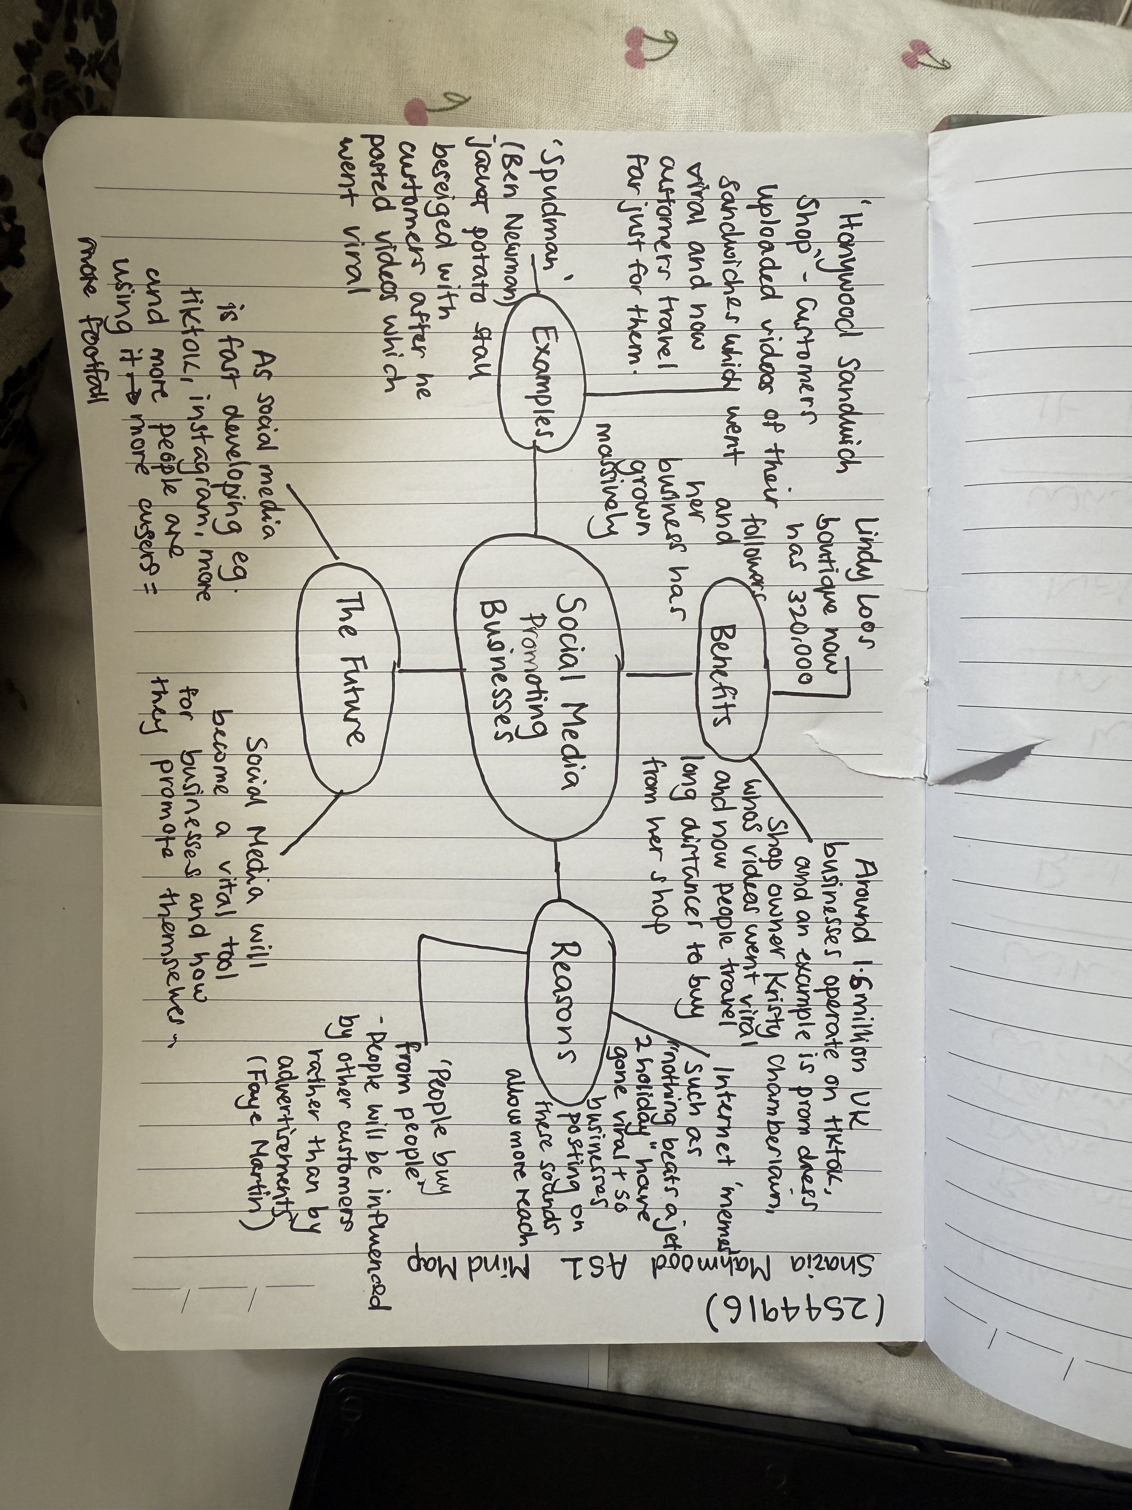

1. Answer these questions using the sentence starters below
a. What is the main idea of the text?
The main idea is that social media platforms such as Tiktok and Instagram have helped to promote businesses.
b. What are two key points?
One key point is that customers prefer to, and are more likely to buy from another customers promotion rather than an advertisement.
Another key point is that sometimes businesses can unwantingly become the centre of attention on social media platforms, through customers posting ‘review’ videos, which owners are unaware of
c. What part of the text did you find most important? Why?
The most important part was the real life examples from business owners on how the use of social media has impacted their business. I think it was most important because these people are showing their personal experiences on how just a small act of uploading a video can reach thousands of people.
d. Was anything unclear or difficult to understand?
I was not sure about how to differentiate between two different key ideas, as I missed the class.
e. How did your group help you understand the text better?
I did not receive help from my class and I missed the workshop due to unforeseen circumstances.
2. One sentence reflection
Question: What did you find challenging about this task?
The hardest part was completing the mind map on my own at home as I previously mentioned unfortunately I missed the workshop where this task was done. I think as I am still quite new to the course I struggled to navigate through moodle to catch up on my previous work missed.

