Task 1 (b)
Developing discipline and motivation is fundamental for academic and professional success. Discipline enables students to maintain focus and complete their work efficiently, while motivation provides the underlying purpose behind their efforts. For example, a Computer Science student who continually reflects on their long-term career goals is more likely to remain engaged and resilient throughout challenging assignments. Motivation and discipline are interrelated—sustained motivation often strengthens self-discipline, creating a productive cycle of academic and personal growth.
Teamwork also plays a crucial role in both academic and professional contexts. Effective communication, problem-solving, and time management within a team can significantly enhance employability. These abilities are often developed through participation in group projects, sports, clubs, and community activities. Such experiences help individuals cultivate adaptability, leadership, and interpersonal understanding—qualities that are highly valued by employers in the digital era [1].
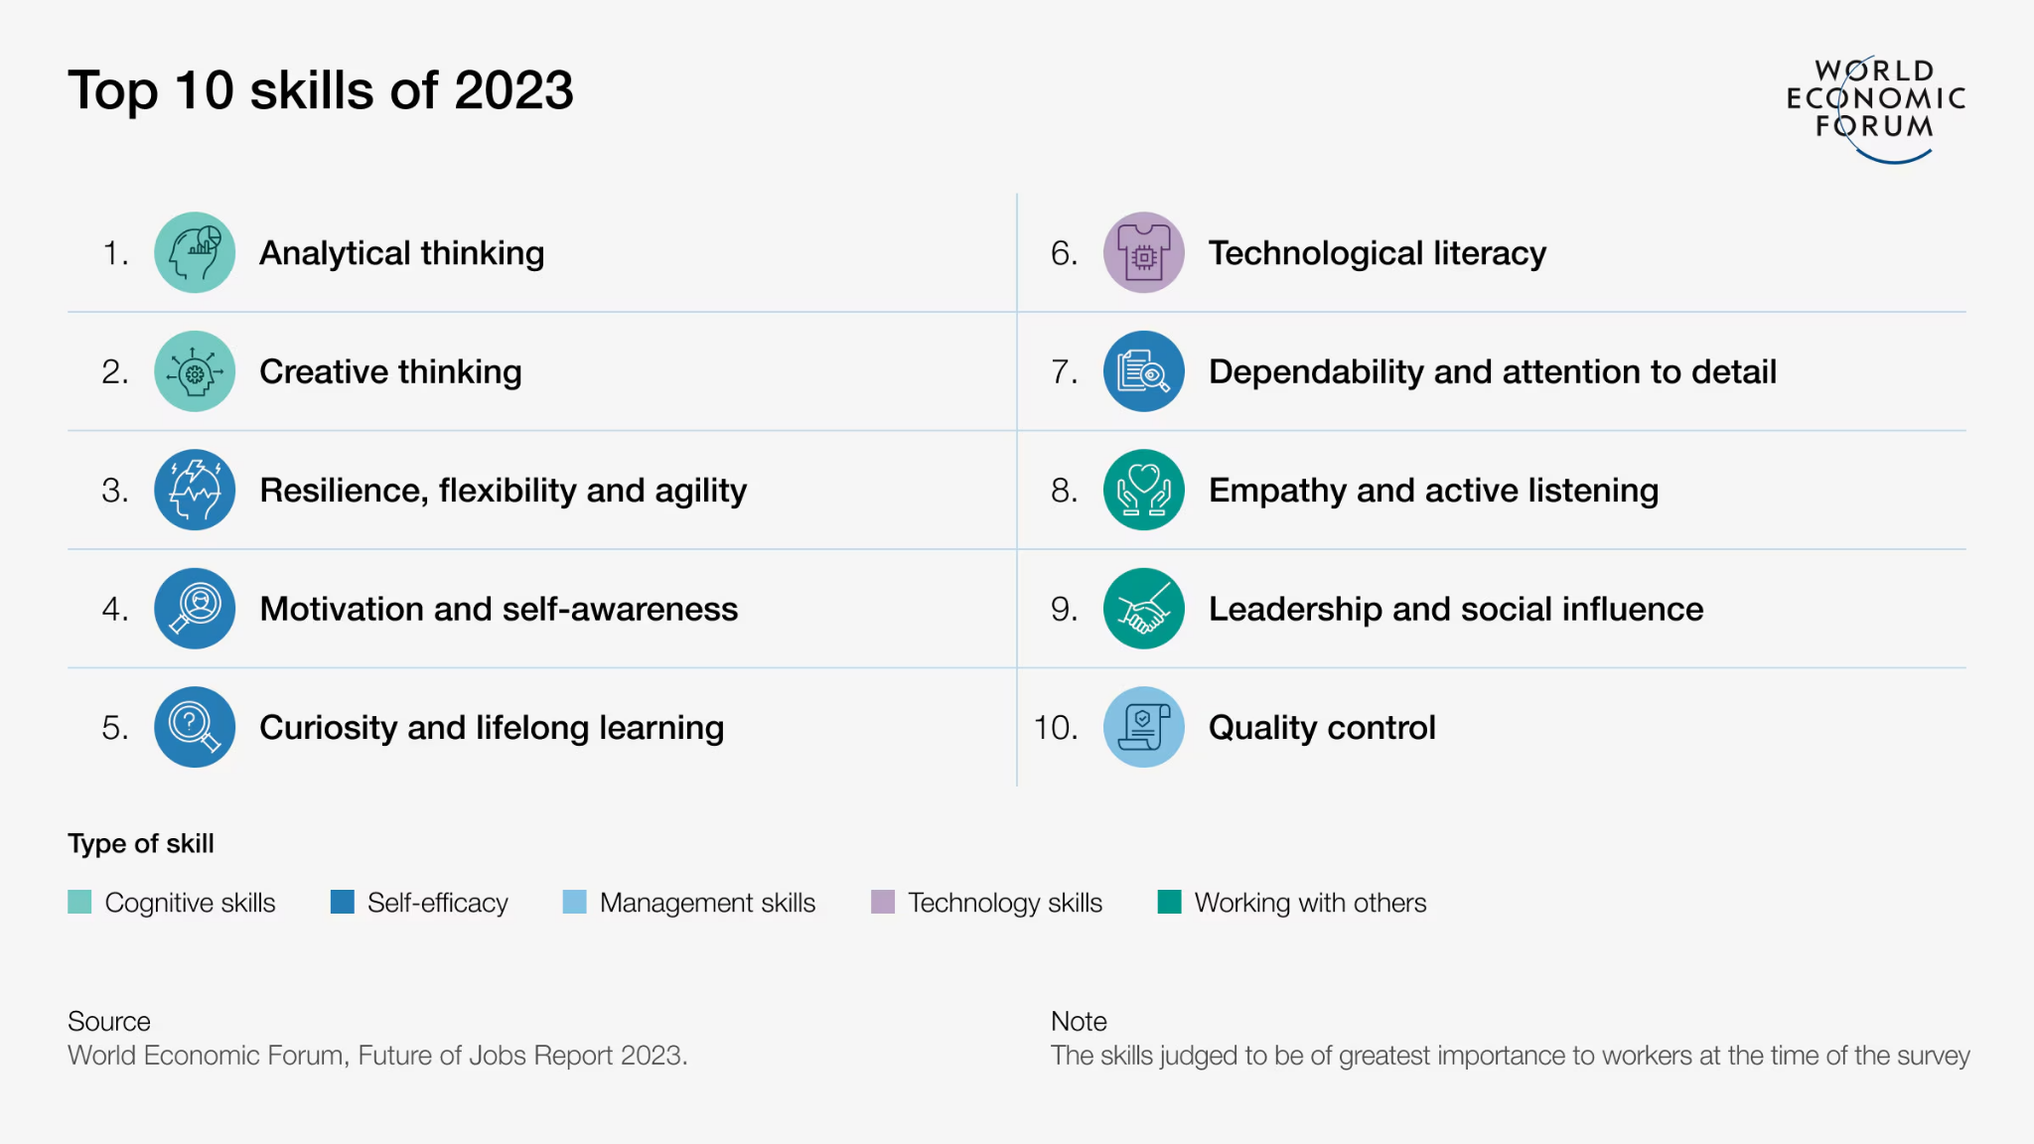
Figure 1: Top ten skills for students [3]
In addition to teamwork, several other essential employability skills include critical thinking, information literacy, and active listening. Critical thinking allows individuals to analyse and evaluate complex information to make informed decisions. Information literacy ensures that data and sources are used effectively and ethically to produce accurate, high-quality work. Active listening promotes collaboration and productivity by fostering mutual respect and improving communication among colleagues [2]. Altogether, these competencies form the foundation for success in both academic studies and future employment.

[1]Wilson, A. (2025, July 9). Employability skills: essential skills for the future. Form the Future CIC.https://formthefuture.org.uk/employability-skills-essential-skills-for-the-future/#:~:text=Aiming%20High%20%E2%80%93%20setting%20clear%2C%20tangible,different%20aspects%20of%20the%20curriculum.
[2]National Foundation for Educational Research. (n.d.). The six most essential employment skills people will need to thrive in the future workforce. NFER. https://www.nfer.ac.uk/blogs/the-six-most-essential-employment-skills-people-will-need-to-thrive-in-the-future-workforce/#:~:text=Working%20with%20researchers%20at%20the,the%20basis%20of%20this%20list.
[3]Future of jobs: These are the most in-demand skills in 2023 - and beyond. (2025, June 3). World Economic Forum. https://www.weforum.org/stories/2023/05/future-of-jobs-2023-skills/

