Advanced web: Michael Dacey
assignment 2
Josh Ford

Contents
1. Introduction 2
2. Black and white box testing 2
3. Behavioural driven development 3
4. Testing frameworks 4
5. Conclusion 6
6. References 7
7. Code Listings 8

Figure 1: Coverage 4
Figure 2: Example1 4
Figure 3: Example2 5
Figure 4: example3 5

Introduction
In this document it will look at types of testing and behavioural driven development. Firstly, it will look at black and white testing and how they differ in the techniques they use to test, examples of both techniques and what the techniques are and used, then, the difference in people that use the techniques. It will then look at behavioural driven development, what it is, what it involves, how it is used and some benefits of using this technique. Finally, it will be investigating a test framework, it will look at the main characteristics of a test framework and how it is used. Then it shows the framework using examples and diagrams to more explain in detail how it works.

Black and white box testing
Black and white box testing are techniques that are used in software testing. White box testing is when the structure and implementation of the application is known to the person testing. This means that to test the application, the tester will need a knowledge of programming [1]. White box testing can also be called glass box testing because of the point made that the tester sees all of the code and application, this is so if they need to alter code to test certain features [2]. Techniques that are used in white box testing are data-flow analysis and unit testing[3]. Unit testing is when the tester uses a piece of code and calls a method for the code to complete something. It then looks at the behaviour of the resulted code that is being tested and if the result is how you expected it, it would pass, otherwise it would fail[4]. Data-flow analysis is when sets of variables are validated by looking at the path that they take, this can help in identifying ‘suspicious code blocks’[3].
Black box testing is when the tester does not know the structure or design of the application [5]. This is when the user side of an app is tested rather than coding side of the website. Examples of this are state transitioning testing and equivalence partitioning. Equivalence partitioning is when an input would be between a certain number range. The ranges would then be partitioned into different parts, the values that would be accepted, and the parts that would not be accepted, e.g. values below the ranges accepted, values above the ranges accepted and the values accepted [5]. State transitioning testing is a test to see if a website or app is behaving as it would suppose to, it is used to test the stages of the system while testing[6]. An example would be if a website asked a user to log in, after three attempts the system should lock the account. The test would be if the tester entered incorrect details of an account three times would it lock them out. Also, if they entered correctly, would it direct them to the home page[6].
After looking at them both, white box focusses on the programming side of the application testing functions and variables to see if they work correctly and to see if there is code that is not working correctly or not being used. Black box testing tests the more user side of the website such as inputs of the user.

Behavioural driven development
Behavioural driven development is a mix of a number of techniques but is a mix of two other testing developments, which are test driven development (TDD) and automated acceptance testing[7]. This means that it can use both in one development technique to get the best of out an approach[7]. It is when the tests created are clearly written and easy to understand, this is so when creating the system, it is easy understood what needs to be done and so that stakeholders also understand, this is done because it uses the same language which is understood by both parties[7]. This is also so that the communication between the two key teams can be easily understood, which is the business and the technical team so that the system can have benefits from both sides of the party[8]. The tests focus on the start process, the do’s and don’ts of the test and testing failure, this is so that both sides can see the progress of each test. It focuses on getting an understanding of the software behaviour that is aimed for by communication with the stakeholder[9].
Benefits of this can be firstly, with both the both sides of the party understanding and contributing to the system and have had communication throughout it means that when the system is finished, both sides would have had full communication throughout. This means that one party will not get left in the dark and be disappointed when the system is finished. Another one would be because it is written in the same language which is understood by both parties, they both have high visibility so that everyone can see what is currently happing and how it is progressing[9]. Also, with a strong communication between the two parties, with a better understanding of each test, they will gave a better understanding of what to test and how far they can go without breaking it[9]. Also, with more understandable and precise testing, the quality of code would be better which would mean it would save time and when it comes to maintaining the system it will be easier to do so [9]. Also, with more communication between parties, developers now know what to test, how and what not to test. This will help with again saving time when it comes to deciding what to test because more of an understanding is in place between parties.

Testing frameworks
Testing frameworks are a very useful tool for testing outcomes of code when creating apps. Many frameworks. There are lots of different testing frameworks about and many languages and frameworks recommend different testing frameworks for each one.
A popular testing framework is jest, it is a testing framework for JavaScript applications. Jest is focused on being easy and quick which is useful for testing, it does this by being able to work out of the box [10]. It can give you simple information about the function that is being testing or you can use the coverage flag which can be added to jest in the project which will give you more information about the test taking place, as shown in Figure 1: Coverage. As shown, it tells you what lines and what functions have been looked and tested while it ran, it tells you a percentage of what has been covered for each component.
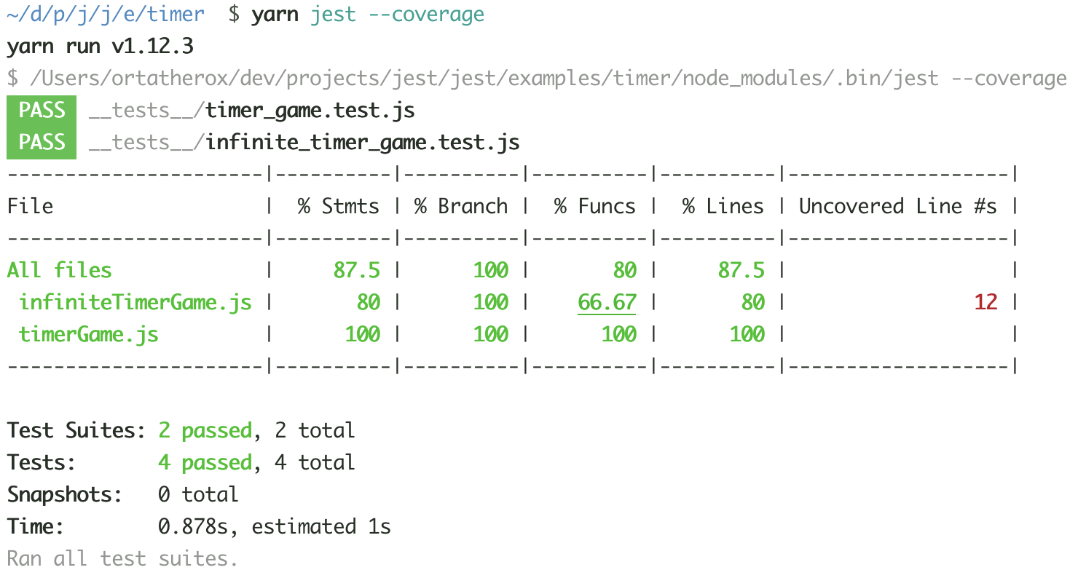
Figure 1: Coverage
Other useful ways of using Jest is with other functions and tasks on a web application is the way in that it tests the different components of a web application, because it is a popular testing framework, it has many different ways if testing and because it is a framework, it is compatible to work with many other frameworks and platforms associated with JavaScript. It can be used with Node, React, Angular, Vue and more[10]. This means that it is a very flexible framework and when creating a web application, most web applications will associate with one of these or at least include one of these. Also, if used in a web application, it would be to enhance the use of a web app to include something interactive and that’s where Jest would come in. Some of the biggest companies even use Jest because of its ease of use and flexibility between languages, examples of companies that use Jest include Facebook, Twitter, The New York Times, Spotify, Airbnb, Instagram and many more.[10]

Some examples of Jest being used would be for functions, the main example shown below. As shown in Figure 2, there is a function called sum which its purpose is to add A and B, once exported below, it allows the function to be accessed from a separate file which is solely for testing. After creating and exporting the function it is called from the testing file, it creates a const which requires the sum function from the page specified. Now every time the sum const is called it is being referred to the function from the other page. Next, shown in Figure 3, test followed by a quick description of what should happen. After that, it has more Jest syntax which is built in for making testing easier that writing a lot of if statements etc compared to similar testing methods. It uses a word called expects which means that it should expect and look for the function sum and 1 and 2 which is being referred to a and b which will be added, so that it looks for 1 and 2 followed by tobe which expects 3 to be the sum of 1 and 2.
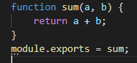
Figure 2: Example1
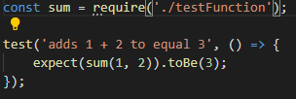
Figure 3: Example2
Next, the test needs to be run, so after installing Jest and setting it as the primary Testing dependency for the app, so that when it is run using the word test it will run the tests created. After running npm test, it will run the test in a couple of seconds or however long the test is, and it will tell the user Pass or fail and the files it was run from. Then it will tell the user about the test itself and how it got on. In the example shown in Figure 4, only the one test was completed so it says 1 passed and 1 total. If more tests were completed it would state, the number of tests that were completed and how they got on.
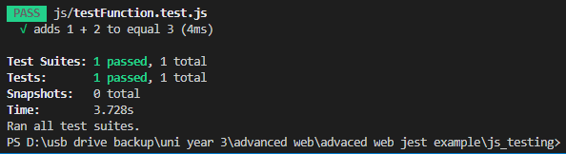
Figure 4: example3
Other useful ways Jest can be used in testing is it contains helpers that let the user be more specific about what they expect the component to return, these toBeNull, tobeUndefined, toBeDefined [11]. Like that, there are more examples in that you can test for if a function is to return numbers over a certain value, under a certain value or even a value specifically. It can also test to see if it returns strings and it can test to see if it contains certain values. This can be useful if the user is displaying information and is testing to see if a certain value is being displayed and rather than displaying it and checking each one individually, the user can create a test to see if it is returning a specific string.

Conclusion
To conclude, after using ajax, typescript and Node to create an application that displays data that had been entered into it, alter the appearance of the web app with buttons using jQuery and typescript without a refresh of a page was a successful way of doing so. It was a success because it has many function that were created so that it did not have to be refreshed. This was done by linking jQuery to the pages and then creating pages that controlled the sole html page that had the ability to do so.
Then, after looking at white box and black box testing and how it differs from the two. White box testing is also called glass box because the tester gets access to all of the app and code, meaning that this technique will require the tester to have knowledge of the code and programming in general. Black box testing on the other hand is when they do not know the structure of the application and often test features of the web app that does not need knowledge of the code, such as the appearance of the website rather than what happens behind the scenes.
Then it looked at behavioural driven testing and how it used. It was found to be a mix of two techniques that can be used but when use as behavioural driven technique it has benefits that the other two do not have. It helps the shareholders and developers have a better understanding on what is happening and what needs to happen.
Finally, looking at testing frameworks and how they are used. Firstly, by looking at what a test framework is and how it works, then looking at a specific framework in Jest and how it works. It then looks at examples of Jest testing techniques and how they work, before then looking at the syntax and how it can be extended.

References

[1] ‘Differences Between Black Box Testing and White Box Testing - Software Testing Fundamentals’. [Online]. Available: http://softwaretestingfundamentals.com/differences-between-black-box-testing-and-white-box-testing/. [Accessed: 02-Apr-2020].
[2] A. C. Barus, D. I. P. Hutasoit, J. H. Siringoringo, and Y. A. Siahaan, ‘White box testing tool prototype development’, in Proceedings - 5th International Conference on Electrical Engineering and Informatics: Bridging the Knowledge between Academic, Industry, and Community, ICEEI 2015, 2015, pp. 417–422.
[3] ‘White Box Testing | CISA’. [Online]. Available: https://www.us-cert.gov/bsi/articles/best-practices/white-box-testing/white-box-testing. [Accessed: 02-Apr-2020].
[4] ‘Unit Testing and Coding Best Practices for Unit Tests: A Test-Driven Perspective | Toptal’. [Online]. Available: https://www.toptal.com/qa/how-to-write-testable-code-and-why-it-matters. [Accessed: 02-Apr-2020].
[5] ‘Black Box Testing - Software Testing Fundamentals’. [Online]. Available: http://softwaretestingfundamentals.com/black-box-testing/. [Accessed: 02-Apr-2020].
[6] ‘Black Box Testing: An In-depth Tutorial with Examples and Techniques’. [Online]. Available: https://www.softwaretestinghelp.com/black-box-testing/. [Accessed: 02-Apr-2020].
[7] C. Solís and X. Wang, ‘A study of the characteristics of behaviour driven development’, in Proceedings - 37th EUROMICRO Conference on Software Engineering and Advanced Applications, SEAA 2011, 2011, pp. 383–387.
[8] A. Sheshasaayee and P. Banumathi, ‘Impacts of behavioral driven development in the improvement of quality software deliverables’, 2020, pp. 228–230.
[9] ‘The Benefits of Behavior-Driven Development - DZone DevOps’. [Online]. Available: https://dzone.com/articles/a-few-benefits-you-get-by-doing-bdd. [Accessed: 02-Apr-2020].
[10] ‘Jest · 🃏 Delightful JavaScript Testing’. [Online]. Available: https://jestjs.io/en/. [Accessed: 17-Apr-2020].
[11] ‘Using Matchers · Jest’. [Online]. Available: https://jestjs.io/docs/en/using-matchers. [Accessed: 17-Apr-2020].

Code Listings
Songmanagement.html
<!DOCTYPE html>
<html>
<head>
<link rel="stylesheet" href="../css/main.css">

</head>
<body>
<div id="theme">
<h3>Choose a theme</h3>
<input id="white" type="button" value="White">
<input id="green" type="button" value="green">
<!-- <input id="Blue" type="button" value="Blue"> -->
<input id="grey" type="button" value="grey">

</div>
<input id="darkMode" type="button" value="Dark Mode">

<br/>
<br/>
<br/>
<br/>
<div id="info">Press me </div>
<h1>Find a Song</h1>

<form>
Title <input id="song-title-text-box" type="text" /><br/><br/>
Artist <input id="song-artist-text-box" type="text" /><br/><br/>
Length <input id="song-slength-text-box" type="text" /><br/><br/>
Album <input id="song-album-text-box" type="text" /><br/><br/>
<input id="add-song-button" type="button" value="Add song!"/><br/>

<span id="song-opstatus">waiting..</span><br/><br/>

<input id="readall-songs" type="button" value="Find song" /> <br/>
<p>
<div id="display-song-div">
songs shown here
</div>
</p>
</form>

<p id="timeP"></p>
<input id="time" type="button" value="Press for info"/>

<script src="https://code.jquery.com/jquery-3.4.1.min.js"></script>
<script src="../dist/songmanagementpage.js"></script>

</body>
</html>

Songmanagementpage.ts
class SongManagementPage {
//attributes

//constructir
constructor() {
$.ajaxSetup({ cache: false });
}

//propperties

//methods
PageLoad(): void {
$('#readall-songs').click(this.LoadAllSongClick);
$('#add-song-button').click(this.AddSongClick);
$('#darkMode').click(this.EnableDarkMode);
$('#white').click(this.White);
$('#green').click(this.Green);
$('#blue').click(this.Blue);
$('#grey').click(this.Grey);
$('#info').hover(this.info);
$('#time').click(this.time);
}

info = (e: JQuery.Event): boolean => {
$('#info').text('Please choose a theme!');

return false;
};

time = (e: JQuery.Event): boolean => {
var date = new Date();

$('#timeP').text(Date);

return false;
};

EnableDarkMode = (e: JQuery.Event): boolean => {
$('body').css('background-color', '#222831');
$('form').css('color', 'lightgrey');
$('h1').css('color', 'lightgrey');

e.preventDefault();
return false;
};

private White = (e: JQuery.Event): boolean => {
$('body').css('background-color', 'white');
$('form').css('color', 'black');
$('h1').css('color', 'black');

e.preventDefault();
return false;
};
private Green = (e: JQuery.Event): boolean => {
$('body').css('background-color', 'green');
$('form').css('color', 'lightgrey');
$('h1').css('color', 'lightgrey');

e.preventDefault();
return false;
};
private Blue = (e: JQuery.Event): boolean => {
$('body').css('background-color', 'blue');
$('form').css('color', 'lightgrey');
$('h1').css('color', 'lightgrey');

e.preventDefault();
return false;
};

private Grey = (e: JQuery.Event): boolean => {
$('body').css('background-color', 'grey');
$('form').css('color', 'lightgrey');
$('h1').css('color', 'lightgrey');

e.preventDefault();
return false;
};

private LoadAllSongClick = (e: JQuery.Event): boolean => {
$.ajax({
cache: false,
type: 'GET',
url: 'http://localhost:1339/songs/read',
data: '{}',
contentType: 'json',
success: this.SongReadAll,
error: this.AjaxError,
});

e.preventDefault();
return false;
};

private SongReadAll = (
songs: { title: string; artist: string; slength: number; album: string }[],
status: string,
req: JQueryXHR
): void => {
let rows: string = '';
for (let i in songs) {
let song: {
title: string;
artist: string;
slength: number;
album: string;
} = songs[i];

rows += `<tr>
<td>Name</td><td>${song.title}</td>
</tr>
<tr>
<td>Description</td><td>${song.artist}</td>
</tr>
<tr>
<td>Price</td><td>${song.slength}</td>
</tr>
<tr>
<td>Album</td><td>${song.album}</td>
</tr>`;
// rows += `<tr><td>title</td><td>${song.title}</td>/tr><tr><td>artist</td><td>${song.artist}</td></tr><tr><td>length</td><td>${song.slength}</td></tr>`;
}

$('#display-song-div').html(`<table>${rows}</table>`);
};

private AddSongClick = (e: JQuery.Event): boolean => {
let song: { title: string; artist: string; slength: number; album: string };

song = {
title: $('#song-title-text-box').val() as string,
artist: $('#song-artist-text-box').val() as string,
slength: parseFloat($('#song-slength-text-box').val() as string),
album: $('#song-album-text-box').val() as string,
};

$.ajax({
cache: false,
type: 'POST',
url: 'http://localhost:1339/songs/add',
data: JSON.stringify(song),
contentType: 'application/json',
dataType: 'json',
success: this.SongAdded,
error: this.AjaxError,
});

e.preventDefault();
return false;
};

private SongAdded = (json: any, status: string, req: JQueryXHR): void => {
if (json.done === true) {
$('#song-opstatus').html('song added at index ' + json.songid);
}
};

private AjaxError = (req: JQueryXHR, status: string, error: string): void => {
window.alert(
'ajax error --' +
'\n' +
'status: ' +
status +
'\n' +
'RdyStatus: ' +
req.readyState +
'\n' +
'Message: ' +
req.statusText
);
};
}

$(function () {
let page: SongManagementPage = new SongManagementPage();

page.PageLoad();
});

Server.ts
import { WebServer, UploadDetails } from './webserver';

import { Router } from './router';

import { KeyValuePairs } from './keyvaluepairs';

import * as process from 'process';

import { ServerResponse, Server } from 'http';

import { inspect } from 'util';
import { url } from 'inspector';

class WebPageProcess {
private _hostname: string = process.env['SERVER_IP_ADDRESS'] || '127.0.0.1'; // In local computer
private _port: number = 1339;
private _messages: string[] = ['message one', 'message two', 'message three'];
private _songs: {
title: string;
artist: string;
slength: number;
album: string;
}[] = [];

Start(): void {
let router: Router = new Router();
let server: WebServer = new WebServer(
this._hostname,
this._port,
router,
'./clientside/html'
);

router.AddRoute('/songs', 'GET', 'songmanagement');

router.AddRoute(
'/songs/add',
'POST',
(url: string, responce: ServerResponse, data: KeyValuePairs): boolean => {
let songIndex: number;
let result: { done: boolean; songid: number };

responce.writeHead(200, { 'content-type': 'application/json' });

this._songs.push({
title: data.title,
artist: data.artist,
slength: data.slength,
album: data.album,
});

songIndex = this._songs.length - 1;

result = { done: true, songid: songIndex };
responce.write(JSON.stringify(result));

return true;
}
);

router.AddRoute(
'/songs/read',
'GET',
(url: string, responce: ServerResponse, data: KeyValuePairs): boolean => {
responce.writeHead(200, { 'content-type': 'application/json' });

responce.write(
JSON.stringify(this._songs.filter((s) => typeof s != 'undefined'))
);

return true;
}
);

router.AddRoute(
'/songs/read/$songid:int',
'GET',
(URL: String, responce: ServerResponse, data: KeyValuePairs): boolean => {
responce.writeHead(200, { 'content-type': 'application/json' });

if (typeof this._songs[data.songid] != 'undefined')
responce.write(
JSON.stringify({ done: true, song: this._songs[data.songid] })
);
else responce.write(JSON.stringify({ done: false }));

return true;
}
);

router.AddRoute(
'/songa/put/$songid:int',
'PUT',
(url: string, responce: ServerResponse, data: KeyValuePairs): boolean => {
let result: { done: boolean; songid: number };

responce.writeHead(200, { 'content-type': 'application/json' });

this._songs[data.songid] = {
title: data.title,
artist: data.artist,
slength: data.slength,
album: data.album,
};

result = { done: true, songid: data.songid };
responce.write(JSON.stringify(result));

return true;
}
);

router.AddRoute(
'/songs/delete/$songid:int',
'DELETE',
(url: string, responce: ServerResponse, data: KeyValuePairs): boolean => {
let result: { done: boolean; songid: number };

responce.writeHead(200, { 'content-type': 'application/json' });

delete this._songs[data.songid];

result = { done: true, songid: data.songid };
responce.write(JSON.stringify(result));

return true;
}
);

server.Listen();
}
}

(function () {
new WebPageProcess().Start();
})();

